**Team 12**

**Topic of Project: Image filtering and processing.**

**Problem Statement:**

Our Project aims to solve and implement three types of variations in image processing by usage of numpy, panda and matplotlib

These are:-

• Colour Detection.

• Image Filtering.

• Conversion of RBG image to Black and White image.

**Our Approach:**

We have tried to use all of the three main libraries numpy,pandas and matplotlib.While brainstorming upon the code of Image processing , we stumbled upon a library called “skimage”.This library helped us in various methods to improve the functioning and variety of the output of our source code, thus helping in making our project multi-dimensional.Now let us learn more about the project.

**PART 1:**

We have added a feature to our project that is image color detection.This feature basically shows the color name and its R,G,B values.

**Libraries used are Pandas and opencv**.

About the libraries:

**1.Pandas:**

**Pandas** is a software library written for the Python programming language for data manipulation and analysis. In particular, it offers data structures and operations for manipulating numerical tables and time series.

**2.opencv:**

**OpenCV-Python** is a library of Python bindings designed to solve computer vision problems.cv2.imread() method loads an image from the specified file.

We have used a database that is a csv file which contains the names of colors,their hexadecimal values,and their R G B Content. We will make use of method pd.read_csv to read the data from the colors.csv file.So basically we want that when a user double clicks on any part of the image the color details of that part must be displayed.As soon as an user double clicks on the image, the SetMouseCallBack() method comes into picture.It calls the function draw_function.

**draw_function**:It will calculate the rgb values of the pixel which we double click. The function parameters have the event name, (x,y) coordinates of the mouse position, etc. In the function, we check if the event is double-clicked, then we calculate and set the r,g,b values along with x,y positions of the mouse.

Now after the draw_function is executed,we have successfully extracted the values of x,y coordinates and the r,g,b values now the task is to get the color of corresponding r,g,b value from the data set.For this we have used a function called  **get_color_name(R, G, B).**

**get_color_name(R, G, B):**

We have the r,g and b values. Now, we need another function which will return us the color name from RGB values. To get the color name, we calculate a distance(d) which tells us how close we are to color and choose the one having minimum distance.Our distance is calculated by this formula:

**d = abs(Red – ithRedColor) + (Green – ithGreenColor) + (Blue – ithBlueColor).**

Whenever a double click event occurs, it will update the color name and RGB values on the window.Using the cv2.imshow() function, we draw the image on the window. When the user double clicks the window, we draw a rectangle and get the color name to draw text on the window using cv2.rectangle and cv2.putText() functions.

Displayed images: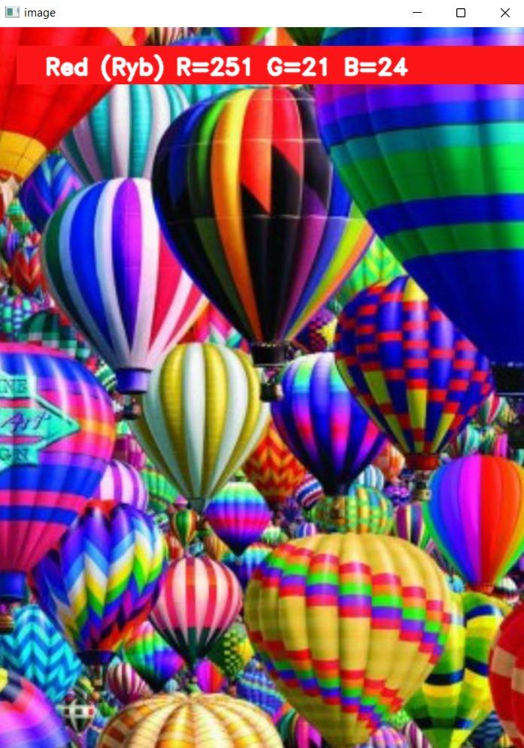

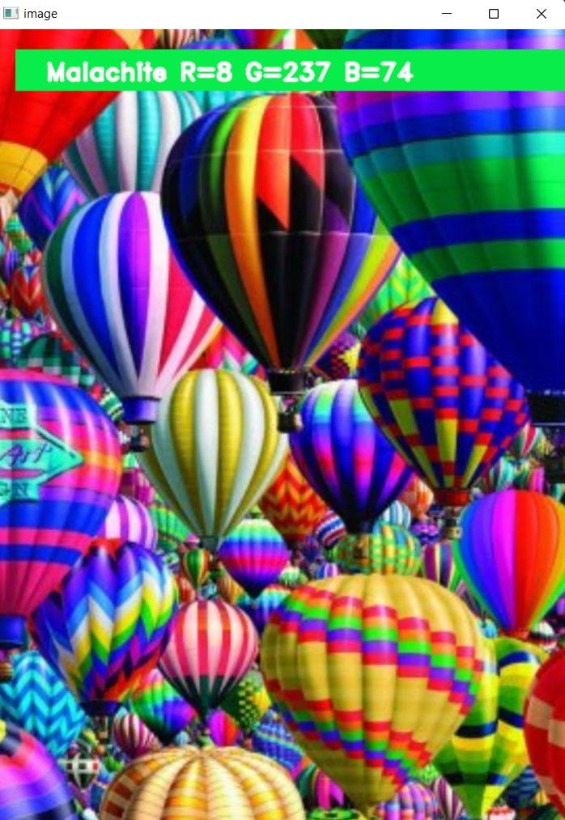

**2nd part:**

Applying various filters to the image and displaying them:

**Libraries used:**

1.Matplotlib

2.Scikit-image

**Matplotlib:**

matplotlib.pyplot is a collection of functions that make matplotlib work like MATLAB. Each pyplot function makes some change to a figure: e.g., creates a figure, creates a plotting area in a figure, plots some lines in a plotting area, decorates the plot with labels, etc.

**scikit-image (a.k.a. skimage):**

It is a collection of algorithms for image processing and computer vision.The main package of skimage only provides a few utilities for converting between image data types; for most features, you need to import one of the following subpackages: imread,imshow and imsave.

**Images:**

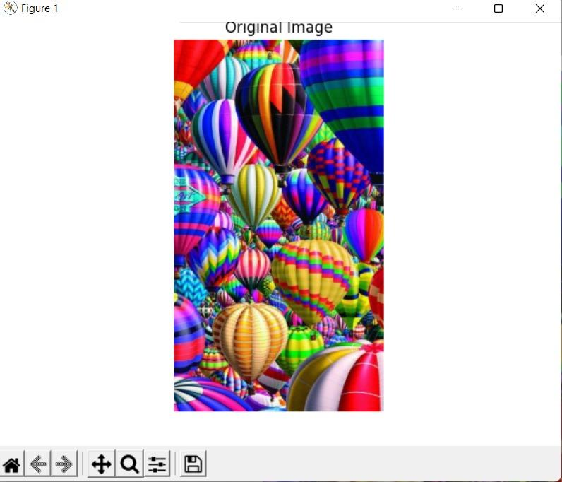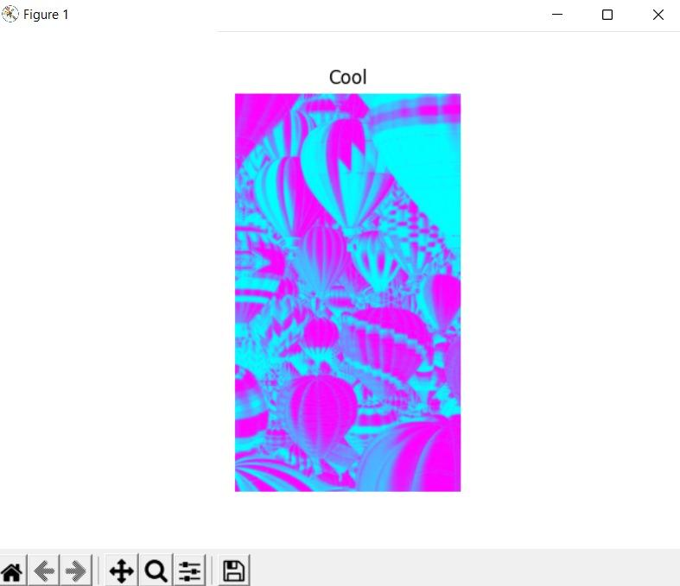

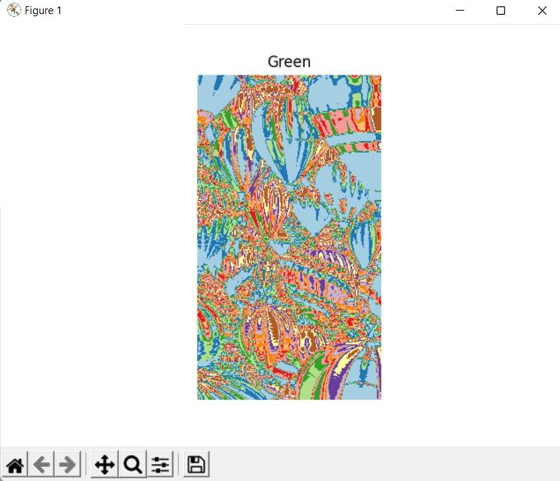

3rd program:

**Given any Image in RGB form convert it to Monochrome (BnW).**

Libraries used:

1.numpy

2.matplotlib

3.Scikit-image

**Numpy:**NumPy, which stands for Numerical Python, is a library consisting of multidimensional array objects and a collection of routines for processing those arrays. Using NumPy, mathematical and logical operations on arrays can be performed.

This reads the image in and converts it into a Numpy array using np.array(img).For grayscale images, the result is a two-dimensional array with the number of rows and columns equal to the number of pixel rows and columns in the image. Low numeric values indicate darker shades and higher values lighter shades. The range of pixel values is often 0 to 255. We divide by 255 to get a range of 0 to 1.

An intuitive way to convert a color image 3D array to a grayscale 2D array is, for each pixel, take the average of the red, green, and blue pixel values to get the grayscale value. This combines the lightness or *luminance* contributed by each color band into a reasonable gray approximation.We do that using **imgmatrix.mean(axis=2)**.The axis=2 argument tells numpy.mean() to average values across all three color channels.

**Result image:**

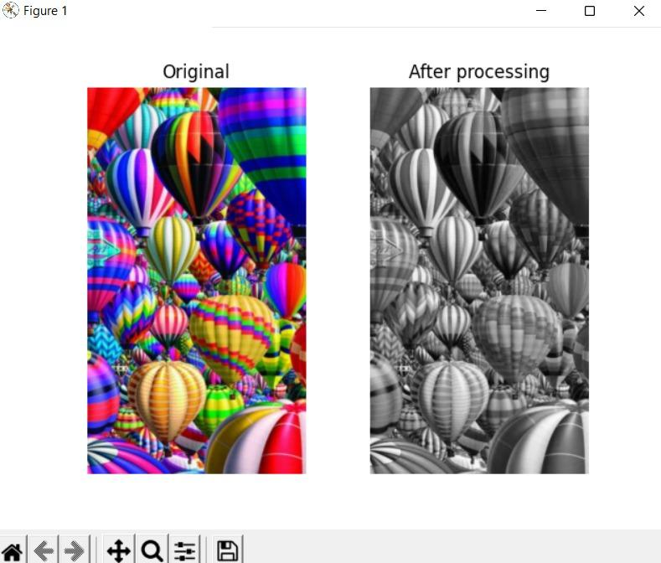

This Project is presented by:

1.Vipra Nagaich.(bt20ece062).

2.Snehal Patil.(bt20ece002).

3.Nandini Palve.(bt20ece058).

4.Anusha Reddy.(bt20ece091).

5.Ashish Yadav.(bt20ece065).

**Course NAME:IT workshop.**

**Course Instructor:Dr.Parnika Paranjape.**