**PRACTICAL NO.7**

* **AIM:-JOIN QUERIES**

**INNER JOIN**

**OUTER JOIN**

**Create table query**

create table supplier

(sid tinyint primary key,

Sname varchar(25),

Address varchar(25)

);

Table created

**Insert value query**

insert into supplier values

(1,’ABC’,’Andheri’);

1row created.

insert into supplier values

(2,’PQR’,’Malad’);

1row created.

insert into supplier values

(2,’PQR’,’Malad’);

1row created.

insert into supplier values

(3,’XYZ’,’Virar’);

1row created.

insert into supplier values

(4,’EFG’,’Kandivali’);

1row created.

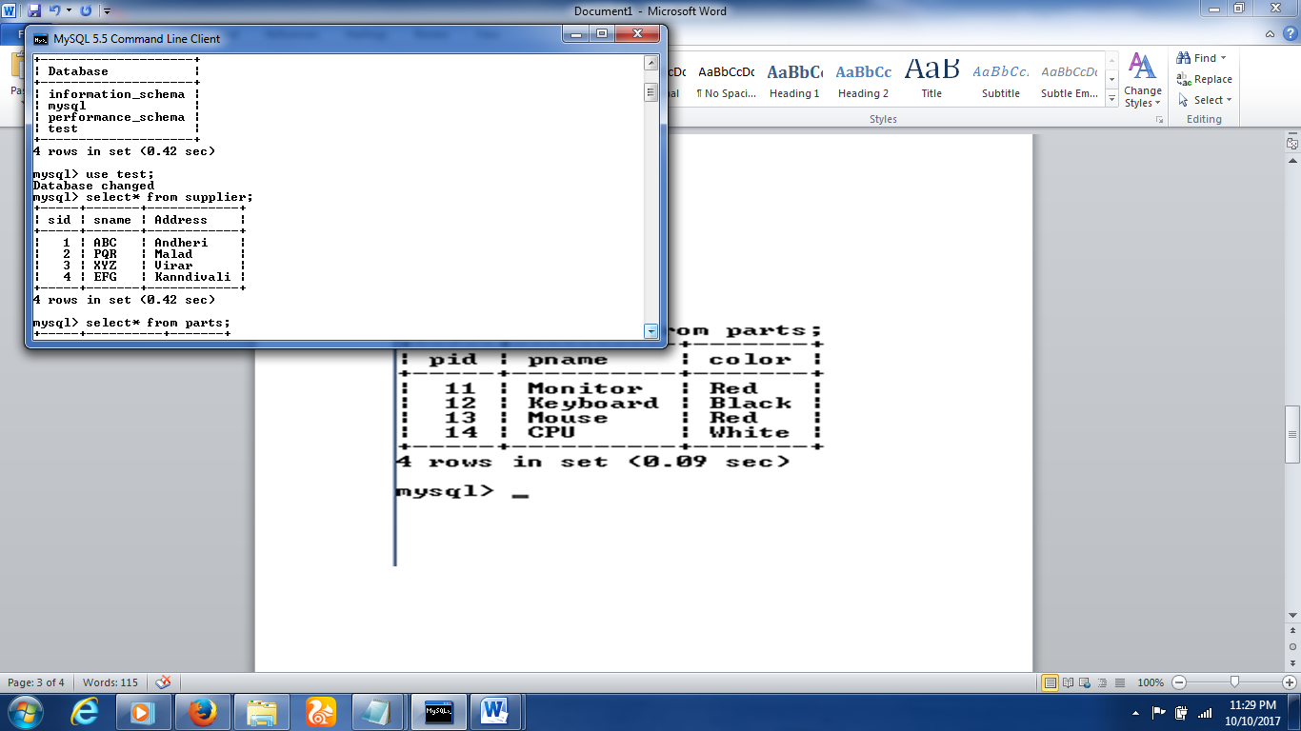

**Create table query**

create table parts

(pid tinyint primary key,

pname varchar(25),

color varchar(15)

);

Table created

**Insert value query**

insert into parts values

(11,’Monitor’,’Red’);

1 row created.

insert into parts values

(12,’Keyboard’,’Black’);

1 row created.

insert into parts values

(13,’Mouse’,’Red’);

1 row created.

insert into parts values

(14,’CPU’,’White’);

1 row created.

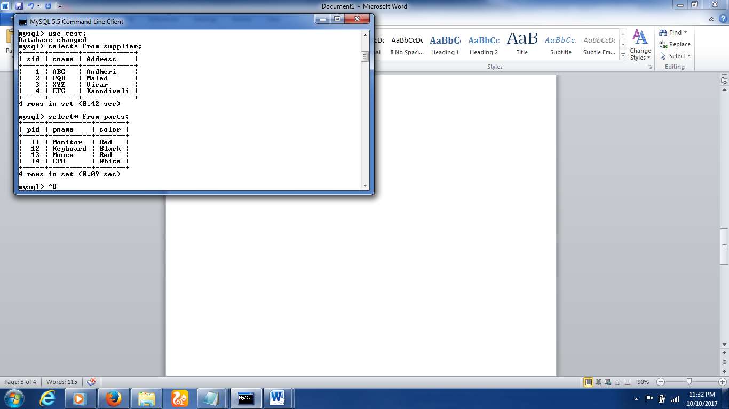

**Create table query**

Create table catalog

(sid tinyint references supplier(sid),

pid tinyint references parts(pid),

cost int

);

Table created

**Insert query**

insert into catalog values

(1,11,1000);

1row craeted.

insert into catalog values

(1,13,2000);

1row craeted.

insert into catalog values

(2,12,350);

1row craeted.

insert into catalog values

(3,13,2200);

1row craeted.

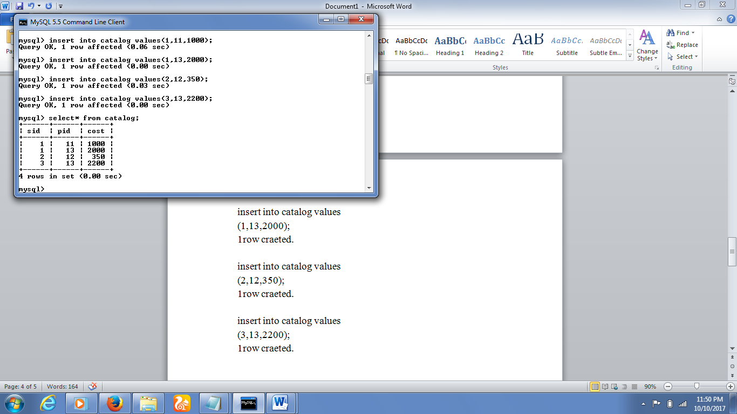

**DEMONSTRATE JOIN CONCEPT**

1)Join supplier table with catalog table .(using INNER join)

QUERY

Select* from supplier

INNER JOIN

catalog ON supplier.sid=catalog.sid;

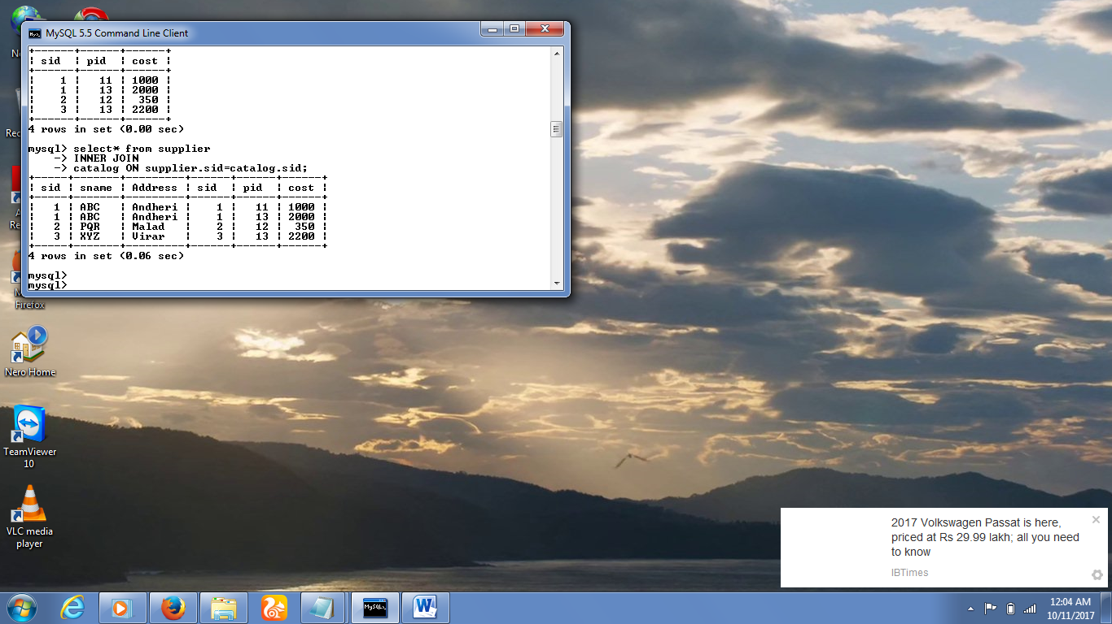

2)Join parts table with catalog table. (using INNER join)

QUERY

Select* from parts

INNER JOIN

Catalog ON parts.pid=catalog.sid;

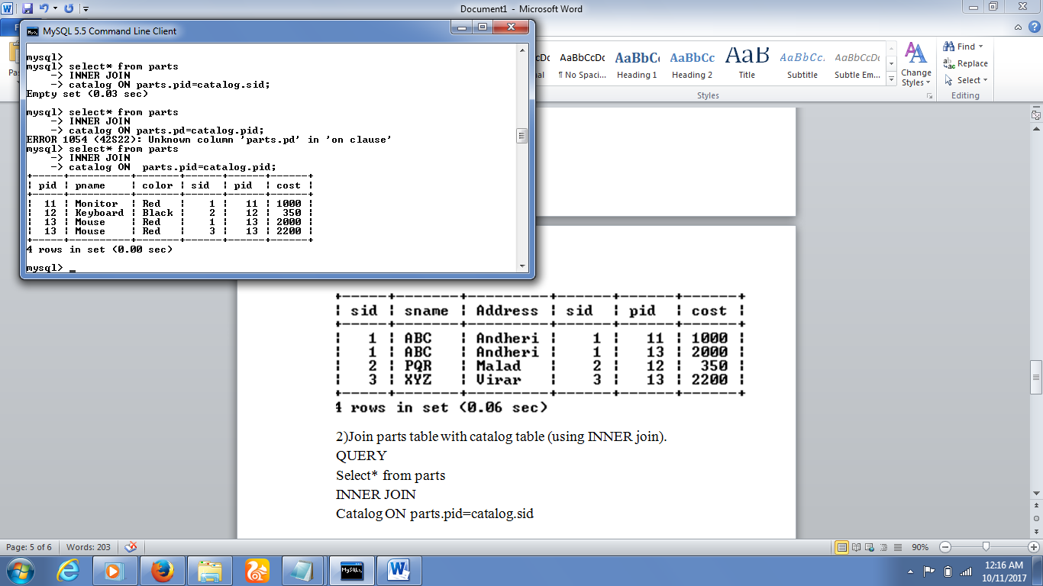

3)Join parts table with supplier table.(using ad hoc relationship)

QUERY

Select* from parts INNER JOIN supplier

ON sid<=pid;

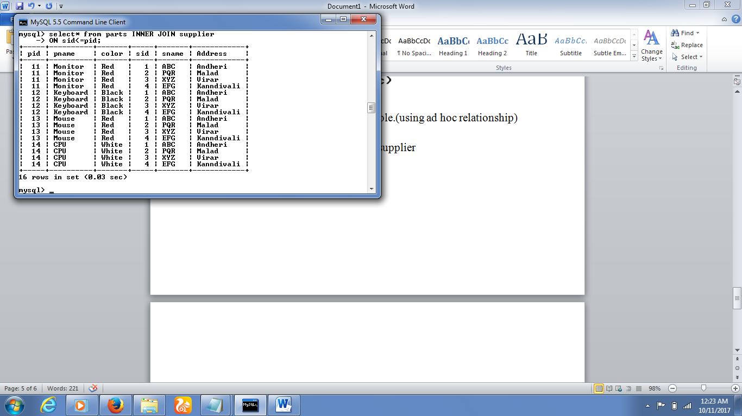

4)Join supplier,parts,catalog table.

5)Join supplier table with catalog table.(using compound join condition)

QUERY

Select*

From supplier INNER JOIN catalog

ON supplier.sid=catalog.sid OR

Supplier.sid<catalog.sid;

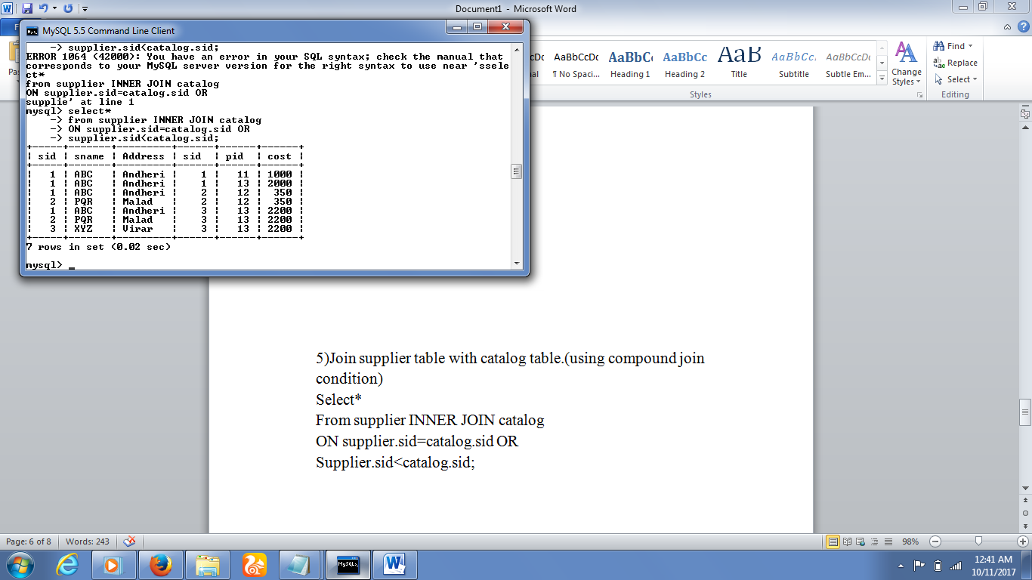

6)Join supplier table with catalog table.(using implicit INNER join syntax)

QUERY

Seelect*

Frrom supplier, catalog

Where supplier.sid=catalog.sid;

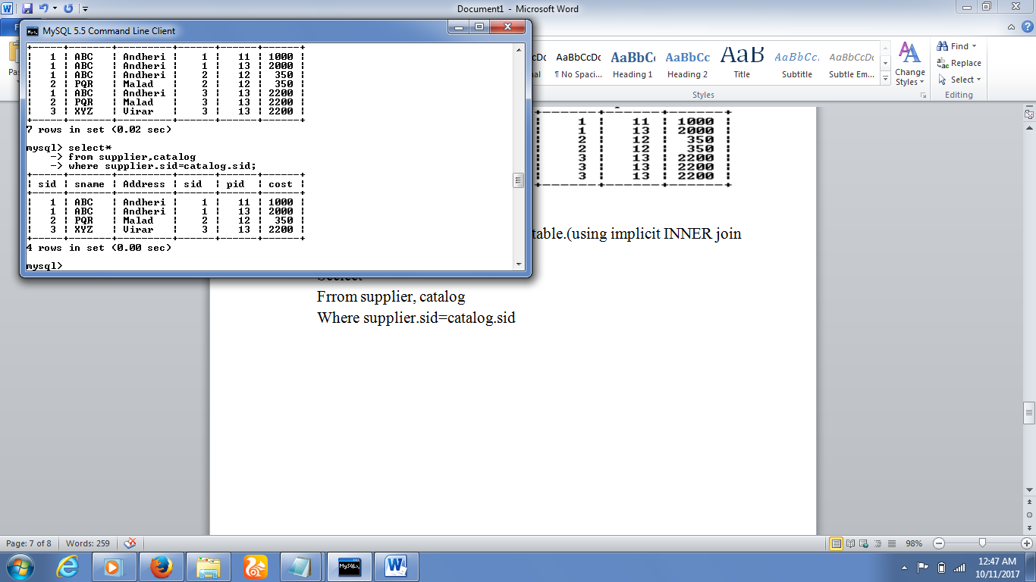7) Join supplier table with catalog table.(using LEFT OUTER join)

QUERY

Select*

From supplier LEFT OUTER JOIN catalog

ON supplier.sid=catalog.sid;

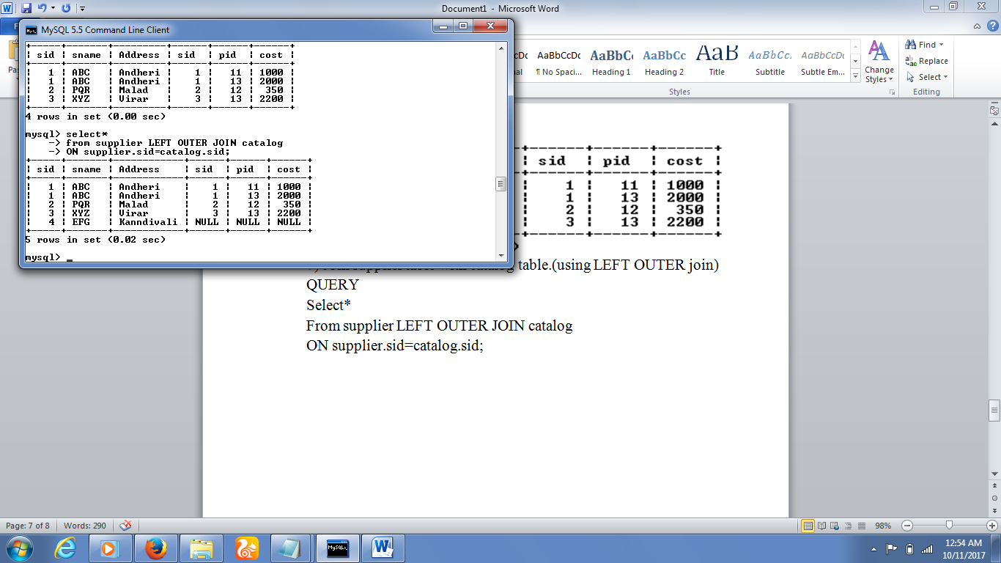

8) Join supplier table with catalog table.(using RIGHT OUTER join)

QUERY

Select*

From supplier RIGHT OUTER JOIN catalog

ON supplier.sid=catalog.sid;

