AWS ECS Blog Application — Full Documentation

Objective
This project deploys a full-stack Blog CRUD application using AWS container services.
The frontend and backend are containerized using Docker and deployed on ECS Fargate.
An Application Load Balancer routes traffic, and PostgreSQL RDS stores blog data.
Architecture
User → Application Load Balancer → ECS Frontend → ECS Backend → RDS PostgreSQL

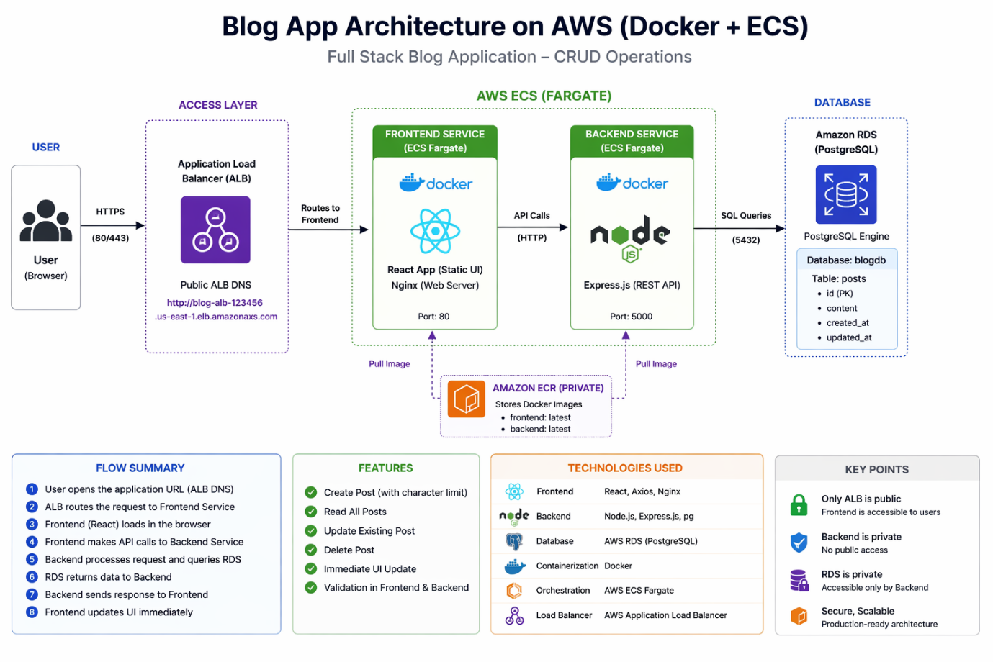
Step 1 — Create ECR Repositories
Create repositories for backend and frontend images.
aws ecr create-repository --repository-name blog-backend --region ap-south-1
aws ecr create-repository --repository-name blog-frontend --region ap-south-1

Step 2 — Login to ECR
aws ecr get-login-password --region ap-south-1 | docker login --username AWS --password-stdin ACCOUNT_ID.dkr.ecr.ap-south-1.amazonaws.com
Step 3 — Build Docker Images
Backend image
docker build -t blog-backend ./backend
Frontend image
docker build -t blog-frontend ./frontend
Step 4 — Tag Images
docker tag blog-backend:latest ACCOUNT_ID.dkr.ecr.ap-south-1.amazonaws.com/blog-backend:latest
docker tag blog-frontend:latest ACCOUNT_ID.dkr.ecr.ap-south-1.amazonaws.com/blog-
Step 5 — Push Images to ECR
docker push ACCOUNT_ID.dkr.ecr.ap-south-1.amazonaws.com/blog-backend:latest
docker push ACCOUNT_ID.dkr.ecr.ap-south-1.amazonaws.com/blog-frontend:latest
Step 6 — Create RDS PostgreSQL
aws rds create-db-instance --db-instance-identifier blog-db --db-instance-class db.t3.micro --engine postgres --allocated-storage 20 --master-username postgres --master-user-password postgres123 --db-name blogdb --publicly-accessible --region ap-south-1
Wait until status = available.
Step 7 — Create IAM Role for ECS
Create trust policy file
ecs-trust.json
{
"Version": "2012-10-17",
"Statement": [
{
"Effect": "Allow",
"Principal": { "Service": "ecs-tasks.amazonaws.com" },
"Action": "sts:AssumeRole"
}
]
}
Create role
aws iam create-role --role-name ecsTaskExecutionRoleBlog --assume-role-policy-document file://ecs-trust.json
Attach policy
aws iam attach-role-policy --role-name ecsTaskExecutionRoleBlog --policy-arn arn:aws:iam::aws:policy/service-role/AmazonECSTaskExecutionRolePolicy
Step 8 — Register Backend Task
backend-task.json
{
"family": "blog-backend",
"networkMode": "awsvpc",
"requiresCompatibilities": ["FARGATE"],
"cpu": "256",
"memory": "512",
"executionRoleArn": "ROLE_ARN",
"taskRoleArn": "ROLE_ARN",
"containerDefinitions": [
{
"name": "backend",
"image": "ACCOUNT_ID.dkr.ecr.ap-south-1.amazonaws.com/blog-backend:latest",
"portMappings": [
{
"containerPort": 5000,
"protocol": "tcp"
}
],
"environment": [
{ "name": "DB_HOST", "value": "RDS_ENDPOINT" },
{ "name": "DB_PORT", "value": "5432" },
{ "name": "DB_USER", "value": "postgres" },
{ "name": "DB_PASSWORD", "value": "postgres123" },
{ "name": "DB_NAME", "value": "blogdb" }
]
}
]
}
Register
aws ecs register-task-definition --cli-input-json file://backend-task.json --region ap-south-1
Step 9 — Register Frontend Task
frontend-task.json
{
"family": "blog-frontend",
"networkMode": "awsvpc",
"requiresCompatibilities": ["FARGATE"],
"cpu": "256",
"memory": "512",
"executionRoleArn": "ROLE_ARN",
"containerDefinitions": [
{
"name": "frontend",
"image": "ACCOUNT_ID.dkr.ecr.ap-south-1.amazonaws.com/blog-frontend:latest",
"portMappings": [
{
"containerPort": 80,
"protocol": "tcp"
}
]
}
]
}
Register
aws ecs register-task-definition --cli-input-json file://frontend-task.json --region ap-south-1
Step 10 — Create Cluster
aws ecs create-cluster --cluster-name blog-cluster --region ap-south-1
Step 11 — Get VPC
aws ec2 describe-vpcs --query "Vpcs[0].VpcId" --output text --region ap-south-1
Step 12 — Get Subnets
aws ec2 describe-subnets --filters Name=vpc-id,Values=VPC_ID --query "Subnets[*].SubnetId" --output text --region ap-south-1
Step 13 — Create Security Group for ALB
aws ec2 create-security-group --group-name blog-alb-sg --description "ALB SG" --vpc-id VPC_ID --region ap-south-1
Allow HTTP
aws ec2 authorize-security-group-ingress --group-id ALB_SG --protocol tcp --port 80 --cidr 0.0.0.0/0 --region ap-south-1
Step 14 — Create ECS Security Group
aws ec2 create-security-group --group-name blog-ecs-sg --description "ECS SG" --vpc-id VPC_ID --region ap-south-1
Allow from ALB

aws ec2 authorize-security-group-ingress --group-id ECS_SG --protocol tcp --port 80 --source-group ALB_SG --region ap-south-1
Allow backend
aws ec2 authorize-security-group-ingress --group-id ECS_SG --protocol tcp --port 5000 --source-group ALB_SG --region ap-south-1
Step 15 — Create Target Groups
Frontend
aws elbv2 create-target-group --name blog-frontend-tg --protocol HTTP --port 80 --target-type ip --vpc-id VPC_ID --region ap-south-1
Backend
aws elbv2 create-target-group --name blog-backend-tg --protocol HTTP --port 5000 --target-type ip --vpc-id VPC_ID --health-check-path /api/posts --region ap-south-1
Step 16 — Create ALB
aws elbv2 create-load-balancer --name blog-alb --subnets SUBNET1 SUBNET2 SUBNET3 --security-groups ALB_SG --scheme internet-facing --type application --region ap-south-1
Step 17 — Create Listener
aws elbv2 create-listener --load-balancer-arn ALB_ARN --protocol HTTP --port 80 --default-actions Type=forward,TargetGroupArn=FRONTEND_TG --region ap-south-1
Step 18 — Create Frontend Service
aws ecs create-service --cluster blog-cluster --service-name blog-frontend-service --task-definition blog-frontend --desired-count 1 --launch-type FARGATE --network-configuration "awsvpcConfiguration={subnets=[SUBNETS],securityGroups=[ECS_SG],assignPublicIp=ENABLED}" --load-balancers "targetGroupArn=FRONTEND_TG,containerName=frontend,containerPort=80" --region ap-south-1
Step 19 — Create Backend Service
aws ecs create-service --cluster blog-cluster --service-name blog-backend-service --task-definition blog-backend --desired-count 1 --launch-type FARGATE --network-configuration "awsvpcConfiguration={subnets=[SUBNETS],securityGroups=[ECS_SG],assignPublicIp=ENABLED}" --load-balancers "targetGroupArn=BACKEND_TG,containerName=backend,containerPort=5000" --region ap-south-1
Step 20 — Create Database Table

Connect to RDS
```sql
CREATE TABLE posts (
id SERIAL PRIMARY KEY,
title TEXT NOT NULL,
content TEXT NOT NULL,
created_at TIMESTAMP DEFAULT CURRENT_TIMESTAMP
);
Final Output

Application deployed successfully.

Features
• React frontend
• Node backend
• PostgreSQL database
• ECS Fargate deployment
• Application Load Balancer
• Docker containers
• REST API CRUD
• High availability architecture

