Project: 3-Tier-StudentApp
🏗️ 3-Tier Architecture Diagram
Flow:User → Web Tier (Nginx) → Application Tier (Tomcat) → Database Tier (RDS/MySQL)
Prerequisite:
- VPC
- Subnets
- Route Table
- Nat Gateway
- Internet Gateway
- RDS
Create VPC
- Name: my-3-tier-vpc
- CIDR: 10.0.0.0/16
Create Subnets
1.Subnet-1
- Name: Public-Subnet-Nginx
- CIDR: 10.0.0.0/23
2.Subnet-2
- Name: Private-Subnet-Tomcat
- CIDR: 10.0.2.0/23
3.Subnet-3
- Name:Private-Subnet-Database
- CIDR: 10.0.4.0/23
Create Internet Gateway
- Name: MY_IGW
- attach igw to vpc
Create Nat Gateway
- Name: 3-tier-NAT-Gateway
- create in public subnet
Create Route Table
- Public-RT
  - add public subnet
  - add igw
  - Subnet Association(public-subnet-Nginx)
2.Private-RT
  - add private subnets
  - add nat
  - Subnet Association(private-subent-Database,private-subnet-Tomcat)
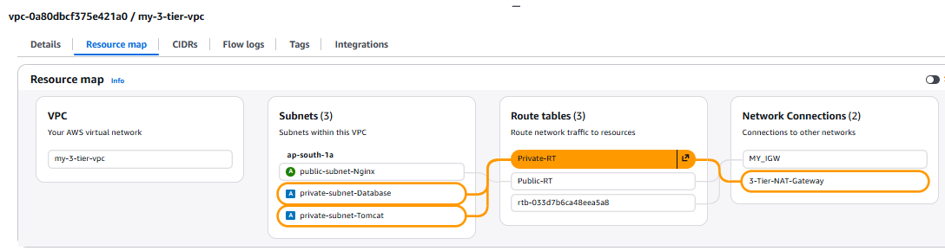
Create EC2 Instances
- Public_Nginx_Instance ->create in public subnet ->allow port = 80,22
- Private_Database_instance->create in private subnet ->allow port = 8080,22
- Private_Tomcat_Instance->create in private subnet ->allow port = 3306,22
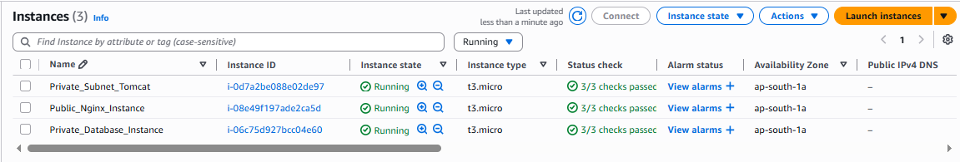
Create Database In RDS
- Go To RDS
- Created Database
- Standard create
- Free tier
- DB name – database-1
- Username – admin
- Password – Passwd123$
- VPC – VPC-3-tier
- Connect to Instance -> choose database instance
- Public access – no
- A.Z. – no preference
- Create database
- Edit security group -> Add 3306 port
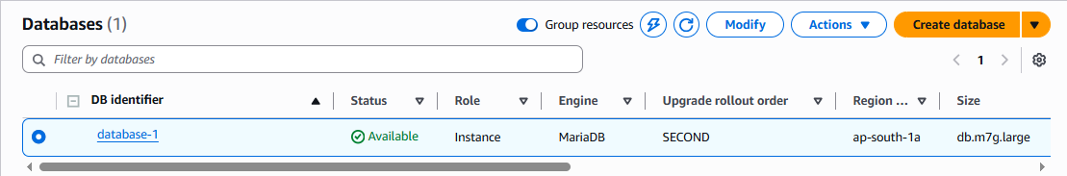
Connect To Nginx-Instance-Public
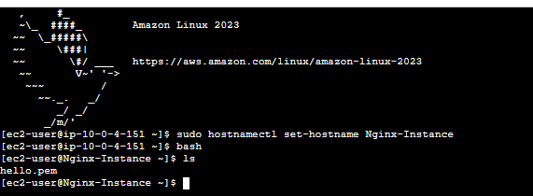
- connect to instance
- change hostname: sudo hostnamectl set-hostname Nginx-Instance
- bash
Now SSH into Database Instance
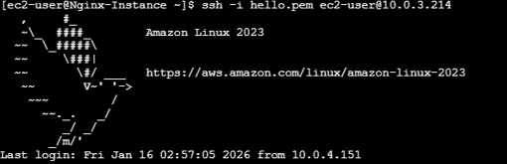
sudo -i
yum install mariadb105-server -y
systemctl start mariadb
systemctl enable mariadb
Log in into database
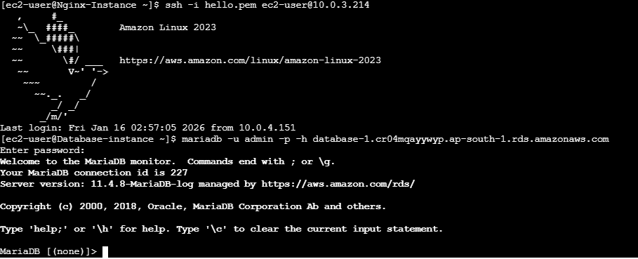
Mariadb -u admin -p -h RDS(endpoint)
Note: replace rds-endpoint with actual endpoint value
show databases;
create database studentapp;
use studentapp;
Run this query to create table:
CREATE TABLE if not exists students(student_id INT NOT NULL AUTO_INCREMENT,
student_name VARCHAR(100) NOT NULL,
student_addr VARCHAR(100) NOT NULL,
student_age VARCHAR(3) NOT NULL,
student_qual VARCHAR(20) NOT NULL,
student_percent VARCHAR(10) NOT NULL,
student_year_passed VARCHAR(10) NOT NULL,
PRIMARY KEY (student_id)
);
show tables;
Logout from database:
exit
Back to nginx-server
Now SSH into Tomcat Server
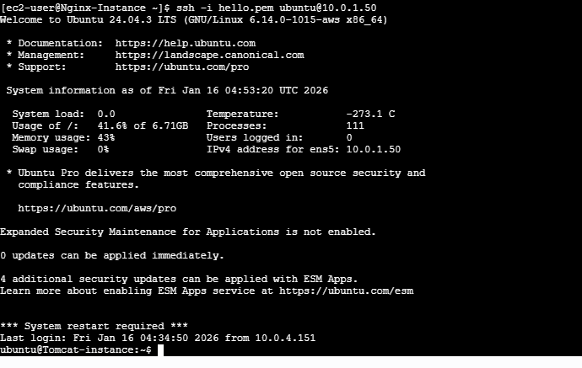
- ssh -i hello.pem ubuntu@ip-of-tomcat-vm
sudo -i
sudo apt update
sudo apt install openjdk-11-jdk -y
java –version
sudo useradd -m -U -d /opt/tomcat -s /bin/false tomcat
cd /tmp
wget https://downloads.apache.org/tomcat/tomcat-9/v9.0.85/bin/apache-tomcat-9.0.85.tar.gz
sudo mkdir /opt/tomcat
sudo tar -xzvf apache-tomcat-9.0.85.tar.gz -C /opt/tomcat --strip-components=1
go to webapps dir and download .war file(application)
cd /opt/apache-tomcat-9.0.85/webapps
curl -O https://s3-us-west-2.amazonaws.com/studentapi-cit/student.war
cd ../lib
curl -O https://s3-us-west-2.amazonaws.com/studentapi-cit/mysql-connector.jar
MODIFY context.xml
cd apache-tomcat-9.0.85.tar.gz/conf
sudo vim context.xml
add below line [connection string] at line 21
<Resource name="jdbc/TestDB" auth="Container" type="javax.sql.DataSource"
maxTotal="100" maxIdle="30" maxWaitMillis="10000"
username="USERNAME" password="PASSWORD" driverClassName="com.mysql.jdbc.Driver"
url="jdbc:mysql://DB-ENDPOINT:3306/DATABASE-NAME"/>
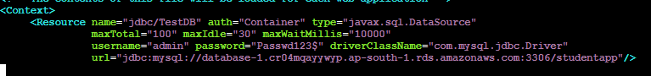
cd ../bin
chmod +x catalina.sh
./catalina.sh start
exit
Back to nginx-server
sudo -i
yum install nginx -y
vim /etc/nginx/nginx.conf
- :set nu (enter below data in line 47 in between error and location)
location / {
proxy_pass http://private-IP-tomcat:8080/student/;
}
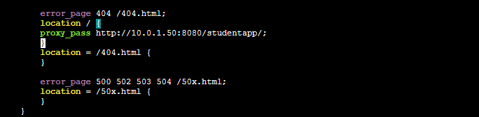
- :wq ->save file
systemctl start nginx
Go To Browser Hit Public-IP Nginx
