TABLE OF CONTENTS

ABSTRACT

1. INTRODUCTION

BACKGROUND OF PROJECT

OPERATION ENVIRONMENT

2. SYSTEM ANALYSIS

SOFTWARE REQUIREMENT SPECIFICATION

SOFTWARE TOOL USED

3. SYSTEM DESIGN

TABLE DESIGN

DATA FLOW DIAGRAM’S

4. SYSTEM IMPLEMENTATION

MODULE DESCRIPTION

SCREEN SHOTS

5. SYSTEM TESTING

INTEGRATION TESTING

UNIT TESTING

6. CONCLUSION & FUTURE SCOPE

7. REFERENCES

ABSTRACT:

Book Library Management System is a system which maintains the information about the books present in the library, their authors, the members of library to whom books are issued, library staff and all. This is very difficult to organize manually.The Book Library Management has been designed to computerize and automate the operations performed over to add new book , update , read and delete the books.

**INTRODUCTION**

The introduction gives an background and operation environment of the system.

**BACKGROUND OF PROJECT**

Book Library Management System is an website which refers to library systems. It is used by Admin to manage the library using a computerized system where Admin add new books.Admin and student modules are also included in this system. With this computerized system there will be no loss of book record.

**OPERATION ENVIRONMENT**

1.PROCESSOR: intel core i5 processor or better performance

2.OPERATING SYSTEM: Windows7, Ubuntu

3.MEMORY: 3.8 GB

4.HARD DISK SPACE: 240 GB

5.DATABASE : Mysql

**SYSTEM ANALYSIS**

In this chapter, we will discuss and analyze about the developing process of Book Library Management System including software requirement specification (SRS) and comparison between existing and proposed system .

SOFTWARE REQUIREMENT SPECIFICATION

FUNCTIONAL REQUIREMENTS

1.Admin SignUp

2.Admin Signin

3.Add Book

4.ShowBooks

5.All Records

6.Student Register

7.Student Login

8.Student View

SOFTWARE REQUIREMENTS

* • Operating system- Windows 7 is used as the operating system as it is stable and supports more features and is more user friendly
* Database MYSQL-MYSQL is used as database as it easy to maintain and retrieve records by simple queries which are in English language which are easy to understand and easy to write.
* Development tools and Programming language- HTML is used to write the whole code and develop webpages with css, java script for styling work and php for sever side scripting.

**HARDWARE REQUIREMENTS**

* Intel core i5 2nd generation is used as a processor because it is fast than other processors an provide reliable and stable and we can run our pc for longtime. By using this processor we can keep on developing our project without any worries
* Ram 3.8 gb is used as it will provide fast reading and writing capabilities and will in turn support in processing.

**SOFTWARE TOOL USED**

The whole Project is divided in two parts the front end and the back end.

**Front End**

The front end is designed using of html ,css, Java script,Bootstrap,Python

**Back End**

For back end we are using MySQL, Django

**SYSTEM DESIGN**

BOOK RECORDS FROM DATABASE:

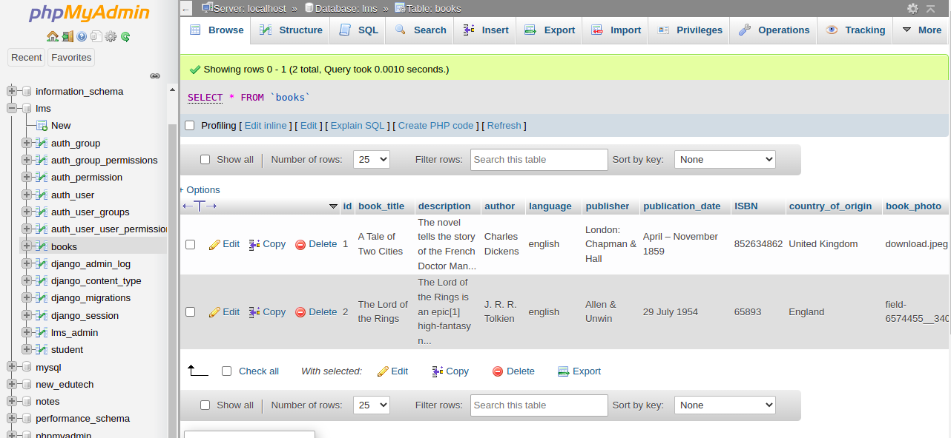

STUDENT RECORD FROM DATABASE:

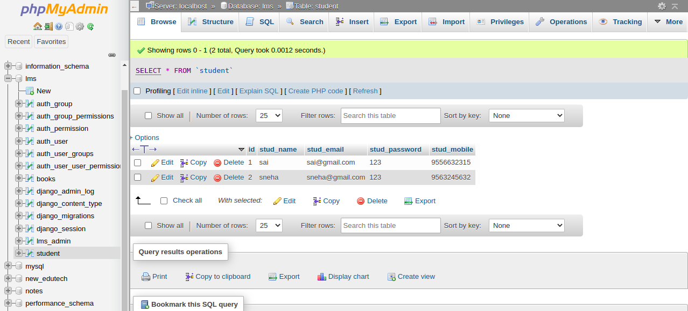

STUDENT STRUCTURE FROM DATABASE:

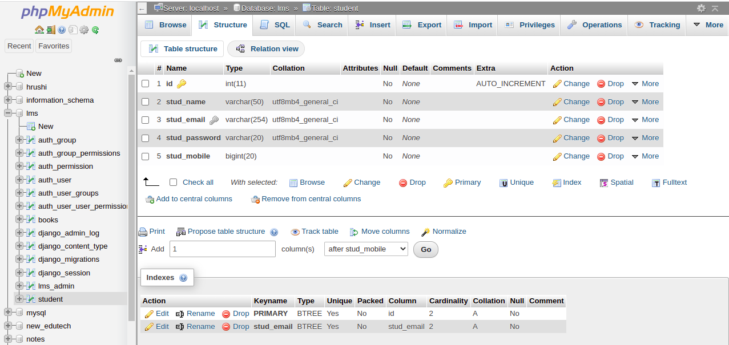

ADMIN TABLE FROM DATABASE:

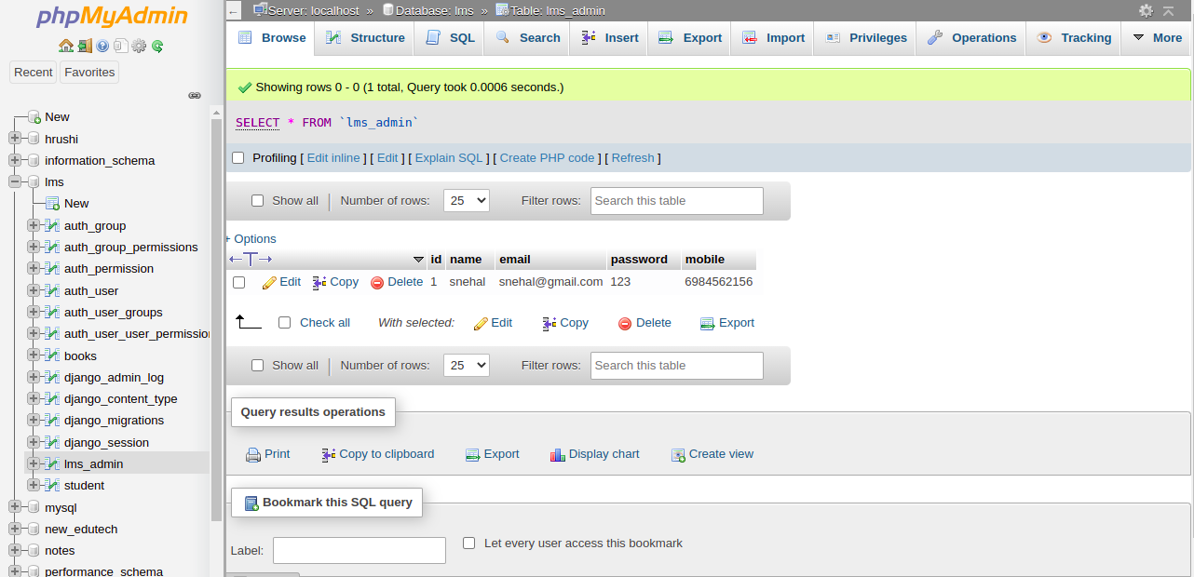

BOOK Library Table From Database:

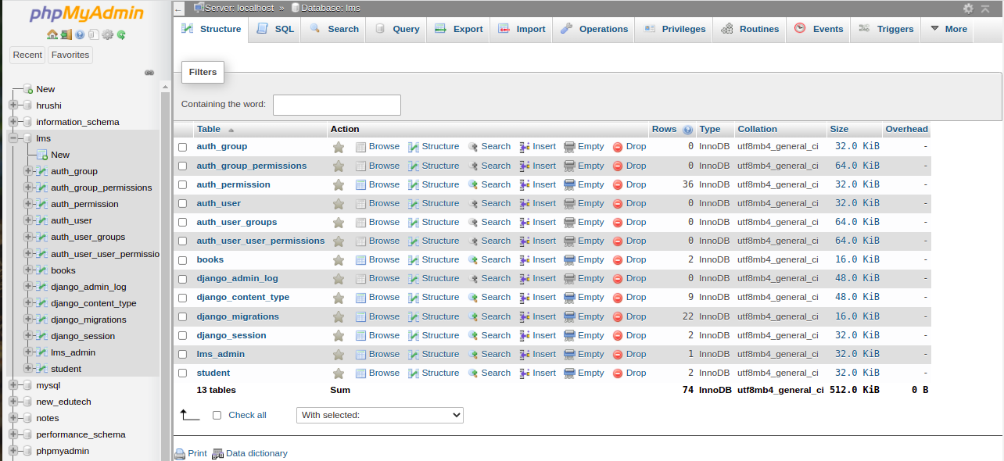

**BOOKLIBRAR ER DIAGRAM:**

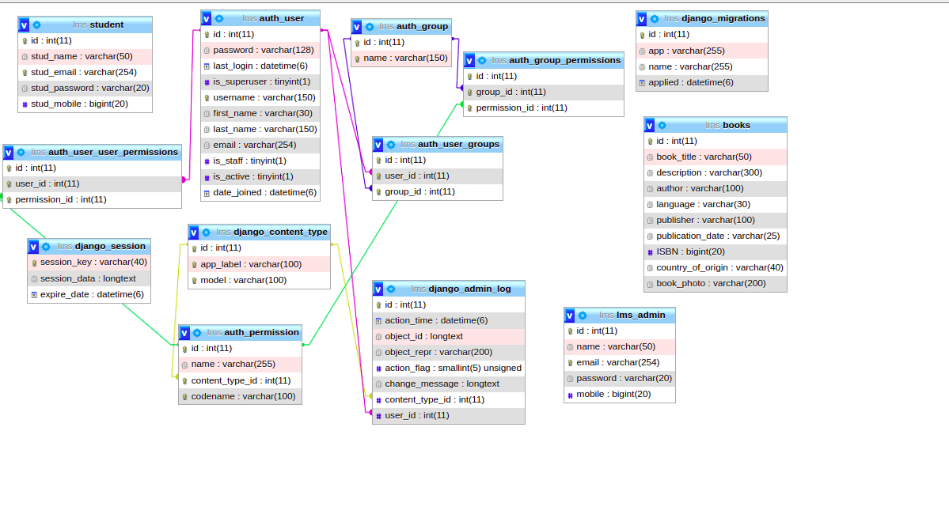

**SYSTEM IMPLEMENTATION**

SCREENSHOT FOR ADMIN REGISTRATION PAGE:

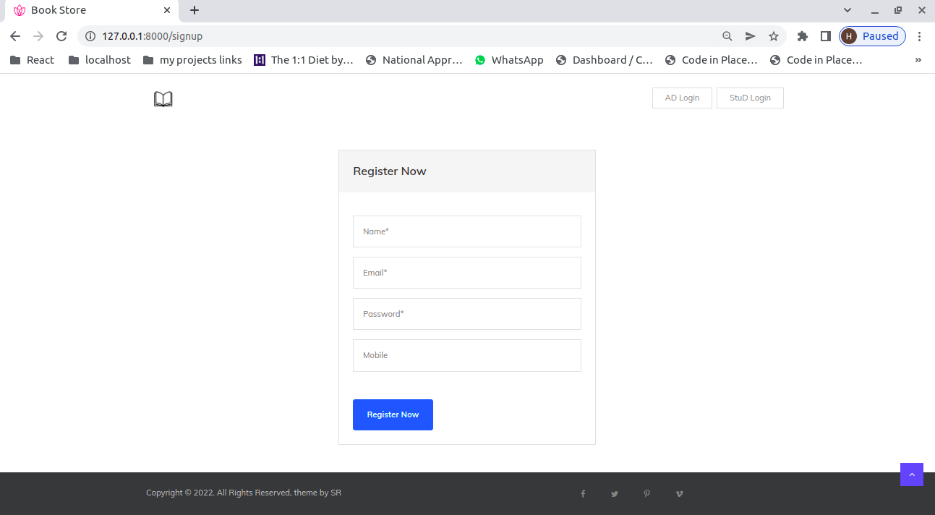

SCREENSHOT OF ADMIN LOGIN PAGE:

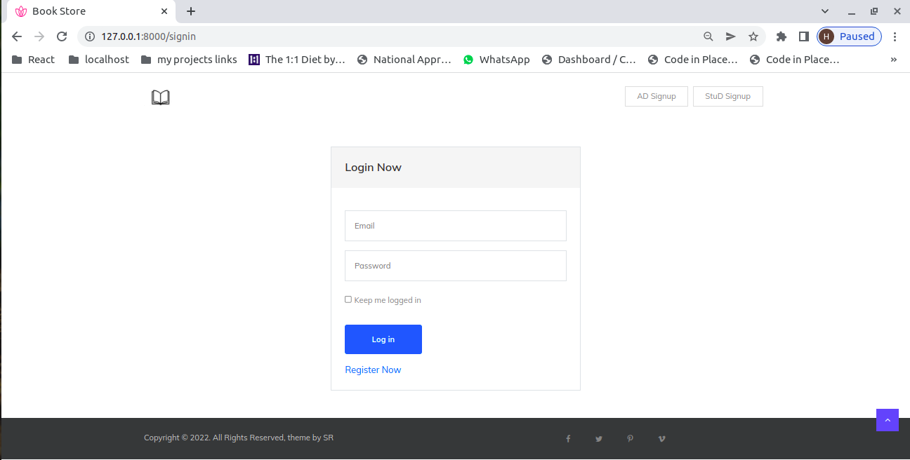

SCREENSHOT OF ADD BOOK:

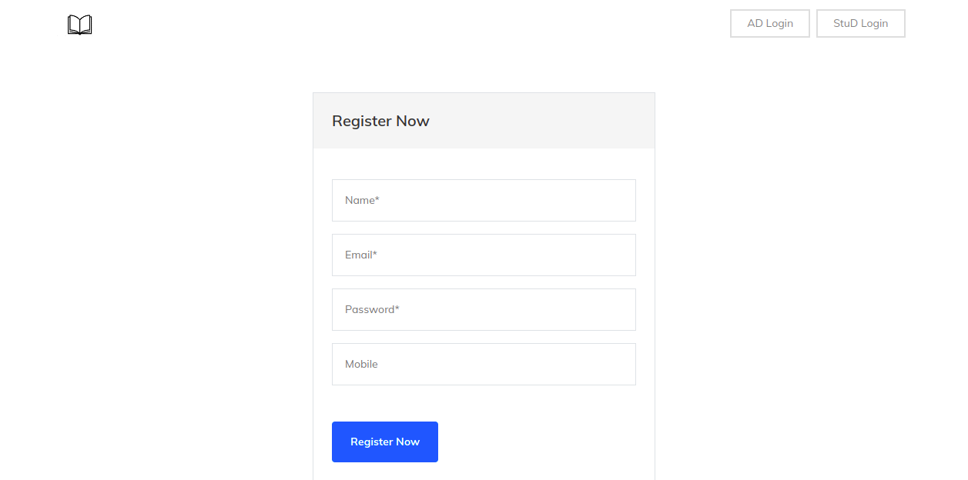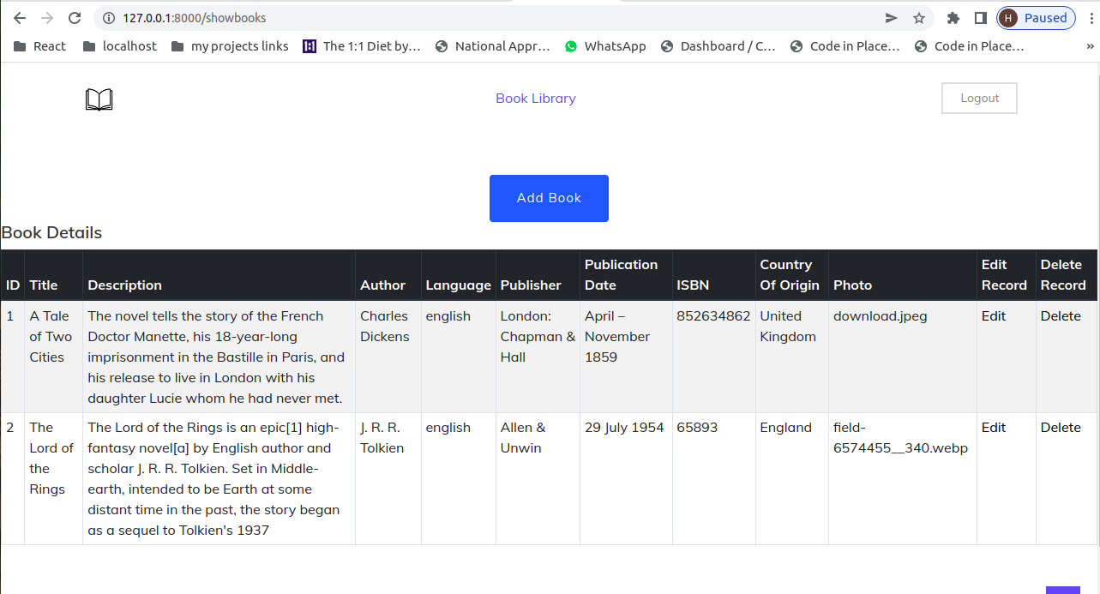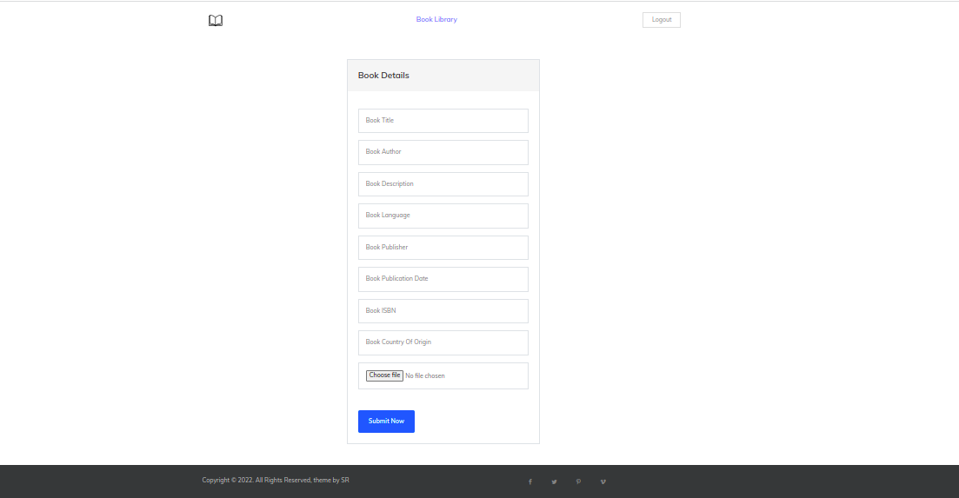

SCREENSHOT OF BOOKLIBRARY:

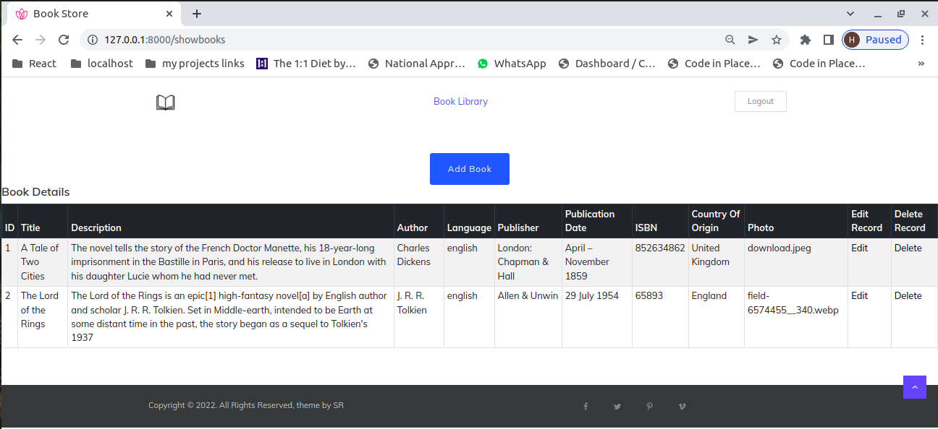

SCREENSHOT OF ALL RECORDS:

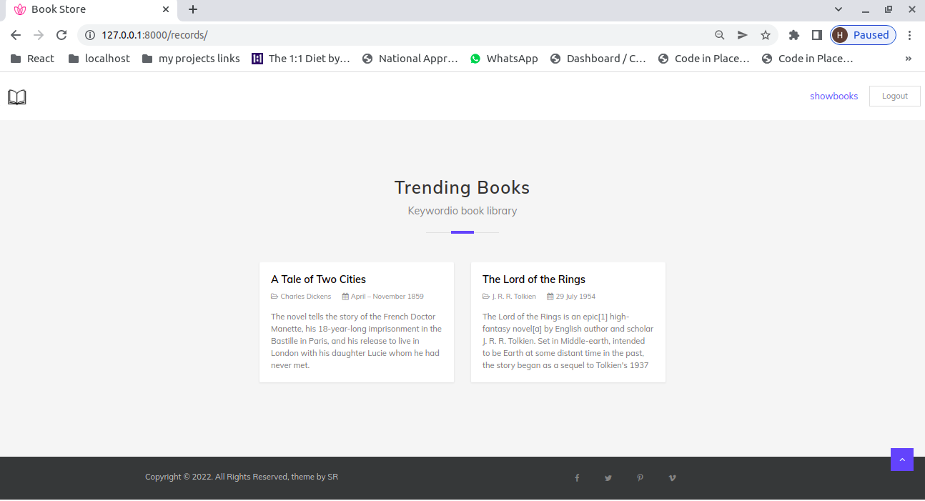

STUDENT REGISTRATION PAGE:

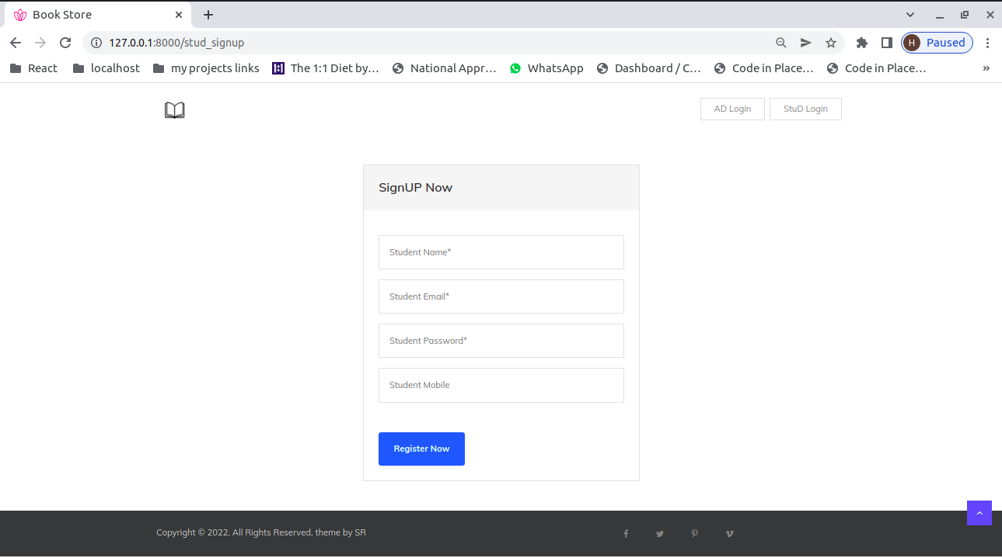

STUDENT LOGIN PAGE:

