**Power BI Assignment 2**

1. Explain the advantages of Natural Queries in PowerBi with an example?

Power BI's Natural Language Query (NLQ) feature allows you to ask questions about your data in plain English and get answers in the form of visualizations, tables, and other insights. This makes it easier for anyone to explore and understand their data, regardless of their technical expertise.

**Why NLQ in Power BI?**

Picture this: you're navigating through your dashboard, and instead of crafting complex queries, you simply type your question into the Q&A box at the top. Power BI, like a wizard, interprets your question and conjures up the most relevant results. It's like having a conversation with your data!

For instance, if you're digging into sales data, try asking:

* What are the total sales for the month of October?
* Which product category had the highest sales last quarter?
* Who are the top 10 customers by sales?

Watch as Power BI automatically generates visualizations and tables, bringing your data to life and revealing trends and patterns in a snap.

**NLQ: Where and How?**

Exciting news – NLQ is at your fingertips across all versions of Power BI, including Power BI Desktop, Power BI Service, and the Power BI mobile app. So, no matter where you are, the power of NLQ is right there with you.

To get started, head to the Q&A box at the top of your dashboards and reports. This feature allows you to ask natural language questions about your data, making exploration seamless, regardless of your technical expertise.

**Real-world Application:**

Let's dive into a practical scenario. Imagine you're a sales manager wanting to analyze monthly performance. With NLQ, you can swiftly ask, "What products contributed most to our sales last month?" – and voila! Instant insights, no SQL expertise required.

**Unlocking the Benefits:**

Why should you embrace NLQ in Power BI? Here are some compelling reasons:

* **Increased Accessibility:** NLQ makes data exploration easy for everyone, regardless of technical expertise.
* **Faster Insights:** Get answers quickly without wrestling with complex queries or custom visualizations.
* **More Natural Interaction:** Speak the language of data in plain English, fostering a more intuitive and engaging experience.

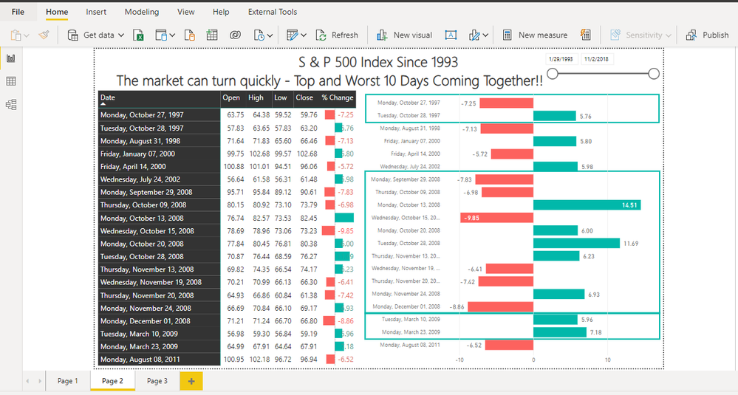

**Tips and Tricks for NLQ Mastery:**

Ready to take your NLQ game to the next level? Consider these tips:

1. Be specific in your questions for more accurate results.
2. Experiment with different phrasings to refine your queries.
3. Explore advanced features to uncover hidden insights.

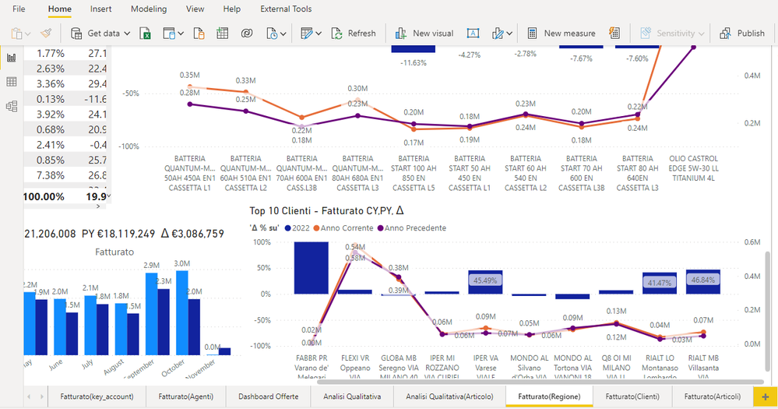

**Join the Conversation:**

Have you tried NLQ in Power BI? Share your experiences, questions, and discoveries here at Microsoft Fabric Community. Your insights contribute to a collective pool of knowledge, enriching the community's learning experience.

1. Explain Web Front End(WFE) cluster from Power BI Service Architecture?

**The Web Front End (WFE) cluster. The WFE cluster manages the initial connection and authentication to the Power BI service.**

1. Explain Back End cluster from Power BI Service Architecture?

**The Back-End cluster. Once authenticated, the Back-End handles all subsequent user interactions. Power BI uses Microsoft Entra ID to store and manage user identities. Microsoft Entra ID also manages data storage and metadata using Azure BLOB and Azure SQL Database, respectively.**

1. What ASP.NET component does in Power BI Service Architecture?

### ASP.NET Core 5 Microsoft Power BI Reporting

*Eric Vogel provides step-by-step instructions to create an ASP.NET 5 Core web app in Visual Studio 2019 and embed a Power BI report in it.*

* **By**[**Eric Vogel**](https://visualstudiomagazine.com/Forms/EmailToAuthor.aspx?AuthorItem=%7bD86A3E12-4B69-4F92-AB89-0241B7A5E964%7d&ArticleItem=%7b19C6566C-235D-44FB-AD7B-3BD252BCF24D%7d)
* **09/23/2021**

Today I'm going to cover how embed a Power BI report in an ASP.NET 5 Core web app. We'll start out by creating a new web app, and then I'll detail how to embed your Power BI report in it.

We'll get started by creating a new ASP.NET Core 5 MVC Web App in Visual Studio 2019 as seen in **Figure 1**.

**[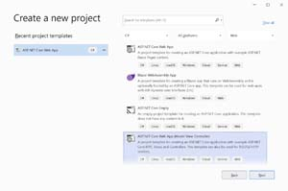](https://visualstudiomagazine.com/Articles/2021/09/23/~/media/ECG/visualstudiomagazine/Images/2021/09/powerbi1.ashx)[Click on image for larger view.]Figure 1:** Create New ASP.NET Core 5 MVC Web App

After that give a name to the web application as seen in **Figure 2**.

**[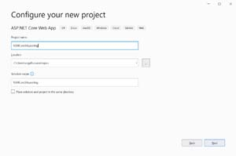](https://visualstudiomagazine.com/Articles/2021/09/23/~/media/ECG/visualstudiomagazine/Images/2021/09/powerbi2.ashx)[Click on image for larger view.]Figure 2:** Naming Your ASP.NET Core 5 App

On the next dialog select **.NET 5** as your target framework as seen in **Figure 3**.

**[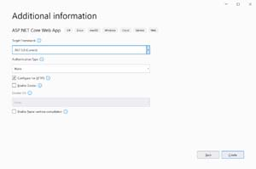](https://visualstudiomagazine.com/Articles/2021/09/23/~/media/ECG/visualstudiomagazine/Images/2021/09/powerbi3.ashx)[Click on image for larger view.]Figure 3:** Select .NET 5 Framework

Next click the **Create** button and you will have a new ASP.NET 5 Core web app that has a Razor page named Index.

Now that we have our web app created, let's get our Power BI report created. In order to create a Power BI report you'll need to [**create a Power BI account**](https://powerbi.microsoft.com/en-us/getting-started-with-power-bi/). I'll be using a new trial account for our demo report. Note that as of now you need a work email address to sign up for a Power BI account.

You should now see the Power BI dashboard where we'll create a new report as seen in **Figure 4**.

**[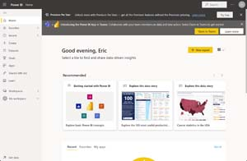](https://visualstudiomagazine.com/Articles/2021/09/23/~/media/ECG/visualstudiomagazine/Images/2021/09/powerbi4.ashx)[Click on image for larger view.]Figure 4:** Power BI Dashboard

Click on the **New report** button. You should now see the screen in **Figure 5** where you can pick your data set. Pick the **Paste or manually enter data** option.

**[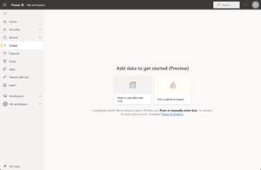](https://visualstudiomagazine.com/Articles/2021/09/23/~/media/ECG/visualstudiomagazine/Images/2021/09/powerbi5.ashx)[Click on image for larger view.]Figure 5:** Pick a Dataset for Our Report

Now we'll enter some test report data in a Customers table as seen in **Figure 6**.

**[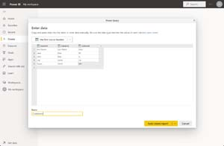](https://visualstudiomagazine.com/Articles/2021/09/23/~/media/ECG/visualstudiomagazine/Images/2021/09/powerbi6.ashx)[Click on image for larger view.]Figure 6:** Creating Test Report Data

Then click on the **Auto create report** button. Power BI will come up with some auto generated reports that aren't very useful, so we'll go to the **Datasets** tab and select our **Customers** dataset as seen in **Figure 7**.

**[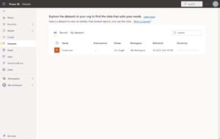](https://visualstudiomagazine.com/Articles/2021/09/23/~/media/ECG/visualstudiomagazine/Images/2021/09/powerbi7.ashx)[Click on image for larger view.]Figure 7:** Customers Dataset

On the next page select the **Create from scratch** option that will bring you to a create a report screen. Enter the settings seen in **Figure 8**.

**[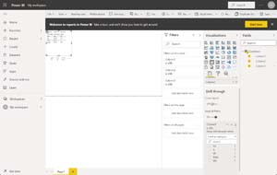](https://visualstudiomagazine.com/Articles/2021/09/23/~/media/ECG/visualstudiomagazine/Images/2021/09/powerbi8.ashx)[Click on image for larger view.]Figure 8:** Creating our Report

Our test report just displays all of our data in a table with a drill through for the third State column. We'll now save our report through **File->Save report** and give our report a name of "Customers" as seen in **Figure 9**.

**[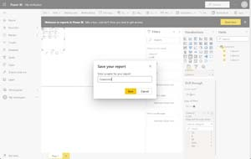](https://visualstudiomagazine.com/Articles/2021/09/23/~/media/ECG/visualstudiomagazine/Images/2021/09/powerbi9.ashx)[Click on image for larger view.]Figure 9:** Saving Our Report

We are now going to publish our report to the web through **File->Embed report-> Publish to web** as seen in **Figure 10**.

**[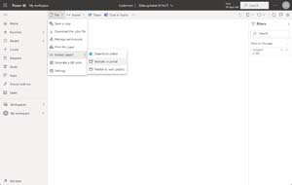](https://visualstudiomagazine.com/Articles/2021/09/23/~/media/ECG/visualstudiomagazine/Images/2021/09/powerbi10.ashx)[Click on image for larger view.]Figure 10:** Publish Report Embed

Your administrator will have to enable this feature in order to successfully publish your report to the web. If this is your own Power BI account, you can also start a free 60-day trial to enable this feature. You will now see a modal with a link to your report and iframe code to embed the report in your web app. Copy the iframe code now as seen in **Figure 11**.

**[Click on image for [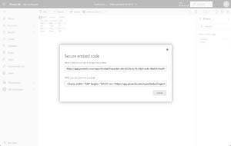](https://visualstudiomagazine.com/Articles/2021/09/23/~/media/ECG/visualstudiomagazine/Images/2021/09/powerbi11.ashx)larger view.]Figure 11:** Power BI Embed Options

1. Compare Microsoft Excel and PowerBi Desktop on the following features:

Data import

Data transformation

Modeling

Reporting

Server Deployment

Convert Models

Cost

|  |  |  |
| --- | --- | --- |
| **Features** | **Power BI** | **Excel** |
| Tabular Reports | It creates relatively  limited tabular reports. | It’s ideal for making tabular  reports. |
| Duplicate Tables | Can’t display duplicated  tables | Allows you to display duplicated  tables |
| Reports | More visually appealing,  customized, appealing, and  interactive reporting. | Reports are simpler and less  appealing than those in Power  BI. |
| Crossed Filters | Supports powerful chart  cross-filtering features. | There is no advanced  Graphics cross-filtering. |
| Charts and Visuals | Dashboards, alarms, and KPIs work best.  Includes richer graphics than Excel and allows  for visual data analysis. | It contains the most powerful  and cutting-edge charting tools, however it isn’t compatible with data models. |
| Automatic Updates | Data is automatically updated. | Data is not automatically  updated. |
| Availability | Repots can be worked on by a  huge number of people, regardless  of their expertise. | The number of users who  can see a report is limited. |
| Analytics | Power BI has fewer data analysis possibilities. | Excel has more advanced  analytical capabilities. |
| Data Model | Ideal for quickly creating complex data models. | Works with simple and  structured data models. |
| Separate Tables | Separate tables can be linked together easily. | Connecting various tables  is tough. |
| Tools | It is a more complex version of the data analysis tool, with more options for working with data. | It’s a standard spreadsheet  tool with a lot of options. |
| Collaborative Work | Power BI makes it simple to share data and reports. | Sharing documents and  working with others is  complex. |
| Big Data | Allows working with significantly bigger data sets. | Can only handle a certain  amount of info. |
| Dashboards | More advanced features for creating custom dashboards. | Users have limited features  for creating dashboards. |
| Processing | Faster processing. | Slower processing. |
| Utility | Dashboards can be created  and shared, as well as advanced  data visualizations. | Typically, it is used to  arrange data, execute  calculations, and build more  complex tabular reports. |
| Data Model Language | DAX language | MDX language |
| Connectivity | Data can be extracted from  any virtual platform, software, or application. | Connectivity to other  apps and systems is limited. |
| Price | It has [a free version](https://dynamics.folio3.com/blog/difference-between-power-bi-pro-vs-free-vs-premium/) and a payment version. | Payment Tool. |
| Usability | Easy to use compared to Excel | More difficult to use  than Power BI |

## Basic Differences Between Power BI and Excel

* Excel is a spreadsheet programme that may be used to organise, transform, and calculate data. Power BI, on the other hand, was designed as a business intelligence and data visualisation tool.
* The quantity of data that Excel can handle is limited. Power BI, on the other hand, can manage significantly larger data sets.
* Excel’s connecting capacity is limited, whereas Power BI can link to a vast number of data sources. Power BI may also be used via mobile devices, unlike Excel.
* Power BI is faster than Excel at processing data.
* Dashboards created with Power BI are more aesthetically appealing, dynamic, and configurable than those created with Excel.
* In terms of comparing tables, reports, or data files, Power BI is a more capable tool than Excel.
* Excel is more user-friendly and intuitive than Power BI.

1. List 20 data sources supported by Power Bi desktop.

Web

SharePoint list

OData Feed

Active Directory

Microsoft Exchange

Hadoop File (HDFS)

Spark

Hive LLAP

R script

Python script

ODBC

OLE DB

Acterys: Model Automation & Planning (Beta)

Anaplan Connector v1.0 (Beta)

Solver

Bloomberg Data and Analytics

Cherwell (Beta)

Cognite Data Fusion

Delta Sharing

EQuIS (Beta)

FHIR

Google Sheets (Beta)

Information Grid (Beta)

Jamf Pro (Beta)

Kognitwin

MicroStrategy for Power BI

Paxata

QubolePresto (Beta)

Roamler (Beta)

SIS-CC SDMX (Beta)

Shortcuts Business Insights (Beta)

Siteimprove

SumTotal

SurveyMonkey (Beta)

Microsoft Teams Personal Analytics (Beta)

Tenforce (Smart)List

Usercube (Beta)

Vena

Vessel Insight

Zucchetti HR Infinity (Beta)

BQE Core

MicroStrategy for Power BI

Starburst Enterprise

Amazon OpenSearch Service (Beta)

OpenSearch Project (Beta)

Blank Query