1. **Write a Python program to convert kilometers to miles?**

**ANS:-**

**def** kilometre_1(km):

    conversion_ratio_1= 0.621371

    miles_1 = km * conversion_ratio_1

**print** ("The speed value of car in Miles: ", miles_1)

km = float (input ("Please enter the speed of car in Kilometre as a unit: "))

kilometre_1(km)

**Output:**

Please enter the speed of car in Kilometre as a unit: 14

The speed value of car in Miles: 8.699194

1. **Write a Python program to convert Celsius to Fahrenheit?**

**ANS:-**

celsius_1 = float(input("Temperature value in degree Celsius: " ))

# For Converting the temperature to degree Fahrenheit by using the above

# given formula

Fahrenheit_1 = (celsius_1 * 1.8) + 32

# print the result

**print**('The %.2f degree Celsius is equal to: %.2f Fahrenheit'

      %(celsius_1, Fahrenheit_1))

**print**("----OR----")

celsius_2 = float (input("Temperature value in degree Celsius: " ))

Fahrenheit_2 = (celsius_2 * 9/5) + 32

# print the result

**print** ('The %.2f degree Celsius is equal to: %.2f Fahrenheit'

      %(celsius_2, Fahrenheit_2))

**Output:**

Temperature value in degree Celsius: 34

The 34.00 degree Celsius is equal to: 93.20 Fahrenheit

----OR----

Temperature value in degree Celsius: 23

The 23.00 degree Celsius is equal to: 73.40 Fahrenheit

1. **Write a Python program to display calendar?**

**ANS:-**

**import** calendar

# Enter the month and year

yy = int(input("Enter year: "))

mm = int(input("Enter month: "))

# display the calendar

**print**(calendar.month(yy,mm))

**Output:**

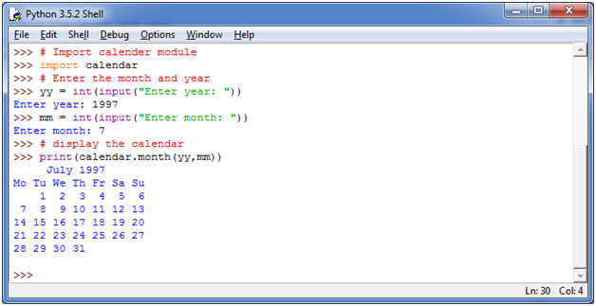

1. **Write a Python program to solve quadratic equation?**

**ANS:-**

ax2+bx+c=0

Here, "x" is unknown which you have to find and "a", "b", "c" specifies the numbers such that "a" is not equal to 0. If a = 0 then the equation becomes liner not quadratic anymore.

In the equation, a, b and c are called coefficients.

Let's take an example to solve the quadratic equation 8x2 + 16x + 8 = 0

**See this example:**

# import complex math module

**import** cmath

a = float(input('Enter a: '))

b = float(input('Enter b: '))

c = float(input('Enter c: '))

# calculate the discriminant

d = (b**2) - (4*a*c)

# find two solutions

sol1 = (-b-cmath.sqrt(d))/(2*a)

sol2 = (-b+cmath.sqrt(d))/(2*a)

**print**('The solution are {0} and {1}'.format(sol1,sol2))

**Output:**

Enter a: 8

Enter b: 5

Enter c: 9

The solution are (-0.3125-1.0135796712641785j) and (-0.3125+1.0135796712641785j)

1. **Write a Python program to swap two variables without temp variable?**

**ANS:-**

a = int(input("Enter value of A: "))

b = int(input("Enter value of B: "))

print("A = {} and B = {}".format(a, b))

a = a + b

b = a - b

a = a - b

print("Now, A = {} and B = {}".format(a, b))

**Output:**

Enter value of A: 20

Enter value of B: 30

A = 20 , B = 30

Now, A = 30 , B = 20