**Schema**

1. SELECT * FROM production.product;

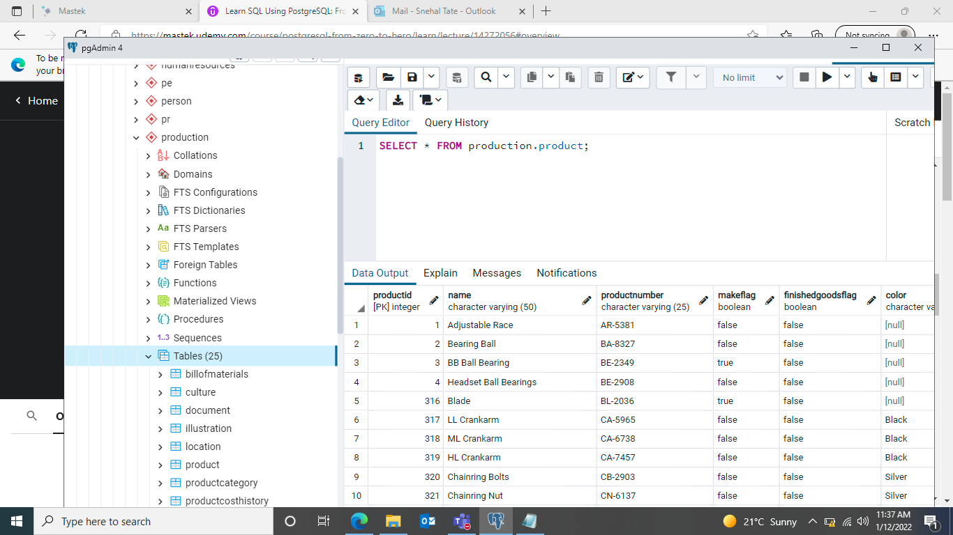

1. selecting everything from vendor table in purchasing

SELECT * FROM purchasing.vendor;