**Neo4j e-Commerce store**

**Name: Sneha Murali**

**Section-0501**

**Date-2/11/2024**

**Overall Structure:**

It comprises products, customers, orders, wishlist, cart, payment details, order status, feedback, referred and referring customers, loyalty points tracking, and product details among others.

**Query 1:**

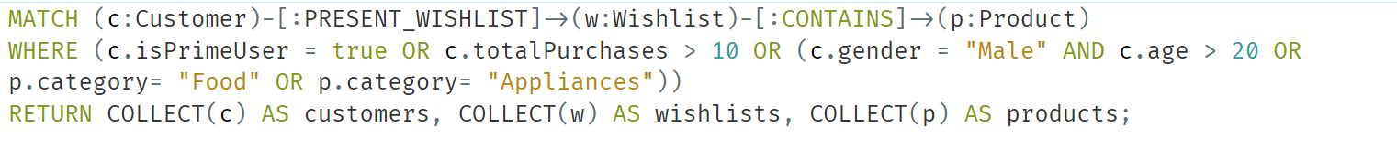

**Output 1:**

**Query 2:**

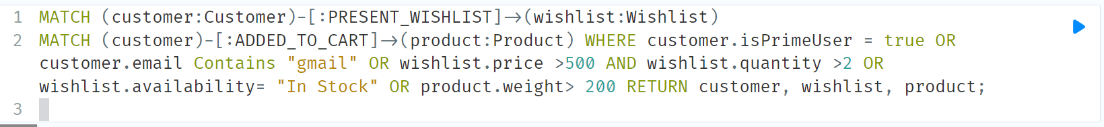

**Output:**

**Query 3:**

**Output:**

**Query 4:**

**Output:**

**Query 5:**

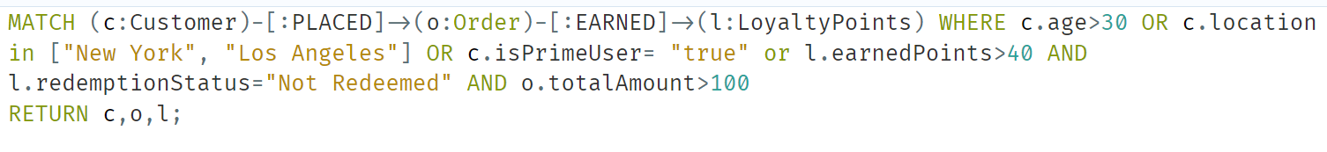

**Output:**

**Query 6:**

**Output:**

**Query 7:**

**Output:**

**Query 8:**

**Output:**

**Query 9:**

**Output:**

**Query 10:**

**Output:**

