**COMPANY PROFILE**

|  |  |
| --- | --- |
| **Name** | Innovant IT Solutions |
| **Address** | Sri Renukeshwara Complex, 2nd floor Near Rajkumar Diagnostics (Above axis bank ATM) Durgigudi Main Road. Shimoga-577202 |
| **Contact Number** | 08182404766 |
| **Email** | info@innovantitsolutions.in |
| **Website** | www.innovantitsolutions.in |
| **Type of the Company** | Private |
| **Company Logo** |  |
| **Vision**  **Nature of the Company** | To build upon the reputation of being one of the most innovative IT solutions & service providers. We believe in doing our work most efficiently with robust and structured methodology, with gradual evolution from hard work to a smart-work culture.  Information Technology |
| **Company Operational Status** | Private |

**CHAPTER 1**

**ABOUT THE COMPANY**

Innovant Solutions is operating on three different continents, They have a digital agency and back office support company, and they have the perfect blend of experts within, Independent road freight dispatch services, application development, and managed services. Their solution can reduce the manual work and act as a centralized system where all the communication, documents, invoices, and all related information against any given haul can be stored, managed, and recalled accordingly.

**1.1 History**

Innovant IT Solutions is a software development, IT product sales & service, and technical training firm based in Shivamogga since 2016. We have extensive experience in many diverse areas of software development. Our approach focuses on a new ways of business, thereby combining IT innovations and adoption while leveraging an organization’s current assets.

Our team is committed to providing services with:

* Quality
* Technology
* Innovation
* Support

**1.1.1 Quality**

Our main emphasis is to deliver the best quality in every project we undertake. With our time-tested business methodology and structured solution-building approach, we ensure to maintain our global business standards.

**1.1.2 Technology**

Technology leadership is the most successful strategy to challenge competitors and consolidate our position since business & technology work hand in hand. Our firm’s belief in this synthesis has motivated & enabled us to deliver solutions with a decisive competitive advantage.

**1.1.3 Innovation**

In each and every project, we emphasize innovation. Our structured team works with a methodology and knowledge to innovate and deliver excellent services.

**1.1.4 Support**

We are committed to providing software development an IT support teams with the required infrastructure at a competitive rate from our State of the art development center.

**1.2 Achievements in Business**

Innovant IT Solutions is where talent meets opportunity and they believe trainee who comes over here in search of their dream job to achieve by taking the professional course. Innovant IT Solutions order to provide coaching and make a student into a professional IT candidate. Currently, it has branches in Shimoga (Sri Renukeshwara Complex, 2nd floor Near Rajkumar Diagnostics (Above axis bank ATM ) Durgigudi Main Road. Shimoga-577202

The major milestones achieved by Innovant IT Solutions are as follows:

* Training 500 engineers every year.
* Up-skill 500 learners every year.

**1.3 Products of Innovant IT Solutions**

**1.3.1 Android Apps**

It is the process by which new applications are created for devices running the Android operating system. Applications are usually developed in Java (and/or Kotlin; or other such option) programming language using the Android software development kit (SDK), but other development environments are also available, such as Kotlin support the exact same Android APIs (and bytecode), while others such as Go have restricted API access.

The Android software development kit includes a comprehensive set of development tools. These include a debugger, libraries, a handset emulator based on QEMU, documentation, sample code, and tutorials. Currently supported development platforms include computers running Linux (any modern desktop Linux distribution), Mac OS X 10.5.8 or later, and

Windows 7 or later. As of March 2015, the SDK is not available on Android itself, but software development is possible by using specialized Android applications.

**1.3.2 Web Application**

It is a client-server computer program in which the client (including the user interface and client-side logic) runs in a web browser. Common web applications include webmail, online retail sales, online auctions, wikis, instant messaging services, and many other functions, web applications use web documents written in a standard format such as HTML and JavaScript, which are supported by a variety of web browsers.

Web applications can be considered as a specific variant of client-server software where the client software is downloaded to the client machine when visiting the relevant web page, using standard procedures such as HTTP

The Client web software updates may happen each time the web page is visited. During the session, the web browser interprets and displays the pages, and acts as the universal client for any web application. The use of web application frameworks can often reduce the number of errors in a program, both by making the code simpler and by allowing one team to concentrate on the framework while another focuses on a specified use case. In applications that are exposed to constant hacking attempts on the Internet, security-related problems can be caused by errors in the program. Frameworks can also promote the use of best practices such as GET after POST.

There are some who view a web application as a two-tier architecture. This can be a "smart" client that performs all the work and queries a "dumb" server, or a "dumb" client that relies on a "smart" server. The client would handle the presentation tier, the server would have the database (storage tier), and the business logic (application tier) would be on one of them or both. While this increases the scalability of the applications and separates the display and the database, it still doesn't allow for true specialization of layers, so most applications will outgrow this model.

An emerging strategy for application software companies is to provide web access to software previously distributed as local applications. Depending on the type of application,

It may require the development of an entirely different browser-based interface, or merely adapting an existing application to use different presentation technology. These programs allow the user to pay a monthly or yearly fee for use of a software application without having to install it on a local hard drive. A company that follows this strategy is known as an application service provider (ASP), and ASPs are currently receiving much attention in the software industry.

Security breaches on these kinds of applications are a major concern because they can involve both enterprise information and private customer data. Protecting these assets is an important part of any web application and there are some key operational areas that must be included in the development process. This includes processes for authentication, authorization, asset handling, input, and logging and auditing. Building security into the applications from the beginning can be more effective and less disruptive in the long run.

**1.3.3 Web design**

It encompasses many different skills and disciplines in the production and maintenance of websites. The different areas of web design include web graphic design; interface design, authoring, including standardized code and proprietary software, user experience design, and search engine optimization. Often many individuals will work in teams covering different aspects of the design process, although some designers will cover them all. The term web design is normally used to describe the design process relating to the front-end (client side) design of a website including writing markup. Web design partially overlaps web engineering in the broader scope of web development.

Web designers are expected to have an awareness of usability and if their role involves creating markup then they are also expected to be up to date with web accessibility guidelines. Web design partially overlaps web engineering in the broader scope of web development. Web designers are expected to have an awareness of usability and if their role involves creating markup then they are also expected to be up to date with web accessibility guidelines.

Web designers use a variety of different tools depending on what part of the production process they are involved in. These tools are updated over time by newer standards and software but the principles behind them remain the same. Web designers use both vector and raster graphics editors to create web-formatted imagery or design prototypes. Technologies used to create websites include W3C standards like HTML and CSS, which can be hand-coded or generated by editing software. Other tools web designers might use include markup validators and other testing tools for usability and accessibility to ensure their websites meet web accessibility guidelines.

**1.3.4 MySQL**

Tech Fortune. They have specifically designed the Oracle Language for those who want to muster their skills in Scripting. Our talented faculty will make complex learning easy. We impart knowledge in a way that by the end of a program, you become a tech freak.

Tech Fortune provides comprehensive consulting services for Enterprise Resource Planning, designed specifically for each customer's schedule, and scope their consultants bring just the right mix of project management and Technical applications expertise to the client project team Whether the user rolls out the applications for the first time, implementing additional functionality or upgrading to the latest version, Tech Fortune is at their side from start to finish, bringing user the benefit of their experience in Techno-Management implementations. They provide clients with the best possible solution which will result in the success of the client.

**MySQL software:**

* Stored procedures, using a procedural language that closely adheres to SQL/PSM.
* Triggers
* Partitioned tables with the pruning of partitions in the optimizer.
* A set of SQL Mode options to control runtime behavior, including a strict mode to better adhere to SQL standards.
* Commit grouping, gathering multiple transactions from multiple connections together to increase the number of commits per second.

**1.3.5 Artificial intelligence**

In computer science, Al research is defined as the study of "intelligent agents": any device that perceives its environment and takes actions that maximize its chance of success at some goal. Colloquially, the term "artificial intelligence" is applied when a machine mimics "cognitive" functions that humans associate with other human minds, such as "learning" and "problem-solving".

Optical character reader optical character reader is the mechanical or electronic conversion of images of typed, handwritten, or printed text into machine-encoded text, whether from a scanned document, a photo of a document, a scene photo (for example the text on signs and billboards in a landscape photo) or from subtitle text superimposed on an image (for example from a television broadcast). It is widely used as a form of information entry from printed paper data records, whether passport documents, invoices, bank statements, computerized receipts, business cards, mail, printouts of static data, or any suitable documentation. It is a common method of digitizing printed texts so that they can be electronically edited, searched, stored more compactly, displayed online, and used in machine processes such as cognitive computing, machine translation, (extracted) text-to-speech, key data, and text mining, OCR is a field of research in pattern recognition, artificial intelligence, and computer vision, Unsupervised machine learning.

It is the machine learning task of inferring a function to describe hidden structure from "unlabeled" data (a classification or categorization is not included in the observations). Since the examples given to the learner are unlabeled, there is no evaluation of the accuracy of the structure that is output by the relevant algorithm which is one way of distinguishing unsupervised learning from supervised learning and reinforcement learning.

**1.4 Overall turnover**

Innovant IT Solutions is a training platform for web developers, android developers, and many more that offers various courses for individuals and educational institutions. Innovant IT Solutions is located at Sri Renukeshwara Complex, 2nd floor Near Rajkumar Diagnostics (Above axis bank ATM) Durgigudi Main Road. Shimoga-577202

**Number of Employees**

At present, there are 10 employees working in Innovant IT Solutions. Faculty are highly competent, skilled, and dedicated to giving their best towards the professional development of students and building competency into over 30 students a month.

Professional development happens when professionals improve their skills which will enhance their performance and the means of achieving it would be through corporate training. They have experience in providing on-site and offshore corporate training programs and have successfully delivered many corporate training programs so far. They work with many organizations to provide corporate training in courses that includes Development. After the training, if the engineers start implementing the topics learned during training, they provide free guidance to identify the gaps and fine-tune the understanding for half a day (if required).

The trainers have more than 6 years of experience in the area of Web Development. Being a software development, IT service & technical training firm, we have amassed an impressive resume of projects. It’s the custom nature of our development projects that has enabled Innovant IT Solutions to acquire vast experience in many diverse areas of software development. Our experience, in conjunction with our quality personnel, enables us to be dynamic enough to tackle almost any IT project.

**1.5 Ethics and Experience**

**1.5.1 Values**

They aim to be the best at what we do. Innovant IT Solutions is aspiring of evolving into

Global IT Company, ensuring that the solutions being delivered include best practices in I.T. with the chosen area of technology. We are proud to have built our organization on the strong pillars of integrity, honesty, and self-respect.

* We operate with complete focus to Maximize customer satisfaction.
* Develop and encourage an environment of mutual respect within the company and
* extend it beyond to clients.
* Encourage commitment and personal learning of the workforce.

**1.5.2 Mission**

To produce excellent services in the field of IT services with maximum efforts driven towards customer satisfaction.

**1.5.3 Vision**

To build upon the reputation of being one of the most innovative IT solutions & service providers. They believe in doing our work in the most efficient way with robust and structured methodology, with gradual evolution from hard work to smart-work culture.

**1.5.4 Experience**

Being a software development, IT service & technical training firm, we have amassed an impressive resume of projects. It’s the custom nature of our development projects that has enabled Innovant IT Solutions to acquire vast experience in many diverse areas of software development. Our experience, in conjunction with our quality personnel, enables us to be dynamic enough to tackle almost any IT project.

**CHAPTER 2**

**ABOUT THE DEPARTMENT**

**2.1 Introduction**

Innovant IT Solutions has developed several products and applications for its clients in this service. Our mature software development processes, combined with excellent infrastructure have significantly increased the “on-time and on-budget” delivery of software. Our services begin with designing, development, testing, and implementation to maintenance.

They offer the following Application Developments:

• Interactive Application Development

• Custom Application Development/ Maintenance

**Interactive Application Development**

Interactive Application Development (IAD) is about harmonizing art with technology. This division of Innovant IT Solution complements the client's requirement for online and desktop applications. A strong team of software professionals empowers the application development capability at IAD.

**Custom Application Development/ Maintenance**

It is a well-known fact that some of the ready-made, packaged applications have failed to meet the requirements of the customers because of their unique needs and differing business practices and processes. They have experienced I.T. Consultants for Project analysis, formulation, and concept planning, right up to project management and installation. They develop customized software that is completely based on the user’s requirement with Graphical User Interface (GUI).

**Web Solutions**

Innovant IT Solutions provides web solutions & services to help customers reach to a wider customer base. The web is a new and different medium for communication and requires a different viewpoint and skill set to use it most effectively. You need web consulting to get more return on your investment in your website. They can help you get the most effective solution through the following aspects:

* Website Development
* Web Promotion
* Web hosting
* E-commerce

**Website Development**

Websites can enhance awareness of your brand, leading to more sales. Build relationships with customers, vendors, and shareholders through your online identity to get more traffic from the search engines, fast-loading web pages with excellent navigation & design. Whether you are looking for a Dynamic or static web application, they can help you acquire both. they make your presence live on the web.

**Web Promotion**

Web Promotion is a two-phase process and they are your companion to see you through both phases and that too very well. We get your site listed in the most popular Internet directories because they can send you substantial amounts of traffic and affect your ranking in various search engines like Google, Yahoo, etc. Email marketing is a great way to promote your electronic Shop to buyers including those who are interested in your shop but have not purchased items from you in the past.

**Web hosting**

They provide services to host your website, and users with online systems for storing information, images, video, or other content accessible via the World Wide Web. They also offer custom web hosting as per your requirements. File Hosting Service: Host your static content, typically large files that are not web pages.

**E-commerce**

They offer e-commerce services in custom-built solutions as well as packaged software customizations and implementations. This helps customers to heave their business from point of sale implementation and go global.

**2.2 Application Maintenance and Support**

They have experience in executing maintenance projects. Our team of experienced consultants has been successfully managing the maintenance projects of our clients. The quality of product deployment, training & support has everything to do with customer success & satisfaction.

They offer annual maintenance plans which are tailor-made as per the client’s requirements. If required we depute a technical team that works at the client site for the system execution or support as per requirement. They provide complete offsite telephone support in the form of consultations, assistance, and advice on the use and maintenance of the Software.

**Security System**

They here at Innovant It Solutions apart from all other IT solutions offer security systems to our clients. Security systems include installation and maintenance of Closed Circuit Television cameras (CCTV) for official and personal usage of customers. CCTVs are available in various specifications as well as ranges on the requirement basis of the clients/customers. Some of them are CC Cams, Bullet Cameras, Dum Cameras, and IP cameras.

**Sales and services of IT products**

They offer sales and services of various IT products, which includes Personal Computers (PCs), laptops, computer peripherals such as processors, motherboards, mouse, keyboards, SSDs, hard disks (both internal and external), graphic cards, speakers, pen drives, various types of printers(inkjet, laser-jet, all-in-one), etc.

**Education / Training**

The educational division of Innovant IT Solutions provides quality education in various fields of IT. In an age of cutthroat competition, a college education is not enough. To have an edge over your counterparts, you need to have something EXTRA. That additional bit is provided by us. We have a highly qualified, capable & experienced team of faculty comprising professionals & technical experts. Individual attention is provided to students and equal emphasis is given to both theory and practical. The mission of our educational division is to provide quality education in the various fields of information technology for people from all walks of life.

**2.3 Courses Offered at IITS**

* C Programming
* C++ Programming
* Core Java
* Advanced JAVA and J2EE
* ANDROID
* Web Designing & PHP(Add-on course Photoshop )
* SQL
* Web Development using JAVA
* Hardware & Networking
* RHEL 7
* Python

They undertake the development of academic projects for students for the computer science (CS) and electronics & communications (E&C) branches. We provide our technical assistance and training to Diploma, BCA, MCA, B.E., B.Tech & M.Tech students for their academic projects and offer internships regarding the same.

**2.3.1 PYTHON**

Innovant IT Solutions have specifically designed the Python Scripting Language for those who want to master their skills in Scripting. Their talented faculty will make complex learning easy. They impart knowledge in a way that by the end of a program you, become a tech freak. Is a widely used high-level programming language for general-purpose programming, created by Guido van Rossum and first released in 1991. An interpreted language, Python has a design philosophy that emphasizes code readability (notably using whitespace indentation to delimit code blocks rather than curly brackets or keywords), and a syntax that allows programmers to express concepts in fewer lines of code than might be used in languages such as C or Java. It provides constructs that enable clear programming on both small and large scales IITS believes features a dynamic type system and automatic memory management that supports multiple programming paradigms, including object-oriented, imperative, functional, and procedural, and has a large and comprehensive standard library of Python interpreters are available for many operating systems. The C, Python, the reference implementation of Python, is open-source software and has a community-based development model, as do nearly all of its variant implementations. C, Python is managed by the non-profit Python Software Foundation

* Project Plan
* Functional Prototyping
* Application Development
* Testing
* Implementation
* Technical Support
* Maintenance

**2.3.2 Android Studio**

Android Studio is the official integrated development environment (IDE) for Google's Android operating system, built on JetBrains' IntelliJ IDEA software and designed specifically for Android development. It is available for download on Windows, macOS, and Linux-based operating systems. It is a replacement for the Eclipse Android Development Tools (E-ADT) as the primary IDE for native Android application development. Android Studio was announced on May 16, 2013, at the Google I/O conference. It was in the early access preview stage starting from version 0.1 in May 2013, then entered the beta stage starting from version 0.8 which was released in June 2014. The first stable build was released in December 2014, starting from version 1.0. At the end of 2015, Google dropped support for Eclipse ADT, making Android Studio the only officially supported IDE for Android development.

**Features**

The following features are provided in the current stable version:

* Gradle-based build support
* Android-specific refactoring and quick fixes
* Lint tools to catch performance, usability, version compatibility, and other problems
* Pro Guard integration and app-signing capabilities
* Template-based wizards to create common Android designs and components
* A rich layout editor that allows users to drag and drop UI components, the option to preview layouts on multiple screen configurations
* Support for building Android Wear apps
* Built-in support for Google Cloud Platform, enabling integration with Firebase Cloud Messaging (Earlier 'Google Cloud Messaging') and Google App Engine
* Android Virtual Device (Emulator) to run and debug apps in the Android studio.

**2.3.3 PHP**

PHP is a general-purpose scripting language geared toward web development. It was created by Danish-Canadian programmer Rasmus Lerdorf in 1993 and released in 1995. The PHP reference implementation is now produced by The PHP Group. PHP was originally an abbreviation of Personal Home Page, but it now stands for the recursive initialism PHP: Hypertext Preprocessor.

PHP code is usually processed on a web server by a PHP interpreter implemented as a module, a daemon, or as a Common Gateway Interface (CGI) executable. On a web server, the result of the interpreted and executed PHP code – which may be any type of data, such as generated HTML or binary image data – would form the whole or part of an HTTP response. Various web template systems, web content management systems, and web frameworks exist which can be employed to orchestrate or facilitate the generation of that response. Additionally, PHP can be used for many programming tasks outside the web context, such as standalone graphical applications and robotic drone control. PHP code can also be directly executed from the command line.

The standard PHP interpreter, powered by the Zend Engine, is free software released under the PHP License. PHP has been widely ported and can be deployed on most web servers on a variety of operating systems and platforms.

The PHP language evolved without a written formal specification or standard until 2014, with the original implementation acting as the de facto standard that other implementations aimed to follow. Since 2014, work has gone on to create a formal PHP specification.

W3Techs reports that, as of January 2023, "PHP is used by 77.8% of all the websites whose server-side programming language we know." It also reports that only 8% of PHP users use the currently supported 8. x versions. Most use unsupported PHP 7, more specifically 7.4, and even PHP 5 has 23% of the use, is also not supported with security updates, and is known to have serious security vulnerabilities.

**2.3.4 Web Development using JAVA**

Web development is known as website development or web application development. Web development creates, maintains, and updates web development applications using a browser. This web development requires web designing, backend programming, and database management. The development process requires software technology.

Web development creates web applications using servers. We can use a web server or a machine server like a CPU. The Web server or virtual server requires web application using technology. Web development requires server-side programming language or technology. Java web development creates a server-side website and web application. The majority of Java web apps do not execute on the server directly. A web container on the server hosts Java web applications. For Java web applications, the container acts as a runtime environment. The Java Virtual Machine is for locally running Java applications, the container is for Java web applications. JVM is used to run the container itself. Java distinguishes between two types of containers: web and Java EE. Additional functionality, such as server load distribution, can be supported by a container. A web container supports Java servlets and JSP ( Java Server Pages ). In Java technology, Tomcat is a common web container. A web container usually has a minimal need for web frameworks.

**Functions of Java Web Development**

Java web development creates applications and websites using static and dynamic resources. The static resource refers to HTML pages with images, and a dynamic resource refers to classes, jars, Servlet, and JSP. Java web development uses several packages, files, and online links. Java web development requires web archive files known as WAR files.

Java web development works on three main factors. These development factors show below.

* Front-end web development using Java technology.
* Backend web development using Java server technology.
* Database management using Java database driver.

The above three factors create, update, remove, display, and operate data or information.

**Front-end web development:** The front-end technology interacts with the user and Java interface. It helps to insert and submit data. Java web development uses Java Server Pages or JSP for the front-end form or table.

**Backend web development:** The backend technology maintains and updates the data of the database. Java uses Servlet, spring, and other advanced technology.

**Database management** handles or fetches data from the database using the Java database driver. Java technology uses JDBC, and Hibernate to handle the database.

**2.4 INTERNSHIP**

They offer internships to the students in their firm where they can learn and experience the corporate culture that is, in-field experience. It includes Behavioral Aspects, working on Live Projects, Client Handling, and so on. An internship is a period of work experience offered by an organization for a limited period of time. Once confined to medical graduates, the internship is used practice for a wide range of placements in businesses, non-profit organizations, and government agencies.

They are typically undertaken by students and graduates looking to gain relevant skills and experience in a particular field. Employers benefit from these placements because they often recruit employees from their best interns, who have known capabilities, thus saving time and money in the long run. Internships are usually arranged by third-party organizations that recruit interns on behalf of industry groups. Rules vary from country to country about when interns should be regarded as employees. The system can be open to exploitation by unscrupulous employers. Internships for professional careers are similar in some ways. Similar to internships, apprenticeships transition students from vocational school into the workforce. The lack of standardization and oversight leaves the term "internship" open to broad interpretation. Interns may be high school students, college and university students, or post-graduate adults. These positions may be paid or unpaid and are temporary.[2] Many large corporations, particularly investment banks, have "insights" programs that serve as a pre-internship event numbering a day to a week, either in person or virtually.

**WORKSHOPS**

IITS conducts workshops on various fields of the IT Industry in locations such as Diploma Colleges, Engineering Colleges, and under-graduation, and post-graduation colleges, in order to keep the students updated on the latest trends & innovations in the field of Information Technology. These workshops will be totally interactive sessions such that students can express out their own ideas regarding the subject of their interest in the field of Information Technology.

**Constituents of Workshop:**

* Necessary tools for the workshop will be provided.
* Tools installation will be taught.
* Students get an opportunity to work on live projects.
* All participants will be awarded a certificate for attending this workshop
* i.e. Certificate of Merit & Live Project Completion Certificate.

**CHAPTER 3**

**TASK PERFORMED**

All the tasks performed during the internship program were based on machine learning using Python. The trainer had assigned a few tasks which would prove to be quintessential for industry standards and understanding the technology easily.

**3.1 Machine Learning**

Machine learning (ML) is a subfield of artificial intelligence (AI) that allows computer systems to learn from data and improve their performance over time without being explicitly programmed. It involves developing algorithms and statistical models that can learn patterns and relationships in data, and then use this knowledge to make predictions or decisions about new data.

There are several types of machine learning algorithms, including supervised learning, unsupervised learning, semi-supervised learning, and reinforcement learning. In supervised learning, the algorithm is trained on a labeled dataset, where the desired output is already known. The algorithm learns to map the input data to the output data, and once trained, it can make predictions on new data. Unsupervised learning, on the other hand, is used when the data is unlabeled, and the algorithm must find patterns or structures on its own. Semi-supervised learning is a combination of both supervised and unsupervised learning, where the algorithm is trained on both labeled and unlabeled data. Reinforcement learning involves learning from feedback, where the algorithm learns by trial and error to maximize a reward.

Machine learning has many practical applications in various fields, including healthcare, finance, transportation, and more. In healthcare, machine learning can be used for medical imaging analysis, disease diagnosis, and drug discovery. In finance, it can be used for fraud detection, credit scoring, and risk management. In transportation, it can be used for traffic prediction, autonomous driving, and route optimization.

To develop machine learning models, data preprocessing and feature engineering are important steps. Data preprocessing involves cleaning, transforming, and normalizing the data to remove any noise or inconsistencies that can negatively affect the performance of the model. Feature engineering involves selecting and extracting relevant features from the data to improve the performance of the model.

Machine learning models can be evaluated using several metrics, including accuracy, precision, recall, and F1 score. These metrics can help determine the performance of the model and identify areas for improvement.

Overall, machine learning has revolutionized the way we approach data analysis and decision-making. With its wide range of applications and continuous advancements, it has become an essential tool in various industries and fields, and its importance is only expected to grow in the future.

Machine learning approaches are traditionally divided into three broad categories, depending on the nature of the "signal" or "feedback" available to the learning system:

• **Supervised learning**

The computer is provided with labeled training data, consisting of example inputs and their corresponding desired outputs. The goal is for the computer to learn a general rule that maps inputs to outputs, which it can then apply to new, unseen data to make predictions or classifications. This type of learning is commonly used in image recognition, speech recognition, and natural language processing.

• **Unsupervised learning**

Unsupervised learning, on the other hand, involves training the computer on unlabeled data, without any specific desired output. The goal is for the computer to identify patterns and structure in the data, and to group similar examples together. This type of learning is commonly used in clustering and anomaly detection.

• **Reinforcement learning**

A computer program interacts with a dynamic environment in which it must perform a certain goal (such as driving a vehicle or playing a game against an opponent). As it navigates its problem space, the program is provided feedback that's analogous to rewards, which it tries to maximize.

**3.1.1 Image Processing**

Image processing is a field of study that deals with the analysis and manipulation of images using algorithms and mathematical techniques. It involves the use of computer algorithms to perform various operations on digital images, such as enhancing image quality, extracting information, and recognizing patterns.

Some of the fundamental image processing steps include image acquisition, image enhancement, image restoration, segmentation, feature extraction, and image classification. These steps are applied in various fields, such as medicine, engineering, security, and entertainment.

**What Is an Image?**

Before we jump into image processing, we need to first understand what exactly constitutes an image. An image is represented by its dimensions (height and width) based on the number of pixels. For example, if the dimensions of an image are 500 x 400 (width x height), the total number of pixels in the image is 200000. This pixel is a point on the image that takes on a specific shade, opacity or color. It is usually represented in one of the following:

* **Grayscale** - A pixel is an integer with a value between 0 to 255 (0 is completely black and 255 is completely white).
* **RGB** - A pixel is made up of 3 integers between 0 to 255 (the integers represent the intensity of red, green, and blue).
* **RGBA** - It is an extension of RGB with an added alpha field, which represents the opacity of the image.

Image processing requires fixed sequences of operations that are performed at each pixel of an image. The image processor performs the first sequence of operations on the image, pixel by pixel. Once this is fully done, it will begin to perform the second operation, and so on. The output value of these operations can be computed at any pixel of the image.

**What Is Image Processing?**

Image processing is the process of transforming an image into a digital form and performing certain operations to get some useful information from it. The image processing system usually treats all images as 2D signals when applying certain predetermined signal processing methods.

**Types of Image Processing**

There are five main types of image processing:

Visualization - Find objects that are not visible in the image

Recognition - Distinguish or detect objects in the image

Sharpening and Restoration - Create an enhanced image from the original image

Pattern Recognition - Measure the various patterns around the objects in the image

Retrieval - Browse and search images from a large database of digital images that are similar to the original image

**Fundamental Image Processing Steps**

**Image Acquisition**

Image acquisition is the process of capturing an image from a physical scene using a camera or imaging device. It involves converting optical information into a digital signal. Quality depends on factors such as sensor resolution, lighting conditions, and lens quality. This step is critical in image processing and computer vision. Techniques include the single-shot, multi-shot, and video-based acquisition.

**Image Enhancement**

Image enhancement is the process of improving the visual quality of an image through various techniques. It can include adjusting brightness, contrast, color balance, and sharpness to make details more visible. Enhancement can also involve removing noise and unwanted artifacts from the image. Image enhancement is an important step in improving the overall quality of images used in various applications, such as medical imaging, surveillance, and photography. The ultimate goal is to make the image more visually appealing, informative, and suitable for further processing.

**Image Restoration**

Image restoration refers to the process of removing noise, distortion, or other imperfections from an image. The goal is to recover the original image as accurately as possible. Restoration techniques can be based on mathematical models or statistical analysis of the image data. Image restoration is used in various applications such as medical imaging, satellite imaging, and forensic analysis. The effectiveness of image restoration techniques depends on the type and severity of the degradation in the image.

**Color Image Processing**

Color image processing is a field of image processing that deals with the acquisition, manipulation, and analysis of color images. It involves the conversion of color images into digital signals that can be processed by a computer. Color image processing techniques are used for a variety of applications, such as color image enhancement, restoration, and segmentation. Common color spaces used in color image processing include RGB, CMYK, HSV, and YUV. Color image processing plays a vital role in many fields, such as medical imaging, remote sensing, and computer vision.

**Wavelets and Multiresolution Processing**

Wavelets are used to represent images in various degrees of resolution. The images are subdivided into wavelets or smaller regions for data compression and for pyramidal representation.

**Compression**

Compression is a process used to reduce the storage required to save an image or the bandwidth required to transmit it. This is done particularly when the image is for use on the Internet.

**Morphological Processing**

Morphological processing is a set of processing operations for morphing images based on their shapes.

**Segmentation**

Segmentation is a challenging image processing step that involves dividing an image into separate objects or regions. This task can be challenging due to the presence of noise, variations in illumination, and object shape complexity. Segmentation algorithms are designed to identify boundaries between different regions in the image and group pixels with similar properties. The output of segmentation is a binary mask, where each object or region is represented by a set of pixels with a unique label. Accurate segmentation is crucial for many image analysis applications, such as object detection, tracking, and recognition.

**Representation and Description**

After an image is segmented into regions in the segmentation process, each region is represented and described in a form suitable for further computer processing. Representation deals with the image’s characteristics and regional properties. Description deals with extracting quantitative information that helps differentiate one class of objects from the other.

**Recognition**

Recognition assigns a label to an object based on its description.

Before we jump into image processing, we need to first understand what exactly constitutes an image. An image is represented by its dimensions (height and width) based on the number of pixels. For example, if the dimensions of an image are 500 x 400 (width x height), the total number of pixels in the image is 200000.

**Representation and Description**

After an image is segmented into regions in the segmentation process, each region is represented and described in a form suitable for further computer processing. Representation deals with the image’s characteristics and regional properties. Description deals with extracting quantitative information that helps differentiate one class of objects from the other.

**Recognition**

Recognition assigns a label to an object based on its description.

**Applications of Image Processing**

Image processing has a wide range of applications in various fields, including medical imaging, remote sensing, surveillance, robotics, autonomous vehicles, gaming, augmented reality, and many others. In medical imaging, image processing techniques are used for image enhancement, segmentation, and analysis for diagnosis and treatment. In remote sensing, image processing techniques are used for satellite and aerial image analysis for land cover classification, vegetation monitoring, and disaster management. In surveillance, image processing is used for face recognition, object tracking, and anomaly detection. In robotics and autonomous vehicles, image processing techniques are used for object detection, navigation, and obstacle avoidance. In gaming and augmented reality, image processing is used for real-time rendering of virtual objects and backgrounds

**Medical Image Retrieval**

Image processing has been extensively used in medical research and has enabled more efficient and accurate treatment plans. For example, it can be used for the early detection of breast cancer using a sophisticated nodule detection algorithm in breast scans. Since medical usage calls for highly trained image processors, these applications require significant implementation and evaluation before they can be accepted for use.

**Traffic Sensing Technologies**

In the case of traffic sensors, we use a video image processing system or VIPS. This consists of a) an image capturing system b) a telecommunication system and c) an image processing system. When capturing video, a VIPS has several detection zones which output an “on” signal whenever a vehicle enters the zone, and then output an “off” signal whenever the vehicle exits the detection zone. These detection zones can be set up for multiple lanes and can be used to sense the traffic in a particular station. Besides this, it can auto record the license plate of the vehicle, distinguish the type of vehicle, monitor the speed of the driver on the highway and lots more.

**Image Reconstruction**

Image processing can be used to recover and fill in the missing or corrupt parts of an image. This involves using image processing systems that have been trained extensively with existing photo datasets to create newer versions of old and damaged photos.

**Face Detection**

One of the most common applications of image processing that we use today is face detection. It follows deep learning algorithms where the machine is first trained with the specific features of human faces, such as the shape of the face, the distance between the eyes, etc. After teaching the machine these human face features, it will start to accept all objects in an image that resemble a human face. Face detection is a vital tool used in security, biometrics and even filters available on most social media apps these days.

**Benefits of Image Processing**

The implementation of image processing techniques has had a massive impact on many tech organizations. Here are some of the most useful benefits of image processing, regardless of the field of operation:

* Digital images can be produced in various formats, such as improved images, X-rays, photo negatives, etc.
* Image processing helps to enhance the quality of images and make them more suitable for human interpretation.
* It enables the extraction of information from images for machine interpretation.
* The density and contrast of pixels in the image can be easily adjusted to improve the image's overall quality.
* Images can be easily stored and retrieved for future use.
* Image processing allows for the easy transmission of images to third-party providers, such as medical institutions or research organizations.

**3.1.2 Python**

Python is a high-level, general-purpose programming language. Its design philosophy emphasizes code readability with the use of significant indentation. Python is dynamically typed and garbage-collected. It supports multiple programming paradigms, including structured (particularly procedural), object-oriented and functional programming. It is often described as a "batteries included" language due to its comprehensive standard library. Guido van Rossum began working on Python in the late 1980s as a successor to the ABC programming language and first released it in 1991 as Python 0.9.0. Python 2.0 was released in 2000. Python 3.0, released in 2008, was a major revision not completely backward-compatible with earlier versions. Python 2.7.18, released in 2020, was the last release of Python 2. It consistently ranks as one of the most popular programming languages.

**Characteristics of Python**

The following are important characteristics of Python Programming

* Python supports both functional and structured programming methods, as well as object-oriented programming (OOP) concepts. This makes it highly flexible and versatile, allowing developers to choose the best approach based on their specific needs.
* Python can be used as a scripting language, which means that the code is executed line by line at runtime. It can also be compiled to byte code for building large applications, making it highly versatile.
* Python provides high-level dynamic data types, which means that variables can change their data type on the fly without the need for explicit data type declarations. This makes programming in Python highly efficient and easy to understand.
* Python supports dynamic type checking, which means that the data type of a variable is checked during runtime, rather than at compile-time. This provides developers with greater flexibility and makes it easier to write code quickly.
* Python has a built-in garbage collector that automatically cleans up unused memory, making it highly efficient and easy to use.
* Python can be easily integrated with other languages such as C, C++, COM, ActiveX, CORBA, and Java. This allows developers to leverage existing code and libraries, making development faster and more efficient.
* Python has a large standard library that provides a wide range of modules and tools for developers to use. This includes modules for working with databases, networking, web development, and more.
* Python is a cross-platform language, which means that it can run on multiple operating systems including Windows, macOS, and Linux. This makes it highly versatile and widely used in various industries.

**Applications of Python**

The latest release of Python is 3. x. As mentioned before, Python is one of the most widely used languages on the web. I'm going to list a few of them here:

**Easy-to-learn** − Python has few keywords, a simple structure, and a clearly defined syntax. This allows the student to pick up the language quickly.

**Open-source** − Python is an open-source language, which means that its source code is freely available and can be modified and distributed by anyone.

**Easy-to-read** − Python code is more clearly defined and visible to the eyes.

**Easy-to-maintain** − Python's source code is fairly easy-to-maintain.

**A broad standard library** − Python's bulk of the library is very portable and cross-platform compatible on UNIX, Windows, and Macintosh.

**Interactive Mode** − Python has support for an interactive mode that allows interactive testing and debugging of snippets of code.

**Portable** − Python can run on a wide variety of hardware platforms and has the same interface on all platforms.

**Extendable** − You can add low-level modules to the Python interpreter. These modules enable programmers to add to or customize their tools to be more efficient.

**Databases** − Python provides interfaces to all major commercial databases.

**GUI Programming** − Python supports GUI applications that can be created and ported to many systems calls, libraries, and windows systems, such as Windows MFC, Macintosh, and the X Windows system of Unix.

**Scalable** − Python provides a better structure and support for large programs than shell scripting.

**3.1.2 Working with Image Processing**

**Image Capturing**

Image capture (image acquisition) The process of obtaining a digital image from a vision sensor, such as a camera. Usually, this entails a hardware interface known as a frame grabber, which captures single frames of video, converts the analog values to digital, and feeds the result into the computer memory. The conversion process is often accompanied by image compression. ML algorithms need a considerable amount of high-quality data to learn and predict highly accurate results. Hence, we'll have to make sure the images are well-processed, annotated, and generic for ML image processing. This is where Computer Vision (CV) comes into the picture; it's a field concerning machines being able to understand image data. Using CV, we can process, load, transform and manipulate images for building an ideal dataset for the machine learning algorithm.

For example, say we want to build an algorithm that will predict if a given image has a dog or a cat. For this, we'll need to collect images of dogs and cats and preprocess them using CV. The preprocessing steps include:

* Converting all the images into the same format.
* Cropping the unnecessary regions on images.

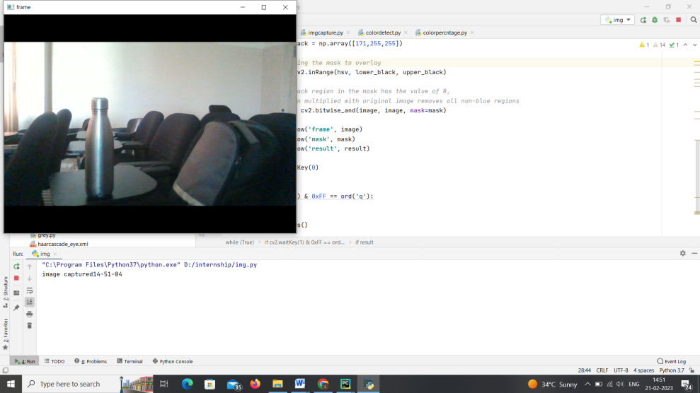

**Fig 3.1 Snapshot of Image Capturing**

**Color Detection**

An open-source library in Python, OpenCV is basically used for image and video processing. Not only supported by any system, such as Windows, Linux, Mac, etc. but also it can be run in any programming language like Python, C++, Java, etc. OpenCV also allows you to identify color in images. Don’t you know how to find these colors in images

**Color Recognition in Images**

A monitor or TV screen basically generates three types of colors, i.e., red, green, and yellow. But the combination and intensities of these three colors make various colors. Thus, each color has its unique HSV color code. For finding the specified color in the given image, we need to use the lower and upper bound of that color.

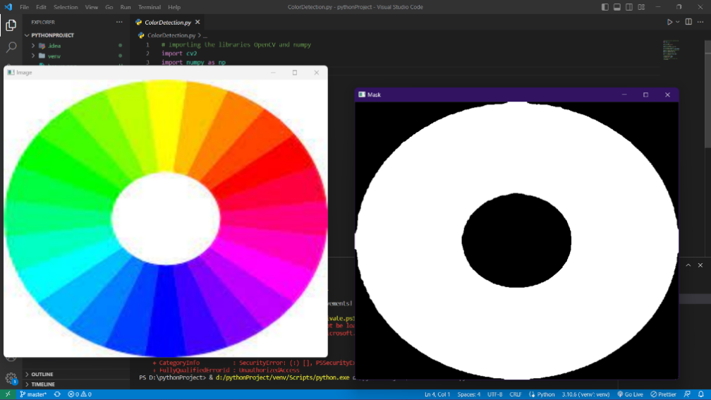

**Fig 3.2 Snapshot of Color Recognition Image**

**Grey Scaling**

Grayscaling is the process of converting an image from other color spaces e.g. RGB, CMYK, HSV, etc. to shades of gray. It varies between complete black and complete white.

**Importance of grayscaling**

Dimension reduction: For example, In RGB images there are three color channels and three dimensions while grayscale images are single-dimensional. Reduces model complexity: Consider training neural articles on RGB images of 10x10x3 pixels. The input layer will have 300 input nodes. On the other hand, the same neural network will need only 100 input nodes for grayscale images. For other algorithms to work: Many algorithms are customized to work only on grayscale images e.g. Canny edge detection function pre-implemented in the OpenCV library works on Grayscale images only.



**Fig 3.3 Snapshot of Image which is colored**



**Fig 3.4 Snapshot of Image which is grey scaled**

**Interface**

Using only Python, you may create your image editor. Tkinter, a graphical user interface library for Python, can be used to create the necessary interface. NumPy and OpenCV enable users to alter the parameters of any action, be it an edit, crop, color change, background blur, picture merge, rotation, scaling, or dragging.

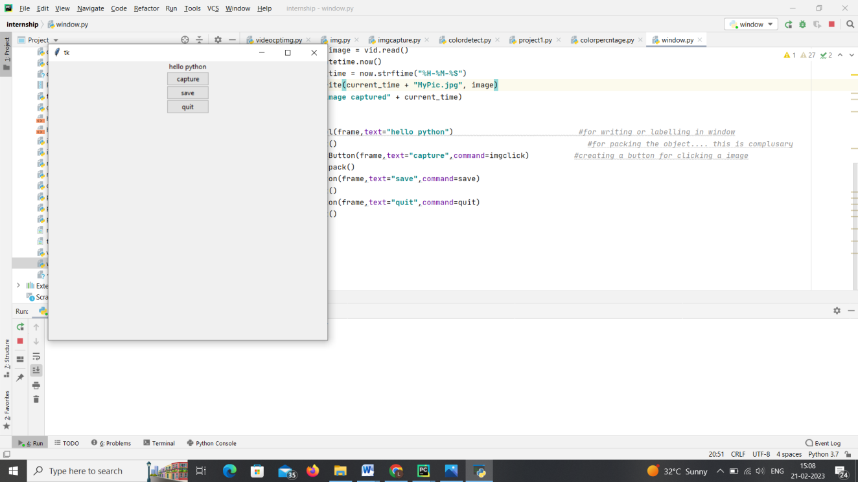

**Fig 3.5 Snapshot of Interface Created**

**3.2 Project**

The project is about Face emotion recognition using Neural networks.

**3.2.1 Introduction**

Facial emotion detection using neural networks is a rapidly advancing technology in the field of computer vision that has gained significant interest and attention in recent years. The technology is designed to recognize and classify the emotional state of a person based on their facial expressions. This application has numerous real-world applications, including human-computer interaction, affective computing, and emotion-based personalization.

The key components of facial emotion detection using neural networks include image processing, deep learning, and computer vision techniques. These components are combined to create a model that can accurately recognize and classify different emotions in facial expressions. The model is trained on a large dataset of annotated facial images that include different emotional expressions such as happiness, sadness, anger, surprise, fear, disgust, and neutral.

Python programming language is the most commonly used language for implementing facial emotion detection projects. This is because it offers various powerful libraries and frameworks for image processing, data manipulation, and machine learning. The libraries used for image processing include OpenCV, scikit-image, and Pillow, among others. On the other hand, deep learning frameworks such as TensorFlow, Keras, and PyTorch are used for building and training neural network models.

The process of facial emotion detection using neural networks involves several steps, including data collection, preprocessing, feature extraction, model building, training, and testing. In the data collection stage, a large dataset of facial images is collected and annotated with different emotional expressions. The dataset is then preprocessed, which involves tasks such as normalization, resizing, and filtering.

The trained model can then be used to make predictions on new, unseen facial images. The model classifies these images into one of the pre-defined emotions, allowing the system to recognize and respond to the user's emotional state.

One of the most significant applications of facial emotion detection is in human-computer interaction (HCI). In this application, the computer system can recognize and respond to the user's emotions, making the interaction more natural and intuitive. This technology can be used in various domains, including education, entertainment, gaming, and healthcare.

Another application of facial emotion detection is affective computing, which involves analyzing and responding to human emotions. This technology has significant potential in fields such as marketing, advertising, and customer service. It can be used to personalize the user experience by tailoring the content to the user's emotional state.

Facial emotion detection is also used in emotion-based personalization, where personalized content is provided to the user based on their emotional state. For instance, a music streaming service can recommend music based on the user's current mood, enhancing the overall user experience.

In conclusion, facial emotion detection using neural networks is a promising technology that has the potential to revolutionize human-machine interaction by making it more natural and intuitive. It is a complex process that involves various techniques from computer vision, deep learning, and image processing. Python programming language offers powerful libraries and frameworks for implementing facial emotion detection projects. This technology has various applications in human-computer interaction, affective computing, and emotion-based personalization, among others.

**3.2.2 System Analysis**

Existing System

Here Python 3.9 is used to perform Face emotion recognition.

Methodology

A. Deep Learning

The deep learning architecture learns a range of significant nonlinear features from the examples presented. After then, the learned architecture is used to predict samples that have never been seen before. To train our deep learning architecture, we acquired images from a variety of sources. The architecture of the learning process is heavily influenced by CNN. The parts that follow go through every aspect of deep learning architecture. Obtaining Datasets: Data from two different sources is collected for training and testing the model. A total of 1915 photographs of persons wearing and not wearing masks were obtained. Eighty percent of the photographs are used for training, while the rest are used for testing. Design of the Learning Model: The learning model is based on a deep learning classifier that can recognise patterns in images. The network is made up of an input layer, many hidden layers, and an output layer. The hidden layers are made up of many convolution layers that generate appropriate filters for extracting crucial features from the input data. To make classification judgments, many dense neural networks use the characteristics acquired by DL.

B. Tensorflow

TensorFlow is a free and open-source dataflow and differentiable programming software framework that may be used to tackle a wide range of problems. It's a symbolic math library that's also used in machine learning applications like neural networks. Google's second-generation system, TensorFlow, is utilised for both research and production.

C. Keras

Keras is a human-centric API, not a machine-centric one. By providing uniform and straightforward APIs, decreasing the number of user activities necessary for typical use cases, and giving clear and actionable error signals, Keras adheres to best practices for lowering cognitive load. Keras contains many implementations of common neural-network building pieces like layers, objectives, activation functions, optimizers, and a slew of other tools to make working with neural networks easier.

D. OpenCV OpenCV (Open-Source Computer Vision Library) is an open-source library that

includes several hundreds of computer vision algorithms. OpenCV is one of the most

popular computer vision libraries. OpenCV handles all the memory automatically. This

OpenCV will help to learn the Image-processing from Basics to Advance, like operations

on Images, Videos using a huge set of OpenCV-programs and projects. OpenCV is the

huge open-source library for the computer vision, machine learning, and image

processing and now it plays a major role in real-time operation which is very important

in today’s systems. By using it, one can process images and videos to identify objects,

faces, or even handwriting of a human. When it integrated with various libraries, such as

NumPy, python is capable of processing the OpenCV array structure for analysis. To

Identify image pattern and its various features we use vector space and perform

mathematical operations on these features.

E. Neural Networks Neural Networks are also known as artificial neural networks. It is a subset of

machine learning and the heart of deep learning algorithms. The concept of Neural

networks is inspired by the human brain. It mimics the way that biological neurons send

signals to one another. Neural networks are composed of node layers, containing an input

layer, one or more hidden layers, and an output layer. A human brain is the inspiration

behind neural network architecture. Human brain cells, called neurons, form a complex,

highly interconnected network and send electrical signals to each other to help humans

process information. Similarly, an artificial neural network is made of artificial neurons

that work together to solve a problem. Artificial neurons are software modules, called

nodes, and artificial neural networks are software programs or algorithms that, at their core, use computing systems to solve mathematical calculations. Simple neural network

architecture.

A basic neural network has interconnected artificial neurons in three layers:

* Input Layer: Information from the outside world enters the artificial neural network from the input layer. Input nodes process the data, analyze or categorize it, and pass it on to the next layer.
* Hidden Layer: Hidden layers take their input from the input layer or other hidden layers. Artificial neural networks can have a large number of hidden layers. Each hidden layer analyzes the output from the previous layer, processes it further, and passes it on to the next layer.
* Output Layer: The output layer gives the final result of all the data processing by the artificial neural network. It can have single or multiple nodes. For instance, if we have a binary (yes/no) classification problem, the output layer will have one output node, which will give the result as 1 or 0. However, if we have a multi-class classification problem, the output layer might consist of more than one output node.

F. Tkinter

Tkinter is the inbuilt python module that is used to create GUI applications. It is

one of the most commonly used modules for creating GUI applications in Python as it is

simple and easy to work with. You don’t need to worry about the installation of the

Tkinter module separately as it comes with Python already. It gives an object-oriented

interface to the Tk GUI toolkit. It is a useful tool for creating a wide variety of graphical

user interfaces, including windows, dialog boxes, and custom widgets. It is particularly

well-suited for building desktop applications and adding a GUI to command-line

programs.

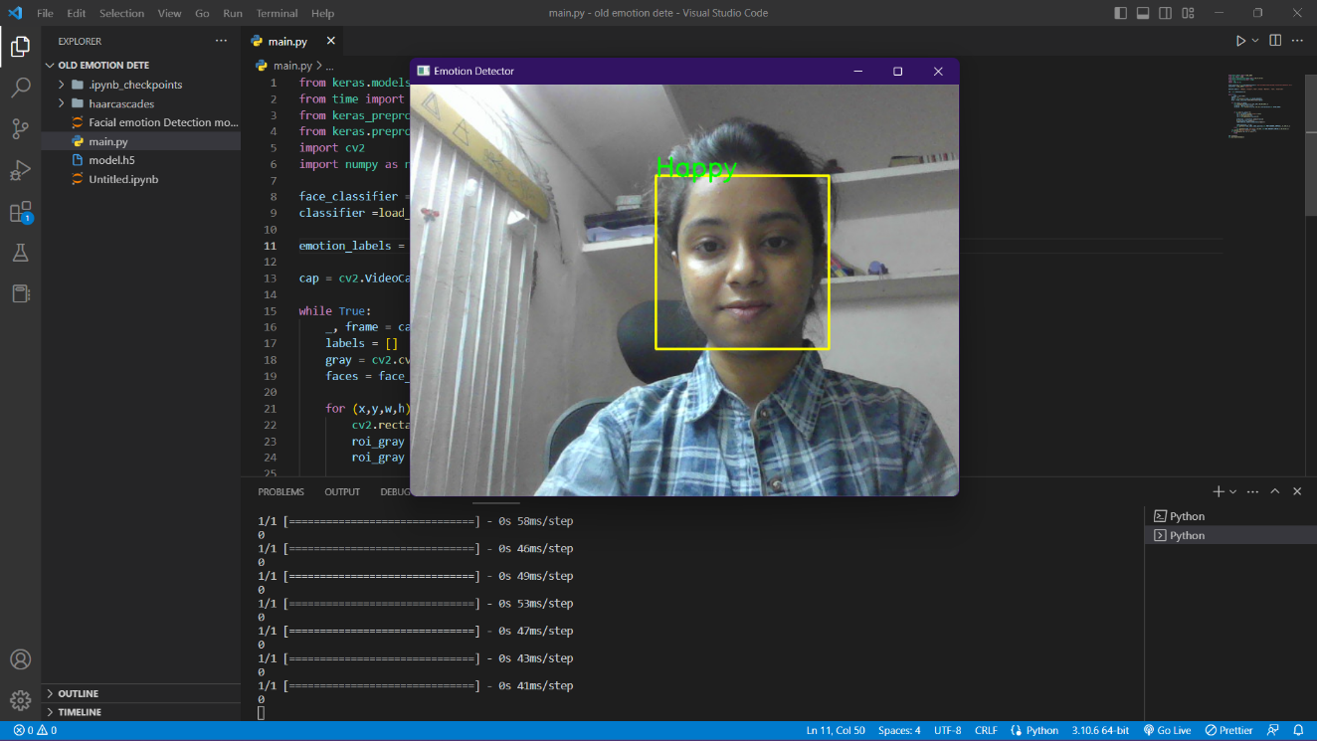

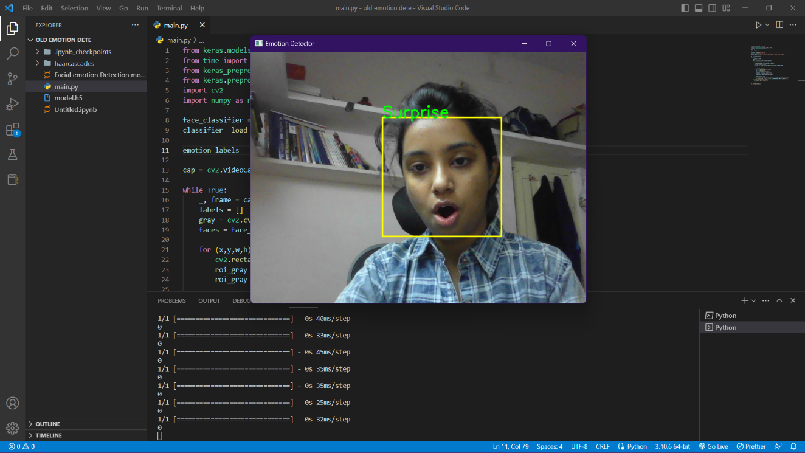

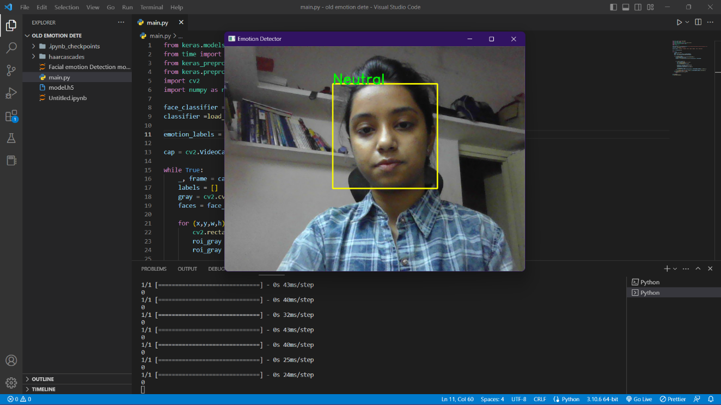

System requirement

• Operating system: Windows XP/7/10

• Tools : tensorflow==1.15.2, keras==2.3.1, imutils==0.5.3, numpy==1.18.2, pencv-python==4.2.0, matplotlib==3.2.1, scipy==1.4.1.

• IDE : Python37

**CHAPTER 4**

**REFLECTION**

As an intern with Innovant IT Solutions, I was fortunate enough to gain valuable knowledge and experience in various technologies. The training provided was effective and taught us the most efficient ways to develop solutions for problem statements within the given time frame. The unique teaching style of our trainer ensured that we understood the concepts by practicing them practically.

One of the highlights of the internship was the opportunity to learn about the basics of Python language and machine learning algorithms. The knowledge I gained helped me understand the concepts of machine learning in Python and further improved my problem-solving and logical thinking skills. I also developed better communication skills during the internship, which are essential for a positive work environment and efficient workflow.

The internship program emphasized the importance of time management, which helped us maximize our productivity and efficiency within a limited time frame. In conclusion, the internship program was a rewarding experience that equipped me with essential skills and knowledge to succeed in my future career path.

**4.1 Experience and Assessments of Internship**

Although internship vary greatly from one organization to the next, the term traditionally refers to real-world work experiences in which students fulfill short-term positions within a company or organization in order to gain hands-on experience and develop career-specific skills. Sponsoring agencies generally work with the student to meet specific learning goals and provide special mentoring or networking opportunities. In exchange, the intern helps the employer in meeting overall work goals for the company. The internship program conducted by the renowned organization Innovant IT Solutions, during the seventh semester of Bachelor of Engineering helped me to get the training in a quite essential way. Initially I approached IITS for this purpose and got opportunity to undergo one month internship program from the experienced employees in that organization. On the first day of my internship HR allotted me a trainer for the basic training about Machine Learning. Initially I was supposed to do the installation of PyCharm IDE that are required to do project. Once the needed software were installed, they explained how to create project in PyCharm and taught me basics of Python Programming Language and all the packages that is used in the machine learning. I was also assigned a task after the basics training which helped me improve my technical skills and Real life experience. Initially I have collected various information about latest topic in the domain machine learning from browsing the Internet, different types of journals and many other sources. The case-study which I selected was "Face mask detection using Machine Learning" which is developed in Python language. The mentor and the trainer who were allotted to me were very supportive and always helped me with their valuable guidance in their busy schedule.

**4.2 Comparison**

In this project we used mainly 3 types of machine learning methods that is based on supervised and unsupervised learning. Where Regression is based on the supervised learning and cluster analysis and association rule mining is based on unsupervised learning Supervised learning that is Regression will predict numeric value of target feature based on input values of other features. Where Unsupervised learning that is association rule mining and clustering analysis will divide input dataset into one or more homogenous groups. This is sometimes used for segmentation analysis which identifies groups of individuals with similar purchasing, donating, or demographic information. Association rule mining is a pattern detection.

**4.3 Technical Outcomes**

The internship program is very useful to get technical knowledge about Machine Learning. Initially I have got basic knowledge about Python programming language. Packages that are used in the Image Processing. When I worked this case-study I have faced some of the challenges. The case- study which I have chosen was Face mask detection using Machine Learning. To do this analysis list of items required. Initially input files can be import from csv file saved in current working directory.

**1**. **Problem Solving Skills**

What real-life problems have you solved till now other than to decide what to wear the next day and how to dodge the upcoming assignment deadline? An internship introduces you to real-life work problems and hence develops your problem-solving skills.

**2. Work Ethics**

You won't really learn about work ethics until you are in a tangible work environment. In college education, we are used to making excuses for late submissions, short attendance and what not! But it is only when we are introduced to the actual environment that we learn work ethics.

**3. Adaptability Skills**

Not everyone is adaptable from the beginning. In fact, you can refuse to be so even during your internship experiences but the loss is yours. Being adaptive to your surroundings easily is one of the most useful soft skills not only desirable to employers but also important to your self-growth. So, make the most of your internship experiences and learn some adaptability skills while you are there**.**

**4. Communication Skills**

Talking of soft skills, can the importance of communication skills be ever put into words? It's one of the top listed skills that recruiters look for in a resume and something that can get you from bottom to top. Communicating well is a gem of a skill which you can learn during your internship experiences.

**5. Responsibility**

Often missed out in the list of soft skills, being responsible is an integral skill required in the job arena. Your internship experience makes you more responsible and accountable for what decisions you make and how you execute what's been allocated to you.

**6. Time Management**

Last on our list, but still as important as the others, is time management. Earlier, you could just miss a class because you had some personal commitments. During an internship which is almost the beginning of your work life, you can't mark your absence on a regular basis. Hence, it helps you learn to manage your time better by maintaining a balance between your work and personal life, without harming any of them.

**CHAPTER 5**

**CONCLUSION**

In conclusion, the need for internships has become more important than ever in today's rapidly evolving industry. The experience gained during the internship at Innovant IT Solutions has given me a better understanding of the industrial standards and the skills required to contribute and grow in the industry. I have also developed self-learning capacities and logical thinking skills that are necessary to keep up with the fast-paced nature of the industry.

The need for the internship is more emergent as one needs to be oriented with self-learning capacities required at very short notice in the industry. Got to know the industrial standards, the skills that are required to help us contribute and grow with the industry, the ability to learn on our own, logical thinking, and many more. The internship program has made me understand the career opportunities that can be explored. An understanding is grown about the lifelong learning one need to sustain in the industry and the curious and open-minded attitude one needs to have for the same.

The internship helped in improving my interpersonal skills. In this internship, we learned how to handle machine algorithms in modern-era problems. The trainer also helped us in improving our logical thinking by giving us small assignments to write our own codes. Some of the technical outcomes of the training are that we can logically analyse and provide considerable solutions.

**5.2 REFERENCE**

[1] https://www.kaggle.com/c/challenges-inrepresentation-learning-facial- expressionrecognition-challenge/data

[2] Dalal, Navneet, and Bill Triggs (2005). Histograms of oriented gradients for human detection. Computer Vision and Pattern Recognition (CVPR), IEEE Computer Society Conference on. Vol. 1

[3] Nicu Sebe, Michael S. Lew, Ira Cohen, Yafei Sun, Theo Gevers, Thomas S. Huang (2007) Authentic Facial Expression Analysis. Image and Vision Computing 25.12: 1856-1863

[4] Y. Tian, T. Kanade, and J. Cohn. Recognizing action units for facial expression analysis. IEEE Transactions on Pattern Analysis and Machine Intelligence, 23(2), 2001.

[5] M.S. Bartlett, G. Littlewort, M. Frank, C. Lainscsek, I. Fasel, and J. Movellan. Fully automatic facial action recognition in spontaneous behavior. In Proceedings of the IEEE Conference on Automatic Facial and Gesture Recognition, 2006.

[6] Cohen, Ira, et al. ”Evaluation of expression recognition techniques.” Image and Video Retrieval. Springer Berlin Heidelberg, 2003. 184- 195..