Expense tracker

Overview

Proposed solution

application for tracking our expenditure in every month.it will calculate the amount we spend in every day. End of the month we can calculate the expenditure for each field.

Goal

To develop a solution that will calculate the monthly expenditure based on the user inputs

Requirements

* Working environment – visual studio code
* Language used - c++

Block diagram

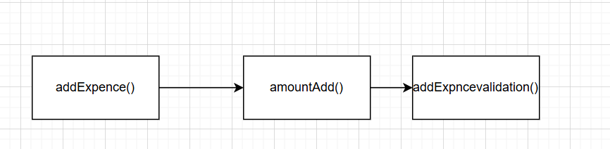

* For each day memory is allocated using dynamic memory allocation
* The input is taken from the user and stored it in the array
* Addexpence() function will store and add the expense in every day
* Viewexpence will show the expenses in each day or month
* Month( )function will shows the expenditure on each month
* Day() function will give the data on amount spend on the given day

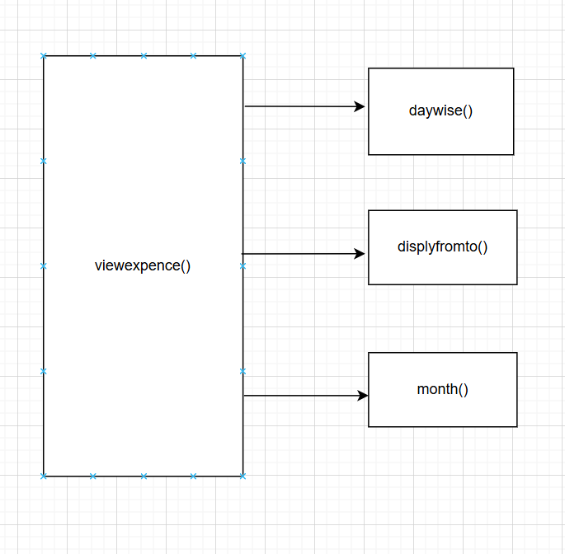

Realtime application

* Can be able to use this application as a daily expenditure calculator
* It will help to compare the monthly expenses