Expense tracker

Overview

Proposed solution

application for tracking our expenditure in a month. It will calculate the amount we spend in every day. End of the month we can calculate the expenditure for each field.

Goal

To develop a solution that will calculate the monthly expenditure based on the user inputs

Requirements

* Working environment – visual studio code
* Language used - c++

Block diagram

* For each day memory is allocated using dynamic memory allocation
* The input is taken from the user and stored it in the array
* Addexpence() function will store and add the expense in every day
* Viewexpence will show the expenses in each day or month
* Month( ) function will shows the expenditure on each month
* Day() function will give the data on amount spend on the given day

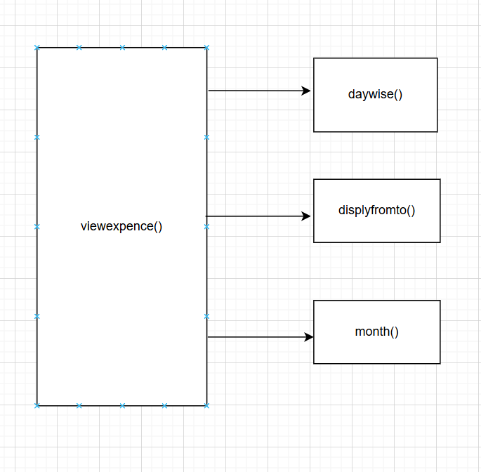

Realtime application

* Can be able to use this application as a daily expenditure calculator
* It will help to compare the day wise expenses