RESEARCH ANALYSIS REPORT

Impact of AI & Social Media on Students
Author: Sneha Mittra | Dataset: AI_SocialMedia_Student_Dataset.csv | Records: 16,000 students | Charts: 8

1. Dataset Overview
16,000 | 13 – 25 | 10 + 3 | 8
Students analysed  (0 duplicates, 0 missing) | Age range across all  education levels | Raw + engineered  features | Charts produced

The dataset covers student demographics (age, gender, education level), daily digital behaviour (social media hours and AI tool hours), lifestyle metrics (sleep and physical activity), and health outcomes (mental health score 0–100, physical health score 0–100). Three engineered features were derived: Total Screen Time, Digital Balance Ratio (proportion of screen time spent on AI tools vs social media), and a composite Wellness Index (equal-weighted average of normalised sleep, activity, mental health, and physical health).

2. Population-Level Averages
4.54 hrs | 2.59 hrs | 6.55 hrs | 1.25 hrs
Avg daily social  media usage | Avg daily AI  tool usage | Avg sleep  per night | Avg physical  activity / day

7.13 hrs | 37.3% | 72.49 | 62.73
Avg total screen  time (social + AI) | Avg Digital Balance  Ratio (AI share) | Avg mental health  score (out of 100) | Avg Wellness Index  (out of 100)

- 38.2% of students exceed 8 hrs/day of combined screen time — the threshold flagged for counselling check-ins.
- 27.2% of students use social media for more than 6 hrs/day, closely associated with the most negative mental health outcomes.
- 91.8% of students use AI tools at least some time per day, indicating near-universal AI adoption in this cohort.

3. Key Correlation Findings
Variable Pair | r Value | Strength | Interpretation
Physical Activity ↔ Wellness Index | +0.785 | Strong Positive | Strongest single predictor of overall student wellness
Sleep Hours ↔ Wellness Index | +0.541 | Moderate Positive | More sleep strongly improves composite wellbeing
Social Media ↔ Mental Health Score | −0.404 | Moderate Negative | Most harmful digital variable for mental health
Social Media ↔ Wellness Index | −0.390 | Moderate Negative | Social media broadly depresses overall wellness
Total Screen Time ↔ Wellness Index | −0.364 | Moderate Negative | Combined screen time erodes wellness
Total Screen Time ↔ Sleep Hours | −0.324 | Moderate Negative | More screen time displaces sleep
Sleep Hours ↔ Mental Health Score | +0.313 | Moderate Positive | Better sleep correlates with better mental health
Physical Activity ↔ Mental Health Score | +0.245 | Weak-Moderate Positive | Exercise supports mental health outcomes
AI Tool Usage ↔ Mental Health Score | −0.111 | Weak Negative | Much weaker than social media; AI use is far less harmful
AI Tool Usage ↔ Wellness Index | −0.078 | Negligible | AI tool use has minimal impact on overall wellness

4. Charts & Key Questions Answered

Chart 1 — Pearson Correlation Matrix: Digital Usage & Health Metrics
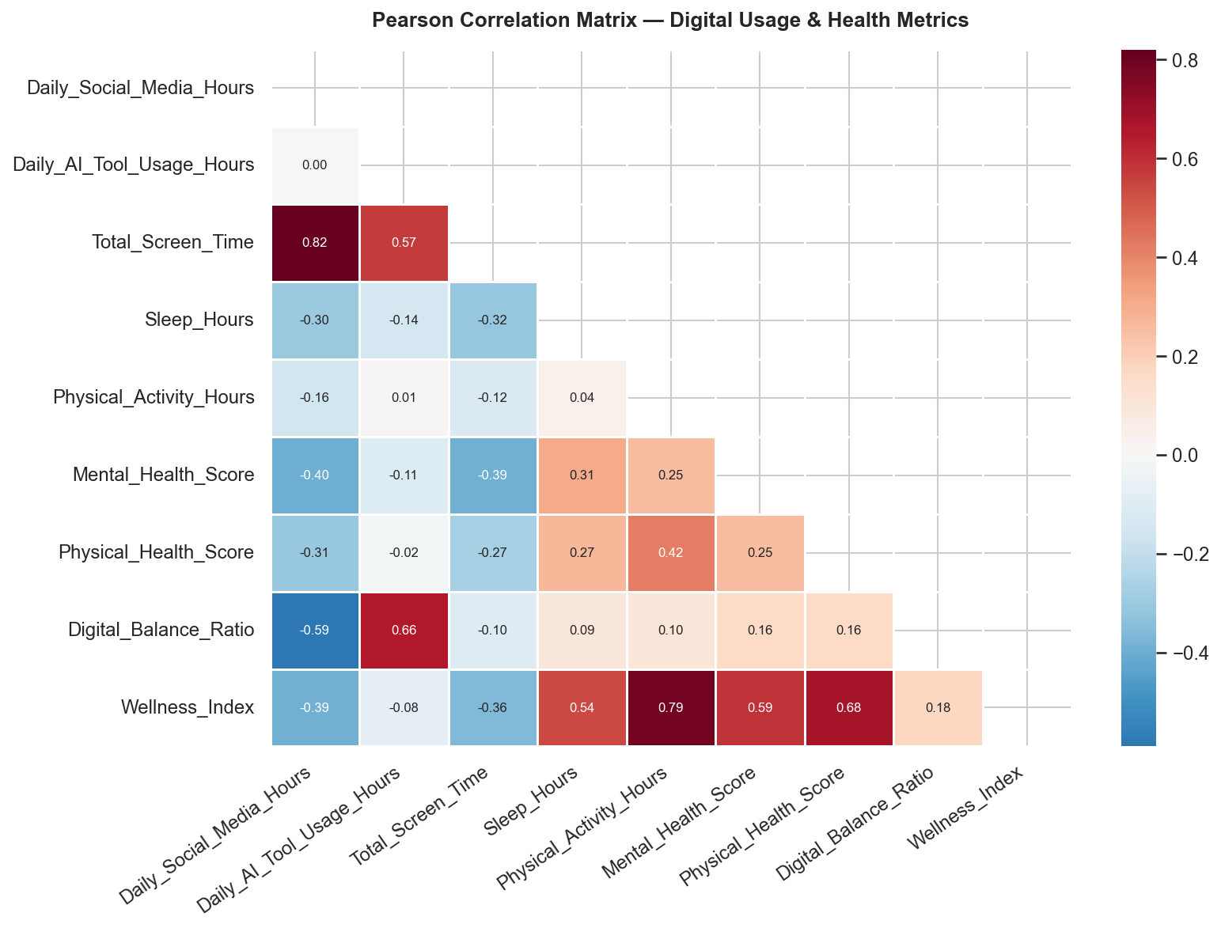
Q: Which variable most strongly predicts overall student wellness?
Physical activity has the strongest positive correlation with the Wellness Index (r = +0.785), far outpacing any digital-usage variable. Sleep is the next most important factor (r = +0.541). Social media hours carry a strong negative correlation with mental health (r = −0.404), making it the most damaging single digital behaviour for wellbeing.

Chart 2 — Total Screen Time vs Mental & Physical Health Scores (by Education Level)
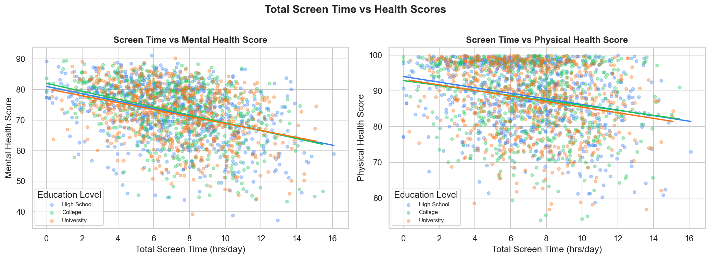
Q: Does more screen time consistently lower health scores across all education levels?
Yes — negative trendlines are visible for all three education groups (High School, College, University) for both mental and physical health. The slope is steeper for mental health, meaning mental wellbeing deteriorates faster with rising screen time. All three education levels show nearly parallel decline rates, suggesting screen-time harm is education-level-agnostic.

Chart 3 — Social Media & AI Tool Hours vs Mental Health Score (by Gender)
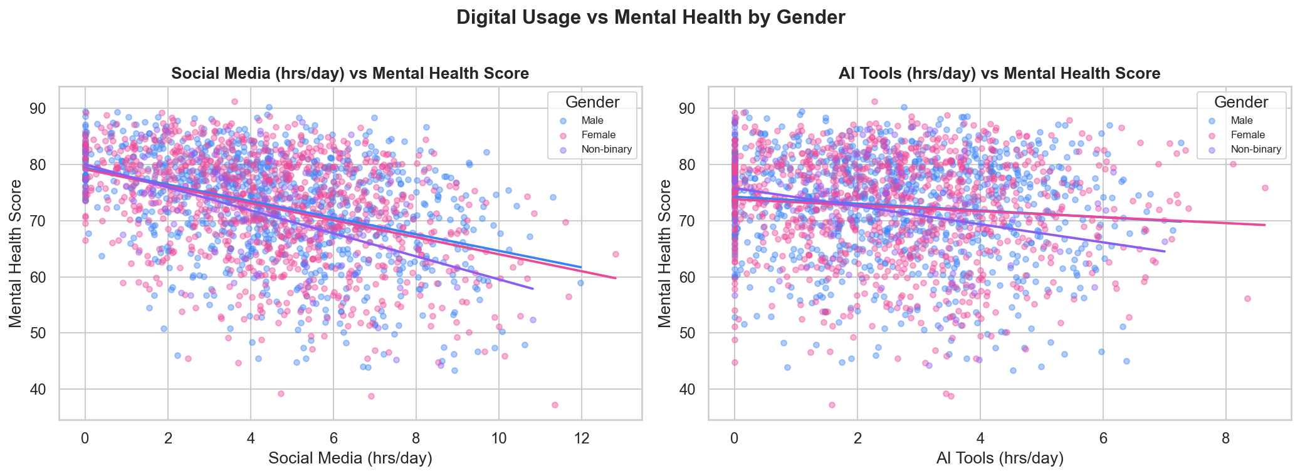
Q: Does the type of digital activity matter — social media vs AI tools — and does gender moderate this?
Strongly yes. Social media usage shows a steep negative slope (r = −0.404) with mental health for all genders. AI tool usage has a much flatter, weaker negative association (r = −0.111), meaning AI tools are significantly less harmful. Non-binary students show a marginally lower baseline mental health score across both axes.

Chart 4 — Average AI Tool Usage & Sleep Hours by Education Level
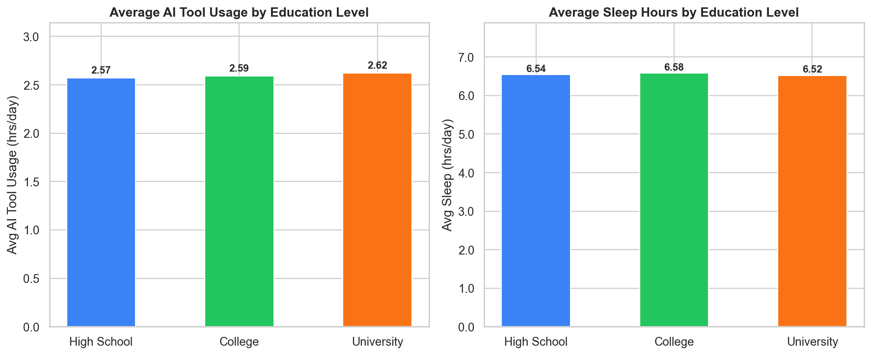
Q: Do higher-education students use AI tools more and sleep less?
AI usage rises slightly with education level: High School (2.57 hrs) → College (2.59 hrs) → University (2.62 hrs). Sleep follows the reverse order: High School (6.54 hrs), College (6.58 hrs), University (6.52 hrs). Differences are modest — education level alone is not a major driver of digital usage or sleep duration.

Chart 5 — Average Mental & Physical Health Scores by Gender
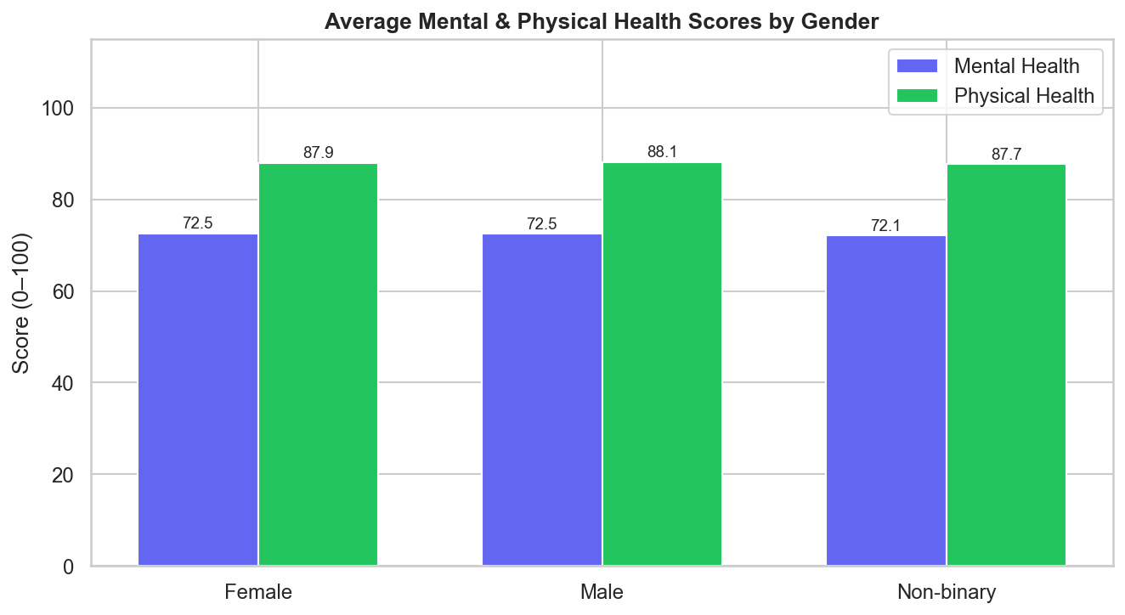
Q: Do mental and physical health outcomes differ significantly by gender?
Differences exist but are small. Mental health: Female (72.54) ≈ Male (72.48) > Non-binary (72.12). Physical health: Male (88.13) > Female (87.94) > Non-binary (87.68). Non-binary students consistently score lowest on both health dimensions, warranting targeted support. Overall gender is not the primary determinant of health outcomes.

Chart 6 — Wellness Index Distribution by Education Level
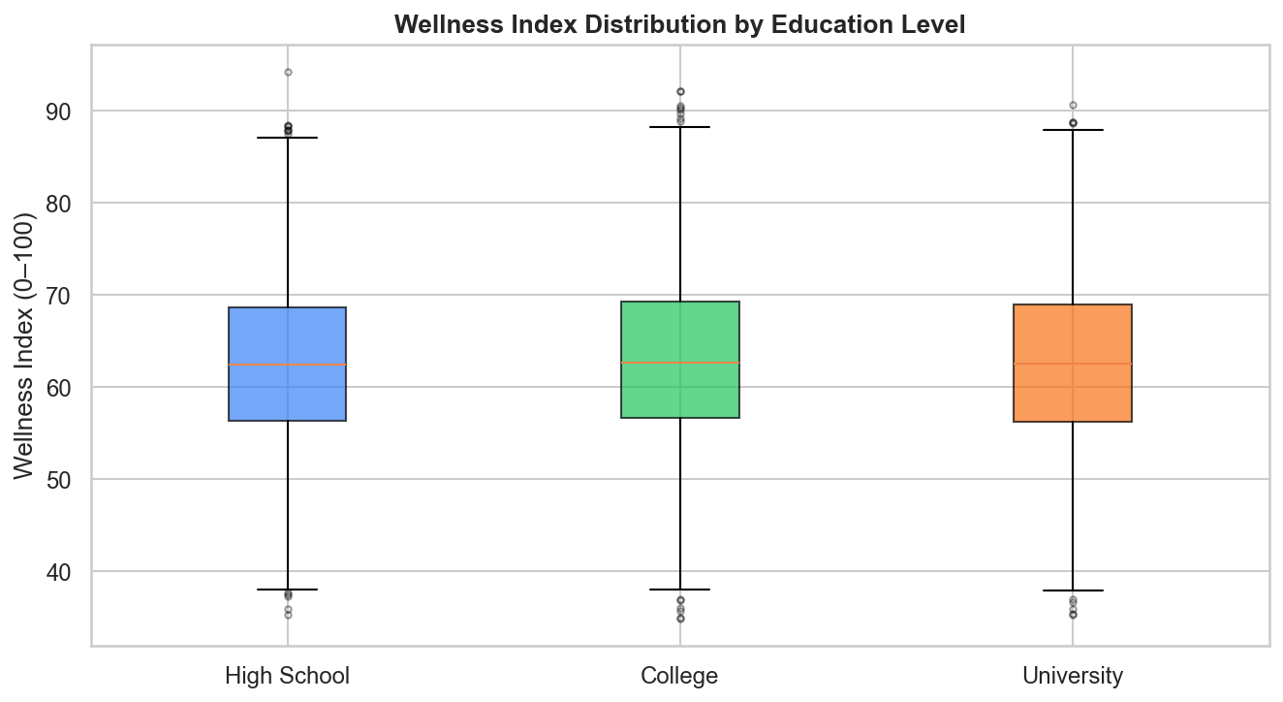
Q: Is wellness spread differently across education levels — are some groups more at risk at the extremes?
Median wellness is similar across groups (~62–63). College students have the highest median wellness (63.02) and University students the lowest (62.63). All groups span roughly 35–94. High School students show a slightly wider lower tail, suggesting a higher proportion of very-low-wellness outliers who may benefit most from early intervention.

Chart 7 — Distributions of Engineered Features
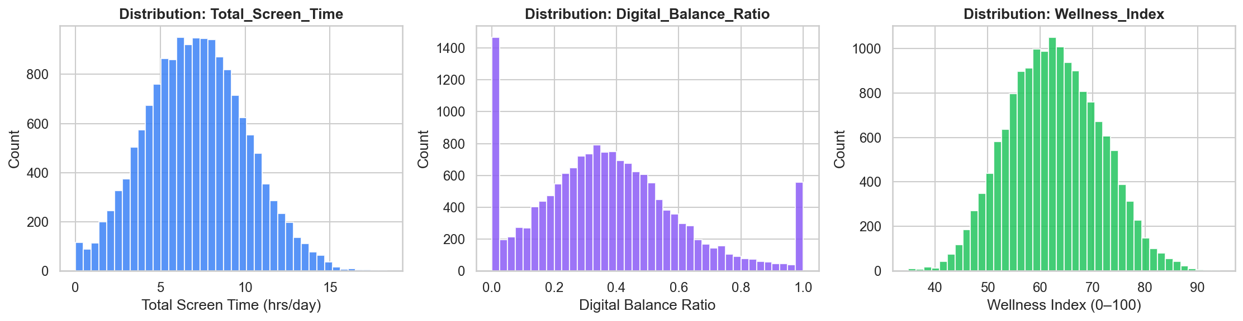
Q: Are the engineered features normally distributed and what do their shapes reveal?
Total Screen Time is roughly bell-shaped centred around 7 hrs (range 0–18.35 hrs). Digital Balance Ratio is slightly right-skewed around 0.37, meaning most students allocate less than half their screen time to AI tools. Wellness Index is approximately normal centred at 62.73, with a long left tail of low-wellness students who represent the highest-risk population.

Chart 8 — Screen Time & Mental Health Score Trend Across Age Groups
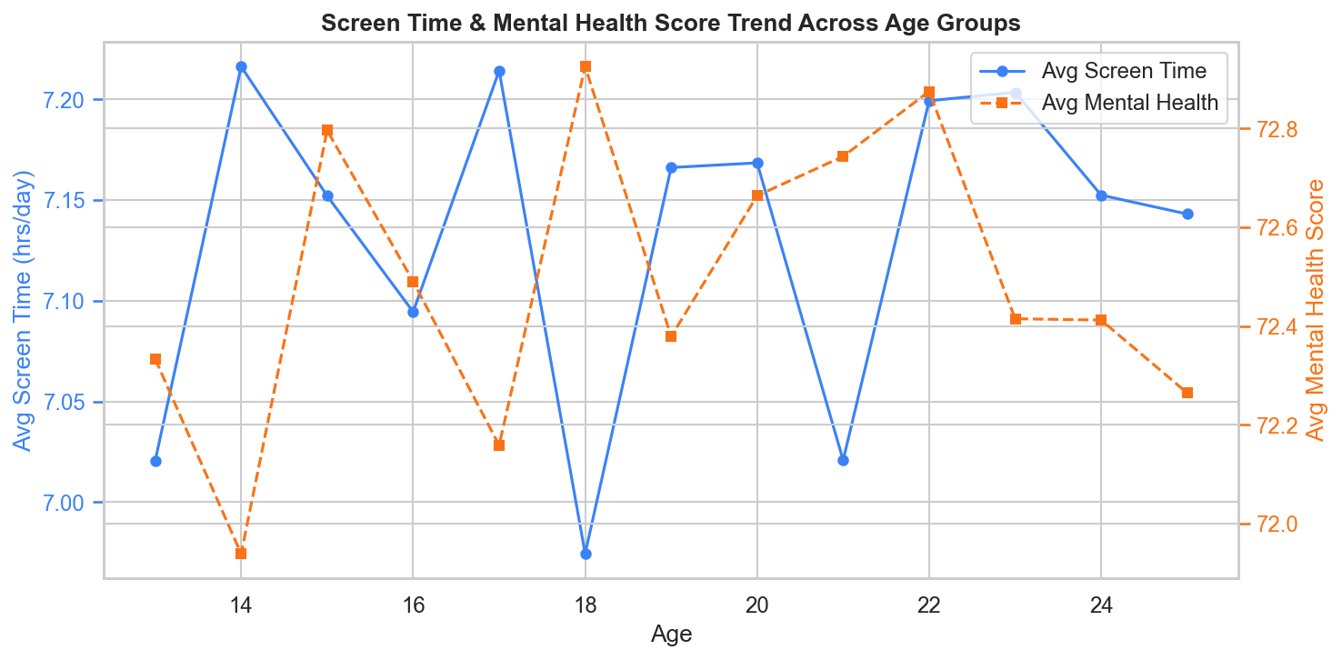
Q: Does screen time or mental health deteriorate as students get older (ages 13–25)?
Surprisingly, both metrics remain relatively flat across all ages (screen time oscillates 6.97–7.22 hrs; mental health 71.94–72.93). There is no clear age-driven upward or downward trend. High screen time and its mental health burden are not concentrated in older or younger students — interventions should target all age groups equally.

5. Subgroup Findings

5.1 By Education Level
Education Level | Students | Avg SM (hrs) | Avg AI (hrs) | Avg Screen (hrs) | Avg Sleep (hrs) | Avg MH Score | Avg WI
High School | 6,083 | 4.57 | 2.57 | 7.14 | 6.54 | 72.34 | 62.57
College | 4,890 | 4.49 | 2.59 | 7.08 | 6.58 | 72.68 | 63.02
University | 5,027 | 4.56 | 2.62 | 7.17 | 6.52 | 72.49 | 62.63
Differences across education levels are small (<0.5 units on most metrics), suggesting digital behaviour and health outcomes are broadly uniform across the student lifecycle.

5.2 By Gender
Gender | Students | Avg SM (hrs) | Avg AI (hrs) | Avg Sleep (hrs) | Avg MH Score | Avg PH Score | Avg WI
Female | 7,628 | 4.55 | 2.61 | 6.55 | 72.54 | 87.94 | 62.70
Male | 7,744 | 4.54 | 2.57 | 6.55 | 72.48 | 88.13 | 62.79
Non-binary | 628 | 4.51 | 2.58 | 6.47 | 72.12 | 87.68 | 62.42
Non-binary students (n=628, ~3.9% of cohort) consistently show the lowest scores across mental health, physical health, sleep, and wellness — a clear equity gap warranting dedicated support resources.

6. Top 6 Key Takeaways
- 1. Physical activity is the #1 wellness lever. With r = +0.785, increasing daily physical activity has the largest measurable positive impact on student wellness — far more than reducing screen time alone.
- 2. Social media is significantly more harmful than AI tools. Social media correlates −0.404 with mental health vs. only −0.111 for AI tools. Shifting screen time from passive social media to productive AI use is a net positive.
- 3. Average sleep (6.55 hrs) is below recommended thresholds. The correlation between screen time and sleep (r = −0.324) confirms that digital devices displace sleep — and sleep itself carries r = +0.313 with mental health. Reducing evening screen time is a dual-benefit intervention.
- 4. 38.2% of students are in the high-risk screen-time zone (>8 hrs/day). Over a third of the student population is already above the flagged threshold, suggesting digital overuse is the rule rather than the exception.
- 5. AI adoption is near-universal (91.8%). The challenge is not AI adoption per se, but ensuring its use is purposeful and productive rather than a passive screen-time addition on top of social media.
- 6. Age and education level show minimal variation in outcomes. Screen time and mental health scores remain flat across ages 13–25 and across all three education levels. Broad, institution-wide policies are needed — no single age group or education stage is uniquely at risk.

7. Institutional Recommendations
1. Campus Wellness Programs
- Regular mental-health screenings, especially for University students (lowest WI: 62.63)
- Weekly mindfulness & stress-management workshops timed to exam periods
- Flag students with combined screen time >8 hrs/day for counselling check-ins (38.2% of cohort)
- Dedicated support services for non-binary students who show the largest equity gap
2. Digital Hygiene Interventions
- Promote the 20-20-20 rule during extended screen sessions
- Designate phone-free study blocks and quiet zones on campus
- Run digital-literacy campaigns with in-app screen-time timers
- Evening social-media cut-off campaigns to protect the average 6.55-hr sleep window
3. Academic AI Integration
- Structured AI-literacy training (purposeful, not habitual) to raise the Digital Balance Ratio
- Embed AI productivity tools into coursework to displace passive social media time
- Target High School students with introductory AI programs early (lowest AI usage: 2.57 hrs)
- Monitor whether rising AI use stays productive as adoption grows
4. Sleep & Physical Activity Targets
- Evidence-based sleep targets: >=8 hrs for High Schoolers, >=7 hrs for College/University
- Gamify physical-activity tracking via campus apps — given r = +0.785, this is the highest-ROI intervention
- Extend evening sports-facility hours during high-screen-time periods
- Integrate short activity breaks into class schedules (10-min movement every 90 min)

8. Charts Index
File | Chart Type | Primary Question Answered
01_correlation_heatmap.png | Heatmap | Pairwise relationships between all digital & health variables
02_scatter_screentime_vs_health.png | Scatter ×2 | Does more screen time reduce mental and physical health scores?
03_scatter_digital_vs_mental_health.png | Scatter ×2 | Do social media and AI tool hours affect mental health differently by gender?
04_bar_ai_sleep_by_education.png | Bar ×2 | How do AI usage and sleep differ across education levels?
05_bar_health_by_gender.png | Grouped Bar | Are there gender differences in mental and physical health scores?
06_boxplot_wellness_by_education.png | Boxplot | How is wellness distributed and where are the low-wellness outliers?
07_histograms_engineered_features.png | Histogram ×3 | What are the distributions of screen time, digital balance, and wellness?
08_line_screentime_mentalhealth_by_age.png | Dual-axis Line | Does screen time or mental health worsen with age from 13 to 25?

Made with IBM Bob

