**[Login using credintials](https://signin.aws.amazon.com/signin?redirect_uri=https%3A%2F%2Fap-south-1.console.aws.amazon.com%2Fec2%2Fv2%2Fhome%3Fregion%3Dap-south-1%26state%3DhashArgs%2523Instances%253A%26isauthcode%3Dtrue&client_id=arn%3Aaws%3Aiam%3A%3A015428540659%3Auser%2Fec2&forceMobileApp=0&code_challenge=YY_pLRMZlc9ACJknX4E1stgcAQ1StTaG_mshffbrL60&code_challenge_method=SHA-256)**

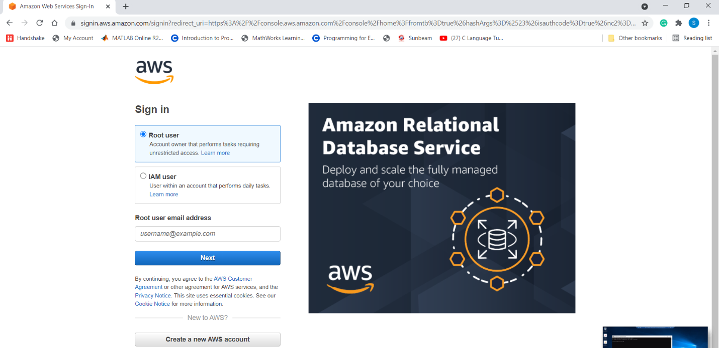

**Select ec2 instance**

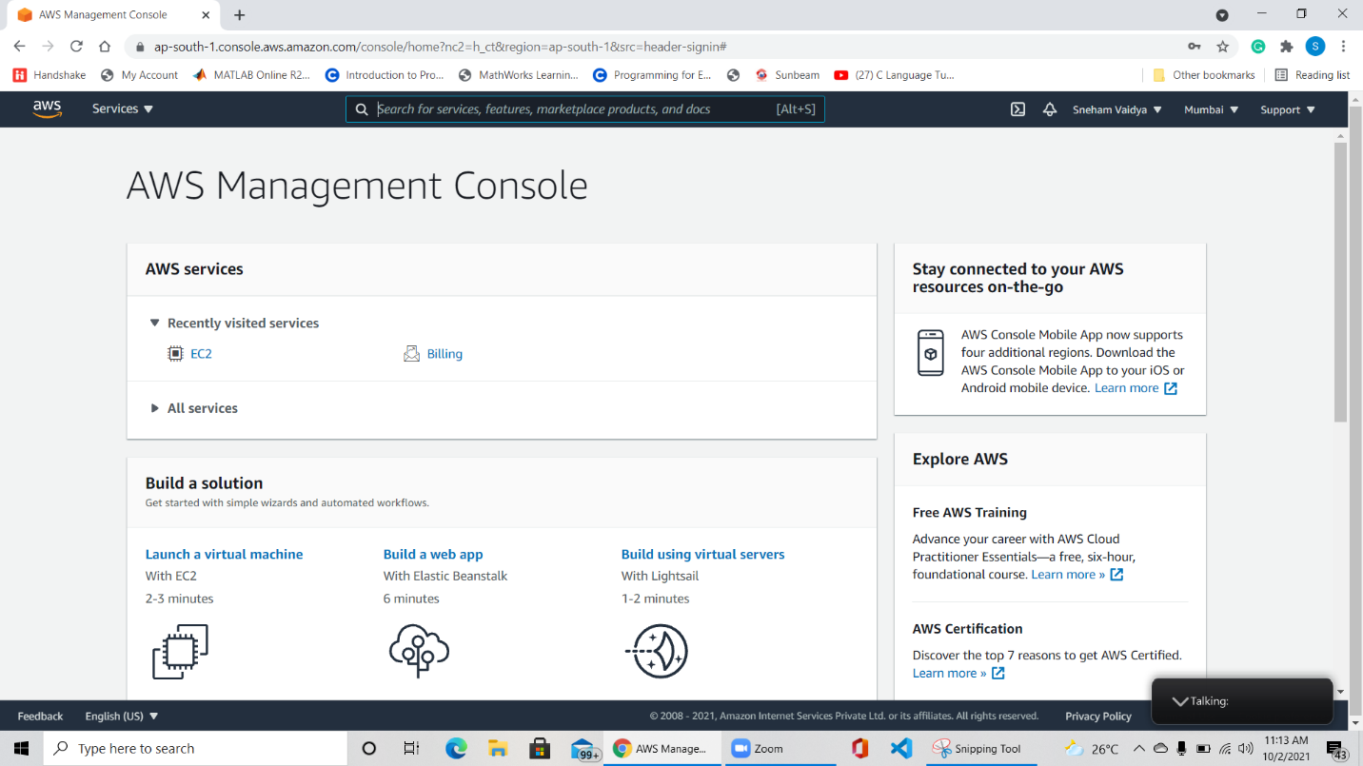

**Click launch instance**: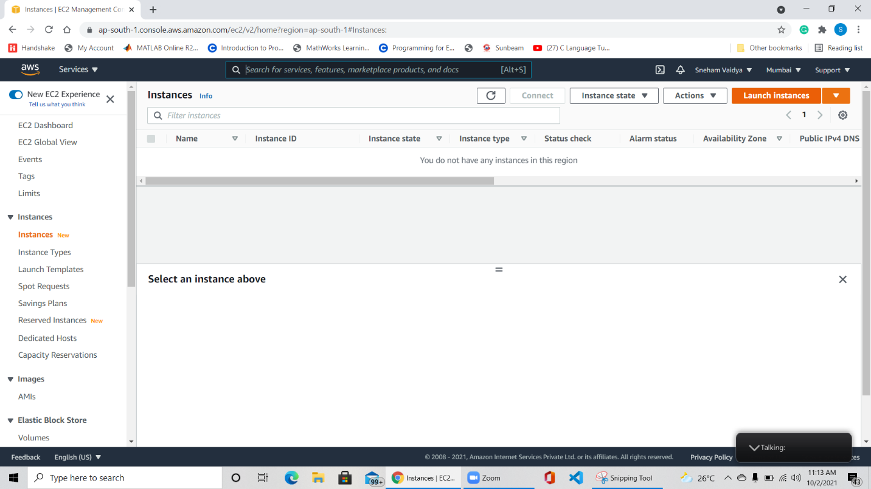

**Select windows free tier**

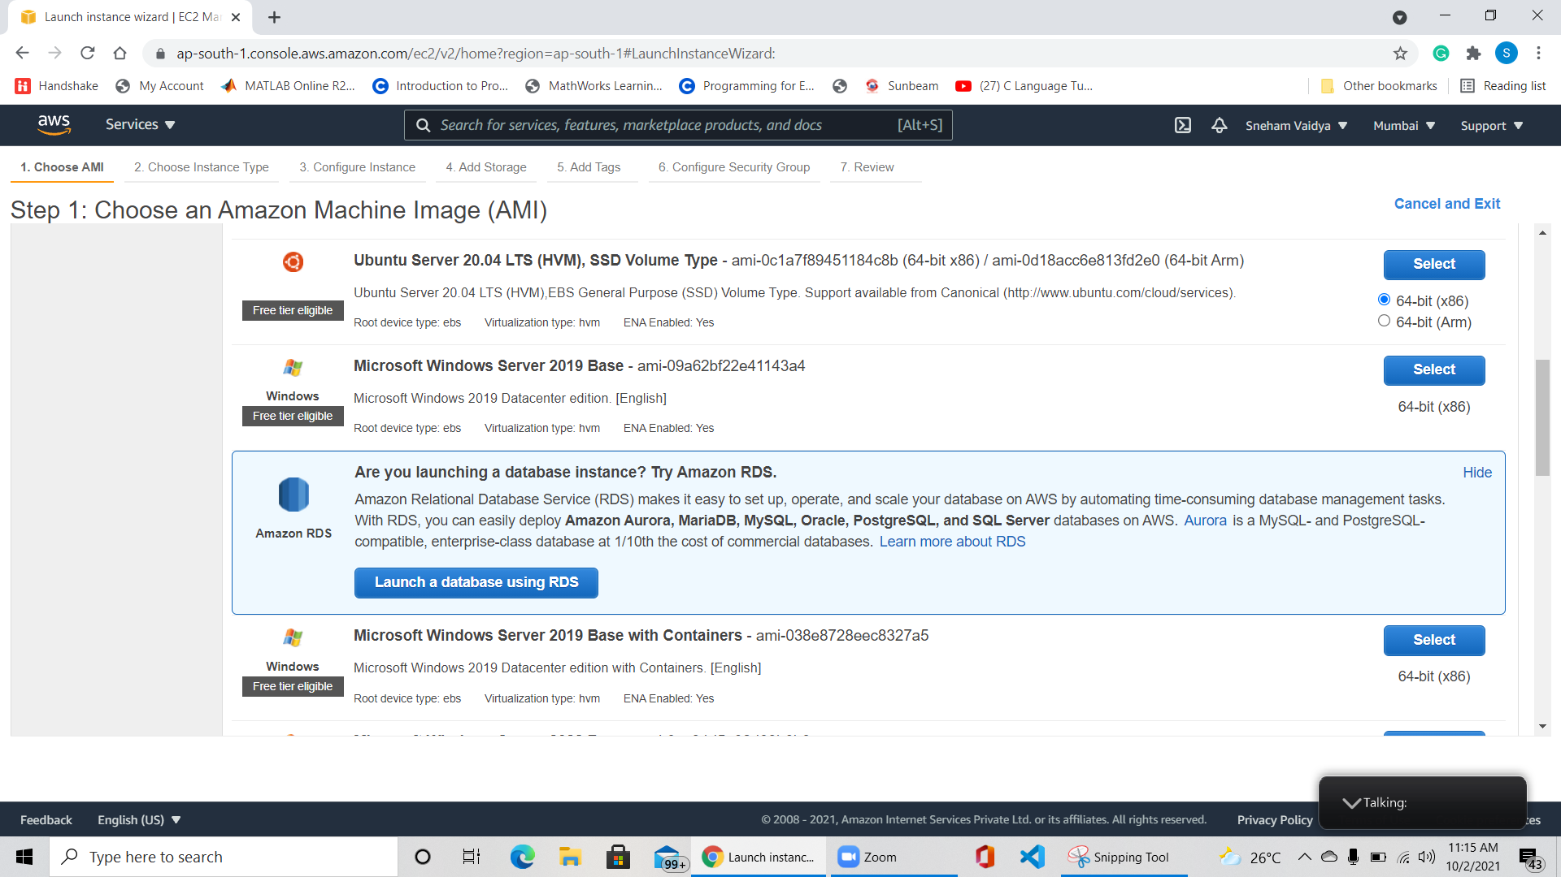

**Create key** 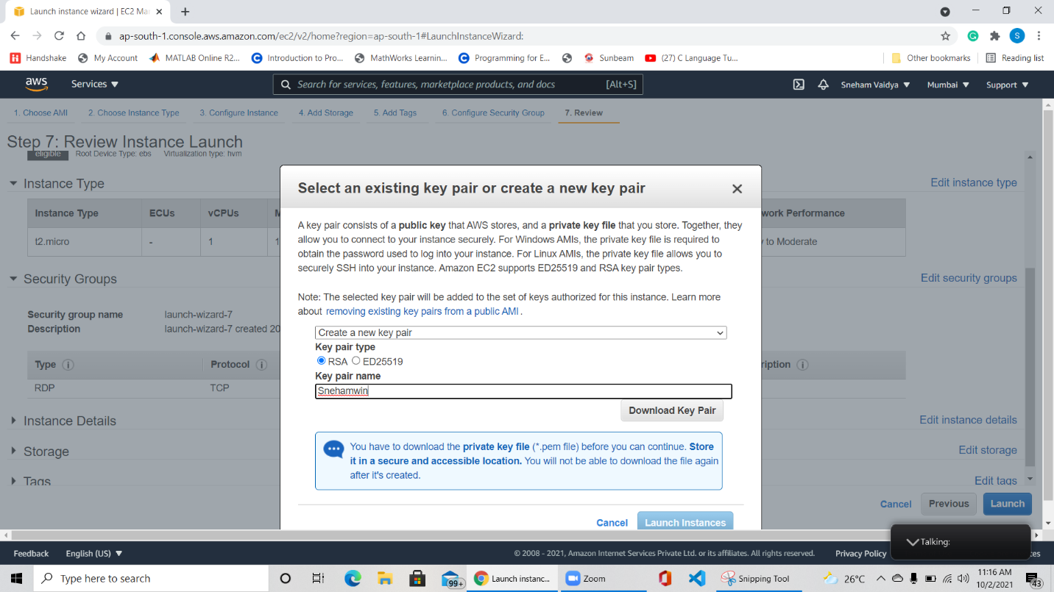

**Remote desktop file download RDP client**

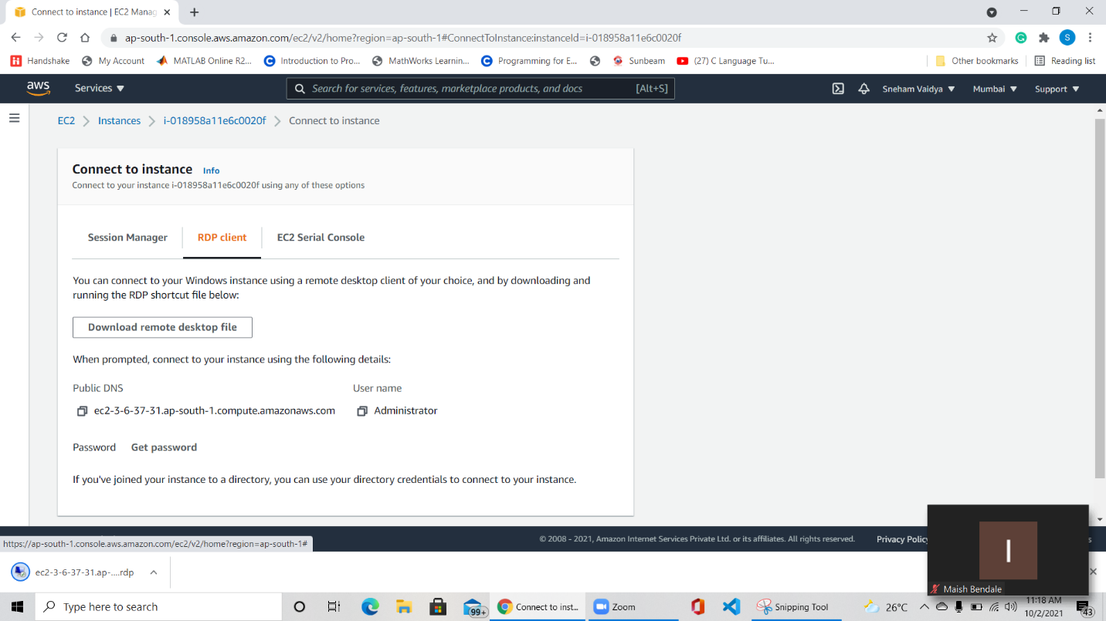

**Click connect**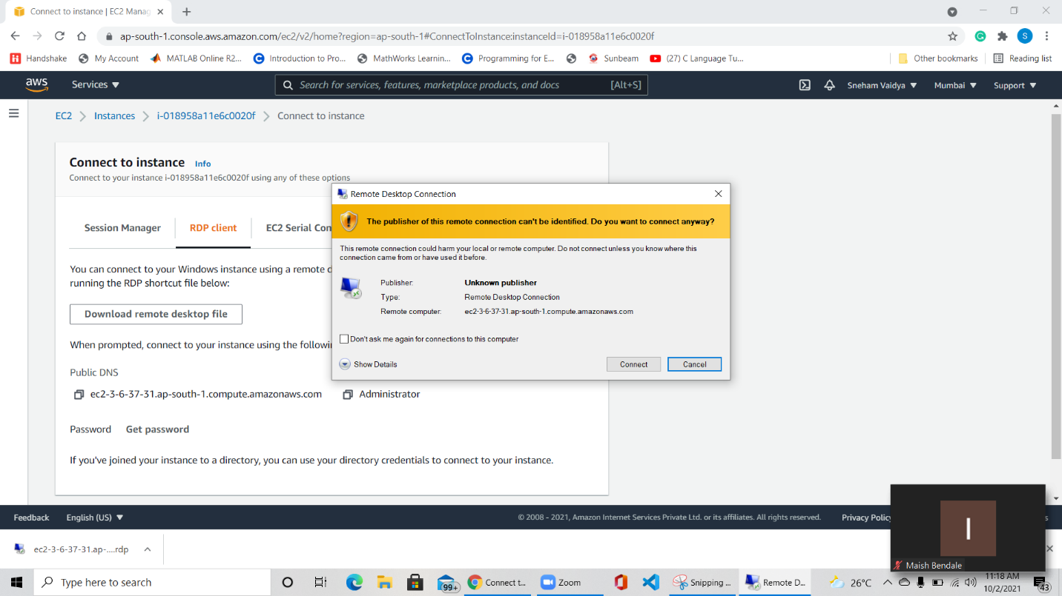

**Select the instance created**

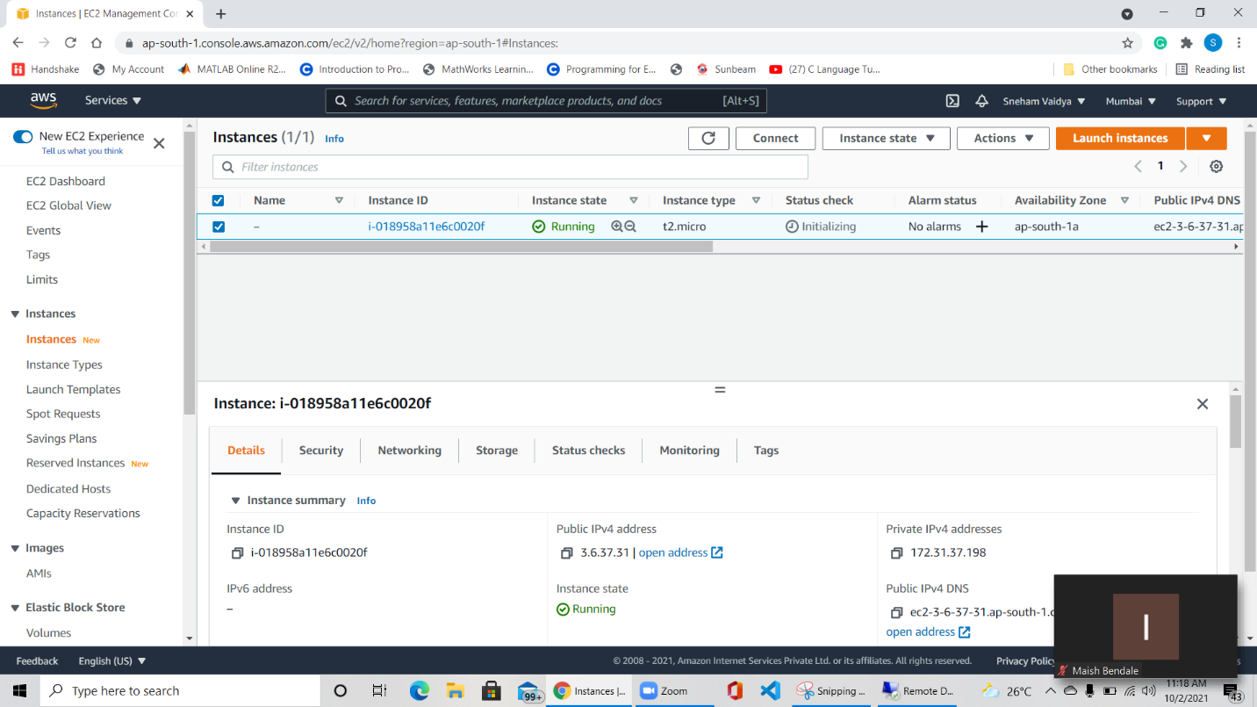

**In security get password**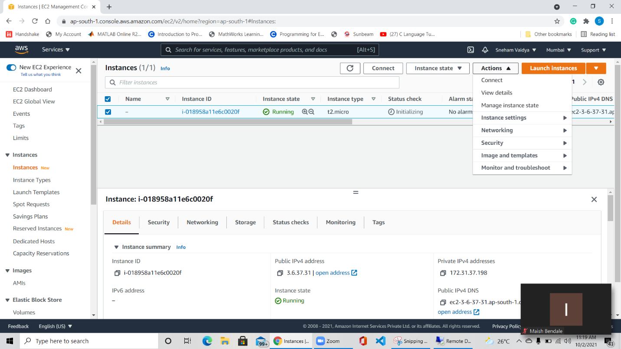

**Decrypt Password**

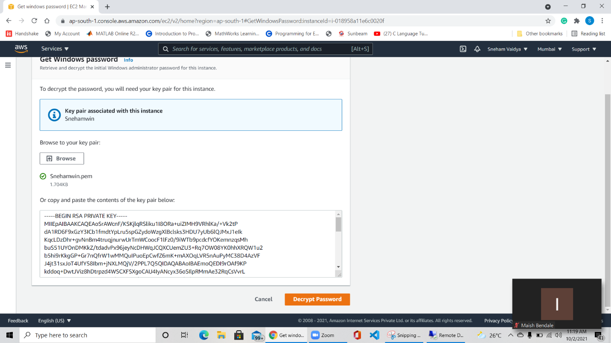

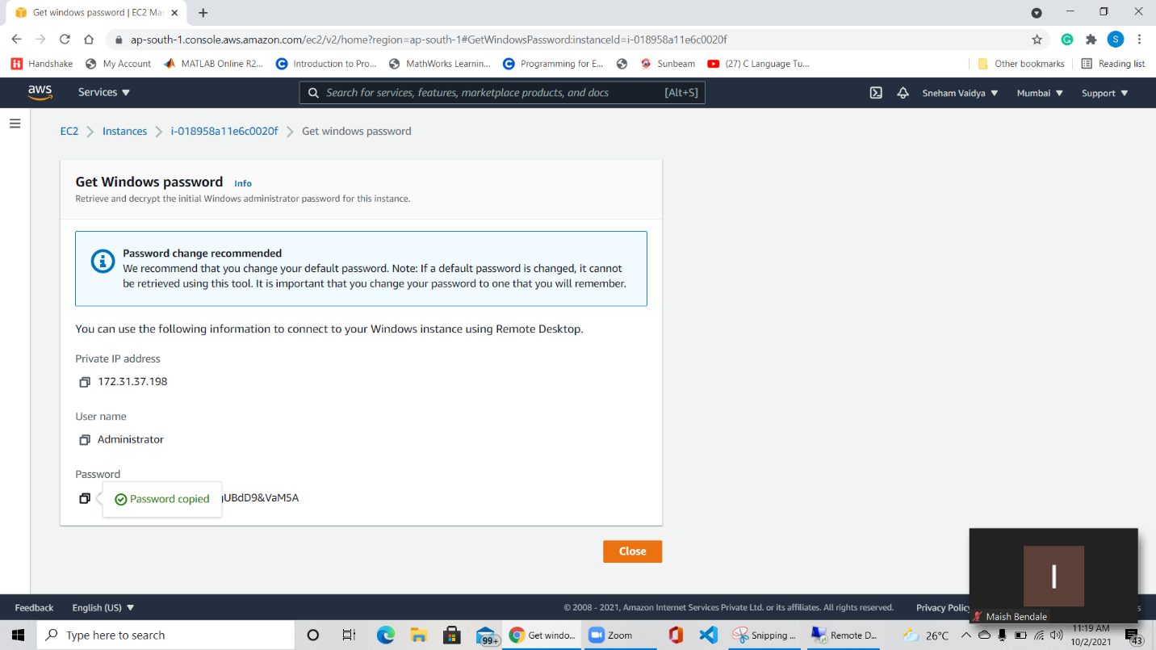

**Open desktop remote app connect using password created**

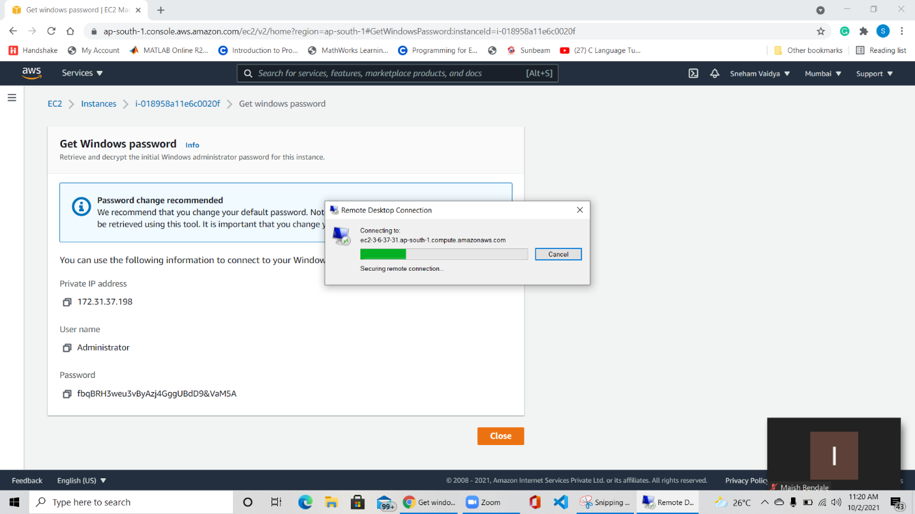

**The windows will start Enjoy you machine and shutdown after use**