ASSIGNMENT 1 | FINAL IMPLEMENTATION GUIDE
JalDrishti
AI-based Village Pond Planning System
Complete design, implementation, algorithms, testing, deployment, and viva reference
DOCUMENT PURPOSE
A beginner-friendly but technically complete explanation of how the application turns contour or live geospatial evidence into ranked pond-screening options. It documents the deployed release and its limits; it is not a construction drawing or excavation approval.

Document field | Value
Student | Sneha Nagmoti
Course deliverable | Assignment 1 - Phase 3 final implementation
Verified release | 0a385c0
Verification date | 29 August 2026
Frontend | sneha-village-pond-planning-2026.onrender.com
Repository | github.com/snehanagmoti/Village-Pond-planning

Document control and how to use this guide
This guide is written so that a reader with no GIS or hydrology background can follow the system from input to output. Read Sections 1-4 for the big picture, Sections 5-10 for the algorithms, Sections 11-15 for engineering and software details, and the appendices for demonstration and viva preparation.
ACADEMIC INTEGRITY
AI-assisted development was used for review, implementation support, testing, and document formatting. The submitted algorithms and measurements were inspected and exercised with automated and production tests. The student remains responsible for understanding and explaining every component.

Item | Verified state
Scope | Code, algorithms, UI, tests, deployment, and documentation
Functional release | 0a385c0 deployed on both Render services
Backend verification | 68 tests passed; 88.79% statement coverage; Ruff passed
Frontend verification | 11 tests passed; Oxlint passed; Vite production build passed
Production contour verification | KML, KMZ, automatic, point, region, and invalid-point cases exercised
Design status | Screening prototype; field and qualified engineering verification required

Table of contents
The entries below are internal links in the editable Word document.
1. Abstract
2. Requirement traceability
3. System architecture
4. Phase 2 contour-file analysis
4.1 Input and validation
4.2 Terrain reconstruction
4.3 Hydrology and candidate selection
4.4 Provided-map result
5. Location-based elevation and hydrology
6. Rainfall analysis
7. Satellite surface screening and land limits
8. Runoff and pond geometry
9. Frontend and visualization
10. API, errors, and security
11. Reliability and operations
12. Verification evidence
13. Deployment and submission
14. Limitations and required field work
15. AI-tool usage and academic integrity
16. Conclusion
References
Appendix A. Algorithms explained from first principles
Appendix B. River and water edge cases
Appendix C. Complete output dictionary
Appendix D. API examples and error behavior
Appendix E. Manual test script
Appendix F. Viva preparation
Appendix G. Glossary
Appendix H. Submission links and final checklist

1. Abstract
This project implements a web-based decision-support system for preliminary village pond planning. It provides two connected workflows. The Phase 2 workflow accepts an arbitrary KML/KMZ contour map, reconstructs a terrain grid from the uploaded geometry, identifies a hydrologically strong candidate point, and delineates its contributing catchment. The complete application also supports a location-based workflow that combines satellite imagery, elevation, historical rainfall, surface screening, D8 hydrology, runoff estimation, and approximate pond geometry in an interactive map.
The implementation is deliberately transparent about uncertainty. Results carry source provenance, quality status, limitations, and a screening-only flag. The software does not claim government ownership, legal land availability, surveyed terrain accuracy, or construction safety. Those decisions require cadastral records, field survey, soil and groundwater investigation, qualified engineering design, and statutory approval.

2. Requirement traceability
Assignment requirement | Implemented evidence
Satellite imagery | Leaflet satellite base map and bounded imagery mosaic service
Contour visualization | Live DEM contour overlays and uploaded contour study boundary
Suitable/available land | Conservative bare-surface candidate; ownership explicitly unverified
Catchment area | Priority-flood conditioning, D8 routing, reverse catchment traversal, area in ha
Historical rainfall | Complete-year Open-Meteo ERA5-Land analysis with a validated NASA POWER fallback
Runoff volume | V = C x A x P with visible coefficient and documentary basis
Pond depth/capacity | Side-sloped rectangular-frustum screening geometry with freeboard
Selected point and maps | Leaflet point, catchment, study area, candidate land and contour layers
User pond-site choice | Automatic ranking, validated point selection, or polygon-constrained search
River/water safeguard | Detected-water cells and a configurable 60 m buffer are hard-excluded before scoring
KML/KMZ backend route | POST /api/analyze-contour plus assignment-compatible aliases
Structured result | Strict Pydantic JSON models, stable errors and OpenAPI documentation
Generalized implementation | All locations, geometry, elevations and outputs derived from input
Accessible frontend | Responsive keyboard-friendly React UI with explicit status/warnings
Installation/API docs | README, docs/API.md, docs/DEPLOYMENT.md, Swagger and ReDoc
Testing/code quality | Automated unit/API/UI tests, lint, coverage, audits, migrations and builds

3. System architecture
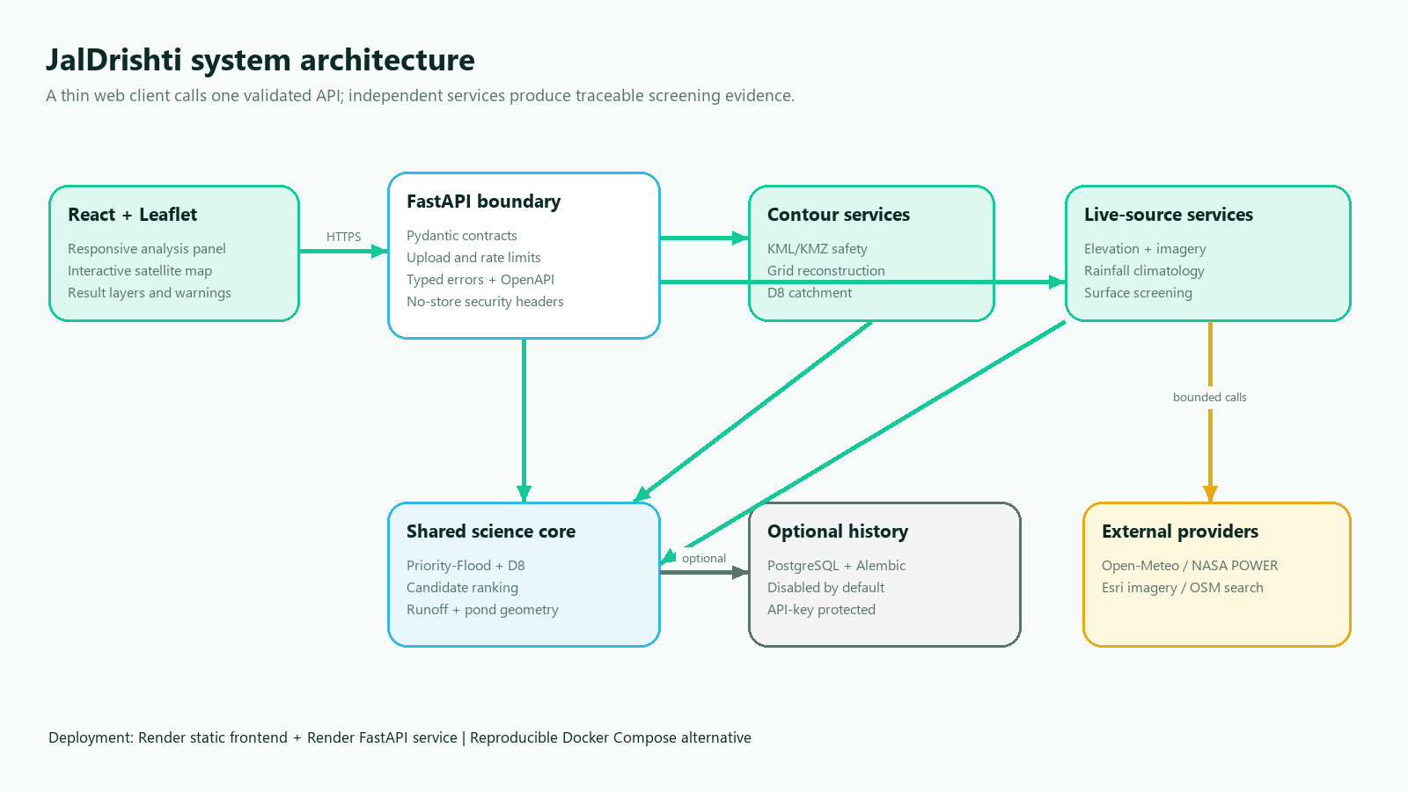
Figure 1. System architecture and service boundaries
The browser client is a Vite/React single-page application using Leaflet for map display. It sends either a multipart contour upload or a location/radius JSON request to a FastAPI backend. Axios cancellation and a monotonically increasing request sequence prevent stale responses from replacing newer analysis.
FastAPI validates all public contracts with Pydantic and delegates geospatial work to independent services. Uploaded contours pass through a safe parser, terrain-grid reconstruction, and the shared hydrology pipeline. Location analysis uses independent elevation, rainfall, imagery, geocoding, terrain, runoff, and pond modules. CPU-heavy OpenCV and terrain work runs outside the asynchronous event loop.
PostgreSQL history is optional and disabled by default because it stores precise locations. When enabled, history requires an API key, bounded queries, Alembic migrations, and non-default credentials.
React / Leaflet
|-- KML/KMZ multipart --> FastAPI --> safe parser --> interpolated DEM
| `--> D8 catchment JSON
`-- location + radius --> FastAPI --> elevation + rainfall + imagery
`--> runoff + pond screen
Optional protected history -------------------------------> PostgreSQL

4. Phase 2 contour-file analysis
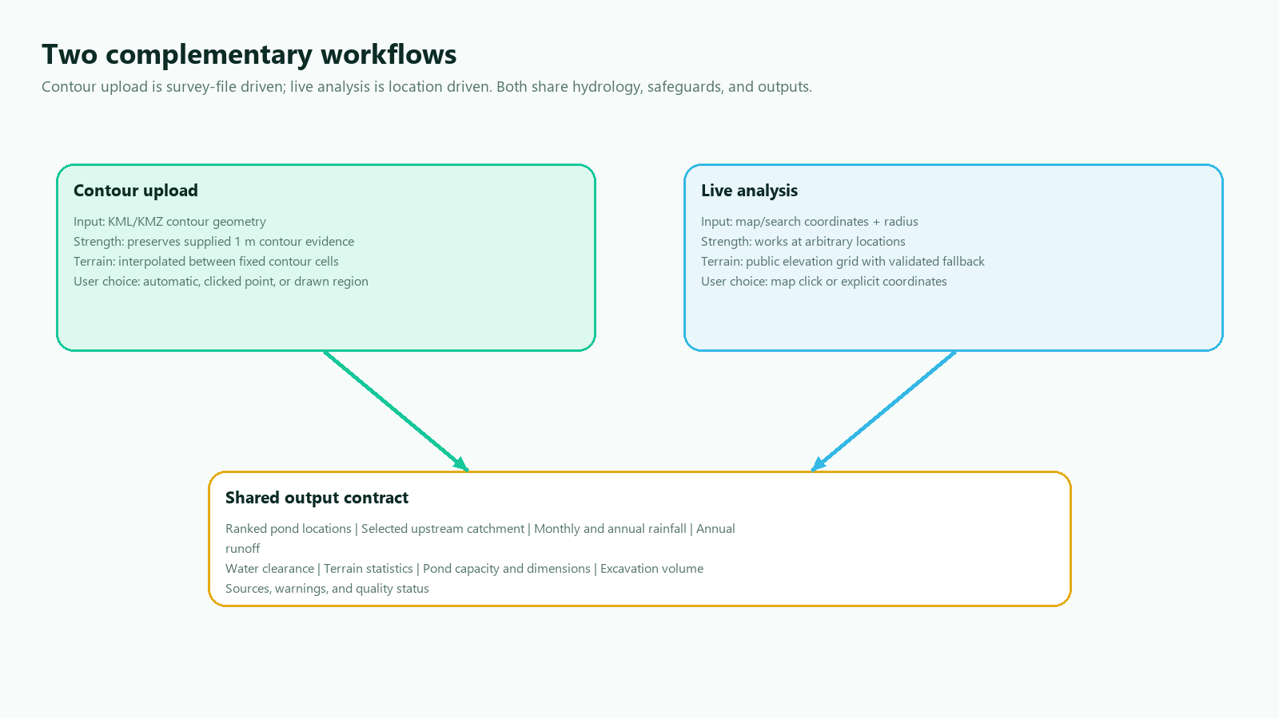
Figure 2. How contour upload and live analysis complement each other

4.1 Input and validation
The canonical route is POST /api/analyze-contour; the multipart field name is contour_file. Hidden compatibility aliases /api/analyzeContour and /api/findCatchment accept the same request. The route reads at most the configured 15 MiB plus one byte, closes the temporary upload, and runs CPU work in a worker thread.
The parser supports plain KML and KMZ. It obtains a line elevation, in order, from a numeric Placemark name, an elevation-like Data or SimpleData field, or a constant altitude coordinate. It accepts namespace variants and MultiGeometry because it traverses Placemark geometry recursively.
Validation rejects malformed XML, DTD/entity declarations, invalid coordinates, encrypted archives, unsafe compression ratios, too many archive entries, large expanded KMZ content, excessive contour/point counts, fewer than three lines or levels, and less than 0.5 m total relief. An uploaded polygon supplies a study boundary; otherwise a buffered convex hull is derived from the input contours.

4.2 Terrain reconstruction
KML stores vector isolines rather than a complete elevation raster. The service projects the study extent to a latitude-corrected metric grid. Grid dimensions are selected from input extent and contour interval, then bounded by configuration. Each contour is rasterized into fixed observed cells. Unknown interior cells are initialized from neighboring observations and solved by iterative harmonic interpolation while observed values remain fixed. The result records observed-cell ratio, iteration count, convergence, cell size, and method.
The study boundary masks both interpolation and later hydrology so cells outside the uploaded domain cannot become part of the catchment. Results are always labelled degraded, even on successful convergence, because an interpolated surface is not equivalent to a surveyed DEM.

4.3 Hydrology and candidate selection
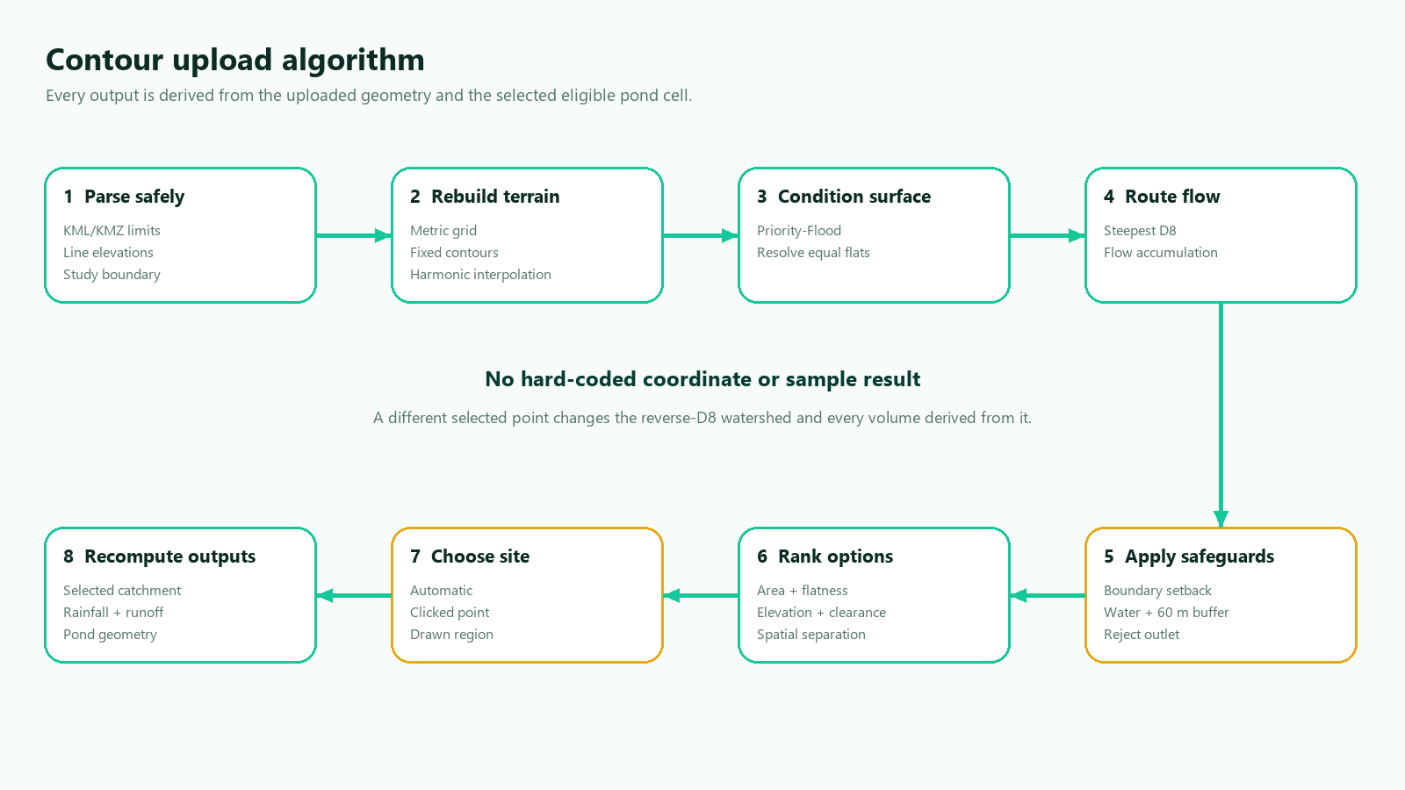
Figure 3. End-to-end contour upload algorithm
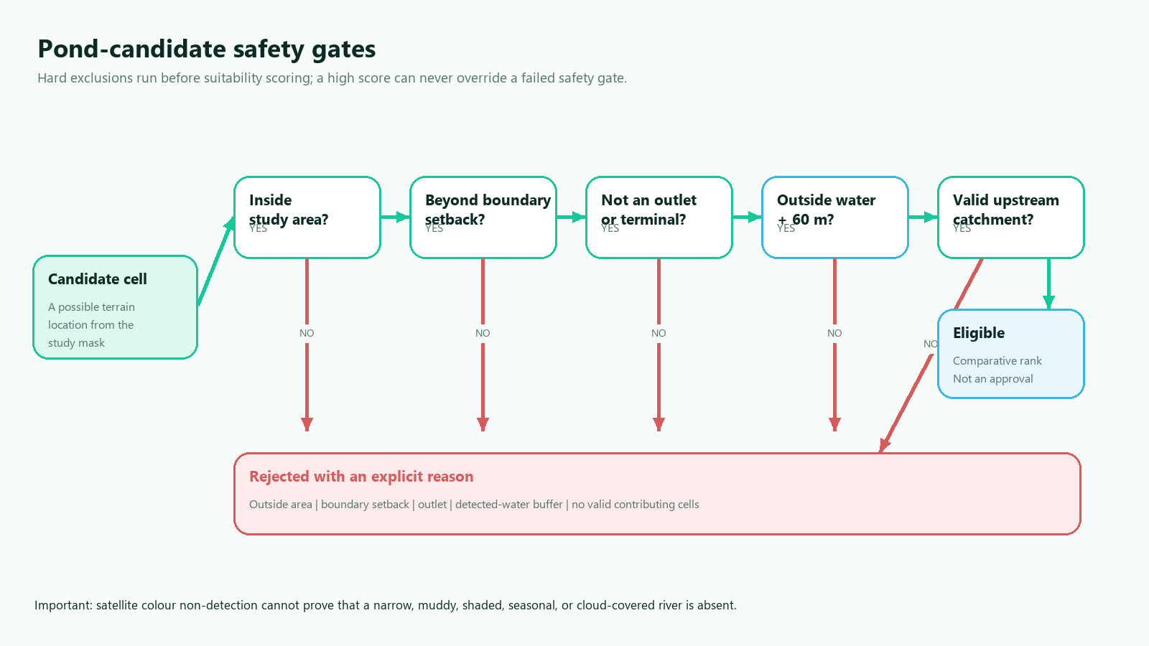
Figure 4. Hard candidate eligibility gates
The shared deterministic pipeline performs:
- finite grid and analysis-mask validation;
- priority-flood depression filling;
- a very small deterministic gradient for equal-elevation flats;
- steepest lower-neighbor D8 flow direction;
- topological upstream flow accumulation;
- local-slope, relative-elevation, analysis-boundary-clearance, and detected- water-clearance calculation;
- hard eligibility filtering that rejects cells outside the study area, inside the configurable boundary or detected-water setbacks, on a terminal outlet, or without a valid upstream land catchment;
- explainable multi-criteria ranking. When water evidence is available, the score uses 52% logarithmic contributing area, 20% local flatness, 10% lower relative elevation, 8% boundary clearance, and 10% water clearance. Without water evidence the normalized weights are 58%, 22%, 11%, and 9%;
- deterministic non-maximum suppression that keeps three alternatives at least 100 m or three grid cells apart;
- selection by the top automatic option, a user point snapped to an eligible grid cell, or the highest-scoring cell inside a user-drawn polygon;
- reverse graph traversal to collect every cell draining to the actually selected candidate, rather than the larger study-area outlet watershed;
- latitude-corrected catchment-area calculation; and
- simplified WGS84 boundary extraction for JSON and Leaflet.
Manual selections pass the same hard safeguards as automatic options. An outside, boundary-setback, outlet, or detected-water point returns a typed 422 error instead of a plausible-looking result. Changing the selected option restarts reverse traversal and therefore recomputes catchment, rainfall-based runoff, capacity, dimensions, and excavation volume for that point.
No sample coordinate, candidate point, catchment boundary, area, or expected elevation is stored in the implementation.

4.4 Provided-map result
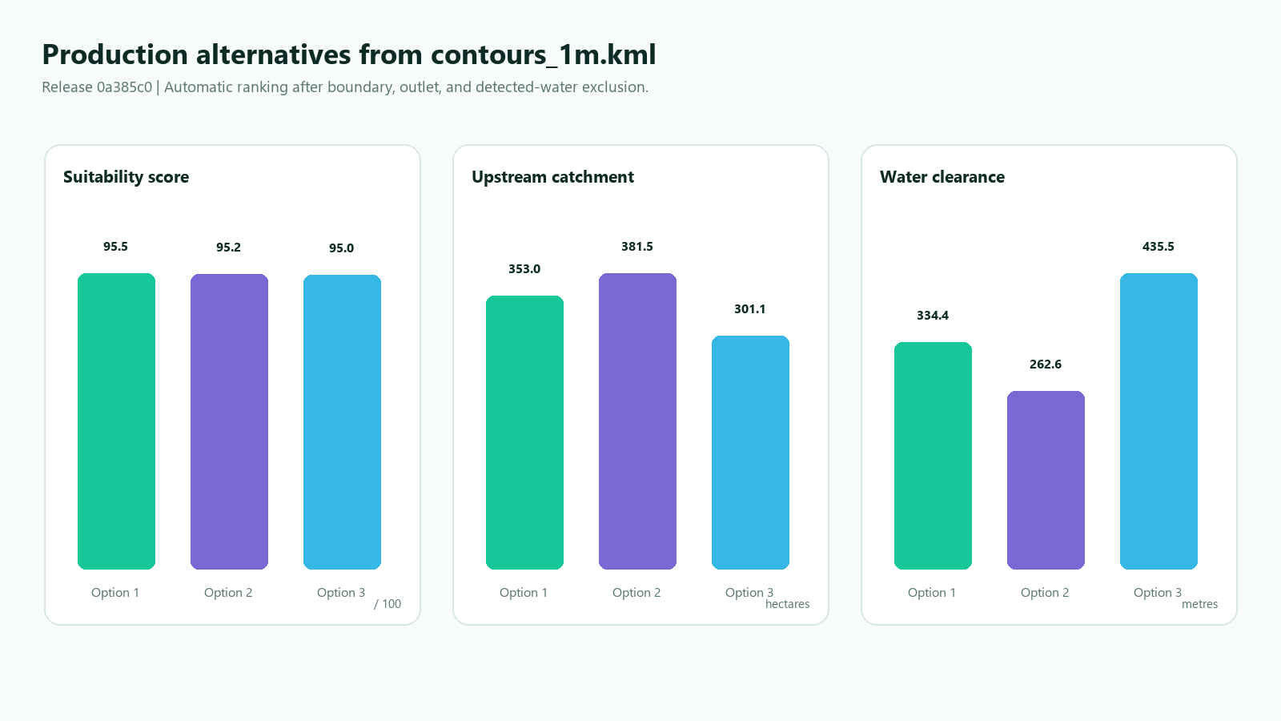
Figure 5. Three ranked options from the supplied KML
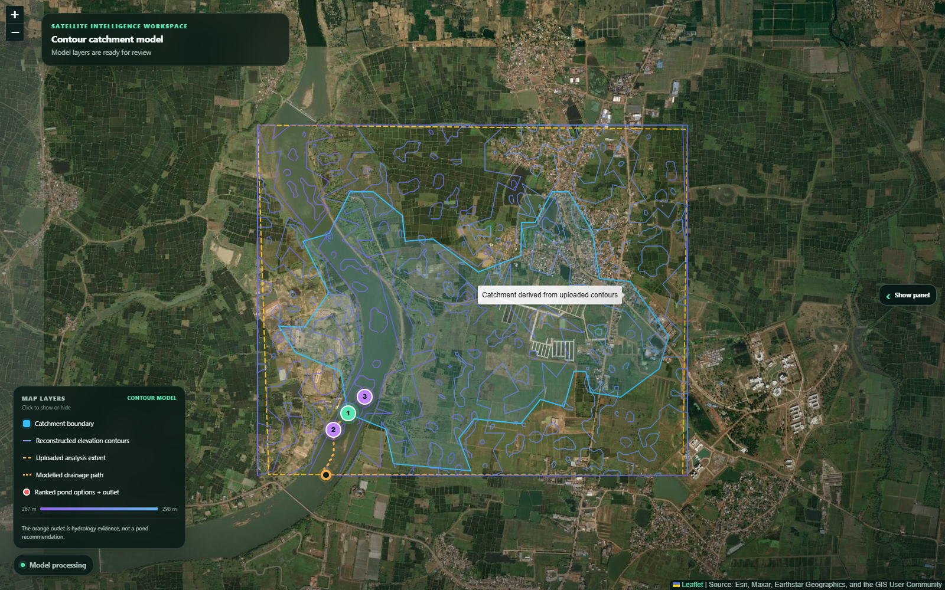
Figure 6. Expanded production map with panel collapsed
The supplied contours_1m.kml was processed through release 0a385c0 of the deployed service on 29 August 2026. The measured automatic output was:
Metric | Result
Contour LineStrings | 1,355
Source vertices | 159,113
Distinct elevation levels | 32
Elevation range | 267.0-298.0 m
Median contour interval | 1.0 m
Analysis grid | 148 x 181
Cell size | 18.0 m
Directly observed analysis cells | 85.206%
Harmonic iterations | 31, converged
Candidate coordinate | 21.244025, 81.288000
Candidate interpolated elevation | 270.0 m
Candidate suitability | 95.54 / 100
Local slope | 2.899%
Boundary / detected-water clearance | 467.99 m / 334.35 m
Modelled catchment | 3,529,523.47 m² / 352.9523 ha
Catchment cells | 10,894
Catchment share of study grid | 41.752%
Historical rainfall | 1,280.13 mm/year, 35 valid years
Screening runoff volume | 1,355,474.66 m³/year at C = 0.30
Preliminary pond capacity | 1,084,379.73 m³
Preliminary excavation volume | 1,224,734.67 m³
Production API time | 12.47 s, HTTP 200

The three returned alternatives were:
Rank | Coordinate | Score | Upstream area | Slope | Water clearance
1 | 21.244025, 81.288000 | 95.54 | 352.9523 ha | 2.899% | 334.35 m
2 | 21.242893, 81.286959 | 95.16 | 381.4633 ha | 2.777% | 262.63 m
3 | 21.245156, 81.289215 | 95.04 | 301.1143 ha | 2.777% | 435.54 m

Selecting option 3 as a point produced the exact 301.1143 ha upstream catchment, 1,156,396.32 m³/year runoff, and 925,117.06 m³ capacity. Restricting the search to a small polygon around option 2 selected that point and produced 381.4633 ha, 1,464,967.75 m³/year runoff, and 1,171,974.20 m³ capacity. This proves that each output is recomputed for the selected point rather than copied from the automatic result. A KMZ created from the same KML produced an identical automatic result. An outside manual point returned HTTP 422 with invalid_contour_selection.
Production satellite screening detected 0.33% water-like pixels and applied the 60 m hard exclusion before ranking. A separate deterministic synthetic-river test placed the water mask over the otherwise best KML candidate and verified that the point was rejected as inside the exclusion buffer.
These figures demonstrate the working algorithm on the provided map; they are not a field-verified pond recommendation.

5. Location-based elevation and hydrology
The location workflow requests WGS84 elevation points through Open-Meteo. The documented source is Copernicus DEM 2021 GLO-90. Grid density is radius-aware and targets approximately 90 m cells, subject to configured limits. The public API path is capped at 23 x 23 locations to remain below its public request allowance; the response is marked degraded when this cap is coarser than the target.
If the point API fails or returns insufficient coverage, the backend uses a bounded Terrain Tiles fallback rather than fabricating elevations. The fallback downloads only the required HTTPS Terrarium PNG tiles and validates tile count, response size, media type, dimensions, channels, decoded elevation range, and coverage. Terrarium values are decoded as (red x 256 + green + blue / 256) - 32768. The result identifies the AWS Open Data/Tilezen source, reports its own resolution, and is always marked degraded.
Every batch is checked for matching length, numeric range, finite coverage, and final shape. The system does not fill a failed batch with synthetic terrain. A small percentage of isolated missing cells can be locally interpolated, while larger missing regions make elevation unavailable.
Priority-flood, D8, accumulation, catchment traversal, area calculation, and boundary extraction match the contour workflow. A radius is the half-width of the square grid, not proof that the full upstream catchment lies inside it. Roads, culverts, irrigation channels, breached embankments, structures, and DEM vertical error can materially change real drainage.

6. Rainfall analysis
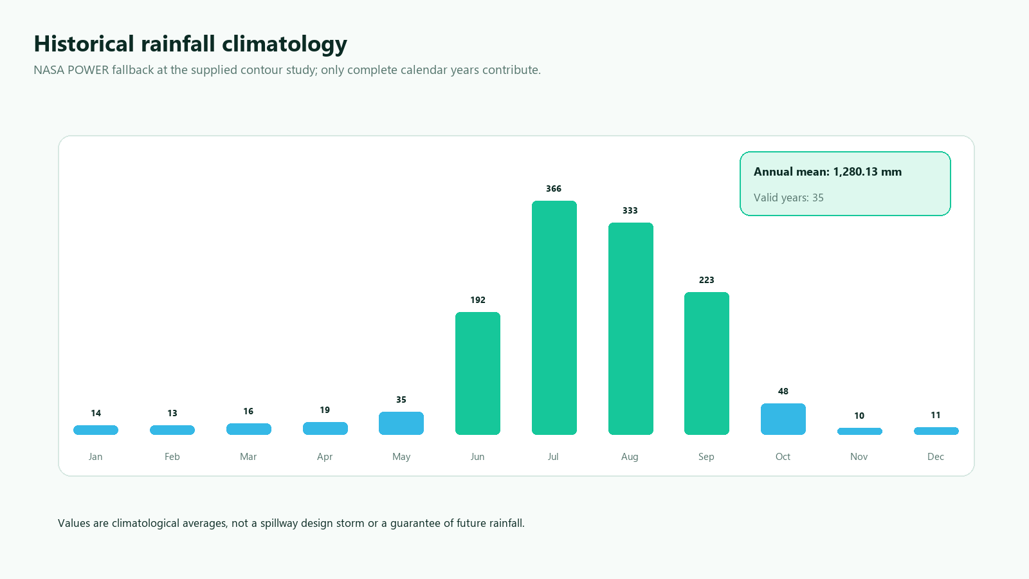
Figure 7. Historical monthly rainfall at the contour study
The default period is 1991-2025 and the primary model is ERA5-Land through Open-Meteo. When that service is rate-limited or returns insufficient complete years, the backend requests PRECTOTCORR from NASA POWER. The fallback is identified as MERRA-2 corrected precipitation and marked degraded because its 0.5 by 0.625 degree grid is not a village rain gauge.
For both sources, daily non-negative precipitation is grouped by calendar year. Only years containing every expected date are used, so gaps cannot reduce a total as if they were zero rainfall. Response size, sentinel values, date/value alignment, numerical range, complete-year count, and coverage are validated. Monthly means state their contributing complete-year count.
Mean annual rainfall supports screening water yield. It is not a design storm and cannot size a spillway or establish flood safety.

7. Satellite surface screening and land limits
The imagery service downloads all tiles needed for the selected extent and rejects missing, malformed, blank, low-contrast, or inconsistent images. Zoom is radius-aware to bound network work and memory. Provider name, retrieval time, approximate resolution, source status, and terms link are returned.
OpenCV screens broad HSV/RGB classes for vegetation, water-like pixels, brown or sandy surface, and low-saturation surface. Morphological cleanup removes small noise. The largest qualifying region becomes a bare-surface candidate, and candidate placement is restricted to its intersection with the modelled catchment. Water is treated differently from an ordinary score: detected water and a configurable 60 m metric buffer are removed from the candidate mask before ranking in both workflows. Candidate cards report their measured clearance from detected water.
Satellite color cannot prove government ownership, legal availability, soil, rock, crops, seasonal water, utilities, protected status, or excavation suitability. It can also miss a narrow, muddy, shaded, seasonal, cloud-covered, or recently shifted river. Therefore the UI and API never describe this polygon as verified government land and never treat water non-detection as proof that a river is absent. Cadastral, hydrography, field, and engineering verification are mandatory.

8. Runoff and pond geometry
Annual screening water yield is:
V = C x A x P
where V is cubic metres per year, C is a documented runoff coefficient, A is modelled catchment area in square metres, and P is mean annual rainfall in metres. The system does not infer C from image color. If the coefficient or its basis is absent, runoff and pond geometry are unavailable rather than guessed.
The hosted course demo labels C = 0.30 as a demonstration scenario so the complete calculation path can be shown. It is not a site-approved coefficient and must be replaced for real work. Peak flow is separate and remains absent until an approved design rainfall intensity is configured:
Q = C x i x A / 3.6
for area in square kilometres and intensity in millimetres per hour.
Pond capacity uses rectangular-frustum geometry with configurable length/width ratio, side slope, water depth, freeboard, and capture efficiency. Capacity is measured to water level; excavation volume and crest dimensions include freeboard. The footprint is constrained by candidate area and no geometry is returned if even the minimum cross-section cannot fit.
The module does not design an inlet, outlet, spillway, bund, liner, sediment forebay, ramp, fencing, slope stabilization, or construction sequence.

9. Frontend and visualization
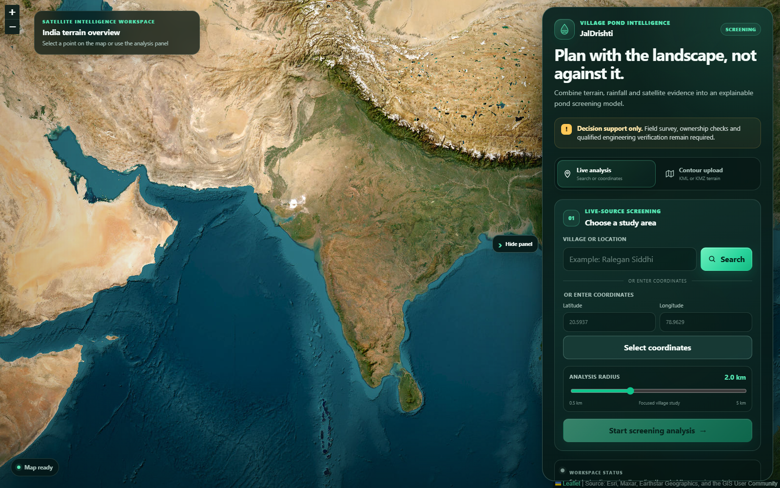
Figure 8. Production home and live-analysis interface
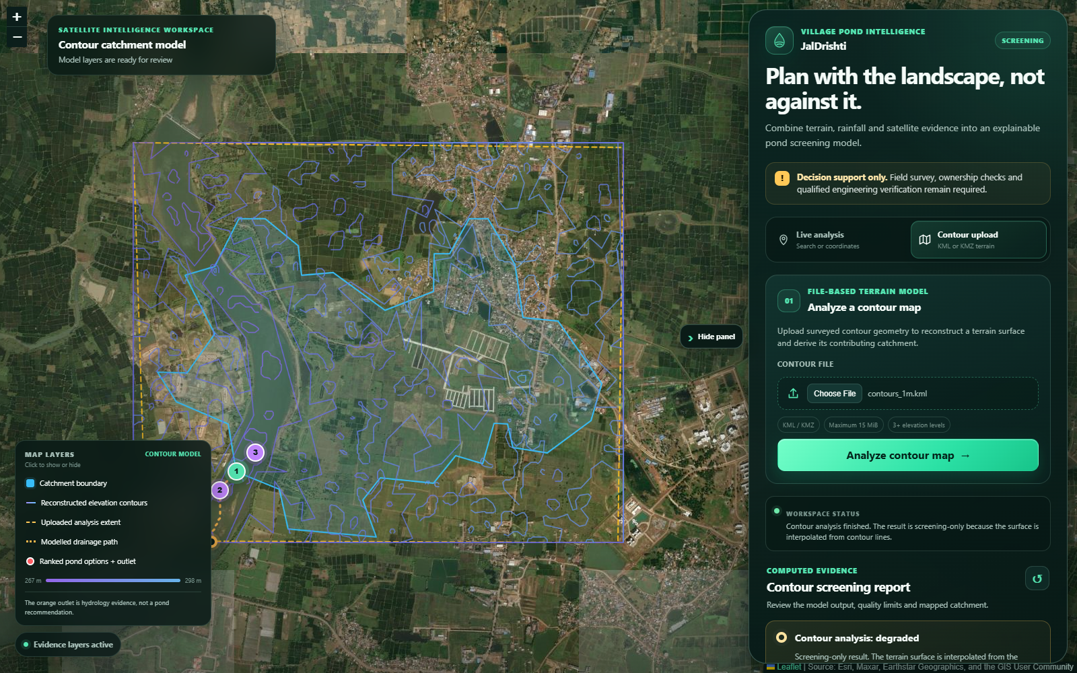
Figure 9. Production contour result workspace
The responsive sidebar contains a Phase 2 file uploader plus place search, coordinate entry, radius selection, request start/cancel controls, and reset. For an uploaded contour map, the user can keep automatic ranking, click one eligible map point, or draw a polygon that restricts the search. Ranked option cards can also recompute the result with one action. The entire results panel is collapsible so it does not hide the map.
The map displays satellite imagery and individually toggleable evidence layers. Contour-upload results show reconstructed contour lines, uploaded analysis extent, computed catchment, modelled drainage path, the separate hydrology outlet, and numbered pond alternatives. The legend explicitly explains that the orange outlet is evidence, not a pond recommendation. Location results show the catchment, DEM contours, surface candidate, selected centre, and pond options.
Results include source panels, quality chips, warnings, terrain/hydrology statistics, monthly rainfall chart, land-screening ratios, runoff assumptions, and pond dimensions. Form labels, keyboard focus, high contrast, live regions, text alternatives, reduced-motion support, and responsive breakpoints improve accessibility.

10. API, errors, and security
FastAPI provides Swagger at /docs, ReDoc at /redoc, and OpenAPI JSON at /openapi.json when enabled. Pydantic rejects unknown fields, non-finite values, unsupported coordinates, invalid radius, and malformed response data. Error payloads use stable codes and safe messages.
Per-scope rate limits protect analysis, contour upload, search, and history. Logs contain a sanitized request ID, method, path, status, and duration, but not exact submitted coordinates or secrets. API responses use no-store and add anti-sniffing, frame, referrer, and permissions headers. CORS and trusted hosts are explicit in deployment. The 15 MiB upload limit is enforced before parsing and at the Nginx boundary.
Secrets remain outside version control. Production configuration rejects wildcard origins/hosts, placeholder geocoding contacts, insecure provider URLs, weak history configuration, unbased runoff values, and unconfirmed provider authorization.

11. Reliability and operations
External requests share a bounded HTTP connection pool and use timeouts, retries with capped backoff, bounded TTL caching, and source-specific validation. Liveness and readiness are separate. A database outage affects readiness only when history is enabled, and persistence failure does not erase an otherwise valid analysis response.
The backend and Nginx containers run as non-root users with health checks and restart policies. Docker Compose keeps the API and PostgreSQL off public host ports and exposes the frontend proxy on 8080. The Render Blueprint provides a free FastAPI service plus a static CDN frontend with cache and security headers.

12. Verification evidence
The final local quality matrix includes:
Gate | Result
Backend Pytest suite | 68 passed
Backend statement coverage | 88.79%, above 70% CI threshold
Python Ruff lint | Passed
Python dependency consistency | pip check passed
Python vulnerability audit | 0 known vulnerabilities
Frontend Vitest suite | 11 passed
Frontend Oxlint | Passed with 0 warnings
Vite production build | Passed
npm high-severity audit | 0 vulnerabilities
Provided KML direct analysis | Passed; automatic, point, region, and synthetic-water cases
Hosted KML automatic upload | HTTP 200 in 12.47 s with complete typed response
Hosted manual point selection | HTTP 200; catchment recomputed to 301.1143 ha
Hosted region selection | HTTP 200; option 2 selected, 381.4633 ha
Hosted KMZ upload | HTTP 200; result matched the source KML
Hosted invalid point | HTTP 422, typed invalid_contour_selection
OpenAPI schema route | Passed
Docker backend build | Included in local/CI verification
Docker frontend build | Included in local/CI verification
Alembic PostgreSQL migration | Included in GitHub Actions
Hosted frontend and security headers | HTTP 200; frame, MIME and referrer headers passed
Hosted API readiness and OpenAPI | Verified through the deployed service
Hosted 2 km location analysis | 35 rainfall years; 152.07 ha selected catchment; three pond options

Backend tests cover contour/KMZ safety, parsing variants, KML route behavior, input limits, D8 flow, accumulation, selected-point catchment traversal, priority-flood, boundary/water masking, option separation, manual point and region validation, runoff equations, frustum sizing, imagery validation, rainfall gaps, upstream failures, response quality, security defaults, rate limiting, health, and privacy defaults. Frontend tests cover explicit search, search validation, rainfall rendering, select-then-confirm analysis, KML upload, ranked options, complete output rendering, and contour-selection interactions.

13. Deployment and submission
The repository contains render.yaml for repeatable deployment in the Singapore region. Release 0a385c0 was deployed and verified on 29 August 2026:
- Frontend: Open link
- API: Open link
- API documentation: Open link
Free Render web services can sleep after inactivity, so the first API request may require a cold-start wait. The final hosted KML verification processed all 1,355 contours and 159,113 source vertices in 12.47 seconds, returned three ranked and water-screened alternatives, and completed the rainfall, runoff, and pond-geometry branches. Point and region re-selection, KMZ upload, and negative selection rejection were then exercised against the same deployed release.
The final hosted location test also exercised the complete fallback rainfall and pond paths: 35 complete rainfall years, 1,324.2 mm mean annual rainfall, a 152.07 ha catchment upstream of the selected pond option, 604,080 m³ screening runoff, 483,264 m³ capacity, and three spatially separated alternatives. Its degraded quality status and field-verification warnings are intentional and visible to the user. Docker deployment and post-deploy checks are documented separately in docs/DEPLOYMENT.md.

14. Limitations and required field work
Before any excavation decision, obtain:
- cadastral ownership, easements, consent, and legal land availability;
- total-station, RTK/GNSS, or equivalent terrain and outlet survey;
- soil, infiltration, erodibility, lining, slope stability and geotechnical data;
- groundwater level, recharge objective and downstream-impact assessment;
- approved runoff coefficient and intensity-duration-frequency design rainfall;
- sediment, evaporation, seepage, routing and environmental-release allowances;
- utilities, buildings, roads, crops, ecology, protected areas and water quality;
- detailed civil/geotechnical design, drawings, bill of quantities and approvals.
These limits are part of the result contract and user interface rather than being hidden only in this report.

15. AI-tool usage and academic integrity
OpenAI Codex was used as an AI-assisted development tool for requirement review, code review, debugging, refactoring suggestions, automated test development, security checks, and documentation formatting. Generated suggestions were not accepted as unverified output: project files were inspected, algorithms were checked against the assignment, tests and audits were executed, failures were corrected, and the supplied KML was processed end to end. The student remains responsible for understanding and explaining every submitted component, including KML parsing, interpolation, D8 hydrology, runoff equations, pond geometry, API contracts, deployment, and limitations.

16. Conclusion
The completed project satisfies the assignment's software deliverables with a generalized Phase 2 KML/KMZ catchment API, automatic and user-guided pond-site selection, upstream catchment recomputation, detected-river exclusion, historical rainfall, runoff and preliminary pond geometry, an integrated accessible frontend, deployment infrastructure, and a repeatable test matrix. The main design achievement is not only producing a result, but offering traceable alternatives while distinguishing computed screening evidence from facts that require cadastral, survey, environmental, and engineering authority.

References
- Open-Meteo Elevation API: Open link
- Open-Meteo Historical Weather API: Open link
- Nominatim Usage Policy: Open link
- FastAPI documentation: Open link
- Leaflet documentation: Open link
- OpenCV documentation: Open link
- Render Blueprint specification: Open link
- AWS Open Data Terrain Tiles: Open link
- Tilezen Terrarium format: Open link
- NASA POWER Daily API: Open link
- Barnes et al., Priority-Flood depression filling: Open link
- O'Callaghan and Mark, D8 drainage networks: Open link
- OGC KML 2.3 standard: Open link
- USDA NRCS runoff-volume guidance: Open link

Appendix A. Algorithms explained from first principles

A.1 What a contour line means
A contour line connects locations having the same elevation. Lines close together usually mean a steeper surface; lines farther apart usually mean a gentler surface. A KML contour map is still only a set of lines. Water-flow algorithms need an elevation value for every grid cell, so the system first reconstructs the unknown cells between lines.
KML VERSUS KMZ
KML is readable XML containing placemarks and coordinates. KMZ is a ZIP archive whose main content is KML, commonly named doc.kml. Compressing KML to KMZ changes storage and transfer size; it does not improve terrain accuracy. The deployed API accepts and validates both formats.

A.2 Harmonic interpolation
The rasterized contour cells are fixed observations. Every unknown interior cell is initialized from nearby observations and repeatedly replaced by the mean of valid neighboring cells. The fixed cells never move. Repetition creates a smooth surface that exactly preserves the rasterized contours. The process stops when the maximum update is below tolerance or the iteration limit is reached.
- Why use it: deterministic, bounded, easy to audit, and appropriate for smoothly varying terrain between dense contours.
- What it cannot know: breaks of slope, channels, embankments, and survey errors not represented by the contour geometry.

A.3 Priority-Flood depression conditioning
Digital surfaces often contain one-cell pits caused by sampling or interpolation. A naive D8 router would trap water in those cells. Priority-Flood begins at the analysis boundary and visits cells from low to high elevation using a priority queue. If an unvisited neighbor is lower than the current spill elevation, it is raised only enough to drain. The output is a connected drainage surface, while the report records how much of the grid changed so large corrections remain visible.

A.4 D8 flow direction, accumulation, and reverse catchment
D8 means each cell may drain to one of its eight neighbors. The implementation chooses the lower neighbor with the greatest elevation drop divided by travel distance. Cardinal neighbors are one cell away and diagonal neighbors are √2 cells away. A tiny deterministic gradient resolves perfectly equal flats without random results.
- Flow direction creates a directed graph: each cell has at most one downstream neighbor.
- Topological accumulation starts every valid cell with one contributing cell and passes that total downstream.
- After a pond point is selected, reverse traversal follows upstream links and collects only cells that drain to that point.
- Cell area is corrected for latitude and multiplied by collected-cell count to obtain square metres and hectares.
THE CRITICAL CORRECTION
The reported catchment is delineated upstream of the selected pond option, not at the map-edge hydrology outlet. Selecting a different option changes the catchment and therefore changes runoff and pond geometry.

A.5 Multi-criteria pond ranking
No single terrain variable is sufficient. A large catchment may be on a steep or unsafe cell; a flat cell may collect almost no water. Therefore the system first applies hard exclusions and then combines normalized evidence. Logarithmic catchment area is used because raw accumulation can span orders of magnitude and would otherwise dominate every other factor.
Criterion | With water evidence | Without water evidence | Reason
Log upstream area | 52% | 58% | Favors useful contributing area without letting very large basins overwhelm the score
Local flatness | 20% | 22% | Favors gentler local terrain for preliminary siting
Lower relative elevation | 10% | 11% | Prefers natural receiving locations within the study area
Boundary clearance | 8% | 9% | Reduces truncated or edge-dominated selections
Detected-water clearance | 10% | Not available | Rewards separation after the hard 60 m exclusion

After sorting by score, non-maximum suppression keeps alternatives at least 100 m or three cells apart. This prevents three nearly identical markers from being presented as meaningful choices.

Appendix B. River and water edge cases
A pond should not be recommended directly in a river channel. The implementation therefore aligns the satellite water mask to the terrain grid, expands it by a metric buffer, and removes those cells before ranking. Manual point and region modes use the same eligibility mask; they cannot bypass the rule.
Edge case | Implemented response | Remaining real-world check
Wide visible river | Water pixels and 60 m surroundings are excluded | Confirm bankfull width, floodplain, and statutory setback
Narrow or shaded stream | Warning states that non-detection is not absence | Field walk, hydrography data, and local drainage knowledge
Muddy or seasonal channel | May be missed by RGB/HSV colour classification | Multi-season imagery and monsoon evidence
Canal, culvert, road drain | May alter real flow but not appear in the contour DEM | Survey crossings and drainage structures
Point placed on detected water | HTTP 422 invalid_contour_selection | Do not override without qualified investigation
Region contains water and land | Only eligible land cells inside the polygon are ranked | Verify the selected parcel and access

WHY THE RESULT IS STILL DEGRADED
A conservative colour mask reduces obvious false positives but cannot establish a legal river boundary or construction clearance. The degraded status is an honest quality label, not a software failure.

Appendix C. Complete output dictionary
Field | Contents | Meaning
analysis_status | reliable / degraded / incomplete | Overall evidence status; contour interpolation remains degraded by design
contour_summary | counts, range, interval | What the KML/KMZ contained and whether it had sufficient terrain evidence
grid | rows, columns, cell size, convergence | Quality and resolution of the reconstructed surface
pond_location | coordinate, elevation, slope, score | The selected eligible grid cell and how it was chosen
candidate_options | ranked array | Spatially separated alternatives with upstream area and water clearance
selection | automatic / point / region | User request, snapped distance, and optional region vertices
outlet_location | coordinate | Hydrology evidence at the map edge; explicitly not a pond recommendation
catchment | boundary, m², ha, cells | Every selected grid cell that drains to the pond point
rainfall_data | annual mean + 12 months | Complete-year climatology and valid-year counts
runoff_stats | C, A, P, annual volume | Screening water yield V = C × A × P
pond | depth, dimensions, capacity | Preliminary water and excavation geometry, including freeboard
water_screening | ratio, buffer, method | How detected water affected eligibility
contours / drainage_path | map arrays | Evidence layers displayed by Leaflet
quality.sources | provenance records | Provider, retrieval date, resolution, model, coverage, license link
quality.warnings | plain-language array | Known omissions and required verification

C.1 Exact automatic production output
Output | Production value
Selected point | 21.244025, 81.288000
Suitability | 95.54 / 100
Selected catchment | 352.9523 ha
Historical rainfall | 1280.13 mm/year; 35 years
Annual runoff | 1,355,474.66 m³/year
Pond capacity | 1,084,379.73 m³
Excavation volume | 1,224,734.67 m³
Water screening | 0.33% detected; 60 m buffer

Appendix D. API examples and error behavior

D.1 Automatic contour analysis
curl.exe -X POST ^
-F "contour_file=@C:\path\contours_1m.kml" ^
-F "selection_mode=automatic" ^
https://sneha-village-pond-api-2026.onrender.com/api/analyze-contour

D.2 Manual point
curl.exe -X POST ^
-F "contour_file=@C:\path\contours_1m.kml" ^
-F "selection_mode=point" ^
-F "selected_lat=21.245156" ^
-F "selected_lng=81.289215" ^
https://sneha-village-pond-api-2026.onrender.com/api/analyze-contour

D.3 Region-constrained search
selected_region=[
{"lat":21.2424,"lng":81.2864},
{"lat":21.2434,"lng":81.2864},
{"lat":21.2434,"lng":81.2875},
{"lat":21.2424,"lng":81.2875}
]

HTTP | Stable code | Meaning
200 | success | Typed screening response returned
413 | contour_file_too_large | Compressed upload exceeds configured maximum
422 | invalid_contour_file | Unsafe, malformed, or insufficient contour content
422 | invalid_contour_selection | Point/region is malformed or fails an eligibility gate
429 | rate_limit_exceeded | Client request budget exhausted
500 | contour_analysis_failed | Unexpected server-side processing error with a safe message

Appendix E. Manual test script

Application shell
- □ Open the production URL and confirm satellite imagery, live/contour tabs, decision-support warning, keyboard focus, and the Hide panel control.
- □ Collapse and reopen the panel; verify that the map expands and all layers remain aligned.
- □ Resize to a narrow window; verify that controls remain readable and no content becomes unreachable.

Automatic KML
- □ Upload contours_1m.kml and confirm the filename, progress message, and successful contour screening report.
- □ Confirm all 1,355 contours are represented, the uploaded extent is visible, and the legend distinguishes catchment, contours, drainage path, outlet, and options.
- □ Confirm three option cards, 352.9523 ha selected catchment, 1,280.13 mm rainfall, 1,355,474.66 m³ runoff, and 1,084,379.73 m³ capacity.

Alternative point
- □ Choose option 3 and recompute.
- □ Confirm the selected marker changes and catchment becomes 301.1143 ha.
- □ Confirm runoff becomes 1,156,396.32 m³ and capacity becomes 925,117.06 m³.

Region selection
- □ Activate Draw region and create a polygon around option 2.
- □ Confirm the chosen point is inside the polygon and the catchment becomes 381.4633 ha.
- □ Confirm clearing the selection returns the workflow to automatic mode.

Negative and safety
- □ Attempt a point outside the uploaded extent; verify a clear rejection rather than a result.
- □ Attempt a point inside a detected-water buffer in a controlled test; verify invalid_contour_selection.
- □ Read the warning that satellite non-detection does not prove a river is absent.

KMZ and live analysis
- □ Upload the KMZ equivalent and confirm the same automatic output.
- □ Run live analysis at 21.24, 81.29 with a 2 km radius.
- □ Confirm three live options, 35 rainfall years, annual runoff, pond geometry, sources, and degraded-quality explanations.

Appendix F. Viva preparation
Question | Short answer
Why is contour output degraded? | Because the raster is interpolated between vector isolines and is not equivalent to a surveyed DEM.
Why Priority-Flood? | It removes artificial sinks in a deterministic, efficient way so the D8 network can drain.
What is D8? | A single-flow-direction model where each cell drains to its steepest lower neighbor among eight choices.
What was the major catchment fix? | Reverse traversal now starts at the selected pond cell, not the map-edge outlet.
Why offer three options? | A comparative model should expose spatial alternatives; one maximum is not an engineering approval.
Can a user force any point? | No. Clicked points are snapped and still must pass boundary, outlet, water, and catchment gates.
How are rivers handled? | Detected water plus 60 m is excluded, but field/hydrography verification remains mandatory because RGB can miss channels.
How is annual runoff calculated? | V = C × A × P, with P converted from millimetres to metres.
Is rainfall a design storm? | No. It is a multi-year climatological mean; peak-flow and spillway design need approved intensity-duration-frequency data.
What does pond capacity mean? | Preliminary storage to water level from rectangular-frustum geometry, constrained by available area.
Why not claim government land? | Satellite colour cannot prove ownership, tenure, consent, or legal availability.
How was the result verified? | 68 backend tests, 11 frontend tests, lint/build gates, exact KML/KMZ production uploads, and manual selection checks.

Appendix G. Glossary
Term | Plain-language meaning
Catchment / watershed | Land area whose modelled drainage reaches the selected point
Contour | Line connecting places with equal elevation
DEM | Digital elevation model: a grid of ground elevations
D8 | Eight-neighbor single-flow-direction routing method
Flow accumulation | Count or area of upstream cells contributing through a cell
Freeboard | Vertical margin between design water level and crest
Harmonic interpolation | Smoothly estimates unknown grid cells while preserving fixed observations
Hydrology outlet | Terminal drainage cell at the analysis boundary; not automatically a pond site
KML | XML geospatial format standardized by OGC
KMZ | Compressed ZIP package containing KML
Priority-Flood | Priority-queue algorithm for conditioning depressions in a DEM
Runoff coefficient C | Fraction of rainfall volume assumed to become direct runoff
Screening | Preliminary comparative decision support, not an approved final design
Suitability score | Normalized comparative score after all hard eligibility checks

Appendix H. Submission links and final checklist
LIVE FRONTEND
Open link

GITHUB REPOSITORY
Open link

INTERACTIVE API DOCUMENTATION
Open link

- □ Source code is committed and pushed.
- □ Both Render services report the verified release deployed successfully.
- □ The production frontend opens and both workflows return complete results.
- □ The provided KML and its KMZ equivalent return HTTP 200.
- □ Automatic, point, region, and invalid-selection behavior was checked.
- □ The editable documentation and final PDF were rendered and visually inspected.
- □ The student has reviewed the limitations and can explain the algorithms in the viva.

