Currency Conversion – Use case

Team 18

Week 2:

-> Successfully implemented ToR routing.

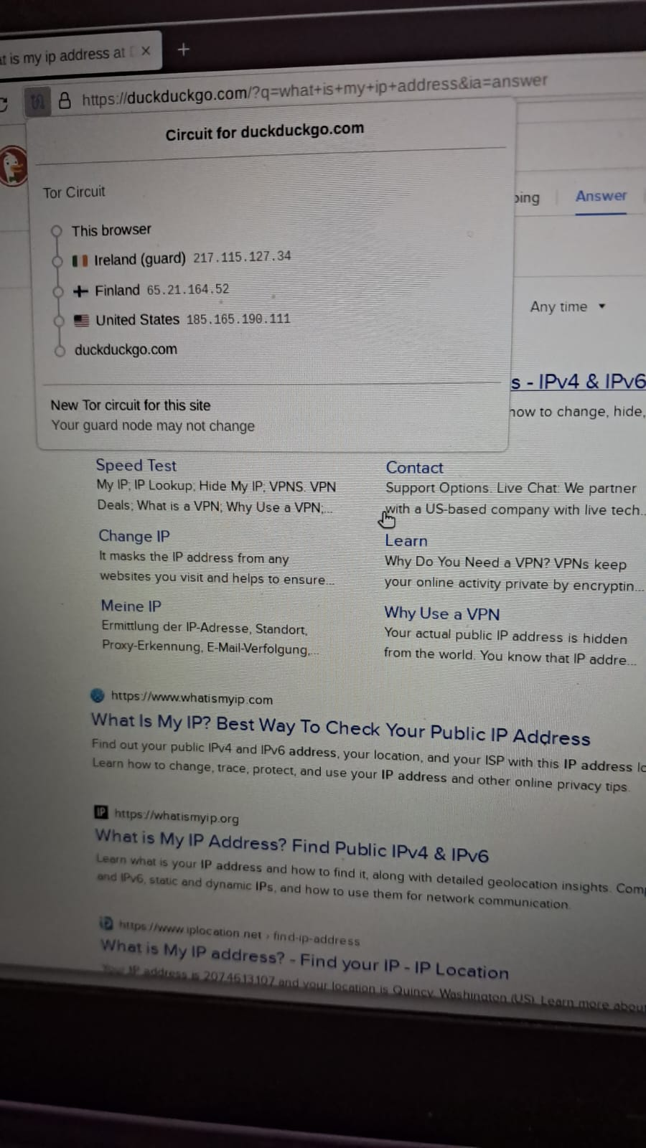

-> Trial on various scrapping browsers including selenium , beautiful soup.

-> Testing various rag model version to prepare our airport duty taxation with different vector databases.

-> Trial on image search.

Team member:

-> Harshini

-> Sanjay Palanisami

-> Sanjay S

-> Sree Snehan (L)