Currency Conversion – Use case

Team 18

Week 3:

-> Successfully implemented local rag model which can retrieve files form chroma DB which is used to stream through all countries duty/custom tax policies.yet to use a local embedding model tho :(

-> Successfully implemented proper parsing and scraping with selenium.

-> Trying on proxy servers and techqniques to accept cookies , retrieve java script content similar to how a human would perform with open source - recently being developed application = firecrawl.

[FireCrawl – github](https://github.com/mendableai/firecrawl/blob/main/CONTRIBUTING.md)

-> Implementation of image based search database to simulate working of a google lens is done.This is part of our application which can search for products based on image

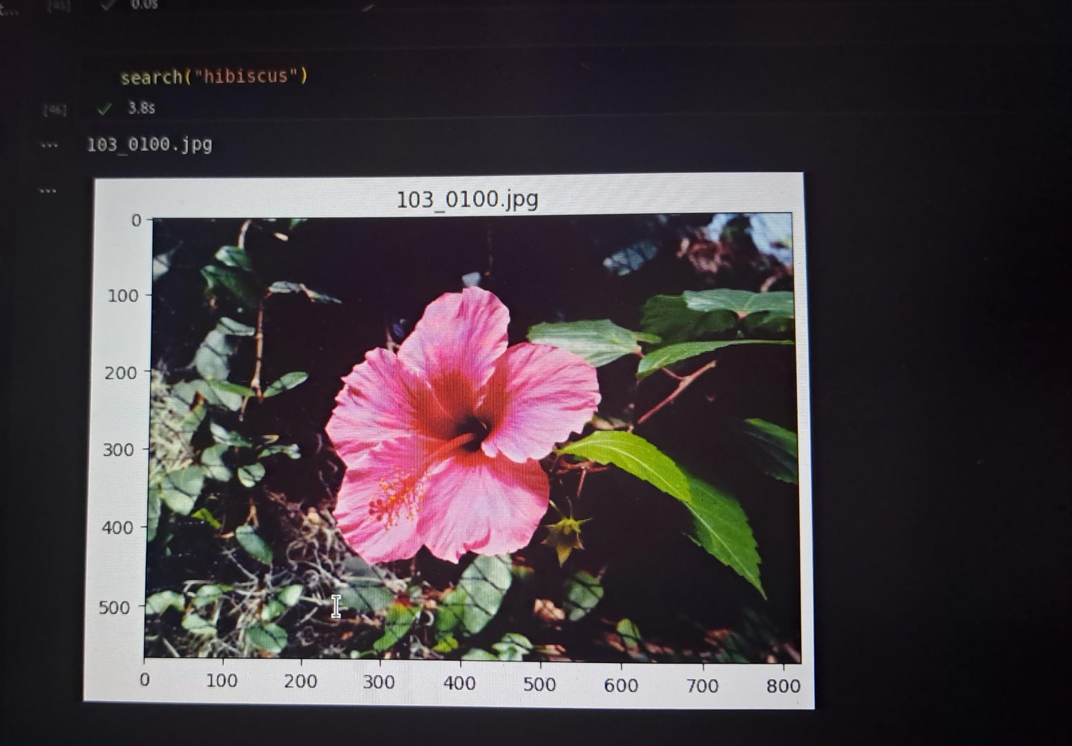

Team member:

-> Harshini

-> Sanjay Palanisami

-> Sanjay S

-> Sree Snehan (L)