Currency Conversion – Use case

Team 18

Week 4:

-> Implementation of local llm/rag model completed.

-> To navigate through retail 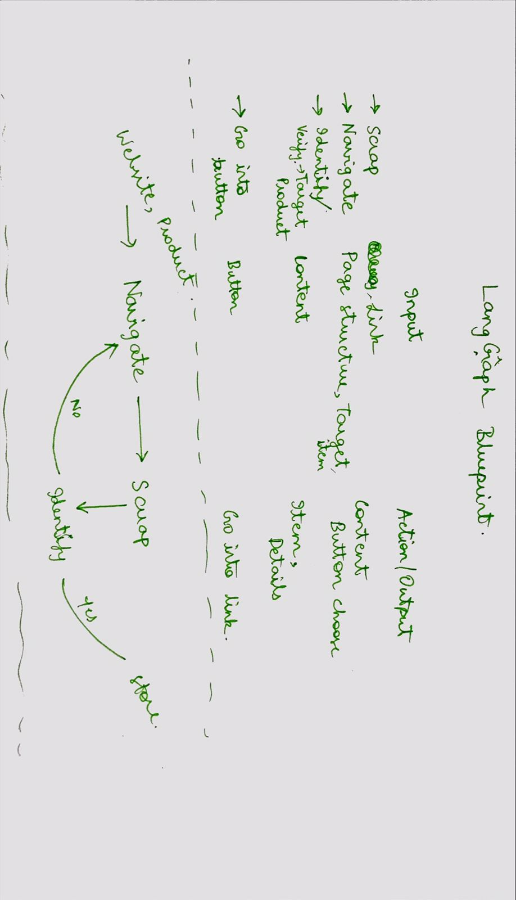websites at a faster rate and more efficient than manually scrapping retail store websites , we have 40% implemented a LangGraph based agent to control the scrapping to specific pages rather than brute force scrapping.This also reduces computation costs by a lot.

-> i.e The agent controls the scrapping of the website and sub webpages of the website by dynamically navigating the website under supervision of the SLM.The agent choose which part of website the product might be located and scraps towards that link.

-> This loop of agent can be implemented using phi3 or tinyllama , implementation with bert is feasible with proper finetuning. The dataset for fintuning is planned to be prepared by this week.

-> We are expected to finish the fully working agent based scrapping mechanism demo with 1B+ model by this week. Next week plans are to finetune smaller bert models to accurately perform this functionality at the same level as the 1B+ model since 1B+ model is a bit overkill for this purpose.

-> Experimentation of preoduct/detail extraction from the specific web-pages and their content are being held , to determine the appropriate one.

Team member:

-> Harshini

-> Sanjay Palanisami

-> Sanjay S

-> Sree Snehan (L)