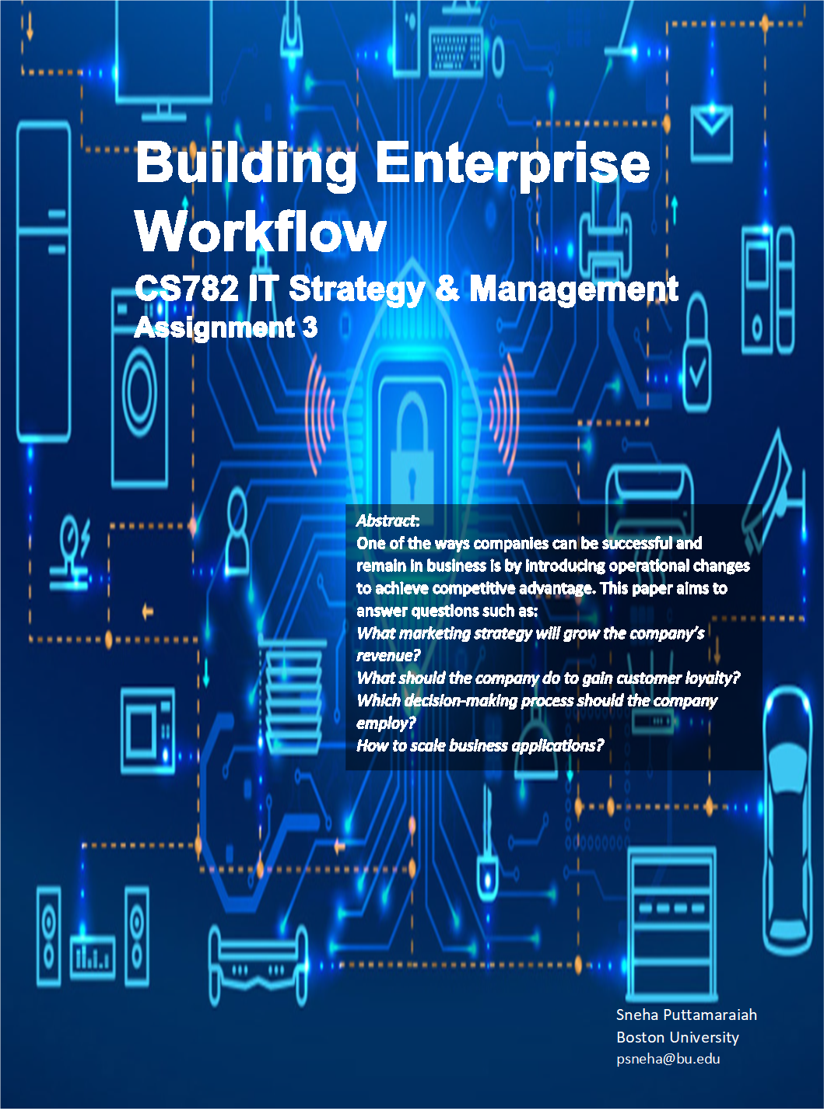

Table of Contents

**SECTION 1: INTRODUCTION** 1

**SECTION 2: WORKFLOW FACILITATION** 2

**Web Services/ REST** 2

**Service-Oriented Architecture (SOA)** 2

**Data Mining** 2

**Customer Relationship Management (CRM) Systems** 2

**SECTION 3: WEB SERVICES/ REST** 2

**SECTION 4: SERVICE-ORIENTED ARCHITECTURE** 5

**SECTION 5: DATA MINING** 6

**SECTION 6: CUSTOMER RELATIONSHIP MANAGEMENT (CRM) SYSTEMS** 8

**SECTION 7:** **CONCLUSION** 10

**REFERENCES** 10

Table of Figures

Figure 3 - 1 Introduction 1

Figure 3 - 2 Sources of Web Services Benefits 3

Figure 3 - 3 Web Services Balanced Scorecard Framework 3

Figure 3 - 4 Improving Internal Business Processes using Web Services 4

Figure 3 - 5 Importance of SOA 6

Figure 3 - 6 Ways in Which Data Mining Can Help a Business 7

Figure 3 - 7 Importance of CRM Software 9

# **SECTION 1: INTRODUCTION**

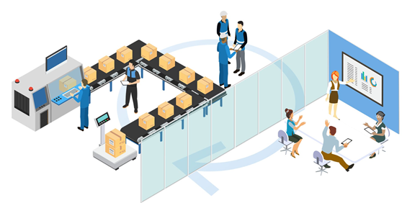

Figure 3 - Introduction

*Source: https://weeverapps.com/process-map-workflow-horizontal/*

HomeSmarts.com is a company that specializes in manufacturing IoT (Internet of Things) devices. The company has its head office in the US and maintains a presence in other countries such as China, India, and Russia. The consumers of the company are permitted to purchase a home assistance device that can integrate with other devices that are part of a bigger environment. There is a mobile-based app to manage the IoT devices. Consumers can access and purchase HomeSmart.com’s goods over the company’s e-commerce and m-commerce applications. The goods are also available for purchase at retail outlets like Walmart, Target, Best Buy, and other outlets that also emphasize technology. The company maintains strong relationships with other ecosystem vendors such as Google, Amazon, Blink, and Phillips.

Currently, the workflow has a lot of manual filing that decelerates customer service and jeopardizes the sustainability of the organization. In today’s progressively digital atmosphere, it is vital to improving the company’s competitive and operational strategies. So, the IT department shall employ the following technologies.

* Web services/ REST (representational state transfer) – to streamline operations of product delivery through the e-commerce process
* Service-oriented architecture (SOA) – to streamline operations for delivery of the mobile application
* Data mining – to improve decision making to compete effectively
* Customer Relationship Management (CRM) systems – to improve communication and collaboration with customers

# **SECTION 2: WORKFLOW FACILITATION**

The following provides an overview of the four chosen technologies – Web services/ REST, service-oriented architecture (SOA), data mining, and customer relationship management (CRM) systems – improve HomeSmarts.com’s competitive and operational strategies.

## **Web Services/ REST**

Web services are exceptional in contrast to previous integration technologies as it decreases the cost and complexity of diverse applications irrespective of coding language, platform, and location. Another distinctive element of this technology, essential for facilitating cross-platform integration, is that all its operational standards (SOAP, WSDL, and UDDI) are defined in the standard XML syntax. (Hu, 2004) HomeSmarts.com is powered by its e-commerce website for sales, so integrating REST can be beneficial as it will be possible to utilize modules individually, scale module interactions, implement better security, and lower latency.

## **Service-Oriented Architecture (SOA)**

Mobile phones have become a widespread platform for business applications. As the number of mobile users rises, so does the requirement for efficient mobile data access and management. A conventional approach to business application and database design is not appropriate for mobile phones due to the limited memory and connection bandwidth. (Natchetoi, Kaufman and Shapiro) Hence, a service-oriented architecture-based approach will be adopted to overcome these concerns.

## **Data Mining**

HomeSmarts.com shall make educated and calculated decisions by using data mining tools to forecast upcoming trends and behaviors. The advanced data analysis uncovers formerly undetermined, logical relationships in enormous groups of data. Data mining helps the business elevate the processes to provide relevant services to clients; the service cost is equivalent to the earnings gained from the clients.

## **Customer Relationship Management (CRM) Systems**

According to an article in Forbes, CRM facilitates companies to create a relationship with their clients that builds loyalty and customer retention. As both customer loyalty and revenue impact the income of the company, CRM is a management tactic that marks enhanced revenues for the company. A CRM tool generates a user interface to collect information that will help companies identify and connect with consumers in a scalable manner. (Kulpa, 2017)

# **SECTION 3: WEB SERVICES/ REST**

SOAP and RESTful web services present distinctive variations, so HomeSmarts.com will consider both the options to leverage the business’s competitive and operational strategies. Web services can establish significance in three dimensions: infrastructure, strategies, and operations. (Hu, 2004)

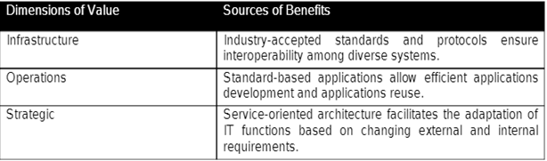

Figure 3 - Sources of Web Services Benefits

*Source: https://www.researchgate.net/publication/228559255_Integrating_Web_Services_With_Competitive_Strategies_The_Balanced_Scorecard_Approach*

**Web Services to Improve Competitive Strategies**

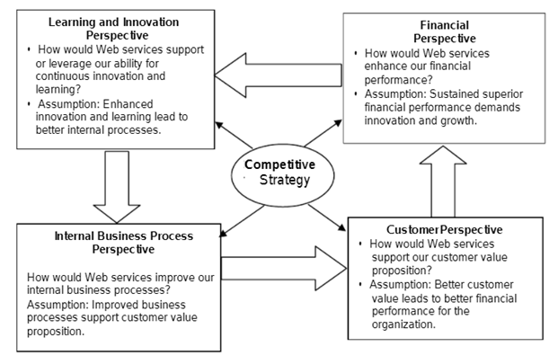

Figure 3 - Web Services Balanced Scorecard Framework

*Source: https://www.researchgate.net/publication/228559255_Integrating_Web_Services_With_Competitive_Strategies_The_Balanced_Scorecard_Approach*

The above figure shows a Web services Balanced Scorecard (WS-BSC) framework that concentrates on the integration of Web services technology into HomeSmarts.com’s competitive strategy to deliver useful solutions. The framework helps managers address the questions shown in the figure under different perspectives.

Web services improve customer relationships, customer retention, and customer value. Web services technologies can make way for improved financial performance and shareholder value due to decreased operational costs and increased revenue. (Hu, 2004)

**Web Services for Improving Business Operations**

Web services technology can make way for internal business processes that will be further effective because of process automation and acceleration, increased interoperability and integration, and improved process design. (Hu, 2004) The following figure elucidates these benefits.

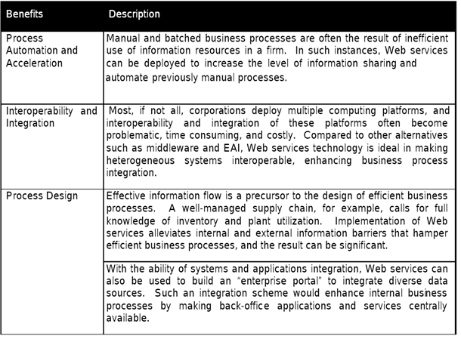

Figure 3 - Improving Internal Business Processes using Web Services

*Source: https://www.researchgate.net/publication/228559255_Integrating_Web_Services_With_Competitive_Strategies_The_Balanced_Scorecard_Approach*

HomeSmarts.com is powered by its e-commerce website for sales, so integrating REST can be beneficial as it will be possible to utilize modules individually, scale module interactions, implement better security, and lower latency. Whenever a shopper adds a product into the shopping cart on HomeSmarts.com’s e-commerce website, REST guarantees that the products in the cart are detected and administered on the checkout page.

# **SECTION 4: SERVICE-ORIENTED ARCHITECTURE**

Business applications require a reliable, high-speed network to process humongous amounts of data. The applications that can be loaded via a browser over a desktop computer will not load or appear the same on mobile phones. Service-oriented architecture (SOA) will provide numerous services and technologies to make these applications work on mobile devices. The services in SOA are loosely coupled, suggesting the components are not interdependent and the application will remain unaltered by any modifications in the future. SOA will allow the IT team to develop applications by combining several services devoid of added performance or implementation intricacies. The platform-independent nature of the architecture allows developers to choose hardware and software of their preference.

HomeSmarts.com can benefit from implementing SOA in the following ways (Stephen, 2017):

* *Reduce development time –* SOA promotes code reusability, so developers can reuse existing code to build a new function or software. SOA significantly eases development time; thereby, lowers costs as new functionalities or applications need not be developed from scratch.
* *Promote interaction –* SOA improves the interaction between platforms that are developed in different programming languages by establishing a standard protocol for communication. SOA can circumvent corporate firewalls, enabling businesses to share information critical to operations.
* *Scalability –* SOA allows the business to increase its scale to meet client’s needs by slashing the degree of communication between clients and services.
* *Reduced costs* – SOA makes it feasible to cut down expenses while still sustaining a required amount of output. The company can control the extent of analysis needed when building custom solutions.

The following figure shows how business processes are aligned in a monolithic application vs. an SOA-integrated application.

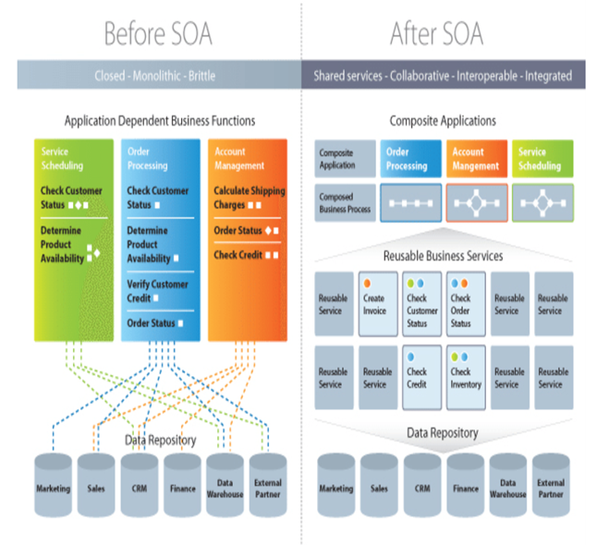

Figure 3 - Importance of SOA

*Source: https://medium.com/@SoftwareDevelopmentCommunity/what-is-service-oriented-architecture-fa894d11a7ec*

# **SECTION 5: DATA MINING**

Data mining tools provide the best solutions to devise both strategic and competitive decisions needed for a business to endure. The following image provides an overview of how data mining can be beneficial to a business.

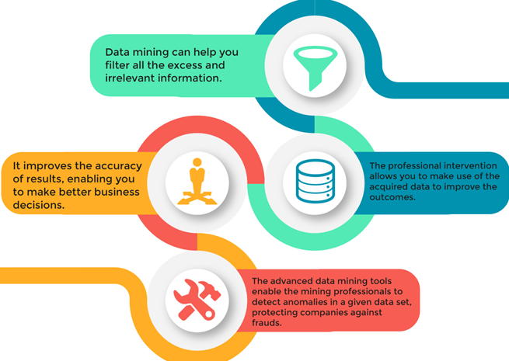

Figure 3 - Ways in Which Data Mining Can Help a Business

*Source: https://www.ucollectinfographics.info/an-introduction-to-data-mining-and-its-applications/*

Data mining can provide information on sales volume and stock levels. It can also dig the database to provide information by predicting seasonal requirements that match a client’s profile and analyzing stock that functions differently in diverse market divisions or functions differently demographically. HomeSmarts.com will use data mining tools to evaluate current trends in its sales force and the outcomes to come up with better targeting of retailers and identify the marketing strategy that will largely influence the business in the upcoming months. By effectively mining consumer data, the company can develop solid brands and customer loyalty. From the top executives to customer care representatives, all have access to the same data. When a customer calls the company regarding an issue, the customer care representative will know the customer’s problem in advance. The customers feel at ease knowing that the company is aware of their problem.

There are different types of data mining. (Module 3) The following elucidates how they can be applied to HomeSmart.com’s business:

* **Market basket analysis:** This technique finds what other products are being purchased by each customer along with a certain product. For example, a customer buying a wearable fitness tracker maybe adding other items such as a screen protector and/or a blood pressure monitor.
* **Classification:** This technique helps segment customers based on their age, income, demographics, etc. For instance, people living in areas where house break-ins are common are highly likely to invest in smart home security systems.
* **Clustering:** This technique identifies similar data items and groups them into different clusters. For example, the majority of smart car buyers are in their 50s and their salary is at least $65k per annum.
* **Trend analysis:** This technique spots current and upcoming trends which can help tailor customer demands. For instance, this technique can discover that millennials in certain cities are purchasing GPS trackers for vehicles more than millennials in any other city.

There are several data mining activities, as discussed below, that help in decision-making. (Module 3)

* **Discovery/Modeling –** describes the statistical likelihood that someone bought a home security system given their demographical area.
* **Forensics** – Suppose the model predicted that a certain region is prone to crime and people living in this region are likely to invest in home security systems, but the outcomes were different. This activity discovers this prediction to be false and analyzes the reasons behind it. Forensics activity may build an additional model providing the explanation. Some of the reasons can be that the people in these regions have a low income and cannot invest in home security systems or the crime rates have significantly reduced.
* **Prediction –** predictsfuture behaviors. (Module 3) When customers load the HomeSmarts.com website, their demographical information can help steer them toward high-end, wearable fitness trackers.
* **Detection –** detectsnew anomalies. (Module 3) For example, a customer who was predicted to buy a high-end, wearable fitness device ended up buying an inexpensive fitness tracker instead.

# **SECTION 6: CUSTOMER RELATIONSHIP MANAGEMENT (CRM) SYSTEMS**

Organizing and managing customer data through a CRM tool will empower the company to fully understand its customers, which can have an advantage to further associated messaging. Numerous activities can be computerized to focus on sales forces, advertising, efficient delivery, and better customer service. A completely integrated CRM can eliminate data silos, easing cross-departmental collaborations, so that an integrated facade can be presented to the customers. (Oracle)

The following image summarizes the importance of a CRM system.

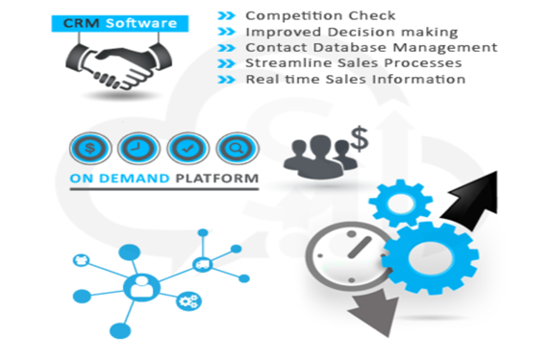

Figure 3 - Importance of CRM Software

*Source:https://medium.com/@salestalk/top-tips-tactics-why-crm-is-important-for-organization-392ab2d73703*

**What do CRM systems provide?** (Oracle)

* *Sales automation*

A CRM system offers automated workflows that will assist HomeSmarts.com’s marketing department to invest time on strategic responsibilities like establishing promotion campaigns that reverberate, analyzing the data collected from campaigns, and assessing several methodologies built on the analytics. Customer service representatives can invest time in resolving customers’ complicated problems or needs, which can help the companies build a better relationship with the customers.

* *AI-enabled sales and marketing tools*

Leverage automated messaging tools such as chatbots and digital assistants to manage straightforward queries (e.g., order status, refund, etc.) from customers.

* *Improved cross-departmental collaboration*

All information pertaining to the business, transactions, and customer is contained within the CRM system. Any team that has access to the CRM system can collaborate. Developments on a customer’s query can be tracked as the same data is available across teams.

HomeSmarts.com shall employ either of these CRM tools: HubSpot CRM, Salesforce CRM, or NetSuite CRM.

# **SECTION 7:** **CONCLUSION**

HomeSmarts.com, a company that manufactures IoT devices, will replace its existing manual labor with automation by digitizing the workflow, employing technologies such as Web services/ REST, customer relationship management (CRM) systems, data mining tools, and service-oriented architecture (SOA). Implementing Web services and RESTful services to the company’s e-commerce site can leverage the business’s competitive and operational strategies. Application functionality is made available over mobile devices by utilizing SOA. Data mining utilizes several techniques to collect data and analyze to offer competitive advantages. CRM helps the company attract and retain customers and improve the company’s relationship with its customers. Hence, these are the technologies ideal for the company to leverage its competitive and operational strategies.

# **REFERENCES**

1. Huang, C. Derrick. “Integrating Web Services with Competitive Strategies: A Balanced Scorecard Approach.” *Communications of the Association for Information Systems*, vol. 13, 2004. *Crossref*, doi:10.17705/1CAIS.01306.
2. Kaplan, Robert S. “The Balanced Scorecard: Translating Strategy into Action.” Long Range Planning, vol. 30, no. 3, 1996, p. 467. Crossref, doi:10.1016/s0024-6301(97)80925-9.
3. Watts, Stephen. “What Is SOA? Service-Oriented Architecture Explained.” *BMC Blogs*, 31 May 2017, www.bmc.com/blogs/service-oriented-architecture-overview/#.
4. Natchetoi, Yuri, et al. “Service-Oriented Architecture for Mobile Applications.” *ResearchGate*, 2008, doi:10.1145/1370888.1370896.
5. Software Development Community. “What Is Service-Oriented Architecture? - Software Development Community.” *Medium*, 15 Feb. 2019, medium.com/@SoftwareDevelopmentCommunity/what-is-service-oriented-architecture-fa894d11a7ec.
6. Thomas, David. “An Introduction To Data Mining And Its Applications | UCollect Infographics.” UCollect Infographics, 7 Mar. 2018, www.ucollectinfographics.info/an-introduction-to-data-mining-and-its-applications.
7. “Module 3.” Bu.Edu, Boston University Metropolitan College, onlinecampus.bu.edu/bbcswebdav/pid-9311633-dt-content-rid-57724817_1/courses/21fallmetcs782_o1/course/module3/allpages.htm. Accessed 27 Sept. 2021.
8. Business Solutions Lead. “Process-Map-Workflow-Horizontal.” Weever, 14 July 2020, weeverapps.com/process-map-workflow-horizontal.
9. Kulpa, Jason. “Why Is Customer Relationship Management So Important?” Forbes, 24 Oct. 2017, www.forbes.com/sites/forbesagencycouncil/2017/10/24/why-is-customer-relationship-management-so-important/?sh=1382ecb77dac.
10. Thomas, John. “Top Tips & Tactics: Why CRM Is Important for Organization?” Medium, 13 July 2015, medium.com/@salestalk/top-tips-tactics-why-crm-is-important-for-organization-392ab2d73703.
11. “Azure Sphere: A Secured Hardware Solution for Your IoT Device Security.” *Einfochips*, 31 Mar. 2020, www.einfochips.com/blog/azure-sphere-a-secured-hardware-solution-for-your-iot-device-security.
12. Anderson, Joan, and Antigone Kotsiopulos. “Enhanced Decision Making Using Data Mining: Applications for Retailers.” Ncsu.Edu, 2002, textiles.ncsu.edu/tatm/wp-content/uploads/sites/4/2017/11/anderson_full-1.pdf.