

**Leveraging M-Commerce and Mobile Strategies**

**CS 782 – IT STRATEGY & MANAGEMENT**

**ASSIGNMENT 4**

*Abstract*:

E-commerce has been fairly popular for quite some time; it is mobile commerce (m-commerce) that is climbing up the ladder. M-commerce is a subset of e-commerce, except it is beneficial for handheld devices such as smartphones and tablets. This paper discusses why Nebula Co. should integrate its business with m-commerce and what makes it remarkable.

Sneha Puttamaraiah

Boston University

psneha@bu.edu

Table of Contents

SECTION 1: INTRODUCTION 1

SECTION 2: M-COMMERCE COMPETITIVE PERSPECTIVE 2

I. SIMPLIFY CUSTOMER EXPERIENCE 2

II. EXPANDING TO NEW MARKETS 3

III. DRIVING PROFITABILITY 4

SECTION 3: M-COMMERCE OPERATIONAL PERSPECTIVE 6

I. WORKFLOW 6

II. CULTURE 8

III. MANAGEMENT STRUCTURE 8

ONLINE PRESENCE 8

IMPROVING COMMUNICATION WITH CUSTOMERS 8

IMPROVE MANAGEMENT 9

CONCLUSION 12

REFERENCES 12

Table of Figures

Figure 4 - 1 Percentage of Products or Services Purchased Using Mobile Devices 1

Figure 4 - 2 Why Do People Prefer Apps? 3

Figure 4 - 3 Smartphones Helping in Purchase Decisions 4

Figure 4 - 4 Significance of Mobile Apps 5

Figure 4 - 5 Automating the Process from E-Commerce To M-Commerce 7

Figure 4 - 6 Being Consistent 9

Figure 4 - 7 How to Deal with Negative Reviews? 10

Figure 4 - 8 How Do Consumers Feel About Online Reviews? 11

# SECTION 1: INTRODUCTION

Nebula Co. is an American luxury jewelry and specialty retailer with its center of operations located in Los Angeles, California. The company has about 435 stores, mostly mall-based, nation-wide, and has an active e-commerce platform. The company primarily sells luxury products such as jewelry, watches, and perfumes.

Nebula Co. will be expanding its business to incorporate a mobile commerce (m-commerce) platform to capture the minds of its current and potential customers. Over the years, more and more people are using smartphones and tablets which in turn led to more users using the mobile Internet and shopping over mobile applications. However, the company is facing hardships as it did not consider presenting a pleasant shopping experience to users over their mobile. The following chart predicts the percentage of m-commerce retail sales in the US.

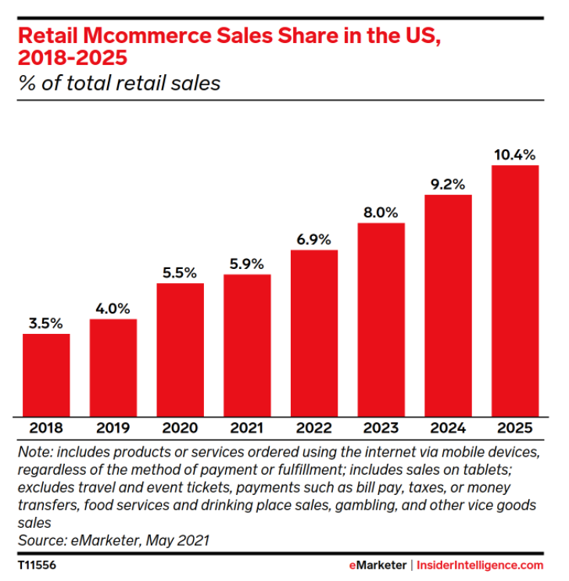

Figure 4 - Percentage of Products or Services Purchased Using Mobile Devices

*Source: https://www.emarketer.com/content/mcommerce-forecast-2021*

An article in *GlobeNewswire* mentions that the comprehensive mobile commerce market was projected at $472 billion in 2019 and is projected to achieve $3,901 billion by 2026. From 2019 to 2026, the overall mobile commerce market is projected to expand at a compound annual growth rate (CAGR) of USD 34.9%.

# SECTION 2: M-COMMERCE COMPETITIVE PERSPECTIVE

Many individuals today rely on their smartphones to perform day-to-day activities; be it booking a movie ticket, ordering groceries, or simply browsing the web. Technology is advancing every day and nearly every business has an m-commerce application, so a business not having a mobile presence and an m-commerce platform may drive customers away. Nebula Co. has an e-commerce website that provides simple search functionality to look up products. The product pages are user-friendly providing all the product details along with images. The checkout process is simple too; customers can save their card details for faster transactions. The company offers two types of shipping: standard, expedited, and same-day delivery. Customers can easily reach out to the customer support team and their queries are resolved efficiently. Data privacy, increased storage, mobile Internet, and user-friendliness are some of the attributes shaping m-commerce sales. The IT team will be taking measures to optimize its listings to work on mobile devices or a mobile application.

## SIMPLIFY CUSTOMER EXPERIENCE

Customers, now more than ever, are accepting their mobile devices as a medium to shop goods online, so enhancing their experience through m-commerce can be game-changing for the business. The one device that people carry everywhere – their smartphone – is especially beneficial when users want to buy something that came to their mind at that instant. Traditionally, it would require the shopper to take out time to go on a shopping trip. The shopper would have had to come back to their desk to access the e-commerce site especially if the site did not support mobile access. M-commerce also makes it easy to share links over text messages or other apps such as WhatsApp, Facebook, Instagram, etc. Digital mobile wallets such as Apple Pay, Google Pay, or Samsung Pay will simplify the process of checkout as shoppers need not take out their credit cards for transactions.

Other features that the IT team shall implement to simplify customers’ experience using Nebula Co.’s m-commerce platform will be:

* Provide an easy sign-up/ sign-in process by allowing customers to log in via their Gmail, Facebook, Twitter, or Instagram.
* Provide seamless application experience across multiple mobile devices.
* Shoppers can use “search by voice” functionality to access a wide range of products or they can use the traditional search functionality where they enter text (e.g., product name).
* Shoppers can book an appointment to visit the store directly from the application.
* In-app support will enable customers to contact the customer support team easily via chat, e-mail, or call (audio or video).
* Shoppers can measure the size of a ring by simply placing an existing ring on their smartphone’s screen and the application will calculate the size. Size charts are also provided.
* The Notifications icon will display past and current orders and Wishlist items. Customers can easily initiate returns and receive refunds.
* Customers can select the size and gross weight of a piece of jewelry. For items that are out of stock, customers can set a reminder to be alerted when they are back in stock.
* Check if an item is available in a store near them by entering the zip code. Integrate with a positioning system like GPS to direct users to a store near them.
* Provide personalized recommendations based on the products they shop or search.
* Customers can either pick up their item from the store or choose a delivery method: standard, expedited, or same-day delivery.
* Payment processes include net banking, credit cards, debit cards, and mobile wallets.

The following image provides statistal preference from users on characteristics of mobile apps.

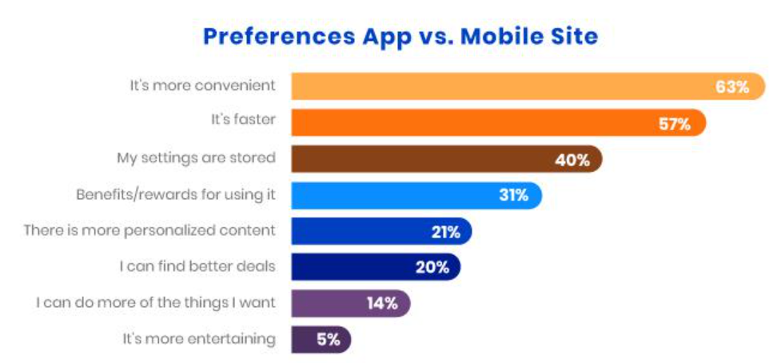

Figure 4 - Why Do People Prefer Apps?

*Source: www.inc.com/quora/why-many-e-commerce-sites-are-remaking-themselves-as-mobile-first.html.*

## EXPANDING TO NEW MARKETS

Integrating m-commerce can lead to new prospects and help reach new markets internationally. The company will expand its business in other countries like the UK, Mexico, and Canada. Nebula Co. will build a mobile app that is available for download on Google Play Store and Apple’s App Store. The figure below illustrates why users prefer to shop on a mobile app.

The company will also enter the gaming industry by launching another mobile app on Play Store and App Store. The game, or the app, will be called “Nebula Designers” where users can design their own pieces of jewelries or watches from collecting items available in the inventory. The inventory will include metals such as bronze, silver, gold, and platinum and various gems. The metals can be of different weights and sizes and are priced accordingly. These items will be available in real-time at the stores or online. Users can become the business’s potential customers or even valuable employees if their designs are extraordinary. Another initiative that can be considered is developing a digital wallet to ensure secure transactions.

Mobile ads seem to outperform desktop ads as they have a higher click-through rate (CTR) – running a 0.37% CTR in contrast to desktop ads’ 0.22% CTR. (Walgrove, 2016) Nebula Co. will augment its advertising by making use of social media platforms by focusing on building followers/ subscribers.

## DRIVING PROFITABILITY

The following figure illustrates how shoppers use their smartphones for their shopping decisions.

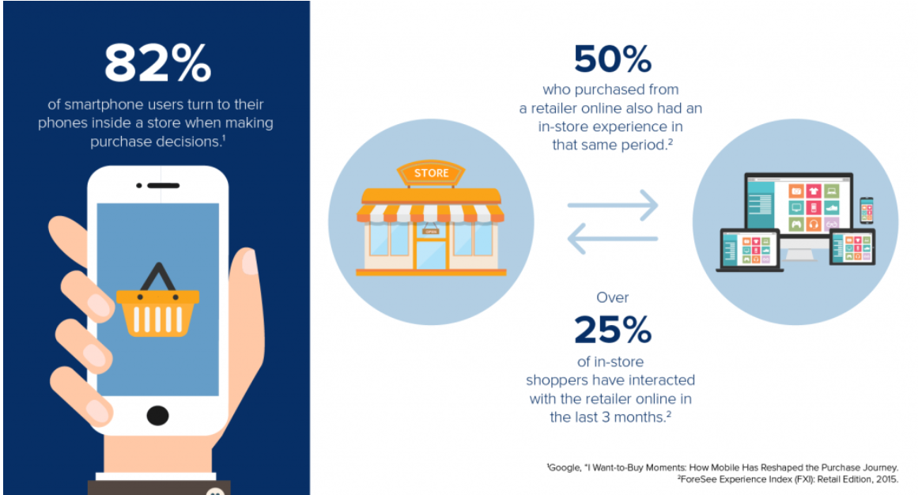

Figure 4 - Smartphones Helping in Purchase Decisions

*Source: https://v12data.com/blog/what-do-consumers-want-mobile-shopping-experience/*

As mentioned in the previous section, mobile CTRs are higher than desktop CTRs that implies many folks are devoting most of their hours to their smartphone than to their desktop. Since the app will allow social media integration, consumers also do their part in spreading the word about the business and thus, eliminating the marketing costs needed for flyers, newsletter papers, SMS, etc. The company can also profit by employing ads within the app. *Search Engine Land* discovers the following details about mobile users.

* People that search for products or information over their smartphone tend to act sooner. The mobile search results have influenced approximately 50% of the searchers to purchase products or services.
* Google discovers substantial smartphone usage throughout the shopping process:
  + 74% of smartphone shoppers end up purchasing goods or services
  + 79% use smartphones to receive assistance while shopping
  + 70% use smartphones at a physical store
* People are more likely to notice mobile ads and recognize a business.

The figure below summarizes why a mobile app is important for a business.

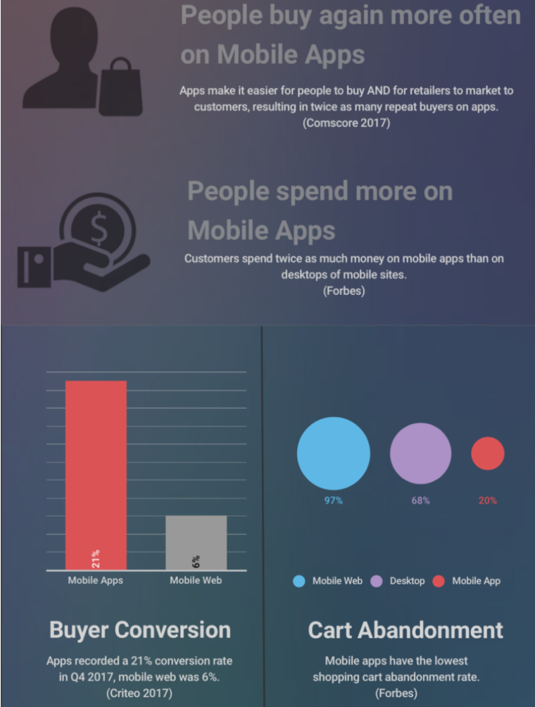

Figure 4 - Significance of Mobile Apps

*Source: https://medium.com/@drync/mobile-web-vs-mobile-app-6df0fbd48503*

Merely having a mobile app does not promise profit, but it can be a constructive tool to enhance customer engagement. People are highly likely to use the app again for more purchases. While desktops and mobile sites have high cart abandon rates (68% and 97% respectively), the cart abandonment rate for mobile is the lowest at 20%. (Inc., 2018)

# SECTION 3: M-COMMERCE OPERATIONAL PERSPECTIVE

M-commerce adds value to a company’s business but having a mobile site with reduced performance can impact the business negatively. Consumers will not endorse a business with a bad mobile site. Furthermore, they may end up leaving the site and move on to the competitor’s site. A fast and mobile-friendly site can attract customers; any glitches or lags are detrimental to the company’s image and its sales (e.g., abandoned carts).

## I. WORKFLOW

Nebula Co.’s IT infrastructure can boost its efficiency using a mobile customer relationship management (CRM) system. Evolutions in mobile devices have accelerated the changes in the alliance between the users and IT. CRM entails the insight needed to offer value to customers by establishing a relationship with them. Since m-commerce is handled as a single body, the current CRM techniques and m-commerce will have to work together to make things happen. There is a multitude of CRM apps like Salesforce, Zoho CRM, Capsule CRM, Nimble, etc. that lets businesses deliver superior customer support via mobile devices.

Incorporating mobile devices with an enterprise resource planning (ERP) system can boost efficiency and recover manufacturing and maintenance costs. Mobile ERP can be beneficial for the company as they facilitate incorporation as well as support scalability. Mobile ERPs also offer flexibility to employees as they can access and register information even when they are remote; thus, increasing their productivity. The biggest challenge the IT team will face is standardizing the platform across all mobile devices. The company shall hire developers highly skilled developers than it currently holds to develop a stable app that can provide a seamless experience across all mobile devices. Test engineers will be required to test the mobile app and mobile sites across all devices and discover loopholes before the shoppers or competitors do.

The supply chain management (SCM) system will function as usual and is not greatly impacted. SCM provides prominence to the supply chain that minimizes the time needed for administration and communication activities, which will be automatically accessible to notify suppliers in advance. The company will mirror its brand image in each component of order fulfillment. Online purchases for Nebula Co. peak just before weekends, hitting the highest point on Fridays, then gradually drop at the beginning of the week. SCM will be responsive as customers may not wait until items are back in stock and turn to competitors.

The following image illustrates an automated m-commerce workflow.

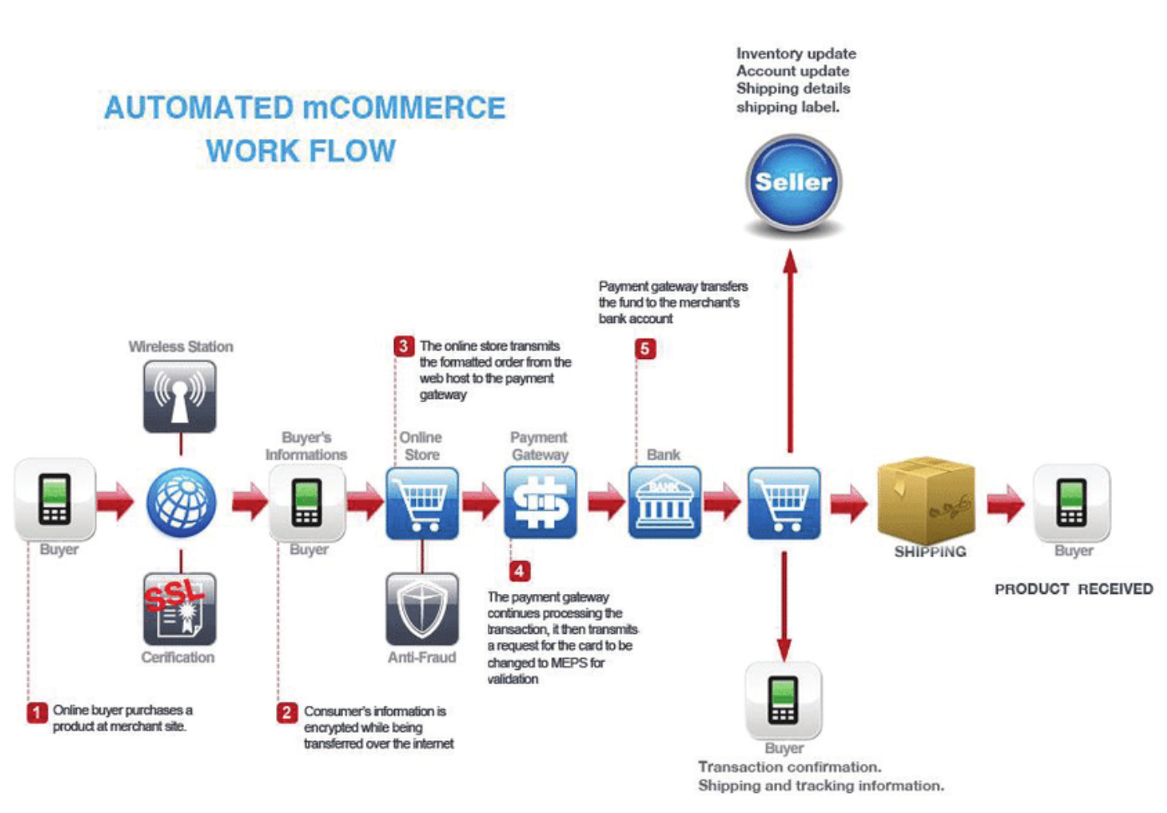

Figure 4 - Automating the Process from E-Commerce To M-Commerce

Source: https://www.researchgate.net/publication/322001953_Association_between_shopping_habit_and_demographics_of_m-commerce_user's_in_India_using_two_way_ANOVA

## II. CULTURE

Nebula Co. will push itself into a position where it can fully embrace m-commerce to transform its business and the culture at Nebula Co. will be marginally affected. Both employees and customers will become a part of the m-commerce ecosystem. The company will view m-commerce as a new opportunity for the business to grow by attracting additional customers.

The focus will primarily be on serving the customers by adopting attributes like flexibility and speed. As the business progresses faster, so should the process of decision-making. Teams should try to avoid any congestion in the workflow by being punctual and finishing their tasks on time, so a team’s work is not hampered by another team it relies on for making decisions as it can also hamper the business. Relevant employees will be trained on understanding data secured from customer communication to impact the decision-making process and obtain determined profit for the business.

## III. MANAGEMENT STRUCTURE

Nebula Co. will step away from its conventional practice of prioritizing tasks by getting various teams to equip themselves with databases of budgets and priorities, all coming from their personal viewpoint. The company will appeal to excellent talent; when talented individuals are employed, they make work more amusing.

The financial team at the company will be responsible to adhere to Sarbanes Oxley (SOX) compliance clauses. The CEO and CFO will be responsible for all financial records. The marketing team will follow FTC (Federal Trade Commission) Act regulations ensuring all forms of advertising are factual and not misleading the customers. To ensure security, the IT team will make sure only authorized users have access to the data, systems, and software. Developers will ensure there are no security holes in software, and it is up-to-date. Employees need to ensure the inventory is updated.

# ONLINE PRESENCE

## IMPROVING COMMUNICATION WITH CUSTOMERS

**Pay attention to customers**

With Nebula Co.’s mobile app, customers can get in touch with the customer support team by placing a call in-app or through in-app chat and email messages. The app will integrate with customer’s social media accounts, collect customer data through these accounts, and target personalized marketing. The support team will respond to customer queries swiftly, even if the customers message on the company’s account on social media or comment their queries on a company’s post. Follow-up on their queries to ensure the issues have been resolved and the customer is satisfied. Shoppers shall also choose to participate in surveys and/or review the app as this provides insights into what customers like or dislike about the business, products, and services. The data shall be used to reflect on the business and make changes to provide a better experience for the shoppers.

**Send alerts**

The app shall send push notifications to users, so they are alerted during sales or when new products are added. The customer data, location, shopping patterns, and product views shall be used to customize content to the customer. The cart abandonment rate can be reduced by reminding the customer that they left something in the cart.

**Ensure Consistency**

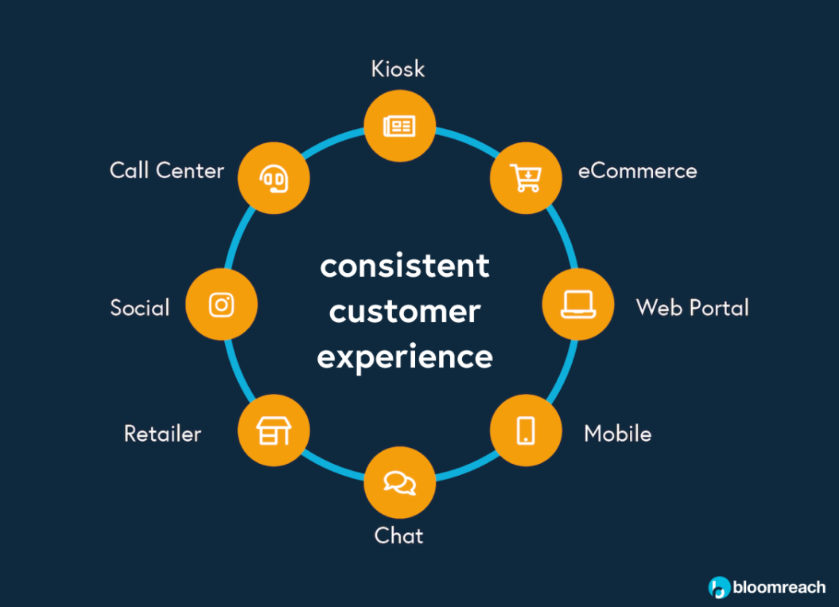

Figure 4 - Being Consistent

*Source: https://www.bloomreach.com/en/blog/2019/07/digital-commerce-explained.html*

The above image displays several touchpoints across which consistency should be maintained. If a shopper adds a product to the cart over the e-commerce site, the product should be present in the cart when the shopper loads the mobile site or app. This ensures engagement and prevents the shopper from being frustrated.

## IMPROVE MANAGEMENT

Online reviews can transform a company’s reputation in the nick of time. The management shall aim to get 5-star reviews for its mobile app by providing the best performance and experience. Trust is an important element that plays a vital role in attracting and retaining customers. If there are a significant number of negative reviews online, the business will plummet. The IT department shall continually monitor reviews and fix issues faced by customers who left a negative review. There are several ways in which negative reviews can be handled. Some of the ways are listed in the image that follows.

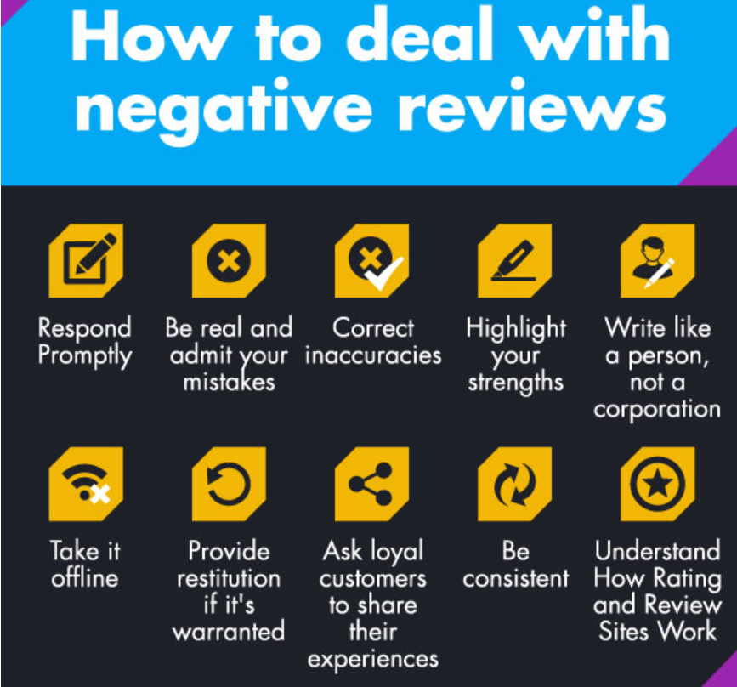

Figure 4 - How to Deal with Negative Reviews?

*Source:https://www.invespcro.com/blog/the-importance-of-online-customer-reviews-infographic/*

Negative reviews do not always account for negative experiences as some of these can be fake or irrelevant. The following table lists the types of negative reviews and how they should be treated.

|  |  |
| --- | --- |
| **Negative Review Type** | **Action** |
| Fake reviews | Flag or report the reviews so the website’s or service’s support team can evaluate them. |
| Insensitive reviews | These contain profanities or hate speech that violates the policy. Flag or report these reviews so the website’s or service’s support team can evaluate them. |
| Inaccurate reviews | These are written just to provoke the business to start a dispute. Overlook such reviews to avoid further disputes that may make the business look bad. |
| Negative reviews | Respond to these reviews to show the customer the business cares. |

**Why do positive reviews matter?**

According to Invesp - Conversion Rate Optimization Experts, the subsequent statistics were observed:

* 90% of shoppers read online reviews before shopping from a business.
* 88% of shoppers’ belief in online reviews is nearly the same as believing in personal recommendations.
* Shoppers are expected to spend 31% extra on businesses that have high ratings.
* 86% of shoppers hesitate to buy from businesses that have negative reviews.

It is important to have a good rating as the higher the rating, the higher the app’s rank will be. According to the Local Consumer Review Survey, the following statistics were observed.

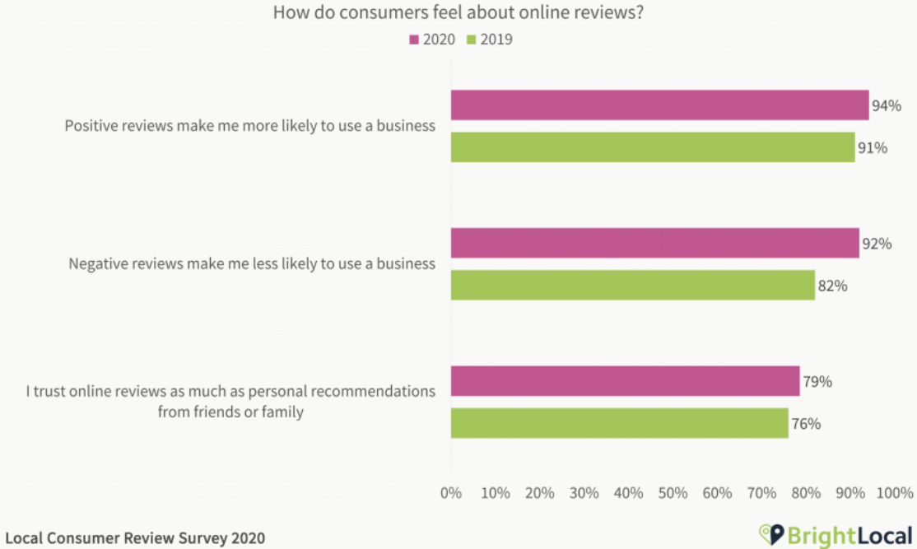

Figure 4 - How Do Consumers Feel About Online Reviews?

*Source: https://www.brightlocal.com/research/local-consumer-review-survey/*

While the customer support team is already handling reviews, engaging someone who understands the business well will make the process more efficient. An experienced employee who has spent over a year in the company will do a better job in fixing negative reviews quickly. The in-app issues shall be handled by a developer and other business-related reviews can be handled by an associate manager.

# CONCLUSION

Nebula Co. will incorporate m-commerce into current advertising strategies to take advantage of omnichannel consumers. Having a mobile app or site for the business can simplify the customer experience, drive profitability, and help expand the business into new markets. M-commerce adds value to the company but having a mobile site with reduced performance can impact the business negatively. Hence, from an operational standpoint, workflow, organizational culture, and management structure will be affected to some degree. Maintaining an online presence is vital for the business to be successful in the digital world; the company shall focus on improving its customers’ experience and the existing management.

# REFERENCES

1. Wurmser, Yoram. “Mcommerce Forecast 2021.” Insider Intelligence, 4 Aug. 2021, www.emarketer.com/content/mcommerce-forecast-2021.
2. Factors, Facts. “Global M-Commerce Market Size Will Reach USD 3,901 Million by 2026: Facts & Factors.” GlobeNewswire News Room, 23 Dec. 2020, www.globenewswire.com/news-release/2020/12/23/2149983/0/en/Global-M-Commerce-Market-Size-Will-Reach-USD-3-901-Million-by-2026-Facts-Factors.html.
3. Bedgood, Larisa. “What Do Consumers Want in Mobile Shopping | V12.” V12 Data, 15 Feb. 2020, v12data.com/blog/what-do-consumers-want-mobile-shopping-experience.
4. Walgrove, Amanda. “Infographic: How to Design Branded Content for Mobile.” Contently, 30 Sept. 2016, contently.com/2016/09/26/branded-content-infographic.
5. Sterling, Greg, and Greg Sterling. “Google: 50 Percent Of Those Exposed To Mobile Ads Took Action.” Search Engine Land, 28 Aug. 2021, searchengineland.com/google-50-percent-of-smartphone-users-exposed-to-ads-took-action-74760.
6. Quora. “Why Many E-Commerce Sites Are Remaking Themselves as Mobile First.” Inc.Com, 5 Jan. 2021, www.inc.com/quora/why-many-e-commerce-sites-are-remaking-themselves-as-mobile-first.html.
7. Drync. “Mobile Web vs. Mobile App - Drync.” Medium, 20 June 2018, medium.com/@drync/mobile-web-vs-mobile-app-6df0fbd48503.
8. Verma, Shanti, and Kalyani Patel. “Association Between Shopping Habit and Demographics of M-Commerce User’s in India Using Two Way ANOVA.” ResearchGate, 2017, doi:10.1109/I2CT.2017.8226090.
9. Roberts, Tessa. “Digital Commerce Explained (2021 Edition) | Bloomreach.” Bloomreach.Com, 9 June 2021, www.bloomreach.com/en/blog/2019/07/digital-commerce-explained.html.
10. Saleh, Khalid. “The Importance Of Online Customer Reviews [Infographic].” Invesp, 11 Apr. 2018, www.invespcro.com/blog/the-importance-of-online-customer-reviews-infographic.
11. Murphy, Rosie. “Local Consumer Review Survey 2020.” BrightLocal, 9 Dec. 2020, www.brightlocal.com/research/local-consumer-review-survey.
12. Grapestock. “Shopping Cart Icon On Smart Phone Screen Over Blur Mall Stockfoto en meer beelden van Elektronische handel.” iStock, 25 Aug. 2016, www.istockphoto.com/photo/shopping-cart-icon-on-smart-phone-screen-over-blur-mall-gm586061816-100560345.