1.Create a SQL query using GROUP BY to show the total number of orders placed by each user in an 'orders' table, displaying user_id and order_count.
select user_id ,COUNT(*) AS order_count FROM orders GROUP BY user_id;
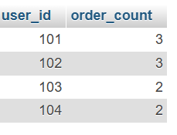
2. Write a SQL query to display the names of restaurants from a 'restaurants' table that have received an average rating above 4.0, using GROUP BY and HAVING.
SELECT name, AVG(rating) AS average_rating FROM restaurants GROUP BY name HAVING AVG(rating) > 4.0;

3. Suppose you have a 'payments' table with columns user_id, amount, and payment_date. Write a subquery to find user_ids who have made a single payment above ₹2000 in any transaction.
SELECT user_id FROM payments WHERE user_id IN(SELECT user_id FROM payments WHERE amount>2000);
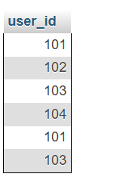
4. Using a nested subquery, display the names of movies from a 'movies' table that have a higher average rating than the overall average rating of all movies.<br><br><em><strong>Hint:</strong> Use a subquery to calculate the overall average rating, then compare each movie's average rating against it in the main query.</em>

