)Perform assignment 3 above using any available attribute selection algorithm in WEKA and

note the accuracy and compare it with accuracy obtained in assignment 3 above.

**Dataset** : Diabetes

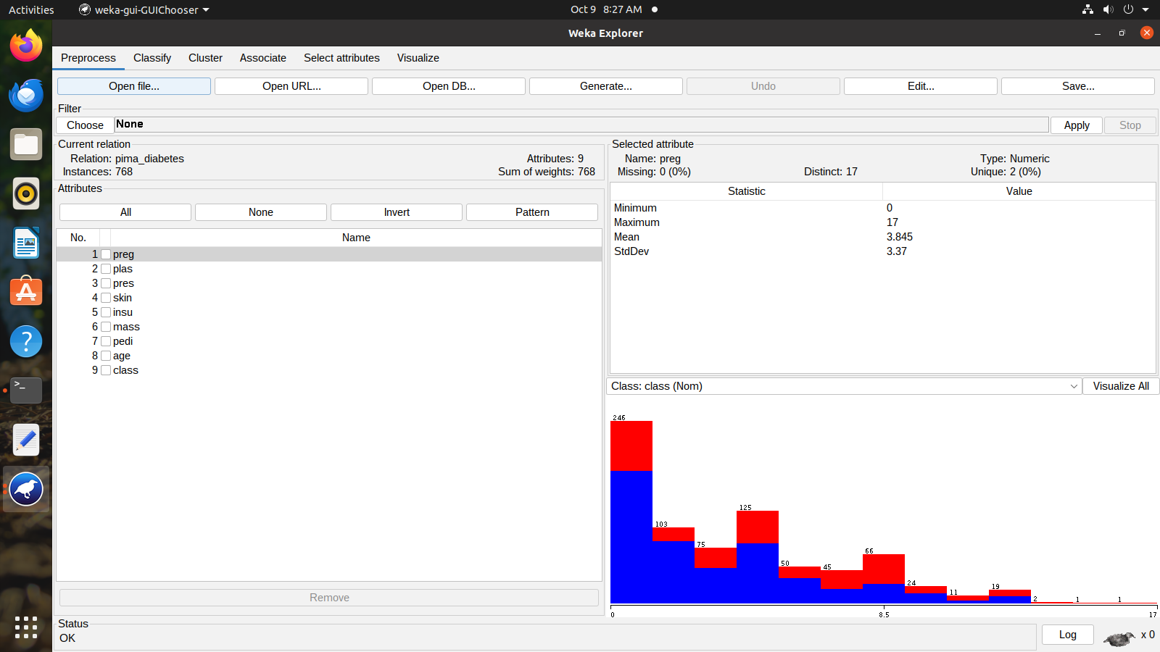

**Result before applying attribute selection**

=== Run information ===

Scheme: weka.classifiers.functions.MultilayerPerceptron -L 0.3 -M 0.2 -N 500 -V 0 -S 0 -E 20 -H a

Relation: pima_diabetes

Instances: 768

Attributes: 9

preg

plas

pres

skin

insu

mass

pedi

age

class

Test mode: 10-fold cross-validation

=== Classifier model (full training set) ===

Sigmoid Node 0

Inputs Weights

Threshold -2.7229322532147213

Node 2 1.4723226659593016

Node 3 7.820430499517925

Node 4 2.4438687225161058

Node 5 3.201530885671735

Node 6 -3.028108946415126

Sigmoid Node 1

Inputs Weights

Threshold 2.722932258743451

Node 2 -1.4723226671089324

Node 3 -7.820430653667111

Node 4 -2.4438687292638233

Node 5 -3.201530892432127

Node 6 3.0281089587884145

Sigmoid Node 2

Inputs Weights

Threshold -2.87837544881838

Attrib preg -9.079447868879242

Attrib plas -9.396273506987917

Attrib pres 2.9422558149576776

Attrib skin 2.0758003770037368

Attrib insu -8.023036419765168

Attrib mass -10.734818857856771

Attrib pedi -3.351846628388006

Attrib age 10.737145998129124

Sigmoid Node 3

Inputs Weights

Threshold -7.418945790100178

Attrib preg 1.15067357427161

Attrib plas -1.9072546608611596

Attrib pres 3.4032823123017653

Attrib skin -7.795475278795803

Attrib insu 0.5709218287459247

Attrib mass -6.1769858300956875

Attrib pedi 11.30181125188743

Attrib age 2.158947378531027

Sigmoid Node 4

Inputs Weights

Threshold 0.3325483432081201

Attrib preg 0.9103698712206623

Attrib plas -13.824796952946127

Attrib pres -6.399366681265747

Attrib skin 3.372641947485112

Attrib insu -3.0955093615541673

Attrib mass -8.775026662333566

Attrib pedi -5.1923681596094315

Attrib age 9.269528793152954

Sigmoid Node 5

Inputs Weights

Threshold -3.3767476603255835

Attrib preg 9.122015480585302

Attrib plas -12.642913808448132

Attrib pres 5.675804474758246

Attrib skin -0.06085501320155377

Attrib insu 2.3070185070106217

Attrib mass -5.23208091635601

Attrib pedi -0.7354842913650297

Attrib age -19.2656337017977

Sigmoid Node 6

Inputs Weights

Threshold 0.05437383478947769

Attrib preg 12.836762781789405

Attrib plas -6.062276016682751

Attrib pres -1.3896840458164672

Attrib skin 0.34997084802063716

Attrib insu -2.2119408147264896

Attrib mass -0.9589656235929852

Attrib pedi 6.090003751353246

Attrib age -8.833262465394625

Class tested_negative

Input

Node 0

Class tested_positive

Input

Node 1

Time taken to build model: 0.27 seconds

=== Stratified cross-validation ===

=== Summary ===

Correctly Classified Instances 579 75.3906 %

Incorrectly Classified Instances 189 24.6094 %

Kappa statistic 0.4484

Mean absolute error 0.2955

Root mean squared error 0.4215

Relative absolute error 65.0135 %

Root relative squared error 88.4274 %

Total Number of Instances 768

=== Detailed Accuracy By Class ===

TP Rate FP Rate Precision Recall F-Measure MCC ROC Area PRC Area Class

0.832 0.392 0.798 0.832 0.815 0.449 0.793 0.850 tested_negative

0.608 0.168 0.660 0.608 0.633 0.449 0.793 0.667 tested_positive

Weighted Avg. 0.754 0.314 0.750 0.754 0.751 0.449 0.793 0.786

=== Confusion Matrix ===

a b <-- classified as

416 84 | a = tested_negative

105 163 | b = tested_positive

**Result before applying attribute selection**

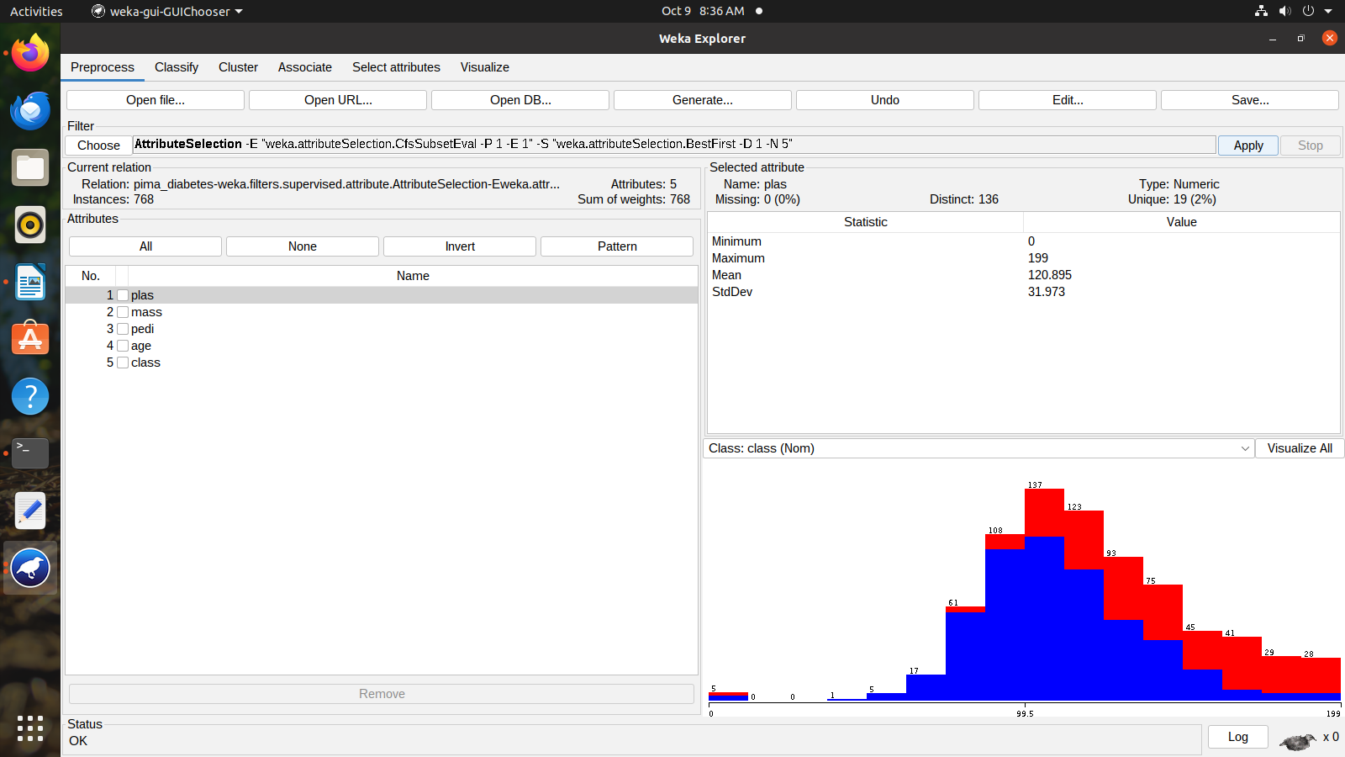

=== Run information ===

Scheme: weka.classifiers.functions.MultilayerPerceptron -L 0.3 -M 0.2 -N 500 -V 0 -S 0 -E 20 -H a

Relation: pima_diabetes-weka.filters.supervised.attribute.AttributeSelection-Eweka.attributeSelection.CfsSubsetEval -P 1 -E 1-Sweka.attributeSelection.BestFirst -D 1 -N 5

Instances: 768

Attributes: 5

plas

mass

pedi

age

class

Test mode: 10-fold cross-validation

=== Classifier model (full training set) ===

Sigmoid Node 0

Inputs Weights

Threshold -1.9396490241236628

Node 2 2.4094535696965385

Node 3 3.103496141774343

Node 4 1.7212034257011746

Sigmoid Node 1

Inputs Weights

Threshold 1.9396490241236628

Node 2 -2.409453569696538

Node 3 -3.1034961417743423

Node 4 -1.7212034257011748

Sigmoid Node 2

Inputs Weights

Threshold -3.489942331515255

Attrib plas -7.514880654511207

Attrib mass -1.4410499965380517

Attrib pedi 0.45582921121385234

Attrib age -7.176685926181191

Sigmoid Node 3

Inputs Weights

Threshold -1.3712543022039156

Attrib plas -4.725720808456523

Attrib mass -10.310588784920197

Attrib pedi 1.5154251393298108

Attrib age 10.782154190489312

Sigmoid Node 4

Inputs Weights

Threshold -4.7163499563886555

Attrib plas -6.407492692902781

Attrib mass -7.157605207260032

Attrib pedi -8.656364800300688

Attrib age -1.5100105809783027

Class tested_negative

Input

Node 0

Class tested_positive

Input

Node 1

Time taken to build model: 0.17 seconds

=== Stratified cross-validation ===

=== Summary ===

Correctly Classified Instances 580 75.5208 %

Incorrectly Classified Instances 188 24.4792 %

Kappa statistic 0.4518

Mean absolute error 0.3062

Root mean squared error 0.4075

Relative absolute error 67.3589 %

Root relative squared error 85.4856 %

Total Number of Instances 768

=== Detailed Accuracy By Class ===

TP Rate FP Rate Precision Recall F-Measure MCC ROC Area PRC Area Class

0.832 0.388 0.800 0.832 0.816 0.453 0.809 0.869 tested_negative

0.612 0.168 0.661 0.612 0.636 0.453 0.809 0.676 tested_positive

Weighted Avg. 0.755 0.311 0.752 0.755 0.753 0.453 0.809 0.802

=== Confusion Matrix ===

a b <-- classified as

416 84 | a = tested_negative

104 164 | b = tested_positive

**RESULT COMPARISON :**

**1.Accuracy Comparison :**

|  |  |  |
| --- | --- | --- |
|  | Correctly Classified Instances | Incorrectly Classified Instances |
| Before attribute selection | 75.39 | 24.6 |
| After attribute selection | 75.52 | 24.47 |