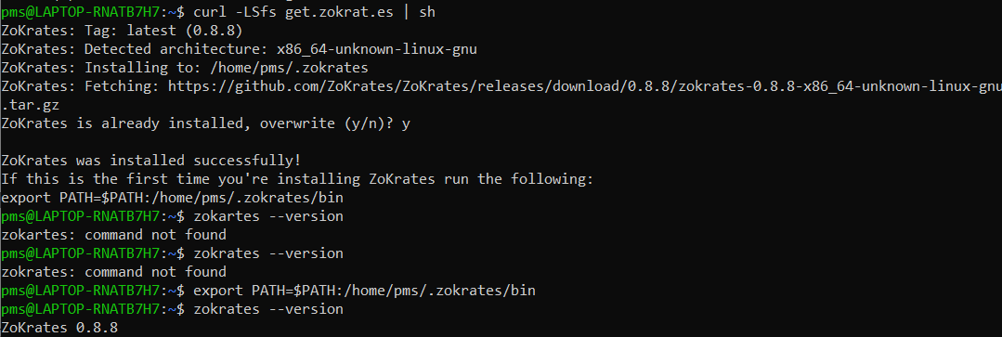

Compilation stage

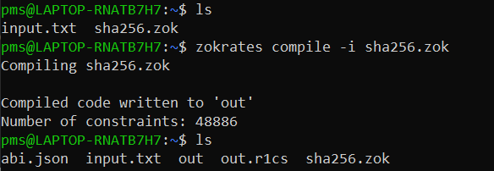

Setup phase where compiled code is used to generate proving & verification keys.

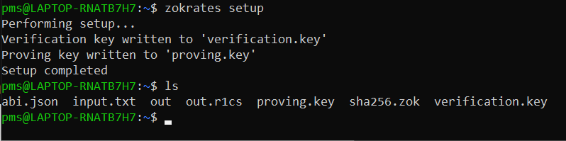

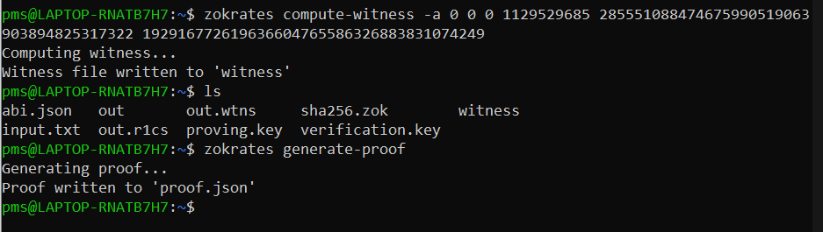s