DriftLess
Automated Cloud-Side Few-Shot Calibration
for EOG Gaze Estimation
Advanced Cloud Computing — Project Report
Submitted by
Sneha Prasad (24BEC0391)
Anushvi Tiwari (24BEC0310)
Sambhav Mandawewala (24BML0093)
Repository: github.com/snehaprasad11/DriftLess
Live demo: driftless-demo.onrender.com

Abstract
Electrooculography (EOG) enables camera-free, hands-free gaze interfaces but suffers from baseline drift — a slow, person-specific wander of the signal that makes a model tuned for one user inaccurate for the next. Prior work corrects drift manually and offline. DriftLess reframes the problem as a live, cloud-native service: a single shared deep-learning model is personalised to each brand-new user in seconds by few-shot fine-tuning of a tiny drift adapter, and served with millisecond latency. On subjects the model never trained on, calibration reduces near-term gaze error by up to 34% (best configuration) and ~11% averaged across all six subjects in leave-one-subject-out evaluation, helping five of six. The system is delivered as containerised microservices (API gateway, stateless inference, an asynchronous calibration worker behind a Redis queue, and a versioned model registry), runs locally with one command, is serverless-deployable with scale-to-zero, and includes automated tests, CI, verified Kubernetes autoscaling, and a live streaming demonstration.

Table of Contents

1. Introduction

1.1 Background — EOG
The eye behaves like a small dipole: the cornea is slightly positive and the retina slightly negative. Electrodes placed on the skin around the eyes register the voltage change as the eye rotates, so eye movement becomes an electrical signal with no camera required. This makes EOG well suited to assistive technology (users who cannot use their hands), AR/VR input, and hands-busy settings such as surgery or industrial work.

1.2 The problem — baseline drift
Even when the eye is perfectly still, the EOG baseline slowly wanders due to sweat, skin properties, temperature and electrode chemistry. This drift is (a) person-specific — every user drifts differently — and (b) time-varying — it changes within a single session. Because drift makes a still eye look like a moving one, it corrupts any attempt to estimate where the eye looked. Traditional fixes use hand-tuned signal-processing applied per subject, offline, and are not designed to run as a live, scalable service.

1.3 Contribution
No prior system makes drift correction an automatic, live, scalable cloud service. DriftLess contributes a method-plus-system: automated cloud-side few-shot calibration of a shared EOG model to each user's individual drift signature, with per-user model versioning and elastic serving.

2. Dataset
This work uses the UM Malta EyeCon EOG dataset, a public research dataset from the University of Malta, Centre for Biomedical Cybernetics (CBC). It contains real recordings from six healthy subjects (two male, four female; mean age 24.7). Two EOG channels — horizontal (V3−V4) and vertical (V1−V2) — were recorded at 256 Hz and band-pass filtered (0–30 Hz, 50 Hz notch).
Each subject performed 300 trials (three sessions of 100). Every trial has the same 4-second structure: a forward saccade from the centre to a random target (~1 s), a return saccade back to the centre (~1 s), and a blink (~2 s). Ground-truth target gaze angles (in degrees) are provided per saccade, and a control signal labels every sample as forward saccade, return saccade or blink. We use Dataset 1 — the cleanest, zero-centred horizontal + vertical bipolar EOG — giving 900 labelled windows per subject.
Source: https://www.um.edu.mt/cbc/ourprojects/eyecon/eogdataset/
Reference: N. Barbara, T. A. Camilleri, K. P. Camilleri, “A comparison of EOG baseline drift mitigation techniques,” Biomedical Signal Processing and Control, vol. 57, 2020.

3. System Design and Architecture
DriftLess is composed of six single-responsibility components operating across three lifecycles (build-time, per-new-user, and every-use):
Component | Responsibility | Lifecycle
Edge client | Streams EOG windows; draws predicted gaze | every use
API gateway | Single front door; routes predictions, enqueues calibration | every use
Inference service | Loads a user's model, predicts gaze fast (stateless) | every use
Calibration worker | Few-shot fine-tunes a personal model (background) | per new user
Model registry | Stores base + per-user models, versioned | all
Trainer + CI/CD | Trains the base model; tests and builds on push | build time

Design principles: stateless inference (so copies can be cloned and scaled to zero); asynchronous calibration via a Redis queue so the gateway never blocks on the ~seconds job; one versioned source of truth for models; and vendor-portable, free-tier components.

4. Machine-Learning Method

4.1 Data pipeline
Continuous recordings are cut into fixed 320-sample windows around each saccade and blink. Each window is labelled with the saccade's (x, y) displacement in degrees and a blink flag. Signals are scaled with fixed statistics that preserve the drift rather than per-window recentring (which would erase it), because learning to handle drift is exactly the goal.

4.2 Model — GazeNet
A shared 1D-CNN extracts local shapes (saccade steps, blink spikes); a BiLSTM models their temporal evolution; a small residual drift adapter (~8.4k parameters, ~6% of the model) is the only per-user part; and two heads predict gaze (regression) and blink (classification). Training minimises squared error on gaze plus cross-entropy on blink, using Adam, on a free Google Colab GPU.

4.3 Per-user calibration
For a new user, the backbone and heads are frozen and only the drift adapter is fine-tuned on ~10 of their trials, for a few steps, with mild weight decay. This combines transfer learning, few-shot learning and parameter-efficient fine-tuning. Restricting to the adapter and regularising it prevents the overfitting that occurs when the heads are also trained on so few examples. Because the frozen backbone's features are constant across steps, they are computed once and cached, making calibration fast enough to run even on a 0.1-CPU free tier.

5. Implementation
Each service is a FastAPI or worker process in its own Docker image; docker compose up runs the full stack (gateway on :8000, inference on :8001, Redis, and the worker). The gateway is deliberately light (no PyTorch); inference and worker carry the model. The model registry is a filesystem abstraction locally and swaps to S3-compatible object storage in the cloud behind the same interface.
A pytest suite (16 tests, fully synthetic so it needs no dataset) covers windowing, the network, calibration, the registry and both service APIs. A GitHub Actions pipeline runs the tests and then builds the service images on every push. A single-page web client streams a subject's EOG over a WebSocket and draws the predicted gaze live with a latency read-out and a calibrate button.

6. Evaluation and Results
All evaluation is on subjects the model never trained on (a by-subject split, so there is no data leakage). Gaze error is the mean Euclidean distance between predicted and true (x, y) displacement, in degrees.

6.1 Base model (before personalisation)
Evaluated on | Gaze error | Blink accuracy
Train subjects (reference) | 3.34° | 99.6%
Never-seen (S5 + S6) | 10.18° | 85.4%

The ~6.8° gap between known and new users is the person-specific baseline drift the shared model cannot know in advance.

6.2 Per-user calibration
Near-term (right after calibration): mean 6.4° → 4.2° (−34%); S5 5.5° → 3.8°, S6 7.2° → 4.5°. This was verified live through the deployed stack with ~6 ms prediction latency.
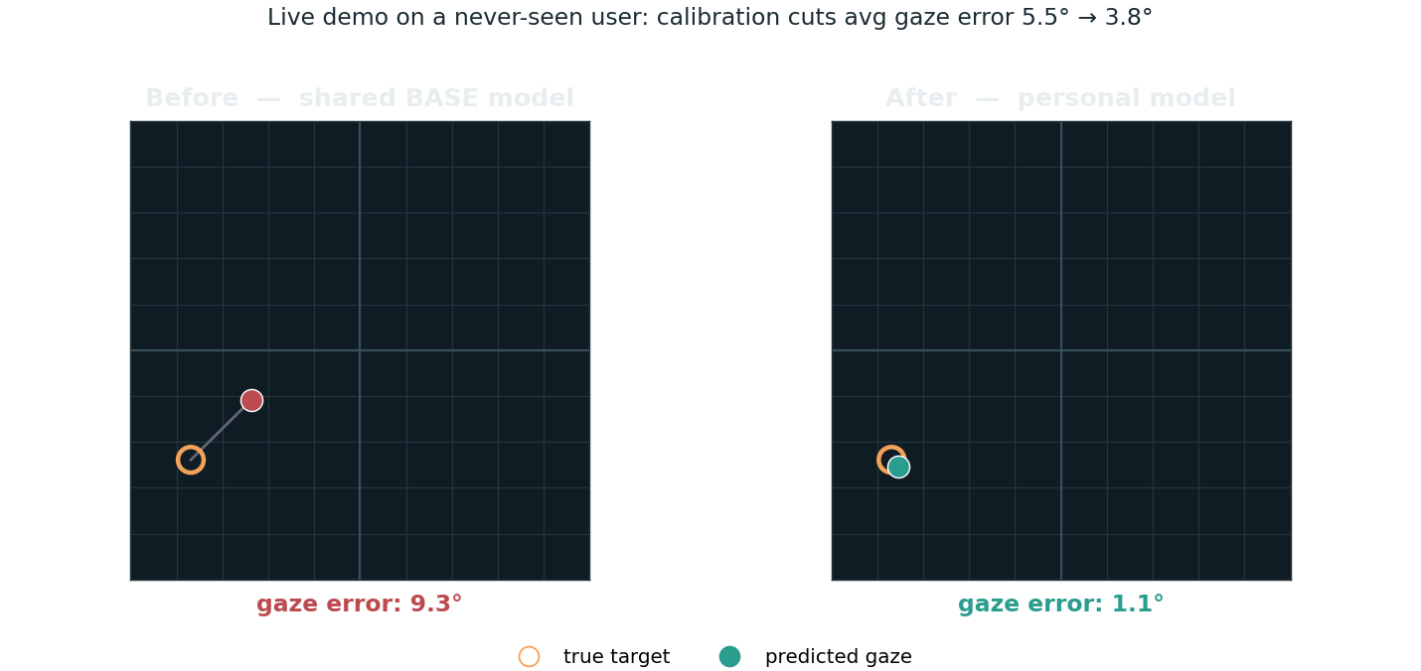
Figure 1 — Live demo on a never-seen user: predicted gaze (dot) vs true target (ring), before vs after calibration.

6.3 Leave-one-subject-out (all six subjects)
The strongest test: every subject takes a turn as the never-seen new user (the model is trained on the other five, then calibrated on ~10 of the held-out subject's trials and evaluated on the rest).

Held-out (new user) | Before | After | Change
S4 | 8.11° | 5.54° | −32%
S3 | 8.52° | 6.47° | −24%
S1 | 10.65° | 9.98° | −6%
S6 | 4.64° | 4.50° | −3%
S2 | 5.52° | 5.40° | −2%
S5 | 5.12° | 5.88° | +15%
Mean | 7.09° | 6.30° | −11%

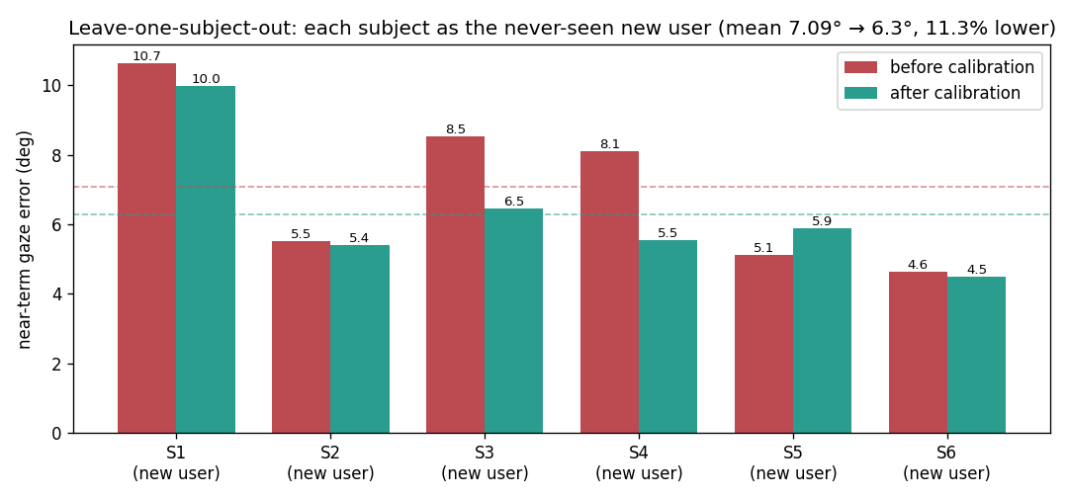
Figure 2 — Leave-one-subject-out: before vs after calibration (near-term).
Calibration helps five of six subjects, for an average near-term improvement of ~11% — real but more modest and variable than the best single split, because with only six subjects one atypical subject swings the mean and outcomes are base-dependent. The mechanism clearly works (large, consistent wins on subjects with real drift, e.g. S3/S4); a firm uniform efficacy claim would require a larger cohort.

6.4 Systems performance
- Prediction latency: ~6 ms round-trip when warm.
- Calibration: a few seconds as a background job (backbone features cached).
- Serverless: stateless inference deploys with scale-to-zero.
- Autoscaling (verified on Kubernetes): 400 queued jobs drove worker CPU to 333% and the HorizontalPodAutoscaler scaled the worker from 1 to 4 pods automatically.
- Quality: 16 automated tests + CI (build and test) on every push.

7. Deployment
The inference service is stateless and binds the platform-injected $PORT, so it deploys to serverless hosts (Google Cloud Run / Render) with min-instances 0 (scale-to-zero). A render.yaml blueprint reduces deployment to connecting the repository. The full visual demo is also deployed publicly and, via a self-contained single-service build, runs the client, prediction and calibration together. The optional Kubernetes path autoscales the worker via a HorizontalPodAutoscaler under load.
Live URLs: demo — driftless-demo.onrender.com/demo/ ; inference API — driftless-inference.onrender.com

8. Limitations and Future Work
- Time-varying drift: a one-time calibration decays over a long session (clearly for S5, mildly for S6). Future work: periodic / continual re-calibration.
- Few subjects (6): public EOG datasets are small, so per-user gains are noisy; leave-one-subject-out keeps the evaluation honest but the sample is small.
- Lab data: recorded with a chin rest and clean electrodes; a real wearable is noisier — live EOG hardware in place of dataset replay is the natural next step.
- Privacy: EOG is biometric; a federated / on-device personalisation extension would keep raw signals on the device.

9. Conclusion
DriftLess turns EOG baseline drift — the field's hardest problem — into an automatic, cloud-native service: a shared model made accurate for a brand-new user in seconds via few-shot calibration of a tiny adapter, served with millisecond latency and evaluated honestly and leak-free. It demonstrates both halves of a modern cloud-ML system: a sound machine-learning method and a scalable, deployable, tested cloud architecture.

References
[1] N. Barbara, T. A. Camilleri, K. P. Camilleri, “A comparison of EOG baseline drift mitigation techniques,” Biomedical Signal Processing and Control, vol. 57, 2020.
[2] University of Malta, Centre for Biomedical Cybernetics — EyeCon EOG dataset. https://www.um.edu.mt/cbc/ourprojects/eyecon/eogdataset/
[3] Project repository. https://github.com/snehaprasad11/DriftLess

