Report (CSN – 291 Project)

**Group Number 18**

**Project Name: Group Expense Tracker**

**Project Type: Android App**

Team Members:

1. Hardik, 19114035
2. Dhrubojeet, 19114029
3. Sneha, 19114082
4. Piyush, 19114061
5. Pramegh, 19114085

Problem Specification

Expense Management System

* This Expense Tracker application serves the important purpose of managing expenses while on trip with friends and colleagues.
* Application allows user to add trip to calculate all the expenses done by each member in the group.
* This application takes all the expenses from multiple users and divides the amount round sum amount between each.
* The application also specifies the name of group member to whom the amount is to be given equally.

UML Diagrams

* **Class Diagram**

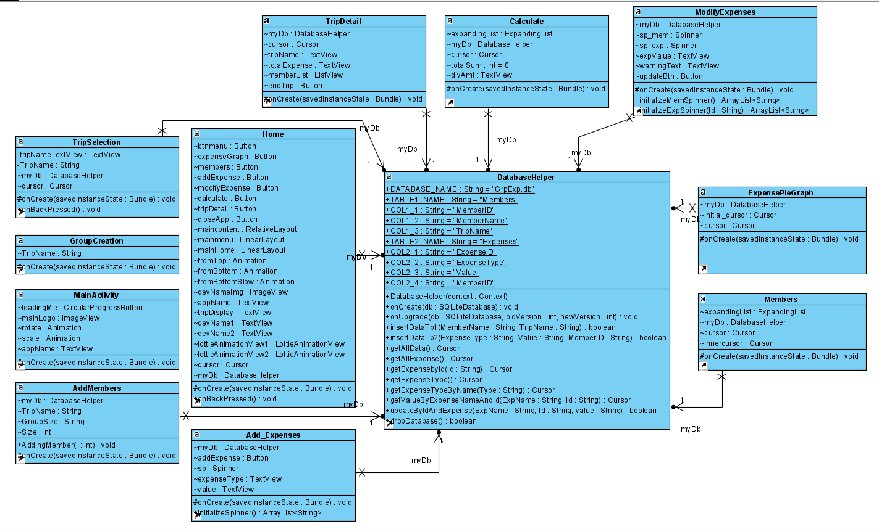

* **Use Case Diagram**

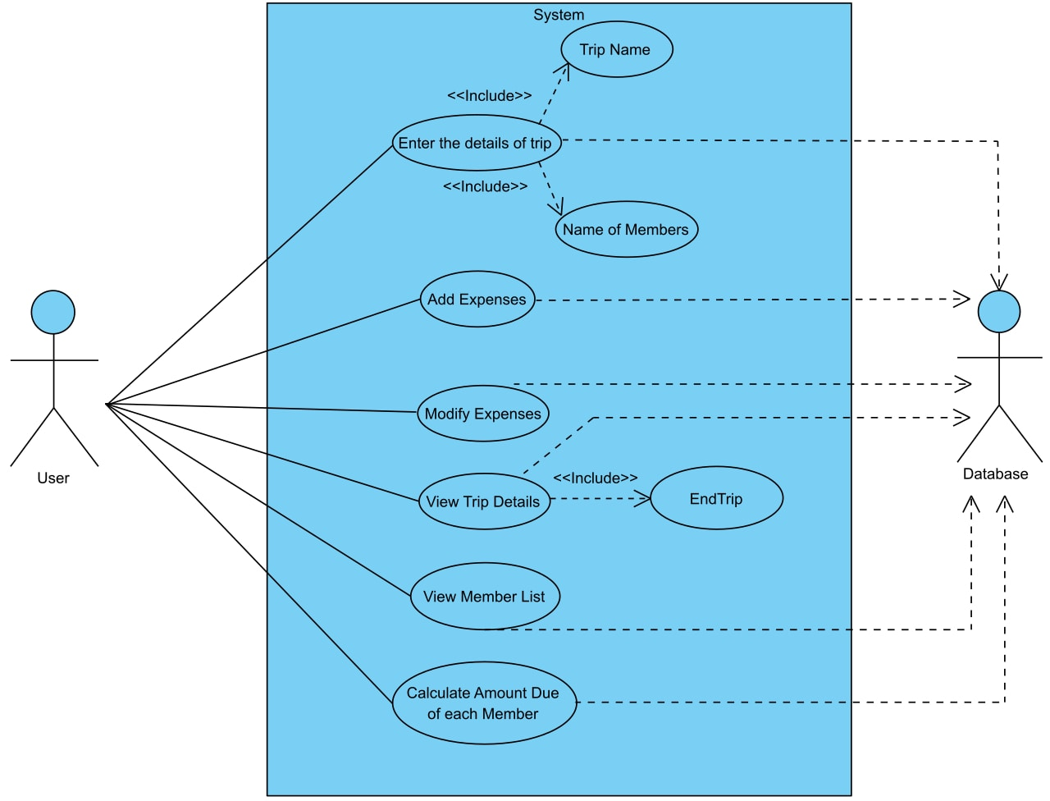

* **Sequence Diagram**

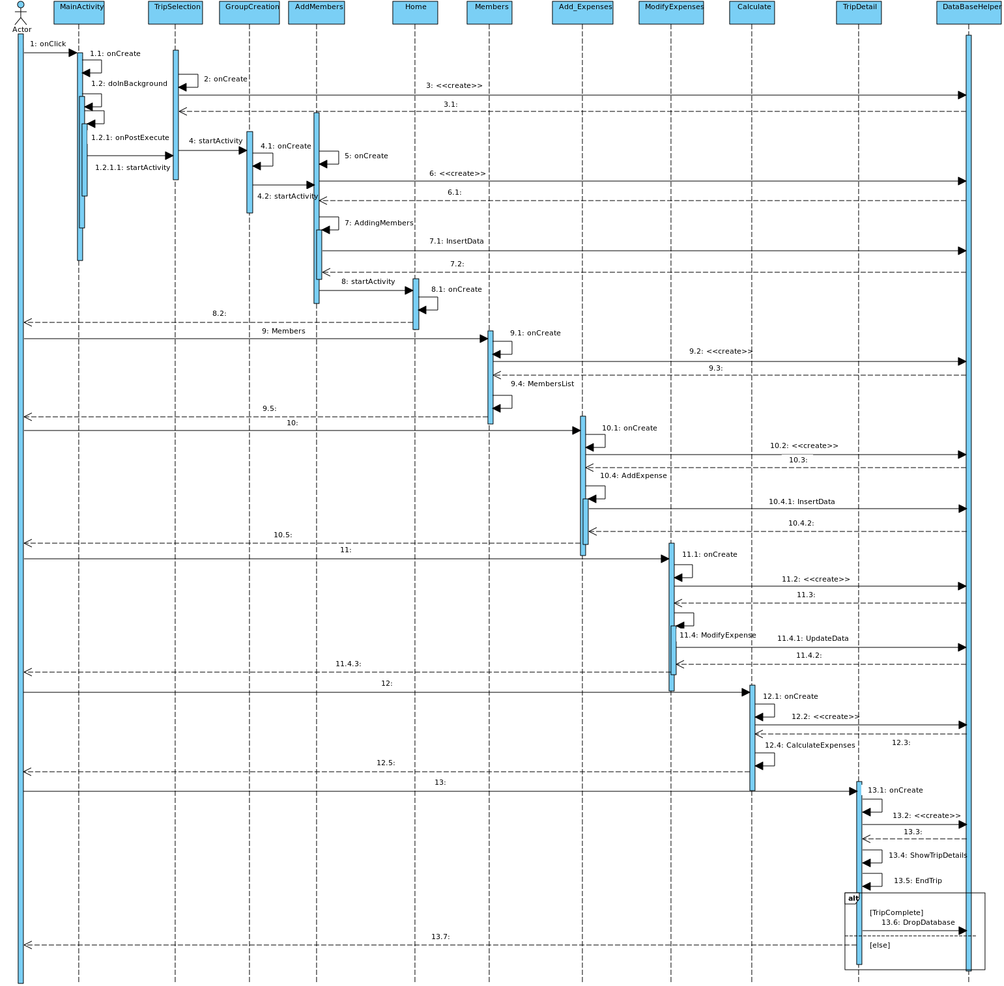

Tools & Technologies used

Software Used: **Android Studio**

Programming Languages used: **Java**

App Compatibility: **Android 4.2 (Jelly Bean) or higher**

**External Libraries** used

* br.com.simplepass:loading-button-android:1.7.2
* com.github.PhilJay:MPAndroidChart:v3.1.0-alpha
* com.diegodobelo.expandingview:expanding-view:0.9.4
* com.sdsmdg.tastytoast:tastytoast:0.1.0
* com.airbnb.android:lottie:2.2.0

Snapshots of Software

