## **how to upload file on github.com using command line**

###### **ChatGPT said:**

ChatGPT

To upload a file to GitHub using the command line, you need to use **Git**, which is a version control system. Below are the steps to upload your files to a GitHub repository via the command line.

### **Pre-requisites:**

1. **Git installed** on your computer. You can check if Git is installed by running git --version in your terminal.
2. **GitHub account** and a **GitHub repository** where you want to upload the file. If you don't have a repository yet, you can create one on GitHub.

### **Steps to Upload a File to GitHub:**

#### **1. Initialize Git (if not already initialized)**

* If you haven't already initialized a Git repository in your project folder, navigate to your project directory and run:

bash

Copy code

git init

#### **2. Add Remote GitHub Repository**

* If you haven’t linked your local repository to a GitHub repository yet, you'll need to add a remote URL.
* Copy the repository URL from GitHub (it should look like <https://github.com/username/repository.git> or git@github.com:username/repository.git).
* Run this command:

bash

Copy code

git remote add origin <repository-url>

Example:

bash

Copy code

git remote add origin <https://github.com/username/my-repository.git>

#### **3. Stage the Files**

* To upload a specific file, you need to **stage** it for commit. Use the git add command:

bash

Copy code

git add <filename>

Example:

bash

Copy code

git add myfile.txt

* If you want to add all files in the directory, you can use:

bash

Copy code

git add .

#### **4. Commit the Changes**

* After staging the file(s), commit the changes with a descriptive message:

bash

Copy code

git commit -m "Added myfile.txt"

#### **5. Push to GitHub**

* Finally, push your changes to GitHub. If it's your first time pushing to the repository or you have no previous commits, you may need to specify the branch (usually main or master):

bash

Copy code

git push -u origin main

* If your repository uses a different branch, replace main with the name of that branch.
* If you have already pushed to the repository before, you can simply use:

bash

Copy code

git push

### **Example Workflow:**

bash

Copy code

# Navigate to your project directory  
cd /path/to/your/project  
  
# Initialize the git repository (if not done already)  
git init  
  
# Add the remote repository URL  
git remote add origin <https://github.com/username/my-repository.git># Stage a specific file for commit  
git add myfile.txt  
  
# Commit the changes  
git commit -m "Added myfile.txt"  
  
# Push to GitHub repository (specifying the branch)  
git push -u origin main

### **Additional Notes:**

* **Authentication**: If you are prompted for authentication when pushing (such as your GitHub username and password), and you are using **HTTPS**, you might want to use **GitHub Personal Access Tokens** instead of your GitHub password (GitHub has deprecated password authentication).
* If you use **SSH**, ensure that your SSH key is added to GitHub to avoid being prompted for a username and password every time you push changes.

### **Troubleshooting:**

* **If you face an error with the push** (like "rejected non-fast-forward"), it might be because the remote repository has changes that aren't in your local repository. In such a case, you should fetch the changes using git pull and resolve any conflicts before pushing again.

bash

Copy code

git pull origin main

4o mini

**Tried this next as resolution 25 Nov 2024 =>**

C:\Users\sneha.putta\sneha-git-space>git branch

* master

C:\Users\sneha.putta\sneha-git-space>git push origin master

info: please complete authentication in your browser...

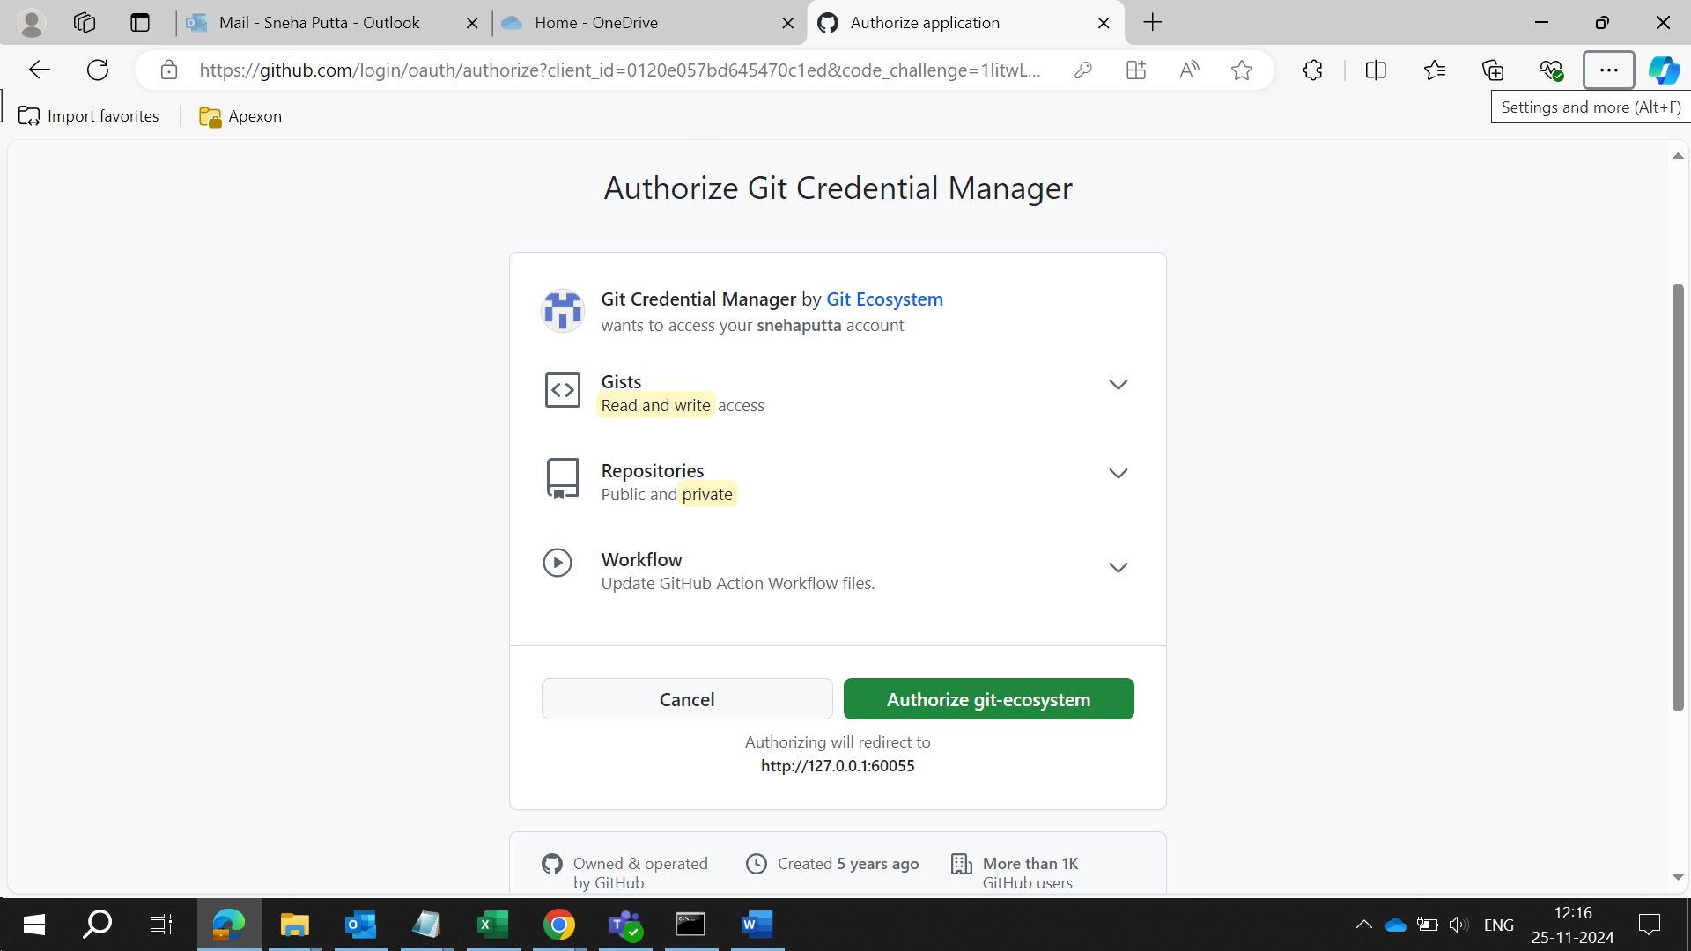

(but did not accept the pull request ... )

C:\Users\sneha.putta\sneha-git-space>git push origin master

info: please complete authentication in your browser...

Enumerating objects: 3, done.

Counting objects: 100% (3/3), done.

Delta compression using up to 8 threads

Compressing objects: 100% (3/3), done.

Writing objects: 100% (3/3), 4.13 KiB | 1.38 MiB/s, done.

Total 3 (delta 0), reused 0 (delta 0), pack-reused 0 (from 0)

remote:

remote: Create a pull request for 'master' on GitHub by visiting:

remote: https://github.com/snehaputta/practice/pull/new/master

remote:

To https://github.com/snehaputta/practice.git

* [new branch] master -> master

C:\Users\sneha.putta\sneha-git-space>

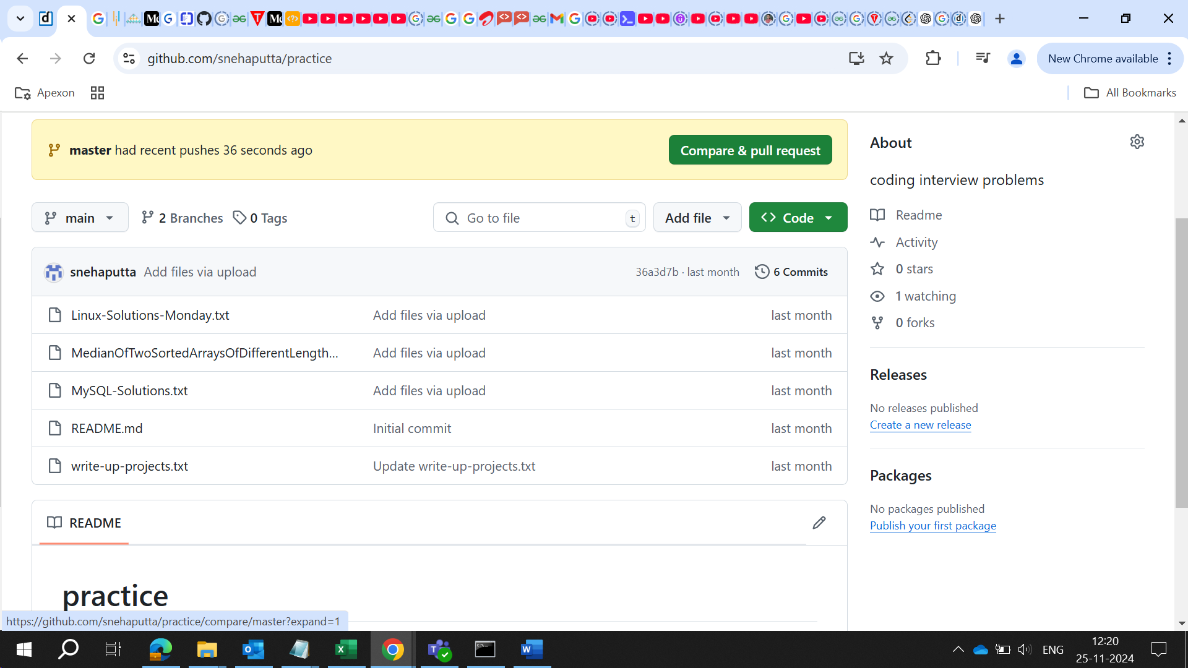

C:\Users\sneha.putta\sneha-git-space>git checkout -b main

Switched to a new branch 'main'

C:\Users\sneha.putta\sneha-git-space>git branch

* main

Master

C:\Users\sneha.putta\sneha-git-space>git push -u origin main

To https://github.com/snehaputta/practice.git

! [rejected] main -> main (fetch first)

error: failed to push some refs to 'https://github.com/snehaputta/practice.git'

hint: Updates were rejected because the remote contains work that you do not

hint: have locally. This is usually caused by another repository pushing to

hint: the same ref. If you want to integrate the remote changes, use

hint: 'git pull' before pushing again.

hint: See the 'Note about fast-forwards' in 'git push --help' for details.

C:\Users\sneha.putta\sneha-git-space>git pull origin main

remote: Enumerating objects: 18, done.

remote: Counting objects: 100% (18/18), done.

remote: Compressing objects: 100% (16/16), done.

remote: Total 18 (delta 5), reused 0 (delta 0), pack-reused 0 (from 0)

Unpacking objects: 100% (18/18), 10.54 KiB | 91.00 KiB/s, done.

From https://github.com/snehaputta/practice

* branch main -> FETCH_HEAD

* [new branch] main -> origin/main

fatal: refusing to merge unrelated histories

**If the remote repository already has content and you want to push your changes from the local repository, you can merge the histories using the following command:**

C:\Users\sneha.putta\sneha-git-space>git pull origin main --allow-unrelated-histories

From https://github.com/snehaputta/practice

* branch main -> FETCH_HEAD

Merge made by the 'ort' strategy.

Linux-Solutions-Monday.txt | 130 +++++++++++++++++++++

MedianOfTwoSortedArraysOfDifferentLengths.java.txt | 54 +++++++++

MySQL-Solutions.txt | 113 ++++++++++++++++++

README.md | 2 +

write-up-projects.txt | 39 +++++++

5 files changed, 338 insertions(+)

create mode 100644 Linux-Solutions-Monday.txt

create mode 100644 MedianOfTwoSortedArraysOfDifferentLengths.java.txt

create mode 100644 MySQL-Solutions.txt

create mode 100644 README.md

create mode 100644 write-up-projects.txt

C:\Users\sneha.putta\sneha-git-space>

**Once the histories are merged, you can push your local commits to the remote repository:**

C:\Users\sneha.putta\sneha-git-space>git pull origin main --allow-unrelated-histories

From https://github.com/snehaputta/practice

* branch main -> FETCH_HEAD

Merge made by the 'ort' strategy.

Linux-Solutions-Monday.txt | 130 +++++++++++++++++++++

MedianOfTwoSortedArraysOfDifferentLengths.java.txt | 54 +++++++++

MySQL-Solutions.txt | 113 ++++++++++++++++++

README.md | 2 +

write-up-projects.txt | 39 +++++++

5 files changed, 338 insertions(+)

create mode 100644 Linux-Solutions-Monday.txt

create mode 100644 MedianOfTwoSortedArraysOfDifferentLengths.java.txt

create mode 100644 MySQL-Solutions.txt

create mode 100644 README.md

create mode 100644 write-up-projects.txt

C:\Users\sneha.putta\sneha-git-space>git push origin main

Enumerating objects: 4, done.

Counting objects: 100% (4/4), done.

Delta compression using up to 8 threads

Compressing objects: 100% (2/2), done.

Writing objects: 100% (2/2), 361 bytes | 361.00 KiB/s, done.

Total 2 (delta 1), reused 0 (delta 0), pack-reused 0 (from 0)

remote: Resolving deltas: 100% (1/1), completed with 1 local object.

To https://github.com/snehaputta/practice.git

36a3d7b..34db4e2 main -> main

C:\Users\sneha.putta\sneha-git-space>

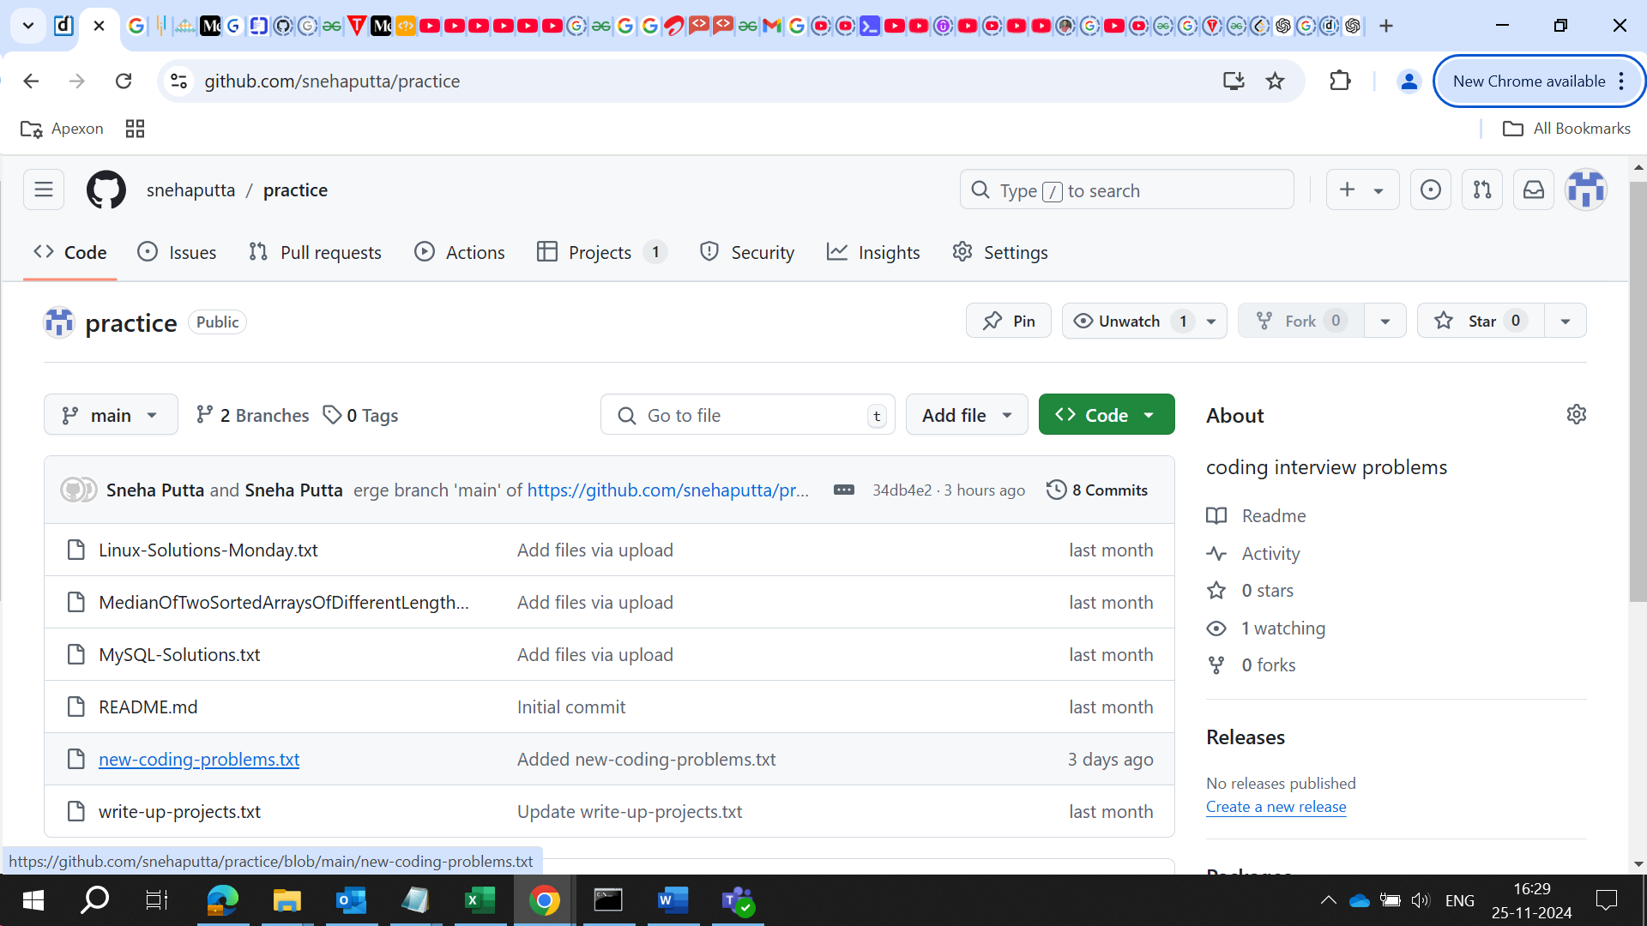

Successfully added to online repository

Below is snapshot from local:

Copy / Paste prevented

## **Difference between Swagger and Postman:**

**Swagger** and **Postman** are both widely used tools in API development and testing, but they serve different purposes and are used at different stages of the API lifecycle. Here’s a breakdown of their key differences:

### **1. Purpose and Use Case**

* **Swagger**:
  + **Purpose**: Swagger (now known as **OpenAPI**) is primarily a **documentation and design tool** for APIs. It is used to **define, describe, and document RESTful APIs** in a standardized format.
  + **Key Use Cases**:
    - **API Documentation**: It helps developers generate interactive API documentation that can be viewed by end users and developers.
    - **API Design**: It allows you to define your API endpoints, request/response formats, authentication methods, and other details in a machine-readable format (OpenAPI specification).
    - **API Mocking**: It can generate mock APIs for testing purposes before the actual implementation is done.
    - **Integration**: It integrates with various tools for auto-generation of client SDKs, server stubs, and more.
* **Postman**:
  + **Purpose**: Postman is a **collaborative API testing tool** that allows developers to **test, debug, and automate the testing of APIs**. It’s primarily used to make **HTTP requests** to APIs, check responses, and automate test scripts.
  + **Key Use Cases**:
    - **API Testing**: It’s widely used for manual and automated API testing, allowing you to send requests and validate responses.
    - **API Monitoring**: Postman can be used to set up automated tests to check API performance over time.
    - **API Automation**: It supports writing test scripts in JavaScript to validate API responses, status codes, headers, and more.
    - **Collaboration**: Postman provides a platform for team collaboration where you can share collections, environments, and test results.

### **2. Key Features**

* **Swagger**:
  + **OpenAPI Specification**: Standard format (JSON or YAML) for describing RESTful APIs.
  + **API Documentation**: Automatic generation of interactive API documentation.
  + **Mock Servers**: Ability to mock API behavior for early testing.
  + **Code Generation**: Can generate client SDKs and server stubs in different programming languages.
  + **Swagger UI**: A web-based UI to interact with APIs and visualize endpoints.
* **Postman**:
  + **API Requests**: Supports a wide range of HTTP methods (GET, POST, PUT, DELETE, etc.) for sending requests to APIs.
  + **Test Scripting**: Allows writing test scripts in JavaScript for validating API responses.
  + **Environment Management**: Supports environments and variables for reusable API calls (e.g., different API keys, base URLs).
  + **Collection Runner**: Allows batch running of API requests with data input from external files.
  + **Collaboration and Version Control**: Postman workspaces for team collaboration, sharing collections, and version control.

### **3. Workflow Integration**

* **Swagger**:
  + More focused on the **design** and **documentation** phases of API development.
  + Swagger files can be shared with developers, allowing them to generate code, documentation, and understand API endpoints.
  + Ideal for **defining** APIs before actual development begins or for documenting already developed APIs.
* **Postman**:
  + More focused on **testing** and **debugging** APIs during the development and post-development phase.
  + Great for **manual testing** and **automated test scripts**.
  + Supports integration with CI/CD pipelines for continuous testing of APIs.

### **4. Collaboration**

* **Swagger**:
  + Collaboration is primarily around the **API specification** and ensuring the API is well-defined across teams.
  + Used mostly by developers and architects to standardize and document API contracts.
* **Postman**:
  + Strong collaboration features for teams working on testing and monitoring APIs.
  + Teams can share collections of requests, environments, and test cases for collaborative API testing.

### **5. User Interface**

* **Swagger**:
  + Swagger UI provides an interactive web interface to visualize and interact with API endpoints directly from the documentation.
  + Typically used by developers to understand how to interact with the API and by consumers who want to see how the API works.
* **Postman**:
  + Provides a desktop and web app with a rich user interface for crafting and sending API requests, viewing responses, and automating tests.
  + Offers a more hands-on interface for testers and developers working with API data and responses.

### **6. Integration and Automation**

* **Swagger**:
  + Swagger integrates with tools like **SwaggerHub**, **Swagger Codegen**, and **OpenAPI Generator** for generating client SDKs and server stubs, facilitating smoother collaboration across teams.
* **Postman**:
  + Supports integration with CI/CD tools (like Jenkins) for **automated API testing**.
  + Can be used to run automated tests as part of a DevOps pipeline.

### **7. Main Focus**

* **Swagger**: API **design** and **documentation**.
* **Postman**: API **testing**, **debugging**, and **automation**.

### **Summary:**

* **Swagger** is great for **defining** and **documenting** APIs using the OpenAPI specification. It's typically used by developers and architects during the **design** phase and to generate interactive API documentation.
* **Postman** is primarily focused on **testing** and **validating** APIs. It's used to send requests, inspect responses, and write automated tests, making it ideal for QA engineers and developers involved in **testing** and **debugging**.

In practice, both tools are complementary: Swagger is often used in the **design and documentation** phases, while Postman is used for **testing and debugging** the API during development and after deployment.

## **how to mention in resume that I have worked on XML and XSLT**

To effectively highlight your experience with **XML** and **XSLT** on your resume, focus on the tasks you performed and how these technologies contributed to the overall project or solution. Here are some examples of how you could phrase this:

### **1. Basic Mention**

* **"Worked with XML and XSLT to design, transform, and process structured data for various applications."**

### **2. Task-Oriented**

* **"Developed and maintained XML schemas, using XSLT to transform XML data into different formats for reporting and integration purposes."**

### **3. Focus on Automation and Efficiency**

* **"Utilized XSLT for efficient XML data transformation, streamlining data flow between systems and improving processing time."**

### **4. Specific Use Cases**

* **"Created and optimized XSLT stylesheets to transform XML data for rendering in HTML and generating dynamic reports."**
* **"Integrated XML and XSLT to facilitate data exchange between external systems, ensuring smooth and accurate data processing."**

### **5. Project or Result-Oriented**

* **"Led the development of XML-based data structures and implemented XSLT transformations to automate the reporting process, reducing manual effort by 30%."**

### **6. Complex Transformations and Processing**

* **"Designed complex XSLT transformations to manipulate XML data for web service consumption and database integration."**

Choose the one that best matches your experience and tailor it to the specific job you're applying for.

## **difference between JaxWS and JaxRS**

**JAX-WS** and **JAX-RS** are two different **Java APIs** for building web services, but they are used in different contexts. Here's a breakdown of their differences:

### **1. JAX-WS (Java API for XML Web Services)**

* **Purpose**: JAX-WS is used for creating **SOAP (Simple Object Access Protocol)** web services. SOAP is a protocol for exchanging structured information in the implementation of web services, using XML as the message format.
* **Architecture**: JAX-WS is focused on **RPC-style** (Remote Procedure Call) web services, where method calls are made over a network using XML-based messages.

**Common Use Cases**:

* + Enterprise applications where formal standards are required (e.g., WS-Security, WS-ReliableMessaging).
  + When interoperability with legacy SOAP-based systems is needed.
* **Protocol**: SOAP
  + The communication is based on the **SOAP** protocol, which is XML-based and supports complex message structures.
* **Data Format**:
  + **XML**: JAX-WS relies heavily on XML for message formatting. It uses the XML Schema Definition (XSD) to define the structure of messages and relies on **WSDL (Web Service Definition Language)** to describe the service.
* **Service Description**:
  + JAX-WS relies on **WSDL** to describe the service and its operations.
* **Binding**:
  + JAX-WS uses **SOAP Binding**, which includes various WS-* (Web Services) specifications such as WS-Security, WS-Addressing, and WS-Reliability.
* **Typical Usage**:
  + JAX-WS is typically used in **enterprise applications** where robust security, reliability, and transactions are critical.

### **Example of JAX-WS Code:**

java

Copy code

@WebService  
public class HelloService {  
 @WebMethod  
 public String sayHello(String name) {  
 return "Hello, " + name;  
 }  
}

### **2. JAX-RS (Java API for RESTful Web Services)**

* **Purpose**: JAX-RS is used for creating **REST (Representational State Transfer)** web services. REST is an architectural style that is lightweight, simple, and based on HTTP, often using JSON or XML as the data format for messages.

**Common Use Cases**:

* + Building modern web applications or microservices that use simple HTTP methods (GET, POST, PUT, DELETE) for communication.
  + Services that need to be stateless and scalable, and interact with various devices and platforms (e.g., web, mobile, IoT).
* **Architecture**: JAX-RS is based on the **RESTful** architectural style. It works with HTTP methods and usually returns data in a standard format like **JSON** or **XML**.
* **Protocol**: HTTP
  + JAX-RS uses the **HTTP** protocol for communication. Requests are typically made using the standard HTTP methods (GET, POST, PUT, DELETE, etc.).
* **Data Format**:
  + **JSON** or **XML**: While JAX-RS can return both XML and JSON, it is often associated with **JSON** for lightweight, modern web and mobile apps.
* **Service Description**:
  + JAX-RS does not require **WSDL** for service description like SOAP does. It uses **annotations** and **Java classes** to define RESTful endpoints.
* **Binding**:
  + JAX-RS uses **HTTP-based** communication, with simple annotations to map HTTP requests to Java methods.
* **Typical Usage**:
  + JAX-RS is ideal for building **lightweight services** and APIs, especially in **microservices** and **cloud-native applications**.

### **Example of JAX-RS Code:**

java

Copy code

@Path("/hello")  
public class HelloResource {  
 @GET  
 @Produces(MediaType.TEXT_PLAIN)  
 public String sayHello() {  
 return "Hello, World!";  
 }  
}

### **Key Differences Between JAX-WS and JAX-RS**

|  |  |  |
| --- | --- | --- |
| **Feature** | **JAX-WS (SOAP)** | **JAX-RS (RESTful)** |
| **Protocol** | SOAP (XML-based messaging protocol) | HTTP (uses HTTP methods like GET, POST, PUT) |
| **Message Format** | XML (SOAP messages) | JSON or XML (usually JSON in modern apps) |
| **Service Description** | WSDL (Web Service Description Language) | No WSDL; uses annotations to define resources |
| **Service Style** | RPC (Remote Procedure Call) or Document Style | Resource-oriented (uses URIs to represent resources) |
| **Complexity** | More complex (supports advanced features like security, transactions, etc.) | Lightweight, simple, and easy to use |
| **Use Case** | Enterprise-level applications, legacy systems, and complex business logic | Modern web services, microservices, mobile apps, and public APIs |
| **Data Format** | XML (usually) | JSON or XML (often JSON) |
| **Security & Reliability** | Supports WS-Security, WS-Reliability, etc. | No built-in advanced security, though can use HTTPS |
| **Statefulness** | Can be stateful (e.g., maintaining session state) | Stateless (designed to be stateless) |
| **Ease of Integration** | Heavier integration due to SOAP complexity | Easier integration with web apps and mobile apps |

### **Summary:**

* **JAX-WS** is best suited for **SOAP-based web services** with a focus on reliability, security, and complex message structures.
* **JAX-RS** is better for **RESTful web services**, offering a simpler, more flexible approach suited for lightweight, stateless communication over HTTP, typically using JSON.

If you’re building a **modern, web-oriented application** or **microservices**, **JAX-RS** is usually the better choice. If you’re dealing with **enterprise-level applications** or need to integrate with legacy systems, **JAX-WS** (SOAP) might be more appropriate.

## Headin 2

## Headin2

## Heaing2

**Finance-Related-Conversations with Chat-GPT-4-mini**

**In the investment context, which is better Systematic Investment Plan or the National Pension Scheme**

When comparing a **Systematic Investment Plan (SIP)** and the **National Pension Scheme (NPS)** in the context of investment, it’s important to note that they are both investment vehicles, but they serve very different purposes and cater to different needs. The choice between SIP and NPS depends on your financial goals, risk tolerance, and investment horizon. Here's a detailed comparison:

### **1. Systematic Investment Plan (SIP)**

* **What is SIP?**
  + **SIP** is a **method of investing** in mutual funds where you invest a fixed amount regularly (monthly or quarterly) in a mutual fund scheme.
  + It's a **flexible and disciplined approach** to investing in mutual funds, allowing you to benefit from **rupee cost averaging** (buying more units when prices are low and fewer units when prices are high) and **compounding** over time.
  + SIPs can be started with a small amount (often as low as ₹500 per month).
* **Key Features of SIP**:
  + **Investment in Mutual Funds**: SIPs allow you to invest in a variety of mutual fund schemes (equity, debt, hybrid, etc.).
  + **Flexibility**: You can choose the amount to invest, the frequency of investment, and the type of fund.
  + **Rupee Cost Averaging**: This method averages the cost of buying units over time, reducing the impact of market volatility.
  + **No Lock-In Period**: SIPs do not have a lock-in period (unless you choose to invest in tax-saving mutual funds like ELSS, which have a 3-year lock-in).
  + **Liquidity**: You can redeem your SIP investment at any time (except in ELSS, where the lock-in applies).
* **Benefits of SIP**:
  + **Discipline**: Encourages regular investing, which is ideal for long-term wealth creation.
  + **Affordability**: Small, regular contributions allow you to start with a low initial investment.
  + **Diversification**: You can invest in a variety of mutual funds, allowing for portfolio diversification across asset classes.
  + **Power of Compounding**: Long-term SIPs benefit from compounding, especially in equity funds.
* **Taxation**:
  + **Tax-saving SIPs (ELSS)**: Eligible for tax deduction under **Section 80C** of the Income Tax Act, with a 3-year lock-in.
  + **Non-tax saving SIPs**: Mutual fund returns are taxed based on the holding period (short-term or long-term capital gains tax).
* **Best Suited For**:
  + Individuals who have a long-term financial goal (e.g., buying a house, funding children's education, retirement).
  + Those looking for **flexible** and **liquid** investment options.
  + Investors who are willing to **take on market risk** and are looking for higher returns in the long term.

### **2. National Pension Scheme (NPS)**

* **What is NPS?**
  + The **National Pension Scheme (NPS)** is a **government-backed retirement savings scheme** designed to provide a **regular income** post-retirement.
  + NPS allows you to invest in a mix of **equity**, **corporate bonds**, and **government securities**, providing a balanced approach to retirement savings.
  + You can start contributing to NPS at the age of 18 and continue until the age of 70.
* **Key Features of NPS**:
  + **Retirement-focused**: NPS is specifically designed to help you save for retirement. It encourages long-term investing and offers a regular pension after retirement.
  + **Tax Benefits**: Contributions to NPS are eligible for tax deductions:
    - **Section 80C**: Contributions of up to ₹1.5 lakh qualify for tax deduction.
    - **Section 80CCD(1B)**: Additional tax deduction of up to ₹50,000 over and above 80C (for NPS contributions).
  + **Asset Allocation**: You can choose between different asset classes (equity, corporate bonds, government securities) based on your risk tolerance. The government has also introduced a **Auto Choice** option where the allocation is automatically adjusted based on your age.
  + **Taxation on Withdrawal**:
    - At retirement, only **40% of the corpus** needs to be used to purchase an annuity (pension), while the rest is available as a lump sum.
    - The **annuity income** is taxed, but the lump sum withdrawal is **tax-free**.
* **Benefits of NPS**:
  + **Government-backed**: NPS is backed by the Government of India, providing a high degree of safety and trust.
  + **Tax Efficiency**: NPS offers tax breaks both during the investment phase and at the time of withdrawal.
  + **Long-term Retirement Savings**: NPS is specifically tailored for long-term retirement planning, providing a structured way to build wealth for retirement.
  + **Low Management Costs**: The **NPS** has relatively low fund management fees compared to mutual funds.
* **Lock-In Period**:
  + Contributions to NPS cannot be withdrawn until the age of 60, except under specific circumstances like premature death or critical illness.
  + Partial withdrawals are allowed after 3 years for specific reasons (e.g., children's education, marriage, purchase of a house).
* **Best Suited For**:
  + Individuals looking for **retirement-focused** investment solutions.
  + Those seeking **tax-efficient long-term savings** and planning for post-retirement income.
  + People who want the security of **government-backed savings** and low-cost management.

### **Comparison: SIP vs NPS**

|  |  |  |
| --- | --- | --- |
| **Feature** | **SIP** | **NPS** |
| **Purpose** | Wealth creation (not specifically for retirement). | Retirement planning and pension accumulation. |
| **Investment Type** | Mutual funds (equity, debt, hybrid, etc.). | Combination of equity, corporate bonds, and government securities. |
| **Tax Benefits** | Tax benefits on ELSS (under Section 80C). | Tax deductions under Section 80C and additional Section 80CCD(1B). |
| **Lock-In Period** | No lock-in for most funds; 3 years for ELSS. | Lock-in until age 60, with partial withdrawals allowed after 3 years. |
| **Withdrawal** | Flexible (except in ELSS). | At age 60 (with 40% mandatory annuity purchase). |
| **Risk Level** | Depends on the mutual fund (equity funds carry higher risk). | Generally lower risk, with a mix of equity and bonds. |
| **Liquidity** | Highly liquid (except for ELSS). | Low liquidity (mainly accessible at retirement). |
| **Returns Potential** | Potentially higher (depends on equity market performance). | Moderate returns, but steady due to a balanced asset allocation. |
| **Management Fees** | Varies depending on the mutual fund scheme. | Generally low (government-backed). |

### **Which is better for you?**

* **Choose SIP if**:
  + Your primary goal is **wealth creation**, and you are investing for long-term goals like **buying a house, children's education**, or **retirement**.
  + You prefer flexibility in terms of investment amount, frequency, and asset allocation.
  + You are comfortable with **market risk** and are willing to let your investments grow over time, benefiting from **compounding**.
* **Choose NPS if**:
  + Your primary goal is to build a **pension corpus** for **retirement** and receive a regular income after retirement.
  + You want a **government-backed** investment with **tax benefits** and a **low-cost structure**.
  + You are looking for a **structured** and **disciplined approach** to retirement savings with a **long-term horizon**.

### **Conclusion:**

* **SIP** is better suited for **flexible, long-term wealth creation** across various goals, especially if you're open to **equity risk** and want to take advantage of **compounding** over time.
* **NPS** is better for **retirement-focused** investors who want the **safety** of a **government-backed** scheme, tax advantages, and a structured pension plan for the future.

Both are excellent tools depending on your specific financial objectives!

**Can I use Systematic Investment Funds for building retirement corpus?**

Yes, **Systematic Investment Plans (SIPs)** are an excellent tool for building a **retirement corpus**. In fact, many investors use SIPs as a part of their long-term investment strategy to accumulate wealth for retirement. SIPs provide the benefits of **discipline**, **rupee cost averaging**, and **compounding**, which are essential for long-term goals like retirement.

However, whether SIP is the best strategy for building your retirement corpus depends on various factors, such as your risk tolerance, time horizon, and the type of mutual funds you choose to invest in. Here's a breakdown of how SIPs can help in building a retirement corpus:

### **How SIPs Work for Building Retirement Corpus**

1. **Discipline and Regular Investing**:
   1. With an SIP, you commit to investing a fixed amount at regular intervals (e.g., monthly), which fosters discipline and helps you avoid market timing mistakes. This disciplined approach can accumulate significant wealth over time.
2. **Rupee Cost Averaging**:
   1. SIPs automatically take advantage of **rupee cost averaging**, meaning that when the market is down, you buy more units of the mutual fund, and when the market is up, you buy fewer units. Over the long term, this helps reduce the impact of short-term market fluctuations, and you end up buying at an average cost over time.
3. **Compounding**:
   1. The **power of compounding** is one of the biggest advantages of SIPs. When you invest consistently over many years, the returns generated on your investments start to earn additional returns (compounding), which can result in significant wealth growth.
4. **Long-Term Growth**:
   1. For retirement, you typically have a **long investment horizon** (20, 30, or even 40 years), which allows your SIP investments to grow significantly over time, especially if you are investing in **equity mutual funds**. Equity-based funds generally provide higher returns over the long term, although they come with higher risk.
5. **Flexibility**:
   1. SIPs offer **flexibility** in terms of the amount you invest and the type of mutual funds you choose. You can start with a small amount (e.g., ₹500 per month) and gradually increase the SIP amount as your income grows. You can also switch funds if your goals or risk appetite change.

### **Types of Mutual Funds for Retirement Corpus**

To build a retirement corpus using SIPs, the choice of mutual funds is crucial. Since retirement is a **long-term goal**, you need to select funds that can provide **higher returns** to outpace inflation and ensure that your money grows over time. Here's a breakdown of different types of mutual funds that you can consider for your retirement corpus:

1. **Equity Mutual Funds**:
   1. **Best for Long-Term Growth**: These funds invest primarily in **stocks** and are suitable for investors with a long investment horizon (10+ years). Over the long term, equity funds have historically provided higher returns compared to other asset classes.
   2. **Types of Equity Funds**:
      1. **Large-cap funds**: Invest in large, well-established companies. These tend to be less volatile and offer steady returns over time.
      2. **Mid-cap and small-cap funds**: Invest in smaller companies with higher growth potential but also higher risk.
      3. **ELSS (Equity Linked Savings Scheme)**: Offers tax deductions under **Section 80C** and a **3-year lock-in** period. These are good for both tax saving and long-term growth.
2. **Hybrid Funds**:
   1. **Balanced Approach**: These funds invest in a mix of **equity** and **debt** instruments, offering a balanced risk-return profile. These funds are ideal for investors who want exposure to both growth (equity) and safety (debt) while being less volatile than pure equity funds.
   2. **Ideal for Moderate Risk Tolerance**: Hybrid funds provide a good mix of capital appreciation and some protection against market volatility.
3. **Debt Funds**:
   1. **Low Risk, Lower Returns**: Debt funds invest in **bonds** and **fixed income** securities. These are typically safer than equity funds but provide lower returns. Debt funds can be used to reduce risk as you approach retirement age, but for long-term retirement planning, they are not the primary driver of returns.
   2. **Suitable for Later Years of Retirement**: As you get closer to retirement, you may want to start shifting a portion of your SIP investments into debt funds to reduce the overall risk of your portfolio.
4. **Index Funds**:
   1. **Low-Cost and Long-Term Growth**: Index funds track a specific market index (e.g., Nifty 50, Sensex). These funds generally have **lower fees** and provide returns similar to the overall market. Over the long term, index funds have the potential to generate steady returns with less effort than actively managed funds.

### **Advantages of Using SIPs for Retirement**

1. **Tax Benefits** (if using ELSS):
   1. **Equity Linked Savings Scheme (ELSS)** mutual funds are eligible for tax deductions under **Section 80C** of the Income Tax Act (up to ₹1.5 lakh per year). This provides the dual benefit of wealth accumulation and tax saving.
2. **No Need for Large Initial Investment**:
   1. You don’t need a large lump sum investment to get started. With SIPs, you can begin with as little as ₹500 per month and gradually increase your investment over time, making it suitable for people at different stages of life.
3. **Compounding Effect**:
   1. SIPs help you capitalize on the **compounding** of returns over time, especially when you're investing in equity or hybrid funds with higher potential returns.
4. **Diversification**:
   1. With SIPs, you can diversify your investment across different types of mutual funds (equity, debt, hybrid), thus reducing overall risk while aiming for long-term returns.
5. **Goal-Oriented Investing**:
   1. SIPs are an ideal way to invest for long-term goals like retirement because you can set clear investment goals, track progress, and adjust as needed over the years.

### **Things to Consider When Using SIPs for Retirement**

1. **Time Horizon**:
   1. For building a **retirement corpus**, you need to start early. The earlier you start SIPs, the more time your investments will have to grow through **compounding**.
   2. SIPs work best when you have a long-term horizon (ideally 15–30 years) to ride out market volatility and benefit from market growth.
2. **Asset Allocation**:
   1. A good retirement corpus typically includes a mix of **equity** for growth in the early years and **debt** or **hybrid funds** as you approach retirement to reduce risk.
   2. Regularly **review and rebalance** your portfolio to ensure it aligns with your risk tolerance and retirement goals.
3. **Inflation**:
   1. The primary challenge for retirement planning is **inflation**, which erodes purchasing power over time. Equity funds, despite their higher volatility, are essential for staying ahead of inflation over the long term.
4. **Withdrawal Strategy**:
   1. Once you reach retirement age, you’ll need a clear strategy for withdrawing your corpus. Many people switch from aggressive (equity-based) funds to safer, income-generating (debt) funds in the years leading up to retirement to preserve capital.

### **Conclusion: SIPs for Retirement**

**Yes**, you can absolutely use SIPs to build your **retirement corpus**, and it can be one of the most effective ways to do so. The key benefits of SIPs—**discipline, flexibility, rupee cost averaging, and compounding**—make them ideal for long-term investment goals like retirement. However, it’s important to choose the right mix of mutual funds (equity, hybrid, and debt) based on your age, risk tolerance, and time horizon. Starting early with SIPs can help you accumulate a significant retirement corpus over time.

If you're looking to supplement your SIP investments, you may also consider other options like the **National Pension Scheme (NPS)**, which is designed specifically for retirement and offers additional tax benefits.

**Other-Chance-Conversations**

**which is better SIP or NPS**

**SIP** (Session Initiation Protocol) and **NPS** (Network Policy Server) are technologies used in completely different domains, so it's not quite accurate to compare them as one being "better" than the other. However, I can explain the roles of each and where each might be appropriate based on their specific use cases.

### **1. SIP (Session Initiation Protocol)**

* **Domain**: Telecommunications / VoIP (Voice over IP)
* **Purpose**: SIP is a **protocol** used for initiating, maintaining, and terminating communication sessions in real-time over the Internet. These sessions can include voice calls, video calls, and messaging.

**Key Features**:

* + **Session Setup and Management**: SIP is used to establish, modify, and terminate communication sessions, such as VoIP calls or video conferencing.
  + **Scalability**: SIP works with various types of media (audio, video, text), making it highly flexible and widely adopted for VoIP systems, Unified Communications (UC), and other real-time communication applications.
  + **Decentralized**: SIP can operate in a peer-to-peer manner, where there is no need for a central server for communication, though servers are often used to handle more advanced features like registration, authentication, and routing.
  + **Interoperability**: SIP is an open standard and can interoperate across different platforms and devices, which is why it’s commonly used in VoIP systems, IP PBXs (Private Branch Exchanges), and conferencing tools.
* **Common Use Cases**:
  + **VoIP** systems (like Skype, Zoom, and Cisco systems)
  + **Video conferencing**
  + **Instant messaging** and presence services (e.g., chat apps)
  + **IP Telephony** and Unified Communications solutions

### **2. NPS (Network Policy Server)**

* **Domain**: Networking / Authentication and Access Control
* **Purpose**: NPS is a **Microsoft server role** used for managing **network access** and **authentication**. It acts as a central point for enforcing network access policies and authentication methods, such as 802.1X, VPN access, and wireless authentication.

**Key Features**:

* + **Authentication**: NPS allows administrators to authenticate users who are trying to access a network, such as through a VPN, wireless network, or RADIUS (Remote Authentication Dial-In User Service) protocols.
  + **Authorization**: It determines what resources a user or device is allowed to access based on predefined network policies.
  + **Accounting**: NPS can log connection requests and track network access activities for auditing and reporting purposes.
  + **Integration with Active Directory**: NPS typically integrates with **Active Directory** (AD), which allows it to use AD credentials to authenticate users and enforce policies based on user or group membership.
  + **RADIUS Support**: NPS functions as a **RADIUS** server, a protocol for remote authentication, and can be used in a variety of network environments for controlling access to services like VPNs, wired and wireless networks, and more.
* **Common Use Cases**:
  + **Remote Access VPNs** (for securely connecting to corporate networks)
  + **Wi-Fi Access Control** (using 802.1X for secure wireless network authentication)
  + **RADIUS-based authentication** for network devices
  + **Centralized policy enforcement** for network access (e.g., conditional access based on device health)

### **Comparing SIP and NPS:**

|  |  |  |
| --- | --- | --- |
| **Feature** | **SIP (Session Initiation Protocol)** | **NPS (Network Policy Server)** |
| **Primary Purpose** | Establishing and managing real-time communication sessions (voice, video, messaging). | Enforcing network access policies and authenticating users. |
| **Domain** | Telecommunications, VoIP, Real-Time Communication. | Networking, Authentication, Access Control. |
| **Use Case** | VoIP calls, video conferencing, real-time chat, and messaging. | Controlling and securing access to networks (e.g., VPNs, Wi-Fi). |
| **Technology Type** | Protocol for communication. | Server role for network authentication and authorization. |
| **Common Protocols** | SIP, RTP (Real-time Transport Protocol). | RADIUS, 802.1X, EAP (Extensible Authentication Protocol). |
| **Key Benefit** | Enables flexible, decentralized, and scalable communication. | Centralized policy management for secure network access. |

### **Which One is "Better"?**

It depends on your specific needs:

* **SIP** is better if you're working with real-time communication technologies like **VoIP**, **video conferencing**, or **instant messaging**. It's essential in **telecommunications**, **IP telephony**, and **Unified Communication** systems.
* **NPS** is better if you need to manage **network access**, authenticate users, and enforce security policies for network services like **VPNs**, **Wi-Fi** access, and **remote authentication**. It's important in a corporate or enterprise **network security** context where controlling who can access your network and services is crucial.

### **Conclusion:**

* **Choose SIP** if you're dealing with communication technologies (e.g., voice, video, messaging).
* **Choose NPS** if you're focused on **network security**, user authentication, and **access control** to network resources.

They're not directly comparable as they serve different purposes—one for communication (SIP) and the other for network security and management (NPS). Therefore, "better" depends entirely on your use case.

**What is ITIL?**

ITIL, which stands for Information Technology Infrastructure Library, is a set of best practices for IT service management. It provides a practical framework for identifying, planning, delivering, and supporting IT services to businesses.

Here are some key points about ITIL:

* **Service Strategy**: Defines the perspective, position, plans, and patterns that a service provider needs to execute to meet an organization's business outcomes.
* **Service Design**: Guides the design and development of services and their management processes.
* **Service Transition**: Provides guidance on managing the transition of new or changed services into live operations.
* **Service Operation**: Focuses on delivering and supporting services in a manner that meets agreed service levels.
* **Continual Service Improvement**: Ensures that IT services continue to align with changing business needs by identifying and implementing improvements.

ITIL helps organizations improve their efficiency, achieve predictable service levels, and deliver better value to customers. Many IT professionals and organizations adopt ITIL to enhance their service management capabilities.