RESEARCH PAPER

Product Line Profitability & Margin Performance Analysis
for Nassau Candy Distributor

Data Analytics Research Project
Python • Pandas • NumPy • Matplotlib • Seaborn • Plotly • Streamlit
Dataset: Nassau Candy Distributor
10,194 Records • 18 Columns • 15 Products • 3 Divisions • 4 Regions

Project Documentation & Research Paper

1. Abstract
This research paper presents a data-driven analysis of product-line profitability and margin performance for the Nassau Candy Distributor dataset. The study examines 10,194 transaction records across 15 products, 3 divisions, and 4 regions. The analysis focuses on revenue, cost, gross profit, gross margin, profit per unit, contribution, cost intensity, margin risk, and profit concentration. Python-based data preparation and exploratory analysis were combined with an interactive Streamlit dashboard to support management-oriented interpretation. The dataset contained no missing values, duplicate rows, zero or negative sales, invalid units, or non-positive costs. Gross profit was validated as Sales minus Cost for every record. Overall, the dataset generated $141,783.63 in sales, $48,340.83 in cost, and $93,442.80 in gross profit, corresponding to an overall gross margin of 65.91%. The study demonstrates how product profitability analytics can identify margin risks and support pricing, sourcing, and product-mix decisions.

2. Keywords
Data Analytics; Profitability Analysis; Gross Margin; Product Performance; Cost Analysis; Pareto Analysis; Business Intelligence; Streamlit

3. Introduction
In distribution businesses, sales volume alone does not adequately describe commercial performance. A product can generate strong revenue while producing comparatively weak profit because of high cost. Conversely, a lower-sales product may contribute meaningful profit because of stronger margins. Product-line profitability analysis therefore provides a more useful basis for management decisions than revenue analysis alone.
This project applies descriptive and diagnostic analytics to the Nassau Candy Distributor dataset. The scope is intentionally centered on product economics: sales, cost, gross profit, gross margin, contribution, cost intensity, and margin risk. The final output combines a research paper, analytical notebook, processed datasets, and an interactive Streamlit dashboard.

4. Business Background
The dataset represents transaction-level distributor activity with product, order, customer, geographic, division, regional, and financial information. The availability of Sales, Gross Profit, Cost, and Units supports analysis of both financial scale and profitability efficiency.
The business perspective of this project is to identify products that create economic value, products that require margin attention, divisions with stronger profitability, and opportunities for pricing and cost optimization.

5. Problem Statement
Strong sales performance does not necessarily indicate strong profitability. Without product-level margin analysis, management may have difficulty identifying which products create the most economic value, which products carry excessive cost burden, and which products present margin risk. The problem addressed in this study is therefore the need for a structured analytical approach to measure product profitability and translate the results into actionable management decisions.

6. Research Objectives
Measure overall sales, cost, gross profit, and gross margin.
Evaluate profitability at product and division levels.
Identify high-sales products with comparatively weak margins.
Analyze cost intensity and its relationship with gross margin.
Measure revenue and profit contribution to understand portfolio concentration.
Classify products according to margin risk and management priority.
Develop product-level recommendations related to pricing, sourcing, and profitability monitoring.
Build an interactive Streamlit dashboard for decision support.

7. Research Questions
- Which products contribute the most gross profit?
- Which products have the strongest and weakest gross margins?
- Which divisions contribute most to revenue and gross profit?
- Are high-cost percentages associated with weaker margins?
- How concentrated are revenue and profit across the product portfolio?
- Which products should receive priority management review?
- How can the findings support pricing and cost-optimization decisions?

8. Dataset Description
The source file used in this project is Nassau Candy Distributor.csv. It contains 10,194 records and 18 columns covering transaction identifiers, dates, customer information, geography, business structure, products, units, and financial measures.
Category | Fields / Measure | Purpose
Transaction | Row ID, Order ID | Transaction and order identification
Dates | Order Date, Ship Date | Time-based analysis and validation
Customer / Geography | Customer ID, Country/Region, City, State/Province, Postal Code | Customer and geographic context
Operations | Ship Mode | Order-level operational context
Business Structure | Division, Region | Division and regional comparison
Product | Product ID, Product Name | Product-level profitability
Financial | Sales, Gross Profit, Cost | Revenue, cost and profit
Volume | Units | Volume and profit-per-unit analysis
The dataset contains 15 unique products, 3 divisions, 4 regions, 8,549 unique orders, and 5,044 unique customers. No records were removed during preparation.

9. Data Cleaning and Validation
Data preparation was performed using Python and Pandas. Order Date and Ship Date were converted from text to datetime format. Year, Month, Month Name, Year-Month, and Shipping Days were derived for analytical use. The research scope remained focused on profitability rather than shipping-route efficiency.
Missing values: 0
Duplicate rows: 0
Zero sales records: 0
Negative sales records: 0
Zero units: 0
Invalid or negative units: 0
Zero or negative cost: 0
Incorrect Gross Profit calculations: 0
Gross Profit was independently validated using Gross Profit = Sales − Cost. All 10,194 records satisfied this relationship.

10. Methodology and Tools Used

10.1 Methodology
- Data ingestion
- Data validation
- Data preparation
- Exploratory Data Analysis
- Profitability KPI development
- Product and division aggregation
- Cost and margin-risk analysis
- Profit concentration analysis
- Streamlit dashboard development
- Insight and recommendation generation

10.2 Tools and Technologies
Python — data analysis and processing
Pandas — data manipulation and aggregation
NumPy — numerical calculations
Jupyter Notebook — interactive analysis
Anaconda — development environment
Matplotlib / Seaborn — exploratory visualization
Plotly — interactive dashboard charts
Streamlit — interactive dashboard development
CSV — source and analytical output format

11. KPI Framework
The project uses financial and portfolio KPIs to summarize business performance.
Gross Margin % = (Gross Profit / Sales) × 100
Profit per Unit = Gross Profit / Units
Cost % = (Cost / Sales) × 100
Revenue Contribution % = Product Sales / Total Sales × 100
Profit Contribution % = Product Gross Profit / Total Gross Profit × 100
KPI | Overall Value
Total Revenue | $141,783.63
Total Cost | $48,340.83
Gross Profit | $93,442.80
Gross Margin | 65.91%
Products | 15
Orders | 8,549
Customers | 5,044
Records | 10,194

12. Exploratory Data Analysis

12.1 Product Profitability Analysis
Product profitability was calculated by aggregating Sales, Units, Cost, and Gross Profit for each product. Gross Margin % and Profit per Unit were then derived. Product performance is interpreted using both scale and profitability so that high-sales/low-margin products are not overlooked.

12.2 Division Performance Analysis
Division-level aggregation provides Sales, Cost, Gross Profit, Units, Gross Margin, Profit per Unit, Revenue Contribution, and Profit Contribution. Comparing revenue contribution with profit contribution helps identify differences between sales volume and economic contribution.

12.3 Cost Diagnostics
Cost diagnostics compare product Sales with Cost and Cost % with Gross Margin %. Products with elevated cost burden and weaker margins are treated as candidates for procurement, sourcing, or pricing review.

12.4 Margin Risk Analysis
Products with below-median gross margin and at-or-above-median cost percentage are classified as high margin risk. Products with either weaker margin or elevated cost intensity are treated as moderate risk. This creates a practical management-priority framework.

12.5 Profit Concentration Analysis
Products are ranked by revenue and gross profit and cumulative contribution is calculated. The number of products needed to reach approximately 80% of revenue or profit provides a simple measure of portfolio concentration.

13. Findings and Interpretation
The overall portfolio generated $141,783.63 in sales and $93,442.80 in gross profit from $48,340.83 of recorded cost. The resulting aggregate gross margin is 65.91%. These values establish a strong baseline for product-level comparison.
The analysis demonstrates that revenue alone is insufficient for profitability management. Product gross margin, profit per unit, and cost percentage provide complementary measures for evaluating the quality of sales.
The Pareto-style analysis provides an additional portfolio perspective by showing whether revenue and profit are concentrated among a smaller group of products. This supports prioritization of products that have a material effect on overall profitability.

14. Business Recommendations
Pricing Review: Review high-sales products with weaker margins for pricing, discount, and product-mix opportunities.
Cost Optimization: Investigate high Cost % products for procurement, supplier negotiation, sourcing, and avoidable cost opportunities.
Portfolio Prioritization: Protect and monitor products that contribute strongly to gross profit.
Margin Monitoring: Use regular gross margin and cost-percentage monitoring for risk products.
Profit Concentration Management: Pay particular attention to products that account for a large share of cumulative profit.
Product Rationalization: Evaluate persistently weak sales/weak margin products for repositioning or rationalization.

15. Limitations
The study is limited to fields available in the supplied dataset and does not include external market, competitor, or supplier-contract information.
Gross profit is treated as Sales minus Cost; other operating expenses and overheads are not included.
The analysis is descriptive and diagnostic rather than causal.
Risk thresholds based on medians are analytical rules and can be refined using business policy.

16. Conclusion
This study demonstrates an end-to-end framework for product-line profitability analysis using the Nassau Candy Distributor dataset. Data validation, profitability metrics, exploratory analysis, cost diagnostics, concentration analysis, and margin-risk classification were combined to convert transaction-level data into management-oriented insights.
The Streamlit dashboard extends the research by providing interactive filters and visual decision support. The project can support pricing review, cost optimization, product prioritization, and ongoing margin monitoring.

17. Future Scope
Time-series forecasting for sales, cost, and profit
Customer-level profitability and segmentation
Predictive margin-risk modeling
Price and cost scenario analysis
Automated refresh pipelines
Role-specific management dashboards

18. Project Summary
The project transformed raw Nassau Candy Distributor transaction data into a structured profitability analytics solution. The workflow combined data validation, exploratory data analysis, KPI development, product and division analysis, cost diagnostics, profit concentration analysis, recommendations, and interactive dashboard development.
The final solution provides a reusable analytical framework for evaluating product economics and supporting evidence-based management decisions.

19. Key Business Insights
Aggregate gross margin is 65.91%, based on total gross profit of $93,442.80 and total sales of $141,783.63.
The dataset contains 15 unique products, allowing detailed product-level comparison.
High-sales products should be evaluated together with margin rather than revenue alone.
Cost percentage is a useful diagnostic for identifying products that may require cost optimization.
Profit concentration analysis helps management prioritize the products with the largest contribution to total profit.

20. Final Project Deliverables
- Research Paper
- Jupyter Notebook
- Analyzed Dataset
- KPI Summary Dataset
- Product Profitability Analysis
- Division Performance Dataset
- Regional Performance Dataset
- Product Recommendations Dataset
- Profit Concentration Summary
- Streamlit Dashboard
- Dashboard Screenshots / Evidence

21. Declaration
I hereby declare that this project titled “Product Line Profitability & Margin Performance Analysis for Nassau Candy Distributor” was completed as a Data Analytics project. The project involved data validation, exploratory data analysis, profitability KPI development, product and division analysis, margin-risk analysis, profit concentration analysis, management recommendations, and interactive dashboard development.

22. Acknowledgement
I would like to express my sincere gratitude to the organization and mentors who provided the opportunity to undertake this Data Analytics project. I am thankful for the project resources, guidance, and dataset that supported the development of practical skills in data preparation, profitability analysis, visualization, dashboard development, and business interpretation. This project provided valuable experience in transforming raw transaction data into meaningful analytical insights.

23. Learning Outcomes
- Data loading and preparation using Python
- Data validation and quality checking
- Exploratory Data Analysis
- Profitability analysis
- Gross margin analysis
- Product performance analysis
- Division performance analysis
- Cost diagnostics
- Profit concentration analysis
- Risk classification
- Data visualization
- Streamlit dashboard development
- Data-driven recommendation development
- Research-paper preparation
- Interpretation of analytical limitations

24. References
- Nassau Candy Distributor Dataset — Nassau Candy Distributor.csv.
- Project brief and analytical requirements for Product Line Profitability & Margin Performance Analysis.
- Python Documentation — Reference for Python programming and implementation.
- Pandas Documentation — Reference for data manipulation and analysis.
- NumPy Documentation — Reference for numerical computation.
- Plotly Documentation — Reference for interactive visualization.
- Streamlit Documentation — Reference for interactive dashboard development.
- Matplotlib Documentation — Reference for data visualization.

25. Appendix – Dashboard and Analysis Evidence
The Streamlit dashboard provides an interactive view of product profitability, division performance, cost diagnostics, profit concentration, margin risk, and management recommendations.
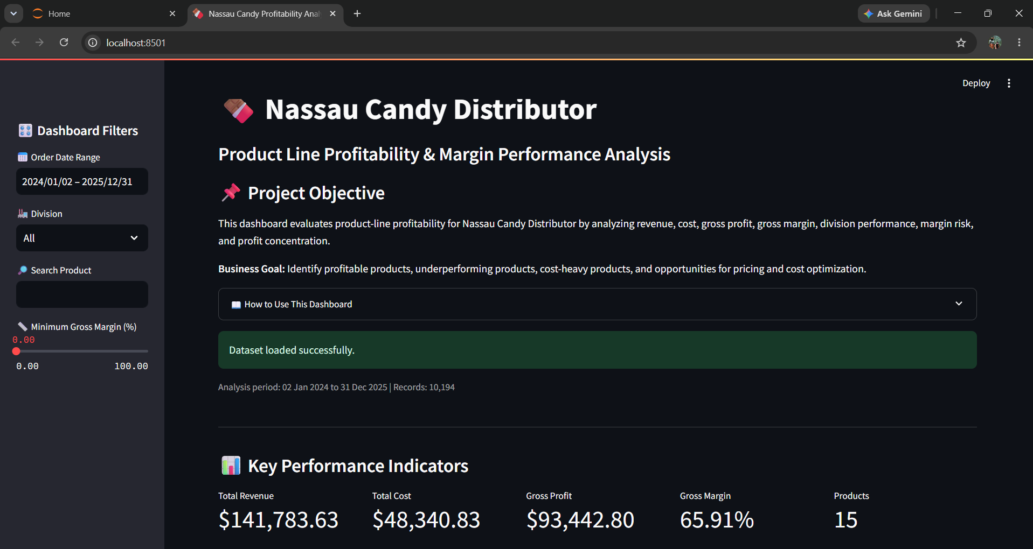

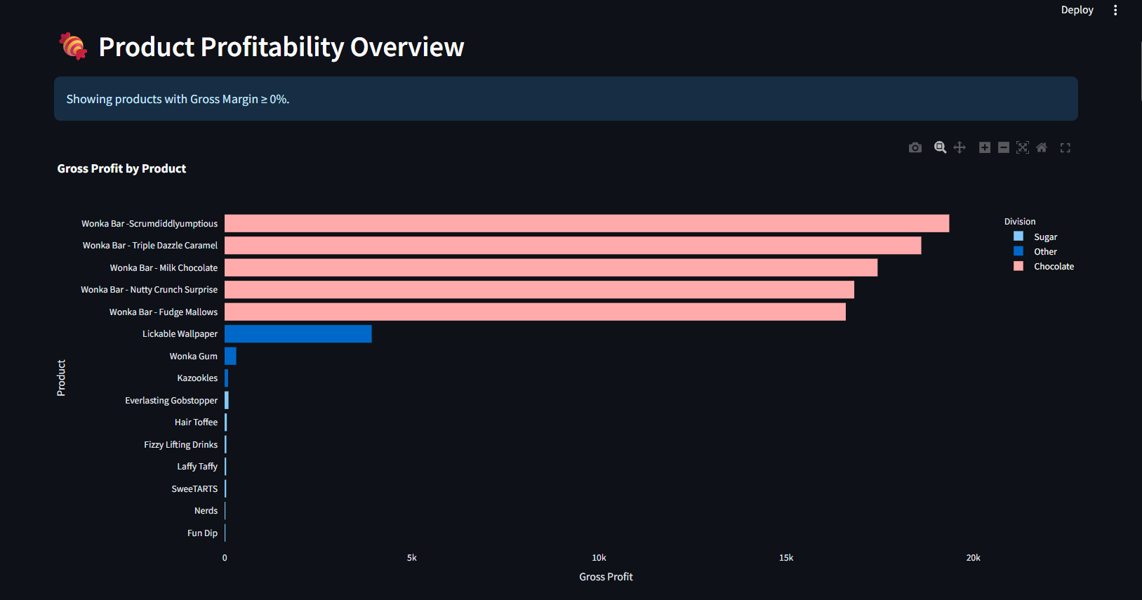

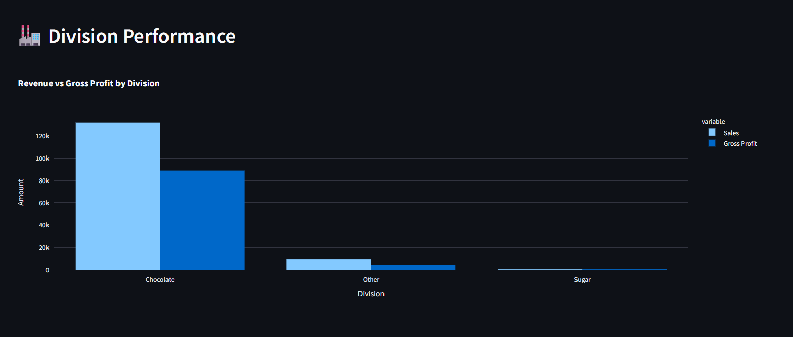
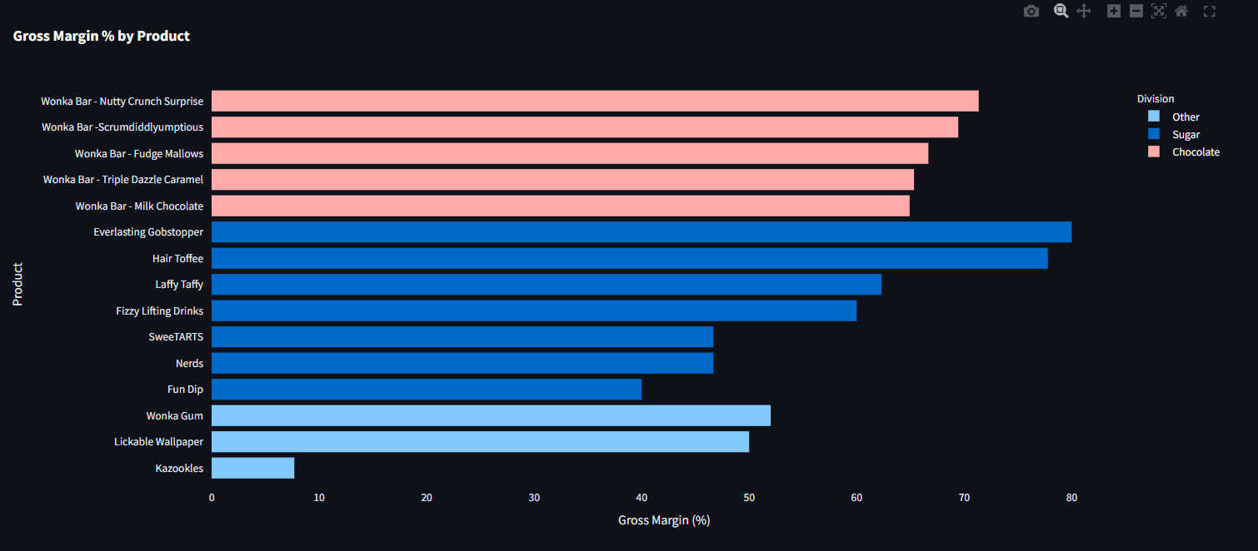

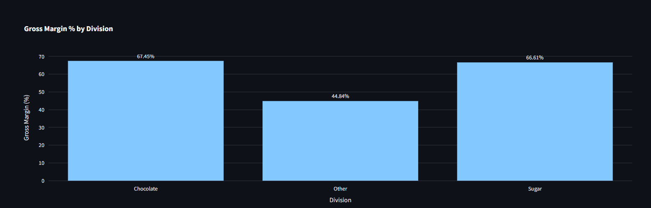

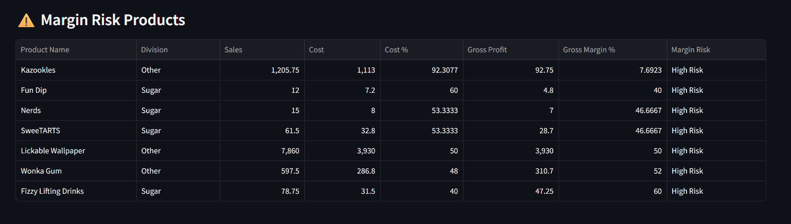
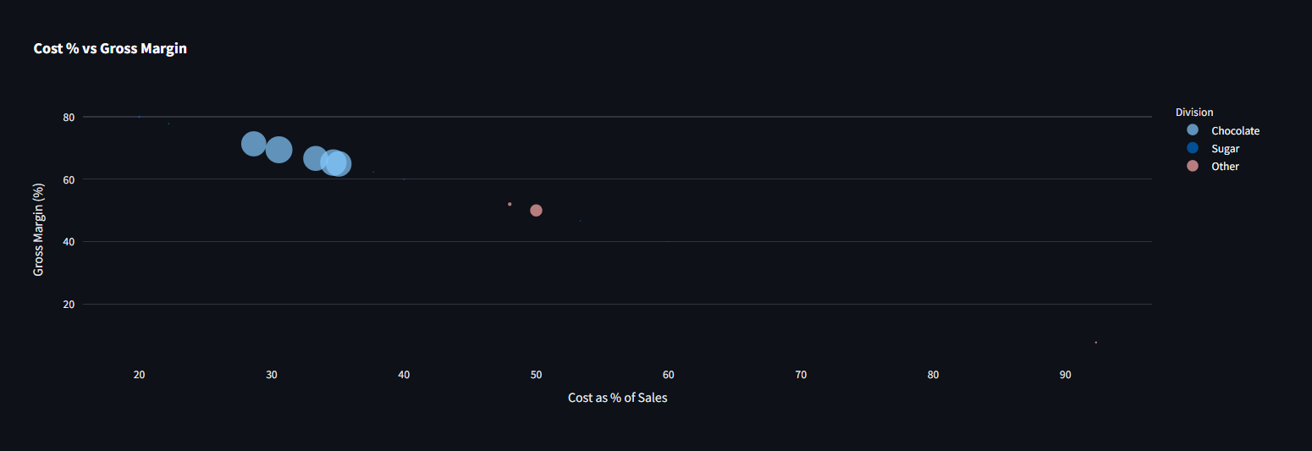
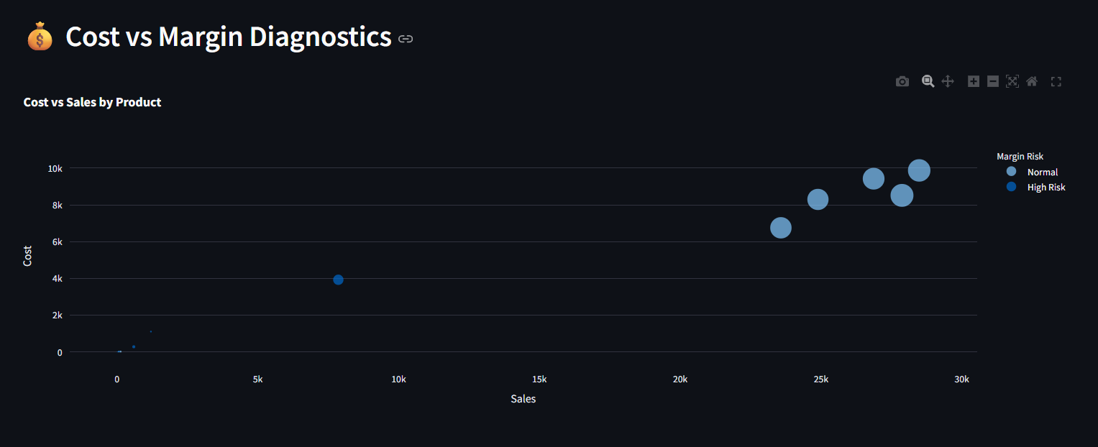

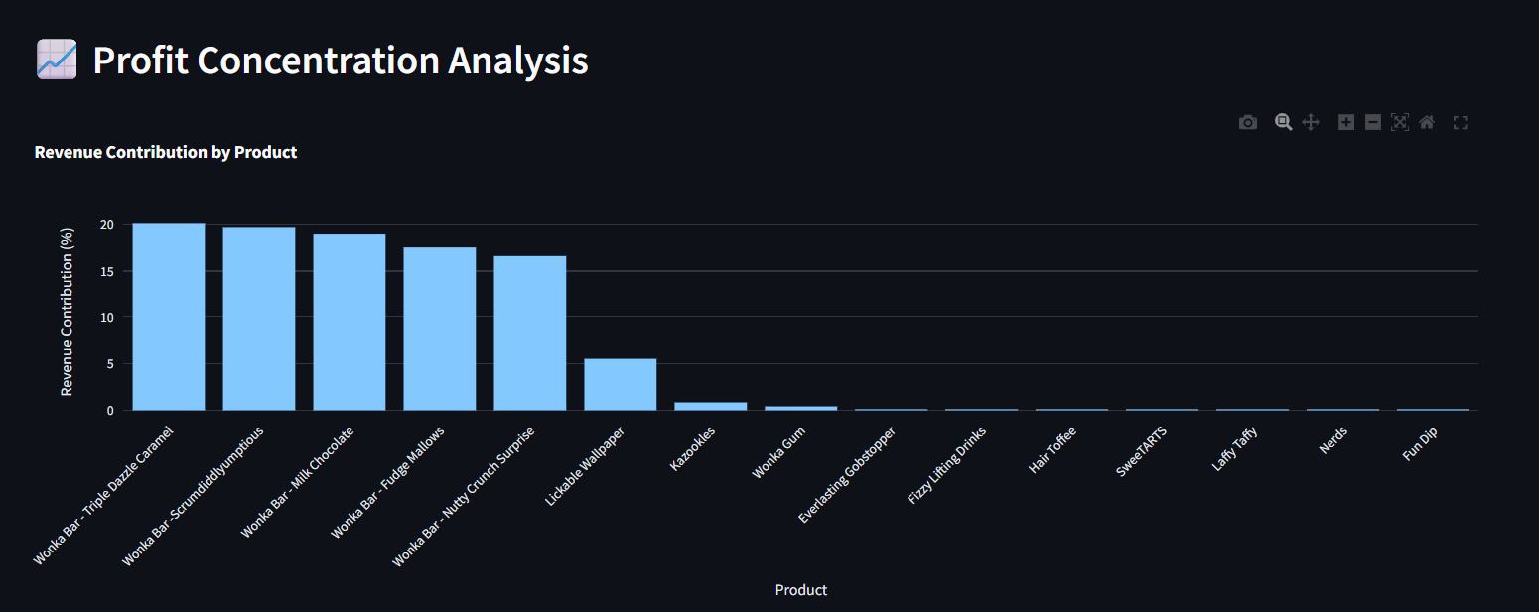

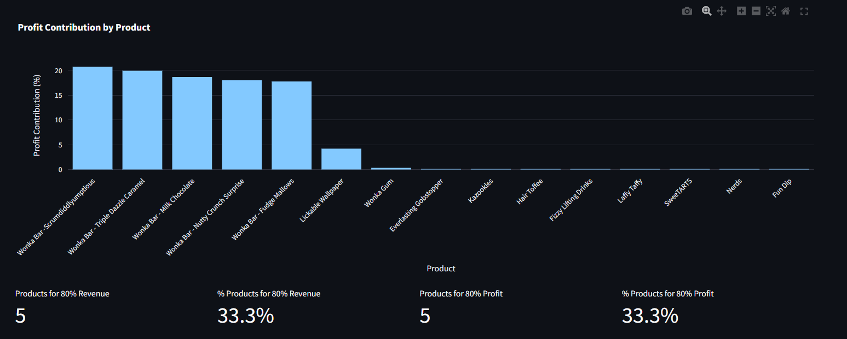

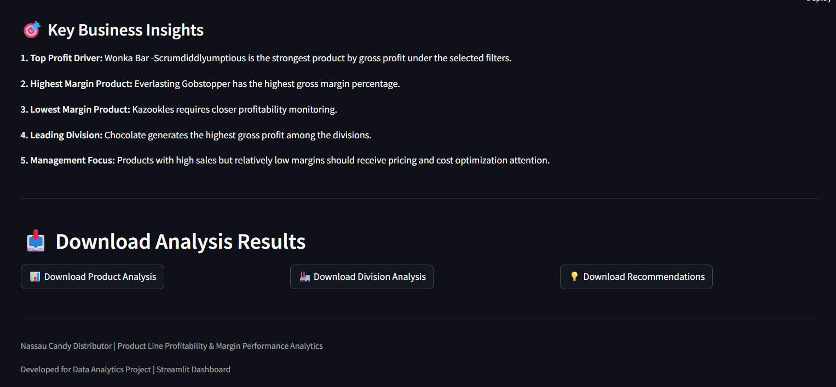
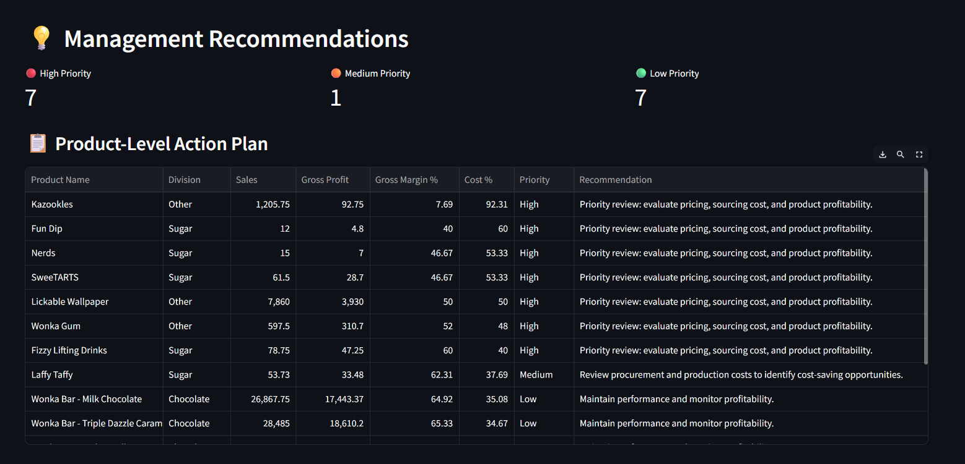

26. Streamlit Dashboard – Introduction
The Streamlit dashboard was developed as the interactive component of the project. It converts the profitability analysis into an interface where users can examine financial performance, product-level margins, division performance, cost diagnostics, profit concentration, and management recommendations.
The dashboard uses Nassau_Candy_Analyzed.csv as its primary analytical data source and provides filters for order-date range, division, product search, and minimum gross margin.

27. Dashboard Features

27.1 KPI Dashboard
Displays Total Revenue, Total Cost, Gross Profit, Gross Margin, and Product Count based on the active date, division, and product filters.

27.2 Product Profitability Analysis
Provides Gross Profit by Product, Gross Margin % by Product, and a detailed profitability table.

27.3 Division Performance
Compares Sales and Gross Profit by Division and displays division-level gross margin.

27.4 Cost vs Margin Diagnostics
Uses interactive scatter plots to compare Cost versus Sales and Cost % versus Gross Margin, while identifying high-risk products.

27.5 Profit Concentration Analysis
Ranks products by revenue and gross profit contribution and calculates the number of products required to reach approximately 80% contribution.

27.6 Management Recommendations
Provides product-level action categories based on gross margin and cost percentage, including High, Medium, and Low priority.

27.7 Interactive Filters
Users can filter by Order Date Range, Division, Product Search, and Minimum Gross Margin.

27.8 Downloadable Outputs
Users can download Product Profitability Analysis, Division Performance, and Management Recommendation tables as CSV files.

28. Final Remarks
The completed project provides a structured analytics framework for understanding product profitability through sales, cost, gross profit, gross margin, cost intensity, and profit contribution. The combination of the research paper, analytical notebook, processed datasets, recommendation outputs, and Streamlit dashboard provides a complete end-to-end Data Analytics project.
The project demonstrates how business transaction data can be transformed into measurable profitability insights and an interactive decision-support tool.

29. End of Document

Project Title: Product Line Profitability & Margin Performance Analysis for Nassau Candy Distributor

Dataset: Nassau Candy Distributor
Project Type: Data Analytics Research Project

End of Document

