PIZZA SALES SQL QUERIES

- KPI’s
- Total Revenue:
SELECT SUM(Total_price) AS Total_Revenue FROM Pizza_sales;
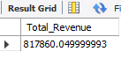
- Average Order value
SELECT SUM(Total_price)/COUNT(DISTINCT Order_ID) AS Average_Order_value FROM Pizza_sales;
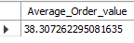
- Total Pizzas sold
SELECT SUM(Quantity) AS Total_pizzas_sold FROM Pizza_Sales;
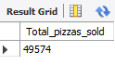
- Total orders placed
SELECT COUNT(DISTINCT Order_ID) AS Total_orders FROM Pizza_sales;
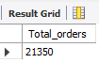

- Average Pizzas per order
SELECT CAST(SUM(Quantity)/COUNT(DISTINCT Order_ID) AS DECIMAL (10,2))AS Average_pizza_per_order FROM Pizza_sales;
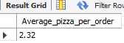

- Charts Requirement

- Daily Trend for Total Orders:
SELECT DAYNAME(STR_TO_DATE(Order_date, '%d-%m-%Y')) AS Order_day,
COUNT(DISTINCT Order_ID) AS Total_orders
FROM Pizza_sales
GROUP BY DAYNAME(STR_TO_DATE(Order_date, '%d-%m-%Y'));

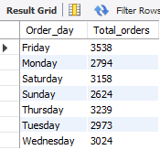

- Monthly Trend of Orders
SELECT MONTHNAME(STR_TO_DATE(Order_date, '%d-%m-%Y')) AS Order_Month,
COUNT(DISTINCT Order_ID) AS Total_orders
FROM Pizza_sales
GROUP BY MONTHNAME(STR_TO_DATE(Order_date, '%d-%m-%Y'));
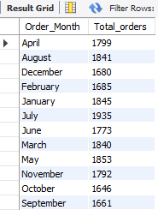
- % Sales by Pizza Category
SELECT
Pizza_category,
SUM(Total_price) AS Total_sales,
CAST(
SUM(Total_price) * 100 /
(
SELECT SUM(Total_price)
FROM Pizza_sales
WHERE MONTH(STR_TO_DATE(Order_date, '%d-%m-%Y')) = 2
)
AS DECIMAL(10,2)
) AS PCT
FROM Pizza_sales
WHERE MONTH(STR_TO_DATE(Order_date, '%d-%m-%Y')) = 2
GROUP BY Pizza_category;

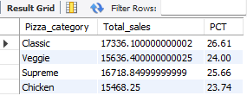
- % Sales by Pizza size
SELECT
Pizza_size,
ROUND (SUM(Total_price),2) AS Total_sales,
CAST(
SUM(Total_price) * 100 /
(
SELECT ROUND(SUM(Total_price),2)
FROM Pizza_sales
)
AS DECIMAL(10,2)
) AS PCT
FROM Pizza_sales
GROUP BY Pizza_size;
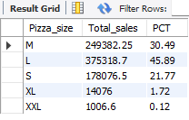

- Total pizzas sold by Pizza category
SELECT Pizza_category, COUNT(Quantity) AS Total_pizzas_sold
FROM Pizza_sales
GROUP BY Pizza_category;
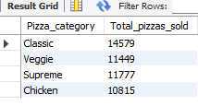

- Top 5 Best sellers by Revenue, Total quantity and total orders
SELECT Pizza_name, SUM(Total_price) AS Total_Revenue FROM Pizza_sales
GROUP BY Pizza_name
ORDER BY Total_Revenue DESC
LIMIT 5;

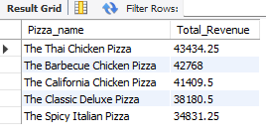
- Bottom 5 Best sellers by Revenue, Total quantity and total orders
SELECT Pizza_name, SUM(Total_price) AS Total_Revenue FROM Pizza_sales
GROUP BY Pizza_name
ORDER BY Total_Revenue
LIMIT 5;
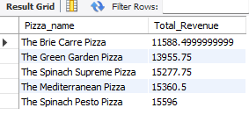

SELECT Pizza_name, SUM(Quantity) AS Total_quantity FROM Pizza_sales
GROUP BY Pizza_name
ORDER BY Total_Quantity DESC
LIMIT 5;
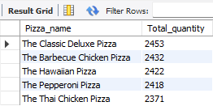
SELECT Pizza_name, COUNT(DISTINCT Order_ID) AS Total_orders FROM Pizza_sales
GROUP BY Pizza_name
ORDER BY Total_orders DESC
LIMIT 5;
