SQL Exercise 1

1. Create the table SEMP with the following structure:-
EMPNO CHAR(4)
EMPNAME CHAR(20)
BASIC FLOAT
DEPTNO CHAR(2)
DEPTHEAD CHAR(4)
- create table SEMP(
- -> Empno char(4),
- -> EMPNAME CHAR(20),
- -> BASIC FLOAT,
- -> DEPNO CHAR(2),
- -> DEPTHEAD CHAR(4));
- Query OK, 0 rows affected (0.25 sec)

2. Create the table SDEPT with the following structure:-
DEPTNO CHAR(2)
DEPTNAME CHAR(15)
- create table SDEPT(
- -> Deptno char(2),
- -> Deptname char(15));
- Query OK, 0 rows affected (0.03 sec)

3. Insert into the SDEPT table the following values:-
10, Development
20, Training
- insert into SDEPT(deptno, deptname) values(10, 'Development'),
- -> (20, 'Training');
- Query OK, 2 rows affected (0.01 sec)
- Records: 2 Duplicates: 0 Warnings: 0

4. Insert into the SEMP table the following values:-
0001, SUNIL, 6000, 10
0002, HIREN, 8000, 20
0003, ALI, 4000, 10, 0001
0004, GEORGE, 6000, 0002
- insert into SEMP values(0001, 'Sunil',6000,10,null),
- -> (0002,'Hiren',8000,20,null),
- -> (0003,'Ali',4000,10,0001),
- -> (0004,'George',6000,null,0002);
- Query OK, 4 rows affected (0.01 sec)
- Records: 4 Duplicates: 0 Warnings: 0
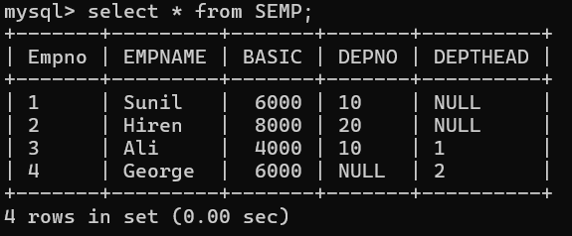

Create S, P, J, SPJ tables as specified below and insert a few rows in each table:-
SUPPLIER
(S#, Sname, Status, City) - S
- create table S(
- -> `S#` varchar(5),
- -> sname varchar(30),
- -> Status int,
- -> city varchar(30));
Query OK, 0 rows affected (0.06 sec)

PARTS
(P#, Pname, Color, Weight, City) - P
- create table P(
- -> `P#` varchar(5),
- -> pname varchar(20),
- -> color varchar(20),
- -> weight int,
- -> city varchar(30));
Query OK, 0 rows affected (0.03 sec)

PROJECTS
(J#, Jname, City) - J
- create table J(
- -> `J#` varchar(5),
- -> jname varchar(30),
- -> city varchar(30));
Query OK, 0 rows affected (0.03 sec)

SUPPLIER-PARTS-PROJECT
(S#, P#, J#, Qty) - SPJ
- create table SPJ(
- -> `S#` varchar(5),
- -> `P#` varchar(5),
- -> `J#` varchar(5),
- -> qty int);
Query OK, 0 rows affected (0.03 sec)

Sample data for S# column:- ‘S1’, ‘S2’, ‘S3’, etc.
INSERT INTO S VALUES
-> ('S1','Smith',10,'London'),
-> ('S2','Jones',20,'Paris'),
-> ('S3','Blake',30,'Rome');
Query OK, 3 rows affected (0.01 sec)
Records: 3 Duplicates: 0 Warnings: 0

Sample data for P# column:- ‘P1’, ‘P2’, ‘P3’, etc.
INSERT INTO P VALUES
-> ('P1','Nut','Red',12,'London'),
-> ('P2','Bolt','Green',17,'Paris'),
-> ('P3','Screw','Blue',14,'Rome');
Query OK, 3 rows affected (0.01 sec)
Records: 3 Duplicates: 0 Warnings: 0

Sample data for J# column:- ‘J1’, ‘J2’, ‘J3’, etc.

mysql> INSERT INTO J VALUES
-> ('J1','ProjectA','London'),
-> ('J2','ProjectB','Paris'),
-> ('J3','ProjectC','Rome');
Query OK, 3 rows affected (0.01 sec)
Records: 3 Duplicates: 0 Warnings: 0

Sample data for Status column:- 10, 20, 30, etc.
INSERT INTO SPJ VALUES
-> ('S1','P1','J1',100),
-> ('S2','P2','J2',200),
-> ('S3','P3','J3',300);
Query OK, 3 rows affected (0.01 sec)
Records: 3 Duplicates: 0 Warnings: 0

Write the SELECT queries to do the following:-
5. Display all the data from the S table.
- Select * from S;
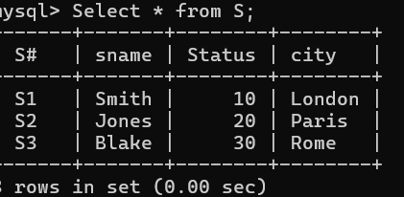
6. Display only the S# and SNAME fields from the S table.
- select `S#`, sname from S;
- 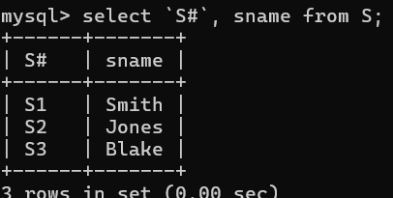

7. Display the PNAME and COLOR from the P table for the CITY=”London”.
- select pname, color from P where city = 'London';
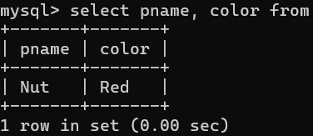
8. Display all the Suppliers from London.
- select * from S where city = 'London';
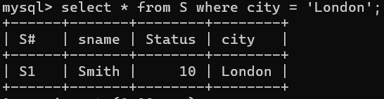
9. Display all the Suppliers from Paris or Athens.
- select * from S where city = 'Paris' OR city = 'Athens';
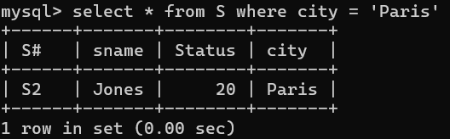
10. Display all the Projects in rome.
- select * from J where city ='rome';
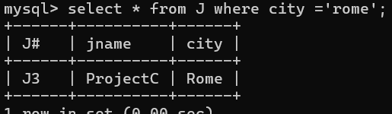
11. Display all the Partnames with the weight between 12 and 14 (inclusive of both).
- select pname from P where weight between 12 and 14;
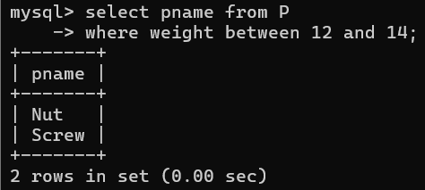

12. Display all the Suppliers with a Status greater than or equal to 20.
- select sname from S where status >=20;
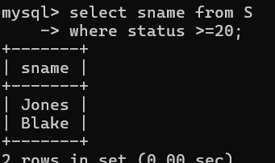
13. Display all the Suppliers except the Suppliers from London.
- select * from S where city != 'London';
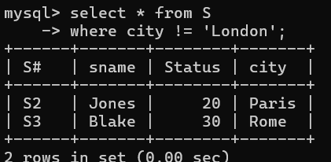
14. Display only the Cities from where the Suppliers come from.
- select DISTINCT City from S;
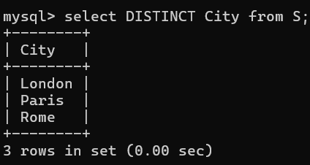
15. Assuming that the Part Weight is in GRAMS, display the same in MILLIGRAMS and KILOGRAMS.
select pname,
-> weight as WeightG,
-> weight * 1000 as WeightMilligrams,
-> weight / 1000 as Weightkilograms
-> from P;
