SQL Exercise 2

1. Display the Supplier table in the descending order of CITY.
- select * from S order by city desc;
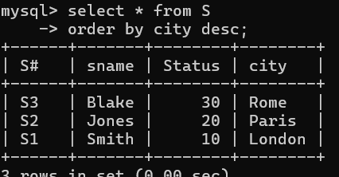

2. Display the Part Table in the ascending order of CITY and within the city in the ascending order of Part names.
- select * from P order by City asc, pname asc;
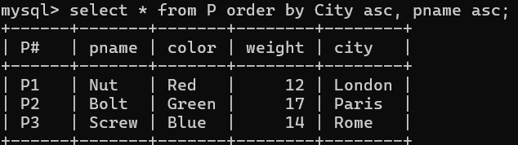

3. Display all the Suppliers with a status between 10 and 20.
- select * from S where status Between 10 and 20;
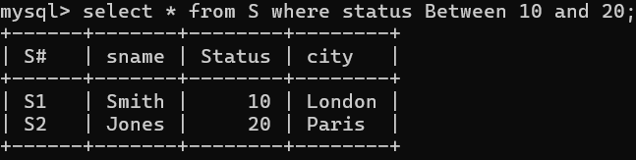

4. Display all the Parts and their Weight, which are not in the range of 10 and 15.
- select * from P where weight NOT BETWEEN 10 and 15;
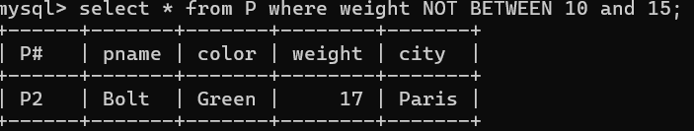

5. Display all the Part names starting with the letter ‘S’.
- select * from P where pname LIKE 'S%';
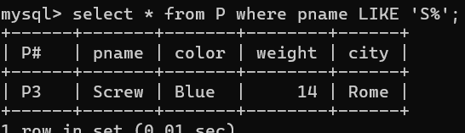

6. Display all the Suppliers, belonging to cities starting with the letter ‘L’.
- select * from S where city LIKE 'L%';
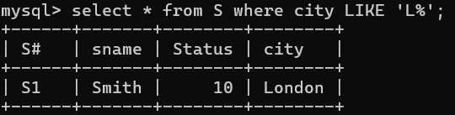

7. Display all the Projects, with the third letter in JNAME as ‘n’.
- select * from J where jname LIKE '__n%';
