SQL Exercise 3

1. Display all the Supplier names with the initial letter capital.
- select concat(upper(left(sname,1)), lower(substring(sname,2))) from S;

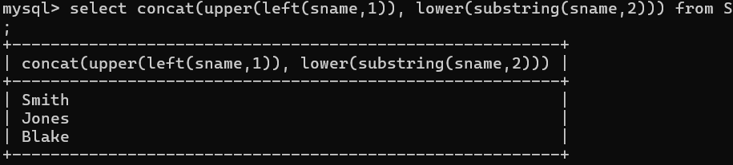

2. Display all the Supplier names in upper case.
- select upper(sname) from S;
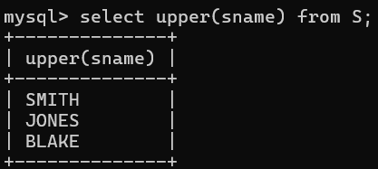

3. Display all the Supplier names in lower case.
- select lower(sname) from S;
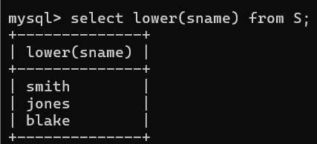

4. Display all the Supplier names padded to 25 characters, with spaces on the left.
- select LPAD(sname,25,' ') from S;
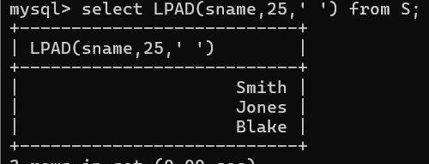

5. Display all the Supplier names (with ‘la’ replaced by ‘ro’). HINT: REPLACE.
- select REPLACE(sname,'la','ro') from S;
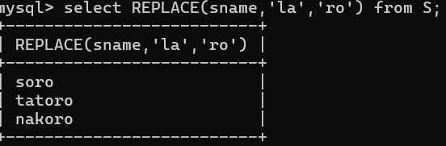

6. Implement the above command such that ‘o’ is replaced with ‘r’ and ‘r’ is replaced with ‘o’.
- select REPLACE(REPLACE(Sname,'r','o'),'l','i') as Modifiednm from S;
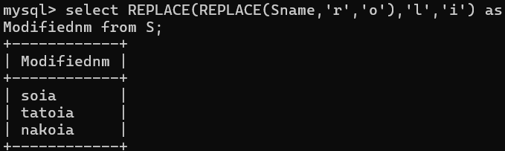

7. Display the Supplier names and the lengths of the names.
- select sname, length(sname)as length from S;
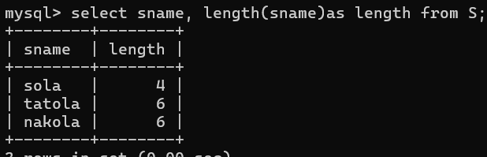

8. Use the soundex function to search for a supplier by the name of ‘BLOKE’.
- select * from S where Soundex(sname) = Soundex('Bloke');

9. Display the Supplier name and the status (as Ten, Twenty, Thirty, etc.).
- select sname,
- -> case
- -> when status = 10 then 'Ten'
- -> when status = 20 then 'Twenty'
- -> when status = 30 then 'Thirty'
- -> else 'Other'
- -> end as Status_in_words
- -> from S;
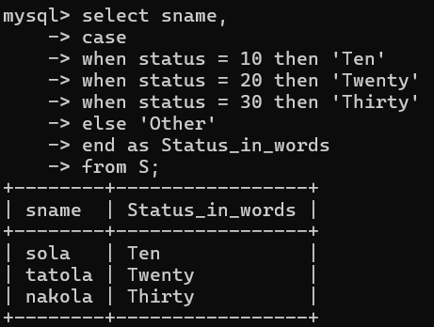
10. Display the current day (e.g. Thursday).
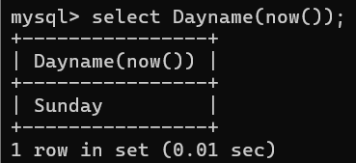
- select Dayname(now());

