SQL Exercise 4

1. Display the minimum Status in the Supplier table.
- select min(Status) from S;
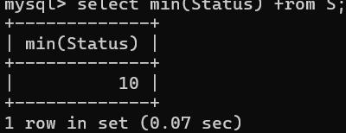
2. Display the maximum Weight in the Parts table.
- select max(Weight) from P;
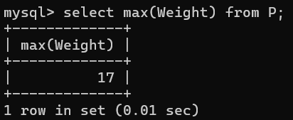
3. Display the average Weight of the Parts.
- select avg(Weight) from P;
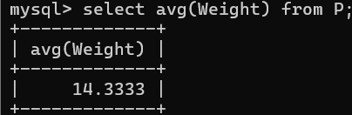
4. Display the total Quantity sold for part ‘P1’.
- select Sum(Qty) from SPJ where `P#` = 'P1';
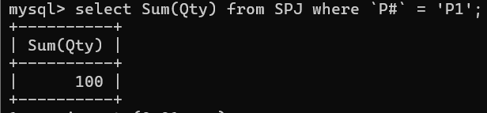
5. Display the total Quantity sold for each part.
- select `P#`, Sum(Qty) from SPJ Group by `P#`;
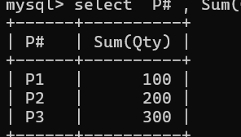

6. Display the average Quantity sold for each part.
- select `P#`, avg(Qty) from SPJ Group by `P#`;
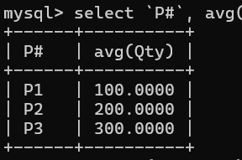
7. Display the maximum Quantity sold for each part, provided the maximum Quantity is greater than 800.
- select `P#`, Max(Qty) from SPJ Group by `P#` having Max(Qty) > 800;
- Empty set (0.01 sec)
8. Display the Status and the count of Suppliers with that Status.
- select Status, COUNT(*) from S Group by Status;
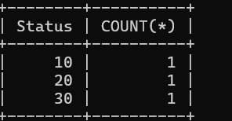
9. Display the count of Projects going on in different cities.
- select City, Count(*) from J group by city;
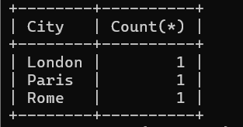
10. What is the difference between COUNT(Status) and COUNT(*) ?
- COUNT(Status)
Counts only non-NULL values in the Status column
Ignores rows where Status is NULL
SELECT COUNT(Status) FROM S;
Counts only rows where Status has a value

- COUNT(*)
Counts all rows.
Includes rows even if they contain NULL values in any column.
SELECT COUNT(*) FROM S;
Counts total number of records in table S

11. Display the Status and the Count of Suppliers with that Status in the following format as shown below:-
Status Count
Ten 1
Twenty 2
Thirty 3
- select case
-> when status = 10 then 'Ten'
-> when status = 20 then 'Twenty'
-> when status = 30 then 'Thirty'
-> else 'Other'
-> End as Status,
-> Count(*) As Count
-> From S
-> Group by Status;
