SQL Exercise 5

1. Display the Supplier name and the Quantity sold.
- select S.sname, SPJ.Qty from S
- JOIN SPJ on S.`S#` = SPJ.`S#`;
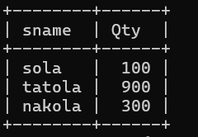
2. Display the Part name and Quantity sold.
- select P.pname, SPJ.Qty from P
- JOIN SPJ on P.`P#` = SPJ.`P#`;
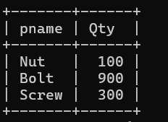
3. Display the Project name and Quantity sold.
- select J.jname, SPJ.Qty from J
- JOIN SPJ on J.`J#` = SPJ.`J#`;
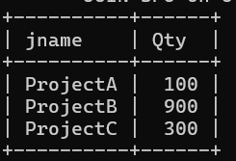
4. Display the Supplier name, Part name, Project name and Quantity sold.
- select S.sname, P.pname, J.jname, SPJ.Qty from SPJ
-> JOIN S on SPJ.`S#` = S.`S#`
-> JOIN P on SPJ.`P#` = P.`P#`
-> JOIN J on SPJ.`J#` = J.`J#`;

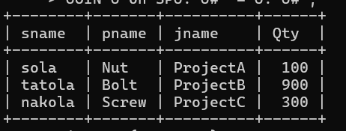

5. Display the Supplier name, Supplying Parts to a Project in the same City.
- select Distinct S.sname, P.pname from SPJ
-> JOIN S on SPJ.`S#` = S.`S#`
-> JOIN P on SPJ.`P#` = P.`P#`
-> JOIN J on SPJ.`J#` = J.`J#`
-> where S.city = J.city;
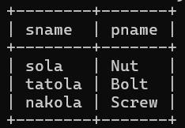
6. Display the Part name that is ‘Red’ is color, and the Quantity sold.
- select P.pname, SPJ.Qty from SPJ
-> JOIN P on SPJ.`P#` = P.`P#`
-> where P.color = 'red';
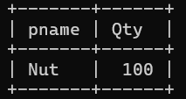
7. Display all the Quantity sold by Suppliers with the Status = 20.
- select SPJ.Qty, S.sname from SPJ
-> JOIN S on SPJ.`S#` = S.`S#`
-> where S.Status = 20;
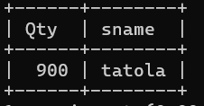
8. Display all the Parts and Quantity with a Weight > 14.
- select P.pname, SPJ.Qty from SPJ
-> JOIN P on SPJ.`P#` = P.`P#`
-> where P.weight > 14;
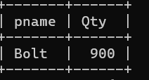

9. Display all the Project names and City, which has bought more than 500 Parts.
- Select J.jname, J.city from SPJ
-> JOIN J on SPJ.`J#` = J.`J#`
-> Group by J.`J#`, J.jname,J.city
-> Having Sum(SPJ.Qty) > 500;
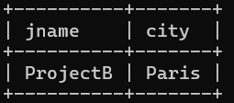
10. Display all the Part names and Quantity sold that have a Weight less than 15.
- Select P.pname, SPJ.Qty from SPJ
-> JOIN P on SPJ.`P#` = P.`P#`
-> where P.weight < 15;
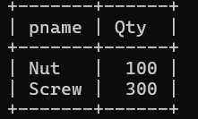
11. Display all the Employee names and the name of their Managers.
- Select E.Empname, M.Mname form Employee
->Left Join Employee M on E.mgrid = E.empid;

