Assignments_1

mysql> create table SalesPeople(
-> Snum int(4),
-> sname varchar(10),
-> City varchar(10),
-> Comm float(3,2));
Query OK, 0 rows affected, 2 warnings (0.20 sec)
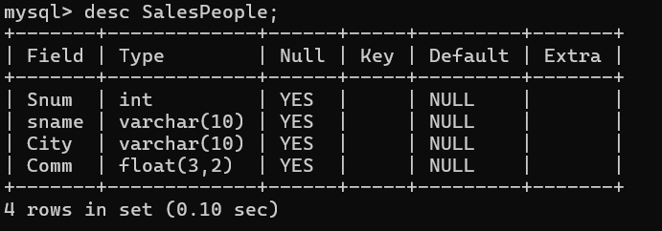

mysql> create table Customers(
-> Cnum int(4),
-> Cname varchar(10),
-> City varchar (10),
-> Rating int(4),
-> Snum int(4));
Query OK, 0 rows affected, 3 warnings (0.15 sec)
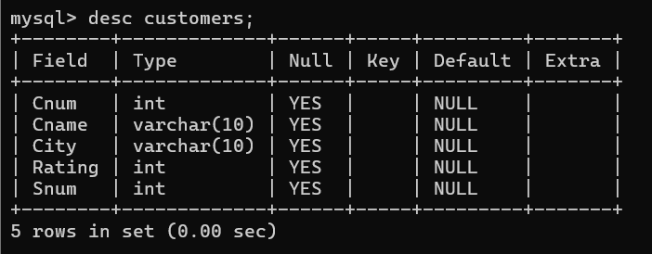

mysql> create table Orders(
-> Onum int(4),
-> Amt float(7,2),
-> Odate date,
-> Cnum int(4),
-> Snum int(4));
Query OK, 0 rows affected, 4 warnings (0.03 sec)
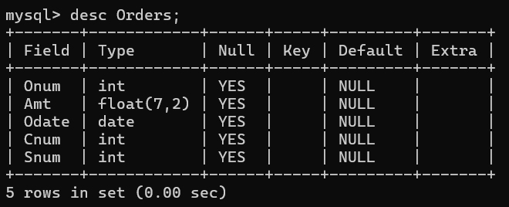

mysql> insert into SalesPeople values(1002,'Serres','San Jose',.13),
-> (1004,'Motika','London',.11),
-> (1007,'Rifkin','Barcelona',.15),
-> (1003,'Axelrod','New York',.10);
Query OK, 4 rows affected (0.11 sec)
Records: 4 Duplicates: 0 Warnings: 0

mysql> select * from SalesPeople;
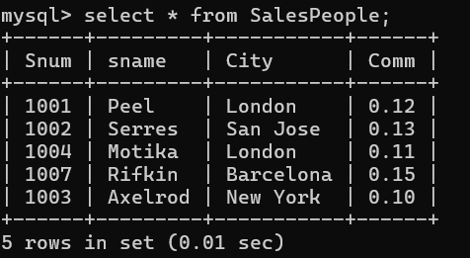

mysql> insert into Customers values(2001,'Hoffman','London',100,1001),
-> (2002,'Giovanni','rome',200,1003),
-> (2003,'Liu','San Jose',200,1002),
-> (2004,'Grass','Berlin',200,1002),
-> (2006,'Clemens','London',100,1001),
-> (2008,'Cisneros','San Jose',300,1007),
-> (2007,'Pereira','Rome',100,1004);
Query OK, 7 rows affected (0.03 sec)
Records: 7 Duplicates: 0 Warnings: 0

mysql> select * from Customers;
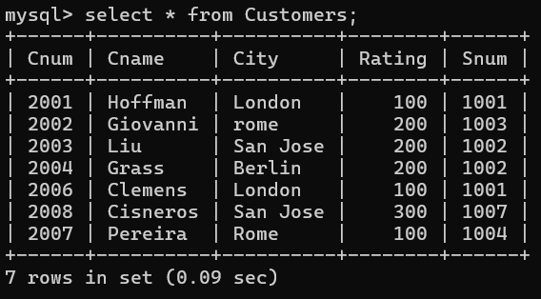

mysql> insert into Orders values(3001,18.69,'1990-10-03',2008,1007),
-> (3003,767.19,'1990-10-03',2001,1001),
-> (3002,1900.10,'1990-10-03',2007,1004),
-> (3005,5160.45,'1990-10-03',2003,1002),
-> (3006,1098.16,'1990-10-03',2008,1007),
-> (3009,1713.23,'1990-10-04',2002,1003),
-> (3007,75.75,'1990-10-04',2004,1002),
-> (3008,4723.00,'1990-10-05',2006,1001),
-> (3010,1309.95,'1990-10-05',2004,1002),
-> (3011,9891.88,'1990-10-06',2006,1001);
Query OK, 10 rows affected (0.01 sec)
Records: 10 Duplicates: 0 Warnings: 0

mysql> Select * from Orders;
