Assignment – 12
Using the operators IN, ANY, and ALL.
1) Write a query that selects all customers whose ratings are equal to or greater than ANY of Serres’.
- select * from Customers
-> where rating >=Any (
-> Select rating
-> from Customers
-> where cname = 'Serres'
-> );
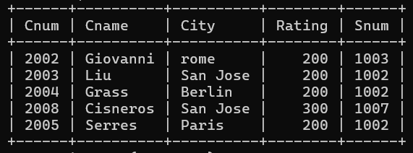
2) Write a query using ANY or ALL that will find all salespeople who have no customers located in their city.
- select * from Salespeople s
-> where s.city <> ALL (
-> Select c.city
-> from Customers c
-> where c.snum = s.snum
-> );
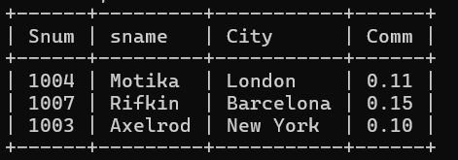
3) Write a query that selects all orders for amounts greater than any for the customers in London.
- select * from Orders
-> where amt > ANY (
-> select O.amt -> From Orders O
-> Join Customers c ON O.cnum = c.cnum
-> where c.city = 'London'
-> );
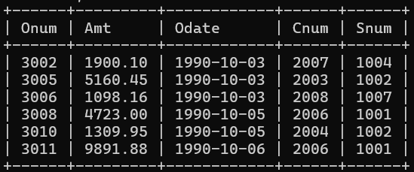
4) Write the above query using MIN or MAX.
- select * from Orders
-> where amt > (
-> select Min(O.amt)
-> From Orders O
-> Join Customers c ON O.cnum = c.cnum
-> where c.city = 'London'S
-> );
