Assignment – 19
Views

1) Create a view that shows all of the customers who have the highest ratings.
- create VIEW TopCustomers As
-> Select * from Customers
-> where rating =(Select MAX(rating) from Customers);
Query OK, 0 rows affected (0.01 sec)
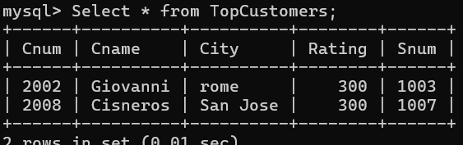
2) Create a view that shows the number of salespeople in each city.
- create VIEW SalepeoPerCity AS
-> Select City, Count(*) as num_Salespeo
-> from Salespeople
-> Group by city;
Query OK, 0 rows affected (0.01 sec)
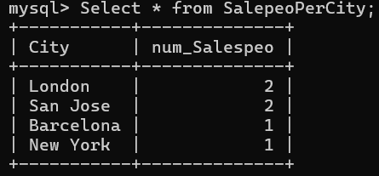
3) Create a view that shows the average and total orders for each salesperson after his or her name. Assume all names are unique.
- create VIEW SalesSummary AS
-> Select S.sname,
-> SUM(o.amt) AS totalOr,
-> AVG(o.amt) AS avgOr
-> from Salespeople S
-> JOIN orders o On S.snum = o.snum
-> Group by S.sname;

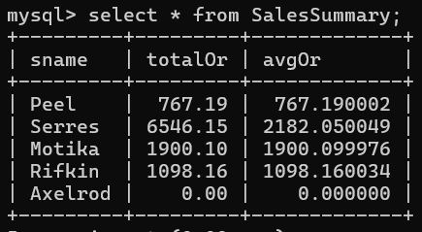
4) Create a view that shows each salesperson with multiple customers.
- CREATE VIEW SalespeoWithMultiCustomers AS
-> SELECT S.sname, S.snum
-> FROM Salespeople S
-> JOIN Orders O ON S.snum = O.snum
-> GROUP BY S.sname, S.snum
-> HAVING COUNT(DISTINCT O.cnum) > 1;
Query OK, 0 rows affected (0.01 sec)

