DATA 266 — Homework 2
Sneha Singh
SID4 = 0670 | SEED = 670 | SLICE = 670 | HP_ID = 4 | CLS_A = 0 | CLS_B = 5
Git repo: https://github.com/snehas-SJSU/Data266-0670/tree/main/HW-2
HP_ID 4 is only reported. This homework has no capacity / lr / schedule arm, so I did not change chunk size, epochs, or model size from it.
Notebooks: embeddings.ipynb, rag.ipynb, optimizations.ipynb, amp_cuda_colab.ipynb. Kernel: Python (HW1). Mixed precision ran on Colab Tesla T4.

1. Embedding transfer learning (4 points)
I loaded Google News Word2Vec (word2vec-google-news-300). 3,000,000 words, 300-d. Those vectors come from news, not movie reviews, so plot can look like a conspiracy and screen can look like a phone.
I copied the five word vectors first. Then I trained a Word2Vec model on 5,000 IMDB reviews (seed 670), after stuffing in the Google News vectors for words that overlap. That is the transfer step. api.load only gives KeyedVectors, which cannot train(), so I could not call train() on the downloaded object itself.
Words: cast, score, plot, screen, review.

1.1 Neighbors before and after
Table 1 — top-3 nearest neighbors (cosine)
Word | Before (Google News) | After (IMDB)
cast | casts=0.722; casting=0.719; Cast=0.664 | casting=0.726; actors=0.706; supporting=0.700
score | scoring=0.720; scores=0.660; scored=0.638 | scores=0.678; scoring=0.675; scored=0.618
plot | plots=0.762; Plot=0.652; plotting=0.633 | plots=0.729; story=0.719; storyline=0.699
screen | screens=0.773; onscreen=0.612; LCD_screen=0.560 | screens=0.691; stage=0.619; theatre=0.593
review | reviewed=0.663; reviewing=0.661; reviews=0.638 | reviews=0.784; uwe=0.694; seagal=0.687
plot and screen moved toward movie language. cast picked up actors / supporting. score barely moved — still the same word family (scoring / scores). review went to reviews plus IMDB junk (Uwe Boll / Seagal). That last one is ugly but it is what the 5,000 reviews did.
In this subset, plot showed up in 1015 reviews and score in only 178, which matches who moved.

1.2 Figure — t-SNE for plot
I picked plot because in news it often means a conspiracy (one neighbor was even Guy Fawkes) and in reviews it means the story.
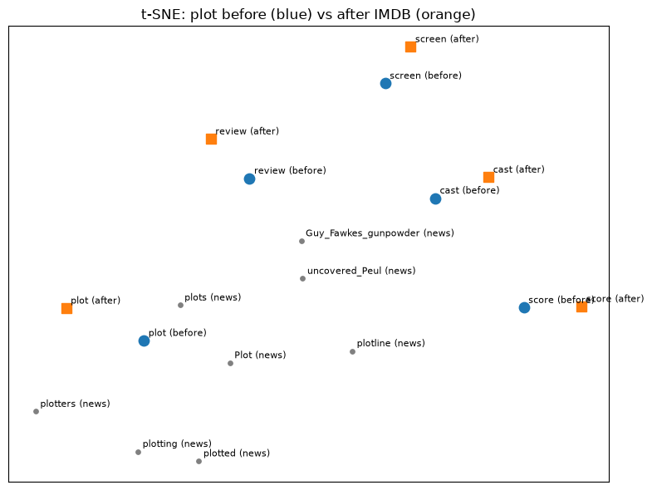
Figure 1. Blue circles = Google News. Orange squares = after IMDB. Gray = original news neighbors of plot. This is only a 2D picture. Distances here are not cosine in 300-d. Table 2 is the real shift number.

1.3 How far each word moved
Lower cosine = the vector moved more.
Table 2 — cosine(original, fine-tuned)
Word | cosine
review | 0.7306
plot | 0.7806
screen | 0.7885
cast | 0.8019
score | 0.8618
- Shifted the most: review
- Shifted the least: score

2. RAG pipeline (4 points)
I loaded 10 Wikipedia movie pages with WikipediaLoader, split them (chunk 500, overlap 50), embedded with MiniLM, and stored them in an in-memory vector store. The pipeline is PromptTemplate + retriever + Flan-T5-small, called separately. I did not use one pre-built chain.
I picked colliding titles on purpose: The Batman / Batman Begins / The Dark Knight, and two Dune films. The other pages are Inception, Interstellar, Parasite, Titanic, The Godfather.

2.1 Five questions (chunk 500 / overlap 50)
Q | Question | LLM answer | Top-1 source
1 | Who directed The Batman? | Matt Reeves | The Batman (film)
2 | In what year was Dune released as a film? | 2021 | Dune: Part Two (talking about the 2021 film)
3 | Which award did Parasite win at Cannes? | Academy Award for Best Picture | Parasite (2019 film)
4 | Who composed the score for Inception? | Nolan | Inception
5 | Who played Jack Dawson in Titanic (1997)? | Leonardo DiCaprio | Titanic (1997 film)
Full chunks are in rag.ipynb.

2.2 Chunk size change (Q1 and Q2)
I rebuilt the store with chunk 200 / overlap 20 and re-ran Q1 and Q2.
- Q1 still answered Matt Reeves. Rank 1 stayed The Batman. Ranks 2 and 3 became Batman Begins (Nolan / Bale). Smaller chunks made the Batman name collision worse. The 500/50 run had all three hits on The Batman.
- Q2 still answered 2021. Dune: Part Two was still ranked high.

2.3 Retrieval scoring (top-3, 500/50)
I scored retrieval by hand. The LLM can be wrong even when the chunk is right.
Table 3
Q | Gold | In top-3? | Rank | Notes
1 | Matt Reeves, The Batman (film) | Yes | 1 | right page
2 | Dune 2021 | Yes | 1 | year is in the chunks; rank 1 is the Part Two page
3 | Palme d'Or at Cannes | Yes | 1 | Palme d'Or is in rank 1; LLM still said Oscar
4 | Hans Zimmer | No | — | top-3 never name Zimmer
5 | Leonardo DiCaprio as Jack Dawson | Yes | 2 | rank 1 is the Halifax grave labeled J. Dawson
Retrieval Success Rate = 4 / 5 = 0.80

2.4 Two RAG failures
Failure A — Q4, relevant chunk not retrieved. Gold is Hans Zimmer. The retriever stayed on Inception but the top-3 chunks are the opening (Nolan, DiCaprio), a screenplay paragraph, and Oscars / box office. Chunk 3 says nominated for Best Original Score and never names Zimmer. I only kept the first 15,000 characters of each Wikipedia page, so the composer section may not even be in the doc. The LLM answered Nolan, which is sitting in chunk 1.
Failure B — Q3, context was right, LLM was not. Gold is Palme d'Or. Rank 1 has Palme d'Or and also Academy Award for Best Picture, with the Oscar sentence first. Flan-T5 answered Academy Award for Best Picture. That is not a Cannes award. The retriever did its job. The small LLM copied the Oscar.

3. Training optimizations (2 points)
Same 12-layer MLP, width 512, batch 64, 40 Adam steps, lr 0.001, seed 670. Device: mps (Apple GPU) for tensor-create, init, checkpointing, and accumulation. mem_mb there is MPS current allocated memory, not CUDA peak, so it barely moves. Mixed precision is a separate CUDA run on Colab Tesla T4 (amp_cuda_colab.ipynb).
Table 4
Tensor create, 2048×2048, mean of 3 after warmup, with torch.mps.synchronize():
place | ms | mem_mb
cpu | 61.087 | n/a
mps | 2.167 | 0.1
Weight init (same net / data / steps):
init | seconds | mem_mb | final_loss
default | 4.559 | 28.4 | 1.4873
xavier | 0.231 | 26.3 | 1.6886
zeros | 0.204 | 26.3 | 2.2914
Checkpointing:
checkpoint | seconds | mem_mb | final_loss
False | 0.273 | 26.3 | 1.4873
True | 0.333 | 26.3 | 1.4873
Gradient accumulation (effective batch still 64, 40 opt steps):
accum | micro | seconds | mem_mb | final_loss
1 | 64 | 0.395 | 26.3 | 1.4873
4 | 16 | 0.990 | 26.2 | 1.5353
Mixed precision (Colab Tesla T4, amp_cuda_colab.ipynb; same net / data / batch / steps):
amp | seconds | peak_mem_mb | final_loss | forward dtype
False | 0.2343 | 82.6 | 1.4924 | torch.float32
True | 0.2688 | 82.6 | 1.4793 | torch.float16
Zeros init did not train (loss 2.29, about ln(10)). Default vs Xavier both went down. I am not reading 4.56 s vs 0.23 s as “default is slow.” Default was the first train on a cold MPS graph.
Checkpointing took longer (0.273 → 0.333) and loss matched. Memory did not drop on this MPS meter.
Accumulation: loss stayed close (1.49 vs 1.54), time went up because each step does four forwards.
Mixed precision used real fp16 on CUDA (torch.autocast(..., dtype=torch.float16) + GradScaler; probe used_fp16: True). Warmup was untimed. Times are the mean of 3 with torch.cuda.synchronize(). AMP was a little slower (0.2343 → 0.2688 s). CUDA peak memory stayed 82.6 MB. Loss stayed close (1.4924 vs 1.4793). This net is small; Tensor Cores did not help.

4. Short conclusion
Fine-tuning Google News on IMDB did move movie words. plot went toward story / storyline, screen toward stage / theatre, review moved the most (cosine 0.73). score moved the least (0.86) and still looks like sports morphology.
RAG retrieval was 4/5. The two misses I care about are Q4 (Zimmer never in the top-3, LLM said Nolan) and Q3 (Palme d'Or was in the chunk, LLM said Oscar anyway). Smaller chunks made Batman titles collide more.
On MPS, making a big tensor on GPU is faster than CPU. Checkpointing and accumulation behaved like the lecture on time. Memory did not drop on the MPS meter. Real mixed precision on a Tesla T4 used fp16; it did not speed this 12×512 MLP up, and CUDA peak memory stayed the same.

