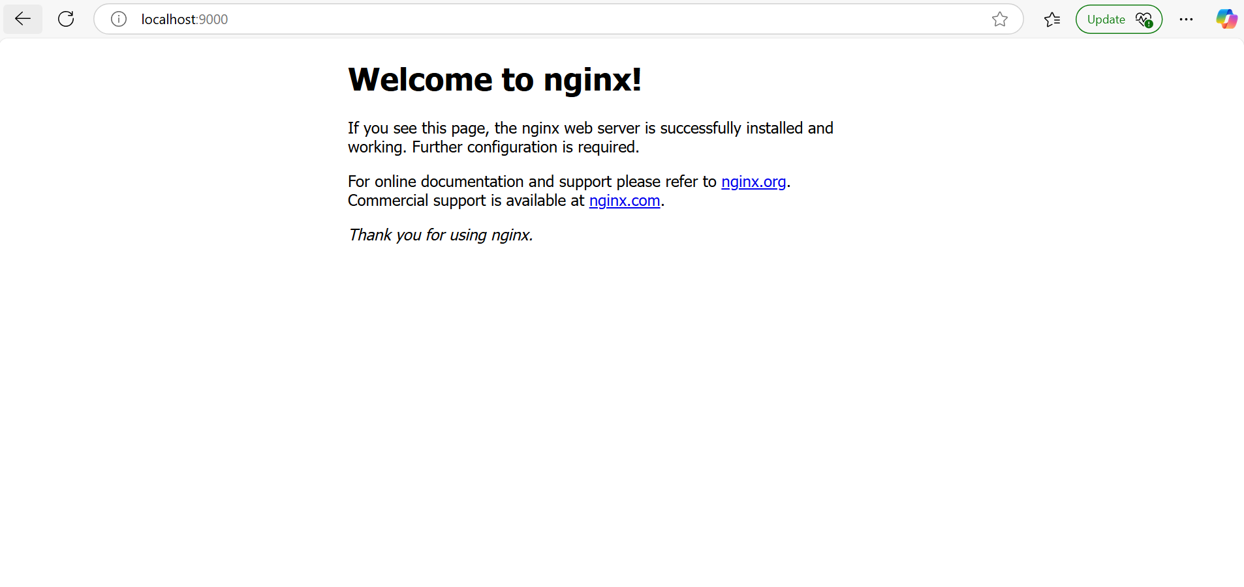
PowerShell 7.2.24
Copyright (c) Microsoft Corporation.

https://aka.ms/powershell
Type 'help' to get help.

PS C:\Users\ssami> docker ps
CONTAINER ID IMAGE COMMAND CREATED STATUS PORTS NAMES
fcdbf67e9a08 nginx:1.27 "/docker-entrypoint.…" 2 minutes ago Up 2 minutes 80/tcp jolly_maxwell
PS C:\Users\ssami> docker stop fcdbf67e9a08
fcdbf67e9a08
PS C:\Users\ssami> docker run -d -p 9000:80 nginx:1.27
29a8dbc95619accc4423e9e8a40cf72a338d874bff3b3d72b4dde97f6aab5bdc
PS C:\Users\ssami> docker ps
CONTAINER ID IMAGE COMMAND CREATED STATUS PORTS NAMES
29a8dbc95619 nginx:1.27 "/docker-entrypoint.…" About a minute ago Up About a minute 0.0.0.0:9000->80/tcp objective_matsumoto
PS C:\Users\ssami> docker logs 29a8dbc95619
/docker-entrypoint.sh: /docker-entrypoint.d/ is not empty, will attempt to perform configuration
/docker-entrypoint.sh: Looking for shell scripts in /docker-entrypoint.d/
/docker-entrypoint.sh: Launching /docker-entrypoint.d/10-listen-on-ipv6-by-default.sh
10-listen-on-ipv6-by-default.sh: info: Getting the checksum of /etc/nginx/conf.d/default.conf
10-listen-on-ipv6-by-default.sh: info: Enabled listen on IPv6 in /etc/nginx/conf.d/default.conf
/docker-entrypoint.sh: Sourcing /docker-entrypoint.d/15-local-resolvers.envsh
/docker-entrypoint.sh: Launching /docker-entrypoint.d/20-envsubst-on-templates.sh
/docker-entrypoint.sh: Launching /docker-entrypoint.d/30-tune-worker-processes.sh
/docker-entrypoint.sh: Configuration complete; ready for start up
2025/02/12 15:13:42 [notice] 1#1: using the "epoll" event method
2025/02/12 15:13:42 [notice] 1#1: nginx/1.27.4
2025/02/12 15:13:42 [notice] 1#1: built by gcc 12.2.0 (Debian 12.2.0-14)
2025/02/12 15:13:42 [notice] 1#1: OS: Linux 5.15.167.4-microsoft-standard-WSL2
2025/02/12 15:13:42 [notice] 1#1: getrlimit(RLIMIT_NOFILE): 1048576:1048576
2025/02/12 15:13:42 [notice] 1#1: start worker processes
2025/02/12 15:13:42 [notice] 1#1: start worker process 30
2025/02/12 15:13:42 [notice] 1#1: start worker process 31
2025/02/12 15:13:42 [notice] 1#1: start worker process 32
2025/02/12 15:13:42 [notice] 1#1: start worker process 33
2025/02/12 15:13:42 [notice] 1#1: start worker process 34
2025/02/12 15:13:42 [notice] 1#1: start worker process 35
2025/02/12 15:13:42 [notice] 1#1: start worker process 36
2025/02/12 15:13:42 [notice] 1#1: start worker process 37
172.17.0.1 - - [12/Feb/2025:15:15:19 +0000] "GET / HTTP/1.1" 200 615 "-" "Mozilla/5.0 (Windows NT 10.0; Win64; x64) AppleWebKit/537.36 (KHTML, like Gecko) Chrome/132.0.0.0 Safari/537.36 Edg/132.0.0.0" "-"
2025/02/12 15:15:19 [error] 32#32: *3 open() "/usr/share/nginx/html/favicon.ico" failed (2: No such file or directory), client: 172.17.0.1, server: localhost, request: "GET /favicon.ico HTTP/1.1", host: "localhost:9000", referrer: "http://localhost:9000/"
172.17.0.1 - - [12/Feb/2025:15:15:19 +0000] "GET /favicon.ico HTTP/1.1" 404 555 "http://localhost:9000/" "Mozilla/5.0 (Windows NT 10.0; Win64; x64) AppleWebKit/537.36 (KHTML, like Gecko) Chrome/132.0.0.0 Safari/537.36 Edg/132.0.0.0" "-"
PS C:\Users\ssami> docker ps-a
docker: 'ps-a' is not a docker command.
See 'docker --help'
PS C:\Users\ssami> docker ps -a
CONTAINER ID IMAGE COMMAND CREATED STATUS PORTS
NAMES
29a8dbc95619 nginx:1.27 "/docker-entrypoint.…" 6 minutes ago Up 6 minutes 0.0.0.0:9000->80/tcp objective_matsumoto
fcdbf67e9a08 nginx:1.27 "/docker-entrypoint.…" 21 minutes ago Exited (0) 10 minutes ago
jolly_maxwell > docker stop
"docker stop" requires at least 1 argument.
See 'docker stop --help'.

Usage: docker stop [OPTIONS] CONTAINER [CONTAINER...]

Stop one or more running containers
PS C:\Users\ssami> docker stop 29a8dbc95619
29a8dbc95619
PS C:\Users\ssami> docker start 29a8dbc95619
29a8dbc95619
PS C:\Users\ssami> docker stop 29a8dbc95619
29a8dbc95619
PS C:\Users\ssami> docker run --name web-app -d -p 9000:80 nginx:1.27
ddadc9cf72ffd599d56e113cbb4a223bcfa4317afdcb0b0d6de36ff57f476dba
PS C:\Users\ssami> docker ps
CONTAINER ID IMAGE COMMAND CREATED STATUS PORTS NAMES
ddadc9cf72ff nginx:1.27 "/docker-entrypoint.…" 7 seconds ago Up 6 seconds 0.0.0.0:9000->80/tcp web-app
PS C:\Users\ssami> docker logs web-app
/docker-entrypoint.sh: /docker-entrypoint.d/ is not empty, will attempt to perform configuration
/docker-entrypoint.sh: Looking for shell scripts in /docker-entrypoint.d/
/docker-entrypoint.sh: Launching /docker-entrypoint.d/10-listen-on-ipv6-by-default.sh
10-listen-on-ipv6-by-default.sh: info: Getting the checksum of /etc/nginx/conf.d/default.conf
10-listen-on-ipv6-by-default.sh: info: Enabled listen on IPv6 in /etc/nginx/conf.d/default.conf
/docker-entrypoint.sh: Sourcing /docker-entrypoint.d/15-local-resolvers.envsh
/docker-entrypoint.sh: Launching /docker-entrypoint.d/20-envsubst-on-templates.sh
/docker-entrypoint.sh: Launching /docker-entrypoint.d/30-tune-worker-processes.sh
/docker-entrypoint.sh: Configuration complete; ready for start up
2025/02/12 15:24:52 [notice] 1#1: using the "epoll" event method
2025/02/12 15:24:52 [notice] 1#1: nginx/1.27.4
2025/02/12 15:24:52 [notice] 1#1: built by gcc 12.2.0 (Debian 12.2.0-14)
2025/02/12 15:24:52 [notice] 1#1: OS: Linux 5.15.167.4-microsoft-standard-WSL2
2025/02/12 15:24:52 [notice] 1#1: getrlimit(RLIMIT_NOFILE): 1048576:1048576
2025/02/12 15:24:52 [notice] 1#1: start worker processes
2025/02/12 15:24:52 [notice] 1#1: start worker process 29
2025/02/12 15:24:52 [notice] 1#1: start worker process 30
2025/02/12 15:24:52 [notice] 1#1: start worker process 31
2025/02/12 15:24:52 [notice] 1#1: start worker process 32
2025/02/12 15:24:52 [notice] 1#1: start worker process 33
2025/02/12 15:24:52 [notice] 1#1: start worker process 34
2025/02/12 15:24:52 [notice] 1#1: start worker process 35
2025/02/12 15:24:52 [notice] 1#1: start worker process 36
PS C:\Users\ssami>

