Experiment: 04

Aim: Use function types, scope, and closures; apply try-catch; build a palindrome checker.
Software / Tools Required:
- Visual Studio Code (VS Code)
- Google Chrome / Microsoft Edge
- HTML5, CSS3

Theory:
Functions:
A function is a reusable block of code used to perform a particular task. Functions improve code reusability, organization, and readability. JavaScript provides different types of functions such as function declarations, function expressions, anonymous functions, and arrow functions. In this practical, a function is used to reverse the digits of the given number.
Scope:
Scope refers to the area of a program where a variable can be accessed. JavaScript mainly provides global scope, function scope, and block scope. Variables declared using let and const have block scope, which helps in controlling variable access and avoiding unintended changes.
Closures:
A closure is formed when an inner function retains access to variables belonging to its outer function even after the outer function has completed execution. Closures are useful for maintaining data, preserving state, and creating private variables.
Try-Catch:
try-catch is an exception-handling mechanism in JavaScript. Statements that may generate an error are placed inside the try block, while the catch block handles the error. It helps prevent unexpected termination of the program and allows meaningful error messages to be displayed to the user.
Palindrome:
A palindrome is a number that remains unchanged when its digits are reversed. For example, 121, 1331, and 444 are palindrome numbers, whereas 123 and 456 are not. The program stores the original number, reverses it using a function, and compares the reversed value with the original value.
Working of the Program
- The user enters a number through the webpage.
- The entered number is stored as the original number.
- A JavaScript function reverses the digits of the number.
- The original number is compared with the reversed number.
- If both values are equal, the number is displayed as Palindrome.
- Otherwise, it is displayed as Not Palindrome.
- try-catch is used to handle invalid input and possible errors.

NAME: SNEHA SHAH PRN: 24070521271
PATH: file:///D:/Symbiosis%20University/Sem%205/JavaScript/JavaScript%20VSCode/Practical%204/Case%20Study/palindrome.html

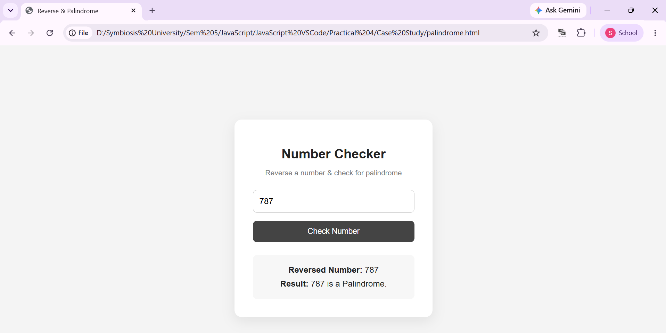

Additional Assignment:
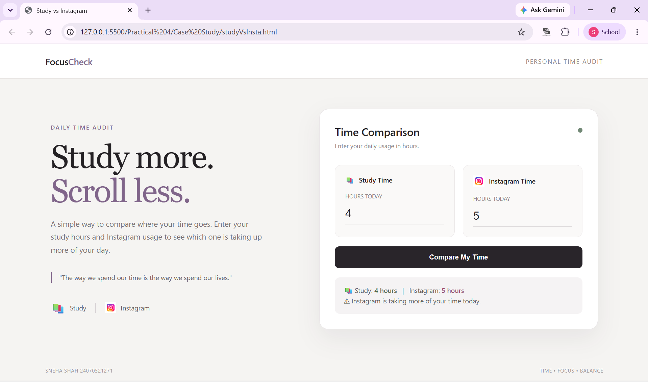
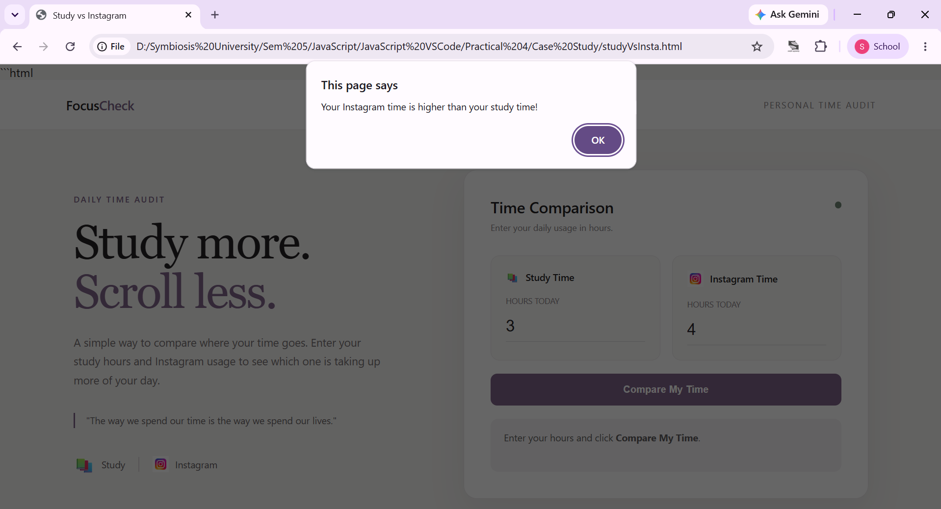
Conclusion: Thus, the palindrome checker was successfully implemented using JavaScript concepts of functions, scope, closures, and try-catch exception handling.

