Experiment: 07
Aim
To perform DOM traversal and updates, and to develop a to-do list application with add, edit, and delete features using JavaScript.
Software Required
- Visual Studio Code (or any code editor)
- Web browser (Google Chrome / Microsoft Edge / Mozilla Firefox)
- Live Server extension (or any local server) for VS Code
- Basic knowledge of HTML, CSS and JavaScript
Theory: The Document Object Model (DOM)
The Document Object Model (DOM) is a programming interface for HTML and XML documents. It represents the structure of a webpage as a tree of nodes, where each element, attribute, and piece of text is a node that JavaScript can access, traverse, and modify at runtime. The DOM is what allows a static HTML page to become dynamic and interactive.
DOM Traversal refers to navigating between nodes of this tree to locate a specific element relative to another. Common traversal properties include parentNode / parentElement (moves up to the containing element), childNodes / children (accesses all child nodes), firstElementChild / lastElementChild (the first or last child element), and nextElementSibling / previousElementSibling (adjacent elements at the same level). Modern code most often uses querySelector() and querySelectorAll(), which locate elements directly using CSS-style selectors rather than manual step-by-step traversal.
DOM Updates refer to changing the structure or content of the page once an element has been located. document.createElement() creates a new node, appendChild() / append() inserts it into the tree, and removeChild() / remove() deletes a node from the tree. innerHTML and textContent read or overwrite the content inside an element, while setAttribute() and classList methods (add, remove, toggle) update attributes and styling dynamically.
In a to-do list application, these concepts work together directly: Add uses createElement() and appendChild() to insert a new list item; Edit locates the relevant item (often through closest() or a stored reference) and updates its textContent or swaps it into an editable input; and Delete traverses to the parent list item of the clicked button and calls remove() on it. Rather than attaching a separate event listener to every item, event delegation is used — a single listener is placed on the parent list, and event.target identifies which child triggered it. This keeps the app efficient even as items are added and removed dynamically.
Case Study
Aim of the Case Study
To design and develop a smart, role-based to-do application that helps users manage time effectively by scheduling alarms according to different activities such as study, sleep, work, fitness, and custom events, while improving productivity, routine tracking, and user convenience.
File Path: file:///D:/Symbiosis%20University/Sem%205/JavaScript/JavaScript%20VSCode/Practical%207/Case%20Study/index.html
24070521271_SnehaShah
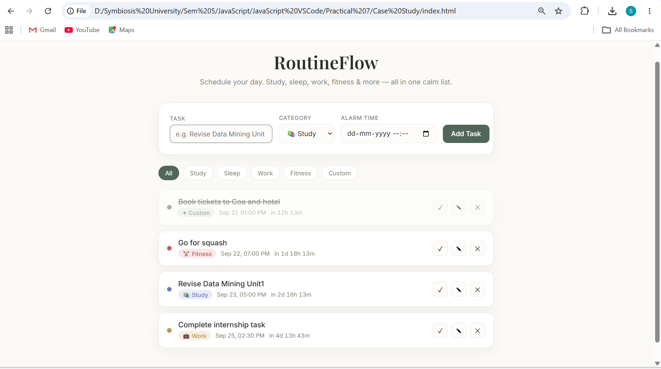
Output and Final Results
The application renders a task-entry form where the user types a task, selects a category (study, sleep, work, fitness, or custom), and sets an alarm date and time. Submitted tasks appear as cards below the form, each tagged with a colour-coded category dot and pill, alongside a live countdown (e.g., "in 2h 14m") that recalculates automatically. When a task's scheduled time is close (within five minutes) or has passed, its card gains a pulsing highlight and the countdown text turns red, acting as a visual alarm in place of a system notification. Users can filter the list by category using the chip bar at the top, mark a task complete, edit an existing task (which repopulates the form and switches it into a save mode), or delete it entirely — all handled through DOM traversal methods such as closest() and dataset attributes, combined with event delegation on the parent list. Every change is written to the browser's localStorage, so the task list persists even after the page is refreshed or the browser is reopened. The overall interface uses a light, off-white background with serif headings and soft accent colours per category, giving it a calm, classy appearance suited to a personal routine-planning tool.
Conclusion
Thus, the concepts of DOM traversal and DOM updates were studied and successfully applied to build a functional to-do list application with add, edit, and delete capabilities. These concepts were then extended into a more comprehensive case study — a smart, role-based to-do and alarm planner that organises tasks by activity type, visually alerts the user as scheduled times approach, and persists data across sessions. This demonstrates how JavaScript's DOM manipulation capabilities can be used to build practical, real-world productivity tools that go beyond static webpages.

