Experiment: 02
Aim: Use var, let, const and demonstrate basic features like template literals and destructuring; build an online shopping website with user input.
Software Required: VS Code (HTML, JS), Google Chrome
Theory:
JavaScript provides three keywords for declaring variables: var, let, and const.
1. var
var is the older keyword used to declare variables in JavaScript. It is function-scoped, which means a variable declared inside a function is accessible throughout that function. A var variable can be reassigned and redeclared.
Example:
var x = 10;
x = 20; // Reassignment allowed
var x = 30; // Redeclaration allowed
2. let
let was introduced in ES6 (ECMAScript 2015) to provide a better way of declaring variables. It is block-scoped, meaning it is accessible only within the block { } where it is declared. A let variable can be reassigned but cannot be redeclared in the same scope.
Example:
let age = 20;
age = 21; // Reassignment allowed
// let age = 22; // Redeclaration not allowed
3. const
const is used to declare a block-scoped constant whose binding cannot be reassigned after initialization. It is useful when a value should remain the same throughout the program.

Example:
const pi = 3.14;
// pi = 3.15; // Not allowed
Note: For objects and arrays declared with const, their contents can still be modified; the variable itself cannot be assigned to a different object or array.
ES6 Features
ES6 (ECMAScript 2015) is a major version of JavaScript that introduced several new features to make programming easier, cleaner, and more efficient. Some important ES6 features are:
1. Template Literals
Template literals use backticks and allow variables and expressions to be embedded using ${}.
Example:
let name = "Sneha";
console.log(`Hello, ${name}!`);
2. Destructuring
Destructuring allows values from arrays or objects to be extracted and assigned to variables easily.
Example:
let student = ["Sneha", 20];
let [name, age] = student;

console.log(name);
console.log(age);

CASE STUDY
Aim: Build a simple online shopping website. The webpage accepts customer details and product information, processes the purchase details, calculates the total amount and GST, and dynamically displays an order summary. Template literals are used to generate the order details, while destructuring is used to extract product information efficiently.
OUTPUT:
24070521271_SnehaShah
File Path: file:///D:/Symbiosis%20University/Sem%205/JavaScript/JavaScript%20VSCode/Practical%202/CaseStudy/index.html

24070521271_SnehaShah
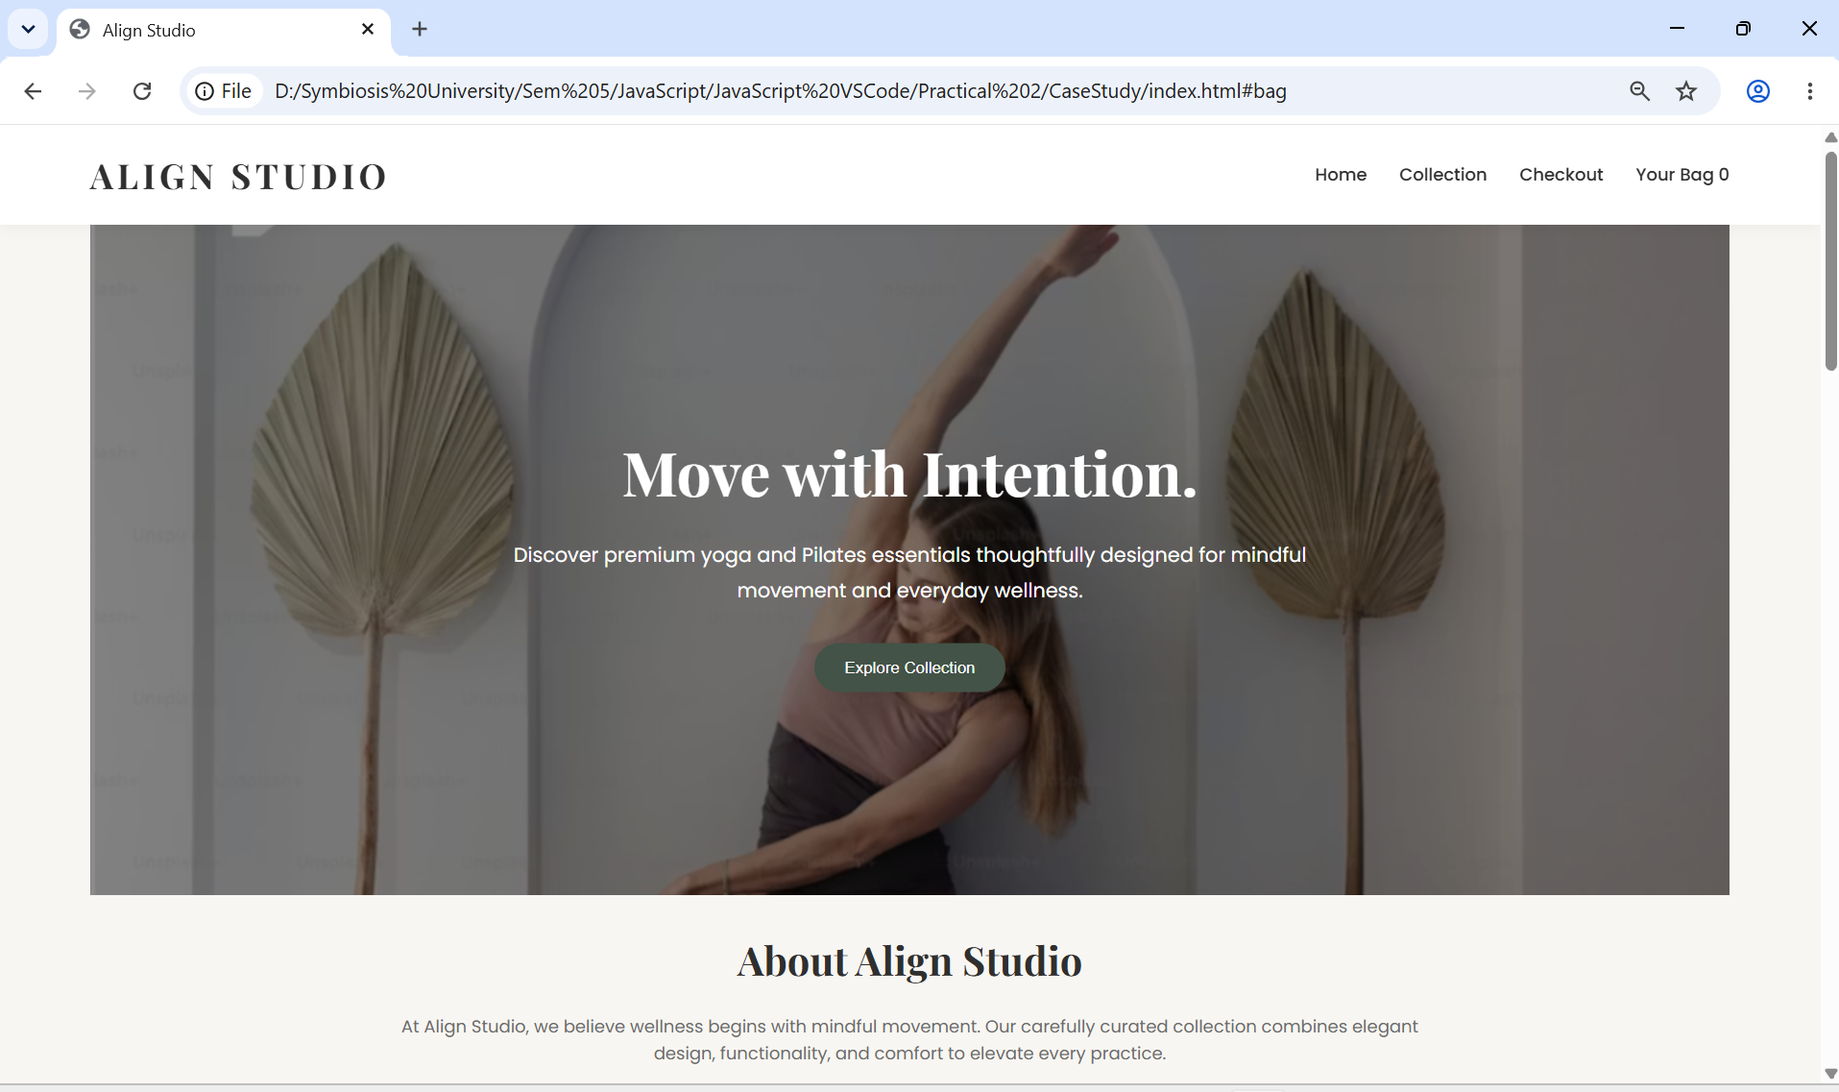

24070521271_SnehaShah
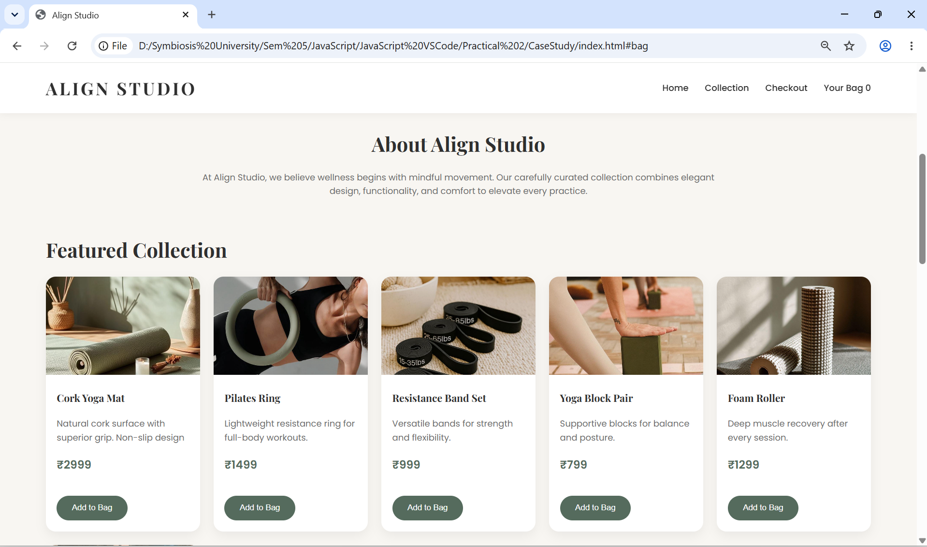

24070521271_SnehaShah
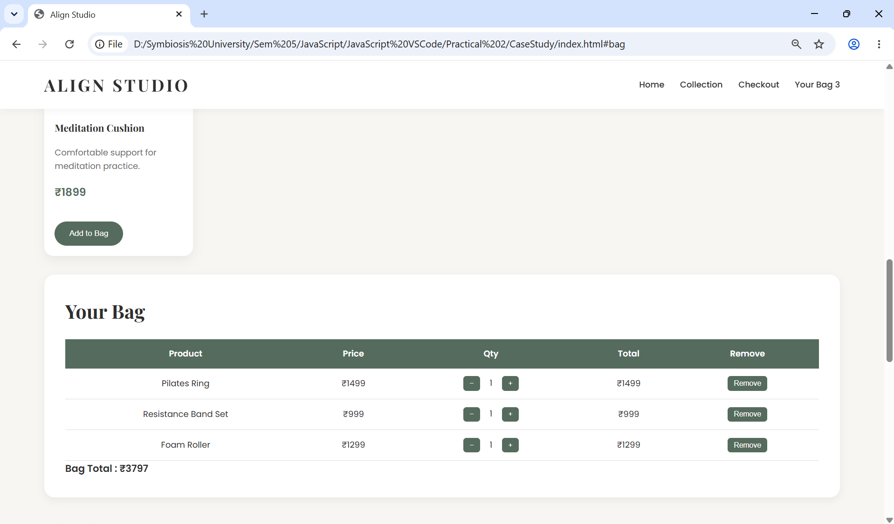
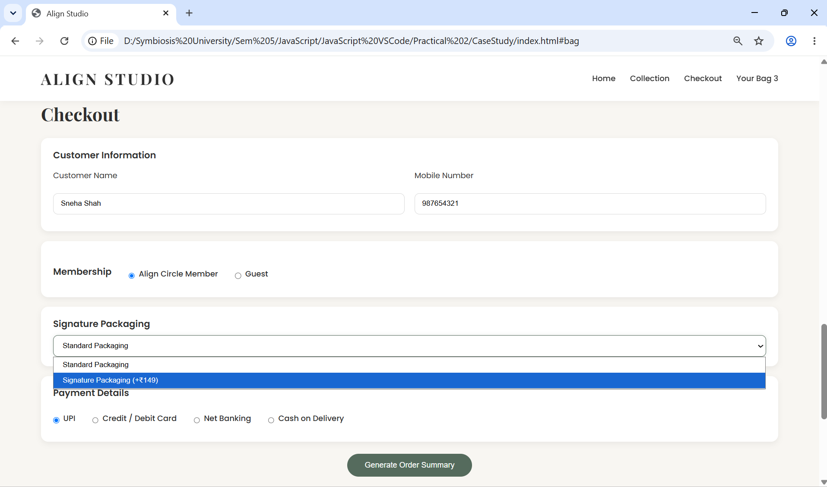

24070521271_SnehaShah
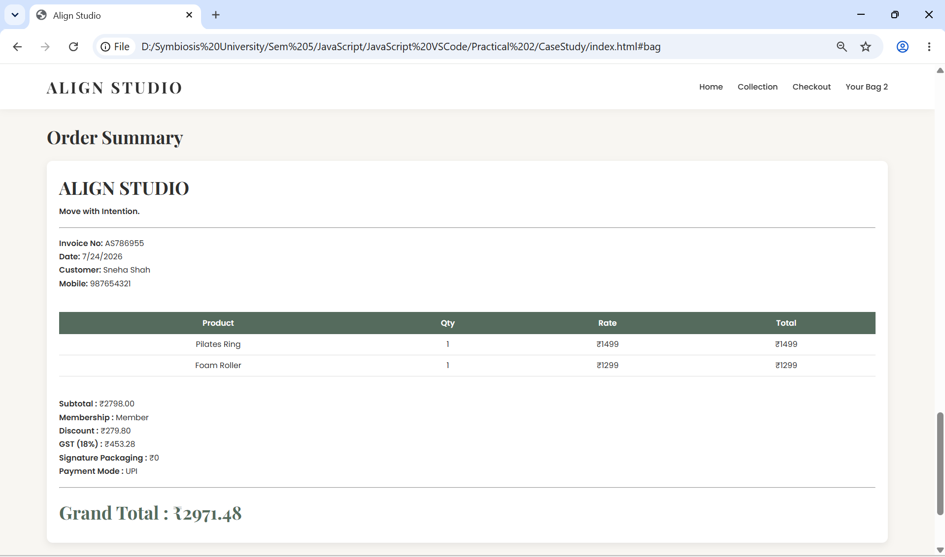

Conclusion: The experiment was completed successfully. The concepts of var, let, and const were implemented to understand variable declaration and scope. Modern JavaScript features such as template literals and destructuring were successfully used while developing an Online Shopping Website. The application accepted user input, processed product and customer details, calculated the total amount and GST, and displayed a dynamically generated order summary, demonstrating the practical implementation of ES6 features in web development and prints a bill at last.

