24070521271_D_SnehaShah
JavaScript Lab
Practical 1
Aim: Demonstrate inline, internal, external JavaScript; use console methods; create a webpage showing user info and a welcome page.
Software Required: VS Code (HTML, JS), Google Chrome
Experiment Program Code:
1. Inline JavaScript –
<!DOCTYPE html>
<html lang="en">
<head>
<meta charset="UTF-8">
<meta name="viewport" content="width=device-width, initial-scale=1.0">
<title>Document</title>
</head>
<body>
<h2> Inline JavaScript Example</h2>
<button onclick = "alert('Welcome to JavaScript!')">
Click Me
</button>
</body>
</html>

2. Internal JavaScript:
<!DOCTYPE html>
<html lang="en">
<head>
<meta charset="UTF-8">
<meta name="viewport" content="width=device-width, initial-scale=1.0">
<title>Document</title>
</head>
<body>
<h2> JavaScript in body</h2>
<p id = "demo"></p>
<script>
document.getElementById("demo").innerHTML = "My First Javascript";
</script>
<script src = "external.js"></script>
</body>
</html>
3. External JavaScript:
external.html
<!DOCTYPE html>
<html lang="en">
<head>
<meta charset="UTF-8">
<meta name="viewport" content="width=device-width, initial-scale=1.0">
<title>External JavaScript Demo</title>
</head>
<body>
<h2> External JavaScript Demo</h2>
<p id = "demo">Welcome!</p>
<button onclick="changeText()">Click Me</button>
<script src = "external.js"></script>

</body>
</html>
external.js
function changeText(){
document.getElementById("demo").innerHTML = "Hello! This is external javascript"
window.alert("first program")
}

4. Console Logs –
<!DOCTYPE html>
<html lang="en">
<head>
<meta charset="UTF-8">
<meta name="viewport" content="width=device-width, initial-scale=1.0">
<title>Document</title>
</head>
<body>
<button onclick = "startProgram()">Click Here</button>
<script>
function startProgram(){
displayMessage();
}
function displayMessage(){
console.log("Welcome to JavaScript");
console.trace("Function Call Trace");
}
</script>
</body>
</html>

Code Outputs:

- Inline JS
24070521271_SnehaShah
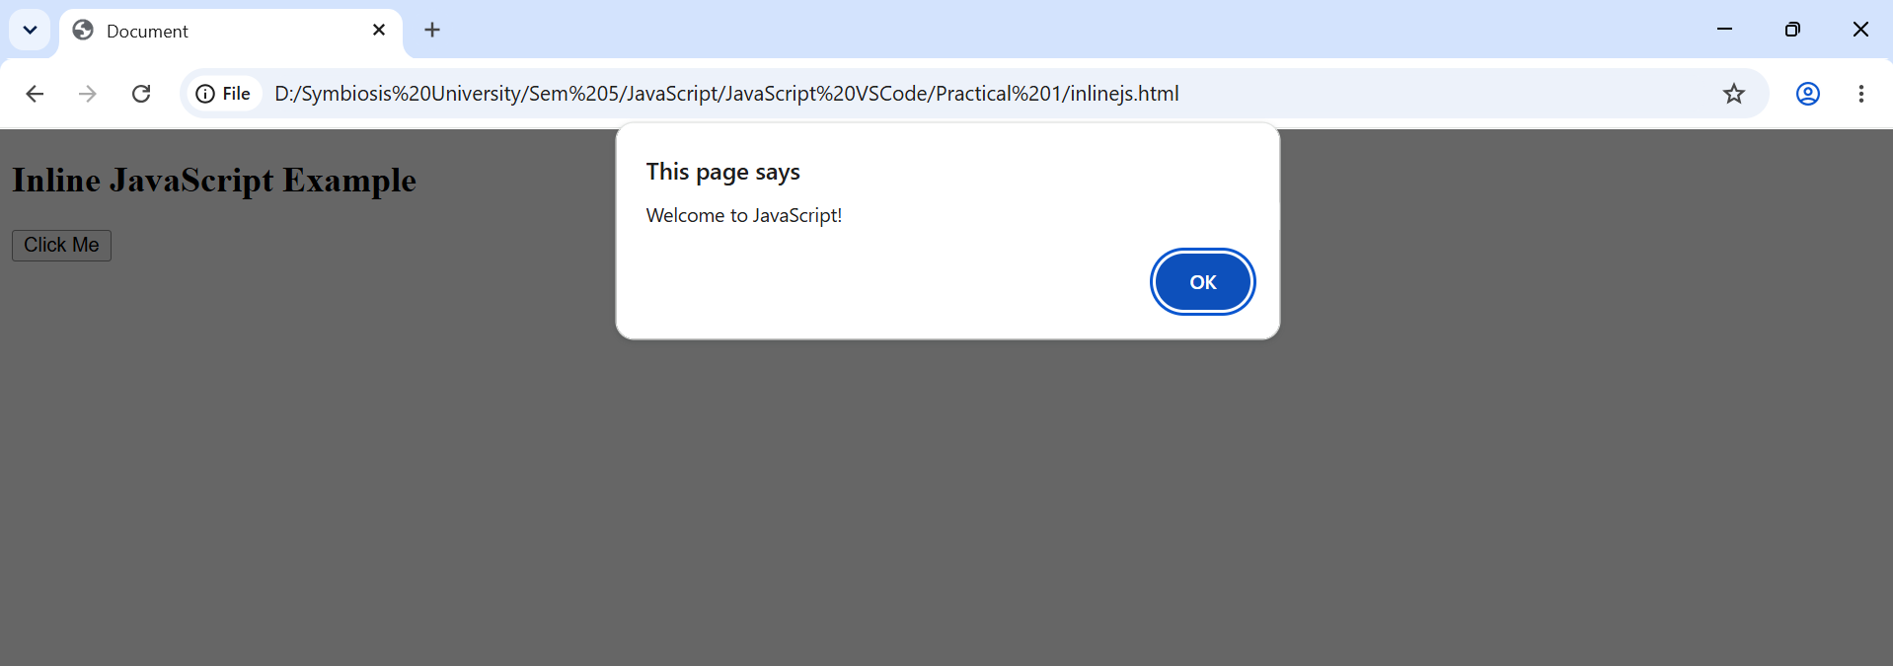
- Internal JS-
24070521271_SnehaShah
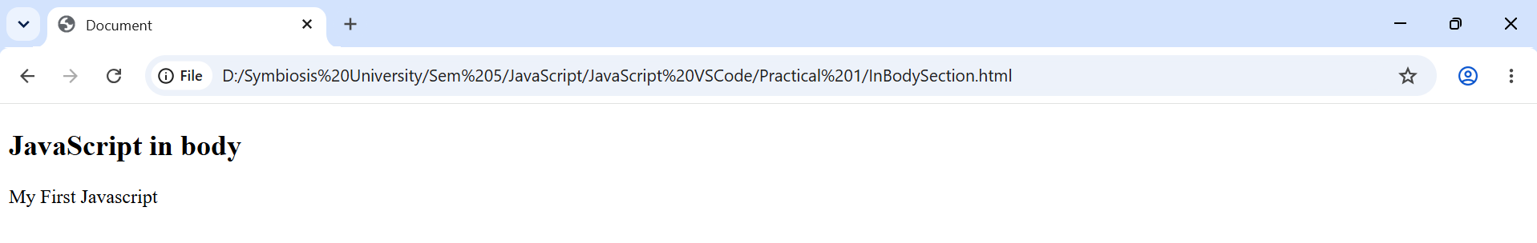

- External JS
24070521271_SnehaShah
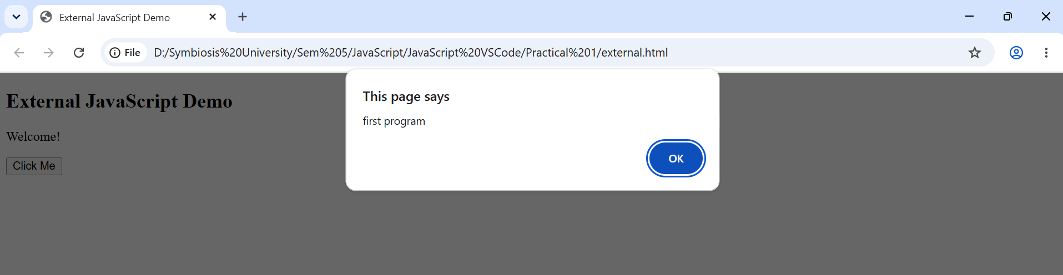

- Console Logs
24070521271_SnehaShah
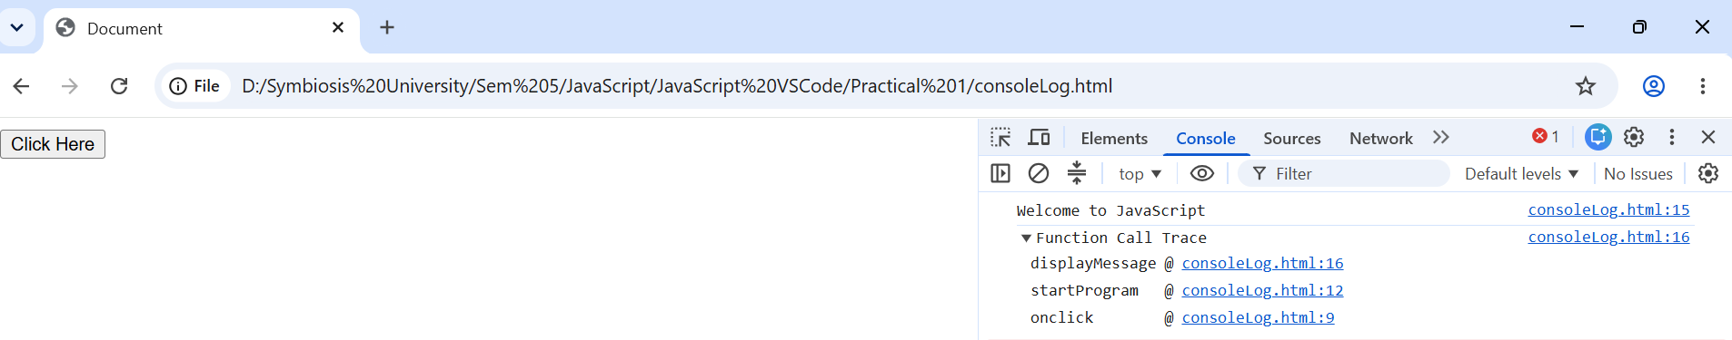

Case Study Title – Create a webpage for college department and link student information page with it and write a javascript program to display “Welcome to SIT Nagpur” in an alert box.
Case Study Program Output –
24070521271_SnehaShah
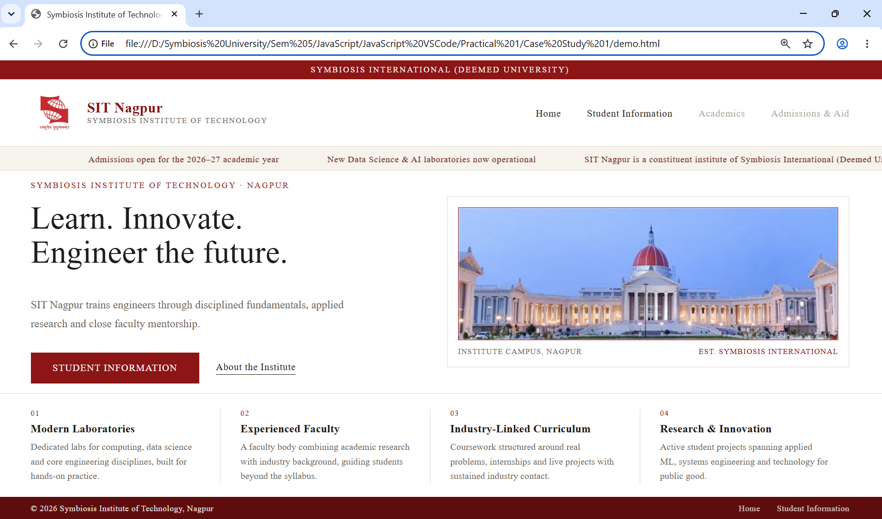

24070521271_SnehaShah
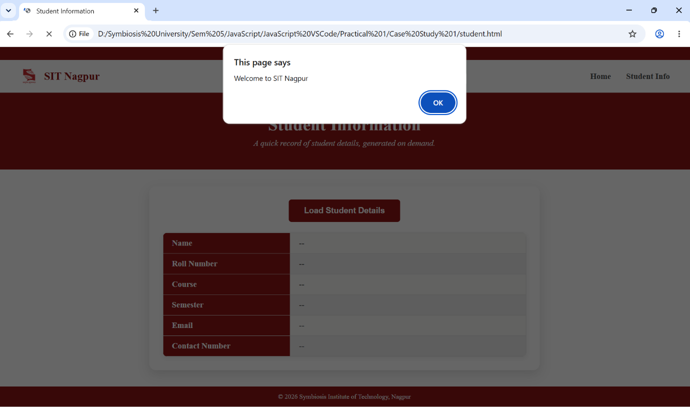
24070521271_SnehaShah
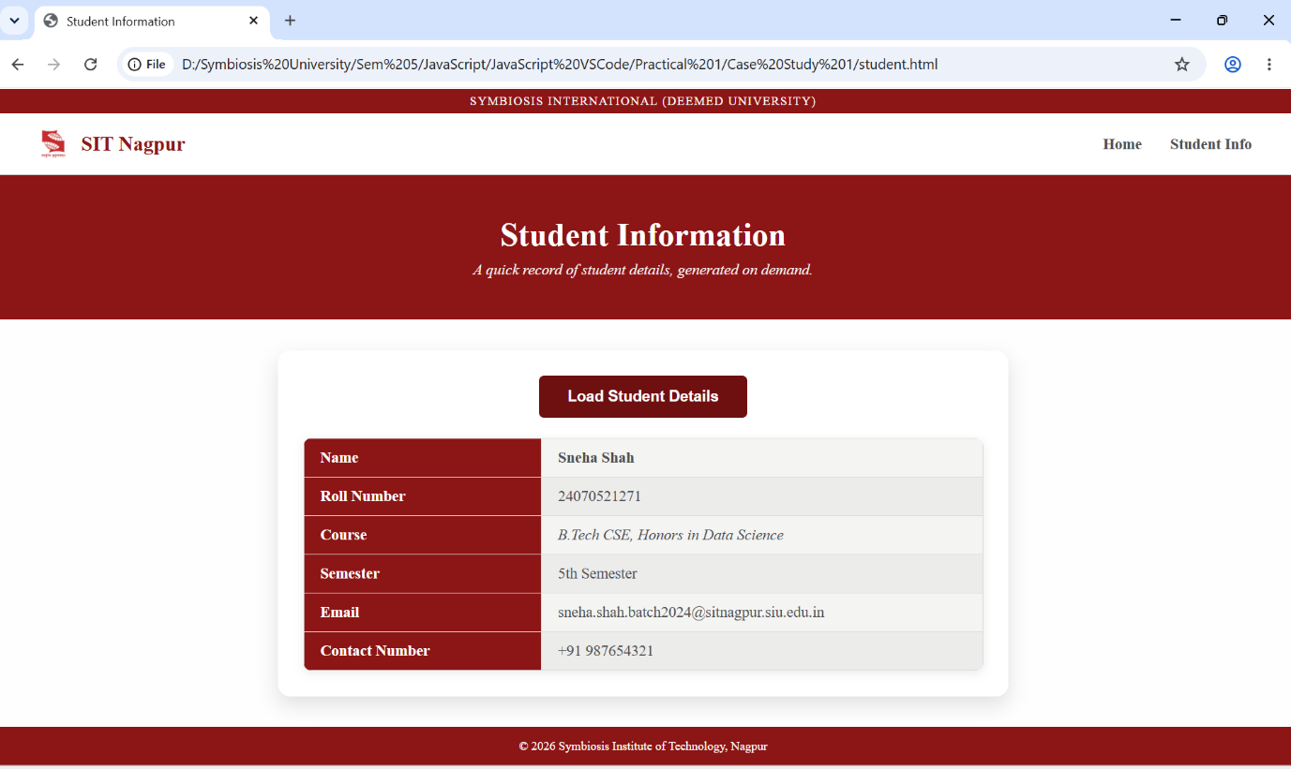

Conclusion: Thus, different ways of integrating javascript into a webpage were successfully demonstrated along with console methods.

