The AI Side of Our Project — Explained Simply
Counterfeit Currency Detection System · built by Sneha Shaw
This note explains, in plain English, the “smart” parts of our project — the Generative AI features, the un-clonable circular security pattern, and the various machine-learning techniques we use to decide if a note is real or fake. No technical background needed.
• • •

The one-line summary
We built an app where you take a photo of an Indian banknote and it tells you if it looks REAL, SUSPICIOUS, FAKE, or “can’t tell — retake the photo.” On top of that it has three AI helpers: one that explains the result in simple words, one that draws an un-copyable security pattern, and a chat assistant that answers your questions about the app.
Everything runs on your own computer. No internet needed, nothing is uploaded.
• • •

Part 1 — The brain: how it decides real vs fake (the “many techniques” bit)
Instead of trusting one opinion, the app asks several different experts and combines their answers — exactly why the project is called “…with Various Machine Learning Techniques.”
Think of it like a panel of judges, each looking at the note differently:
- A deep-learning “eye” (a neural network called MobileNetV2). It looks at the whole note like a human glancing at it and gives a gut feeling: real or fake. Fast, but it can be fooled by unusual photos — so we don’t let it decide alone.
- A panel of about 15 forensic checks. These are small, focused tests, each checking one security feature the way a bank teller would — the serial number, the denomination, the size and shape vs the real RBI measurements, the watermark, security thread, Gandhi portrait, colour, micro-printing, bleed lines, the touch-mark, and more. Each test honestly says PASS, FAIL, or “couldn’t tell” — it never fakes a result.
- A second team of classical ML models (with names like SVM, Random Forest, KNN). They study measurable clues — texture, colour, structure — and give an independent “second opinion.” On our data these actually beat the fancy neural network, which is why showing several techniques matters.
The final verdict is all of these fused together, with a few “hard rules”: if the structure, colour, or size are clearly wrong, the note is failed no matter what — the way one glaring red flag overrides everything else.
Why this is good: one model can be confidently wrong. A panel that has to agree is much harder to fool, and we can show you exactly which check caused the verdict.
• • •

Part 2 — Generative AI feature #1: “Explain with AI”
A raw result is full of jargon (“hue entropy”, “aspect deviation”…). Most people don’t want that. So we added a button — Explain with AI — that turns the technical output into a short, calm, plain-language explanation, like:
“This ₹500 note looks likely genuine. The watermark, security thread and colour all checked out. This isn’t a 100% guarantee — if it matters, also check it by hand: tilt it to see the number change colour…”
What makes it nice:
- It also tells you what to check by hand — tilt for the colour shift, hold to light for the watermark, feel the raised print. Useful in the real world.
- It can be read out loud and works in Hindi too — built with visually-impaired users in mind (the same people RBI’s touch-features are for).
- It always works. When an AI key is available it uses Claude (a large language model) to write the explanation. When there’s no key or no internet, it falls back to a built-in template that says the same thing. The user never sees an error.
Important and honest: this AI explains a result. It does NOT generate money or claim certainty. It openly says the app can be wrong on good fakes.
• • •

Part 3 — The “un-clonable circle”: Security Pattern Studio
This is the circular pattern feature you remember. Here’s the simple idea.
The problem with copying money isn’t the picture of Gandhi — it’s the incredibly fine, woven, swirling line-work printed on real notes. Those swirls are called guilloché. They look like the spiro-art you may have drawn as a kid with a gear and a pen, but far denser. They are easy for a computer to draw perfectly from a formula, but very hard to copy by hand or through a scan-and-print — a photocopier smudges the fine lines.
Our Security Pattern Studio generates exactly this:
- You give it a seed — any word or number (for example a serial number).
- It instantly draws a unique, intricate circular pattern: woven rings on the outside, a tiny ring of micro-text, and a layered rosette (spirograph-style swirls) in the middle.
- Same seed → exactly the same pattern, every time, on any computer. A different seed → a completely different pattern.
Why that’s the “un-clonable” part, in plain terms:
- The pattern is mathematically exact and reproducible, so a genuine pattern for a given serial can always be re-generated and compared — if a copy doesn’t match precisely, it’s suspect.
- The fine, interwoven detail is what defeats casual copying — the same principle real security printers rely on.
What it is NOT (and this is deliberate): it does NOT create fake notes or anything that looks like currency — no Gandhi, no “RBI”, no rupee layout. It only makes abstract decorative art that demonstrates the anti-copy design idea. Making realistic fake-note images would be illegal, so we intentionally did not build that. This is the legitimate, honest version of the “make something that can’t be cloned” idea.
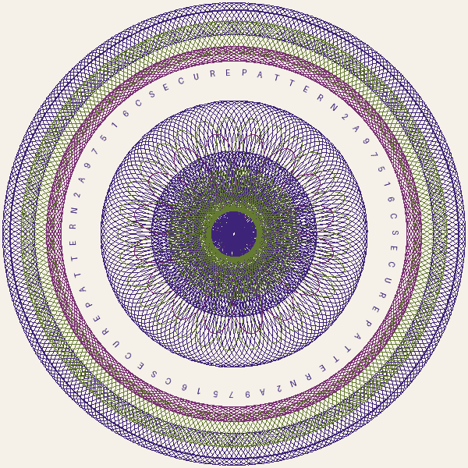
An example generated security pattern (abstract art — not currency).
• • •

Part 4 — Generative AI feature #2: the Help Chatbot
There’s a little chat assistant in the corner of the app. You can ask it anything about the project in normal language:
- “How does it work?”
- “What does SUSPICIOUS mean?”
- “How accurate is it?”
- “What is the security pattern / the AI heatmap / Hindi mode?”
- “How do I run it?”
How it behaves:
- It’s friendly and knows this project inside-out — it’s loaded with a curated summary of how everything works.
- Like the explainer, it uses Claude when a key is available, and a built-in question-and-answer brain when offline — so it always replies, even with no internet, during a demo.
- It only talks about this project. If someone asks it how to make or pass off fake money, it politely refuses — it’s a verification tool, not a how-to.
- (Small fun touch: it knows Sneha built it.)
• • •

Putting it together — what to tell someone in 20 seconds
- You photograph a note, the app gives an honest verdict and shows why.
- It uses many techniques at once (a neural net + ~15 forensic checks + a classical-ML second opinion) instead of trusting one — harder to fool.
- Three AI helpers sit on top:
- Explain with AI — plain-language result + hand-checks, in English/Hindi, can be read aloud.
- Security Pattern Studio — generates the un-clonable circular guilloché pattern (abstract art, not currency).
- Help Chatbot — answers questions about the app, refuses misuse.
- It’s honest about limits: it’s a screening aid on a phone photo, not a guarantee, and it never pretends to be certain.
• • •
Questions? Just ask the in-app chat assistant — or ping Sneha.

