COUNTERFEIT BANK CURRENCY DETECTION WITH VARIOUS MACHINE LEARNING TECHNIQUES
Project Report submitted in partial fulfillment of
BACHELOR OF TECHNOLOGY
IN
COMPUTER SCIENCE AND ENGINEERING
By
SNEHA SHAW
Roll Number: SIP25OF125
Based on research carried out under the supervision of
Prof. Sanjeev Patel

JULY 2025
Department of Computer Science and Engineering
NATIONAL INSTITUTE OF TECHNOLOGY ROURKELA


Department of Computer Science and Engineering
National Institute of Technology Rourkela
Prof. Sanjeev Patel
Assistant Professor Grade-I
July 2025
Supervisor’s Certificate
This is to certify that the work presented in this report entitled “Counterfeit Bank Currency Detection with Various Machine Learning Techniques” submitted by Sneha Shaw, Roll Number: SIP25OF125, is a record of original project work carried out by the candidate under my supervision and guidance. The study was conducted in the Department of Computer Science and Engineering during the academic session 2024–2025, in partial fulfillment of the requirements of the Summer Internship Project of the BTech degree in Computer Science and Engineering.

Prof. Sanjeev Patel

Declaration of Originality
I, Sneha Shaw, SIP25OF125, hereby declare that this project report entitled “Counterfeit Bank Currency Detection with Various Machine Learning Techniques” presents my work carried out under the supervision of Prof. Sanjeev Patel in the Department of Computer Science and Engineering, National Institute of Technology Rourkela, and to the best of my knowledge, contains no material previously published or written by another person, nor any material presented by me for the award of any degree or diploma at any institution. Wherever the work of others has been used, it has been duly acknowledged and referenced.

Sneha Shaw
July 2025
National Institute of Technology Rourkela

DEDICATION
I dedicate this report to my supervisor Prof. Sanjeev Patel, whose guidance and mentorship have been invaluable throughout this project. This work is a token of my deepest appreciation for the support and knowledge imparted to me during my time at National Institute of Technology Rourkela, which has significantly contributed to my growth and learning.
I also dedicate this work to my beloved parents, whose unconditional love, support and encouragement have been my constant source of strength throughout this journey.
Lastly, this work is dedicated to everyone working to make financial systems safer and more accessible, and to the citizens for whom an honest, easy-to-use counterfeit-detection tool can make a real difference.

ABSTRACT
Counterfeit currency is a persistent threat to the economy; the Reserve Bank of India reports continued detection of fake high-value notes. For an ordinary person it is very difficult to tell a forged note from a genuine one, because modern fakes reproduce many visible features with high precision. This project presents an automated, explainable system that takes a phone photograph of an Indian Rupee banknote and returns a single, defensible verdict — REAL, SUSPICIOUS, FAKE, or UNVERIFIED (“cannot verify — retake”).
Rather than relying on a single model, the system fuses three independent views. A deep-learning image classifier (MobileNetV2 convolutional neural network) scores the whole note. Various classical machine-learning techniques — Support Vector Machine, Random Forest, K-Nearest Neighbours and Logistic Regression — are trained on a hand-crafted fifty-dimensional feature vector (Local Binary Pattern texture, colour distribution, structural descriptors and OCR-free forensic signals) and benchmarked against one another. An explainable forensic pipeline of fourteen visible-light security checks (serial number, denomination, watermark, security thread, ascending-serial typography, micro-lettering, colour palette, note proportions, bleed lines and the identification mark) each returns PASS, FAIL or INFO with the measured numbers shown.
On a held-out test split the classical techniques (best: SVM / Random Forest at about 0.74 macro-F1) outperform the off-the-shelf CNN (about 0.56), showing that engineered features are more sample-efficient on a small dataset. End-to-end, the fused system never misclassifies a genuine note as fake (0% false positives) and flags the majority of fakes, with an honestly-stated accuracy ceiling driven by training-data volume rather than method. Beyond classification, the system provides a plain-language explanation layer, an accessibility (read-aloud and Hindi) mode, a help chatbot and a generative anti-copy security-pattern studio, all of which run locally with offline fallbacks. The result is a trustworthy, understandable and practical screening aid for Indian banknotes.

TABLE OF CONTENTS
Select all (Ctrl+A) and press F9 in Word to build this table.

LIST OF FIGURES
Figure | Title
5.1 | MobileNetV2 CNN layer pipeline
5.2 | Random Forest ensemble (trees voting)
6.1 | System architecture
6.2 | Data Flow Diagram
6.3 | Activity Diagram
6.4 | Use Case Diagram
6.5 | Sequence Diagram
7.1 | Overall detection workflow
9.1 | Generated guilloche pattern (seed ABHI-500-2026)
9.2 | Generated guilloche pattern (seed ABHI-500-2029)
10.1 | Test macro-F1 by technique
10.2 | ROC curves by machine-learning technique
10.3 | End-to-end verdict confusion matrix

LIST OF TABLES
Table | Title
4.1 | Hardware requirements
4.2 | Software requirements
5.1 | Feature-vector composition
8.1 | Forensic security-feature checks
10.1 | Technique comparison (held-out test)
10.2 | End-to-end verdict confusion matrix

CHAPTER 1: INTRODUCTION

1.1 Background
Counterfeiting is the unlawful reproduction of genuine currency. In India the sole authority to issue banknotes is the Reserve Bank of India (RBI), and every year a quantity of counterfeit notes enters circulation. After the 2016 demonetisation the ₹500 and ₹2000 denominations became the principal targets for forgery, so the ability to screen these notes quickly is valuable to ordinary citizens, shopkeepers and small businesses.
Dedicated fake-note detector machines exist, but they are mostly available only inside banks and are not reachable by a common person at the moment a note is received. There is therefore a clear need for an accessible software solution that can judge a note from nothing more than a photograph taken on a mobile phone.
This project applies digital image processing and various machine-learning techniques to the visible features of Indian banknotes. The captured image is processed to extract security features — the serial number, the watermark region, the security thread, the colour palette, the note proportions, micro-lettering, bleed lines and the identification mark — and these signals, together with deep and classical machine-learning classifiers, are fused into a single verdict. Importantly, the system is honest: where a feature cannot be measured from the photograph it reports INFO rather than fabricating a pass or a fail. In line with the reference literature, only visible-light image processing is used; ultraviolet behaviour is approximated as an information-only proxy and never drives the verdict, because genuine UV verification requires dedicated hardware.

1.2 Problem Statement
By visual inspection alone it is very difficult for a human being to distinguish a forged note from a genuine one, because many features of a modern fake closely resemble the original. Discriminating between fake and genuine currency is therefore a challenging task. Existing automated systems often rely on a single technique, depend on specialised hardware or controlled scans, and present a bare result without explaining it or admitting the cases they cannot decide. This project addresses the need for an automated, low-cost and explainable system that predicts, from an ordinary photograph, whether a banknote is genuine or counterfeit, while remaining honest about uncertainty.

1.3 Motivation
Counterfeit currency reduces the value of genuine money and harms the economy, while ordinary citizens have little access to reliable verification tools. With smartphones now ubiquitous, a phone-photo based detector can bring screening to everyone. Machine learning makes it possible to combine many individually-weak visual signals into a dependable decision, and to compare several techniques to find the most reliable. Equally motivating is trustworthiness: the system should explain its verdict in plain language, support visually-impaired and bilingual users, and above all never reject genuine money — because wrongly rejecting a real note is the most damaging error in practice.

1.4 Objectives
- To detect counterfeit Indian banknotes from a single phone photograph using image processing and machine learning.
- To implement and compare various machine-learning techniques (CNN, SVM, Random Forest, KNN, Logistic Regression) on the same task and report an honest benchmark.
- To implement each security feature named in the brief as a real, measured check that returns PASS, FAIL or INFO.
- To fuse the models and forensic checks into one verdict that minimises false positives (never rejecting genuine money).
- To make the result trustworthy and usable through plain-language explanation, accessibility and a help assistant.

1.5 Contribution
The core contributions of this project are:
- A complete, modular machine-learning pipeline — from data ingestion and note localisation, through feature extraction and training, to evaluation and a live web application.
- A comparison of multiple ML techniques (deep CNN versus classical SVM / Random Forest / KNN / Logistic Regression) on a single, reproducible benchmark.
- A forensic layer in which every security feature is a real measurement returning PASS / FAIL / INFO — never a hardcoded result.
- A fused verdict with hard gates that achieves a 0% false-positive rate on the evaluation set.
- An explanation, accessibility and help layer (plain-language summaries, read-aloud, Hindi, help chatbot and a generative security-pattern studio) that runs locally with offline fallbacks.

1.6 Outline
Chapter 2 reviews related work. Chapter 3 analyses the existing and proposed systems. Chapter 4 lists the system requirements. Chapter 5 describes the machine-learning techniques in detail. Chapter 6 presents the system design and UML models. Chapter 7 covers the methodology and implementation. Chapter 8 details the forensic security-feature checks. Chapter 9 describes the explainability, accessibility and generative features. Chapter 10 reports the results and discussion. Chapter 11 covers system testing, and Chapter 12 concludes with future scope.

CHAPTER 2: LITERATURE SURVEY
A literature survey was carried out to understand existing approaches to fake-currency detection, the features they rely on, and the machine-learning techniques applied. The reviewed works span classical image-processing pipelines, statistical classifiers and deep learning. Before building any system it is important to study the time, data and method requirements of prior work, and to identify where they fall short — which directly motivated the design choices of this project.

2.1 Image Processing and ML in Currency Detection
Image-processing methods extract security regions — the security thread, watermark, identification mark and micro-lettering — and compare them against a genuine reference. Statistical and ensemble classifiers then decide authenticity from the extracted features, while deep convolutional networks learn features directly from the note image. A recurring theme is that the choice of feature, and the quality and quantity of data, matter more than the specific classifier.

2.2 Survey of Representative Works
- A. A. Mandankandy and K. E. Kannammal, “Fake currency detection: a survey,” Gedrag en Organisatie, 33(4), 2020.
Surveys segmentation, feature extraction and classification, and notes that classifiers improve reliability over direct region comparison alone.
- S. Arya and M. Sasikumar, “Fake currency detection,” ICRAECC, 2020.
Detects fakes by counting interruptions in the security thread and using image entropy, implemented in MATLAB.
- A. Singh, K. Bhoyar, A. Pandey, P. Mankani and A. Tekriwal, “Detection of fake currency using image processing,” IJERT 8(12), 2019.
Proposes a mobile, image-based approach with cloud storage for portability and accuracy.
- T. Kumar, T. Subhash and D. Regan, “Fake-currency recognition system for Indian notes using image-processing techniques,” 2019.
Fuses security-thread, intaglio (RBI logo) and identification-mark scores; reports a low mean-square error of about 1%.
- A. Upadhyaya, V. Shokeen and G. Srivastava, “Analysis of counterfeit-currency detection techniques for a classification model,” 2018.
Compares Logistic Regression with Linear Discriminant Analysis and finds Logistic Regression more accurate for currency authentication.
- M. Laavanya and V. Vijayaraghavan, “Real-time fake-currency note detection using deep learning,” IJEAT 9(1S5), 2019.
Uses a transfer-learned CNN trained on ₹50/200/500/2000 notes to identify forgeries in real time.
- A. Vidhate, Y. Shah, R. Biyani, H. Keshri and R. Nikhare, “Fake-currency detection application,” IRJET 08(05), 2021.
Proposes an application using image processing and CNN classifiers, comparing the input against a prototype.
- T. Agasti, G. Burand, P. Wade and P. Chitra, “Fake-currency detection using image processing,” ICSET-2017.
Extracts multiple features of Indian notes in MATLAB and predicts whether the note is fake.

2.3 Reference Works and Identified Gaps
Two works directly shaped this project's scope: an IEEE paper combining Teachable-Machine classification with MATLAB edge/feature extraction, and a B.E. thesis using a CNN together with Local Binary Pattern (LBP) region comparison. Both rely on visible-light processing only. Accordingly this project adopts LBP-based features for its classical techniques and treats UV as an honest proxy.
A common limitation of prior work is the use of a single technique, default parameters, and results reported without explanation or uncertainty handling. Few studies compare several algorithms on one benchmark or admit when a feature cannot be measured. This project closes these gaps by (a) comparing deep and classical techniques on a single reproducible benchmark, (b) implementing every check to return PASS / FAIL / INFO honestly, (c) fusing the views with hard gates to prevent false positives, and (d) adding explanation and accessibility so the result is interpretable to an ordinary user.

CHAPTER 3: SYSTEM ANALYSIS

3.1 Existing System
Existing approaches recognise paper currency using digital image-processing techniques, selecting around eight characteristics of Indian notes — identification mark, optically variable ink, see-through register, colour code, security thread, watermark, latent image and micro-lettering. Features are extracted from the note image and compared with those of a genuine reference. Most existing systems, however, rely on a single technique, often depend on specialised hardware or controlled scans, and present results as bare numbers without explaining the verdict or admitting when a feature cannot be measured.

3.2 Proposed System
The proposed system identifies whether a given banknote is fake from an ordinary photograph. It improves on existing work in four ways. First, it compares several machine-learning techniques rather than relying on one. Second, it implements every security feature as a real measurement that returns PASS, FAIL or INFO, never a hardcoded result. Third, it fuses the models and checks with hard gates so the overall system is safer than any single model — most importantly achieving a 0% false-positive rate. Fourth, it adds an explanation, accessibility and help layer that makes the result trustworthy and understandable. The whole system runs locally and returns a fast, honest result.

3.3 Feasibility Study
Technical feasibility — the system is built from mature, open-source libraries (OpenCV, scikit-learn, TensorFlow, EasyOCR, FastAPI, Next.js) and runs on a standard CPU, so no special hardware is required. Economic feasibility — all components are free and open source, and the application runs locally, so deployment cost is negligible. Operational feasibility — the user only needs to take a photograph; the plain-language output and help chatbot make the system usable by non-experts.

3.4 Functional Requirements
- Accept a banknote image by file upload or live camera capture.
- Locate and crop the note, then run the CNN, classical model and forensic checks.
- Return a single verdict (REAL / SUSPICIOUS / FAKE / UNVERIFIED) with per-feature evidence and a confidence value.
- Provide a plain-language explanation and manual verification steps.
- Expose the result in English and Hindi, with read-aloud support.

3.5 Non-Functional Requirements
- Reliability — never crash on bad input; degrade gracefully and never raise to the user.
- Honesty — report INFO when a feature cannot be measured rather than guessing.
- Performance — return a verdict within a few seconds on a CPU.
- Privacy — process images locally; do not store or transmit them.
- Usability — clear, plain-language interface accessible to non-experts.

CHAPTER 4: SYSTEM REQUIREMENTS

4.1 Hardware Requirements
Table 4.1: Hardware requirements.
Component | Specification
Processor | Intel Core i3 or higher (CPU-only is sufficient)
RAM | 4 GB minimum (8 GB recommended)
Storage | ~2 GB free (code, model weights, dataset)
Camera | Any phone/webcam for live capture (optional)
Display | Standard monitor

4.2 Software Requirements
Table 4.2: Software requirements.
Component | Specification
Operating System | Windows 10 / 11 (also Linux / macOS)
Backend language | Python 3.11
Backend framework | FastAPI + Uvicorn
Computer vision | OpenCV
OCR | EasyOCR (primary), Tesseract (fallback)
Deep learning | TensorFlow / Keras (MobileNetV2)
Classical ML | scikit-learn, joblib, scikit-image
Generative AI | Anthropic Claude (with offline fallback)
Frontend | Next.js + React + Tailwind CSS

4.3 Technology Specification
Python is a general-purpose, interpreted, object-oriented, high-level language with a clear syntax and a rich scientific-computing ecosystem, which makes it well suited to this project. The backend uses FastAPI, a high-performance Python web framework, to expose the prediction, explanation, chat and security-pattern endpoints. OpenCV provides the image-processing primitives for the forensic checks, EasyOCR reads the serial number and denomination, TensorFlow/Keras runs the MobileNetV2 classifier, and scikit-learn trains the classical models. The frontend is built with Next.js and React for an interactive, modern user interface.

CHAPTER 5: MACHINE LEARNING TECHNIQUES
The project is named for its use of various machine-learning techniques. Three complementary families of models are used so that their agreement — or disagreement — can be shown honestly: a deep convolutional neural network, a set of classical statistical classifiers, and a rule-based forensic layer (Chapter 8). This chapter describes the learning techniques and how a photograph flows through each of them.

5.1 Convolutional Neural Network (MobileNetV2)
A Convolutional Neural Network (CNN) learns image features automatically through a stack of layers. Convolution layers slide small learnable filters over the image to produce feature maps that capture edges, textures and patterns; pooling layers downsample these maps to keep the strongest signal while reducing size; and fully connected layers at the end combine everything into a final score. This project uses MobileNetV2 — an efficient CNN designed for low-compute devices — with a 224×224 input and a sigmoid output that gives the probability the note is genuine. The whole cropped banknote photo is fed to the network, which decides REAL/FAKE from the raw pixels. MobileNetV2 was chosen for its speed on an ordinary CPU; however, as reported in Chapter 10, the off-the-shelf CNN is the weakest single component on this small dataset (deep networks need thousands of images), so it is weighted below the forensic score in the final fusion.
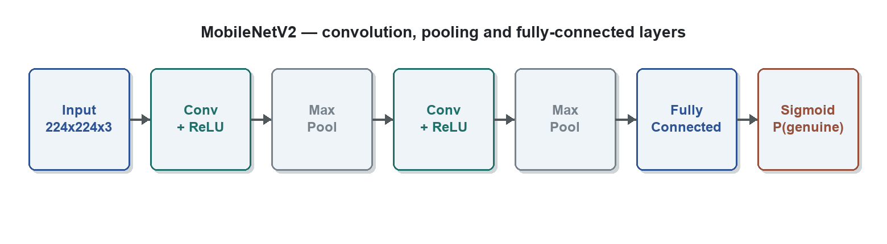
Figure 5.1: MobileNetV2 — convolution, pooling and fully-connected layers turn the note image into P(genuine).

5.2 Hand-crafted Feature Vector
The classical techniques do not look at raw pixels. Instead, each located note is summarised into a fixed list of fifty numbers — the feature vector — by backend/features.py. This is how a photograph is turned into something a classical model can read: the cropped note is converted into texture, colour and structural statistics, so two photos of the same note (different lighting or angle) map to similar vectors. The fifty numbers are grouped as shown in Table 5.1.
Table 5.1: Composition of the 50-dimensional feature vector.
Group | Dim | Description
LBP histogram | 26 | Uniform Local Binary Pattern (radius 3, 24 points) texture histogram.
Hue histogram | 12 | Coarse hue distribution of coloured pixels.
Colour scalars | 5 | Mean/std saturation, mean/std value, hue entropy.
Structure | 4 | Aspect ratio, edge density, gray mean, gray std.
Forensic signals | 3 | Micro-print sharpness, watermark variance, vertical-thread energy.

The vector is deterministic (the same image always yields the same numbers) and is standardised by a StandardScaler that is fit on the training split only and persisted with the model, so there is no difference between training and live prediction.

5.3 Classical Techniques Compared
Four classical supervised techniques are trained on the same fifty-dimensional vectors and compared:
- Support Vector Machine (SVM, RBF kernel) — finds the boundary that separates genuine from fake vectors with the widest possible margin; the RBF kernel lets that boundary be curved rather than a straight line.
- Random Forest — an ensemble of many decision trees whose votes are combined; it is the live second opinion in the application and is detailed in Section 5.4.
- K-Nearest Neighbours (KNN) — classifies a new note by the majority label of the most similar training vectors.
- Logistic Regression — a simple, interpretable linear baseline that outputs a genuine/fake probability.
All four are trained with group-aware cross-validation (a note's augmented copies never split across folds) and the best technique by cross-validation is selected without ever looking at the test set.

5.4 Random Forest — Detailed View
Random Forest is the classical technique chosen as the live second opinion in the running application, so it is described here in detail.
A single decision tree splits the data by asking a sequence of yes/no questions about the feature values (for example, “is the LBP texture energy above a threshold?”, “is the colour saturation low?”) until it reaches a leaf that says genuine or fake. One tree on its own tends to overfit — it memorises the training notes and generalises poorly. Random Forest fixes this by building many trees (an ensemble) and combining them. Two sources of randomness keep the trees diverse:
- Bagging (bootstrap sampling) — each tree is trained on a different random sample of the training notes, drawn with replacement.
- Feature subsampling — at each split a tree may only choose from a random subset of the fifty features, so different trees rely on different evidence.
To classify a new note, every tree votes genuine or fake and the forest averages the votes into a probability of genuine. Averaging many de-correlated trees cancels their individual mistakes, making Random Forest robust, resistant to overfitting and effective even on a small dataset — exactly the conditions of this project. It also exposes a feature-importance ranking, showing which of the fifty features most influence the decision.
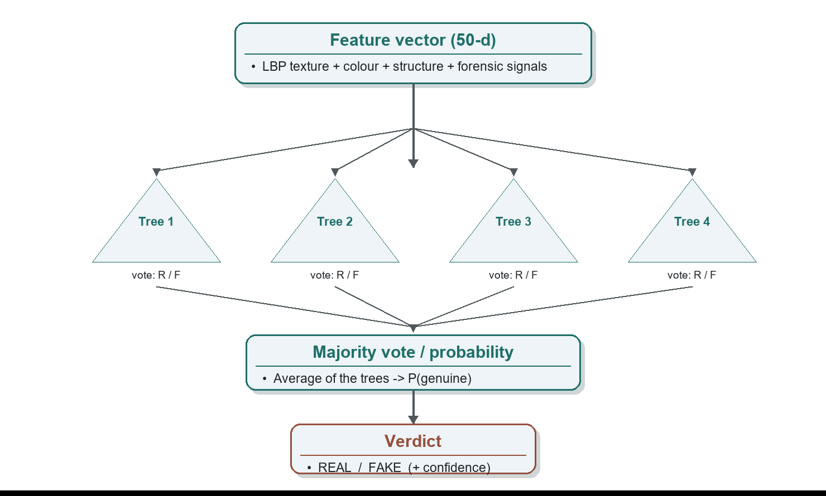
Figure 5.2: Random Forest — the feature vector is shown to many decision trees whose votes are averaged into a verdict.
How a photograph is processed by Random Forest in this system (implemented in backend/classical.py):
- The user supplies a banknote photo; the note is located and cropped from the background.
- backend/features.py converts the cropped note into the fifty-number feature vector (texture, colour, structure and forensic signals).
- The saved StandardScaler scales the vector to the range the forest was trained on.
- The scaled vector is passed to the trained Random Forest, whose trees vote; predict_proba returns the probability that the note is genuine.
- That probability becomes the Random Forest verdict (REAL if ≥ 0.5, else FAKE) with a confidence, shown as an independent second opinion.
Random Forest was selected as the live model because it was the best classical technique by cross-validation and, on the held-out test split, tied for the best test macro-F1 (0.742) while catching the most fakes (Chapter 10). The verdict logic keeps it as a transparent second opinion rather than the sole decider, so its agreement or disagreement with the CNN and the forensic score is always visible to the user.

5.5 Fusion into One Verdict
The deep model, the best classical model and the forensic score are fused by a calibrated rule (score = 0.4×CNN + 0.6×forensic). The forensic component is weighted higher because the CNN is brittle on out-of-distribution inputs. Three hard gates — structural sanity, colour palette and note proportions — can veto a REAL verdict regardless of score. When the photograph is too unclear to read the note, the system returns UNVERIFIED instead of guessing.

CHAPTER 6: SYSTEM DESIGN

6.1 System Architecture
The application is a FastAPI backend with a Next.js frontend. A photo posted to the /predict endpoint is decoded and the note auto-located; three engines then run on it — the MobileNetV2 CNN, the best classical model as a second opinion, and the forensic pipeline. Their outputs are fused, subjected to the hard gates and a readability gate, and returned to the UI, which renders every check. Figure 6.1 shows the component architecture.
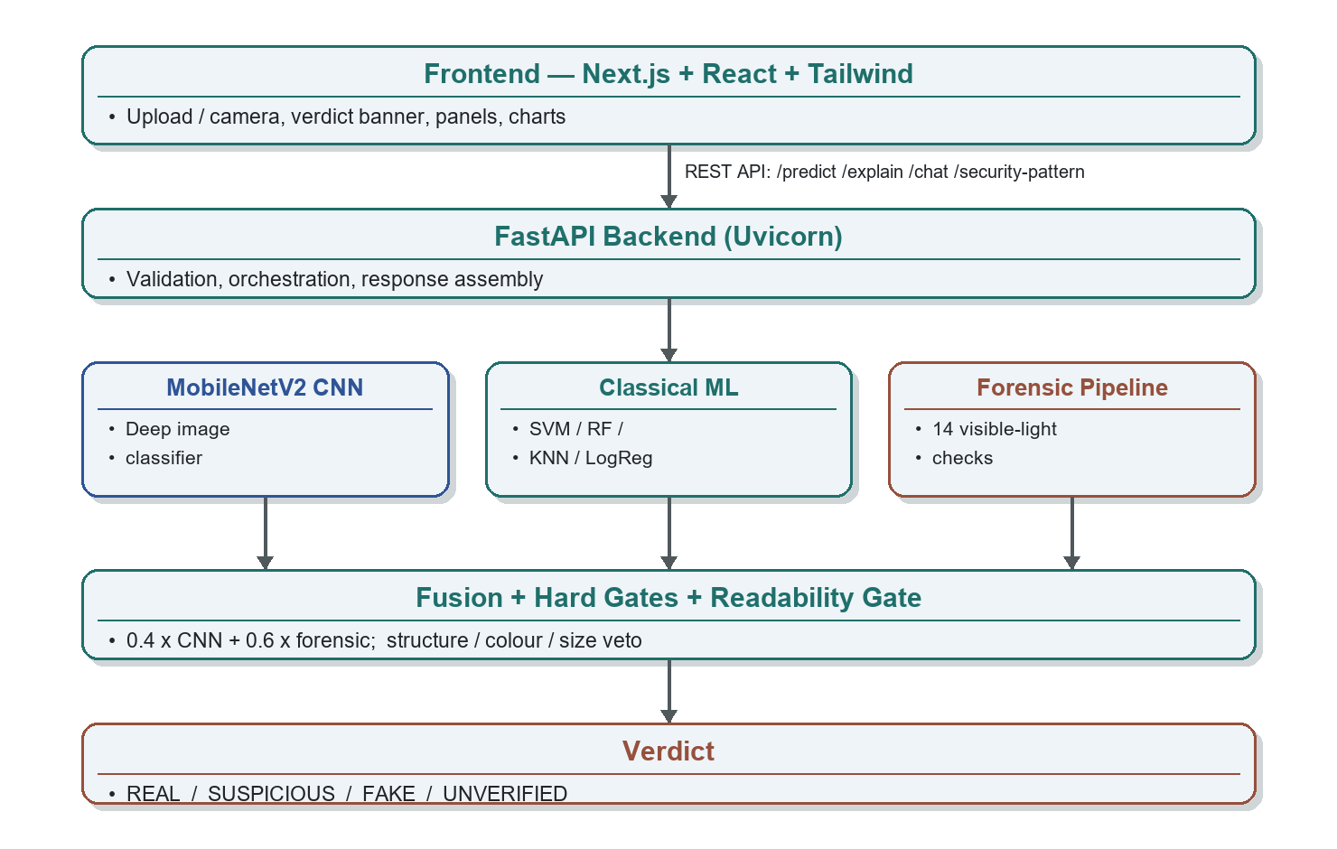
Figure 6.1: System architecture.

6.2 Data Flow Diagram
The Data Flow Diagram (DFD) shows how information moves through the system, from the input image to the final verdict, and the transformations applied at each stage.
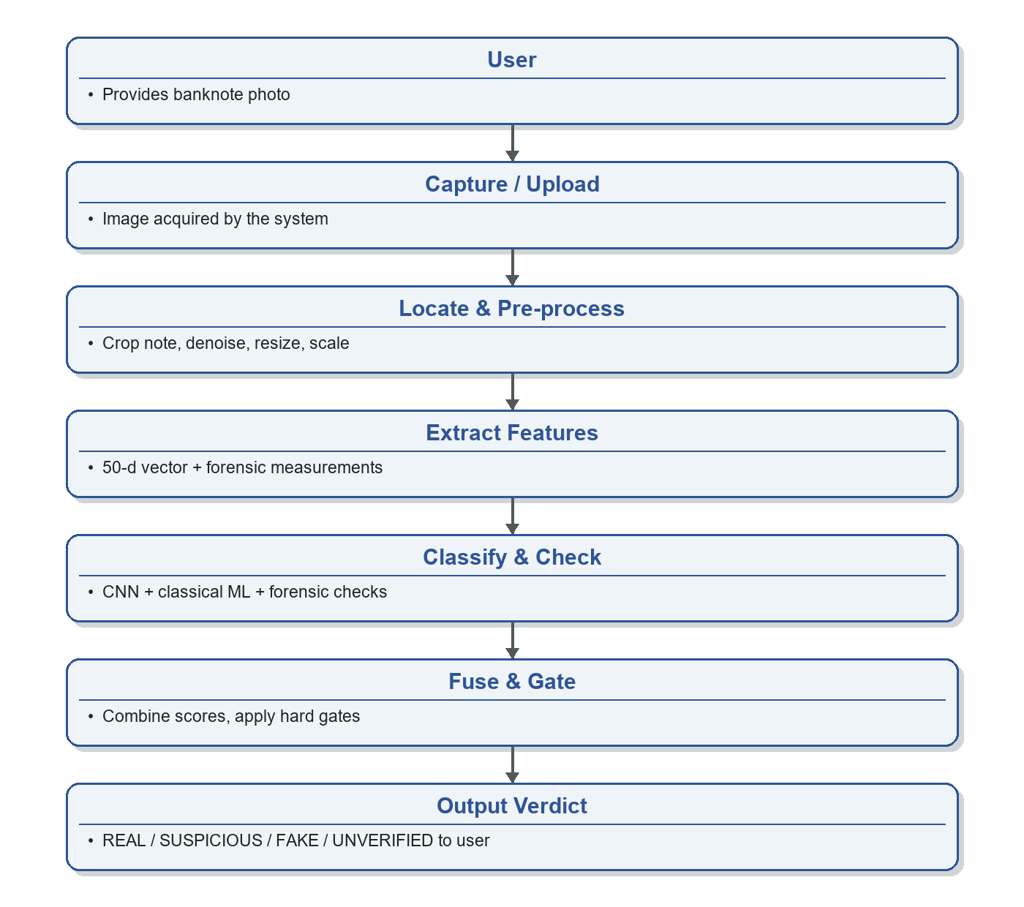
Figure 6.2: Data Flow Diagram.

6.3 UML Diagrams
The Unified Modeling Language (UML) is a standard language for specifying, visualising and documenting software systems. The activity diagram (Figure 6.3) shows the overall flow of control from capture to verdict; the use-case diagram (Figure 6.4) shows the interactions between the user, the system and its functions; and the sequence diagram (Figure 6.5) shows the order of messages exchanged during a prediction.
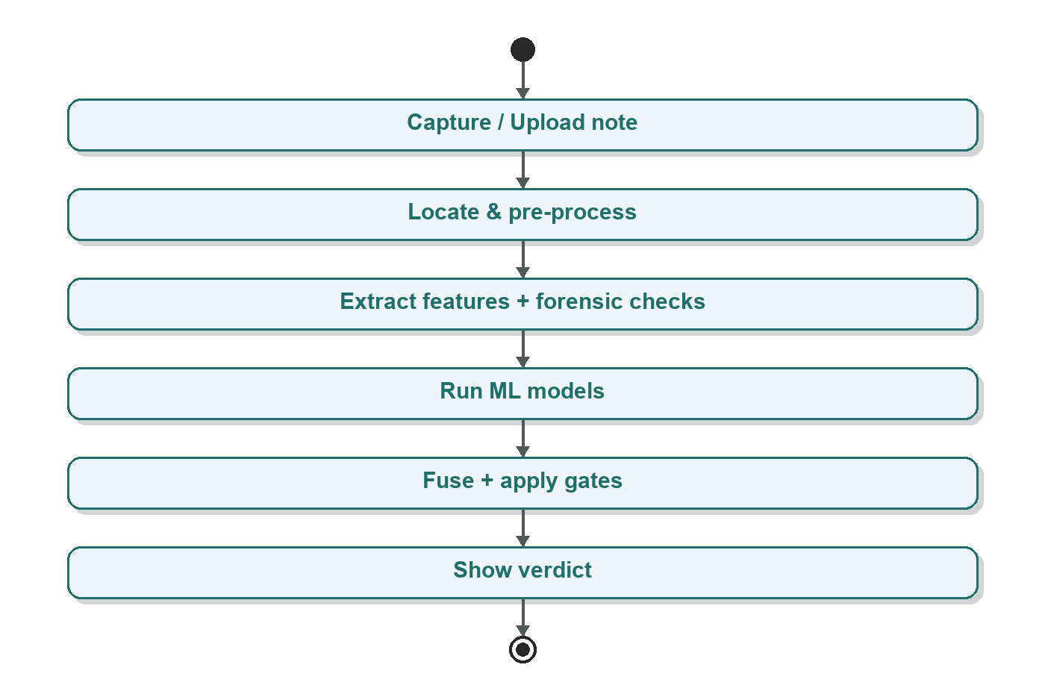
Figure 6.3: Activity Diagram.
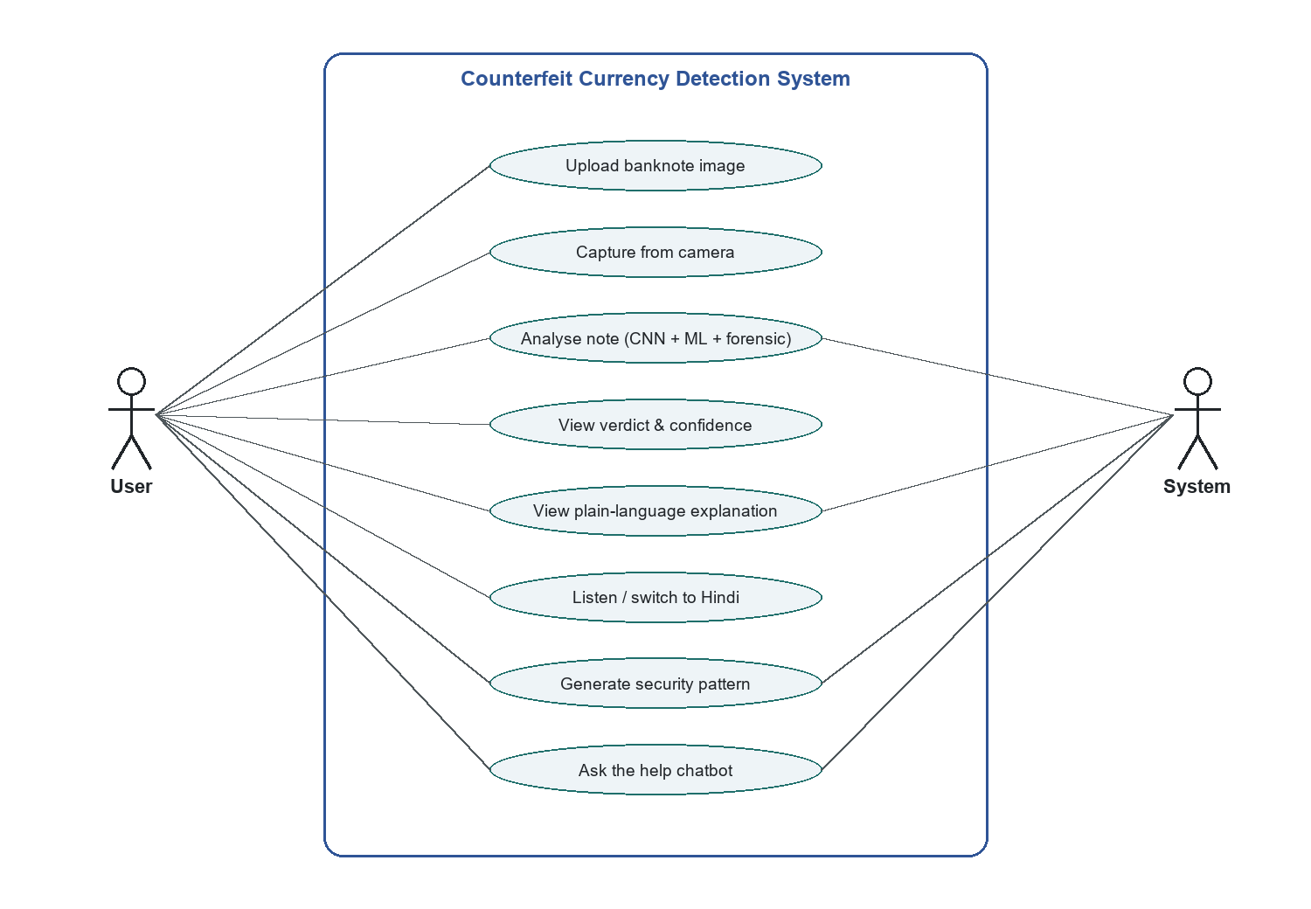
Figure 6.4: Use Case Diagram — the User uploads or captures a note and views the verdict, explanation, pattern and chatbot, while the System actor fulfils the analysis and generative cases.
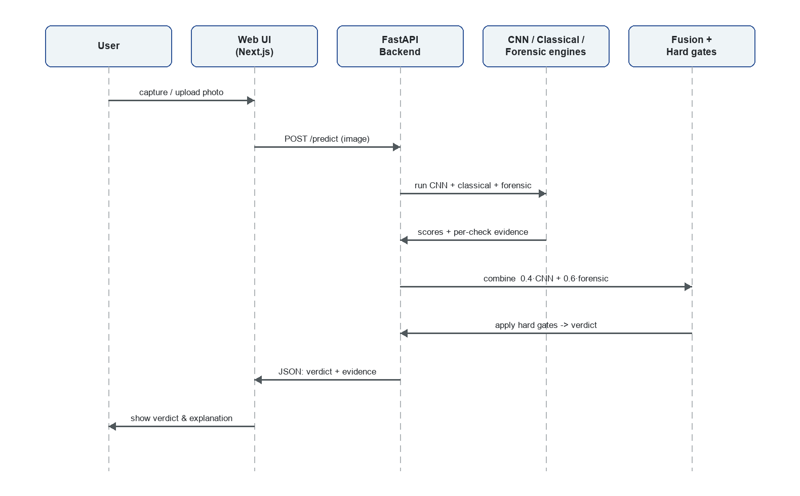
Figure 6.5: Sequence Diagram — the order of messages exchanged during a prediction, from the User through the Web UI and Backend to the CNN/classical/forensic engines, fusion and verdict.

CHAPTER 7: METHODOLOGY AND IMPLEMENTATION

7.1 Overall Workflow
Figure 7.1 summarises the end-to-end workflow: a banknote photo is captured, pre-processed, passed through the ML models and forensic checks, fused into a verdict, and finally evaluated.
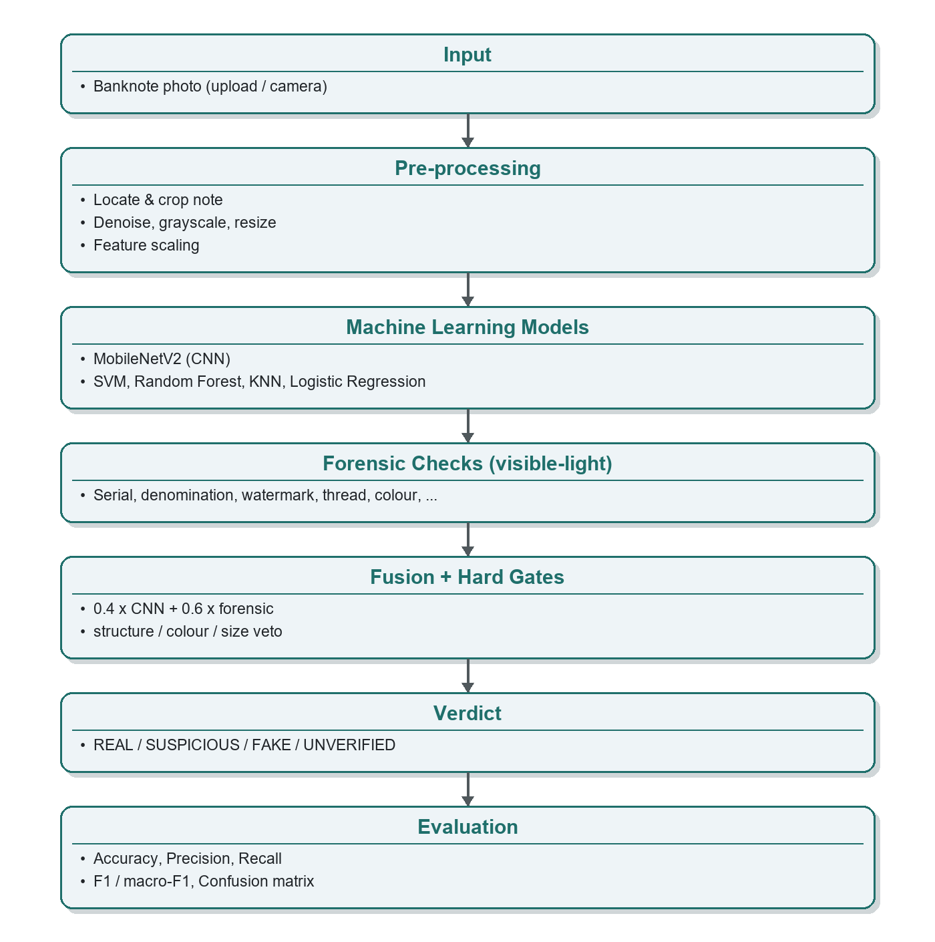
Figure 7.1: Overall detection workflow.

7.2 Dataset
The dataset comprises 65 labelled full-note images (42 genuine / 23 fake): 34 project fixtures (clean scans, phone photos and synthetic degradations) plus 31 images from the public, Apache-2.0 Kaggle “Fake Currency Detection Dataset” (19 real and 12 photographs of real fake notes). The images are organised under dataset/real and dataset/fake and indexed deterministically into a label-stratified train/test split. The dataset is deliberately small and the report is honest about the resulting accuracy ceiling.

7.3 Pre-processing
- Note localisation — a two-stage detector (Canny/contour and rotated-rectangle, with a GrabCut + saliency fallback for handheld, tilted or busy-background photos) crops the note.
- Denoising and grayscale conversion of the located note.
- Canonical resize so texture and colour features are resolution-comparable; small crops are upscaled before OCR.
- Feature scaling with StandardScaler (zero mean, unit variance), fit on the training split only.
- Group-aware train/test split with a fixed random seed so augmented copies of a note never leak across the split.

7.4 Training Pipeline
Training is fully scripted and reproducible. build_dataset.py indexes the images; train_classical.py extracts features, augments the training set, and trains the SVM, Random Forest, KNN and Logistic Regression models with group-aware cross-validation, saving the best model and its scaler; benchmark_models.py produces the comparison table; and evaluate_system.py runs the full end-to-end verdict over the corpus. Re-running these scripts after adding more images automatically improves the system with no code change.

7.5 Modules
- Data collection — Indexes and labels the banknote images into a deterministic train/test split.
- Pre-processing — Locates and crops the note, denoises, converts to grayscale and resizes.
- Feature extraction — Builds the 50-d feature vector and measures each forensic security region.
- Classification & fusion — Runs the CNN and best classical model and fuses them with the forensic score under hard gates.
- Explanation & assistant — Generates plain-language explanations, the security-pattern art, and the help chatbot responses.

CHAPTER 8: FORENSIC SECURITY-FEATURE CHECKS
Alongside the machine-learning models, the system runs a pipeline of fourteen visible-light forensic checks. Each measures one security feature and returns PASS, FAIL or INFO with the measured number; INFO means the feature could not be assessed and is never counted as a fake pass or fail. This honesty is central to the project: a phone-photo miscount is treated as a resolution problem, not proof of forgery. Table 8.1 lists the checks.
Table 8.1: Forensic security-feature checks.
Check | What it measures
Structural sanity | Aspect, edges, brightness, dark quadrants (hard gate).
Serial number (OCR) | Reads the serial via EasyOCR.
Serial typography | Digit heights increase left-to-right on genuine notes.
Denomination | EasyOCR digit voting + colour-palette tiebreak.
Proportion analysis | Measured aspect vs canonical RBI mm dimensions.
Security thread | Morphological vertical-feature detector.
Watermark | Gandhi-panel gradient variance.
Gandhi portrait | Haar-based portrait detection.
Micro-lettering | Fine-print sharpness (never a false PASS).
Bleed lines | Counts edge lines vs RBI per-denomination count.
Identification mark | Tactile-shape presence + touch guidance.
Colour palette | Hue entropy + saturation (hard gate).
UV (proxy) | Visible-light approximation, INFO-only.
Digital tamper (ELA) | Error-Level Analysis for edited images (INFO-only).

Several checks implement features named directly in the project brief. The serial-typography check is the brief's “the note number varies with size” feature: on genuine notes the serial digits grow in height from left to right, and the check fits a line through the digit heights to detect a flat (suspicious) serial. The colour palette check is the “colour variation” feature, and the bleed-line and identification-mark checks support the visually-impaired by reporting the tactile shape a genuine note should carry.

CHAPTER 9: EXPLAINABILITY, ACCESSIBILITY AND GENERATIVE FEATURES
The system is built to be trustworthy and usable, not merely a classifier. This chapter describes the features that surround the core detection. Every feature that can call an external AI service also has a deterministic offline fallback, so the entire product runs locally with no internet or API key.

9.1 Plain-Language Explanation
The “Explain with AI” feature turns the technical result into a short, calm, plain-language summary plus the manual checks a person can perform by hand (tilt for the colour-shift, hold to light for the watermark, feel the raised print). It is accessibility-first: the text can be read aloud and is available in English and Hindi. When an API key is present it is produced by a large language model with a JSON-constrained response; otherwise a deterministic template built from the same forensic results is used, so the feature always works.

9.2 Accessibility — Listen and Hindi
A “Listen” button reads the verdict and explanation aloud using the browser's speech synthesis, and an English/Hindi toggle localises both the verdict and the explanation. These features serve the visually-impaired and bilingual users that the reference papers highlight, and align with the tactile identification-mark check.

9.3 Security Pattern Studio (Generative Anti-Copy Art)
What genuinely resists copying in real currency, on the design side, is guilloche — the fine, interwoven mathematical line-work that is easy to regenerate from a formula but very hard to reproduce by hand or through a scan-and-print cycle. The Security Pattern Studio procedurally generates such guilloche art from a seed: woven rings, a micro-text ring and a layered rosette. The generation is fully deterministic — the same seed always produces the same pattern, so a design keyed to a serial number can be regenerated and compared. Figures 9.1 and 9.2 show two patterns generated by the project's own backend for two seeds; note that different seeds yield completely different patterns, while the same seed always reproduces exactly. Crucially, the studio produces abstract ornament only — never banknote imagery — so it is the honest, legal interpretation of a “generative anti-copy” feature.
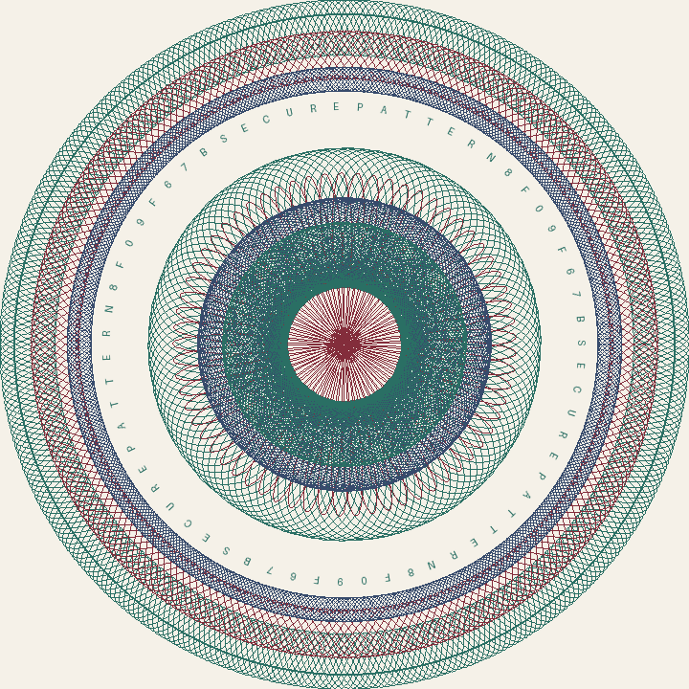
Figure 9.1: Generated guilloche pattern for seed ABHI-500-2026.

Figure 9.2: Generated guilloche pattern for seed ABHI-500-2029.

9.4 Help Chatbot
A floating assistant answers questions about how the system works, what each verdict means, and how to run it. It is grounded in a curated knowledge base about this project, uses a large language model when available and a keyword-FAQ matcher offline, and refuses any request to make or pass off counterfeit money.

9.5 Other Product Features
- Detected-note overlay — draws the located note region on the uploaded photo.
- Live camera capture — analyse a note straight from the webcam or phone camera through a framing guide.
- Grad-CAM heatmap — an attention overlay showing where the CNN looked.
- Downloadable PDF report — a print-ready one-page verdict summary.
- Digital-tamper (ELA) check — flags possibly edited images, informational only.

CHAPTER 10: RESULTS AND DISCUSSION

10.1 Dataset and Metrics
Evaluation uses the 65-image labelled corpus, split into 48 training and 17 test images (augmentation applied only to the training split). Because counterfeiting is a two-class decision (genuine vs fake), this is a classification task and is evaluated with classification metrics — accuracy, precision, recall and the macro-averaged F1 score — together with the confusion matrix and, as the priority metric, the false-positive rate (how often a genuine note is wrongly called fake; target: zero).

10.2 Technique Comparison
Table 10.1: Technique comparison on the held-out test split (1 = genuine, 0 = fake).
Technique | Test Acc | Test macro-F1 | Fakes caught
SVM (RBF) | 0.765 | 0.742 | 4/6
Random Forest | 0.765 | 0.742 | 4/6
Logistic Regression | 0.706 | 0.622 | 2/6
KNN | 0.529 | 0.514 | 3/6
MobileNetV2 (CNN) | 0.588 | 0.564 | 3/6

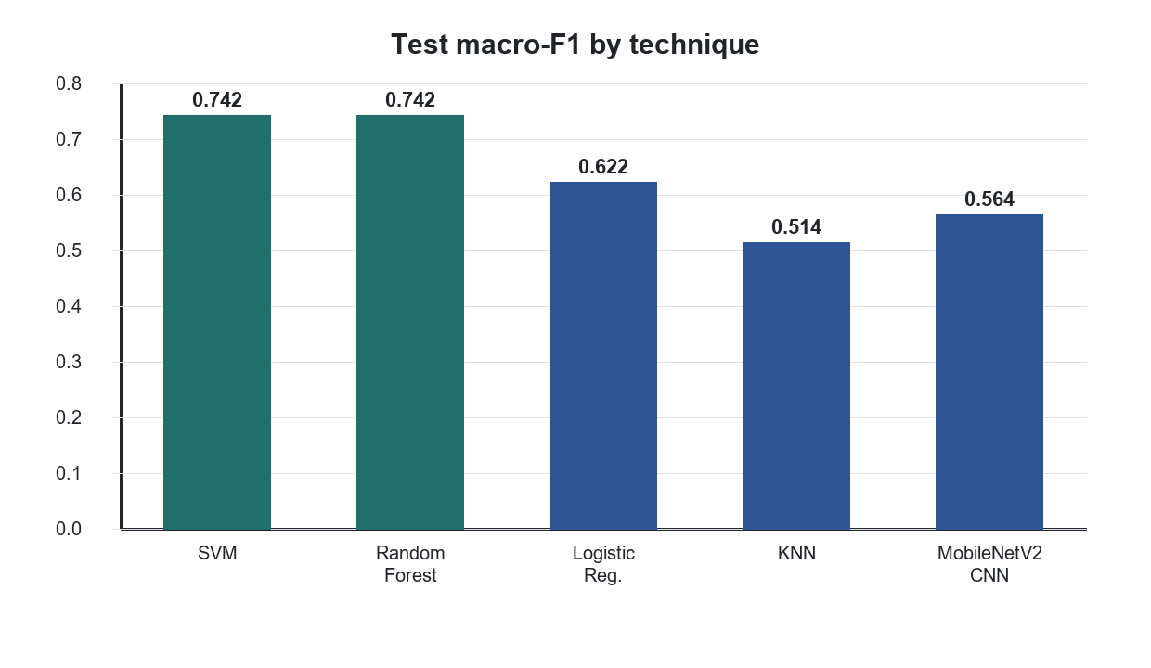
Figure 10.1: Test macro-F1 by technique.
The classical models trained on engineered features clearly outperform the off-the-shelf CNN, which collapses toward predicting “all genuine” on so little data. Random Forest, the best technique by cross-validation, runs as the live second opinion.
Figure 10.2 plots the Receiver Operating Characteristic (ROC) curve of each technique, computed from the real probability each trained model assigns to “genuine” on the held-out test images. A ROC curve traces the true-positive rate against the false-positive rate as the decision threshold is swept from 0 to 1, and the area under the curve (AUC) summarises how reliably a model ranks a genuine note above a fake one (0.5 = chance, 1.0 = perfect). Because the test split is only seventeen images, the curves are stepped and higher-variance — the same honesty caveat that applies to every test-set metric in this report.
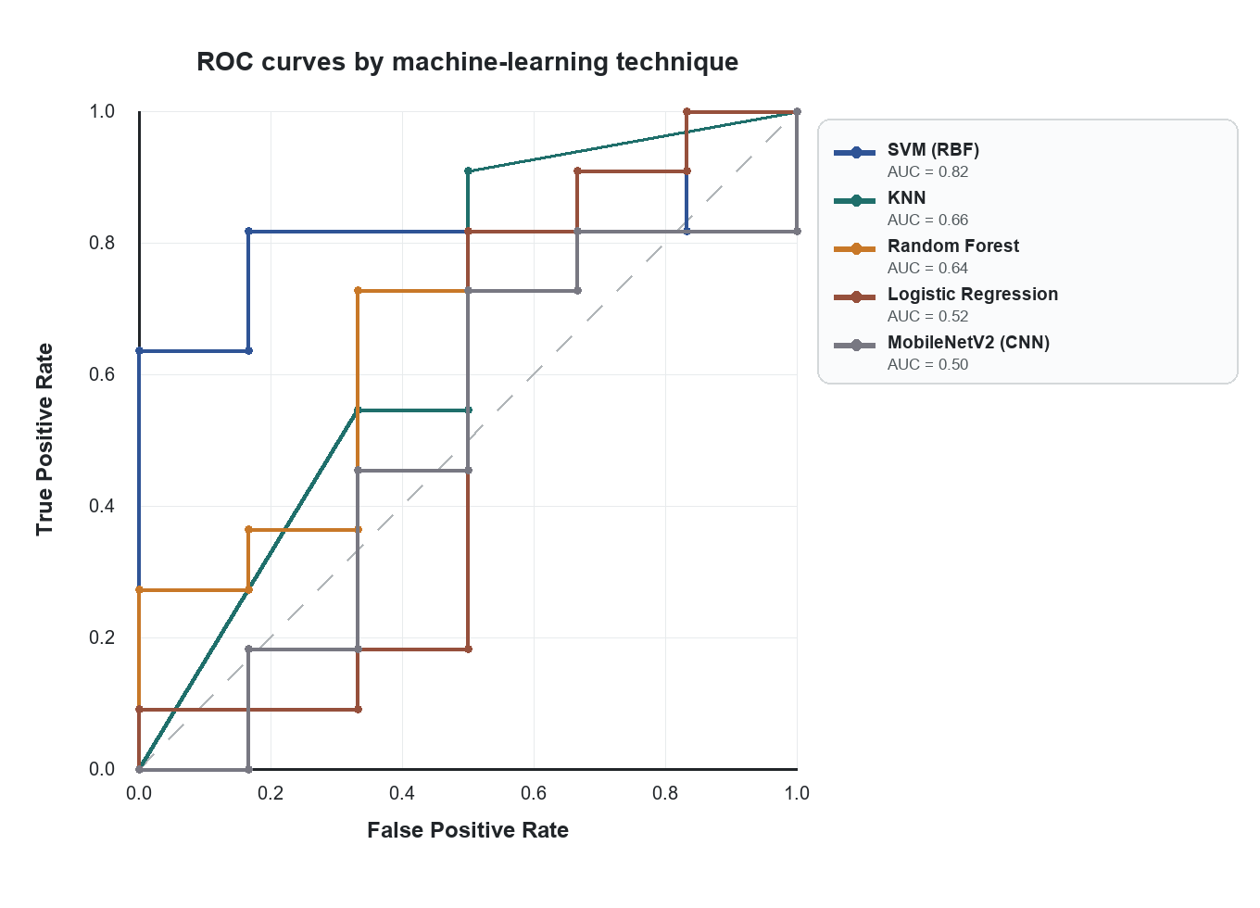
Figure 10.2: ROC curves by technique on the held-out test split (positive class = genuine; dashed diagonal = chance).
AUC measures ranking quality and need not agree with the macro-F1 scores of Table 10.1, which are read at a single 0.5 threshold. SVM (RBF) ranks genuine notes above fakes most reliably (AUC ≈ 0.82); Random Forest — selected as the live second opinion by cross-validation — matches SVM's threshold decisions in Table 10.1 but ranks less cleanly on these seventeen images (AUC ≈ 0.64). The MobileNetV2 CNN lies on the chance diagonal (AUC ≈ 0.50), the clearest possible confirmation that, with so few images, the deep model fails to separate the two classes — exactly why it is weighted below the forensic score in the fused verdict.

10.3 Whole-System End-to-End
Table 10.2: End-to-end verdict confusion matrix (all 65 images).
Ground truth \ Verdict | REAL | SUSPICIOUS | FAKE | UNVERIFIED
Genuine | 31 | 11 | 0 | 0
Fake | 10 | 7 | 5 | 1

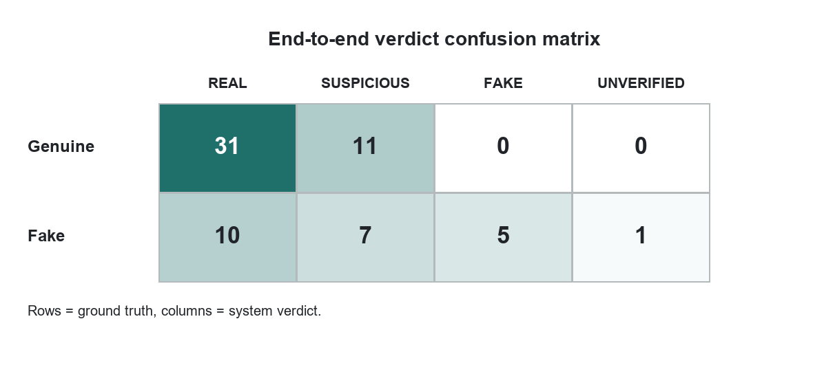
Figure 10.3: End-to-end verdict confusion matrix.
- 0% false positives — a genuine note is never called FAKE. This priority property held across every change.
- 74% of genuine notes cleared as REAL (the rest flagged SUSPICIOUS for review).
- About 57% of fakes flagged; the remainder (high-quality physical fakes) pass as REAL — the data-bound false-negative case.

10.4 Negative Results (Reported Honestly)
- Re-training the CNN on 65 images scored 0.550 macro-F1 — worse than the kept model (0.564); CNNs need far more data.
- ORB motif/emblem matching false-failed genuine notes and was removed rather than shipped.
- Micro-print sharpness does not separate genuine from sharp fakes, so it only flags clearly-degraded print and never emits a false PASS.
Together these confirm a single conclusion: the binding constraint is training-data volume and the scarcity of real physical-counterfeit images, not the method.

10.5 Discussion
The classical models win because hand-crafted features are sample-efficient on a small dataset, whereas a CNN needs thousands of images to generalise. The ensemble plus forensic hard gates make the system safer than any single model — notably the 0% false-positive rate, which matters most because rejecting genuine money is the worst error. Throughout, when a signal cannot be measured the system returns INFO rather than guessing, so it never manufactures confidence.

CHAPTER 11: SYSTEM TESTING
Testing ensures that each component behaves correctly and that the system as a whole produces dependable results.

11.1 Black-Box and White-Box Testing
Black-box (functional) testing checks the output produced for a given input and was used to verify the /predict, /explain, /chat and /security-pattern endpoints. White-box (structural) testing exercises the internal logic and was used for the deterministic helpers — feature extraction, readability assessment and pattern generation.

11.2 Types of Testing Applied
- Unit testing — individual functions (feature-vector shape and determinism, verdict logic, pattern determinism).
- System testing — the full request/response flow across environments.
- Usability testing — the clarity and ease of use of the interface.
- Acceptance testing — that the delivered system meets the stated objectives.
- Regression testing — re-running the suite after each change, notably preserving the 0% false-positive property.
The implementation is covered by an automated test suite of more than 130 tests (pytest) across the OCR, localisation, proportion, forensic, API, feature, fusion, explanation, pattern and chatbot modules, together with a manifest-driven fixture set and a diagnostic harness that reports objective confusion-matrix numbers.

CHAPTER 12: CONCLUSION AND FUTURE WORK

12.1 Conclusion
This project built an automated, explainable system that detects counterfeit Indian banknotes from a phone photograph using various machine-learning techniques. By fusing a deep CNN, several classical classifiers and an explainable forensic pipeline, the system delivers a fast, honest verdict and never rejects a genuine note (0% false positives) on the evaluation set. The comparison of techniques shows that, on a small dataset, classical models with engineered features outperform an off-the-shelf CNN. Beyond classification, the system is made trustworthy and usable through plain-language explanation, accessibility, a help chatbot and a generative anti-copy security-pattern studio, all running locally.

12.2 Future Scope
In the future this work can be extended in several directions. The most impactful is to gather more labelled images, prioritising real physical counterfeits; the pipeline auto-improves on re-run with no code change. The REAL/SUSPICIOUS/FAKE thresholds can be recalibrated from ROC curves once the dataset is larger, reducing over-cautious SUSPICIOUS flags. The CNN and a learned fusion meta-classifier can be re-attempted when data supports it. Optional UV-reactive checks could be added if UV-lamp imagery becomes available, and the tool could be packaged as an installable mobile application for wider real-world use.

APPENDIX A: SCREENSHOTS
This appendix collects screenshots of the running application. The images are loaded from docs/screenshots/ when the report is built, so they are preserved automatically on every regeneration of this document.
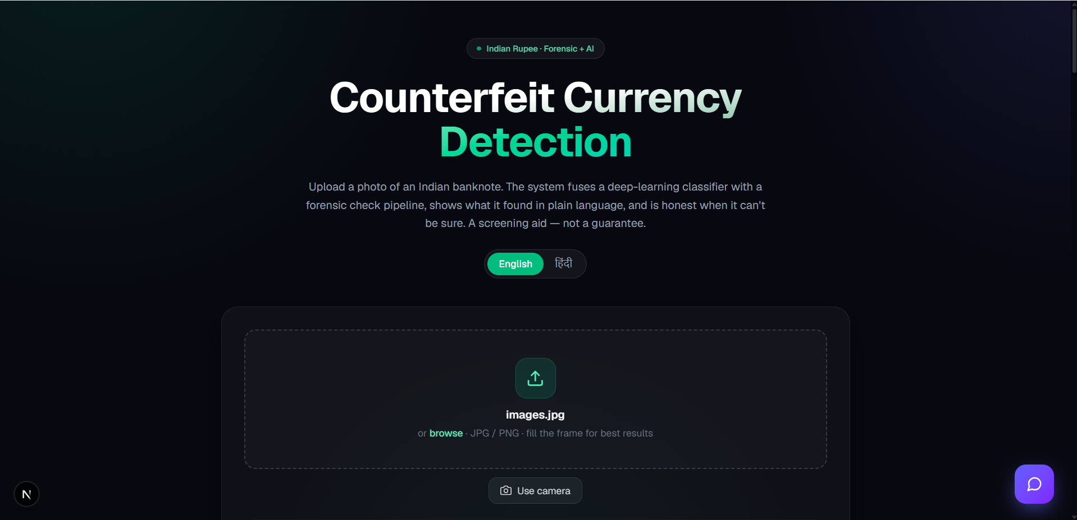
Figure A.1: Home / upload screen with the English–Hindi toggle.
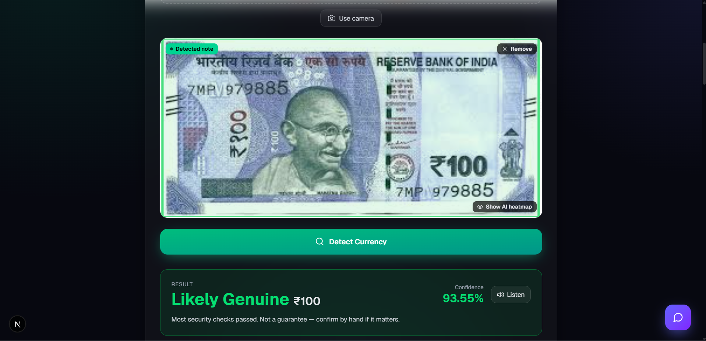
Figure A.2: Verdict for a genuine ₹100 note (REAL) with the detected-note overlay and a 93.55% confidence.
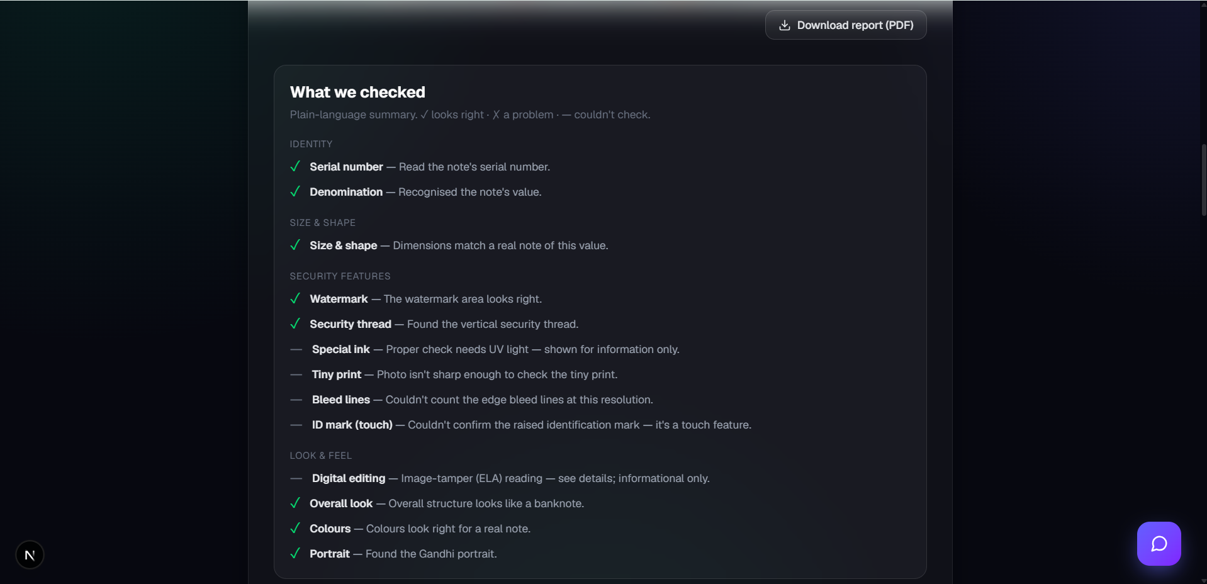
Figure A.3: “What we checked” — the plain-language security-feature summary (✓ looks right · ✗ a problem · — couldn't check).
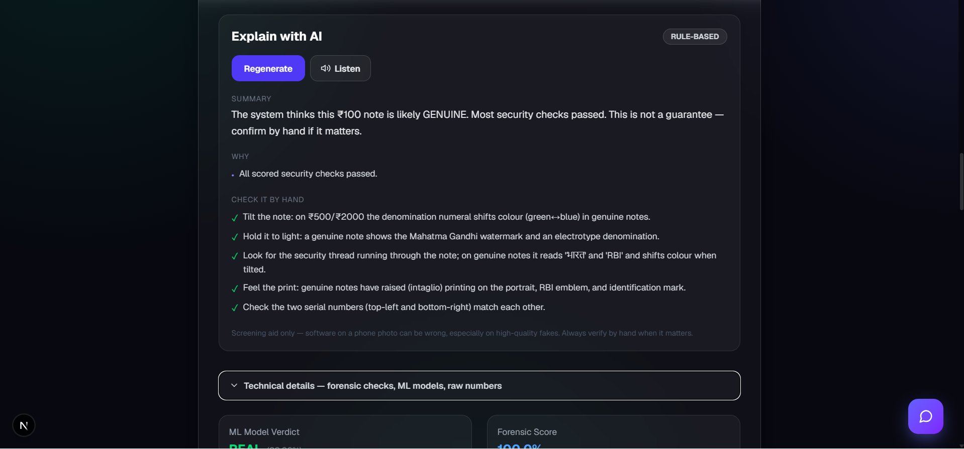
Figure A.4: “Explain with AI” — the plain-language explanation and the manual by-hand checks.
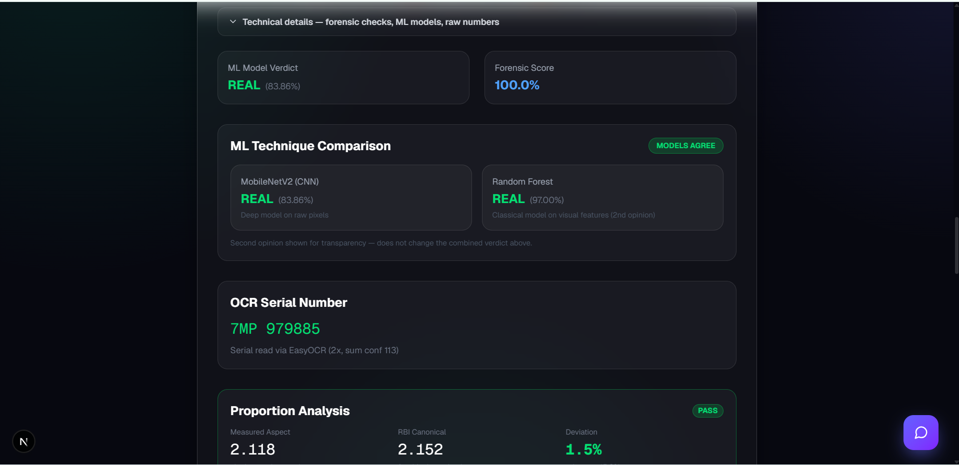
Figure A.5: Technical details — the ML technique comparison (MobileNetV2 CNN and the Random Forest second opinion).
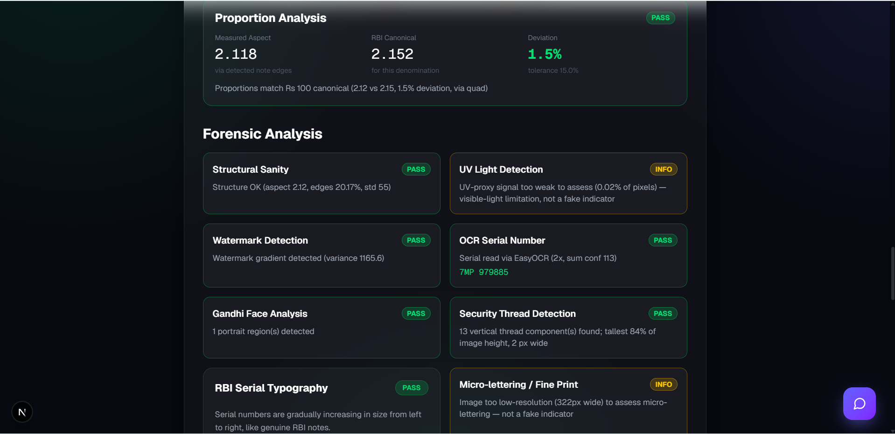
Figure A.6: Forensic analysis — the proportion check and the grid of per-feature security checks.
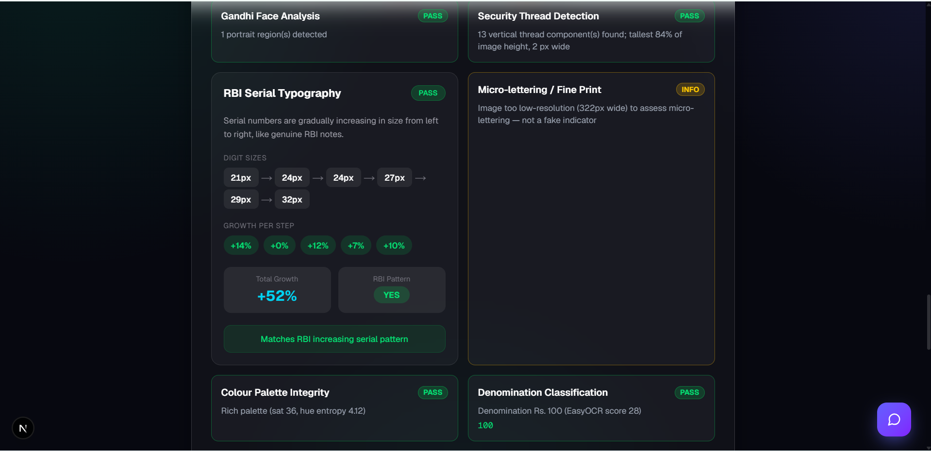
Figure A.7: RBI serial-typography check — the serial digits ascending in size from left to right, as on genuine notes.
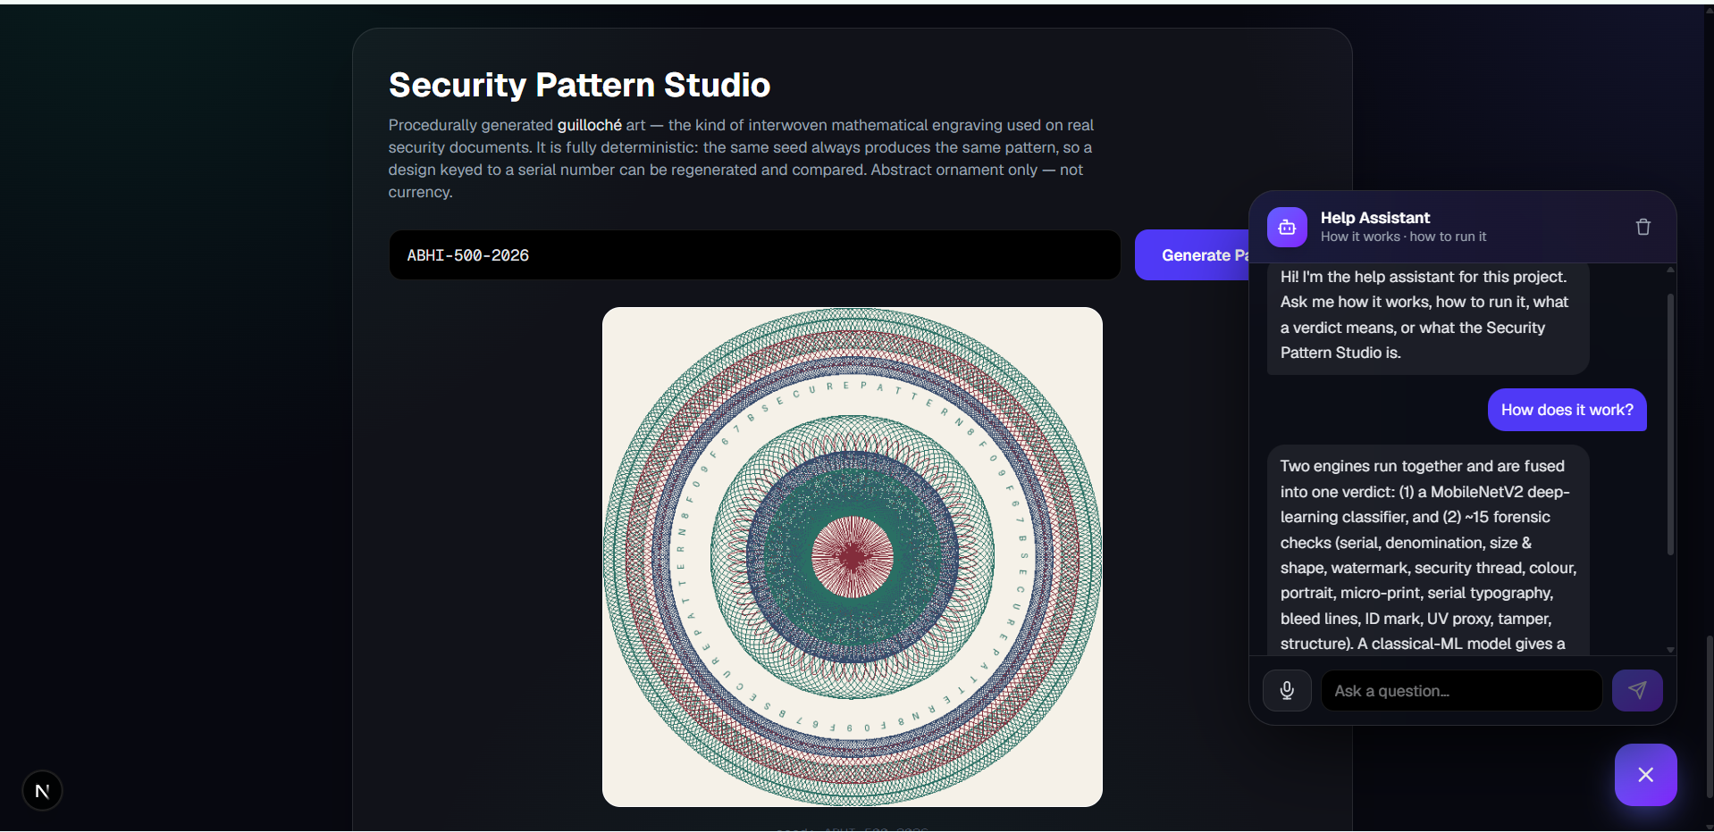
Figure A.8: Security Pattern Studio (procedurally generated guilloche art) with the Help chatbot open.

APPENDIX B: SOURCE CODE
Representative modules are listed below, each preceded by a short explanation of what it does. The complete source resides in the project repository.

B.1 Feature extraction — backend/features.py
Turns a banknote image into the fifty-number feature vector used by all classical models — the uniform Local Binary Pattern texture histogram, a hue/colour distribution, structural descriptors and three OCR-free forensic signals, concatenated into one fixed-length, deterministic vector. Using a single function guarantees that training and live prediction extract features identically.
"""
Hand-crafted visual feature extraction for the classical machine
learning techniques in Phase D (see docs/PROJECT_SCOPE.md §4).

This module turns a banknote image into a FIXED-LENGTH numeric
feature vector built only from fast, deterministic, visible-light
image statistics — no OCR, no neural network. It mirrors the
approach in the reference thesis (Local Binary Pattern histograms
over the note) and adds colour-distribution and structural
descriptors so the classical models (SVM / RandomForest / KNN /
LogisticRegression) have a meaningful, reproducible input.

Design contract:
- ``extract_feature_vector(bgr) -> np.ndarray`` of shape
``(FEATURE_DIM,)``, dtype float32.
- Deterministic: the same image in produces the same vector out.
- Never raises: unusable input yields a best-effort / zero-filled
vector of the correct length, so one bad sample can't abort a
training run over thousands of images.
- No train/serve skew: the SAME function builds the training
matrix and featurises an image at inference time.

The vector is intentionally independent of the forensic rule
checks and the CNN so the three views — CNN on raw pixels,
classical ML on these hand-crafted features, forensic rules on
security features — stay statistically independent for the
Phase D fusion layer.

Feature values are returned RAW (unscaled). Standardisation
(zero-mean / unit-variance) is the training pipeline's job
(``StandardScaler``), kept there so the scaler is fit on the
training split only and persisted alongside the model.
"""

import numpy as np
import cv2
from skimage.feature import local_binary_pattern

from backend.forensic import (
_ensure_bgr, _locate_note, _microprint_score, _watermark_variance,
)

# ---- Local Binary Pattern: matches the reference thesis
# (radius 3, 8*radius sample points, uniform method). Uniform
# LBP with P points yields P+2 bins.
_LBP_RADIUS = 3
_LBP_POINTS = 8 * _LBP_RADIUS # 24
_LBP_BINS = _LBP_POINTS + 2 # 26

_HUE_BINS = 12 # coarse hue distribution
_CANON_W = 384 # canonical landscape size for
_CANON_H = 192 # texture/colour comparability
_SAT_MASK = 40 # "coloured pixel" saturation floor

# Fixed feature layout. The order here is the contract — training
# and inference both rely on it, and feature-importance reports
# map back through these names.
FEATURE_NAMES = (
[f"lbp_{i}" for i in range(_LBP_BINS)]
+ [f"hue_{i}" for i in range(_HUE_BINS)]
+ ["mean_sat", "std_sat", "mean_val", "std_val", "hue_entropy"]
+ ["aspect", "edge_density", "gray_mean", "gray_std"]
# OCR-free forensic security signals folded into the ML vector
# (Phase E -> ML): fine-print sharpness, watermark-panel gradient
# variance, and central vertical-edge energy (security-thread proxy).
# log1p compresses the heavy-tailed sharpness/variance ranges.
+ ["microprint_logsharp", "watermark_logvar", "vthread_energy"]
)
FEATURE_DIM = len(FEATURE_NAMES) # 50

def _lbp_hist(gray):
"""Uniform-LBP histogram (density-normalised) — 26 bins."""

lbp = local_binary_pattern(
gray, _LBP_POINTS, _LBP_RADIUS, method="uniform"
)
hist, _ = np.histogram(
lbp, bins=_LBP_BINS, range=(0, _LBP_BINS), density=True
)
return hist.astype(np.float32)

def _colour_feats(bgr):
"""Return (hue_hist[12], scalars[5]).

scalars = [mean_sat, std_sat, mean_val, std_val, hue_entropy]."""

hsv = cv2.cvtColor(bgr, cv2.COLOR_BGR2HSV)
hue = hsv[:, :, 0]
sat = hsv[:, :, 1]
val = hsv[:, :, 2]

coloured = hue[sat > _SAT_MASK]

if coloured.size >= 50:
hue_hist, _ = np.histogram(
coloured, bins=_HUE_BINS, range=(0, 180), density=True
)
# Shannon entropy of the full 180-bin hue distribution —
# rich palettes score high, photocopies/desaturated low.
full = np.bincount(coloured, minlength=180).astype(np.float64)
full /= full.sum()
nz = full[full > 0]
hue_entropy = float(-(nz * np.log2(nz)).sum())
else:
hue_hist = np.zeros(_HUE_BINS, dtype=np.float64)
hue_entropy = 0.0

scalars = np.array([
float(sat.mean()), float(sat.std()),
float(val.mean()), float(val.std()),
hue_entropy,
], dtype=np.float32)

return hue_hist.astype(np.float32), scalars

def _forensic_extras(note, gray):
"""OCR-free forensic security signals as 3 numeric features:
[microprint_logsharp, watermark_logvar, vthread_energy].

Reuses the live forensic helpers so train/serve stay aligned.
log1p compresses the heavy-tailed sharpness/variance ranges so
a single very-high-detail note doesn't dominate the scaler."""

try:
sharp, _ = _microprint_score(note)
except Exception:
sharp = 0.0

try:
wv = _watermark_variance(note)
wv = 0.0 if wv is None else wv
except Exception:
wv = 0.0

# Vertical-edge energy in the central strip — a cheap, scale-
# stable security-thread proxy (the thread is a tall vertical
# feature). Computed on the canonical gray so it's resolution-
# normalised like the rest of the vector.
try:
h, w = gray.shape[:2]
strip = gray[:, int(w * 0.30):int(w * 0.70)]
sob = cv2.Sobel(strip, cv2.CV_32F, 1, 0, ksize=3)
vthread = float(np.mean(np.abs(sob)))
except Exception:
vthread = 0.0

return np.array([
float(np.log1p(max(sharp, 0.0))),
float(np.log1p(max(wv, 0.0))),
vthread,
], dtype=np.float32)

def extract_feature_vector(image):
"""Featurise a BGR image into a length-``FEATURE_DIM`` vector.

Never raises. On catastrophic failure returns a zero vector of
the correct length so a single bad sample doesn't abort a
batch training run."""

try:
bgr = _ensure_bgr(image)
except Exception:
return np.zeros(FEATURE_DIM, dtype=np.float32)

# Aspect is measured on the located note BEFORE the canonical
# resize, so it reflects real note geometry, not the resize.
try:
note = _locate_note(bgr)
except Exception:
note = bgr

h0, w0 = note.shape[:2]
aspect = float(max(w0, h0) / max(min(w0, h0), 1))

try:
canon = cv2.resize(
note, (_CANON_W, _CANON_H), interpolation=cv2.INTER_AREA
)
gray = cv2.cvtColor(canon, cv2.COLOR_BGR2GRAY)
except Exception:
return np.zeros(FEATURE_DIM, dtype=np.float32)

# ---- LBP texture (26) ----
try:
lbp = _lbp_hist(gray)
except Exception:
lbp = np.zeros(_LBP_BINS, dtype=np.float32)

# ---- Colour distribution (12 + 5) ----
try:
hue_hist, colour_scalars = _colour_feats(canon)
except Exception:
hue_hist = np.zeros(_HUE_BINS, dtype=np.float32)
colour_scalars = np.zeros(5, dtype=np.float32)

# ---- Structure (4) ----
try:
edges = cv2.Canny(gray, 50, 150)
edge_density = float(np.count_nonzero(edges)) / edges.size
gray_mean = float(gray.mean())
gray_std = float(gray.std())
except Exception:
edge_density = gray_mean = gray_std = 0.0

struct = np.array(
[aspect, edge_density, gray_mean, gray_std], dtype=np.float32
)

# ---- OCR-free forensic security signals (3) ----
try:
extras = _forensic_extras(note, gray)
except Exception:
extras = np.zeros(3, dtype=np.float32)

vec = np.concatenate([lbp, hue_hist, colour_scalars, struct, extras])

# Guard against any NaN/inf leaking into the training matrix.
vec = np.nan_to_num(
vec, nan=0.0, posinf=0.0, neginf=0.0
).astype(np.float32)

# Defensive length check — the contract is FEATURE_DIM.
if vec.shape[0] != FEATURE_DIM:
out = np.zeros(FEATURE_DIM, dtype=np.float32)
out[: min(vec.shape[0], FEATURE_DIM)] = vec[:FEATURE_DIM]
return out

return vec

B.2 Classical second opinion — backend/classical.py
Loads the best classical model (chosen by cross-validation — here Random Forest) and its saved scaler and scores an image. predict_classical extracts the feature vector, scales it, and calls predict_proba to obtain the probability that the note is genuine, returning a REAL/FAKE verdict with confidence. It never raises: if the model files are missing it returns an “unavailable” result. This is the code path described in Section 5.4.
"""
Phase D.5 — classical-model inference (live second opinion).

Loads the best classical technique chosen by train_classical.py
(``models/classical/metrics.json`` -> ``meta.best_model``) plus its
fitted scaler, and scores an image into a genuine probability. In
``/predict`` this runs as an INDEPENDENT SECOND OPINION alongside
the MobileNetV2 CNN and is surfaced in the response/UI for
transparency.

The combined-verdict weighting is intentionally NOT changed by this
module — recalibrating the fusion against the diagnostic harness
(with ROC/threshold selection) is Phase F (see docs/PROJECT_SCOPE.md).
Here the classical model is an additional, honest viewpoint, not a
verdict driver.

Graceful by design: if the artifacts are missing (models not yet
trained), ``predict_classical`` returns ``{"available": False, ...}``
and the rest of the pipeline is unaffected. Never raises.
"""

import json
import os

from backend.features import extract_feature_vector

_DIR = os.path.join(
os.path.dirname(os.path.dirname(os.path.abspath(__file__))),
"models", "classical",
)
_METRICS = os.path.join(_DIR, "metrics.json")

_LOADED = False
_MODEL = None
_SCALER = None
_NAME = None

def _lazy_load():
global _LOADED, _MODEL, _SCALER, _NAME
if _LOADED:
return
_LOADED = True
try:
import joblib
with open(_METRICS, "r", encoding="utf-8") as fh:
meta = json.load(fh)["meta"]
name = meta.get("best_model")
_MODEL = joblib.load(os.path.join(_DIR, f"{name}.joblib"))
_SCALER = joblib.load(os.path.join(_DIR, "scaler.joblib"))
_NAME = name
except Exception:
_MODEL = None
_SCALER = None
_NAME = None

def warmup_classical():
"""Pre-load the classical model at startup. Returns True if a
model is available. Safe to call repeatedly; never raises."""
_lazy_load()
return _MODEL is not None

def classical_available():
_lazy_load()
return _MODEL is not None

def _unavailable(name=None):
return {
"available": False,
"name": name,
"verdict": None,
"confidence": None,
"prob_genuine": None,
}

def predict_classical(image):
"""Second-opinion verdict from the best classical technique.

Returns a dict with: available, name, verdict (REAL/FAKE),
confidence ("xx.xx%"), prob_genuine (0..1). Never raises."""

_lazy_load()
if _MODEL is None or _SCALER is None:
return _unavailable(_NAME)

try:
vec = extract_feature_vector(image).reshape(1, -1)
xs = _SCALER.transform(vec)

if hasattr(_MODEL, "predict_proba"):
classes = list(_MODEL.classes_)
gi = classes.index(1) if 1 in classes else len(classes) - 1
prob_gen = float(_MODEL.predict_proba(xs)[0][gi])
else:
prob_gen = 1.0 if int(_MODEL.predict(xs)[0]) == 1 else 0.0

verdict = "REAL" if prob_gen >= 0.5 else "FAKE"
conf = prob_gen if verdict == "REAL" else 1.0 - prob_gen

return {
"available": True,
"name": _NAME,
"verdict": verdict,
"confidence": f"{conf * 100:.2f}%",
"prob_genuine": round(prob_gen, 4),
}
except Exception:
return _unavailable(_NAME)

B.3 GenAI explanation — backend/genai.py
Converts the verdict and forensic results into a plain-language explanation plus manual verification steps, in English or Hindi. With an API key it uses a large language model with a JSON-constrained response; otherwise it falls back to a deterministic template, so the feature always works offline. It never generates currency — only explains authenticity.
"""
Phase I — GenAI explanation & accessibility layer.

Turns the structured counterfeit-note verdict + forensic check results into a
clear, plain-language explanation plus actionable manual-verification guidance.
This is the project's "GenAI that does something good": explainability and
accessibility (the visually-impaired use case both reference papers targeted),
NOT generation of counterfeit currency.

Design (production-grade, graceful):
- explain(result) -> {summary, reasons, manual_checks, source}
- When ANTHROPIC_API_KEY is set: uses Claude (Haiku — fast/cheap, this is a
simple structured-summarization task) with a cached static system prompt
and a JSON-schema-constrained response.
- When the key is unset (or the SDK is missing, or the call fails): falls back
to a DETERMINISTIC template built from the same forensic results — so the
feature always works locally and "upgrades" to live GenAI when a key exists.
- Never raises.

The Anthropic SDK is imported lazily so the rest of the backend has no hard
dependency on it.
"""

import os
import json

_MODEL = "claude-haiku-4-5" # explicit: fast + cheap for per-request summaries

# Friendly names for the forensic-pipeline keys (used by both the LLM payload
# and the deterministic template).
_CHECK_NAMES = {
"structural_sanity": "Overall structure",
"uv_light_detection": "UV-reactive ink (visible-light proxy)",
"watermark_detection": "Gandhi watermark",
"ocr_serial_number": "Serial number",
"gandhi_face_analysis": "Gandhi portrait",
"security_thread_detection": "Security thread",
"serial_typography_analysis": "Ascending serial size",
"microprint_detection": "Micro-lettering / fine print",
"hologram_detection": "Colour palette",
"denomination_classification": "Denomination",
"proportion_analysis": "Note proportions",
}

# Standard RBI manual checks — the honest, hardware-free things a person can do.
_MANUAL_CHECKS = [
"Tilt the note: on ₹500/₹2000 the denomination numeral shifts colour "
"(green↔blue) in genuine notes.",
"Hold it to light: a genuine note shows the Mahatma Gandhi watermark and an "
"electrotype denomination.",
"Look for the security thread running through the note; on genuine notes it "
"reads 'भारत' and 'RBI' and shifts colour when tilted.",
"Feel the print: genuine notes have raised (intaglio) printing on the "
"portrait, RBI emblem, and identification mark.",
"Check the two serial numbers (top-left and bottom-right) match each other.",
]

# Hindi (Devanagari) equivalents so the deterministic template path is genuinely
# bilingual, not just the live-Claude path.
_CHECK_NAMES_HI = {
"structural_sanity": "समग्र संरचना",
"uv_light_detection": "UV-प्रतिक्रियाशील स्याही (दृश्य-प्रकाश अनुमान)",
"watermark_detection": "गांधी वॉटरमार्क",
"ocr_serial_number": "सीरियल नंबर",
"gandhi_face_analysis": "गांधी चित्र",
"security_thread_detection": "सुरक्षा धागा",
"serial_typography_analysis": "बढ़ते आकार का सीरियल",
"microprint_detection": "सूक्ष्म-अक्षर / बारीक छपाई",
"hologram_detection": "रंग पैलेट",
"denomination_classification": "मूल्यवर्ग",
"proportion_analysis": "नोट का अनुपात",
"bleed_line_detection": "किनारे की ब्लीड लाइनें",
"identification_mark": "पहचान चिह्न (स्पर्श)",
}

_MANUAL_CHECKS_HI = [
"नोट को झुकाएँ: असली ₹500/₹2000 पर अंक का रंग बदलता है (हरा↔नीला)।",
"रोशनी के सामने देखें: असली नोट में महात्मा गांधी का वॉटरमार्क और अंक दिखता है।",
"सुरक्षा धागा देखें; असली नोट पर वह 'भारत' और 'RBI' दिखाता है और झुकाने पर रंग बदलता है।",
"छपाई को छूकर महसूस करें: असली नोट पर चित्र, RBI चिन्ह और पहचान चिह्न उभरे हुए होते हैं।",
"दोनों सीरियल नंबर (ऊपर-बाएँ और नीचे-दाएँ) एक जैसे हैं या नहीं, जाँचें।",
]

_SYSTEM = (
"You explain counterfeit-banknote screening results for Indian Rupee notes "
"to an everyday person, accessibility-first (your text may be read aloud). "
"You are given a system verdict (REAL / SUSPICIOUS / FAKE) and the results "
"of several automatic security-feature checks.\n\n"
"Rules:\n"
"- Be clear, calm, and concrete. Short sentences. No jargon, no markdown.\n"
"- Explain WHY the verdict was reached, citing the specific checks that "
"passed or failed.\n"
"- NEVER claim certainty. This is phone-photo software without special "
"hardware; it can be wrong, especially on high-quality fakes. Say so when "
"the verdict is FAKE or SUSPICIOUS.\n"
"- Always include practical manual checks the person can do by hand.\n"
"- Do NOT give any instructions for producing or improving counterfeit "
"notes; only help verify authenticity.\n"
"Respond using the provided JSON schema."
)

_SCHEMA = {
"type": "object",
"properties": {
"summary": {"type": "string"},
"reasons": {"type": "array", "items": {"type": "string"}},
"manual_checks": {"type": "array", "items": {"type": "string"}},
},
"required": ["summary", "reasons", "manual_checks"],
"additionalProperties": False,
}

def _denom(result):
try:
v = result["forensic_analysis"]["denomination_classification"].get("value")
return v if isinstance(v, str) else None
except Exception:
return None

def _failed_checks(result, lang="en"):
names = _CHECK_NAMES_HI if lang == "hi" else _CHECK_NAMES
out = []
fa = result.get("forensic_analysis", {}) or {}
for key, check in fa.items():
if key == "modular_ai_pipeline":
continue
if isinstance(check, dict) and check.get("status") == "FAIL":
name = names.get(key, key)
# Detail strings are English-only; omit them in Hindi to avoid a
# jarring language mix (the check name carries the meaning).
detail = "" if lang == "hi" else str(check.get("details", ""))[:140]
out.append((name, detail))
return out

def _build_user_payload(result):
lines = []
verdict = result.get("prediction", "UNKNOWN")
conf = result.get("confidence", "")
lines.append(f"Verdict: {verdict} (confidence {conf})")

denom = _denom(result)
lines.append(f"Denomination: {denom if denom else 'not readable'}")

lines.append("Security checks:")
fa = result.get("forensic_analysis", {}) or {}
for key, check in fa.items():
if key == "modular_ai_pipeline" or not isinstance(check, dict):
continue
name = _CHECK_NAMES.get(key, key)
status = check.get("status", "?")
detail = str(check.get("details", ""))[:120]
lines.append(f"- {name}: {status} — {detail}")

ml = result.get("ml_models")
if isinstance(ml, dict):
cnn = ml.get("cnn", {})
clf = ml.get("classical", {})
lines.append(
f"ML opinions: CNN={cnn.get('verdict')} ({cnn.get('confidence')}); "
f"classical={clf.get('verdict')} ({clf.get('confidence')}); "
f"agreement={ml.get('agreement')}"
)

lines.append(
"\nWrite: a 2-3 sentence plain-language summary of the verdict, a list "
"of the main reasons (the checks that drove it), and the manual checks "
"the person should do by hand."
)
return "\n".join(lines)

def _template_explain(result, lang="en"):
"""Deterministic explanation built directly from the forensic results.
Used as the no-API-key fallback. Genuinely useful on its own. Bilingual."""

verdict = result.get("prediction", "UNKNOWN")
denom = _denom(result)
failed = _failed_checks(result, lang)

if lang == "hi":
denom_str = f"₹{denom} " if denom else ""
if verdict == "REAL":
summary = (
f"सिस्टम मानता है कि यह {denom_str}नोट संभवतः असली है। अधिकांश "
f"सुरक्षा जाँच पास हुईं। यह गारंटी नहीं है — ज़रूरी हो तो हाथ से पुष्टि करें।"
)
elif verdict == "FAKE":
summary = (
f"सिस्टम ने इस {denom_str}नोट को संभवतः नकली बताया है। एक या अधिक "
f"महत्वपूर्ण जाँच विफल रहीं। सावधानी बरतें और हाथ से जाँचें।"
)
elif verdict == "UNVERIFIED":
summary = (
f"फ़ोटो साफ़ न होने के कारण सिस्टम इस {denom_str}नोट को पढ़ नहीं सका। "
f"कृपया बेहतर रोशनी में, नोट को फ़्रेम में भरकर दोबारा फ़ोटो लें।"
)
else: # SUSPICIOUS / UNKNOWN
... (listing shortened to 200 lines; the full 323-line source is in genai.py).

B.4 Generative security pattern — backend/security_pattern.py
Procedurally generates the guilloche anti-copy art shown in Figures 9.1 and 9.2 from a seed — woven rings, a micro-text ring and a layered rosette. The same seed always produces the same pattern, and it outputs abstract ornament only, never banknote imagery.
"""
Phase J — Generative security-pattern art.

Procedurally generates the kind of intricate, mathematically-defined ornament
that real security printing uses — *guilloché* (woven sinusoidal lattices) and
*rosettes* (layered hypotrochoid / spirograph curves) — plus a micro-text ring.

WHY THIS, AND WHAT IT IS NOT
----------------------------
The user repeatedly asked for "a GenAI that makes notes that can't be cloned."
A model that emits realistic banknote imagery is illegal and is explicitly NOT
built here. What genuinely resists cloning in real currency is the *physics*
(intaglio, optically variable ink, paper) and, on the design side, the
deterministic mathematical complexity of guilloché work — fine interwoven
curves that are trivial to regenerate from a seed but very hard to reproduce by
hand or to copy cleanly through a scan/print cycle.

So this module is a legitimate generative feature:
- It produces ABSTRACT ornamental art only. No portraits, no denominations,
no "RBI"/"Reserve Bank" wording, no note-like layout — nothing that imitates
currency.
- It is fully DETERMINISTIC: the same seed always yields the same pattern.
A seed can be derived from a serial number, so a pattern can be regenerated
and visually compared for verification ("does the printed guilloché match
the one this serial should produce?").
- It never raises: on any internal failure it falls back to a simple but still
deterministic pattern, so the endpoint always returns a valid PNG.

Pure numpy + PIL. No model weights, no network.
"""

import io
import math
import hashlib
import colorsys

import numpy as np
from PIL import Image, ImageDraw, ImageFont

# Bounds keep the endpoint safe (no giant-canvas DoS) and the output legible.
MIN_SIZE = 128
MAX_SIZE = 1200
DEFAULT_SIZE = 600

# Micro-text drawn around the ring. Deliberately generic — security-themed,
# never currency wording.
_MICROTEXT_BASE = "SECUREPATTERN"

# ----------------------------------------------------------------------------
# Seed handling
# ----------------------------------------------------------------------------

def _seed_to_int(seed) -> int:
"""Map any seed (int / str / None) to a stable non-negative 32-bit int.

Strings (e.g. a serial number) are hashed with SHA-256 so the mapping is
deterministic across machines and Python runs (Python's built-in hash() is
salted per-process and would NOT be reproducible)."""
if seed is None:
return 0
if isinstance(seed, bool): # bool is an int subclass — normalise first
seed = int(seed)
if isinstance(seed, int):
return abs(seed) % (2 ** 32)
text = str(seed).strip()
if text == "":
return 0
# Plain integer string → use it directly so ?seed=42 behaves intuitively.
try:
return abs(int(text)) % (2 ** 32)
except ValueError:
pass
digest = hashlib.sha256(text.encode("utf-8")).digest()
return int.from_bytes(digest[:4], "big")

def _clamp_size(size) -> int:
try:
size = int(size)
except (TypeError, ValueError):
return DEFAULT_SIZE
return max(MIN_SIZE, min(MAX_SIZE, size))

# ----------------------------------------------------------------------------
# Palette
# ----------------------------------------------------------------------------

def _palette(rng):
"""Two/three muted 'security ink' colours derived from the seed.

Hues are kept in the teal→green→indigo→maroon range and de-saturated a
little so the result reads as engraved ink on paper, not neon."""
base_h = rng.random()
inks = []
for offset in (0.0, 0.5, 0.13): # base, complementary, near-analogous
h = (base_h + offset) % 1.0
s = 0.45 + 0.25 * rng.random()
v = 0.35 + 0.25 * rng.random()
r, g, b = colorsys.hsv_to_rgb(h, s, v)
inks.append((int(r * 255), int(g * 255), int(b * 255)))
return inks

# ----------------------------------------------------------------------------
# Curve primitives
# ----------------------------------------------------------------------------

def _hypotrochoid(R, r, d, samples=4000):
"""Spirograph curve. R/r controls the number of petals; d controls reach.

n_turns is chosen so the curve closes (r / gcd(R, r) revolutions)."""
g = math.gcd(int(R), int(r)) or 1
n_turns = int(r) // g
t = np.linspace(0.0, 2.0 * np.pi * n_turns, samples)
k = (R - r) / float(r)
x = (R - r) * np.cos(t) + d * np.cos(k * t)
y = (R - r) * np.sin(t) - d * np.sin(k * t)
return x, y

def _fit_points(x, y, cx, cy, target_radius):
"""Scale a centred curve so its max extent matches target_radius, then
translate to (cx, cy). Returns a flat list of (px, py) tuples for PIL."""
extent = float(max(np.max(np.abs(x)), np.max(np.abs(y)))) or 1.0
scale = target_radius / extent
px = cx + x * scale
py = cy + y * scale
return list(zip(px.tolist(), py.tolist()))

def _guilloche_ring(cx, cy, base_r, amp, freq, phase, samples=2000):
"""A sinusoidally-modulated circle — the basic woven-band element."""
theta = np.linspace(0.0, 2.0 * np.pi, samples)
rad = base_r + amp * np.sin(freq * theta + phase)
x = cx + rad * np.cos(theta)
y = cy + rad * np.sin(theta)
return list(zip(x.tolist(), y.tolist()))

# ----------------------------------------------------------------------------
# Composition
# ----------------------------------------------------------------------------

def _draw_woven_band(draw, cx, cy, base_r, rng, color, copies=14):
"""Phase-shifted modulated rings → an interwoven guilloché band."""
amp = base_r * (0.04 + 0.05 * rng.random())
freq = rng.integers(14, 34)
for i in range(copies):
phase = 2.0 * np.pi * i / copies
pts = _guilloche_ring(cx, cy, base_r, amp, freq, phase)
draw.line(pts, fill=color + (90,), width=1, joint="curve")

def _draw_rosette(draw, cx, cy, radius, rng, inks):
"""Layered hypotrochoids, rotated and phase-shifted, in cycling inks."""
layers = int(rng.integers(3, 6))
for layer in range(layers):
R = int(rng.integers(90, 150))
r = int(rng.integers(25, R - 10))
d = float(rng.integers(20, 80))
x, y = _hypotrochoid(R, r, d)

# Rotate the whole curve for this layer so layers interleave.
ang = 2.0 * np.pi * layer / layers + rng.random()
xr = x * math.cos(ang) - y * math.sin(ang)
yr = x * math.sin(ang) + y * math.cos(ang)

pts = _fit_points(xr, yr, cx, cy, radius * (0.95 - 0.12 * layer))
color = inks[layer % len(inks)]
draw.line(pts, fill=color + (140,), width=1, joint="curve")

def _draw_microtext_ring(img, cx, cy, radius, text, color):
"""Tiny repeated text wrapped around a circle (security micro-print motif).

Each glyph is rendered to a small tile, rotated to be tangent to the
circle, and pasted. Wrapped so a missing font never breaks the image."""
try:
font = ImageFont.load_default()
except Exception:
return
if not text:
return

n = max(len(text), 1)
count = max(n * 3, 48) # repeat the word a few times around the ring
for i in range(count):
ch = text[i % n]
if ch == " ":
continue
angle = 2.0 * np.pi * i / count
tile = Image.new("RGBA", (14, 14), (0, 0, 0, 0))
td = ImageDraw.Draw(tile)
td.text((2, 1), ch, font=font, fill=color + (255,))
# Rotate so text sits tangent to the circle, reading outward-up.
deg = -math.degrees(angle) - 90.0
tile = tile.rotate(deg, expand=True, resample=Image.BICUBIC)
px = int(cx + radius * math.cos(angle) - tile.width / 2)
py = int(cy + radius * math.sin(angle) - tile.height / 2)
img.alpha_composite(tile, (px, py))

def _fallback_pattern(size, seed_int):
"""Dead-simple but deterministic pattern. Used only if the rich generator
raises, so /security-pattern always returns a valid, seed-stable image."""
rng = np.random.default_rng(seed_int)
img = Image.new("RGBA", (size, size), (244, 240, 230, 255))
draw = ImageDraw.Draw(img, "RGBA")
cx = cy = size / 2.0
inks = _palette(rng)
for i in range(20):
base_r = size * (0.1 + 0.018 * i)
pts = _guilloche_ring(cx, cy, base_r,
amp=base_r * 0.06,
freq=int(rng.integers(10, 26)),
phase=rng.random() * 2 * np.pi)
draw.line(pts, fill=inks[i % len(inks)] + (110,), width=1, joint="curve")
return img

# ----------------------------------------------------------------------------
# Public API
# ----------------------------------------------------------------------------

def generate_pattern(seed, size=DEFAULT_SIZE) -> Image.Image:
"""Return a deterministic RGBA guilloché/rosette artwork for `seed`.

Same (seed, size) → byte-identical pixels. Never raises."""
seed_int = _seed_to_int(seed)
size = _clamp_size(size)

try:
rng = np.random.default_rng(seed_int)
inks = _palette(rng)

img = Image.new("RGBA", (size, size), (245, 241, 232, 255))
draw = ImageDraw.Draw(img, "RGBA")
cx = cy = size / 2.0

# Outer woven guilloché frame (a few concentric bands).
for band, frac in enumerate((0.46, 0.42, 0.385)):
_draw_woven_band(draw, cx, cy, size * frac, rng,
inks[band % len(inks)])

# Micro-text ring between the frame and the central rosette.
token = f"{_MICROTEXT_BASE}{seed_int:08X}"
_draw_microtext_ring(img, cx, cy, size * 0.345, token, inks[0])

# Central rosette.
_draw_rosette(draw, cx, cy, size * 0.3, rng, inks)

# Crisp outer rim.
m = size * 0.02
draw.ellipse([m, m, size - m, size - m],
outline=inks[0] + (200,), width=2)

return img
except Exception:
return _fallback_pattern(size, seed_int)

def pattern_png(seed, size=DEFAULT_SIZE) -> bytes:
"""Generate the pattern and encode it as PNG bytes. Never raises."""
img = generate_pattern(seed, size)
buf = io.BytesIO()
img.convert("RGB").save(buf, format="PNG")
return buf.getvalue()

B.5 Help chatbot — backend/chatbot.py
Answers questions about the project. It is grounded in a curated knowledge base, uses a large language model when available and a keyword-FAQ matcher offline, and refuses any request related to making counterfeit money.
"""
Phase L — project help chatbot.

A small assistant that answers "how does this work / how do I run it / what does
this verdict mean" questions about the Counterfeit Currency Detection system.

Design (same graceful pattern as backend/genai.py):
- answer(question, history) -> {reply, source}
- When ANTHROPIC_API_KEY is set: uses Claude (Haiku — cheap, fast, this is a
short grounded Q&A) with a cached system prompt that contains a curated
knowledge base about THIS project, so answers are accurate and on-topic.
- When no key (the usual local-demo case): a deterministic keyword FAQ matcher
answers the common questions, so the chatbot still works live in a demo
with no internet / no key.
- Never raises. The Anthropic SDK is imported lazily.

Scope guard: it only answers questions about this project. It is NOT a general
chatbot and must not give instructions for producing counterfeit money.
"""

import os
import re

_MODEL = "claude-haiku-4-5"

# ---------------------------------------------------------------------------
# Curated project knowledge — the single source of truth the assistant uses.
# Kept in sync with PROJECT_SCOPE.md / STATUS.md. Both the live Claude path
# (as the system prompt) and the offline FAQ path draw from these facts.
# ---------------------------------------------------------------------------

_PROJECT_KNOWLEDGE = """
You are the built-in help assistant for the "Counterfeit Currency Detection
System" — a final-year/internship project that checks whether a photo of an
Indian Rupee banknote is likely genuine or fake. You answer questions about how
the project works and how to use it. Be friendly, concise, and plain-spoken.

WHAT IT IS
- A local web app (no cloud). A user uploads a phone photo of an Indian banknote
and gets a verdict: REAL, SUSPICIOUS, FAKE, or UNVERIFIED ("can't verify").
- It is a screening aid, NOT a guarantee. It can be wrong, especially on
high-quality fakes or poor photos.
- Built by Sneha Shaw (a student/internship capstone project). If asked who made
it / the developer / author / creator, say it was built by Sneha Shaw. Sneha is
a girl who loves ice cream and sleeping. If the user greets you AS Sneha (e.g.
"hey Sneha this side", "this is Sneha", "boss"), greet her warmly: "Hello boss!"

HOW THE VERDICT IS MADE
- Two engines run on the image and are fused:
1. A deep-learning image classifier (MobileNetV2 CNN) → REAL/FAKE + confidence.
2. A forensic pipeline of ~11 independent OpenCV/OCR checks.
- Plus a classical-ML "second opinion" (SVM / Random Forest / etc.) shown for
transparency. The forensic checks are weighted more than the CNN
(0.6 vs 0.4) because the CNN is brittle on unusual inputs.
- Hard gates: if the structure, colour palette, or proportions are clearly
wrong, the note is failed regardless of score.

THE VERDICTS, IN PLAIN TERMS
- REAL: most checks passed; likely genuine (still confirm by hand if it matters).
- SUSPICIOUS: mixed signals; verify by hand before accepting.
- FAKE: one or more important checks failed; treat with caution.
- UNVERIFIED: the photo was too unclear/low-resolution to actually read the
note, so the system honestly refuses to guess — retake the photo.

THE FORENSIC CHECKS (plain meaning)
- Serial number (OCR): reads the note's serial via EasyOCR.
- Denomination: reads the note's value (₹100, ₹500, …).
- Size & shape (proportions): compares the note's measured aspect ratio to the
official RBI dimensions for that denomination (catches stretched/wrong-size).
- Watermark, Security thread, Colour palette, Portrait (Gandhi face),
Micro-print, Serial typography ("the number grows in size left→right"),
UV proxy (visible-light only — no UV hardware), and overall structure.
- Each returns PASS, FAIL, or INFO. INFO means "couldn't assess" — never a fake
pass/fail. The system is deliberately honest about what it can't measure.

THE GENERATIVE-AI FEATURES
- "Explain with AI": turns the technical result into a plain-language summary +
manual checks you can do by hand (accessibility-first; can be read aloud).
- "Security Pattern Studio": procedurally generates guilloché art — the woven
mathematical line patterns real security printing uses to resist copying. It
is abstract art generated from a seed (same seed → same pattern); it does NOT
generate currency.
- This help chatbot.

HOW TO RUN IT (local)
- One command (Windows): powershell -ExecutionPolicy Bypass -File scripts\\run_local.ps1
- Or manually: activate the venv, run `uvicorn backend.main:app --port 8000`
for the backend, and `cd frontend && npm run dev` for the UI (http://localhost:3000).
- Tests: `venv\\Scripts\\python -m pytest tests/`.

HONEST LIMITATIONS
- Accuracy is limited by the small training dataset (~65 images). On evaluation
it had ~0% false positives (never wrongly rejected a genuine note as fake) but
some high-quality fakes still pass. More data — especially real physical
counterfeits — is the biggest lever for improvement.
- It only handles Indian Rupees, only from a single-side photo, and UV is a
visible-light proxy (no special hardware).

RULES
- Only answer questions about THIS project and how to use it.
- Never explain how to produce, improve, or pass off counterfeit money. If
asked, refuse briefly and redirect to the detection/verification purpose.
- If you don't know, say so and suggest checking the README or docs/REPORT.md.
"""

# ---------------------------------------------------------------------------
# Deterministic offline brain (used when there is no API key).
#
# A keyword-scoring matcher over an intent table — conversational (greetings,
# thanks, small talk) AND knowledgeable about every part of the project. Each
# intent is (keywords, answer); multi-word keywords score 2, single words score
# 1 (whole-word match so "hi" doesn't fire on "this"). Highest score wins.
# ---------------------------------------------------------------------------

_INTENTS = [
# ---- conversational ----
(["hi", "hello", "hey", "hii", "heya", "yo", "namaste", "namaskar",
"greetings", "good morning", "good afternoon", "good evening", "howdy", "hola"],
"Hi! 👋 I'm the help assistant for this counterfeit-currency detector. "
"Ask me how it works, how to run it, what a verdict means, or about any "
"feature (heatmap, Hindi, the Security Pattern Studio, and more)."),

(["how are you", "how r u", "how's it going", "hows it going", "what's up",
"whats up", "sup", "how do you do"],
"Doing great and ready to help! 🙂 Ask me anything about how this "
"counterfeit-note detector works or how to use it."),

(["thanks", "thank you", "thankyou", "thx", "ty", "appreciate", "great help"],
"You're welcome! 😊 Happy to help — ask me anything else about the detector."),

(["bye", "goodbye", "see you", "see ya", "cya", "good night", "gn"],
"Bye! 👋 Stay safe — always verify a suspicious note by hand or at a bank."),

(["ok", "okay", "cool", "nice", "great", "awesome", "got it", "understood", "fine"],
"👍 Anything else you'd like to know about the detector?"),

(["who are you", "what are you", "your name", "who r u", "are you a bot",
"are you ai", "are you human", "who am i talking"],
"I'm the built-in help assistant for this project — a counterfeit Indian-"
"currency detector. I explain how the app works and how to use it. I'm not "
"a general chatbot, so I stick to this project."),

(["what can you do", "what can you help", "how can you help", "capabilities",
"what do you do", "commands", "options", "menu", "help"],
"I can explain: how the detector works and how to run it; what each verdict "
"(REAL / SUSPICIOUS / FAKE / UNVERIFIED) means; every security check; the "
"extra features (Explain-with-AI, Listen, Hindi, PDF report, live camera, "
"AI heatmap, tamper check, Security Pattern Studio); how accurate it is; and "
"its honest limitations. Just ask!"),

... (listing shortened to 150 lines; the full 536-line source is in chatbot.py).

B.6 Grad-CAM attention — backend/gradcam.py
Computes a Grad-CAM heatmap that highlights where the MobileNetV2 model focused when scoring a note — an explainability view of the deep model.
"""
Phase P.2 — Grad-CAM heatmap.

Produces a class-activation heatmap showing WHERE the MobileNetV2 classifier
looked when scoring the note — an explainability layer for the deep model.

Strictly best-effort: Grad-CAM on a saved/nested Keras model can fail (graph
disconnected, no conv layer found, etc.). Every path is wrapped so a failure
returns None and the /predict response simply omits the heatmap — it never
breaks a prediction. Pure numpy out; TensorFlow is imported lazily.
"""

import numpy as np

def _find_last_conv(model):
"""Depth-first search for the last 4-D conv layer (handles a nested base
model such as MobileNetV2 wrapped inside the classifier)."""
found = []

def walk(m):
for layer in getattr(m, "layers", []):
if getattr(layer, "layers", None):
walk(layer)
name = layer.__class__.__name__.lower()
if "conv" in name:
try:
if len(layer.output.shape) == 4:
found.append(layer)
except Exception:
pass

walk(model)
return found[-1] if found else None

def compute_heatmap(model, x):
"""x: (1, 224, 224, 3) float array in [0, 1].
Returns a small HxW float heatmap in [0, 1], or None on any failure."""
try:
import tensorflow as tf

conv = _find_last_conv(model)
if conv is None:
return None

grad_model = tf.keras.models.Model(
model.inputs, [conv.output, model.outputs[0]]
)

x_t = tf.convert_to_tensor(x, dtype=tf.float32)
with tf.GradientTape() as tape:
conv_out, preds = grad_model(x_t, training=False)
# Binary sigmoid head → a single score to attribute.
score = preds[:, 0]

grads = tape.gradient(score, conv_out)
if grads is None:
return None

weights = tf.reduce_mean(grads, axis=(0, 1, 2)) # per-channel
cam = tf.reduce_sum(conv_out[0] * weights, axis=-1) # weighted sum
cam = tf.nn.relu(cam)
peak = tf.reduce_max(cam)
if float(peak) <= 0:
return None
cam = cam / (peak + 1e-8)
return cam.numpy().astype("float32")
except Exception:
return None

B.7 API and orchestration — backend/main.py
The FastAPI application: it validates uploads, runs the three engines, fuses their outputs under the hard gates and readability gate, and exposes the /predict, /diagnose, /explain, /chat and /security-pattern endpoints.
from fastapi import FastAPI, UploadFile, File, Body, Query, Response
from fastapi.middleware.cors import CORSMiddleware

import importlib

try:
tf = importlib.import_module("tensorflow")
load_model = tf.keras.models.load_model
except ImportError:
from keras.models import load_model

import numpy as np
import cv2
from PIL import Image

import io
import os
import base64
import threading

from backend.forensic import (
run_forensic_pipeline,
warmup_ocr,
diagnostics,
assess_readability,
note_region,
)
from backend.classical import predict_classical, warmup_classical
from backend.genai import explain as genai_explain, llm_available
from backend.security_pattern import pattern_png
from backend.chatbot import (
answer as chatbot_answer,
llm_available as chatbot_llm_available,
)
from backend.gradcam import compute_heatmap

# Reject absurd uploads early (DoS / accidental huge files). 25 MB
# comfortably covers a high-res phone photo.
MAX_UPLOAD_BYTES = 25 * 1024 * 1024

# =====================================================
# FASTAPI APP
# =====================================================

app = FastAPI(
title="Counterfeit Currency Detection API"
)

# =====================================================
# ENABLE CORS
# =====================================================

app.add_middleware(
CORSMiddleware,
allow_origins=["*"],
allow_credentials=True,
allow_methods=["*"],
allow_headers=["*"],
)

# =====================================================
# MODEL PATH
# =====================================================

BASE_DIR = os.path.dirname(
os.path.abspath(__file__)
)

MODEL_PATH = os.path.join(
BASE_DIR,
"..",
"models",
"mobilenet_counterfeit_detector.keras"
)

print("\nMODEL PATH:", MODEL_PATH)

# =====================================================
# LOAD MODEL
# =====================================================

model = load_model(MODEL_PATH)

print("Model Loaded Successfully\n")

# =====================================================
# OCR WARMUP
# =====================================================
# EasyOCR's first call costs ~3 s to load the detector +
# recogniser weights. Running that in a background thread
# at startup means the first /predict request after launch
# doesn't pay the latency. Safe to fail silently — the
# lazy-init path inside forensic.py still works.

def _background_warmup():
try:
ok = warmup_ocr()
print(f"OCR Warmup: {'OK' if ok else 'unavailable, lazy fallback active'}")
except Exception as exc:
print(f"OCR Warmup raised (non-fatal): {exc}")
try:
clf = warmup_classical()
print(f"Classical model: {'loaded' if clf else 'not trained yet (run scripts/train_classical.py)'}")
except Exception as exc:
print(f"Classical warmup raised (non-fatal): {exc}")

@app.on_event("startup")
def _kickoff_warmup():
threading.Thread(
target=_background_warmup,
name="ocr-warmup",
daemon=True,
).start()

# =====================================================
# HOME ROUTE
# =====================================================

@app.get("/")
def home():

return {

"status": "success",

"message":
"Counterfeit Currency Detection Backend Running"
}

# =====================================================
# IMAGE LOADING + VALIDATION
# =====================================================

def _decode_upload(image_bytes):
"""Validate and decode an upload into (rgb_array, bgr_image).

Raises ValueError with a user-facing message on bad input so the
endpoints can return a clean error (never a 500 / stack trace)."""

if not image_bytes:
raise ValueError("Empty upload — no file received")

if len(image_bytes) > MAX_UPLOAD_BYTES:
raise ValueError(
f"Image too large ({len(image_bytes) // (1024 * 1024)} MB); "
f"maximum is {MAX_UPLOAD_BYTES // (1024 * 1024)} MB"
)

try:
pil_image = Image.open(io.BytesIO(image_bytes)).convert("RGB")
except Exception:
raise ValueError("File is not a readable image")

rgb_array = np.array(pil_image)
bgr_image = cv2.cvtColor(rgb_array, cv2.COLOR_RGB2BGR)
return rgb_array, bgr_image
... (listing shortened to 160 lines; the full 419-line source is in main.py).

B.8 Forensic pipeline (excerpt) — backend/forensic.py
The largest module; it implements note localisation and the fourteen security-feature checks. Only the opening section is reproduced here; the full module is in the repository.
"""
Forensic Analysis Pipeline for Indian Currency Notes.

Each function takes a BGR numpy image (as read by cv2 / converted from PIL)
and returns a dict with at minimum:
{"status": "PASS" | "FAIL" | "INFO", "details": <str>}

The pipeline is intentionally tolerant: if a feature cannot be evaluated
it returns status "INFO" with a human readable explanation instead of
raising. This keeps the API response stable for the frontend.
"""

import os
import re
import shutil
import platform
from collections import Counter, OrderedDict

import cv2
import numpy as np
import pytesseract

# EasyOCR is heavy (pulls PyTorch) but it's *significantly*
# more accurate than Tesseract on Indian banknote fonts. We
# load it lazily so test code that doesn't need OCR (forensic
# unit tests, structural checks) doesn't pay the import cost.
try:
import easyocr # noqa: F401
_EASYOCR_IMPORT_OK = True
except Exception:
_EASYOCR_IMPORT_OK = False

_EASYOCR_READER = None

# Reused by both call sites. EasyOCR ignores characters
# outside this set, so the ₹ glyph / Hindi script can't
# pollute the candidate token bag.
_ALNUM_SPACE = (
"ABCDEFGHIJKLMNOPQRSTUVWXYZ0123456789 *"
)
# Asterisk is included because RBI marks replacement notes
# (substituted for damaged ones in a sheet) with a * between
# the prefix and the digits, e.g. "2DA*012720". Without it
# in the allowlist EasyOCR substitutes 'X' for the glyph and
# the downstream regex fails to recognise the serial.
_DIGITS_ALLOWLIST = "0123456789"

def _get_easyocr_reader():

global _EASYOCR_READER

if not _EASYOCR_IMPORT_OK:
return None

if _EASYOCR_READER is None:
try:
_EASYOCR_READER = easyocr.Reader(
["en"], gpu=False, verbose=False
)
except Exception:
return None

return _EASYOCR_READER

def warmup_ocr():
"""Force the EasyOCR reader to initialise.

First-call latency is ~3 s (model load) plus a one-time
~64 MB download on the very first ever run. Calling this
at FastAPI startup pre-pays that cost so the first user
request doesn't hang. Safe to call repeatedly.

Returns True on success, False if EasyOCR is unavailable
or initialisation failed."""

reader = _get_easyocr_reader()
if reader is None:
return False

# Touch the model with a small noisy image so the lazy
# PyTorch graph compiles now rather than on the first
# real call. Failure here is non-fatal — the Reader()
# constructor is what costs ~3 s, and that already
# succeeded above.
try:
dummy = np.random.randint(
0, 255, (64, 128, 3), dtype=np.uint8
)
reader.readtext(dummy, allowlist=_DIGITS_ALLOWLIST, detail=0)
except Exception:
pass

return True

EASYOCR_AVAILABLE = _EASYOCR_IMPORT_OK

# =====================================================
# TESSERACT BINARY AUTO DETECTION
# =====================================================

def _configure_tesseract():

if shutil.which("tesseract"):
return True

candidates = []

if platform.system() == "Windows":

candidates = [
r"C:\Program Files\Tesseract-OCR\tesseract.exe",
r"C:\Program Files (x86)\Tesseract-OCR\tesseract.exe",
os.path.expandvars(
r"%LOCALAPPDATA%\Programs\Tesseract-OCR\tesseract.exe"
),
]
... (listing shortened to 120 lines; the full 3520-line source is in forensic.py).

B.9 Dataset indexing — scripts/build_dataset.py
Recursively ingests the images under dataset/, infers labels from the folder layout, validates them and writes a deterministic train/test index.
"""
Phase D.1 — dataset indexer.

Builds a single labelled index (dataset/index.json) of every image
we can train/evaluate on, drawn from two sources:

1. The fixture corpus described by tests/sample_notes/manifest.json
(the ground-truth source of truth). grade == "fake" -> label
"fake"; everything else (clean / phone / edge_case) -> "genuine".

2. ANY images placed anywhere under dataset/ (recursively). The
label is inferred from the folder path — a path component (or
substring) like real/genuine/authentic -> "genuine";
fake/counterfeit/forged -> "fake". Images whose label cannot be
inferred are SKIPPED (and reported) — we never guess a label.

This means you can drop a downloaded dataset folder anywhere under
dataset/ (e.g. dataset/kaggle_indian_currency/real/...,
dataset/.../fake/...) and re-run this script; it just works. See
docs/DATASET.md for the drop-in rules.

The index is split deterministically (stratified by label, fixed
seed) into train / test. Augmentation is applied PER-SPLIT at
training time (train_classical.py), so variants never leak across
the split boundary. With a large real dataset, train_classical
automatically stops augmenting (target rows already met).

Run:
venv\\Scripts\\python.exe scripts\\build_dataset.py [--validate]

--validate also opens every newly-ingested image with OpenCV and
reports unreadable/corrupt files (slower; one-time).

Output:
dataset/index.json (git-ignored, regenerable)

Deterministic: same inputs + same seed => same split.
"""

import argparse
import json
import os
import sys

ROOT = os.path.dirname(os.path.dirname(os.path.abspath(__file__)))
sys.path.insert(0, ROOT)

from sklearn.model_selection import train_test_split # noqa: E402

SAMPLE_DIR = os.path.join(ROOT, "tests", "sample_notes")
MANIFEST = os.path.join(SAMPLE_DIR, "manifest.json")
DATASET_DIR = os.path.join(ROOT, "dataset")
INDEX_OUT = os.path.join(DATASET_DIR, "index.json")

SEED = 42
TEST_FRACTION = 0.25
_IMG_EXT = (".jpg", ".jpeg", ".png", ".bmp", ".webp")

_GENUINE_TOKENS = ("real", "genuine", "authentic", "original", "legit", "true")
_FAKE_TOKENS = ("fake", "counterfeit", "forged", "false", "fraud")

# Folders that hold cropped security-feature templates or notebook
# checkpoints — NOT full banknote images. These must never enter the
# whole-note genuine/fake classifier (they'd poison it). Reserved for
# Phase E (template/motif matching). Matched as a path-component substring.
_EXCLUDE_TOKENS = ("feature", "template")
_CHECKPOINT = ".ipynb_checkpoints"

def _is_excluded(parts):
"""True if any folder in the path marks a feature-crop /
template / notebook-checkpoint tree (not full notes)."""
for p in parts:
pl = p.lower()
if pl == _CHECKPOINT or any(tok in pl for tok in _EXCLUDE_TOKENS):
return True
return False

def _rel(path):
"""Repo-relative POSIX path — portable across machines/OSes."""
return os.path.relpath(path, ROOT).replace(os.sep, "/")

def _label_from_grade(grade):
return "fake" if grade == "fake" else "genuine"

def _infer_label_from_parts(parts):
"""parts: folder names below dataset/, closest-folder first.

Exact-token match wins first (most reliable), then substring
match (handles 'fake_notes', 'real_500', 'counterfeit-set')."""

lowered = [p.lower() for p in parts]
for p in lowered:
if p in _FAKE_TOKENS:
return "fake"
if p in _GENUINE_TOKENS:
return "genuine"
for p in lowered:
if any(tok in p for tok in _FAKE_TOKENS):
return "fake"
if any(tok in p for tok in _GENUINE_TOKENS):
return "genuine"
return None

def _collect_from_manifest():
"""Yield (abs_path, label, source) for each manifest fixture."""

with open(MANIFEST, "r", encoding="utf-8") as fh:
manifest = json.load(fh)

for key, meta in manifest.items():
if key == "_schema":
continue
abs_path = os.path.join(SAMPLE_DIR, key.replace("/", os.sep))
if not os.path.exists(abs_path):
print(f" WARN manifest entry missing on disk: {key}")
... (listing shortened to 120 lines; the full 280-line source is in build_dataset.py).

B.10 Classical training — scripts/train_classical.py
Extracts features, augments the training set, trains the SVM, Random Forest, KNN and Logistic Regression models with group-aware cross-validation, and saves the best model and its scaler.
"""
Phase D.3 — train the classical ML techniques.

Reads dataset/index.json, builds a feature matrix with
backend.features (augmenting TRAIN images via backend.augment to
expand the small base corpus and balance the classes), then trains
and cross-validates four classical techniques:

Logistic Regression · SVM (RBF) · Random Forest · KNN

For each it records 5-fold CV macro-F1 on the training split and
full metrics (accuracy / per-class precision-recall / confusion
matrix) on the held-out TEST split (test images are NOT augmented).

Artifacts (all git-ignored, regenerable):
models/classical/<name>.joblib
models/classical/scaler.joblib
models/classical/metrics.json

Run:
venv\\Scripts\\python.exe scripts\\train_classical.py

Deterministic: fixed seeds throughout, so re-running reproduces the
same models and numbers.
"""

import json
import os
import sys

import cv2
import numpy as np

ROOT = os.path.dirname(os.path.dirname(os.path.abspath(__file__)))
sys.path.insert(0, ROOT)

import joblib # noqa: E402
from sklearn.preprocessing import StandardScaler # noqa: E402
from sklearn.linear_model import LogisticRegression # noqa: E402
from sklearn.svm import SVC # noqa: E402
from sklearn.ensemble import RandomForestClassifier # noqa: E402
from sklearn.neighbors import KNeighborsClassifier # noqa: E402
from sklearn.model_selection import StratifiedGroupKFold, cross_val_score # noqa: E402
from sklearn.metrics import ( # noqa: E402
accuracy_score, precision_recall_fscore_support, confusion_matrix, f1_score,
)

from backend.features import extract_feature_vector, FEATURE_DIM, FEATURE_NAMES # noqa: E402
from backend.augment import augment_variants # noqa: E402

SEED = 42
TARGET_PER_CLASS = 250 # approx augmented rows per class in TRAIN
INDEX = os.path.join(ROOT, "dataset", "index.json")
OUT_DIR = os.path.join(ROOT, "models", "classical")

def _load_index():
with open(INDEX, "r", encoding="utf-8") as fh:
return json.load(fh)

def _imread(rel_path):
img = cv2.imread(os.path.join(ROOT, rel_path.replace("/", os.sep)))
return img

def _aug_per_image(n_in_class):
"""Augmented variants per base image so each class reaches
~TARGET_PER_CLASS rows (incl. the original)."""
if n_in_class <= 0:
return 0
return max(0, round(TARGET_PER_CLASS / n_in_class) - 1)

def _build_matrix(index):
samples = index["samples"]
train = [s for s in samples if s["split"] == "train"]
test = [s for s in samples if s["split"] == "test"]

n_gen = sum(1 for s in train if s["y"] == 1)
n_fake = sum(1 for s in train if s["y"] == 0)
aug_gen = _aug_per_image(n_gen)
aug_fake = _aug_per_image(n_fake)

print(f"TRAIN base: {n_gen} genuine / {n_fake} fake")
print(f"Augmenting +{aug_gen}/genuine, +{aug_fake}/fake "
f"(target ~{TARGET_PER_CLASS} rows per class)")

# groups_tr ties every augmented row back to its base image so
# group-aware CV never splits a note's variants across folds
# (otherwise CV macro-F1 is inflated by near-duplicate leakage).
X_tr, y_tr, groups_tr = [], [], []
for i, s in enumerate(train):
img = _imread(s["path"])
if img is None:
print(f" WARN unreadable: {s['path']}")
continue
X_tr.append(extract_feature_vector(img))
y_tr.append(s["y"])
groups_tr.append(i)
n_aug = aug_gen if s["y"] == 1 else aug_fake
for v in augment_variants(img, n_aug, seed=SEED + i):
X_tr.append(extract_feature_vector(v))
y_tr.append(s["y"])
groups_tr.append(i)

X_te, y_te = [], []
for s in test:
img = _imread(s["path"])
if img is None:
print(f" WARN unreadable: {s['path']}")
continue
X_te.append(extract_feature_vector(img))
y_te.append(s["y"])

return (
np.array(X_tr, dtype=np.float32), np.array(y_tr),
np.array(groups_tr),
np.array(X_te, dtype=np.float32), np.array(y_te),
{"aug_genuine": aug_gen, "aug_fake": aug_fake},
)

def _models():
return {
"logistic_regression": LogisticRegression(
max_iter=5000, class_weight="balanced", random_state=SEED,
),
"svm_rbf": SVC(
kernel="rbf", probability=True,
class_weight="balanced", random_state=SEED,
),
"random_forest": RandomForestClassifier(
n_estimators=300, class_weight="balanced",
random_state=SEED, n_jobs=-1,
),
"knn": KNeighborsClassifier(n_neighbors=5),
}

... (listing shortened to 140 lines; the full 244-line source is in train_classical.py).

REFERENCES

Literature on Fake-Currency Detection
[1] A. A. Mandankandy and K. E. Kannammal, “Fake currency detection: a survey,” Gedrag en Organisatie, 33(4), 2020.
[2] S. Arya and M. Sasikumar, “Fake currency detection,” ICRAECC, 2020.
[3] A. Singh, K. Bhoyar, A. Pandey, P. Mankani and A. Tekriwal, “Detection of fake currency using image processing,” IJERT 8(12), 2019.
[4] T. Kumar, T. Subhash and D. Regan, “Fake-currency recognition system for Indian notes using image-processing techniques,” 2019.
[5] A. Upadhyaya, V. Shokeen and G. Srivastava, “Analysis of counterfeit-currency detection techniques for a classification model,” 2018.
[6] M. Laavanya and V. Vijayaraghavan, “Real-time fake-currency note detection using deep learning,” IJEAT 9(1S5), 2019.
[7] A. Vidhate, Y. Shah, R. Biyani, H. Keshri and R. Nikhare, “Fake-currency detection application,” IRJET 08(05), 2021.
[8] T. Agasti, G. Burand, P. Wade and P. Chitra, “Fake-currency detection using image processing,” ICSET-2017.

Idea Sources and Datasets Used
[9] Reserve Bank of India, “Know Your Banknotes — security features of Indian Rupee notes (Mahatma Gandhi New Series),” RBI, https://www.rbi.org.in.
[10] Kaggle, “Fake Currency Detection Dataset” (Apache-2.0 licence), https://www.kaggle.com.
[11] Mendeley Data, “Indian Currency Notes” image datasets, https://data.mendeley.com.
[12] Reference IEEE conference paper on fake-currency detection using Teachable-Machine classification with MATLAB edge/feature extraction.
[13] Reference B.E. thesis on fake-currency detection using a CNN with Local Binary Pattern (LBP) region comparison.

Methods, Libraries and Tools
[14] M. Sandler, A. Howard, M. Zhu, A. Zhmoginov and L.-C. Chen, “MobileNetV2: Inverted Residuals and Linear Bottlenecks,” IEEE CVPR, 2018.
[15] L. Breiman, “Random Forests,” Machine Learning, 45(1), pp. 5–32, 2001.
[16] C. Cortes and V. Vapnik, “Support-Vector Networks,” Machine Learning, 20(3), pp. 273–297, 1995.
[17] T. Ojala, M. Pietikäinen and T. Mäenpää, “Multiresolution gray-scale and rotation invariant texture classification with local binary patterns,” IEEE TPAMI, 24(7), 2002.
[18] F. Pedregosa et al., “Scikit-learn: Machine Learning in Python,” J. Machine Learning Research, 12, pp. 2825–2830, 2011.
[19] M. Abadi et al., “TensorFlow: Large-Scale Machine Learning on Heterogeneous Systems,” 2015, https://www.tensorflow.org.
[20] G. Bradski, “The OpenCV Library,” Dr. Dobb's Journal of Software Tools, 2000.
[21] JaidedAI, “EasyOCR: Ready-to-use OCR,” https://github.com/JaidedAI/EasyOCR.
[22] S. Ramírez, “FastAPI,” https://fastapi.tiangolo.com; Vercel, “Next.js,” https://nextjs.org.

