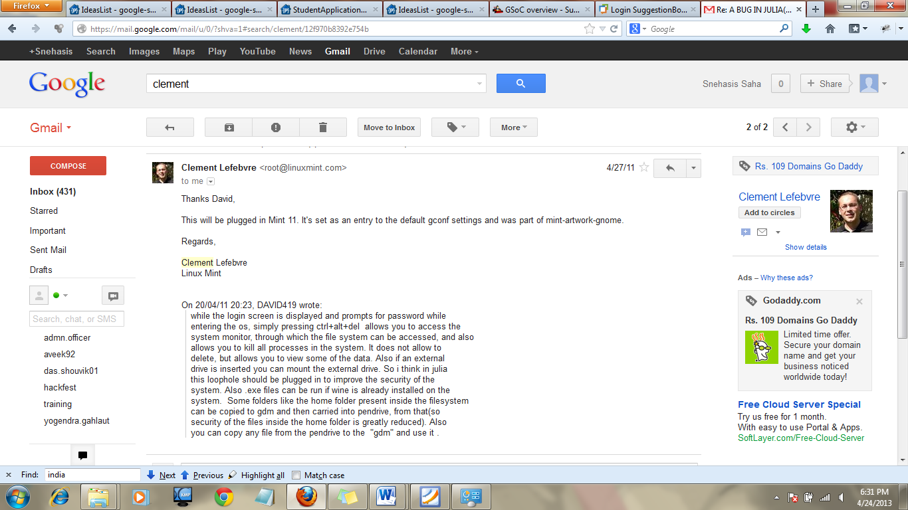
Create a LAN multiplayer mode for Tux Typing project:-
About Myself:-
Name: - Snehasis Saha
Country:- India
University: - Vellore Institute of Technology, India
University Website: - www.vit.ac.in
Current programme: - Bachelor of Technology (Computer Science and Engineering).
Background Overview: - This is Snehasis and I am currently pursuing my B.Tech Degree from Vellore Institute of Technology (VIT). I belong to Kolkata. I really love using free and open source software because well, I believe people should be given access to software even if they don’t have money, so free and I like to know exactly what I am using, so open source. I am a member of the technical team of the GLUG (GNU Linux Users Group) of my college. I am also a member of IEEE and CSI since 2011. I love programming, finding cheap algorithms(less time complexity) and playing computer games. I am also academically sound with a current cgpa (cumulative grade point average) of 9.07 .
Mailing list subscribed via email: - snehasis.saha2010@vit.ac.in
IRC nickname used for channel #tux4kids:- david_419
Coding Skills:-
Platform used to code:- For Hardware I am currently using a Intel Pentium CPU Dual-Core T4400 with 2.20GHz of processing power and 4 GB of RAM. I mainly code on the Linux platform, currently in Linux Mint 14 “Nadia” Cinnamon 32 bit and also in Backtrack 5 R2 32bit. Text editor gedit, ide eclipse and compiler gcc 4.3.2 are mainly worked on by me.
Coding experience in C/C++:- Coding in C/C++ since class 11. So I have around 5 years of experience in the languages till now. Projects made using C/C++ are:-
- Bunk Management System(C):- Did this during the 2nd year of B.Tech degree. Using file handling concept of c for data storage. It helped students to manage their bunks so as to meet the minimum attendance requirements of the university so that they do not get debarred for their exams. It had the functionality to register their bunk, view their current attendance, alert them when their attendance falls short,etc.
- Online railway reservation( C ):- Did this in 12th grade. The normal railway reservation system. Storing the railway information was again done using file handling as I did not experience with databases during that time.
- A 2d car racing game(C++):- In 11th grade I did this one. I mainly used Borland c++ during that time so I had used it’s inbuilt graphics.h header.

Also I have taken part in various coding competitions in c/c++ like ACM ICPC, IEEE Xtreme 6.0 where our team came 5th in India. Also a member of Codechef and Topcoder.
Several other non c++ projects like chatbot,Google SEAL,AD Hoc protocols,Going Dutch,etc.:-
Desired Knowledge Expectations:-
C/C++ skill:- Already mentioned my c/c++ experience in the coding experience in c/c++ header.
Network programming in C:- Well I had a dedicated laboratory course on network programming in C in my college and so I have a good idea on it. We used BSD sockets and so I am familiar with it. Though I am also trying to equip myself with the knowledge of SDL_net to broaden my options of applying either on the project.
Created and Implemented multi-client chat using network programming in C in our Laboratory’s LAN(Local Area Network) and in AD Hoc network in our Hostel.
Git familiarity:- Medium but will equip myself fully with this knowledge as soon as possible. Got introduced to Git this semester and I am trying steadily to familiarize myself with the commands to working Git from the Linux terminal.
Set Myself Up:-
Already set myself up by downloading the current repository of Tux Typing onto my local directory using the Linux Terminal:-
git clone git://git.debian.org/git/tux4kids/tuxtype.git
git clone git://git.debian.org/git/tux4kids/t4kcommon.git
The SDL package libsdl1.2-dev was already installed on my system.
You And Me:-
Have you been involved in Tux4Kids development in the past:- No.
Have you been involved in open source development in the past:- I found the ctrl+alt+del hack in Linux Mint 10 “JULIA” which I reported to the Linux mint forum and it got fixed in Linux Mint 11 onwards. Below is a snapshot of the mail and reply.
Link to the bug:-
https://bugs.launchpad.net/linuxmint/+bug/767480
Why have you chosen your development idea and what do you expect from your implementation:-
Creating a LAN multiplayer mode for the Tux Typing is the idea on which I want to develop on. I chose this project because it falls within my domain knowledge. I am good and interested in c/c++ , network programming, and like playing computer games. So developing a new multiplayer mode for the Tux Typing game will be lot of fun to work on. Also I want to give back to the community of children and instill competitiveness within them and improve their typing skills. Well you learn more by competing with someone rather than playing alone. So this multiplayer mode will help to drastically improve the typing speed for children and even users with less typing speed will get interested to compete with one another and as a result improve their typing speed as well. It will also help me improve my own programming skills even more and help me evolve as a programmer.

My Project:-
Synopsis:-
The Tux Typing game already exists for children in the single player mode. My work is to include a LAN multiplayer mode in the Tux Typing game. This will enable children to play against one another and instill competitiveness and improve their typing speed more drastically.
The Project:-
Well I have decided on two different multiplayer modes to implement during the GSOC 2013 period. So a description of the modes are:-
The LAN mode:- Before starting the LAN mode both players will be asked to select a different colored tux to compete with.
- Versus mode:- To instill competitive spirit within the young children.
- Boxing mode:- In this mode a boxing ring will be there , on which two colored tux will step in to fight. A player will land a punch on his/her opponent only when he/she successfully completes typing a complete word. There will be a threshold value set for the game, say 20. That is, whoever lands 20 punches first on his/her opponent wins the round. We can make the user select the number of rounds for a match. Both will get the same set of words on his/her screen so it would be a fair game.

- Team Mode:- Although it is a competitive world, team spirit is an important value, and to teach kids about this we will also have a team mode.
- Apocalypse:- The world is coming to an end. Tux must save himself and get to an island nearby which has been rumored not to be destroyed. So one Tux will be shown to run from left to right on the screen and behind him the ground would be disintegrating. Both players need to type out the words as fast as possible. The average speed of typing of both the players would be directly proportional to the speed of Tux. So one player would be performing above the average speed and one below. The individual scores would also be displayed at the end. Depending on easy, medium, hard mode the rate of disintegration of the ground behind Tux would also be set and it is constant for a level. If the average rate of typing is falling below the rate of disintegration then a red signal would be given on the top middle of the screen indicating the players to pick up pace. If they can’t, slowly and slowly Tux will get near the disintegrating ground and fall and the game would be over. You win this game, if you can keep yourself alive,i.e not fall into the disintegrating ground behind for a particular amount of time and reach the island.
How I plan to implement the two modes and the LAN:-
At first some changes to the title screen has to be made by editing the titlescreen.c file in src. The options in the main menu would be changed to single player and multiplayer instead of fish cascade and comet zap. On entering the single player mode a person would get the fish cascade and comet zap and on entering multi player the person would get boxing mode and apocalypse mode.
Boxing:- On entering this mode two options would come up:-
- Create Server:- To create a new server on the LAN. The user would be prompted to select the level(easy,medium,hard) and also the word family on which the competition would be there(animals,alphabets,etc.) . Also he would be asked to select the number of rounds for a match(like 3,5,etc). On entering, the user would be prompted to select a colored Tux from five or six different colors. Then a BSD socket would be defined using the socket() function and defining the sockaddr structure. We can take sin_port above 1024 to communicate. The structure is then bound to the socket using bind(). Then it would listen() for incoming connections. The screen will show that currently there are no players in LAN.
- Connect to Server:- Here first you will be prompted to enter the server ip address to whom you want to connect to. On entering that, the sin_addr variable under the sockaddr structure would be given that ip. A BSD socket would be created here as well and then we will connect() to the server. The server then accept() the incoming connection, and then send() information to the client as to what color tux it has selected. . That colored tux gets disabled for the client and the client selects from the remaining colored tuxes The server decides on the sequence of words and send() that information to client so that both server and client will get words in the same sequence. After receiving (receive()) that information the client send() an acknowledgement to the sever. Then we change our connection from tcp to udp as it is the much more preferred way of communication for multiplayer games (we will use SOCK_DGRAM instead of SOCK_STREAM) . We create a different socket on both the client and server on a different port and use this to communicate for the game. A fork() or pthreads are created at both the client and the server side and the game starts.

The game
On the top of a ring image which we will load using the SDL_LoadBMP and other SDL functions the two tuxes(with boxing gloves) will be there. There would be two bars on the top left and right corner of the screen which would be the health bars (like you have in tekken) of the two players. First a timer 3,2,1 and go will be there and the round begins. The words would start coming down from the top and the user has to type as fast as he can. When he successfully completes typing then a function is called which reduces the health bar of the opponent by (1/no_of_strikes) of the original. The no_of_strikes variable defines the number of punches you have to hit to beat your opponent for the round. The function also sends (sendto()) this information to the other party and the same is done there. Also the picture of tux standing with the gloves on is also changed with him punching the other tux and the other tux .png is changed with a tux getting hurt (it is changed back to the original after a small delay). Also a process is created on both sides which renders the screen variables and updates them continuously on both sides using sento() and recvfrom() so that they get the same picture. After the no_of_punches of a player reaches the no_of_strikes it is displayed the player 1 or 2 wins round and the next round begins. A variable tot_no_of_rounds is kept which stores the total number of rounds in the match. One variable on the client side and one on the server side also calculates the number of rounds won by the player. If a player has won ((int)tot_no_of_rounds+1) rounds then he gets the match and a function is called which sendto() this information to the other party and displays the winner on both the screens. Then we get options to either restart or go back to the LAN menu where the server can change options for the game and start again or go back to the main menu.
Apocalypse:- In this mode easy, medium and hard do not define the speed at which the words fall from the top of the screen. It defines the rate at which the ground is disintegrating behind the player. This speed has to found with a little research. In easy mode the rate of disintegration will be directly proportional to the typing speed of below average typers. Medium is for average typers and hard is for advanced typers.
On entering this mode also there would be two options:-
- Create Server:- Here it is the same as the earlier mode’s create server except no prompt is there for selecting number of rounds (as it is not boxing) or a colored tux (as we have just one tux and cooperative play, we will use black).
Instead here we have a variable, distance_to_goal which has three possible values short, medium and long that defines the distance from the starting point to the safety island.
- Connect to server:- Same as the earlier mode except no information about the color of the tux chosen by the server is send to the client. The rest remains same. We change to UDP to begin the game.
The game:-
In the game tux is shown to run from left to right. It can be shown by using the run png’s in the images/tux folder. Tux will be running on top of a ground which will be disintegrating from behind at a speed depending on the level. The scoreboard will be there on the top right corner like it is there for most of the single player games. The speed of movement of tux is directly proportional to (speed of first player+speed of second player)/2. The rate of increase of the score will be directly proportional to |(speed of tux – speed of disintegration)|/2 as we do not want to make the scoreboard to move in the negative axis we take the mod value. When (speed of tux – speed of disintegration)<0 a red light will be flashing on the middle top of the screen to indicate players to pick up pace. If they can’t, slowly tux and the disintegrating ground will move toward one another and finally in a frame tux disappears or falls into the ground. If the players keep themselves alive for the distance to the safety island, the players win and the score is displayed along with the individual scores (no of words attacked by first player and the second player). The network updation occurs in the same way as before. I render the screen variables and update them continuously on both sides using sento() and recvfrom() so that they get the same picture.
Road Map(Time to Devote):-
Current to June 17:-
Currently I have already started editing the source code and making small changes to the tux type game and check the outputs. I am also familiarizing myself even more with SDL libraries and Git. Before the coding starts I want to master these arts. Before June 17 I want to finish the small tasks of the game like editing the main menu bu editing the titlescreen.c file,selecting images to be used for the game, etc.
June 17 to June 25:-
I want to start making the boxing mode first and develop it’s UI.
June 25 to July 17:-
Analyze the dependencies of the network files and build the entire network on which the LAN mode will work out. Also check the network performance, discuss test cases with my mentor and improve the network performance if possible like reducing packet loss,etc. Also I want to document the code at this stage as well.
July 17 to July 29:-
Fusing the UI and the network together and test it or all edge cases. This work I want to finish for the mid term evaluation. (I have nothing to do this summer so dedicating 8 to 10 hours each day won’t be any problem for me).
July 29 to August 10:-
After this I will begin my work with the apocalypse mode. Develop it’s UI. I will work on this mode and discuss test cases again with mentor and document the code.
August 10 to August 15:-
Fusing the UI with the existing network.
August 15 to August 19:-
Check all the test cases and check it’s performance and try to improve it.
August 19 to August 29:-
Take some time for code cleaning, making documentation, beta test it using a few users and try to improve some of its functionality, etc.

After GSOC:-
After this timeline my college reopens so I would be getting very little time or the development. But I want to incorporate another multiplayer mode myself , racing mode where depending on the speed of typing of the players two tuxes would race against each other. And also I want to start contributing more actively to other open source projects as well.
What makes me suited to carry the project?
Well the only two things I like more than eating are finding and putting algorithms to code and playing computer games. I lose track of time when I do either of them. So this project covers the domain of my interest very well. Also I have always wanted to make some prominent contribution to the open source community and this project will help me achieve that and so I am determined to do a great job and to prove myself as a great programmer.
Profit for tux4kids:-
Well a multiplayer mode really increases the interest of a person to play the game. Example: Counter Strike in single player is an ok game, but add the multiplayer mode, it changes to one of the most popular games in the world. So I think adding tis multiplayer mode to the tux typing game would make the game more famous than it already is.

----------------------------------------------------xxxxxxxxxxxxxxxxxxxxxxxxxxxxxxxxxxx-------------------------------------

