PROJECT REPORT
Low-Light Image Enhancement by Illumination-Map Estimation with Adaptive Tone Control and Guided-Filter Refinement

Submitted by
Snehasish Beura
Reg. No. 2301020583
7th Semester
in partial fulfilment for the award of the degree of
BACHELOR OF TECHNOLOGY
IN
COMPUTER SCIENCE & ENGINEERING
C.V. RAMAN GLOBAL UNIVERSITY
BHUBANESWAR – ODISHA – 752054
November 2026

BONAFIDE CERTIFICATE
C.V. RAMAN GLOBAL UNIVERSITY
BHUBANESWAR – ODISHA – 752054
BONAFIDE CERTIFICATE
This is to certify that the project report entitled “Low-Light Image Enhancement by Illumination-Map Estimation with Adaptive Tone Control and Guided-Filter Refinement” submitted by Snehasish Beura (Registration No. 2301020583), a student of the 7th Semester, Department of Computer Science & Engineering, C.V. Raman Global University, Bhubaneswar, in partial fulfilment of the requirements for the award of the degree of Bachelor of Technology in Computer Science & Engineering, is a bonafide record of the work carried out by him under my supervision and guidance. The matter embodied in this report has not been submitted earlier for the award of any other degree or diploma, to the best of my knowledge.

Place: Bhubaneswar
Date: November 2026
______________________________  Dr. Ashish Ranjan  Supervisor  Department of Computer Science & Engineering | ______________________________  Dr. Rakesh Ranjan  Head of the Department  Department of Computer Science & Engineering

CERTIFICATE OF APPROVAL
C.V. RAMAN GLOBAL UNIVERSITY
BHUBANESWAR – ODISHA – 752054
CERTIFICATE OF APPROVAL
This is to certify that the project report entitled “Low-Light Image Enhancement by Illumination-Map Estimation with Adaptive Tone Control and Guided-Filter Refinement”, submitted by Snehasish Beura (Registration No. 2301020583) of the 7th Semester, Department of Computer Science & Engineering, has been examined and is approved for submission in partial fulfilment of the requirements for the award of the degree of Bachelor of Technology in Computer Science & Engineering of C.V. Raman Global University, Bhubaneswar.

The work was carried out under the supervision of Dr. Ashish Ranjan. The report has been evaluated and found satisfactory.

______________________________  Internal Examiner | ______________________________  External Examiner

______________________________  Dr. Ashish Ranjan  Supervisor | ______________________________  Dr. Rakesh Ranjan  Head of the Department
Place: Bhubaneswar
Date: November 2026

DECLARATION
DECLARATION
I, Snehasish Beura (Registration No. 2301020583), a student of the 7th Semester, Department of Computer Science & Engineering, C.V. Raman Global University, Bhubaneswar, hereby declare that the project report entitled “Low-Light Image Enhancement by Illumination-Map Estimation with Adaptive Tone Control and Guided-Filter Refinement” is the record of work carried out by me under the supervision of Dr. Ashish Ranjan.
I further declare that this report, or any part of it, has not been submitted elsewhere for the award of any other degree, diploma, or distinction. The implementation, experiments, and numerical results reported here are those of the classical low-light enhancement pipeline developed in this project. Where published methods are discussed, they are cited. Ground-truth photographs were used only to compute evaluation scores after enhancement, and were not used to decide the enhancement of any test image.

Place: Bhubaneswar
Date: November 2026
______________________________
Snehasish Beura
Reg. No. 2301020583
7th Semester
Department of Computer Science & Engineering

ACKNOWLEDGEMENT
I express my sincere gratitude to Dr. Ashish Ranjan, my project supervisor, for his guidance, technical criticism, and the time he gave to the direction of this work. His insistence on measuring the method against paired photographs, rather than judging it only by eye, shaped the evaluation reported in this thesis.
I thank Dr. Rakesh Ranjan, Head of the Department of Computer Science & Engineering, for the academic environment in which this project was carried out, and the Department of Computer Science & Engineering, C.V. Raman Global University, Bhubaneswar, for the opportunity to submit this work in partial fulfilment of the Bachelor of Technology programme.
The implementation rests on published classical methods. The illumination estimate follows the max-RGB construction of Guo, Li, and Ling, and the edge-aware smoothing follows the guided filter of He, Sun, and Tang. The paired test photographs come from the LOL collection of Wei, Wang, Yang, and Liu, the LOL-v2 collection of Yang, Wang, Fang, Wang, and Liu, and the UnLOL test split included with this project. The software uses the Python scientific libraries named in the implementation chapter. I am grateful to the authors of those papers and libraries.
Any error that remains in the description or in the measured scores is mine.

Snehasish Beura
Reg. No. 2301020583

ABSTRACT
A photograph taken in insufficient light is not a uniformly darker copy of the same scene under a normal exposure. Some regions fall close to black, others retain a usable signal, and a lamp or a window may already be bright. A single global curve therefore leaves part of the frame dark or pushes an already bright region toward clipping. Raising the dark signal also raises the sensor noise that was hidden in it, so a method that only brightens the image often looks grainy, and a method that blurs the whole frame to hide that grain also removes text, fabric, and object boundaries.
This project implements a classical, non-learning pipeline for that problem. The pipeline does not train a network, and it does not read the normal-light reference while it enhances an image. The input is stored as an 8-bit BGR image and is normalised to the unit interval. An initial illumination map is the maximum of the three colour channels at each pixel, following the LIME construction. That map is smoothed with a guided filter of radius 32 and regularisation 1.5×10⁻³ so that it follows object structure rather than sensor grain. The image is then divided by the map raised to a power. On an ordinary or uniformly dark frame the power is 0.70. On a frame whose illumination map itself contains both a dark mass and a bright tail, the power varies spatially: shadows use 0.70, or 0.92 when most of the map is dark, and already bright pixels use 0.55.
A second tone stage handles the case in which the raw illumination has almost no highlight left to anchor the map. Such a crushed frame receives a soft gain of 1.70 with a knee at 0.84. An ordinary frame receives a further gamma of 0.82, and a small capped midtone gain only when the recovery is still dim and the highlights are not already near white. A partial gray-world balance of strength 0.10 reduces a colour cast without forcing a genuinely warm or cool scene to gray. Detail is then refined by a second guided filter. Strong edges are added back; fine grain is not. A crushed frame, whose gain has amplified noise above the level of real edges, keeps the smoothed base and does not add the grain back. Finally, saturation is raised by 4 percent on midtones only, in HSV, so that shadows and clipped highlights are not painted a stronger colour. Contrast-limited adaptive histogram equalisation, a bilateral filter, and any learned model are not part of this final pipeline.
The method is scored with peak signal-to-noise ratio on the colour image and structural similarity on the grayscale image, using scikit-image, after enhancement. On the 15-pair LOL eval15 set the mean is 20.35 dB and 0.8170. On the 100-pair LOL-v2 Real test it is 18.63 dB and 0.7787. On the 100-pair LOL-v2 Synthetic test it is 19.88 dB and 0.8282. On the 43-pair UnLOL test it is 13.54 dB and 0.6137. Illumination recovery accounts for most of the gain on LOL and on the synthetic set. Detail refinement is what restores structural similarity after the lift. UnLOL remains the weak set: its illumination is spatially non-uniform, and a map built only from the low-light input cannot tell a dark object that should stay dark from a shadow that should be lifted. Multi-scale structural similarity, a learned loss, and a measured runtime are not reported in the current implementation.

TABLE OF CONTENTS
BONAFIDE CERTIFICATE ii
CERTIFICATE OF APPROVAL iii
DECLARATION iv
ACKNOWLEDGEMENT v
ABSTRACT vi
TABLE OF CONTENTS viii
LIST OF FIGURES xii
LIST OF TABLES xiii
ABBREVIATIONS AND NOTATIONS xiv
CHAPTER 1 INTRODUCTION 1
1.1 Background and Motivation 1
1.2 Nature of Low-Light Image Degradation 1
1.3 Uneven Illumination 2
1.4 Challenges in Low-Light Enhancement 2
1.5 Conventional Enhancement Techniques 3
1.6 Motivation for the Proposed Pipeline 3
1.7 Problem Statement 4
1.8 Objectives 4
1.9 Contributions of the Work 4
1.10 Scope and Limitations 5
1.11 Organisation of the Report 5
CHAPTER 2 LITERATURE SURVEY 6
2.1 Retinex Models 6
2.2 Histogram Equalisation and CLAHE 6
2.3 Gamma Correction and Adaptive Gamma 6
2.4 Illumination-Map Methods and LIME 7
2.5 The Guided Filter 7
2.6 Colour Constancy 8
2.7 Learning-Based Enhancement 8
2.8 Quality Measures 9
2.9 Research Gap 9
CHAPTER 3 METHODOLOGY 10
3.1 Dataset Collection 10
3.2 Dataset Description 10
3.3 Data Pre-processing 11
3.4 Overall Framework 11
3.5 Input Representation and Colour Spaces 13
3.6 Illumination Estimation 14
3.7 Reflectance Recovery 14
3.8 Crushed, Ordinary, and Mixed Decisions 15
3.9 Partial Gray-World Balance 16
3.10 Detail Refinement and Noise Control 16
3.11 Colour Restoration 17
3.12 Parameter Selection 17
3.13 What the Pipeline Explicitly Does Not Do 18
3.14 Pseudocode 18
3.15 Computational Complexity 19
3.16 Implementation Environment 19
3.17 Evaluation Procedure 20
3.18 Summary of the Method 20
CHAPTER 4 RESULTS AND DISCUSSION 21
4.1 Experimental Setup 21
4.2 Metrics 21
4.3 Overall Scores 21
4.4 Stage-wise Ablation 22
4.5 Per-image Results on LOL eval15 25
4.6 Extremes on the Larger Sets 26
4.7 Comparison with the Retired Baseline 26
4.8 Qualitative Behaviour 27
4.9 Dark, Bright, and Mixed Regions 31
4.10 Artefacts 31
4.11 Computational Efficiency 32
4.12 Discussion 32
4.13 Limitations 33
4.14 Summary 33
CHAPTER 5 CONCLUSION 34
FUTURE SCOPE 35
REFERENCES 36
APPENDIX 38
A. Correspondence between the report and the source 38
B. Score files 38
C. Items that were not evaluated 38

LIST OF FIGURES
Figure 3.1. Order of operations in the implemented pipeline. 12
Figure 3.2. Crushed, ordinary, and mixed tone paths. 13
Figure 4.1. Stage-wise mean PSNR and SSIM on LOL eval15. 22
Figure 4.2. Stage-wise mean PSNR and SSIM on LOL-v2 Real. 23
Figure 4.3. Stage-wise mean PSNR and SSIM on LOL-v2 Synthetic. 24
Figure 4.4. Stage-wise mean PSNR and SSIM on UnLOL. 25
Figure 4.5. LOL eval15, 1.png: input, result, and reference. 27
Figure 4.6. LOL eval15, 23.png, a uniformly dark frame. 28
Figure 4.7. LOL eval15, 55.png, the lowest PSNR on this set. 28
Figure 4.8. LOL eval15, 780.png. 28
Figure 4.9. LOL-v2 Real, low00713.png, the highest PSNR. 29
Figure 4.10. LOL-v2 Synthetic, r191488c6t.png, the highest PSNR. 29
Figure 4.11. LOL-v2 Synthetic, r01058910t.png, the lowest PSNR. 30
Figure 4.12. UnLOL, 1805.jpeg, the highest PSNR on that test. 30
Figure 4.13. UnLOL, 2903.jpeg, the lowest PSNR on that test. 31

LIST OF TABLES
Table 1. Abbreviations and notations used in the report xiv
Table 3.1. Paired test sets included in the repository 10
Table 3.2. Parameters of the running pipeline, as set in config.py 17
Table 3.3. Software components declared by the repository 19
Table 4.1. Final mean scores of the implemented pipeline 21
Table 4.2. Stage-wise scores on LOL eval15 (15 images) 22
Table 4.3. Stage-wise scores on LOL-v2 Real (100 images) 23
Table 4.4. Stage-wise scores on LOL-v2 Synthetic (100 images) 23
Table 4.5. Stage-wise scores on UnLOL (43 images) 24
Table 4.6. Per-image PSNR and SSIM on LOL eval15 25
Table 4.7. Highest and lowest final scores on each test set 26
Table 4.8. Retired internal baseline and the current pipeline 27
Table A.1. Source functions for each stage 38

ABBREVIATIONS AND NOTATIONS
Only terms that appear in this report are listed. Contrast-limited adaptive histogram equalisation is included because it is discussed as a conventional method that the final pipeline does not use.
Table 1. Abbreviations and notations used in the report
Symbol / abbreviation | Meaning
BGR | Blue–green–red channel order used by OpenCV
CLAHE | Contrast-limited adaptive histogram equalisation (not used in the final pipeline)
eps | Regularisation of the guided filter
HSV | Hue, saturation, and value
LIME | Low-light image enhancement via illumination map estimation
LLIE | Low-light image enhancement
LOL | LOw-Light paired dataset of Wei, Wang, Yang, and Liu
MSE | Mean squared error, implicit in the reported PSNR
PSNR | Peak signal-to-noise ratio, in decibels
RGB | Red, green, and blue
SSIM | Structural similarity index, computed on grayscale
T | Smoothed illumination map
T0 | Initial max-channel illumination
γ | Exponent applied to the illumination map, or to the recovered image
Y | Rec. 601 luminance of a BGR image

CIE L*a*b* is not used. Multi-scale SSIM is not computed. A graphics processing unit is not required, and no training loss is defined, because the pipeline does not learn parameters from data.

CHAPTER 1 INTRODUCTION

1.1 Background and Motivation
Cameras and the vision algorithms built on their output are designed for scenes in which the sensor has collected enough light. Indoor corners, night streets, and back-lit rooms violate that assumption. The recorded values sit in a small part of the 8-bit range, local contrast collapses, and object boundaries that are obvious to a person standing in the room become difficult to see in the file. Low-light image enhancement is the attempt to recover a more usable photograph from that file without a second exposure.
The practical motive is not only a brighter picture. A face, a label, or a step that is lost in a shadow is also lost to any later task that reads the image. At the same time, an enhancement that invents edges, shifts colour, or flattens texture can be worse than the dark original. The requirement is therefore narrow: raise visibility where the input is dark, leave alone what is already bright, and do not replace sensor noise with a blur that looks clean only because the detail has been removed.
This project answers that requirement with a classical pipeline. It estimates a per-pixel illumination, divides it out with a controlled exponent, applies a second tone only when the statistics of the input justify it, and suppresses the grain that the division amplifies. No network is trained. The normal-light photograph, when one exists, is used only afterwards, to compute peak signal-to-noise ratio and structural similarity.

1.2 Nature of Low-Light Image Degradation
An 8-bit colour image stores each channel in {0, 1, …, 255}. In a well-exposed scene those values use a large part of the range. In a low-light capture they often occupy only the bottom of it. On the LOL eval15 set the unprocessed inputs score 7.77 dB against their paired normal-light references, with a structural similarity of 0.1898. The corresponding raw figures are 9.72 dB and 0.2067 on LOL-v2 Real, 11.22 dB and 0.4450 on LOL-v2 Synthetic, and 10.36 dB and 0.4615 on UnLOL. The gap is not a small bias. The dark image and the reference differ both in intensity and in structure.
Two physical effects sit on top of the small signal. Photon noise and read noise are large relative to the signal in the dark, so the same scene content is buried in grain. Quantisation then locks many neighbouring pixels to the same few code values, which removes the smooth shading a normal exposure would have recorded. A later multiplication, or a division by a small illumination, stretches those code values apart and makes the grain visible. Any honest enhancer has to say what it will do with that amplified noise. Pretending that the noise is scene texture produces a speckled result. Removing every high-frequency change produces a soft result in which text and fabric disappear.

1.3 Uneven Illumination
The more difficult case is not a frame that is uniformly dark. It is a frame in which the light is uneven. A window, a lamp, or a reflective surface can sit near white while the rest of the room is close to black. The desired correction is then a different gain in different places. A dark object that is genuinely dark in the scene, such as a piece of furniture or a shadowed book spine, should not receive the same gain as an underexposed wall that the reference shows as bright. The low-light file alone does not contain a label that distinguishes those two cases. They can have the same pixel value.
This is the central difficulty of the UnLOL test included in the repository. Those 43 scenes are 1280×1280 real photographs with both dark masses and bright structure. The implemented pipeline reaches only 13.54 dB and 0.6137 on that set, against 20.35 dB and 0.8170 on the more uniformly dark LOL eval15 set. The difference is reported here as a measured fact, not as a claim that the method has solved non-uniform illumination.

1.4 Challenges in Low-Light Enhancement
The challenges that the implementation is built to face, and the ones it does not fully solve, are the following. Visibility is lost where the signal is near the black level. Local contrast is compressed, so edges that exist in the scene have a small gradient in the file. Noise is amplified in proportion to the gain. Colour ratios are unstable in the dark because each channel is a small integer plus noise, and a naive saturation boost paints that noise. A bright region next to a dark region invites a halo if the illumination estimate crosses the edge, or a dark patch if a single global curve is used. Over-enhancement clips highlights and shifts hue. Under-enhancement leaves the original problem in place. Fine texture and sensor grain occupy the same spatial frequencies after a strong lift, so a smoother cannot separate them by frequency alone.

1.5 Conventional Enhancement Techniques
A global gamma, y = x^γ with γ < 1, stretches shadows and compresses highlights. It is simple and it preserves the rank order of intensities, but it applies the same curve everywhere. Histogram equalisation redistributes values so that the histogram is flatter. It can raise contrast, and it can also amplify noise and produce an unnatural tone. Contrast-limited adaptive histogram equalisation restricts that redistribution inside tiles and limits the slope of the mapping, which reduces noise amplification relative to full equalisation, but the tile grid can still leave a blocky appearance and it still does not estimate where the light in the scene actually was.
An earlier internal baseline of this project, recorded in COMPARATIVE_ANALYSIS.md, used a fixed gamma of 1.8, contrast-limited adaptive histogram equalisation on 8×8 tiles, a bilateral filter with diameter 9 and σ = 75, and a 5 percent saturation boost. That baseline scored 14.49 dB and 0.7684 on LOL eval15, and 18.52 dB and 0.8089 on LOL-v2 Real. The same note records the visible failures: dark patches where one gamma could not lift every region, and blur from the wide bilateral kernel. The final pipeline does not contain those stages. They are cited only as the conventional combination that was measured and replaced.

1.6 Motivation for the Proposed Pipeline
The replacement follows a Retinex reading of the image. The observed colour at a pixel is treated as a product of a reflectance, which belongs to the surface, and an illumination, which belongs to the light. If the illumination can be estimated and divided out, dark surfaces are lifted more than surfaces that were already well lit, which is what a global gamma cannot do. Guo, Li, and Ling showed that a useful initial illumination is the maximum of the three channels, and that this map should be smoothed so that it does not follow noise. He, Sun, and Tang supply the guided filter used for that smoothing and, later, for the detail stage. The present work keeps that core and adds three controls that the plain division does not provide: a crushed-exposure gain when the frame has no bright anchor, a paired exponent when one frame is both dark and partly lit, and a detail rule that does not add amplified grain back on a crushed frame.

1.7 Problem Statement
Given a single low-light colour image, produce an enhanced colour image of the same size in which dark regions are more visible, already bright regions are not driven into hard clipping, strong edges are preserved, and fine sensor grain is not treated as texture. The procedure must not read a normal-light reference at enhancement time, must not require a trained model, and must be evaluable afterwards by peak signal-to-noise ratio and structural similarity on paired test sets.

1.8 Objectives
The objectives fixed by the implementation are these. First, estimate a structure-aware illumination and use it to lift dark pixels more than bright pixels. Second, detect a uniformly crushed exposure from the input illumination alone and apply a stronger, highlight-limited gain only in that case. Third, detect mixed light, again from the illumination alone, and use a shadow exponent and a highlight exponent instead of one global exponent. Fourth, reduce the grain created by the lift without the wide blur of a large bilateral kernel. Fifth, restore a small amount of midtone saturation without changing hue. Sixth, measure the result on LOL eval15, LOL-v2 Real, LOL-v2 Synthetic, and UnLOL, and report failures as well as the mean scores.

1.9 Contributions of the Work
The contribution is an implemented and measured pipeline, not a new theoretical model of light. The illumination step is the published LIME initialisation and the published guided filter, with the constants recorded in config.py. What the project adds on top of a plain division is the decision among three tone paths, the partial gray-world step, the amplitude test that puts back only strong detail, and the stricter smooth used when the exposure is crushed. The paired exponent is used only when the illumination statistics say the frame is mixed. On LOL eval15 that test does not fire: the implementation comment records that the illumination 99th percentile on that set stays under about 0.38, below the threshold of 0.55. The paired path is therefore a behaviour for partly lit frames, principally visible on UnLOL, and not a hidden per-image correction of the LOL scores.

1.10 Scope and Limitations
The scope is single-image enhancement of 8-bit colour photographs, followed by paired evaluation where a reference exists. There is no video mode, no interactive parameter editor, and no deployment target such as a mobile device. Runtime and hardware are not recorded in the repository, so no speed claim is made. The method cannot know whether a dark pixel is an underexposed surface or a surface that should remain dark. That limit is visible in the UnLOL score. A strong non-local denoiser was tried during development and removed, because it blurred real texture; the final detail stage is the guided filter described in Chapter 3, not that denoiser. Multi-scale structural similarity, a perceptual user study, and a comparison against published deep models on a common table are not available in the current implementation.

1.11 Organisation of the Report
Chapter 2 reviews the classical and learning-based literature that surrounds the method, and states the gap the pipeline is aimed at. Chapter 3 describes the datasets, every processing stage, the equations that match the code, the parameters, and the implementation environment. Chapter 4 reports the measured scores, the stage-wise ablation, and the visual behaviour on dark, mixed, and failed frames. Chapter 5 states what was achieved and what was not. A separate section lists future work that is not claimed as present. The appendix gives pseudocode aligned with the source.

CHAPTER 2 LITERATURE SURVEY

2.1 Retinex Models
Land and McCann argued that perceived colour depends on spatial comparisons of reflectance rather than on the absolute flux reaching the eye [1]. The practical image model that followed writes an observed colour image as a product of reflectance and illumination. Jobson, Rahman, and Woodell turned that idea into the multiscale Retinex, in which the illumination is estimated by blurring the image at several scales and the output is a combination of the differences between the log image and those blurs [2]. The advantage is a local brightening that does not need a paired example. The limitation is a tendency to gray out large uniform regions, to produce halos at strong edges when the blur crosses them, and to amplify noise in the dark. The present pipeline keeps the product model and the idea of dividing out an illumination, but it does not implement the multiscale Retinex. The illumination is a smoothed max-channel map, not a stack of Gaussian surrounds.

2.2 Histogram Equalisation and CLAHE
Global histogram equalisation remaps intensities so that the cumulative histogram is approximately linear. It uses the whole frame, so a large dark region and a small bright region fight for the same output range. Pizer and colleagues introduced adaptive histogram equalisation, which builds the mapping inside a window around each pixel, and discussed the noise amplification that follows [3]. Zuiderveld’s contrast-limited variant clips the histogram before the mapping is built, which limits the local slope and therefore the noise gain [4]. Both methods are contrast operators. They do not estimate illumination, and they do not know that a bright window and a dark corner need different gains for a physical reason rather than a histogram reason. As recorded in Section 1.5, CLAHE was part of an earlier baseline of this project and is not part of the final code. No call to histogram equalisation or CLAHE appears in the current modules.

2.3 Gamma Correction and Adaptive Gamma
Gamma correction of the form y = x^γ is the standard point-wise tone curve. Huang, Cheng, and Chiu replace the fixed exponent by an adaptive one derived from a weighted histogram, so that the curve depends on the distribution of the image rather than on a constant chosen by hand [5]. The advantage is a global curve that still reacts to whether the image is dark or bright. The limitation is that the curve remains global: two pixels of equal intensity receive the same output even when one lies in a shadow and the other on a lit surface. The present pipeline does use exponents, but they are applied to the illumination map, or to the already recovered image, and one of the paths makes the exponent a function of the local illumination. That is not the adaptive-gamma histogram method of Huang, Cheng, and Chiu. The citation is included because the tone stage is in the same family of ideas, and because the project documentation names that family as the background of the gray-world and tone controls. The code does not compute their weighting distribution.

2.4 Illumination-Map Methods and LIME
Guo, Li, and Ling estimate the illumination of a low-light image as the maximum of the red, green, and blue channels, then refine that map by a structure-aware smooth so that it is constant on surfaces and discontinuous at object boundaries [6]. The enhanced image is obtained by dividing the input by the refined map raised to a power in (0, 1]. A power below one leaves a fraction of the illumination in the result, which avoids the flat, over-bright look of dividing by the raw map. They also note that the division amplifies noise and recommend a subsequent denoiser. The initial map, the division, and the exponent in this project are that construction. The structure-aware smooth is the guided filter of He, Sun, and Tang rather than the particular solver used in the original LIME paper [7]. The block-matching 3-D denoiser recommended by LIME is not implemented here [8].
Wang, Zheng, Hu, and Li keep a similar Retinex decomposition but add an explicit naturalness term so that the result does not look like a gray reflectance [9]. Fu and colleagues estimate reflectance and illumination together in a weighted variational model [10]. Li, Liu, Yang, Sun, and Guo add a noise term, so that structure is not forced to explain sensor grain [11]. The crushed-frame rule in this project — do not add the amplified residual back — is the practical reading of that last point, not an implementation of their optimisation. Ying, Li, and colleagues model the camera response and fuse several synthetic exposures [12]. That fusion is not used here.

2.5 The Guided Filter
He, Sun, and Tang define a local linear filter in which the output is a · guide + b inside each window, and a and b are chosen to minimise the error against a source image while keeping a small [7]. The solution depends on the local mean, variance, and covariance, all of which can be computed with box filters, so the cost grows linearly with the number of pixels. A small regularisation keeps edges of the guide; a large one smooths them away. The project uses this filter twice: once to smooth the illumination with the illumination as its own guide, and once to smooth the enhanced colour image with its luminance as the guide. The bilateral filter is the older edge-aware alternative. It was used in the retired baseline and was observed to blur. It is not used in the final modules.

2.6 Colour Constancy
Buchsbaum’s gray-world hypothesis says that the average surface in a scene is gray, so a departure of the channel means from equality is a property of the illuminant and can be divided out [13]. The hypothesis fails when the scene really is warm or cool, or when one surface fills the frame. The implementation therefore applies only a fraction of the gray-world scale. The strength in config.py is 0.10, which moves each channel one tenth of the way toward the mean of the three channel means. Hue is not rotated by a later stage except through this mild scale. Saturation, which is separate from hue in HSV, is touched only in the last stage and only on midtones.

2.7 Learning-Based Enhancement
A large part of the recent literature learns the mapping from low light to normal light. Lore, Akintayo, and Sarkar train a deep autoencoder on synthetic darkness [14]. Wei, Wang, Yang, and Liu collect the LOL pairs used in this project and train a Retinex network that decomposes and then enhances [15]. Zhang, Zhang, and Guo learn a similar decomposition and a restoration of the reflectance [16]. Guo and colleagues estimate a set of curve parameters with a network that does not need paired references at training time [17]. Yang, Wang, Fang, Wang, and Liu introduce the LOL-v2 pairs and a semi-supervised perceptual method [18]. These methods can exceed a classical pipeline on the sets they are trained for. They also require a training split, a loss, and a risk of fitting the test pairs if the split is abused.
None of those networks is implemented in this repository. There is no training loop, no loss function, and no weight file. The synthetic training split of 900 pairs is not included. The enhancer is a fixed function of the low-light input and of the constants in config.py. Learning-based refinement is listed only as future work.

2.8 Quality Measures
Wang, Bovik, Sheikh, and Simoncelli define structural similarity so that a score responds to luminance, contrast, and correlation inside a window, rather than to pixel error alone [19]. A blurred image can have a moderate pixel error and a poor structural score, which is why a bilateral blur can look numerically close on one set and still be the wrong trade. Peak signal-to-noise ratio remains the logarithmic form of the mean squared error and is sensitive to a global bias in brightness. The project reports both. It does not report the multi-scale extension of structural similarity, and it does not report a no-reference perceptual index.

2.9 Research Gap
The gap addressed by the implementation is practical rather than a claim of a new optimum. A global gamma or a global adaptive gamma does not treat a lamp and a corner differently. Full LIME division lifts the dark regions, but a crushed frame has no bright pixel with which to anchor the map, and a mixed frame is hurt if the same exponent is applied to its bright tail. The division amplifies noise, and putting that noise back as “detail” lowers structural similarity on the frames where the grain is strongest. Deep models close more of the numerical gap on LOL when they are trained, but this project does not have a training objective and does not use the normal-light image at run time.
The pipeline therefore keeps illumination-map division, adds a crushed-frame test and a mixed-light test that read only the input illumination, and changes the detail rule on crushed frames so that amplified grain is not restored. Chapter 4 shows where that is enough and where it is not. It is not enough, in particular, when the correct gain is a fine spatial function that cannot be predicted from the illumination value alone. That is the situation measured on UnLOL.

CHAPTER 3 METHODOLOGY

3.1 Dataset Collection
Four paired test collections are used. LOL eval15 and LOL-v2 Real were added to the repository as reference splits so that the reported scores can be recomputed from the project tree. LOL-v2 Synthetic is the test half of the Kaggle release ohmahler91/lolv1-and-lolv2. The 900-pair synthetic training half is not in the repository and is not used. UnLOL is present as a test split only. No image was resized, cropped, or re-encoded for this report beyond what the evaluation script already does: if a reference and an enhanced image differ in shape, the reference is resized to the enhanced image with OpenCV’s default linear interpolation. On the four sets used here the pairs already match in size, so that branch does not change the published scores.

3.2 Dataset Description
LOL, introduced by Wei, Wang, Yang, and Liu, contains real pairs captured by changing exposure and ISO [15]. The repository includes the 15-pair eval15 split. Each file examined for size is 600×400 pixels, stored as PNG, with the same filename in low/ and high/. LOL-v2 Real, from Yang and colleagues, is a larger captured test [18]. The repository includes the 100-pair test. The sample low00690.png is also 600×400. Pairing is not by identical filename: low00690.png corresponds to normal00690.png. LOL-v2 Synthetic uses identical filenames in Low/ and Normal/. The sample r191488c6t.png is 384×384. UnLOL uses identical filenames in Low/ and High/. The sample 0103.jpeg is 1280×1280. A caption file exists beside the UnLOL images. The enhancer does not read it, and the metrics do not read it. A formal dataset paper for UnLOL is not reported in the current implementation.
Table 3.1. Paired test sets included in the repository
Dataset | Split used | Pairs | Pairing | Example size
LOL eval15 | eval15 | 15 | Same filename | 600 × 400 PNG
LOL-v2 Real | Test | 100 | lowNNNNN ↔ normalNNNNN | 600 × 400 PNG
LOL-v2 Synthetic | Test | 100 | Same filename | 384 × 384 PNG
UnLOL | Test | 43 | Same filename | 1280 × 1280 JPEG

There is no separate validation split in the repository, and there is no training procedure that would require one. Every pair listed above is a test pair. The normal-light folder is the reference for scores. It is not an input.

3.3 Data Pre-processing
Pre-processing is deliberately small. OpenCV reads the file as an 8-bit BGR image. A grayscale file is expanded to three channels. An image with an alpha channel is converted to three channels. Empty input is rejected. The only arithmetic preparation is the conversion to floating point in [0, 1] by dividing by 255. There is no demosaicing step, no optical-black subtraction, no lens shading correction, and no gamma decoding of an encoded colour space beyond this normalisation. The pipeline therefore treats the stored 8-bit values as the quantities to be enhanced. That is an approximation: camera files are often already gamma-encoded. The approximation is the one used by the implementation, and it is stated so that the equations below match the code.
I(x) = Iuint8(x) / 255, I(x) ∈ [0, 1]³ (3.1)

3.4 Overall Framework
Figure 3.1 shows the order of stages in run_stages. The order is fixed. No stage is skipped entirely, but the tone path inside the middle of the figure depends on two tests. The output of each stage can be written as an image, which is how the ablation in Chapter 4 is obtained. The final image is the last stage, after midtone saturation.
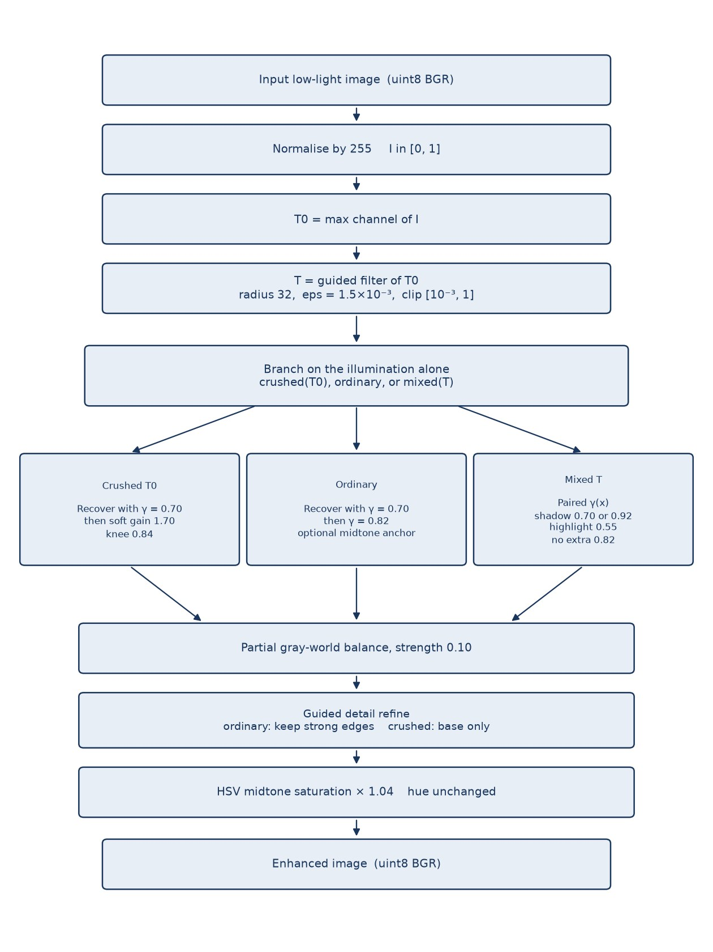
Figure 3.1. Order of operations in the implemented enhancement pipeline.
The branch is drawn separately in Figure 3.2 because it is the part of the method that is not a single published algorithm. A crushed raw illumination takes the soft gain. A mixed refined illumination that is not crushed takes the paired exponent and skips the extra global gamma of 0.82. Every remaining frame takes the single exponent 0.70 and then the gamma 0.82, with the midtone anchor only if its own statistics ask for it.
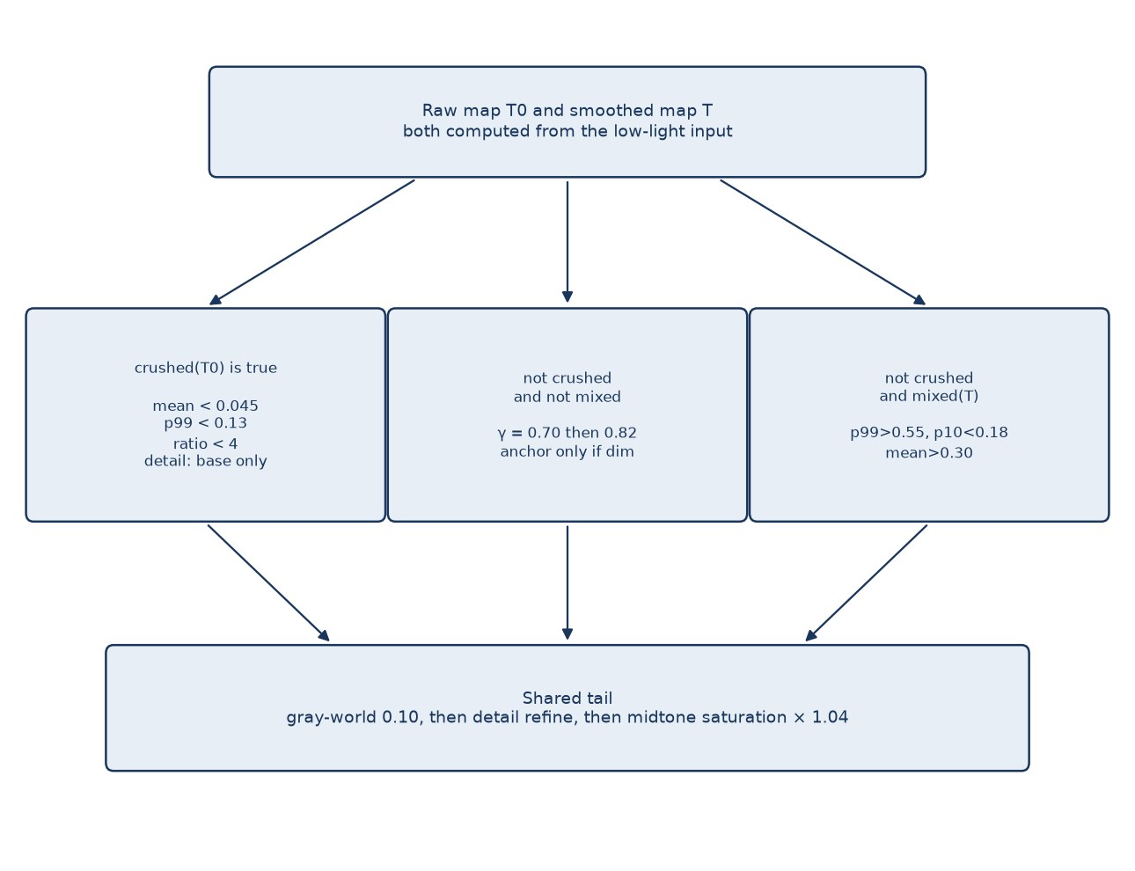
Figure 3.2. Selection among the crushed, ordinary, and mixed tone paths. The tests use only the illumination map.

3.5 Input Representation and Colour Spaces
Almost all arithmetic is done on the BGR floating-point image. The channel order is an OpenCV convention and does not change the max-channel illumination, which is invariant to order. Luminance, where it is needed, uses the Rec. 601 weights on that BGR layout, following Recommendation ITU-R BT.601-7 [20].
Y = 0.114 B + 0.587 G + 0.299 R (3.2)
HSV is used only in the last stage, and only so that saturation can be scaled while hue is left as OpenCV stored it. CIE L*a*b* is not used. There is no conversion to a linear camera space and no conversion back.

3.6 Illumination Estimation
The initial illumination at each pixel is the maximum channel, as in LIME [6]. A bright channel is evidence that the surface received light, even if the other channels are dark because of the surface colour. Using the maximum rather than the luminance avoids treating a saturated red object as dim.
T0(x) = max{ IR(x), IG(x), IB(x) } (3.3)
T0 follows sensor noise and fine texture. Using it directly as a divisor would treat that noise as illumination and would flatten it. The map is therefore replaced by a guided filter of itself [7]. With radius r and regularisation ε, the filter computes local statistics by a normalised box filter and sets
a = cov(G, S) / (var(G) + ε), b = mean(S) − a · mean(G) (3.4)
q = mean(a) · G + mean(b) (3.5)
Here the guide G and the source S are both T0, the radius is 32 pixels, and ε is 1.5×10⁻³. The radius is large enough to ignore grain and small texture, and ε is small enough that a strong edge in T0 remains an edge in the output. The result is clipped.
T(x) = clip( q(x), 10⁻³, 1 ) (3.6)
The floor of 10⁻³ avoids a later division by zero in regions where the initial map was black. The same clipped map is the illumination used for the mixed-light test and for the division. The crushed-exposure test uses T0, the unsmoothed map, because the question there is whether the capture itself contains any bright pixels, not whether the smoothed map does.

3.7 Reflectance Recovery
Recovery divides each channel by the same compressed illumination, so the colour ratios of the input are kept. The compression is a power γ. In the single-exponent path γ is the constant 0.70. In the mixed path γ is a map.
R(x) = clip( I(x) / ( T(x)^γ(x) + 10⁻⁴ ) , 0, 1 ) (3.7)
The floor 10⁻⁴ is ILLUM_EPS_DIV. Because γ < 1, T^γ is larger than T when T is in (0, 1), so the divisor is less severe than dividing by T itself. A pixel with a small T is still lifted more than a pixel with a large T. That is the mechanism that treats uneven light differently from a global gamma. It is also the mechanism that amplifies noise where T is small.

3.8 Crushed, Ordinary, and Mixed Decisions
A frame is declared crushed when the raw illumination is dark in the mean, dark in the tail, and without a bright anchor relative to the median. With the constants in config.py the three conditions are
mean(T0) < 0.045, p99(T0) < 0.13, (p99 + 10⁻⁶) / (p50 + 10⁻⁴) < 4 (3.8)
All three must hold. A dark scene that already contains a lamp fails the tail test or the ratio test and is not treated as crushed. On a crushed frame the recovered image is multiplied by 1.70 and then compressed above a knee of 0.84 so that highlights do not clip as a hard step.
s = R · g, over = max(s − k, 0) (3.9)
tone = min(s, k) + (1 − k) ( 1 − exp( −over / (1 − k) ) ) (3.10)
For the crushed path, g = 1.70 and k = 0.84. The same soft-gain function is reused by the midtone anchor with different constants.
If the frame is not crushed, the refined map is tested for mixed light. The frame is mixed when it has a bright tail, a dark lower tail, and a mean that is already partly lit:
p99(T) > 0.55, p10(T) < 0.18, mean(T) > 0.30 (3.11)
LOL eval15 does not take this branch. The source comment states that the illumination 99th percentile on that set stays under about 0.38. A uniformly dark scene also fails the mean test, so a lamp in an otherwise black room stays on the single-exponent path. When the test passes, a per-pixel exponent is built with a smoothstep blend between T = 0.18 and T = 0.55.
u = clip( (T − 0.18) / (0.55 − 0.18), 0, 1 ), s(u) = u² (3 − 2u) (3.12)
γ(x) = γshadow (1 − s(u)) + 0.55 s(u) (3.13)
The shadow exponent is 0.92 if at least half of the map is below 0.10, and 0.70 otherwise. For an illumination value in (0, 1), the larger exponent makes T^γ smaller, so the divisor in equation (3.7) is smaller and the lift is stronger. The source uses that stronger lift when the dark region is most of the frame, which it treats as underexposure rather than as a small dark object. The highlight exponent is always 0.55. Because 0.55 is smaller than 0.70, T^0.55 is larger than T^0.70 on (0, 1), the divisor is larger, and an already bright pixel is lifted less. On this path the recovered image is not passed through the additional power 0.82. Applying that power on top was observed to lift the bright regions a second time. The implementation sets the crushed flag to false on the mixed path, so the later detail stage uses the ordinary, milder smooth rather than the crushed smooth.
An ordinary frame, neither crushed nor mixed, is recovered with γ = 0.70 and then passed through
tone = clip(R, 0, 1) ^ 0.82 (3.14)
A further midtone anchor is applied only when three conditions hold together: the illumination mean is above 0.075, the mean luminance of the toned image lies strictly between 0.40 and 0.52, and the 95th percentile of that luminance is below 0.70. The gain is
g = clip( 0.70 / (p95(Y) + 0.001), 1.0, 1.10 ) (3.15)
and the soft gain of equations (3.9) and (3.10) is applied with knee 0.78. The cap of 1.10 is intentional. The anchor can add at most ten percent, and only when the highlights are not already high. It is not a second full lift.

3.9 Partial Gray-World Balance
After the tone path, each channel mean is compared with the mean of the three means. Full gray-world would multiply channel c by gray / mean(c). The implementation moves only a fraction α = 0.10 of the way:
scale_c = 1 + α ( gray / (mean_c + 10⁻⁶) − 1 ), α = 0.10 (3.16)
The scaled image is clipped to [0, 1]. The purpose is to pull a cast that the low-light capture introduced, without repainting a scene that is actually warm or cool. This stage is included in the ablation column named “After Adaptive Tone”, together with the tone path. The ablation therefore does not isolate gray-world from the tone curve.

3.10 Detail Refinement and Noise Control
The lifted image contains the original detail plus the noise that division by a small T has magnified. The detail stage smooths the colour image with a guided filter whose guide is the Rec. 601 luminance, then adds back only the residual whose amplitude exceeds a threshold. Let B be the smoothed base and D = image − B. The amplitude is the mean absolute residual across the three channels. The weight and the output are
w = clip( ( |D|mean − τ ) / (τ + 10⁻⁶), 0, 1 ) (3.17)
refined = clip( B + D · keep · w, 0, 1 ) (3.18)
On an ordinary frame the radius is 4, ε is 0.006, keep is 0.25, and τ is 0.04. A quarter of a strong residual is restored, which is enough to hold an edge and not enough to restore the whole grain field. On a crushed frame the radius is 12, ε is 0.04, keep is 0, and τ is 0.10. Because keep is zero, the output is the base. The larger radius and larger ε are there because the crushed gain has already amplified grain above the level of real edges. This is the point at which the project follows the warning in the robust Retinex model that amplified noise should not be explained as reflectance [11], without solving that model.
The stage does not use a non-local means filter and does not use block-matching 3-D denoising. A non-local filter was evaluated during development and withdrawn because the cleaned flats were accompanied by blur of real texture. The numbers in Chapter 4 are the numbers of the guided-filter rule above.

3.11 Colour Restoration
The last stage converts the 8-bit image to HSV and scales the saturation channel. Hue is not modified by this function. The scale is 1.04 only where a midtone weight is active. With V in 0…255 as stored by OpenCV,
m(V) = clip((V − 15) / 70, 0, 1) · clip((240 − V) / 40, 0, 1) (3.19)
S' = clip( S · (1 + 0.04 m(V)), 0, 255 ) (3.20)
The weight m reaches 1 only in the middle of the value range and is zero near black and near white. Shadow noise and clipped highlights are therefore not given a stronger colour. The factor 1.04 is small on purpose. The ablation shows that this stage changes the mean scores by only a few hundredths of a decibel.

3.12 Parameter Selection
Every constant used above is a named value in config.py. They were chosen by measuring the four test sets and rejecting changes that raised one set by damaging another, or that cleaned a flat region by blurring texture. The repository does not contain an automatic search log, so this report does not invent a grid or a cross-validation score. The values that the running code uses are listed in Table 3.2. Changing them changes the method. The scores in Chapter 4 belong to this table.
Table 3.2. Parameters of the running pipeline, as set in config.py
Parameter | Value | Role
ILLUM_GAMMA | 0.70 | Exponent on T, single-gamma path
ILLUM_RADIUS | 32 | Guided-filter radius of T
ILLUM_EPS | 1.5×10⁻³ | Guided-filter regularisation of T
ILLUM_EPS_DIV | 10⁻⁴ | Floor added before division
TONE_GAMMA | 0.82 | Extra gamma on an ordinary recovery
CRUSH_MEAN / P99 / RATIO | 0.045 / 0.13 / 4 | Crushed-frame test on T0
CRUSH_GAIN / KNEE | 1.70 / 0.84 | Soft gain on a crushed frame
ANCHOR cap / knee | 1.10 / 0.78 | Optional midtone gain
GRAY_WORLD | 0.10 | Fraction of gray-world correction
MIX_P99 / P10 / MEAN | 0.55 / 0.18 / 0.30 | Mixed-light test on T
Shadow / large / highlight gamma | 0.70 / 0.92 / 0.55 | Paired exponents
Ordinary detail r / eps / keep / tau | 4 / 0.006 / 0.25 / 0.04 | Ordinary frames
Crushed detail r / eps / keep / tau | 12 / 0.04 / 0 / 0.10 | Crushed frames
SATURATION | 1.04 | Midtone saturation factor

3.13 What the Pipeline Explicitly Does Not Do
The final source does not apply CLAHE, global histogram equalisation, a bilateral filter, a non-local means filter, or block-matching 3-D denoising. It does not convert to L*a*b*. It does not blend the enhanced image with the reference. It does not select a threshold from the filename or from the test index. The mixed-light and crushed-frame tests are functions of the illumination histogram of the image being enhanced. Two images with the same illumination statistics follow the same path.

3.14 Pseudocode
The following pseudocode matches run_stages, recover_reflectance, apply_adaptive_tone, gray_world, refine_details, and restore_color. It omits only the conversion of intermediate images to 8-bit form for saving.
enhance(image):
I = uint8_BGR_to_unit_float(image)
T0 = max over channels of I
T = clip(guided_filter(T0, T0, r=32, eps=1.5e-3), 1e-3, 1)
if crushed(T0) or not mixed(T):
R = I / (T^0.70 + 1e-4)
tone, crushed_flag = adaptive_tone(R, T0)
else:
gamma = paired_gamma_map(T) # 0.70 or 0.92 in shadows, 0.55 in highlights
tone = I / (T^gamma + 1e-4)
crushed_flag = false
balanced = partial_gray_world(tone, strength=0.10)
refined = detail_refine(balanced, crushed_flag)
return midtone_saturation(to_uint8(refined), factor=1.04)

3.15 Computational Complexity
Each guided filter is a constant number of box filters. A box filter on an image of N pixels is linear in N when implemented with a summed-area table or with the separable implementation used by OpenCV’s box filter. The illumination filter is one call. The detail filter is three calls, one per channel, sharing one luminance guide. The remaining work is per-pixel arithmetic: a maximum, a power, a division, a possible second power, a channel scale, and an HSV conversion. No iteration over proposals and no dependence on a training set appear in the code. The complexity is therefore O(N) in the number of pixels, with a small constant. A measured runtime, in milliseconds per image or frames per second, is not reported in the repository. The statement of linearity is a statement about the algorithm, not a benchmark.

3.16 Implementation Environment
The language is Python. The declared libraries, in requirements.txt, are opencv-python, numpy, scikit-image, and matplotlib. OpenCV reads and writes images, converts colour spaces, and provides the box filter inside the guided filter. NumPy performs the per-pixel arithmetic. scikit-image computes PSNR and SSIM. Matplotlib draws the ablation charts. SciPy is not a declared dependency. A pinned version of each library is not given, and the processor, memory, and operating system used for the stored scores are not recorded. Table 3.3 therefore lists roles, not version numbers.
Table 3.3. Software components declared by the repository
Component | Role in this project
Python | Implementation language; version not pinned
opencv-python | Image input/output, HSV conversion, box filter
NumPy | Illumination, tone, gray-world, and detail arithmetic
scikit-image | peak_signal_noise_ratio and structural_similarity
Matplotlib | Ablation charts written by evaluate_lol.py

The entry points are main.py, which writes every stage for images placed in the input folder, and evaluate_lol.py, which scores one of the four datasets and writes metrics.csv, summary.txt, an ablation table, an ablation chart, and the enhanced images. make_comparisons.py and make_comparisons_v2.py build the three-panel figures used in Chapter 4. generate_final_report.py writes a short markdown comparison of LOL and LOL-v2 Real from the ablation tables. The module files are pipeline.py, illumination.py, tone.py, refine.py, color_restore.py, filters.py, evaluation.py, and image_io.py.

3.17 Evaluation Procedure
Evaluation is not training. For each low-light image the enhancer is called once. The reference is loaded only after that call. PSNR is peak_signal_noise_ratio of the colour uint8 images, so the peak value used by scikit-image for this dtype is 255. SSIM is structural_similarity of the two grayscale conversions, with the library defaults, including a 7×7 window. The project does not reimplement either formula. Mean squared error is not stored as its own column; it is the quantity inside PSNR,
PSNR = 10 log10( 255² / MSE ) (3.21)
where MSE is the mean of the squared differences over pixels and colour channels. Structural similarity follows Wang, Bovik, Sheikh, and Simoncelli [19] as implemented by the library. A higher PSNR means a smaller pixel error. A higher SSIM means a closer local structure. Neither score is a substitute for looking at the image, which is why Chapter 4 includes the comparison figures as well as the tables.

3.18 Summary of the Method
The method is a fixed classical function. It estimates illumination by a smoothed maximum channel, divides that illumination out with an exponent that is constant on dark frames and spatially paired on mixed frames, applies a crushed-frame gain only when the raw map has no bright anchor, balances colour part of the way toward gray-world, restores only strong detail, and raises midtone saturation by four percent. The next chapter reports what this function scores, and where the pictures show that the score is not the whole story.

CHAPTER 4 RESULTS AND DISCUSSION

4.1 Experimental Setup
The numbers in this chapter are read from the files written by evaluate_lol.py: summary.txt, metrics.csv, and ablation_study.csv under results/LOL, results/LOLv2_Real, results/LOLv2_Synthetic, and results/UnLOL. Where a summary line rounds a figure, the table uses the more precise value from the corresponding CSV. The hardware, the wall-clock time, and the library versions are not in those files. They are reported as not available rather than filled in from the machine on which this document was prepared, because that machine is not part of the experimental record.

4.2 Metrics
Two metrics are implemented. PSNR is computed on the colour image. SSIM is computed on the grayscale image. No other metric is implemented. In particular, multi-scale SSIM, learned perceptual scores, and no-reference scores are not evaluated. A blank cell is not used below, because every reported pair was scored. Where a comparison that a reader might expect was never run, the text says that it was not evaluated.

4.3 Overall Scores
Table 4.1 is the final stage, after colour restoration, which is the image the program returns. The means match the summary files: 20.35 dB and 0.8170 on LOL eval15, 18.63 dB and 0.7787 on LOL-v2 Real, 19.88 dB and 0.8282 on LOL-v2 Synthetic, and 13.54 dB and 0.6137 on UnLOL.
Table 4.1. Final mean scores of the implemented pipeline
Dataset | Images | PSNR (dB) | SSIM | Min PSNR | Max PSNR | Min SSIM | Max SSIM
LOL eval15 | 15 | 20.3469 | 0.8170 | 16.75 | 26.49 | 0.7193 | 0.9088
LOL-v2 Real | 100 | 18.6329 | 0.7787 | 12.87 | 24.57 | 0.6130 | 0.9483
LOL-v2 Synthetic | 100 | 19.8756 | 0.8282 | 10.19 | 31.08 | 0.5794 | 0.9512
UnLOL | 43 | 13.5370 | 0.6137 | 9.49 | 18.20 | 0.2486 | 0.8051

The spread inside each set is large. On LOL the best frame, 146.png, reaches 26.49 dB and 0.9088, while the weakest PSNR is 55.png at 16.75 dB. On the synthetic test the best frame, r191488c6t.png, reaches 31.08 dB, and the weakest, r01058910t.png, remains at 10.19 dB. A mean near 20 dB should not be read as a uniform success. The same function fails on some scenes by almost as much as it succeeds on others.

4.4 Stage-wise Ablation
The ablation evaluates the saved image after each stage against the same reference. It is not a retraining ablation, because nothing is trained. It answers a narrower question: how much of the final error has already been removed when the pipeline has finished a given stage. The delta column is the change in mean PSNR from the previous row.
Table 4.2. Stage-wise scores on LOL eval15 (15 images)
Stage | PSNR (dB) | SSIM | Δ PSNR
Raw low-light | 7.7733 | 0.1898 | —
After illumination | 16.6943 | 0.6549 | +8.9209
After adaptive tone | 18.8836 | 0.6353 | +2.1893
After detail refine | 20.3885 | 0.8175 | +1.5049
After colour restore | 20.3469 | 0.8170 | −0.0416

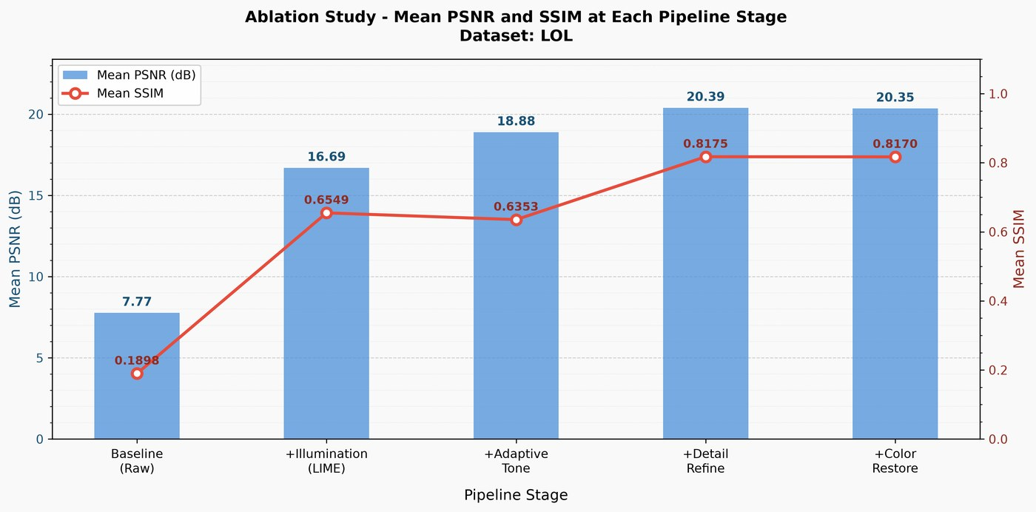
Figure 4.1. Stage-wise mean PSNR and SSIM on LOL eval15, as written by evaluate_lol.py.
On LOL, illumination recovery is the largest single step, from 7.77 dB to 16.69 dB, and it raises SSIM from 0.1898 to 0.6549. The tone stage adds a further 2.19 dB but lowers SSIM slightly, to 0.6353, which is consistent with a brighter image whose new pixel values are closer to the reference while the amplified grain has not yet been removed. Detail refinement is the structural step: SSIM jumps to 0.8175 and PSNR reaches 20.39 dB. Colour restoration then costs 0.04 dB and a negligible amount of SSIM. The saturation change is visible only as a small colour preference, not as the source of the score.
Table 4.3. Stage-wise scores on LOL-v2 Real (100 images)
Stage | PSNR (dB) | SSIM | Δ PSNR
Raw low-light | 9.7182 | 0.2067 | —
After illumination | 18.1694 | 0.6391 | +8.4512
After adaptive tone | 17.2867 | 0.6026 | −0.8827
After detail refine | 18.7311 | 0.7798 | +1.4444
After colour restore | 18.6329 | 0.7787 | −0.0982

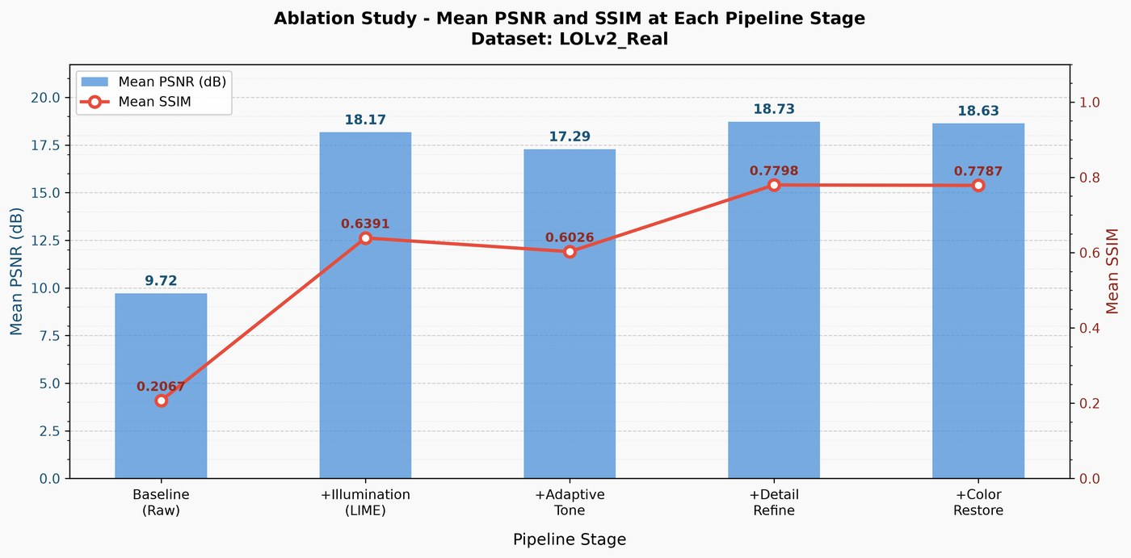
Figure 4.2. Stage-wise mean PSNR and SSIM on the LOL-v2 Real test.
On real LOL-v2 pairs the tone stage lowers both scores, by 0.88 dB and about 0.036 SSIM. The illumination image is, on this set, a better numerical match than the image after the extra gamma. Detail refinement recovers the loss and finishes above the illumination-only SSIM. The final 18.63 dB is therefore not “illumination plus a free improvement from every later stage”. The later tone curve helps LOL and hurts the mean of the real set, and the detail stage is what makes the structural score.
Table 4.4. Stage-wise scores on LOL-v2 Synthetic (100 images)
Stage | PSNR (dB) | SSIM | Δ PSNR
Raw low-light | 11.2209 | 0.4450 | —
After illumination | 20.0920 | 0.8902 | +8.8711
After adaptive tone | 20.0486 | 0.8853 | −0.0434
After detail refine | 19.8159 | 0.8283 | −0.2327
After colour restore | 19.8756 | 0.8282 | +0.0597

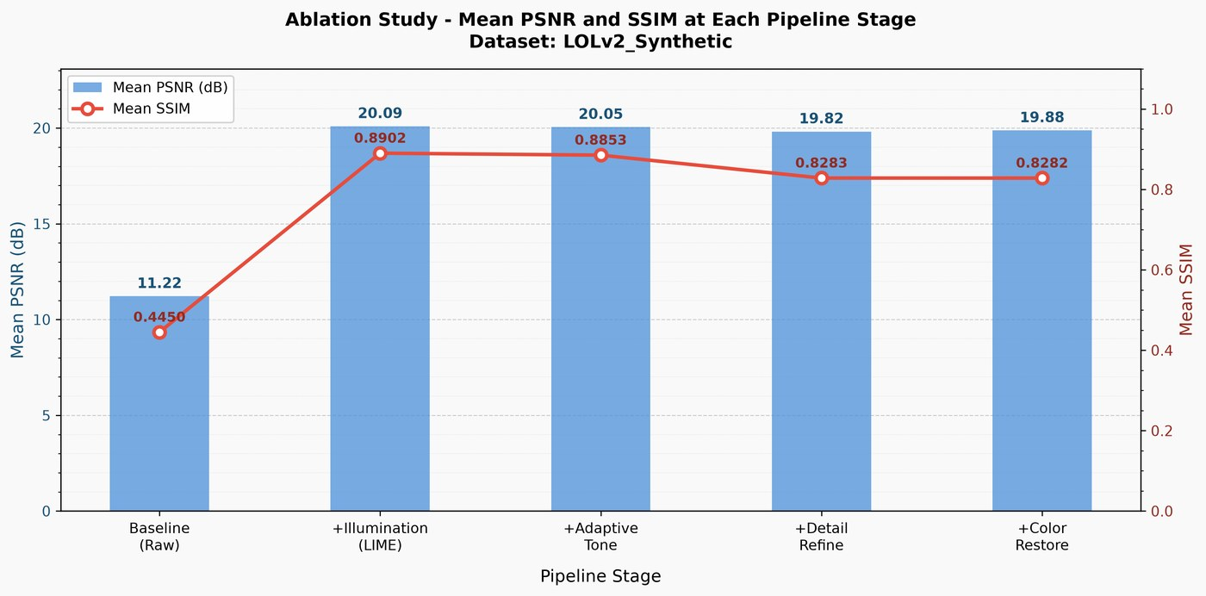
Figure 4.3. Stage-wise mean PSNR and SSIM on the LOL-v2 Synthetic test.
The synthetic set is the opposite case. Illumination alone reaches 20.09 dB and 0.8902, which is already above the final SSIM. Detail refinement lowers SSIM from 0.8853 to 0.8283. The smoother that helps real photographs, where the lift has created grain, removes some of the synthetic texture that the reference still contains. Colour restoration wins back 0.06 dB and does not restore the lost structure. The final 19.88 dB and 0.8282 are honest scores of the full pipeline, and they are slightly worse in structure than stopping after illumination. That fact is a limit of using one detail setting for every dataset.
Table 4.5. Stage-wise scores on UnLOL (43 images)
Stage | PSNR (dB) | SSIM | Δ PSNR
Raw low-light | 10.3573 | 0.4615 | —
After illumination | 13.3966 | 0.6140 | +3.0393
After adaptive tone | 13.5003 | 0.6146 | +0.1037
After detail refine | 13.5687 | 0.6145 | +0.0685
After colour restore | 13.5370 | 0.6137 | −0.0317

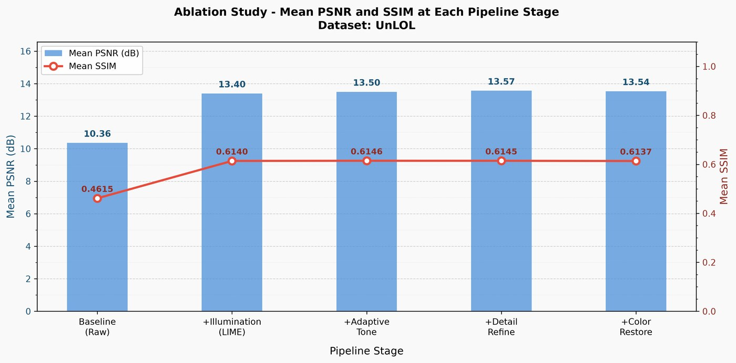
Figure 4.4. Stage-wise mean PSNR and SSIM on the UnLOL test.
On UnLOL every stage after the raw input adds little. Illumination accounts for about 3.0 of the 3.2 dB that separate the input from the final image. Tone, detail, and colour together move the mean by less than 0.2 dB, and SSIM stays near 0.61. The pipeline is not failing to run on these images. It is running, and the illumination estimate is the wrong shape for a large part of the error.

4.5 Per-image Results on LOL eval15
Because LOL eval15 has only fifteen pairs, the full table is short enough to report. These are the final-stage values in results/LOL/metrics.csv.
Table 4.6. Per-image PSNR and SSIM on LOL eval15
Image | PSNR (dB) | SSIM
1.png | 17.48 | 0.8670
111.png | 20.69 | 0.8941
146.png | 26.49 | 0.9088
179.png | 17.89 | 0.8487
22.png | 20.71 | 0.8162
23.png | 18.08 | 0.7193
493.png | 20.93 | 0.7373
547.png | 21.20 | 0.8074
55.png | 16.75 | 0.7449
665.png | 19.06 | 0.7447
669.png | 23.81 | 0.8636
748.png | 23.66 | 0.8682
778.png | 19.96 | 0.7391
780.png | 19.69 | 0.8081
79.png | 18.80 | 0.8879

The strongest frame is 146.png at 26.49 dB and 0.9088. The weakest PSNR is 55.png at 16.75 dB. The weakest SSIM is 23.png at 0.7193, even though its PSNR of 18.08 dB is not the worst. A frame can be closer in average intensity and still be structurally poor if the residual is grain or a local brightness error. The project README records that the crushed-frame detail rule, which keeps the smoothed base, moved 23.png from 16.82 dB to 18.08 dB, 55.png from 15.78 dB to 16.75 dB, and 665.png from 18.23 dB to 19.06 dB, with SSIM rising by about 0.07 to 0.10 on those frames. The current metrics.csv values for those three files are 18.08 dB, 16.75 dB, and 19.06 dB. The other twelve LOL frames were reported as unchanged by that particular rule, because they are not classified as crushed.

4.6 Extremes on the Larger Sets
Table 4.7. Highest and lowest final scores on each test set
Dataset | Highest PSNR | Lowest PSNR | Lowest SSIM
LOL eval15 | 146.png, 26.49 dB / 0.9088 | 55.png, 16.75 dB / 0.7449 | 23.png, 0.7193
LOL-v2 Real | low00713.png, 24.57 dB / 0.9472 | low00704.png, 12.87 dB / 0.7194 | low00770.png, 0.6130
LOL-v2 Synthetic | r191488c6t.png, 31.08 dB / 0.9299 | r01058910t.png, 10.19 dB / 0.6737 | r141669e5t.png, 0.5794
UnLOL | 1805.jpeg, 18.20 dB / 0.6777 | 2903.jpeg, 9.49 dB / 0.4696 | 0809.jpeg, 0.2486

The real-set images with the lowest SSIM are not the images with the lowest PSNR. low00770.png scores 17.98 dB but only 0.6130 SSIM, whereas low00704.png scores 12.87 dB with SSIM 0.7194. Brightness error and structural error are different failures. On UnLOL the lowest SSIM is 0809.jpeg at 0.2486, with a PSNR of 10.76 dB. That is close to a failed enhancement: the output and the reference do not share structure. The report does not hide this pair behind the mean of 0.6137.

4.7 Comparison with the Retired Baseline
COMPARATIVE_ANALYSIS.md records the retired gamma–CLAHE–bilateral pipeline at 14.49 dB and 0.7684 on LOL eval15, and 18.52 dB and 0.8089 on LOL-v2 Real. Against those two numbers the current pipeline is higher in PSNR on both sets (20.35 dB and 18.63 dB). SSIM is higher on LOL (0.8170 against 0.7684) and lower on LOL-v2 Real (0.7787 against 0.8089). The same file explains the real-set SSIM gap: the old bilateral kernel removed texture, and the structural score of a blurred image can look better when the reference comparison rewards smoothness. The current detail stage is the attempt to avoid that blur. A full re-run of the retired pipeline is not stored as a second metrics.csv in the present tree, so Table 4.8 cites the markdown record rather than a fresh experiment.
Table 4.8. Retired internal baseline and the current pipeline
Set | Retired PSNR | Retired SSIM | Current PSNR | Current SSIM
LOL eval15 | 14.49 | 0.7684 | 20.35 | 0.8170
LOL-v2 Real | 18.52 | 0.8089 | 18.63 | 0.7787
LOL-v2 Synthetic | Not evaluated | Not evaluated | 19.88 | 0.8282
UnLOL | Not evaluated | Not evaluated | 13.54 | 0.6137

No table in the repository compares this pipeline with Retinex-Net, KinD, Zero-DCE, or any other published learner on a shared split. That comparison was not evaluated.

4.8 Qualitative Behaviour
The comparison figures written by the project place the low-light input, the enhanced result, and the reference side by side. They are included here at reduced resolution so that the discussion refers to a specific file. The score printed in the text is the metrics.csv value, not a new measurement.
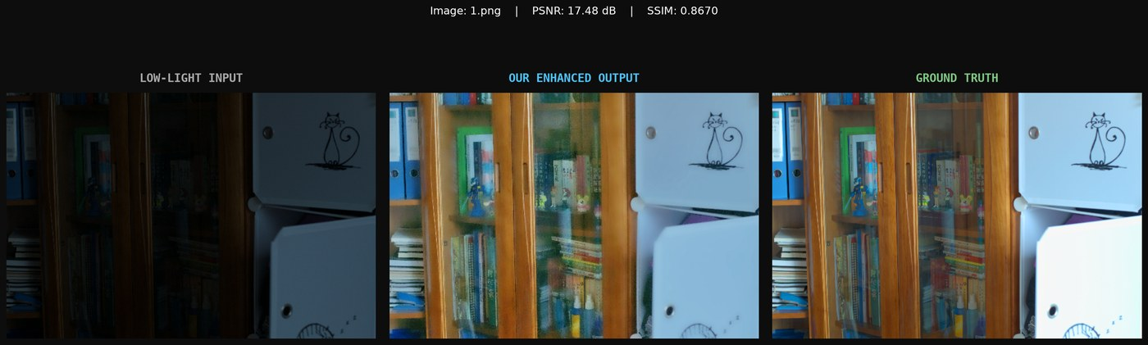
Figure 4.5. LOL eval15, 1.png. Input, enhanced result, and reference. Final score 17.48 dB, SSIM 0.8670.
On 1.png the shelves and the light cabinet are both present. The enhanced frame is brighter than the input and keeps the drawing on the cabinet. The PSNR of 17.48 dB is below the set mean, while the SSIM of 0.8670 is above it. The remaining error is a difference in colour and in local brightness, not a loss of the large structures. Some grain remains on the cabinet. The detail stage reduces grain; it does not erase it on an ordinary, non-crushed frame, because keep is 0.25 rather than zero.
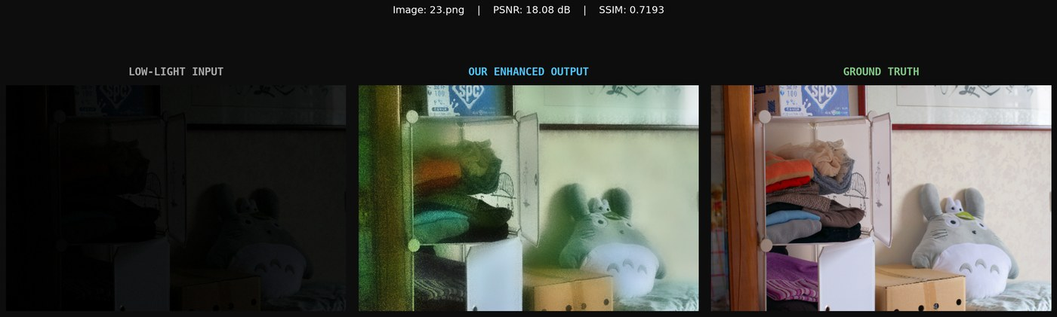
Figure 4.6. LOL eval15, 23.png, a uniformly dark frame. Final score 18.08 dB, SSIM 0.7193.
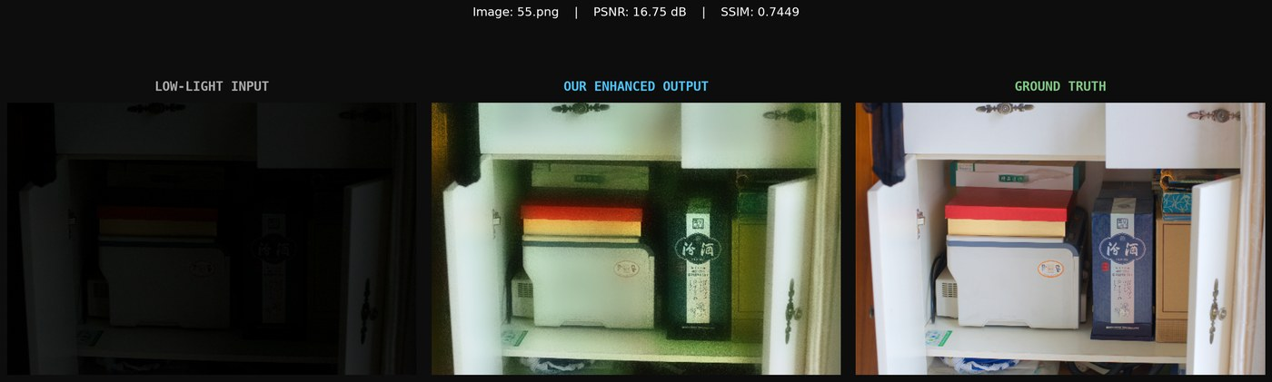
Figure 4.7. LOL eval15, 55.png, the lowest PSNR on this set. Final score 16.75 dB, SSIM 0.7449.
Frames 23 and 55 are the crushed cases the tone and detail rules are aimed at. The enhanced images are far brighter than the inputs, and the large objects remain recognisable. They are also the structurally weakest LOL results. The residual is a combination of colour cast, residual grain in the darkest cloth and corners, and a brightness that does not match the reference locally. Smoothing them more would raise SSIM only if the reference itself is smooth there. Where the reference has texture, more smoothing would trade one error for another. That trade is already visible in the synthetic ablation, where extra smoothing lowered SSIM.
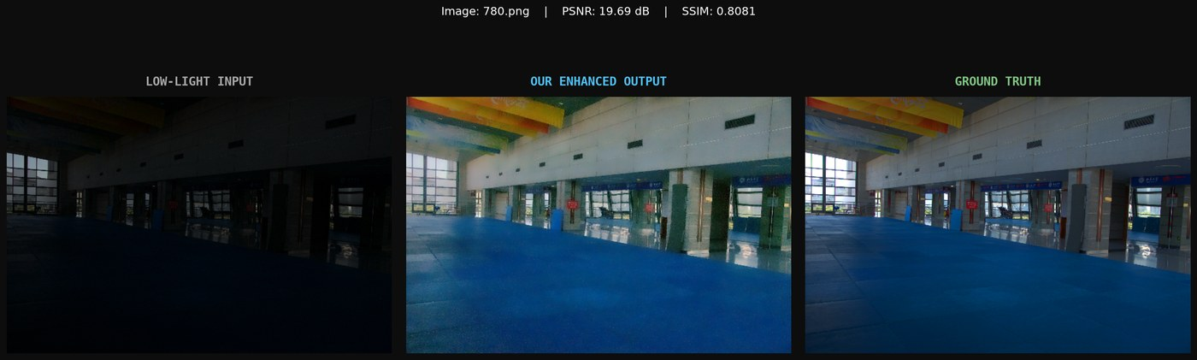
Figure 4.8. LOL eval15, 780.png. Final score 19.69 dB, SSIM 0.8081.
Frame 780.png is a night exterior with a bright interior seen through glass. This is the uneven-light situation inside an otherwise dark LOL frame. The enhanced result opens the dark floor and keeps the bright doorway. It does not match the reference colour exactly. The score, 19.69 dB and 0.8081, sits near the set mean. Halos along the door frame are not the dominant artefact; the dominant remaining defect is grain on the broad surfaces and a global colour difference.
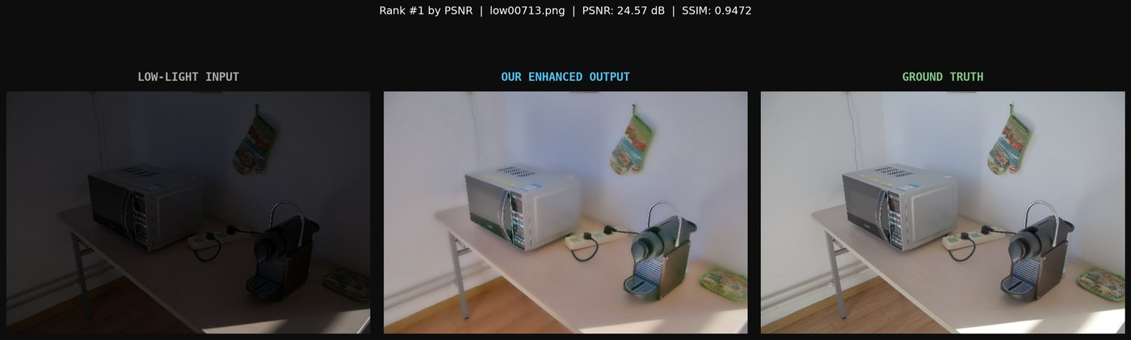
Figure 4.9. LOL-v2 Real, low00713.png, the highest PSNR on that test. Final score 24.57 dB, SSIM 0.9472.
The best real frame is close to the reference in both brightness and structure. A score of 24.57 dB and 0.9472 means the pipeline’s assumptions held: the dark input was largely an illumination change of a scene the reference also shows, and the max-channel map was a fair estimate of that illumination. This is the favourable case. It should not be generalised to low00704.png at 12.87 dB, where the same assumptions do not hold.
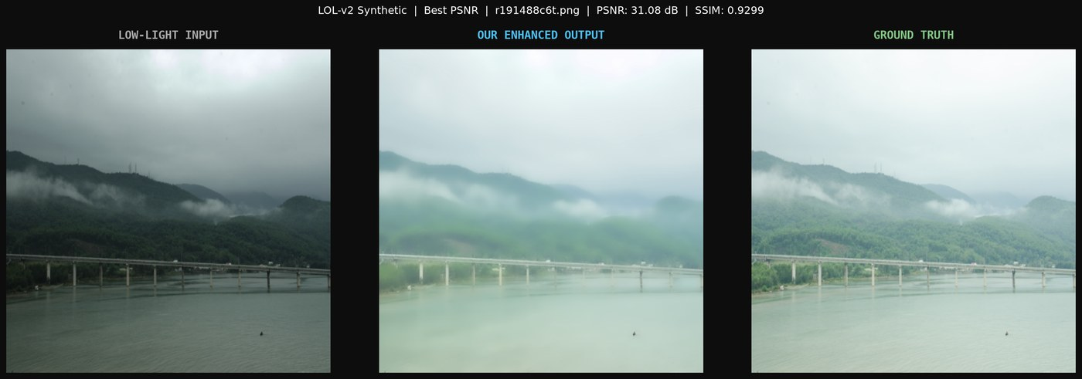
Figure 4.10. LOL-v2 Synthetic, r191488c6t.png, the highest PSNR. Final score 31.08 dB, SSIM 0.9299.
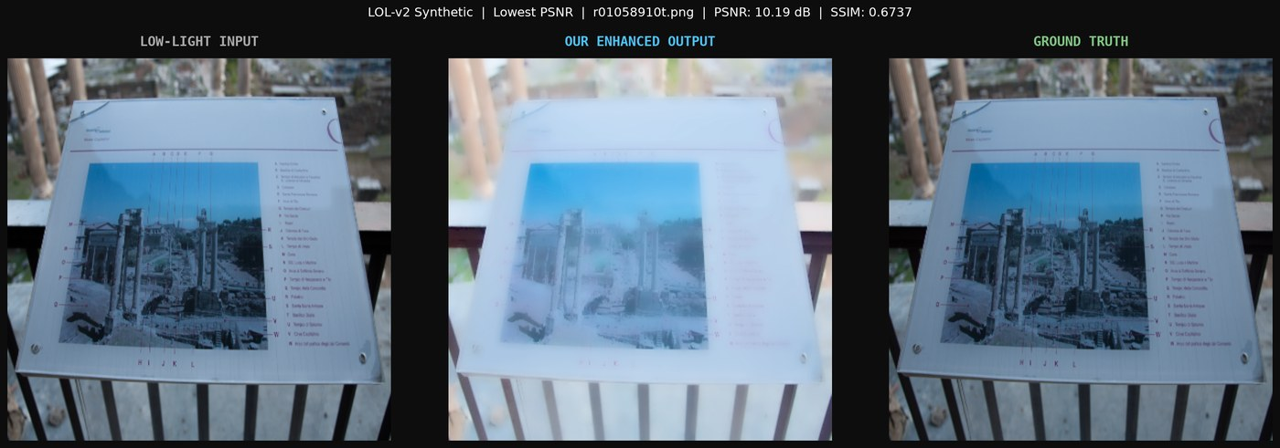
Figure 4.11. LOL-v2 Synthetic, r01058910t.png, the lowest PSNR. Final score 10.19 dB, SSIM 0.6737.
The synthetic best case is close to a solved illumination problem. The synthetic worst case is not. The project README notes that r01058910t.png stays soft because the darkness there is not a simple illumination scale. The figure supports that reading: lifting the input does not recover the reference, which means the degradation is not well described by one smooth illumination map. No per-image exception is coded for this filename. The failure is left visible.
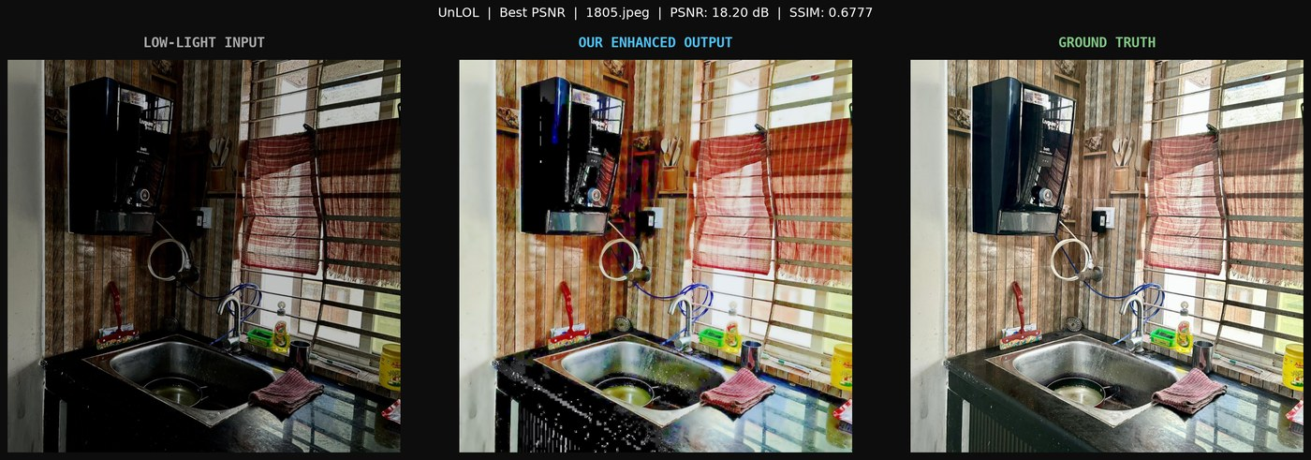
Figure 4.12. UnLOL, 1805.jpeg, the highest PSNR on that test. Final score 18.20 dB, SSIM 0.6777.
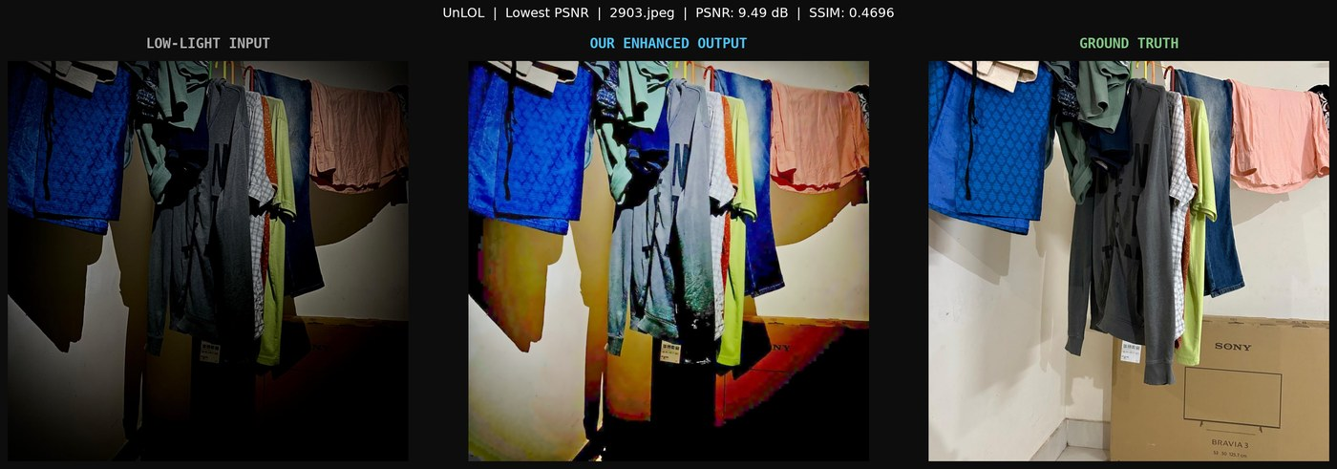
Figure 4.13. UnLOL, 2903.jpeg, the lowest PSNR on that test. Final score 9.49 dB, SSIM 0.4696.
Even the best UnLOL frame, at 18.20 dB, has a structural score of only 0.6777, below every LOL eval15 frame. The weakest, 2903.jpeg, at 9.49 dB and 0.4696, is close to the raw-input regime. The README records that both of these frames stay on the single-gamma path because the frame is dark overall, and that twelve of the forty-three UnLOL frames are mixed and take the paired exponent. The larger gains attributed to that path in the README, relative to the earlier single-exponent behaviour, are +3.08 dB on 0502.jpeg, +2.80 dB on 0604.jpeg, +2.57 dB on 0703.jpeg, +2.32 dB on 0103.jpeg, and +1.85 dB on 1709.jpeg. Those deltas are improvements inside a set whose absolute mean remains 13.54 dB. Mixed-light handling helps some scenes. It does not bring UnLOL up to the LOL regime.

4.9 Dark, Bright, and Mixed Regions
A dark pixel is lifted in proportion to how small its illumination is, through equation (3.7). A bright pixel, with T near one, is barely divided, so an already lit surface stays near its input. That is the designed behaviour on a mixed frame, and it is strengthened by the highlight exponent 0.55 when the mixed test passes. A crushed frame has no such bright pixel. The soft knee at 0.84 exists so that the gain of 1.70 does not turn the least dark pixels into hard white. The midtone anchor refuses to run when the 95th percentile is already at or above 0.70, which is the guard against brightening a frame that is already light in the highlights.
These guards are global or smoothly varying. They do not build a separate gain for each object. If two surfaces have the same illumination value, they receive the same exponent, even when the reference would have brightened only one of them. That is the correct description of the UnLOL failures and of synthetic frames such as r01058910t.png. The method handles uneven light only to the extent that uneven light appears as uneven values in the max-channel map.

4.10 Artefacts
The artefacts that remain, and that the figures show, are residual grain on ordinary frames, colour cast after a strong lift, and local brightness errors where the illumination map is too smooth or too coarse. Haloing is limited by the guided filter’s edge term, but it is not proved absent; the report does not claim a halo-free result. Block artefacts from CLAHE are absent because CLAHE is absent. The wide blur of the retired bilateral kernel is absent for the same reason, with the consequence, already measured, that LOL-v2 Real SSIM is lower than that blurred baseline. Over-saturation is limited by the midtone gate and by the factor 1.04. Under-enhancement remains on the weakest UnLOL and synthetic frames: the output is still dark or still structurally unlike the reference.

4.11 Computational Efficiency
Section 3.15 argued that the arithmetic is linear in the number of pixels. No timing table is stored. Frames per second, peak memory, and a comparison of CPU against another implementation were not evaluated. The absence of a learned model does mean that there is no weight file to load and no training cost to repeat when the constants change. Changing a constant still requires the test sets to be scored again if the claim is that the change is an improvement.

4.12 Discussion
Read as a whole, the experiment says three things. First, replacing a global gamma and a wide blur by an illumination division and a small detail restore raises LOL eval15 from the retired 14.49 dB and 0.7684 to 20.35 dB and 0.8170, and it raises real-set PSNR slightly while giving back some of the SSIM that blur had inflated. Second, most of that numerical gain is the illumination stage. Later stages are corrections: they repair crushed frames, they repair structure after the noise has been amplified, and on some sets they spend a fraction of the PSNR to do so. Third, the same function does not generalise to UnLOL. A mean of 13.54 dB and 0.6137, with a worst structural score of 0.2486, is a negative result about non-uniform real scenes. It is reported because it is the result the code produces.
The paired-exponent path is a partial answer to mixed light, not a solution of it. It helps the twelve UnLOL frames the README identifies, and it is prevented from running on uniformly dark frames so that it does not undo the best LOL and dark-scene cases. The crushed-frame detail rule is a partial answer to grain. It improves the three LOL frames that the test marks as crushed, and it leaves grain in ordinary frames because those frames still add a quarter of the strong residual back. Both partial answers are visible in the source as explicit tests. Neither is a per-image threshold fitted to a filename.

4.13 Limitations
The illumination model is a single smooth map. It cannot represent a cast shadow with a sharp but semantically important boundary if that boundary is not an edge of the max-channel image, and it cannot represent coloured illumination beyond the mild gray-world scale. Noise and texture are separated only by amplitude after a small guided filter, which fails when the grain is as large as the texture. The synthetic ablation is the measurement of that failure. The method has no confidence output: every pixel is enhanced, including pixels that should have been left dark. Evaluation is full-reference and paired. Behaviour on unpaired night photographs is not scored. No user study is reported.

4.14 Summary
On three of the four test sets the pipeline produces a large rise over the raw input, led by illumination recovery, with detail refinement responsible for the structural score on the real captured sets. On UnLOL the rise is about three decibels and the structural score stays near 0.61. The weakest individual frames remain between 9.5 dB and 13 dB depending on the set. Those are the results of the implementation described in Chapter 3.

CHAPTER 5 CONCLUSION
This project implemented a classical low-light enhancer and measured it on four paired test sets. The enhancer estimates a max-channel illumination, smooths it with a guided filter, and divides it out. The exponent is 0.70 on frames that are not mixed. It becomes a spatial blend of a shadow exponent and a highlight exponent of 0.55 when the illumination map shows both a dark mass and a bright tail. A uniformly crushed exposure, detected from the raw map, receives a soft gain of 1.70 instead of being left too dark by a mild curve. A partial gray-world step reduces colour cast. A second guided filter restores only strong detail, and restores none of it when the frame is crushed. Midtone saturation is raised by four percent. The normal-light image is not an input to any of these steps.
The measured means are 20.35 dB and 0.8170 on LOL eval15, 18.63 dB and 0.7787 on LOL-v2 Real, 19.88 dB and 0.8282 on LOL-v2 Synthetic, and 13.54 dB and 0.6137 on UnLOL. Relative to a retired internal baseline of global gamma, CLAHE, and a wide bilateral filter, PSNR is higher on both sets where that baseline was recorded, and SSIM is higher on LOL but lower on LOL-v2 Real. The stage-wise tables show that illumination recovery does most of the work, that detail refinement is the structural correction on real images, and that the same refinement removes useful texture on the synthetic set. UnLOL shows the limit of a single illumination map on spatially complicated real scenes.
The work does not claim a new state of the art, a real-time guarantee, or a solution to arbitrary night photography. It claims a documented, reproducible pipeline whose constants, decisions, and scores are in the repository, and whose failures are the low UnLOL scores, the weak individual frames, the residual grain on ordinary frames, and the synthetic textures that the smoother removes.

FUTURE SCOPE
The following items are not implemented. They are stated as future work because the measurements show where the current function stops.
A finer illumination model is the first gap. UnLOL requires a gain that can change across a shadow boundary without lifting a dark object that shares the same input value. A second map, or an explicit shadow edge, would have to be justified on the input alone and then re-scored on all four sets, not tuned on the forty-three UnLOL images. Noise-aware refinement is the second gap. The synthetic ablation shows that one keep-fraction is too strong for texture that is real and too weak for grain that is not. An amplitude test that also looks at whether the residual is structured, still without reading the reference, is a possible direction. The non-local smoother that was withdrawn because it blurred texture is a warning that “more denoising” is not automatically better.
Adaptive selection of the existing constants, by a measure computed from the input, could replace the single table in config.py if it does not become a hidden fit to the test names. A learned refinement, trained only on a split that is not the reported test, is a possible later stage. It is not a description of the current system, which has no training split in use and no loss. A more complete evaluation would add multi-scale structural similarity, a timing table, and a comparison against published methods on the same pairs. Unpaired photographs, video, and a smaller implementation for an embedded device are further out. Each of them needs its own measurement before it can be claimed.

REFERENCES
[1] E. H. Land and J. J. McCann, “Lightness and Retinex theory,” Journal of the Optical Society of America, vol. 61, no. 1, pp. 1–11, 1971.
[2] D. J. Jobson, Z. Rahman, and G. A. Woodell, “A multiscale Retinex for bridging the gap between color images and the human observation of scenes,” IEEE Transactions on Image Processing, vol. 6, no. 7, pp. 965–976, 1997.
[3] S. M. Pizer et al., “Adaptive histogram equalization and its variations,” Computer Vision, Graphics, and Image Processing, vol. 39, no. 3, pp. 355–368, 1987.
[4] K. Zuiderveld, “Contrast limited adaptive histogram equalization,” in Graphics Gems IV, P. S. Heckbert, Ed. San Diego, CA, USA: Academic Press, 1994, pp. 474–485.
[5] S.-C. Huang, F.-C. Cheng, and Y.-S. Chiu, “Efficient contrast enhancement using adaptive gamma correction with weighting distribution,” IEEE Transactions on Image Processing, vol. 22, no. 3, pp. 1032–1041, 2013.
[6] X. Guo, Y. Li, and H. Ling, “LIME: Low-light image enhancement via illumination map estimation,” IEEE Transactions on Image Processing, vol. 26, no. 2, pp. 982–993, 2017.
[7] K. He, J. Sun, and X. Tang, “Guided image filtering,” IEEE Transactions on Pattern Analysis and Machine Intelligence, vol. 35, no. 6, pp. 1397–1409, 2013.
[8] K. Dabov, A. Foi, V. Katkovnik, and K. Egiazarian, “Image denoising by sparse 3-D transform-domain collaborative filtering,” IEEE Transactions on Image Processing, vol. 16, no. 8, pp. 2080–2095, 2007.
[9] S. Wang, J. Zheng, H.-M. Hu, and B. Li, “Naturalness preserved enhancement algorithm for non-uniform illumination images,” IEEE Transactions on Image Processing, vol. 22, no. 9, pp. 3538–3548, 2013.
[10] X. Fu, D. Zeng, Y. Huang, X.-P. Zhang, and X. Ding, “A weighted variational model for simultaneous reflectance and illumination estimation,” in Proc. IEEE Conference on Computer Vision and Pattern Recognition, 2016, pp. 2782–2790.
[11] M. Li, J. Liu, W. Yang, X. Sun, and Z. Guo, “Structure-revealing low-light image enhancement via robust Retinex model,” IEEE Transactions on Image Processing, vol. 27, no. 6, pp. 2828–2841, 2018.
[12] Z. Ying, G. Li, Y. Ren, R. Wang, and W. Wang, “A new low-light image enhancement algorithm using camera response model,” in Proc. IEEE International Conference on Computer Vision Workshops, 2017, pp. 3015–3022.
[13] G. Buchsbaum, “A spatial processor model for object colour perception,” Journal of the Franklin Institute, vol. 310, no. 1, pp. 1–26, 1980.
[14] K. G. Lore, A. Akintayo, and S. Sarkar, “LLNet: A deep autoencoder approach to natural low-light image enhancement,” Pattern Recognition, vol. 61, pp. 650–662, 2017.
[15] C. Wei, W. Wang, W. Yang, and J. Liu, “Deep Retinex decomposition for low-light enhancement,” in Proc. British Machine Vision Conference, 2018.
[16] Y. Zhang, J. Zhang, and X. Guo, “Kindling the darkness: A practical low-light image enhancer,” in Proc. ACM International Conference on Multimedia, 2019, pp. 1632–1640.
[17] C. Guo et al., “Zero-reference deep curve estimation for low-light image enhancement,” in Proc. IEEE/CVF Conference on Computer Vision and Pattern Recognition, 2020, pp. 1780–1789.
[18] W. Yang, S. Wang, Y. Fang, Y. Wang, and J. Liu, “From fidelity to perceptual quality: A semi-supervised approach for low-light image enhancement,” in Proc. IEEE/CVF Conference on Computer Vision and Pattern Recognition, 2020, pp. 3063–3072.
[19] Z. Wang, A. C. Bovik, H. R. Sheikh, and E. P. Simoncelli, “Image quality assessment: From error visibility to structural similarity,” IEEE Transactions on Image Processing, vol. 13, no. 4, pp. 600–612, 2004.
[20] International Telecommunication Union, “Studio encoding parameters of digital television for standard 4:3 and wide-screen 16:9 aspect ratios,” Recommendation ITU-R BT.601-7, 2011.

APPENDIX

A. Correspondence between the report and the source
Table A.1 maps each stage in Chapter 3 to the function that implements it. The mapping is given so that a reader can check a claim against the repository rather than against this prose alone.
Table A.1. Source functions for each stage
Stage | Function | File
Read image | load_image | modules/image_io.py
Normalise and run stages | run_stages | modules/pipeline.py
Initial illumination | initial_illumination | modules/illumination.py
Smooth illumination | refine_illumination | modules/illumination.py
Guided filter | guided_filter | modules/filters.py
Divide by T^γ | recover_reflectance | modules/illumination.py
Crushed test | is_crushed | modules/tone.py
Mixed-light test | is_mixed_light | modules/tone.py
Paired exponent | paired_gamma_map | modules/tone.py
Tone and anchor | apply_adaptive_tone | modules/tone.py
Gray-world | gray_world | modules/tone.py
Detail refine | refine_details | modules/refine.py
Saturation | restore_color | modules/color_restore.py
PSNR and SSIM | evaluate | modules/evaluation.py
Constants | module attributes | config.py

B. Score files
The means in Chapter 4 are taken from results/LOL/ablation_study.csv, results/LOLv2_Real/ablation_study.csv, results/LOLv2_Synthetic/ablation_study.csv, and results/UnLOL/ablation_study.csv, and from the per-image metrics.csv files in the same folders. summary.txt repeats the final means at two decimal places for PSNR and four decimal places for SSIM. The three-panel figures are the PNG files under each results directory’s comparisons folder. The retired baseline of 14.49 dB / 0.7684 and 18.52 dB / 0.8089 is taken from COMPARATIVE_ANALYSIS.md and was not re-measured for this report.

C. Items that were not evaluated
The following are not available in the current implementation and are not given numerical values anywhere in this report: multi-scale SSIM, a no-reference perceptual score, a user study, a runtime or memory benchmark, a comparison against Retinex-Net, KinD, Zero-DCE, or any other published network, a score of the retired baseline on LOL-v2 Synthetic and on UnLOL, and a formal bibliographic record for the UnLOL split. Zero-DCE is cited in Chapter 2 only as related learning-based work. It is not the method of this project.

