**Online Quiz Platform**

**Project Abstract**

**Version 1.0**

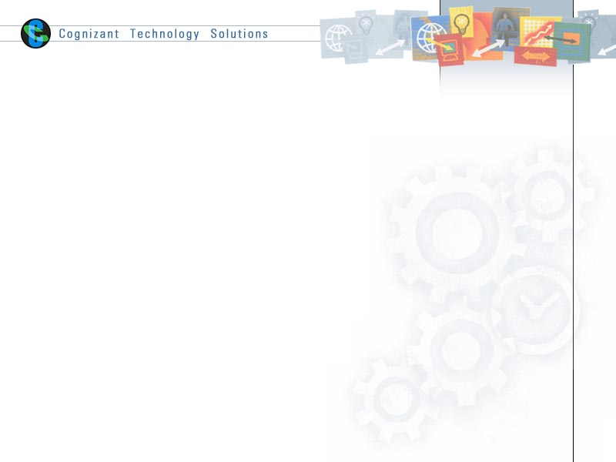

|  |  |  |  |
| --- | --- | --- | --- |
|  | Prepared By / Last Updated By | Reviewed by | Approved By |
| Name | Snehasish Pati |  |  |
| Role | Intern |  |  |
| Signature | Snehasish Pati |  |  |
| Date |  |  |  |

Table of Contents

1.0 Purpose of this document 4

2.0 Business Case 4

3.0 Appendices 4

3.1 Glossary 4

3.2 Other 4

4.0 Terms & Conditions 5

5.0 Change Log 5

# Purpose of this document

This document provides an overview about the business need and the solution that can be provided to fulfil the objective.

# Business Case

* The Library Management System is a web-based application which is employed for automating a library. It allows the librarian to maintain the information about books, magazines, CDs, facilities to its users search for items, browse, checkout items, return items, etc.
* Library Management System maintains the information about the books present in the library, their authors, the members of library to whom books are issued library staff and all, this is very difficult to organize manually.
* Library Management System allows maintaining the resources in a more operative manner that will help to save the time. It is also convenient for the librarian to manage the process of books allocation. It is useful for students as well as a librarian to keep the constant track of the availability of all books in library.

# Appendices

## Glossary

|  |  |
| --- | --- |
| **Acronyms** | **Definitions** |
|  |  |

## Other

# Terms & Conditions

***Disclaimer: Please do not circulate or distribute this document outside of Cognizant Network, We have a Zero Tolerance Policy. Kindly adhere to 100% Compliance at all times.***

# Change Log

*Please note that this table needs to be maintained even if a Configuration Management tool is used.*

|  |  |  |  |  |
| --- | --- | --- | --- | --- |
| Version Number | Changes made | | | |
| V<1.0> | *<If the change details are not explicitly documented in the table below, reference should be provided here>* | | | |
| Page no | Changed by | Effective date | Changes effected |
|  |  |  |  |
|  |  |  |  |
|  |  |  |  |
|  |  |  |  |