BIKE SHARING
DEMAND INTELLIGENCE
Demand Analysis, Statistical Evidence, Forecasting, Fleet Scenarios and a Gemini-Powered Business Assistant
━━━━━━━━━━━━━━━━━━━━━━━━━━━━━━━━━━━━━━━━
DATA SCIENCE CASE STUDY | SIGMOID
UCI Bike Sharing Dataset • Capital Bikeshare • Washington, D.C. • 2011-2012
17,379  hourly observations | 3.29M  completed rentals | 0.8068  test R-squared | 37  automated tests passed
Complete project report
Prepared November 2026
Decision focus: investigate availability and redistribution before committing to broad fleet expansion.

Executive Summary
The case asks whether a bike-sharing operator should buy more bikes when riders report being unable to find one while other bikes appear idle. The analysis uses the UCI hourly and daily rental records to understand completed-rental demand, test day-type patterns, build an hourly demand model and translate the findings into a transparent fleet-planning scenario and a controlled redistribution pilot.
Decision recommendation Do not recommend broad fleet expansion from citywide completed-rental counts alone. First instrument station availability, failed rental attempts, trip records and bike health; then test forecast-guided redistribution against current operations. Consider targeted purchases only if verified unmet demand persists after rebalancing and repairs.

What the project establishes
Finding | Evidence / interpretation
Demand is concentrated in time | 17:00 is the highest average hour at 461.45 completed rentals/hour; working days show stronger commute peaks, while non-working days are more midday-oriented.
Day-type difference is substantial | On complete days, the mean commute-window share is 51.63% on working days versus 26.25% on non-working days, a 25.39 percentage-point difference.
Customer mix differs | Registered customers contribute 86.77% of working-day rentals; casual customers contribute 31.66% of non-working-day rentals.
Forecasting has useful signal | The Random Forest reaches test MAE 64.09, RMSE 94.54 and R² 0.8068 on the final chronological test period.
Fleet estimate is a scenario | At 2012 hourly P95 demand of about 662 rentals/hour, a 20-minute trip, 2.0x positioning buffer and 10% maintenance assumption produce a 491-bike scenario.
Prototype validated | The Gemini-enabled Business Assistant successfully selected an approved function for a live question; 37 local automated tests passed.

Evidence boundary
The data records completed rentals, not people who tried and failed to rent. It contains no station inventory, dock capacity, actual trip duration, station-to-station flows, bike health or rebalancing logs. Therefore, it supports demand-timing analysis and planning scenarios, but it cannot prove station-level shortages, quantify unmet demand or establish the actual fleet size required.

Report roadmap
The report moves from data checks and exploratory results to hypothesis tests, model evaluation, fleet planning, the redistribution experiment, the Gemini prototype, limitations and the final operational recommendation.

1. Business Problem and Study Approach

1.1 The operating question
A city bike-sharing system can experience both temporal and spatial imbalance. Demand rises sharply during certain hours and at particular locations, while bikes may be elsewhere, unavailable, damaged or waiting in low-demand areas. A complaint about bike availability is therefore not automatically evidence that the city needs a larger fleet. It may reflect distribution, maintenance, dock constraints, technology failures or peak-period timing.
The decision to be supported is: should the operator invest in more bikes now, or should it first improve measurement and test whether better allocation and fleet health can improve service?

1.2 Project objectives
- Audit the hourly and daily datasets and construct reliable analytical features.
- Describe demand across hours, day types, customer segments, weather and calendar periods.
- State and test hypotheses about commute-window concentration, time-window demand, weather and seasonality.
- Train and evaluate an hourly completed-rental model using a chronological holdout.
- Translate a demand rate into a transparent, assumption-based fleet scenario using Little’s Law.
- Design a measurable 4-6 week controlled redistribution pilot.
- Build a Streamlit interface that lets an operations manager query evidence in natural language.

1.3 Analytical workflow
Stage | What was done | Output
1. Data audit | Schema, nulls, duplicates, timestamp continuity, target consistency and suspicious values. | Quality findings and analysis-ready records.
2. EDA and feature work | Calendar, time, weather and customer-segment views; derived date features. | Demand patterns and candidate predictors.
3. Statistical tests | Mann-Whitney U, Kruskal-Wallis, Cliff’s delta and Holm correction. | Test decisions and effect-size evidence.
4. Forecasting | Time-ordered train/validation/test split; historical baseline and Random Forest. | Held-out predictions and diagnostics.
5. Fleet scenario | Little’s Law plus trip-duration, positioning and maintenance assumptions. | Sensitivity-based scenario, not a verified fleet requirement.
6. Decision prototype | Streamlit dashboard, Gemini function calling and local validation. | Manager-facing question-and-evidence workflow.

2. Dataset, Data Quality and Feature Engineering

2.1 Dataset overview
The project analyses the UCI Bike Sharing Dataset for Capital Bikeshare in Washington, D.C. The hourly file contains one row per recorded hour; the daily file contains one row per calendar day. The target variable cnt is the total number of completed rentals. Casual and registered are used for segmentation, not as demand-model predictors, because they sum directly to cnt and would leak the target.
Dataset | Rows | Columns | Use
hour.csv | 17,379 | 17 | Hourly EDA, model training and hourly demand profile.
day.csv | 731 | 16 | Daily EDA, weather/season comparisons and hypothesis tests.

2.2 Data quality checks
Check | Hourly file | Daily file / interpretation
Missing cell values | 0 | 0
Duplicate rows | 0 | 0
Duplicate date-hour keys | 0 | Not applicable to daily file.
Timestamp continuity | 165 missing hourly timestamps across 76 incomplete days | Gaps are absent observations, not zero-rental records.
Target identity | casual + registered = cnt for all records | Same identity holds for all daily records.
Extreme / zero values | High-demand observations retained; zero humidity and windspeed values flagged for review. | Weather category 4 has only three hourly observations.

Data-quality interpretation There are no null cells or duplicate records, but timestamp continuity is not complete. Missing hourly timestamps were treated as missing observations rather than filled with zero rentals, avoiding artificial downward bias in hourly and daily totals.

2.3 Feature construction and leakage control
The forecasting workflow uses calendar and time fields (season, year, month, hour, holiday, weekday and working-day indicator), weather variables (weather situation, normalized temperature, feels-like temperature, humidity and windspeed), plus derived year, month, day-of-month and day-of-week features. Categorical variables are one-hot encoded. Customer counts are excluded from the model matrix because casual + registered equals the target cnt.

3. Exploratory Data Analysis

3.1 Overall demand and hour-of-day pattern
The hourly file contains 3,292,679 recorded completed rentals, an average of 189.46 per recorded hour and a maximum observed hourly count of 977. The highest average hour is 17:00 (461.45); 18:00 is next at 425.51. These are citywide completed-rental averages and do not show station-level stock-outs.
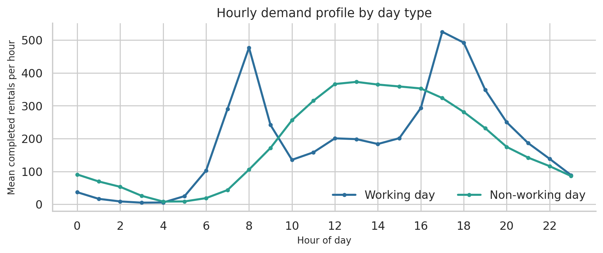
Figure 1. Mean hourly completed rentals split by working-day status. The working-day curve has distinct morning and evening peaks; the non-working-day curve is more midday-oriented.
The two day types have different shapes even though their overall average hourly counts are relatively close. The project therefore treats day type as an important planning dimension rather than assuming one universal daily demand curve.

3.2 Day type, commute windows and customer segments
Day type | Mean hourly rentals | Difference
Working day | 193.21 | 6.51% higher than non-working days.
Non-working day | 181.41 | Relatively more demand around midday.

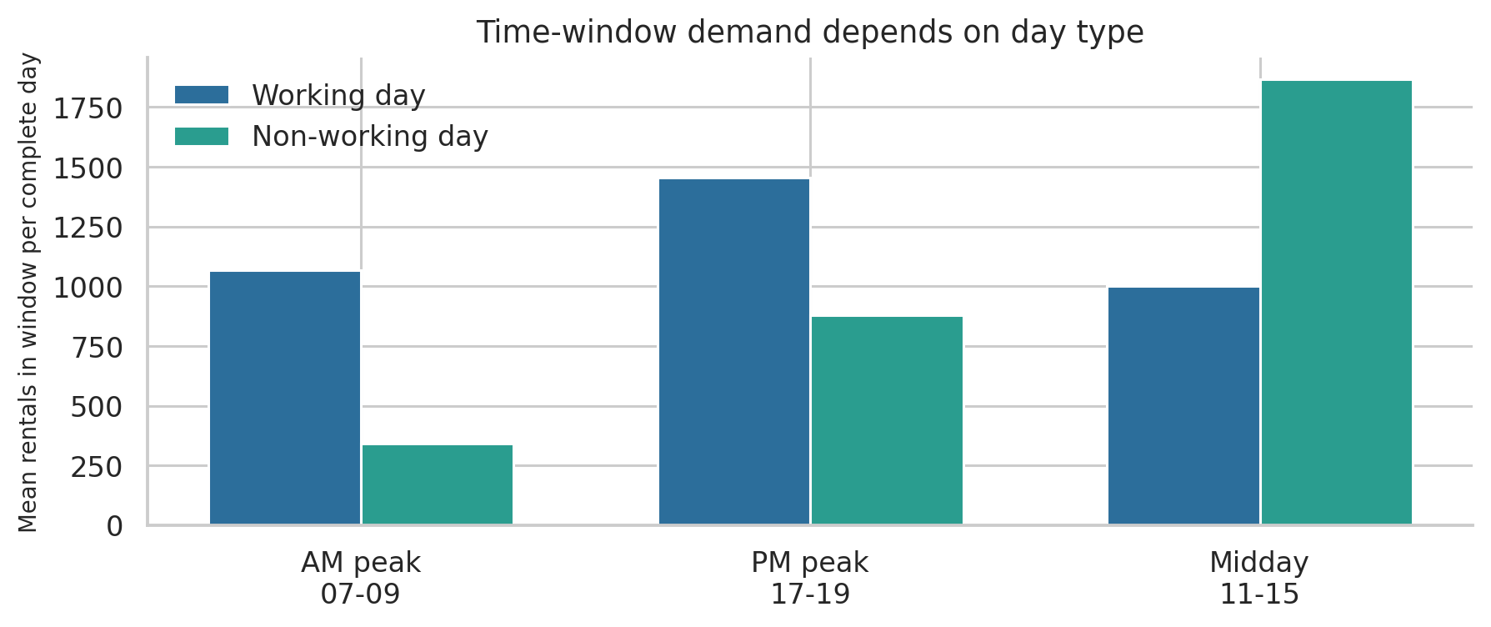
Figure 2. Average rentals accumulated per complete day in AM (07-09), PM (17-19) and midday (11-15) windows.
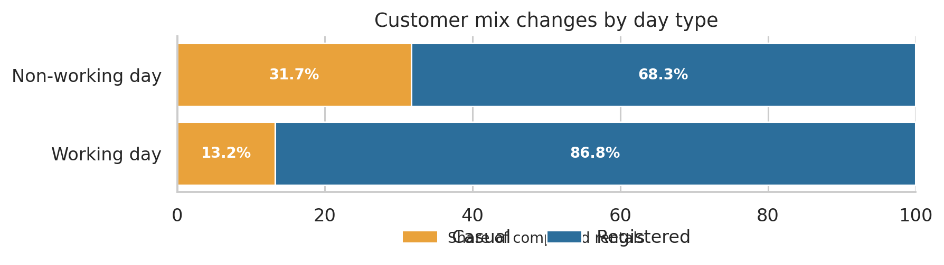
Figure 3. Share of completed rentals by customer segment and day type. Shares are calculated from rental totals within each day-type group.
Registered rentals dominate working days (86.77% share). Casual rentals are a larger component on non-working days (31.66% share). This supports separate weekday and non-working-day profiles for both demand interpretation and operational planning.

3.3 Weather and monthly patterns
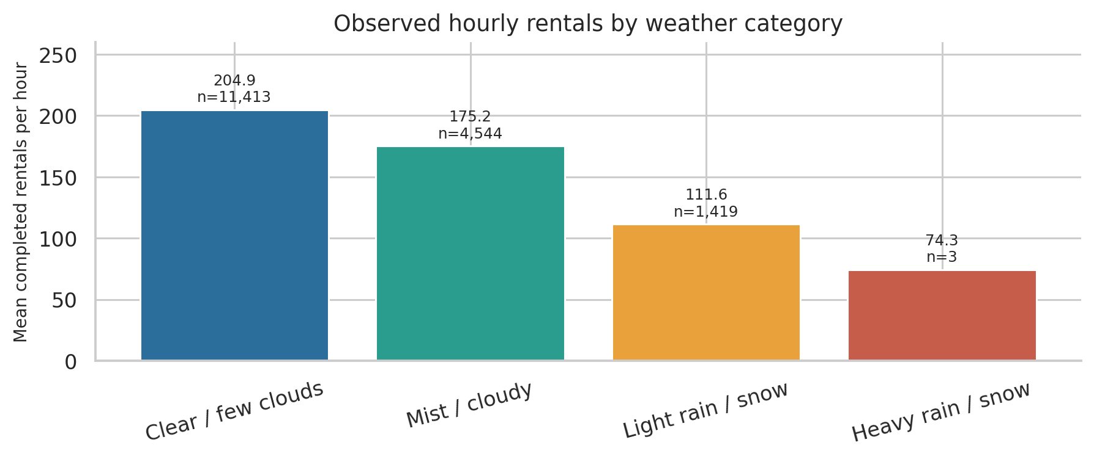
Figure 4. Mean hourly completed rentals by observed weather category. Category 4 has only three hourly records.
Weather patterns are observational associations. The three-observation heavy-rain category is too small for a reliable standalone conclusion.
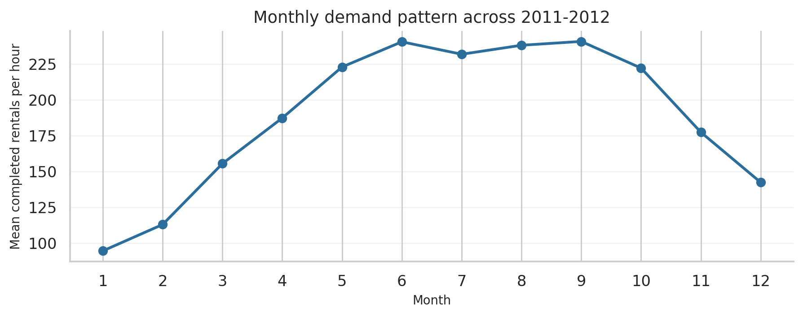
Figure 5. Mean hourly completed rentals by calendar month across the 2011-2012 dataset.
Average hourly rentals are lower in less favourable weather categories in the observed data. Monthly means rise from winter into warmer months and taper toward year-end, but the chart pools the two years and is descriptive rather than a causal seasonal estimate.

4. Statistical Analysis and Hypothesis Testing
The statistical workflow uses complete days for day-type comparisons so each daily observation contributes one value to the test. The commute-window share uses all six hours from 07:00-09:00 and 17:00-19:00 divided by that complete day’s total rentals. Mann-Whitney U tests are used for distribution comparisons; the seasonal omnibus test uses Kruskal-Wallis. Cliff’s delta reports the direction and magnitude of pairwise dominance.

4.1 H1 - commute-window concentration
Hypothesis: the share of daily rentals occurring during commute windows is higher on working days than on non-working days. The analysis includes only complete 24-hour days: 443 working days and 212 non-working days.
Metric | Working days | Non-working days
Complete days | 443 | 212
Mean commute-window share | 51.63% | 26.25%
Median commute-window share | 52.38% | 26.31%

Test statistic | Value
Mean-share difference | 25.39 percentage points
Mann-Whitney U | 93,434
One-sided p-value | 8.54e-94
Cliff’s delta | 0.9897

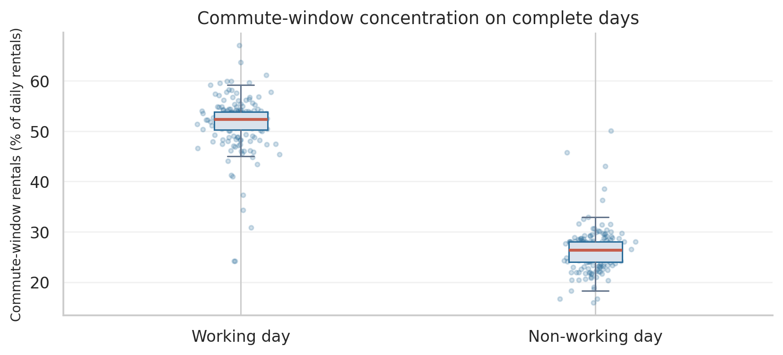
Figure 6. Distribution of each complete day’s commute-window share by day type. The boxplot suppresses only plotted outlier markers; all daily observations are used in the statistical test.
H1 decision Reject the null hypothesis at conventional significance levels. Working days have a much higher commute-window share in the observed data. Cliff’s delta of about 0.990 indicates very strong separation between the two distributions.

The records are consecutive days, so serial dependence may affect inferential uncertainty. The result is strong descriptive evidence of different day-type profiles, not evidence that redistribution caused an improvement.

4.2 H2 - AM, PM and midday windows
Hypothesis: daily rental totals within the AM peak, PM peak and midday windows differ between working and non-working days. Each window is compared using a two-sided Mann-Whitney U test; the three p-values are adjusted together using Holm’s method.
Window | Mean / working day | Mean / non-working day | Holm p-value | Cliff’s delta
AM peak | 1067 | 341 | 4.67e-80 | 0.917
PM peak | 1455 | 877 | 3.94e-32 | 0.569
Midday | 1001 | 1865 | 2.18e-41 | -0.653

The AM and PM windows contain substantially more completed rentals per day on working days; the midday window contains more on non-working days. All three differences remain statistically significant after Holm correction. Window totals are sums across the stated hours, not per-hour rates.

4.3 H3 - clear versus adverse weather
The daily dataset groups weather situation 1 as Clear and situations 2-3 as Adverse. The one-sided Mann-Whitney comparison gives mean daily rentals of 4877 on clear days (n=463) and 3861 on adverse-weather days (n=268). U=80,890, p=3.68e-12, Cliff’s delta=0.304.
The result supports higher completed-rental counts on clear days in this dataset. It remains an observational association; other calendar and seasonal factors may also contribute.

4.4 H4 - differences across seasons
The Kruskal-Wallis test compares daily completed-rental distributions across the four season codes: H=250.93, p=4.11e-54. The omnibus result indicates that at least one season distribution differs.
Season code | Days | Mean daily rentals | Median daily rentals
Season 1 | 181 | 2604 | 2209
Season 2 | 184 | 4992 | 4942
Season 3 | 188 | 5644 | 5354
Season 4 | 178 | 4728 | 4634

Pairwise Mann-Whitney tests with Holm correction show that most season pairs differ; the comparison between season codes 2 and 4 does not remain significant after correction (adjusted p=0.0908). These are coded seasons in the source dataset; the report avoids treating the differences as causal effects.

5. Hourly Demand Forecasting

5.1 Target, predictors and evaluation design
The supervised target is cnt, the number of completed rentals in an hour. Predictors comprise calendar, hour-of-day and weather information. Categorical columns are one-hot encoded; numeric temperature, feels-like temperature, humidity and windspeed are retained as numeric features. casual and registered are omitted from predictors to prevent direct target leakage.
Partition | Rows | Chronological range
Training | 12165 | 2011-01-01 to 2012-05-27
Validation | 2607 | 2012-05-27 to 2012-09-12
Test | 2607 | 2012-09-12 to 2012-12-31

Rows are sorted by date and hour before splitting. The earliest 70% of rows are used for training, the next 15% for validation/model selection, and the final 15% for test evaluation. The final test period is not used to select the model.

5.2 Baseline and selected model
Model | Validation MAE | Validation RMSE | Validation R-squared
Hourly + working-day mean baseline | 125.93 | 167.15 | 0.4393
Random Forest Regressor | 99.13 | 140.25 | 0.6053

Final held-out test metric | Random Forest result
MAE (rentals/hour) | 64.09
RMSE (rentals/hour) | 94.54
R-squared | 0.8068

Model interpretation The Random Forest improves on the hourly + working-day mean baseline during validation. On the final chronological test period it explains about 80.7% of the variation in completed rental counts, with an average absolute error of about 64 rentals per hour. It predicts completed rentals, not failed demand or bike availability.

5.3 Feature importance
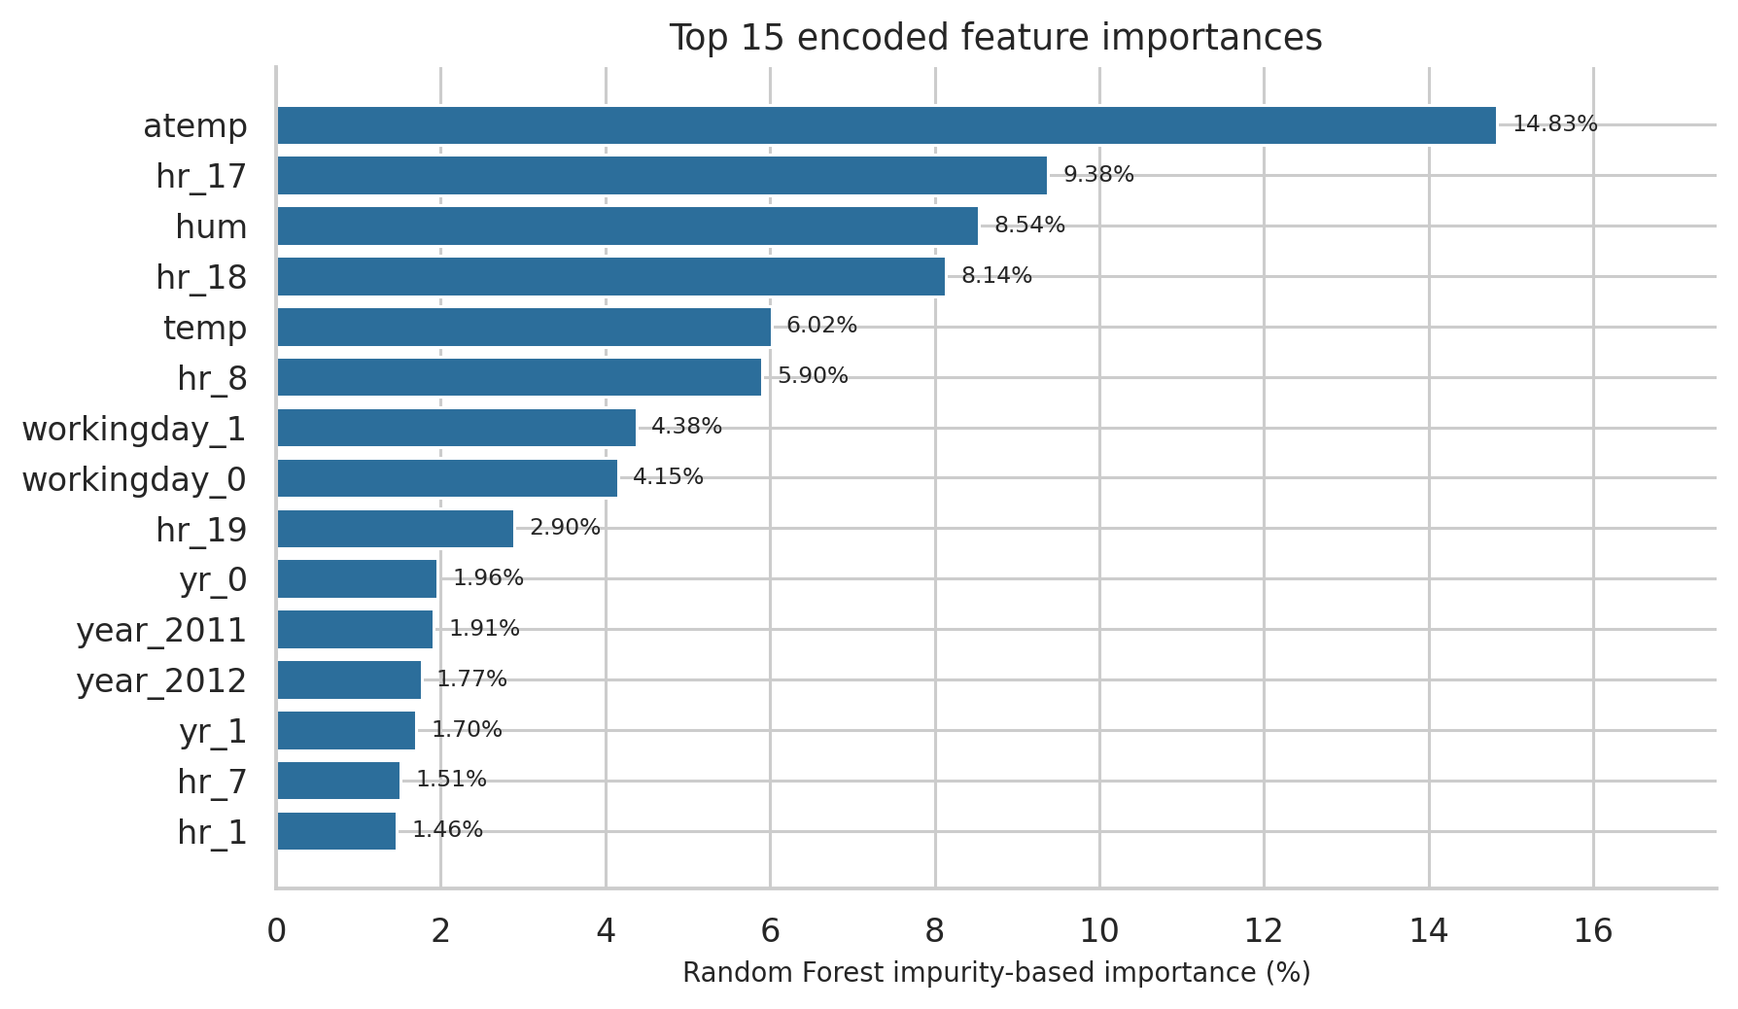
Figure 7. Top 15 one-hot encoded Random Forest features, calculated from the final fitted estimator.
The most important individual encoded feature is feels-like temperature (atemp, 14.83%), followed by the 17:00 hour indicator (9.38%), humidity (8.54%) and the 18:00 indicator (8.14%). Because hour and other categorical variables are expanded into multiple one-hot columns, a single encoded column is not the total importance of the original variable. Feature importance describes model reliance, not causation.

5.4 Held-out predictions and residual diagnostics
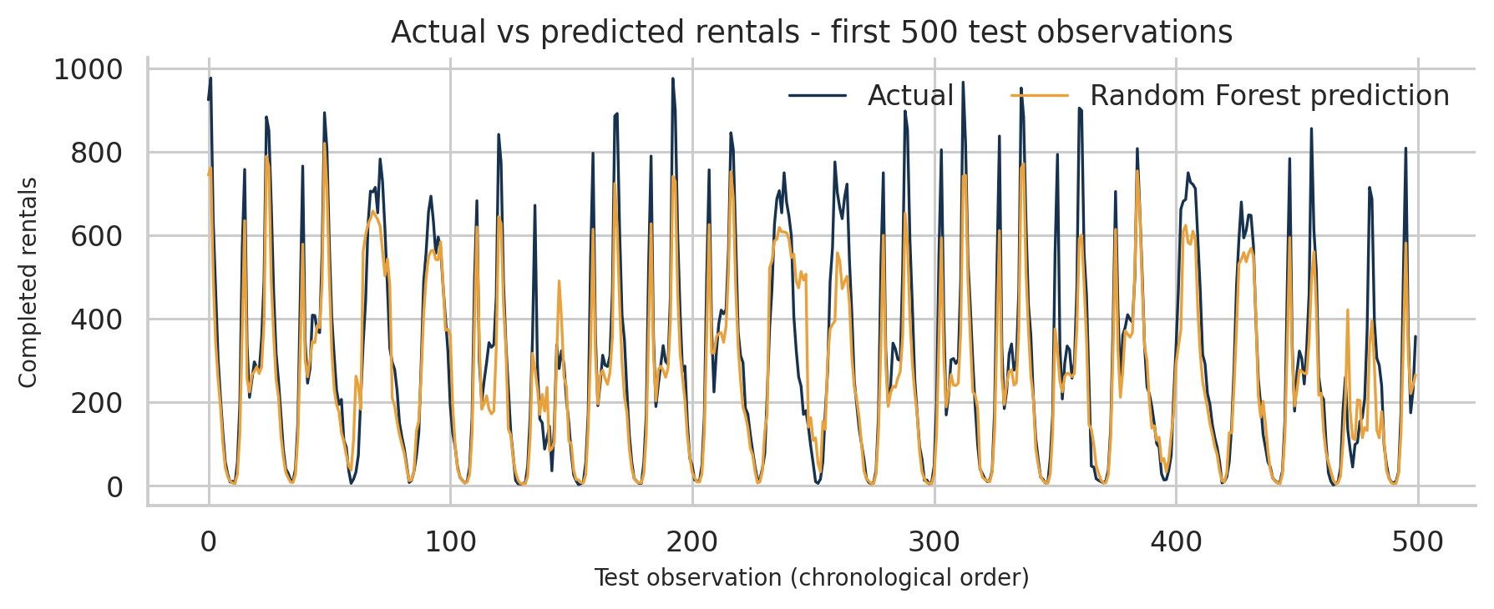
Figure 8. Actual and Random Forest-predicted completed rentals for the first 500 chronologically ordered observations in the held-out test period.
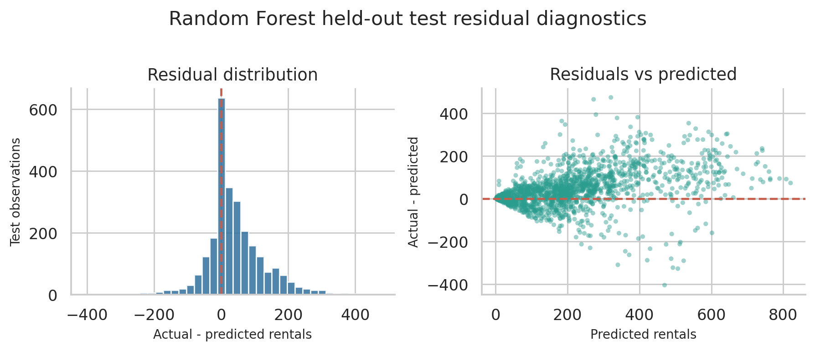
Figure 9. Residual distribution and residual-versus-predicted view for the full test set. Residual is defined as actual minus predicted.
Across the held-out test set, the mean residual (actual minus predicted) is 39.67 rentals/hour, which corresponds to an average prediction bias (predicted minus actual) of -39.67 rentals/hour. The residual spread grows at higher predicted demand, indicating larger uncertainty during high-demand periods.

5.5 Peak-period model errors
For operational interpretation, test observations are grouped into morning peak (07:00-09:00), evening peak (17:00-19:00) and all remaining hours (off-peak). Bias is defined as prediction minus actual; negative values mean the model underpredicts.
Test period | Rows | MAE | RMSE | Bias: pred - actual
Morning peak | 324 | 97.26 | 125.00 | -53.44
Evening peak | 330 | 122.48 | 147.99 | -79.71
Off-peak | 1953 | 48.72 | 75.09 | -30.62

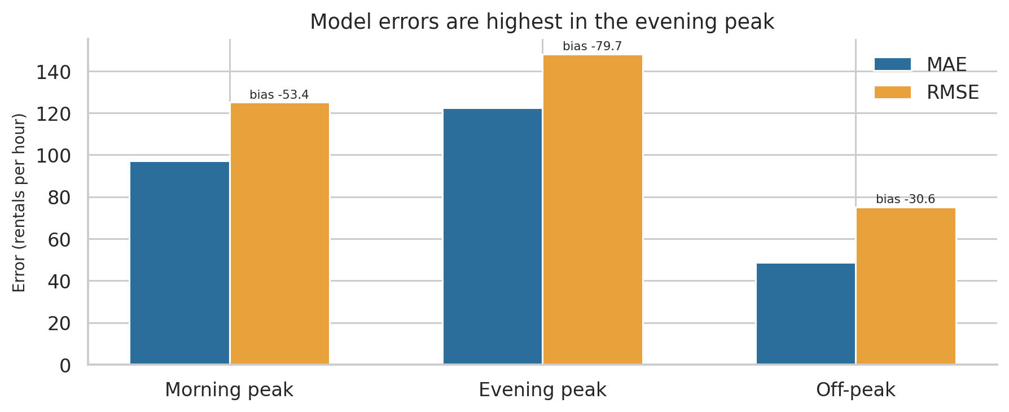
Figure 10. MAE and RMSE by test period. Labels show mean prediction bias (predicted minus actual).
The evening peak has the largest MAE and RMSE and the strongest underprediction. This is operationally important: a model that performs reasonably overall may still understate demand during the periods when a redistribution decision matters most.

6. Fleet Planning and Scenario Analysis

6.1 Little’s Law translation
The project uses Little’s Law to translate an hourly rental-start rate into an average number of bikes in use:
Bikes in motion (L) = rental-start rate (λ) × average trip duration (W)
Spatial positioning and maintenance reserves are additional assumptions beyond Little’s Law. The resulting fleet estimate is therefore a scenario, not an observed requirement.

6.2 Reference scenario
Input / result | Value | Evidence status
2012 observed hourly P95 demand | 662.35 rentals/hour | Historical percentile
Average trip duration | 20 minutes | Assumption
Spatial positioning buffer | 2.0x | Assumption
Maintenance reserve | 10% | Assumption
Bikes in motion | 220.8 | Calculated scenario
Positioned bikes before maintenance reserve | 441.6 | Calculated scenario
Scenario fleet after reserve | 491 bikes | Calculated; rounded up

Calculation: ceil(662.35 × (20/60) × 2.0 ÷ (1 − 0.10)) = 491 bikes. The 2012 P95 is an observed reference rate; trip duration, spatial buffer and maintenance share are not measured in the supplied dataset.

6.3 Sensitivity to assumptions
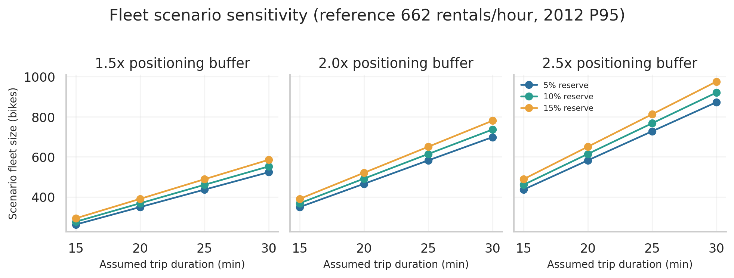
Figure 11. Scenario fleet sensitivity across trip durations, positioning buffers and maintenance reserves, using the observed 2012 P95 rate as the reference.
The scenario changes materially as trip duration, spatial positioning and the maintenance share change. For the central 2.0x buffer and 10% reserve, the scenario is 368 bikes at 15 minutes, 491 at 20 minutes, 613 at 25 minutes and 736 at 30 minutes. These values illustrate sensitivity, not a recommended fleet count.

6.4 Station-level transfer heuristic
The Fleet Planning page can accept a station snapshot containing station_id, available_bikes and forecast_rentals_per_hour, then calculate a simple target-stock donor/receiver shortlist. This is a heuristic, not a route optimiser. The test/example station data are synthetic and do not prove real station shortages, transfer volumes or savings. A real deployment must account for expected returns, dock capacity, bike condition, driver capacity, travel time and route cost.

7. Proposed 4-6 Week Redistribution Experiment

7.1 Testable operational hypothesis
Pilot hypothesis Among comparable station clusters, forecast-guided redistribution reduces empty-station minutes per station-hour during pre-defined peak windows compared with the current redistribution policy, without unacceptable increases in operating cost or safety risk.

7.2 Pilot phases
Phase | Timing | Work
Instrumentation and baseline | Week 1 | Validate inventory snapshots, failed-rental events, trip logs, bike health and driver logs; define peak windows and primary metric.
Controlled pilot | Weeks 2-4 or 2-6 | Matched station clusters: forecast-guided redistribution in treatment clusters and business-as-usual in control clusters.
Close-out | Final days | Reconcile data, estimate treatment effect and uncertainty, assess costs/guardrails and document deviations.

7.3 Experimental design
- Group nearby stations into operational clusters to reduce transfer contamination.
- Match clusters using baseline demand, empty-station minutes, station count, geography and operating hours.
- Randomly assign one cluster in each matched pair to treatment and the other to control.
- Keep assignment stable and log cross-cluster transfers; avoid cross-arm transfers where operationally possible.
- Estimate the difference in change from baseline between treatment and control, with uncertainty clustered at the randomisation unit.
- If there are too few independent clusters, consider a pre-registered randomised switchback by cluster-week with a defined washout period.

7.4 Treatment policy and schedule hypotheses
- Use citywide demand timing to choose when to investigate positioning; use live station-level forecasts and inventory to decide where bikes should move.
- Test completing a morning positioning round before approximately 07:00 and an afternoon round before approximately 16:30 on working days. These are trial timings, not optimised schedules.
- Use a separate non-working-day profile and test midday-oriented positioning only where station-level forecasts support it.
- Each dispatch should account for available stock, expected returns, dock capacity, bike health, driver capacity and travel time.

7.5 Required operational data and success metrics
Data to collect | How it is used
Timestamped rentable-bike and empty-dock snapshots by station | Measure stock-outs and surplus duration, ideally every 5-15 minutes.
Trip start/end stations and timestamps | Estimate flows, trip duration and likely returns.
Failed or abandoned rental attempts and reasons | Measure suppressed demand directly.
Bike health and out-of-service status | Separate allocation shortages from maintenance unavailability.
Rebalancing origin/destination, bikes moved, driver hours, kilometres and cost | Evaluate the operational effort and economics of treatment.

- Primary outcome: empty-station minutes per station-hour during pre-defined peak windows.
- Secondary outcomes: failed rental attempts per 1,000 attempts, completed rentals per station-hour, station-hours within target stock, idle-bike hours, stock-out counts/durations and complaints.
- Guardrails: driver hours and kilometres, cost per additional successful rental, moves per shift, safety incidents, damaged bikes and control-zone service quality.

7.6 Decision rules
- Scale cautiously only if the primary metric improves by a pre-agreed operationally meaningful amount, uncertainty is consistent with benefit and cost/safety guardrails remain acceptable.
- Refine and retest if the direction is positive but uncertain or the benefit is concentrated in particular station types/time windows.
- Do not scale if improvement is not meaningful, costs exceed the agreed limit or safety/service guardrails worsen.
- Consider targeted fleet additions only if reliable stock-out and unmet-demand evidence persists after rebalancing and repairs.

8. Dashboard and Gemini Natural-Language Prototype

8.1 Dashboard modules
Dashboard page | Purpose
Demand Overview | Overall rental statistics and high-level demand patterns.
Hourly Analysis | Hourly demand variation, day-type profiles and peak identification.
Customer Segmentation | Casual and registered customer comparisons.
Demand Prediction | Structured date/hour/weather inputs translated into a model estimate using the saved model bundle.
Fleet Planning & Experiment | Observed/predicted demand context, Little’s Law scenarios, sensitivity, timing and optional station-transfer heuristic.
Business Assistant | Plain-English questions interpreted by Gemini and routed to approved local analytical tools, with fallback and evidence display.

8.2 Gemini function-calling architecture
The operations manager submits a plain-English question in Streamlit. Gemini interprets the request and selects from an explicit allow-list of analytical functions. The local Python dispatcher validates the function name and arguments before executing the selected function against the dataframe, fleet-planning helpers or saved model. Only aggregate function output is sent back for natural-language explanation; Gemini is not given permission to execute arbitrary Python.
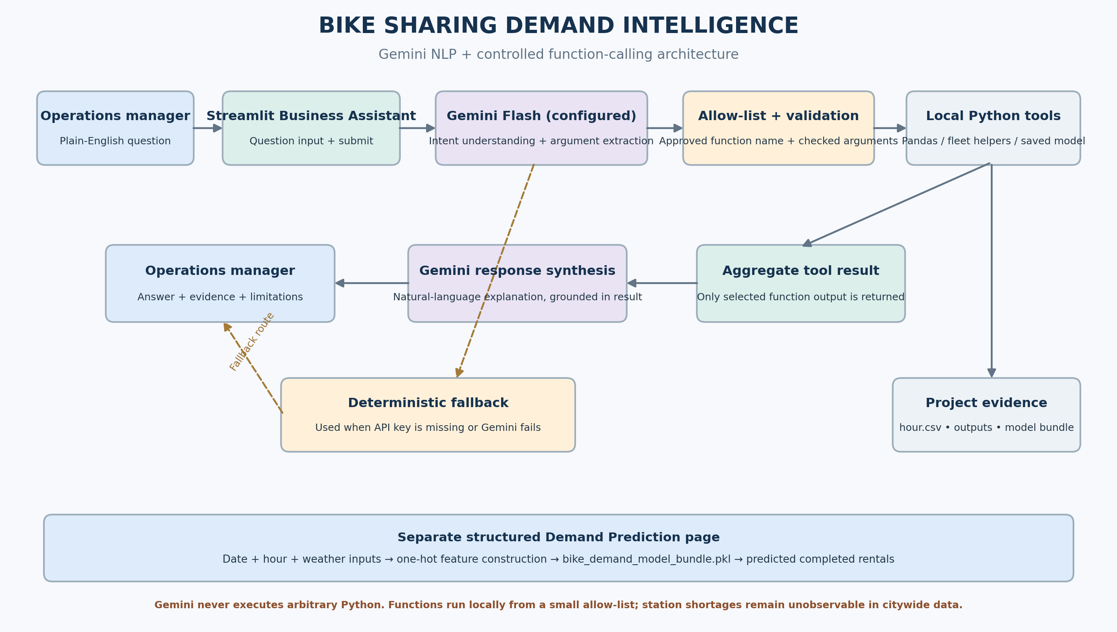
Figure 12. Gemini natural-language and controlled function-calling architecture. The structured Demand Prediction workflow is separate from the conversational Business Assistant.

8.3 Approved analytical functions
Function | Purpose
get_hourly_demand_profile | Observed hourly completed-rental profile and top-demand hours.
compare_day_types | Working-day versus non-working-day summaries and commute-window evidence.
get_customer_segment_summary | Casual and registered customer totals/shares by day type.
get_weather_demand_summary | Completed-rental averages by weather category.
calculate_fleet_scenario | Little’s Law fleet scenario with explicit assumptions.
get_redistribution_recommendation | Demand-timing evidence, pilot direction and decision constraints.
explain_data_limitations | Explains what citywide data cannot answer and which operational records are needed.
predict_hourly_demand | Prediction from the saved model bundle when all required input fields are supplied.

8.4 Live prototype evidence
A live local test asked, “When is demand highest?” Gemini selected get_hourly_demand_profile. The function returned the actual citywide demand profile; the answer identified 17:00 at 461.45 completed rentals/hour. The Streamlit UI displayed the Gemini success state, the selected function and a passing numeric-grounding check. Working-day/non-working-day comparison and customer-segment questions were also manually smoke-tested in the local interface.
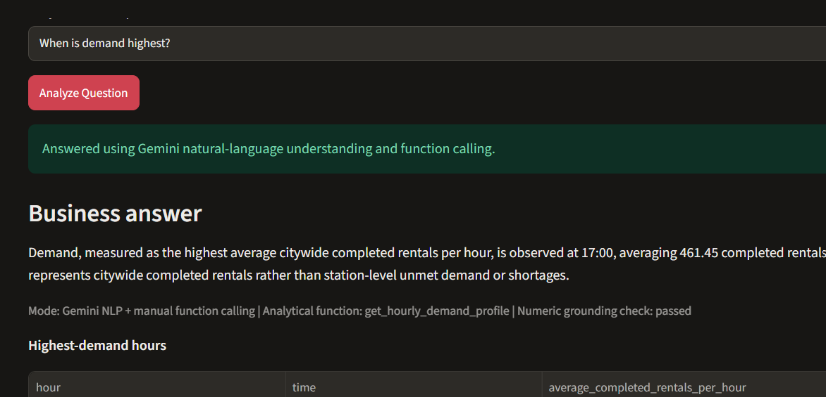
Figure 13. Screenshot from the local Streamlit Business Assistant showing a live Gemini response and the approved hourly-demand function.
This is a genuine local application screenshot. Other live question categories should be captured separately if they are to be shown as individual evidence in a presentation.

8.5 Fallback and key management
If the API key is missing or a Gemini request fails, the app uses deterministic keyword routing and explicitly labels the response as fallback mode. The API key is read from an environment variable or Streamlit secrets; it is not embedded in source code. The project .gitignore excludes environment files and Streamlit secrets.

9. Software Validation and Submission Evidence

9.1 Automated test results
Test suite | Result | Coverage
tests/test_prototype.py | 27 passed | Dataset/model interfaces, fleet-planning calculations, input checks and local application helpers.
tests/test_business_assistant_nlp.py | 10 passed | Analytical tool functions, allow-list and argument checks, prediction interface and fallback behaviour.
Combined: python -m pytest tests -v | 37 passed, 0 failed, 1 warning | Both suites executed together in the local project environment.

The Business Assistant tests are offline tests. They do not call the live Gemini API. Live API execution was verified separately by submitting a question in the running Streamlit dashboard and observing the Gemini success state.

9.2 Project deliverables
Deliverable | Role
Four Jupyter notebooks | Data understanding, EDA, hypothesis testing and demand forecasting.
app_GEMINI_NLP.py | Gemini-enabled Streamlit app entry point; original app.py is retained as a separate version.
business_assistant_nlp.py | Function schemas, allow-listed dispatcher, argument validation, grounded explanations and fallback.
fleet_planning.py | Little’s Law scenarios, percentiles, sensitivity, timing and station transfer shortlist.
data/hour.csv and data/day.csv | Source hourly and daily datasets.
models/bike_demand_model_bundle.pkl | Current one-hot Random Forest model bundle and preprocessing feature schema.
outputs/ | Forecast predictions, test metrics, feature importance, error summaries and prototype architecture.
redistribution_experiment_plan.md | Detailed experiment protocol and operational measures.
tests/ | 27 project tests and 10 Business Assistant tests.
README / implementation notes / decision log / AI usage | Setup, project structure, key decisions and AI-use disclosure.

10. Limitations, Risks and Next Data Requirements
- The dataset is citywide and contains completed rentals only; it does not show failed attempts, latent demand or station availability.
- There is no station-level inventory, dock capacity, station-to-station flow, trip duration or bike health record.
- The 491-bike fleet output depends on assumed trip duration, positioning buffer and maintenance reserve; it is not a measured requirement.
- The station-transfer shortlist is a heuristic; a synthetic test validates software behaviour, not actual operating savings.
- The Random Forest uses historical weather/calendar features. In a live forecast, future weather must be sourced at prediction time and evaluation must avoid using information unavailable when the decision is made.
- Peak-period prediction errors are higher than off-peak errors, particularly in the evening. Operational use should account for this underprediction.
- Weather category 4 has only three hourly observations; conclusions for that category are highly uncertain.
- Statistical observations are consecutive days; temporal dependence can affect uncertainty estimates.

10.1 Minimum operational data to request
- Station inventory snapshots with rentable bikes and empty docks, timestamped at a regular interval.
- Trip records with start/end station and start/end timestamps.
- Failed or abandoned rental attempts, including reason codes.
- Bike health and out-of-service status.
- Rebalancing movements, driver hours, distance, cost and transfer completion times.

10.2 Final recommendation
- Instrument station availability and failed-rental data before diagnosing the complaint as a fleet-size problem.
- Use separate working-day and non-working-day profiles to guide when station-level forecasts should be reviewed.
- Run a matched-cluster, forecast-guided redistribution pilot against business-as-usual operations for 4-6 weeks.
- Evaluate service improvement, operating cost and safety together using pre-registered success criteria.
- Only consider targeted purchases if verified stock-outs persist after rebalancing and fleet-health improvements.
Final decision Prioritise measurement and a controlled forecast-guided redistribution pilot before committing to broad fleet expansion. Current evidence supports demand timing and forecasting; it does not prove station-level imbalance or the exact fleet required.

Appendix A. Key Metric Definitions
Metric | Definition used in this report
MAE | Mean absolute difference between predicted and actual hourly completed rentals.
RMSE | Square root of mean squared prediction error; larger misses are penalised more.
R-squared | Proportion of target variation explained on the held-out test observations.
Residual | Actual minus predicted. Positive residuals indicate underprediction.
Prediction bias | Predicted minus actual. Negative bias indicates underprediction.
Commute-window share | Rentals in hours 07-09 and 17-19 divided by daily rentals; complete days only.
Empty-station minutes per station-hour | Primary pilot outcome: duration with zero rentable bikes within pre-defined peak windows, derived from valid inventory snapshots.
Little’s Law fleet scenario | Hourly rental-start rate × average trip duration, multiplied by explicit positioning and maintenance assumptions.

Appendix B. Fleet Scenario Formula and Assumption Sensitivity
Scenario fleet = ceil(P95 hourly rentals × trip duration in hours × spatial positioning buffer ÷ (1 - maintenance reserve)). For the reference scenario: ceil(662.35 × 20/60 × 2.0 ÷ 0.90) = 491 bikes.
Trip-duration assumption | Positioning buffer | Maintenance reserve | Scenario fleet
15 | 2.0x | 10% | 368
20 | 2.0x | 10% | 491
25 | 2.0x | 10% | 614
30 | 2.0x | 10% | 736

Appendix C. Source and reproducibility notes
Primary source: UCI Bike Sharing Dataset (hour.csv and day.csv), Capital Bikeshare, Washington, D.C., 2011-2012. Model results were reproduced from the project’s 04_demand_forecasting_COMPLETE.ipynb workflow using the same chronological split and Random Forest configuration (300 estimators, min_samples_leaf=2, random_state=42). Statistical tests follow the project’s 03_hypothesis_testing_updated.ipynb definitions. Figures in this report were regenerated from the source CSVs and the reproduced model outputs; the test-prediction and feature-importance figures use the same trained workflow and held-out test split.
Local software verification: python -m pytest tests -v reported 37 passed and 1 warning on 10 November 2026. The warning did not result in a failed test. One live Gemini function-call response was also observed in the local Streamlit app. The report does not claim that an operational redistribution experiment has already been run.

