15CSE376 Net Centric Programming

Review Term: 1

Group Number: 12

Project Title: Alumni Portal

|  |  |
| --- | --- |
| Team Members | Roll Numbers |
| Ishwarya .S | CB.EN.U4CSE16423 |
| Lakshmi Priya E | CB.EN.U4CSE16432 |
| Yamini Sanjana | CB.EN.U4CSE16466 |
| Sneha Varsha | CB.EN.U4CSE16467 |

ABSTRACT

Many institutions, colleges and universities maintain the information manually about present and past students. This does not allow efficient data management and retrieval process. A student willing to get information about others has to approach the college and obtain the details. Often the information may not be available and misleading.

The objective of this application is to allow old and new students of a university or college to communicate with each other. This allows students to know about each other and their current activities.

INTRODUCTION TO WEB DESIGNING

Web design is the visual aesthetics and page layout of a website. It goes hand-in-hand with web development in the creation of a static website or dynamic web application.

Even if you don’t consider yourself a creative person, it’s still a good idea to learn web design. No matter whether you want to make static websites or dynamic web applications, design is an important part of the process. The design is the first thing people notice when they arrive on a website, and if it’s not good enough, they’ll leave.

If you do identify yourself as a creative person, you might even consider a career as a web designer. Today, there is a huge need for competent web designers with up-to-date skills.

Learn coding and you’ll be a valuable asset to many. But learn coding and design and you’ll be second to none!

The web design process starts with a visual concept, which you could sketch by hand or with software like Photoshop. Then, you use HTML and CSS to build the website. HTML and CSS are the codes for writing web pages. HTML handles the basic structure and ‘bones’ of your page, while CSS handles the style and appearance.

**JavaScript** (**JS**) is a high-level, interpreted programming language  will be mainly used for validation.

JS is a lightweight, interpreted, or just-in-time compiled programming language with first class function. While it is most well-known as the scripting language for Web pages, [many non-browser environments](https://en.wikipedia.org/wiki/JavaScript#Uses_outside_Web_pages) also use it, such as Node js, [Apache CouchDB](https://couchdb.apache.org/) and [Adobe acrobat](http://www.adobe.com/devnet/acrobat/javascript.html). JavaScript is a prototype based, multi-paradigm, dynamic language, supporting object-oriented, imperative, and declarative (e.g. functional programming) styles.

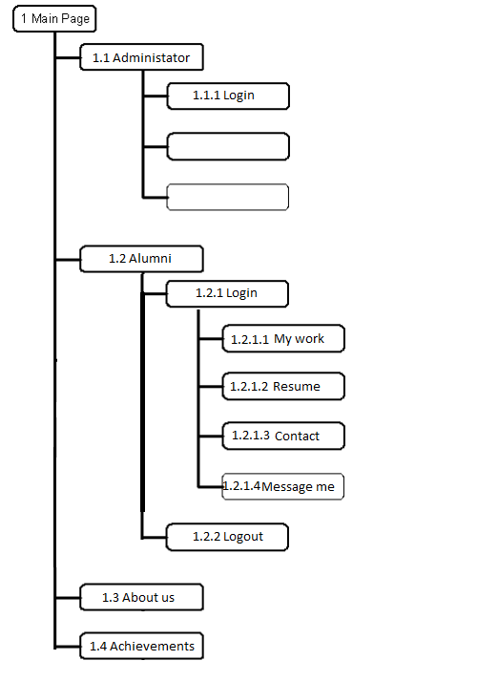

SCREENSHOTS



