PYTHON PROJECT REPORT
(Project Semester: August – December 2025)
Title of the Project: Crime Predictive Analysis.
Submitted by:
Sneha Suman
Registration No.: 12301275
Programme and Section: B.Tech CSE (K23CG)
Course Code: INT234
Under the Guidance of:
Anchal Kaundal
Discipline of CSE/IT
Lovely School of Computer Science & Engineering
Lovely Professional University, Phagwara

DECLARATION
I, Sneha Suman, student of Bachelors of Technology (B.Tech) under CSE/IT Discipline at Lovely Professional University, Punjab, hereby declare that all the information furnished in this project report is based on my own intensive work and is genuine.
Date: 20-December-2025
Signature: Sneha
Registration No.: 12301275
Name of the Student: Sneha Suman

CERTIFICATE
This is to certify that Sneha Suman bearing Registration No. 12301275 has completed INT234 project titled “Crime Predictive Analysis” under my guidance and supervision. To the best of my knowledge, the present work is the result of her original development, effort, and study.
Anchal Kaundal
Assistant Professor
School of Computer Science & Engineering
Lovely Professional University
Phagwara, Punjab
Date: 20-December-2025

ACKNOWLEDGMENT
I would like to express my sincere gratitude to Anchal Kaundal my project guide, for their invaluable support, guidance, and encouragement throughout the development of this project. Their expert insights and constructive feedback have been instrumental in shaping the project's outcome.
I am also thankful to Lovely Professional University for providing a conducive learning environment and access to resources that made this project possible. Additionally, I extend my appreciation to my professors and peers for their continuous motivation and insightful discussions, which greatly enhanced my understanding of the subject.
Lastly, I would like to acknowledge the unwavering support of my family and friends, whose encouragement has been a source of inspiration throughout this journey.

TABLE OF CONTENTS
- Introduction
- Source of Dataset
- Dataset Preprocessing
- Analysis on Dataset (for each objective)
- Conclusion
- Future Scope
- References

Streamlit link :- Streamlit
Github Link :- snehasuman019/Crime_Pridictive_Analysis: Machine learning project on crime data using regression, classification and clustering

1. INTRODUCTION
Crime analysis plays a vital role in understanding criminal behavior, identifying patterns, and supporting effective law enforcement strategies. With the increasing availability of crime-related data, predictive analytics and machine learning techniques can be used to analyze historical crime records and derive meaningful insights that aid decision-making.
This project, Crime Predictive Analysis, focuses on applying machine learning techniques to analyze crime data based on temporal and spatial attributes. The aim is to identify trends, predict crime occurrence characteristics, detect crime hotspots, and evaluate model performance using standard metrics.
The project strictly follows the Predictive Analytics / Machine Learning Laboratory syllabus, covering supervised learning, unsupervised learning, dimensionality reduction, and model evaluation techniques. In addition to notebook-based analysis, an interactive dashboard was developed to visualize insights in a real-world application format.
Objectives of the Project
- To explore and preprocess crime data effectively
- To apply regression models for crime time prediction
- To implement classification models for crime shift prediction
- To identify crime hotspots using clustering techniques
- To apply PCA for dimensionality reduction
- To evaluate models using cross-validation and ensemble methods
- To visualize insights using interactive dashboards and maps

2. SOURCE OF DATASET
The data used in this analysis is derived from ‘data.gov’ . This dataset consists of recorded crime incidents containing spatial, temporal, and categorical information. Key attributes include:
- Year
- Month
- Hour
- Latitude
- Longitude
- Crime Offense Type
- Crime Shift
The dataset provides sufficient complexity and real-world relevance for applying machine learning algorithms. After initial inspection, both raw and preprocessed versions of the dataset were maintained to ensure transparency and reproducibility.
Rationale for Choosing This Dataset
This dataset was chosen because it enables:
- Temporal analysis of crime patterns
- Spatial analysis through geographical coordinates
- Supervised learning for prediction tasks
- Unsupervised learning for hotspot detection
- Real-world application of predictive analytics concepts
Benefits of the Dataset
- Contains both numerical and categorical features
- Suitable for regression and classification tasks
- Enables clustering and geospatial analysis
- Aligns well with academic syllabus objectives

3. DATASET PREPROCESSING
Before applying machine learning models, the dataset underwent a structured preprocessing phase to ensure quality and reliability.
Preprocessing Steps
- Handling Missing Values:
Missing values in key attributes were identified. Rows with critical missing data were removed, while appropriate imputation techniques were applied where required.
- Data Cleaning:
Redundant and irrelevant columns were dropped. Column names were standardized for consistency.
- Feature Engineering:
Temporal attributes such as year, month, and hour were extracted and formatted. Categorical variables were encoded to make them suitable for machine learning algorithms.
- Data Scaling:
Numerical features were scaled to ensure uniformity, particularly for PCA and distance-based algorithms.
- Final Dataset Preparation:
The cleaned and processed dataset was saved separately and used for model training and visualization.
This preprocessing phase ensured the dataset was suitable for accurate analysis and reliable predictions.

4. ANALYSIS ON DATASET
This section discusses the detailed analysis performed on the crime dataset using various machine learning techniques as prescribed in the Predictive Analytics syllabus. The analysis includes regression, classification, clustering, dimensionality reduction, and model performance evaluation. Each method was applied with appropriate preprocessing and evaluation metrics to extract meaningful insights from the dataset.
4.1 Exploratory Data Analysis (EDA)
Before applying machine learning models, exploratory data analysis was conducted to understand the structure, distribution, and relationships within the dataset.
Analysis Performed
- Examined the distribution of crime incidents across different years, months, and hours
- Analyzed numerical attributes such as latitude and longitude
- Identified missing values and outliers
- Studied correlations between temporal and spatial features
EDA helped in identifying important features and guided further preprocessing and model selection.
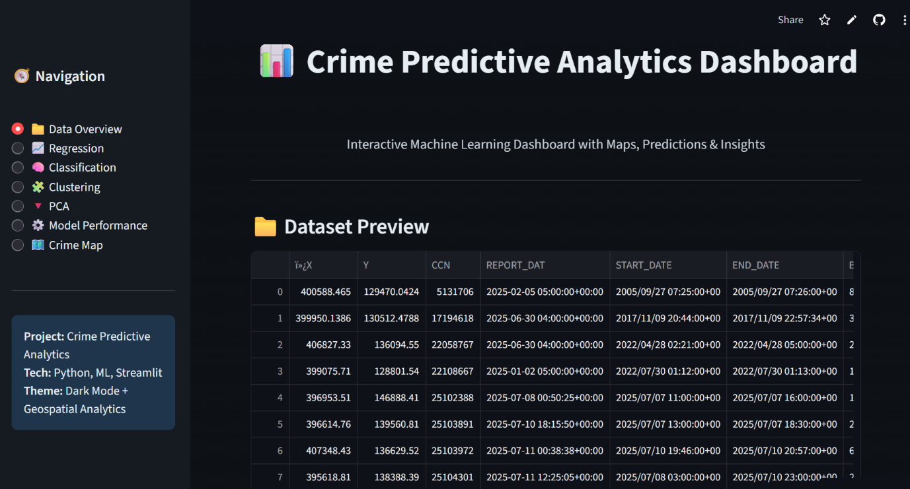
Figure 4.1: Sample view of crime dataset after preprocessing
4.2 Regression Analysis – Crime Time Prediction
Objective
To predict the hour of crime occurrence based on temporal and spatial attributes such as year, month, latitude, and longitude.
Techniques Used
- Simple Linear Regression
- Multiple Linear Regression
- Polynomial Regression
Model Explanation
Regression models were trained using historical crime data to estimate the hour at which a crime is likely to occur. Ordinary Least Squares (OLS) estimation was used to determine optimal regression coefficients.
Evaluation Metrics
- Mean Absolute Error (MAE)
- Mean Squared Error (MSE)
- Root Mean Squared Error (RMSE)
- R-squared (R²)
Observations
- Low R² values indicate that crime occurrence is influenced by multiple complex factors
- Regression models provided baseline insights into temporal crime patterns

Figure 4.2: Regression-based crime hour prediction
4.3 Classification Analysis – Crime Shift Prediction
Objective
To classify crimes into different shifts (Day, Evening, Night) based on crime characteristics.
Techniques Used
- K-Nearest Neighbors (Lazy Learning)
- Naïve Bayes (Probabilistic Learning)
- Decision Tree (Divide and Conquer)
- Support Vector Machine (SVM)
Model Explanation
Classification models were trained to learn decision boundaries from labeled crime data. Decision Tree models were preferred due to their interpretability and ability to handle nonlinear relationships.
Evaluation Metrics
- Accuracy
- Precision
- Recall
- F1-Score
- Confusion Matrix
Observations
- Decision Tree and ensemble-based models performed better than probabilistic models
- Classification highlighted temporal crime behavior patterns
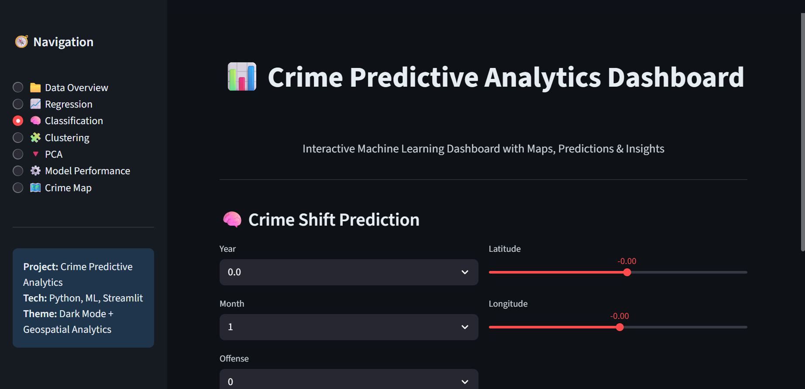
Figure 4.3: Classification-based crime shift prediction
4.4 Clustering Analysis – Crime Hotspot Detection
Objective
To identify crime hotspots by grouping crime incidents based on geographical proximity.
Techniques Used
- K-Means Clustering
- Hierarchical Clustering (conceptual understanding)
Model Explanation
K-Means clustering was applied on latitude and longitude values to form clusters representing areas with high crime density. The number of clusters was selected using empirical analysis.
Observations
- Certain regions showed higher concentration of crime incidents
- Clustering helped visualize spatial crime patterns effectively
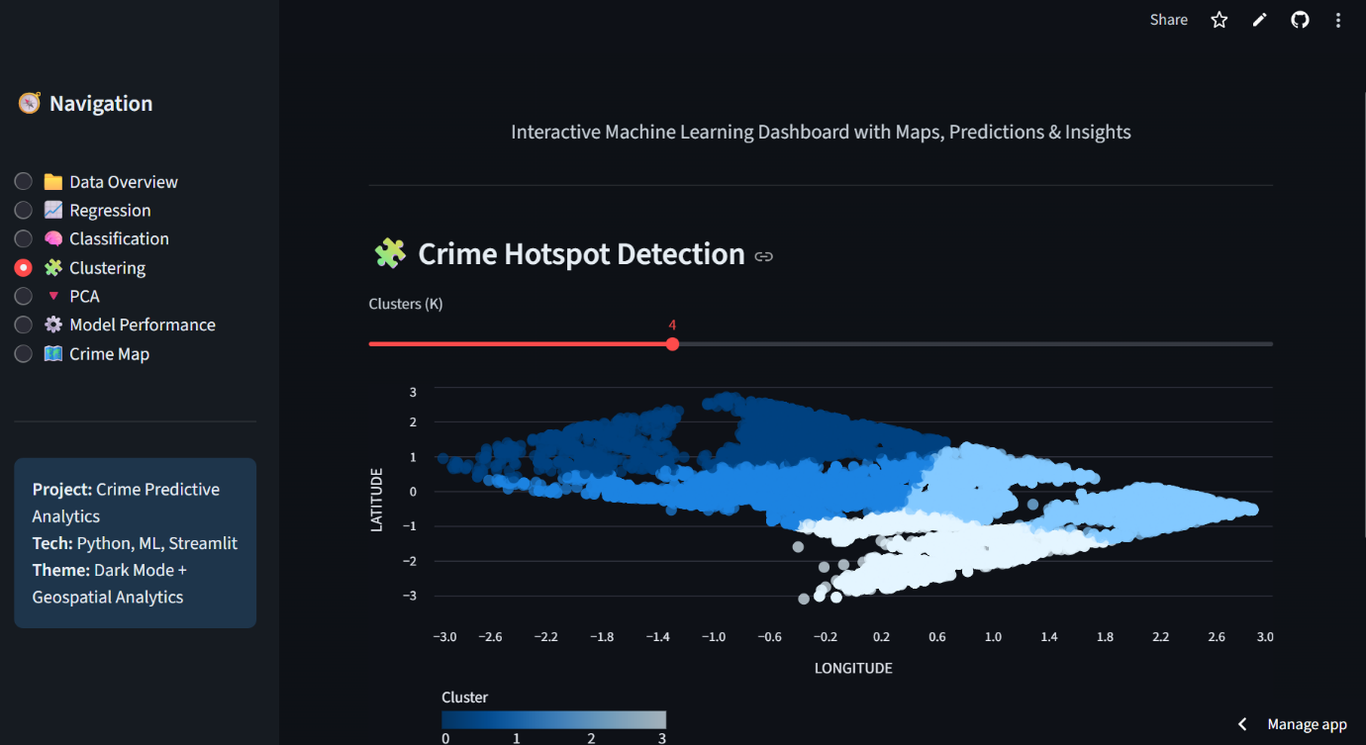
Figure 4.4: Crime hotspot detection using K-Means clustering
4.5 Dimensionality Reduction – Principal Component Analysis (PCA)
Objective
To reduce high-dimensional crime data into fewer components while preserving maximum variance.
Technique Used
- Principal Component Analysis (PCA)
Model Explanation
PCA was applied after data scaling and imputation. It transformed the original features into principal components that capture the most significant variance in the dataset.
Observations
- PCA improved visualization of complex data
- Reduced redundancy among correlated features

Figure 4.5: PCA visualization of crime data
4.6 Model Performance Evaluation
Objective
To evaluate the generalization and robustness of machine learning models.
Techniques Used
- K-Fold Cross-Validation
- Ensemble Learning (Random Forest)
Evaluation Metrics
- Cross-validation accuracy
- Feature importance
Observations
- Cross-validation reduced overfitting and bias
- Random Forest provided stable performance and feature importance insights
- 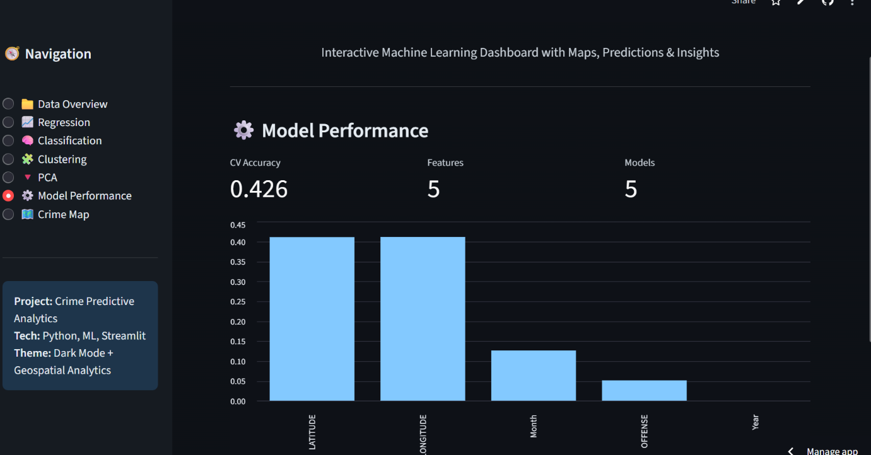
Figure 4.6: Model performance evaluation and feature importance

5. CONCLUSION
This project, Crime Predictive Analysis using Machine Learning, successfully demonstrated the application of predictive analytics techniques on real-world crime data. The primary objective of the project was to analyze historical crime records, extract meaningful patterns, and apply machine learning models to predict and visualize crime behavior based on temporal and spatial attributes.
The project followed a systematic machine learning workflow starting from data exploration and preprocessing, followed by the implementation of supervised and unsupervised learning algorithms. Regression models were applied to predict the hour of crime occurrence, highlighting the complexity of crime patterns influenced by multiple dynamic factors. Classification models were used to predict crime shifts, where Decision Tree and ensemble-based approaches showed better interpretability and performance.
Unsupervised learning techniques such as K-Means clustering enabled the identification of crime hotspots based on geographical coordinates. This helped in understanding spatial crime distribution and regional concentration of crime incidents. Dimensionality reduction using Principal Component Analysis (PCA) effectively reduced data complexity while preserving important variance, improving visualization and computational efficiency.
Model performance was evaluated using standard evaluation metrics and cross-validation techniques, ensuring robustness and generalization. Ensemble learning using Random Forest further enhanced model stability and provided valuable insights into feature importance.
In addition to notebook-based analysis aligned with the academic syllabus, an interactive Streamlit dashboard was developed to present analytical results in a user-friendly and visual manner. The dashboard integrated prediction models, clustering results, PCA visualization, model performance metrics, and a geospatial crime map, bridging the gap between academic learning and real-world application.
Overall, the project achieved its intended objectives and provided a comprehensive understanding of predictive analytics concepts, machine learning workflows, and data visualization techniques. It also demonstrated how analytical models can support informed decision-making in crime analysis and public safety planning.

6. FUTURE SCOPE
Although the project achieved meaningful results, there are several opportunities for enhancement and further research:
- Real-Time Crime Data Integration
The system can be extended to process real-time crime data streams, enabling live crime monitoring and predictive alerts.
- Advanced Time-Series Forecasting
Incorporating time-series models such as ARIMA, SARIMA, or LSTM networks can improve the prediction of crime trends over time.
- Deep Learning Models
Deep learning techniques such as Convolutional Neural Networks (CNNs) and Recurrent Neural Networks (RNNs) can be explored for more complex spatial and temporal pattern recognition.
- Socioeconomic and Environmental Factors
Integrating additional data such as population density, weather conditions, unemployment rates, and socioeconomic indicators can enhance predictive accuracy.
- Improved Geospatial Analysis
Advanced geospatial techniques such as heatmaps, spatial autocorrelation, and GIS-based analytics can provide deeper insights into crime distribution.
- Cloud Deployment and Scalability
Deploying the system on cloud platforms with scalable infrastructure can support larger datasets and wider accessibility.
- Decision Support Systems for Law Enforcement
The model can be integrated into decision-support tools to assist law enforcement agencies in resource allocation, patrol planning, and crime prevention strategies.
- User Authentication and Role-Based Access
Implementing authentication mechanisms can allow different stakeholders to access customized analytics dashboards.
These enhancements can significantly improve the applicability and impact of predictive analytics in crime prevention and public safety.

References
- Han, J., Kamber, M., & Pei, J. (2012). Data Mining: Concepts and Techniques. Morgan Kaufmann Publishers.
- Géron, A. (2019). Hands-On Machine Learning with Scikit-Learn, Keras, and TensorFlow. O’Reilly Media.
- Bishop, C. M. (2006). Pattern Recognition and Machine Learning. Springer.
- James, G., Witten, D., Hastie, T., & Tibshirani, R. (2013). An Introduction to Statistical Learning. Springer.
- Scikit-Learn Documentation.
https://scikit-learn.org/stable/
- Streamlit Documentation.
https://docs.streamlit.io/
- Folium Documentation.
https://python-visualization.github.io/folium/
- Pandas Documentation.
https://pandas.pydata.org/docs/
- Aggarwal, C. C. (2015). Data Mining: The Textbook. Springer.

